AWS Solutions Architect Associate Certification

Class 1: Setup Codebase Gitpod
- Install AWS CLI (search the official website)
- Create environment:
2.1 Option 1
(.gitpod.yml)
tasks:
- name: aws-cli
env:
AWS_CLI_AUTO_PROMPT: on-partial
before: |
cd /workspace
curl "https://awscli.amazonaws.com/awscli-exe-linux-x86_64.zip" -o "awscliv2.zip"
unzip awscliv2.zip
sudo ./aws/install
cd $THEIA_WORKSPACE_ROOT (Environment setting)
2.2 Option 2
(.devcontainer/devcontainer.json)
{
"name": "Ona",
"build": {
"context": ".",
"dockerfile": "Dockerfile"
},
"postCreateCommand":"curl 'https://awscli.amazonaws.com/awscli-exe-linux-x86_64.zip' -o /tmp/awscliv2.zip && unzip /tmp/awscliv2.zip -d /tmp && sudo /tmp/aws/install && rm -rf /tmp/aws /tmp/awscliv2.zip",
"remoteEnv": {
"AWS_CLI_AUTO_PROMPT": "on-partial"
}
}

(.devcontainer/Dockerfile)
FROM mcr.microsoft.com/devcontainers/base:ubuntu-24.04

# use this Dockerfile to install additional tools you might need, e.g.
# RUN apt-get update && export DEBIAN_FRONTEND=noninteractive \
# && apt-get -y install --no-install-recommends <your-package-list-here>

Class 2: Introduction to S3
What is a Object Storage: manage data as objects
S3 object contain your data, they are like files. Object may consist of: KEY, VALUE, VERSION ID, Metadata.
S3 Buckets hold objects.
- Create a S3 bucket.
- Create, delete, search Buckets with CLI. (1:45) Finishe

Class3: do these command in codespace. (3:00)

Class4: Python for s3 (boto3).
Connect to aws – s3 = boto3.Session().client() or boto3.client())
Upload files – s3.upload_fileobjs

Class5: configure and deploy stack. (4:15)

Class6 CDK (4:40) still fixing bug…
CDK login credentials steps:
export AWS_PROFILE=myprofile
export AWS_REGION=eu-central-1
export AWS_DEFAULT_REGION=eu-central-1
export CDK_DEFAULT_ACCOUNT=$(aws sts get-caller-identity --profile myprofile --query Account --output text)
export CDK_DEFAULT_REGION=eu-central-1

class6: Plumi
pulumi aws-python
pulumi up
pulumi destroy
pulumi stack rm my-example-lsc

Class7: S3 Bucket Overview:
- Naming rule (5:13)
Length: 3-63 charactors
Charactors: lowercase, dot (.) and hythens (-)
Start and end: letter or number
No adjacent period.
Can not be Ip address format
Retricted prefix: xn--, sthree-
Restricted suffix -s3alias or –ol-s3
Uniqueness.
Exclusive. Can not be reused in the same partition unless the bucket deleted
Transfer acceleration. Buckets with S3 transfer acceleration can not have dot in their name.

- Buckt Restrictions
Number: 100; request to increase to 1000
Size: no limite, files size < 5T, larget than 100 need multi-part upload
Get, Put, List and Delete are designed for high availability.

- Bucket types
General:
Directory buckets: Only to be used in S3 Express One Zone Storage class.
Single-digit millisecond performance
10 bucket per account

- Bucket folder
General buckets Don’t Have True folders. Folder always have size 0, file inside folder is just have prefix same as the folder name.

- Objects
S3 Objects represent data not infrastructure
Etag: represetent hash of the content, it record changes. It represent version of an object, allow you to check the change without downloading them.

- Checksum
For check data integrity.

- Object prefix
Use “/” to group data, but not true folder. (Key name: the whole, include prefix/filename)
Key length no larger than 1024 characters.

- Metadata
System meta is not changeable.

- WORM: a compliance feature that write data once and can never be modified or deleted.
- Lock
Bucket lock can only be set during creation of an bucket.
Object lock can only be set through aws api (sli, sdk), not aws console.

- S3 Bucket URI (uniform resource identifier)

- aws cli
S3: high level way to interact with s3 buckets and obj.
s3api: low level way to interact with S3
s3control: managing s3 access point, outposts buckets, batch operation, storage lens.
s3outposts: managing endpoint for s3 outposts.

- s3 request style
virtual hosted-style request

- dual-stack endpoint support both ipv4 and ipv6
- strorage type
S3 standard: 11 9’s durability, 4 9’s availability, 3 or more zone, millisecond level retrieve. Pricing: GB, per request, no retrieval fee, no minimal storage duration charge.
S3 reduced redundancy strorage (RRS): not suitable for current user.
S3 intelligence tiering: automatically move objects to different storage tier.
S3 express one zone: faster, cheaper, 50% cheaper per request, single zone.
S3 standard IA (infrequent access): 3 9’s availability, Pricing, has retrieval fee. minimal storage duration charge 30 day.
S3 one-zone IA: 99.5% availability. 20% less cost. Pricing, has retrieval fee. minimal storage duration charge 30 day.
S3 glacier: VAULT -> include deep archive, flexible. But glacier instant is idenpendent.
Glacier instant: 3 9’s availability. 68% lower cost. For long lived data accessd once per quarter. Pricing, has retrieval fee. minimal storage duration charge 90 day.
Glacier flexible: 3 Tier retrieve: expediated: 1-5 min, 250MB
Standard: 3-5 hours, no size limite,
Bulk: 5-12 hours
(Note: 40kb extra for each file, so store large file here)
Glacier Deep Archive: Stardard: 12-48 hours, bulk: 12-48 hours. (Same note above)
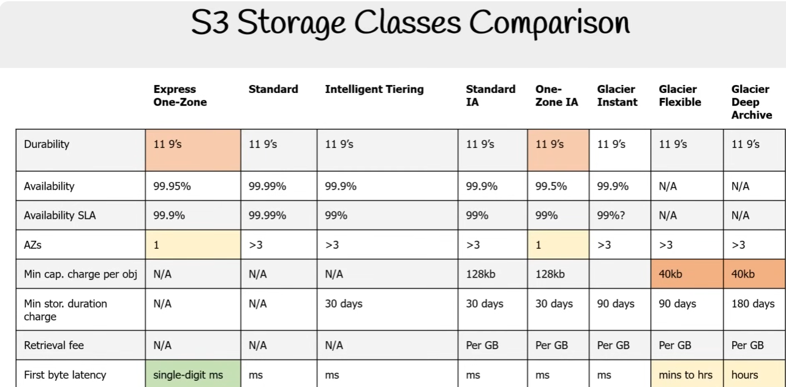
Security overview:
