- Data Download
- Go to website: https://balsa.wustl.edu/ and login.
- Select ConnectomeDB and HCP-Young Adault 2025
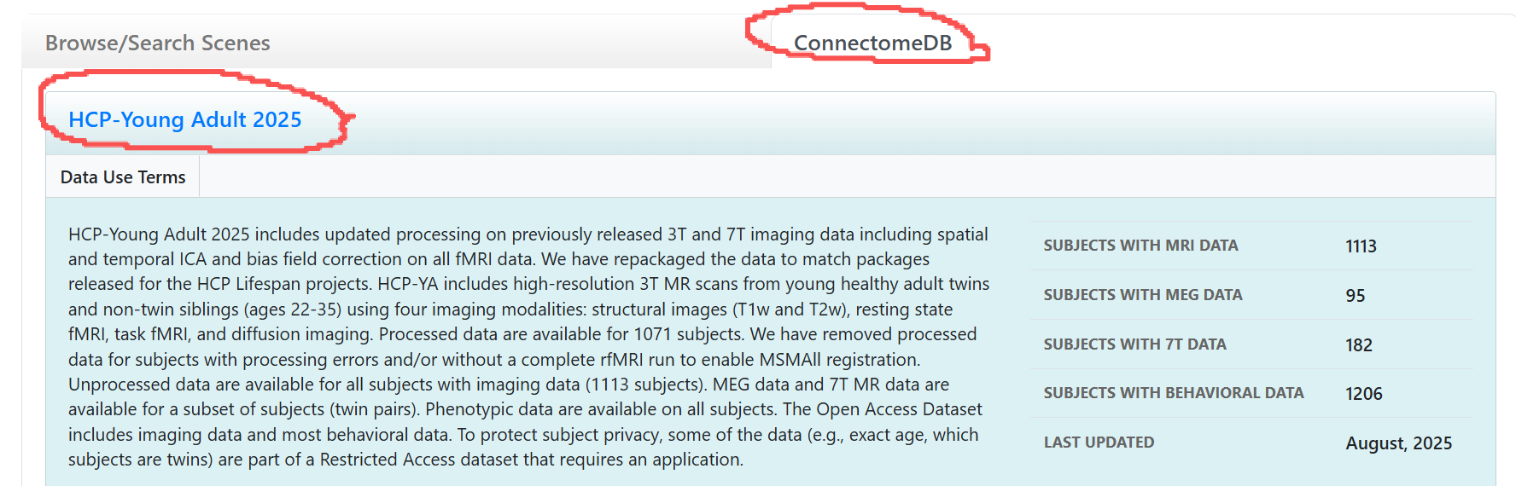
- Find Subject ID and click.
- Download the circled three files to “raw_data” directory .
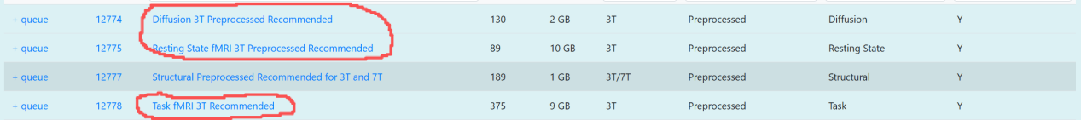

- Process fMRI and dMRI data
- Process fMRI data.
Run “Process_fMRI.bat”, or run“prep_fMRI.py” and “merge.py” sequentially.
This script will process all fMRI-related files in the “raw_data” directory and generate two output files: “output_temp.mat” and “output_final.mat” in the “Processed_fMRI” directory.
“output_temp.mat” contains the processed samples currently stored in “raw_data”.
“output_final.mat” contains all processed data, including both the samples currently in “raw_data” and those processed previously.

- Process dMRI data.
- Download and install MRtrix3.
- Run “unzip_dMRI.py” to extract the dMRI data.
- Launch MSYS2 MINGW64 (MRtrix3 terminal).
- In the opened terminal, run the command “python dMRI_to_graph.py”. (The output will be a directory, named according to the processed subject’s ID, genereated within the “Processed_dMRI” directory.)
- If the program crashes, delete the directory in “Processed_dMRI” that is named after the unsuccessfully processed subject’s ID.

- Delete processed data.
- Delete successfully processed data from “raw_data” directory.
- Delete all files contained in the “HCP_dMRI” directory.

