**Genetic and Epigenetic Analysis to a COL2A1 Caused Czech Dysplasia Pedigree**

Shicheng Guo1,2#, Mengfeng Zhao3#, Steven J Schrodi2,4*, Dongyi He3,5*

1, Center for Precision Medicine Research, Marshfield Clinic Research Institute, Marshfield, WI 54449, USA

2, Computation and Informatics in Biology and Medicine, University of Wisconsin-Madison, Madison, WI, 53706, USA

3, Department of Rheumatology, Shanghai Guanghua Hospital of Integrated Traditional and Western Medicine, Shanghai 200052, China.

4, Department of Medical Genetics, School of Medicine and Public Health, University of Wisconsin-Madison, Madison, WI 53706, USA

5, Arthritis Institute of integrated Traditional and Western medicine, Shanghai Chinese Medicine Research Institute, Shanghai 200052, China.

#These authors contributed equally to this work

*Correspondence:

Dongyi He, M.D., Ph.D.

Department of Rheumatology

Shanghai Guanghua Hospital of Integrated Traditional and Western Medicine,

Shanghai, China

Email: [dongyihe@medmail.com.cn](mailto:dongyihe@medmail.com.cn)

Steven J. Schrodi, Ph.D.

Department of Medical Genetics

School of Medicine and Public Health

University of Wisconsin-Madison

Madison, WI 53706

Tel: xxx-xxx-xxxx

Email: [Schrodi@wisc.edu](mailto:Schrodi@wisc.edu)

## **Abstract**

Aim: COL2A1 mutation has been widely reported in heritable cartilaginous disease. Here, we reported first case of Czech dysplasia (OMIM609162) pedigree in the Chinese population. In order to identify the pathogenic gene to the Czech dysplasia pedigree, we applied whole-genome exon sequencing to three patients and three normal control from the pedigree, respectively. We identified a mutation (NP_001835.3:p.Arg275Cys) in collagen type II alpha 1(*COL2A1*) was dominantly occurred in all the cases while showed wild type in all control individuals. We validated the variants with Sanger sequencing and mechanism of mutation causing the symptoms. Meanwhile, we generated genome-wide methylation profiles (WGBS) and genome-wide expression profile (RNA-seq) for Czech dysplasia with cartilaginous nodules. We identified xx differential gene expression and xxx differential methylation regions in Czech dysplasia. Finally, pathway and IPA analysis showed mutated COL2A1 caused xxx and therefore provide xxx phentoypes to Czech dysplasia patients.

Key words:

Spondyloepiphyseal dysplasia in HGMD

Synovial Chondromatosis, COL2A1

Whole Exome-sequencing

NM_001844.5 (COL2A1):c.823C>T (p.Arg275Cys)

Czech dysplasia vs Synovial Chondromatosis ??

More than 421 mutations (215 missense and nonsense mutation, 81 splicing, 80 small deletion, 28 small insertion) have been observed in COL2A1.

## **Background**

Synovial chondromatosis (SC) is a rare benign lesion characterized by synovial metaplasia and cartilage nodules. The cartilage nodules eventually break, mineralize, and even ossify [1]. Synovial chondromatosis often occur in the joint cavity, a few occur in the joint cavity, and there are very few lesions inside and outside the joint cavity. The cartilage nodules of the synovial chondromatosis occurring outside the joint cavity are derived from the tendon sheath and the bursa [2]. The most common affected joints of Synovial chondromatosis are knee and hip joints [2-4] meanwhile the temporomandibular joint, ankle joint, spine, elbow joint, shoulder joint and hand joint have also been reported to be affected [4,5]. The main symptoms of SC are pain, swelling, sensation of the noose and limited joint activity [1-5]. The incidence of Synovial chondromatosis is 1 in 100,000, usually occurring in men 30-50 years old.

At present, the specific pathogenesis of SC is still unclear, but some studies have found that SC may have bone pathological changes with rheumatic characteristics [7]. Some studies suggest that the pathogenesis of Synovial chondromatosis is associated with tumor suppressor genes, growth factors and proto-oncogenes [7]. However, many studies have found that the onset of Synovial chondromatosis may be related to genetic mutations. As early as 1992, a family study of synovial chondromatosis with dwarfism suggested that Synovial chondromatosis maybe caused by genetic defects affecting bone maturity and joint morphology [8]. Later, some researchers conducted a study on the cytogenetics of three synovial chondromatosis patients and the results showed that there were abnormalities in the number and structure of chromosomes in synovial chondromatosis patients, which was characterized by the deletion of 10q26 and the rearrangement of 1p13 and 12q13 [9]. Meanwhile, previous study showed that the chromosomes of synovial chondromatosis patients are distorted. They studied the cytogenetics and molecular genetics of three synovial chondromatosis patients and found that all patients had aberrations on chromosome 6 [10]. In a recent study, DNA information from 90 synovial chondromatosis patients was detected by Fluorescence in situ hybridization (FISH), and 58 of them were fusion with FN1 and/or ACVRA2 genes [11]. However, these findings were obtained from sporadic cases of synovial chondromatosis. Now, we have identified a family-causing gene by genetically studying a synovial chondromatosis family. Based on the experimental results, we found that the causative gene of the family synovial chondromatosis reported in this paper is COL2A1.

## **Result**

### **1.1 Clinical Characteristics of proband**

The patient, a female of 28 years old, was admitted to the hospital with more than 16 years of swelling and pain in both lower extremities. When she was 12 years ago, she had no obvious incentives and traumatic bilateral hip swelling and pain, joint stiffness, noose, and cannot walk and squat, and severe pain. She took some painkillers and sleeping pills, however, still cannot fall asleep. Later, she made an appointment with a doctor in a hospital and auxiliary examination showed a narrow hip joint. She was diagnosed as gluteal muscle contracture. She accepted the conservative treatment of needle and traction, however, the treatment effect is not well. Later, she accepted the traditional Chinese medicine and acupuncture treatment and the symptoms were slowly relieved. When she was 15 years ago, the patient developed neck and waist pain, discomfort, morning and night stiffness, shoulder joint pain, noose. She went to the hospital again and CT examination suggest she had bilateral ankle arthritis and then she was mistakenly diagnosed as ankylosing spondylitis (AS). She received methotrexate, recombinant human tumor necrosis factor-α, hormone, Leflunomide and folic acid treatment. With one year above treatment, the patients did not receive any better prognosis. When she was 17 years old, the patient began to have severe swelling and pain in the knee joint, and the flexion and extension were unfavorable. He was unable to walk. The patient made an appointment in another hospital and she was diagnosed as undifferentiated arthritis. The patients again received anti-inflammatory painkillers and drug treatment such as nutritional joint medicine, the symptoms are relieved, however, the symptoms recurred afterwards. In the December of 2017, the patients showed symptoms of wrists, fingers, ankle swelling in addition to previous symptoms and she enter to our hospital to seek for treatment.

### **1.2 Pedigree information**

We immediately realized it is a heritable genetic disease since patient’s family have multiple member showed similar symptoms (grandmother, uncle and mother). The patient's grandmother had bilateral hip pain around 30 years old, and showed limited mobility, unable to walk when she was 40 years old and died when she was 88 years old. The patient's uncle is 63 years old. He showed the symptoms when he was about 50 years old. The patient's mother is 54 years old and showed the symptoms at the age of 35 (**Figure 1** and **Table 1**)

### **1.3 Physical, Laboratory Examination, MRI and CT imaging**

We then provided comprehensive examination to the patients (proband). She shows round back symptoms and the left shoulder joint is slightly swollen as well as obvious tenderness at the condyle. The lifting and outreach activities are limited. The lower limbs are of equal length, the internal and external rotation activities are limited, the double 4-word experiment (+), the swelling of the knee joints, the local tenderness points, the extreme flexion pain with the ammunition, and the palpation of the sputum and the obvious nodules or clumps. The activity is 0-120°, the inner and outer grinding experiments (+), the lateral stress (-), the lower limb muscle strength V, the bilateral fourth metatarsal short, and the bilateral dorsal artery can be reached. (**Figure 2a**)

The patients showed normal blood routine test, normal C-reactive protein (CRP), normal erythrocyte sedimentation rate (ESR), and normal liver and kidney functional electrolytes. All the autoimmune antibody test are negative including IgMRF, IgARF, IgGRF. IgG, IgA, IgM, C3, C4, Anti-DNA-ds, DNA-ss. Anti-CCP. HLA-27, and ANA. The plain pelvis showed: the bilateral sacroiliac joints were in place, the joint space was not narrow, and the sacroiliac joints on both sides were slightly uneven, and the joint bones proliferated. The double acetabulum is shallow, the joints are narrow, the shape of the bilateral femoral heads is invariant, the bilateral hip joints are hyperplasia, and the lower limbs of the hips are nodular free bodies (**Figure 2b-2c**). The sacroiliac joint computed tomography (CT) showed that the bilateral sacroiliac joint was in place, the joint edge was slightly hyperplastic, and the joint space was not narrow (**Figure 2d**). Sacroiliac joint Magnetic resonance imaging (MRI) showed that bilateral sacroiliac joints are in the correct place, no stenosis in joint space and smooth joint surface (**Figure 2e**). X-ray of both knees: the medial and lateral stenosis of the femoral condyle of the knee joint, the hyperosteogeny of the joint margin, the lip-like change, and multiple nodular-like free bodies in the knee joint capsule. Round or oval high-density nodules, the nodule density is less uniform, and the central density is lower than the circumference (**Figure 3a-3c**). CT of the right knee: the medial and lateral space of the right knee joint is narrowed, and multiple nodular bone density is seen in the joint capsule, with a maximum diameter of 12 mm (**Figure 3e-3f**). Right knee joint MRI: There was no obvious stenosis in the medial and lateral space of the right knee joint. There was no obvious bone marrow edema in the bones. There were multiple granular osteoids on the anterior and posterior margin of the joint. The diameter was about 5-16 mm. The free body was in MRI image. The upper part shows a T1 phase density close to the muscle mass, and the T2 phase low signal density area coincides with the calcification image shown by CT examination (**Figure 4**). X-ray image showed multiple plaque-like high-density shadows in the left shoulder area and an oval-shaped free body is visible on the lower edge of the humeral head. Meanwhile, a plurality of granular bony free body shadows were seen in the shoulder area and under the condyle (**Figure 5**).

### **1.6 Surgery treatment to remove free bodies from joint cavity.**

We provided an arthroscopic surgical treatment to remove the free bodies in left shoulder and knee. Under the microscope, we found the synovial tissue is hyperplasia and full of different white free bodies in the joint cavity. Some of the free bodies are completely located in the joint cavity while others are present in the superficial layer of the proliferating synovial tissue connected with pedicles. (**Figure 6**)

### **1.7 Hematoxylin and Eosin (H&E) staining to identify tissue types for free bodies**

We conducted Hematoxylin and Eosin (H&E) Staining to selected representative free bodies. We found the outermost layer of the free body is the fibrous membrane formed by the fibrous connective tissue while the middle is the chondrocyte, and the innermost layer is the mature trabecular bone [4, 12]. (**Figure 7**)

### **1.8 Identification of pathogenic gene for Czech dysplasia pedigree with whole-exome sequencing**

In order to identify pathogenic gene for Czech dysplasia pedigree, we applied whole-exome sequencing to 6 members in the pedigree including three cases (II2、II5、III3) and 3 controls (II6、III1、III2). We generated high-depth exome-sequencing (overall average depth=146x, range from 118x to 164x) for each sample in which each have about 75 million 150bp pair-end mapped reads. We identified the more than 99.5% target genomic regions have at least 10x sequencing depth for variants calling. Overall, we detected 50,650 variants within target regions and 123,120 within 150bp flank regions while 143,496 SNPs and 30,274 indels. We found 1,146, 1,136 and 5,417 very high, high and medium priority SNPs respectively. Among these variants, there are 17732 nonsynonymous SNV, 18420 synonymous SNV, 438 frameshift variants and 195 stoploss or stopgain. With the assumption of additive model, we identified 1,594 variants that are existed in all the three cases while showed homozygous wild type and 47 of them showed very high priority (**Table S5**). After carefully manual filtering and checking, we found nonsynonymous variant (rs121912876) in COL2A1 was highly fitting the phenotypes and might be the pathogenic gene. We then validated the rs121912876 status in all the samples with Sanger sequencing and found xxx.

### **1.8 Genome-wide DNA methylation sequencing and RNA-seq identify abnormal genomic network**

We applied whole-genome bisulfite sequencing (WGBS)

### **1.9 Functional study reveal the mechanism of COL2A1 in Czech Dysplasia**

**Discussion**

In this study, we applied whole-exome sequencing to a Czech dysplasia pedigree and we found that the familial synovial chondromatosis reported in this paper is a constant staining caused by non-synonymous mutations in exon 12 and exon 13 of the protein encoded by COL2A1 gene. Sexually transmitted diseases. The disease is completely external and exhibits a clearly consistent expression phenotype. The main manifestations are swelling, pain, noose sensation and limited mobility of the hips, knees and shoulders. The full name of COL2A1 is type II collagen fiber α1, which is located on chromosome 12 of autosomes. The COL2A1 gene encodes the alpha-1 chain of type II collagen, which is found in the cartilage of humans and the vitreous of the eye. The currently known diseases of COL2A1 mutation may be caused by achondroplasia, early onset familial osteoarthritis, congenital vertebral dysplasia, Stickler syndrome, Kniest dysplasia, and Strudwick congenital spine dysplasia.

Czech dysplasia is an autosomal dominant dysplasia characterized by early progressive pseudo-rheumatoid arthritis, flat vertebrae, third and fourth toe shorts [13]. Some researchers have studied familial Czech dysplasia and found that Czech dysplasia is caused by missense mutations in the triple helix domain of the COL2A1 gene (R275C, c.823C>T) [14]. This suggests that mutations in the COL2A1 gene may cause dysplasia of the tibia and, to some extent, explain why the fourth metatarsal is shorter in patients with III3 in this case.

Many studies suggest that the pathogenesis of COL2A1 in synovial chondromatosis is mainly due to the involvement of COL2A1 as an underlying osteogenic gene in the process of synovial metaplasia to form cartilage nodules, and this process is regulated by some transcription factors, bone morphogenetic proteins and fibroblast growth factors. Sox9 is a typical transcription factor that plays a role in chondrocyte differentiation and skeletal development. It has a high mobility group (HMG) 1-box DNA binding domain and a strong transcriptional activation domain [15], which binds to COL2A1. Promoter and activate expression of COL2A1. The study found that in the early stages of chondrogenesis, a new long form of c-Maf transcription factor (Lc-Maf) is the first transcription factor to interact with Sox9, which synergizes with the activation of COL2A1 enhancer, and Increase the transcription of the endogenous COL2A1 gene [16]. Japanese researchers found that bone-forming proteins 2 and 4 (BMP-2 and BMP-4) are highly expressed in free and synovial tissues by detecting the free and synovial tissues of the temporomandibular joint SC. In addition, this BMP-2 derived from the free body and synovial tissue can significantly increase the expression of chondrogenic genes (SOX9, COL2A1, Aggrecan) in the free and synovial tissues, and stimulate the slip in an autocrine or paracrine manner. Membrane cells differentiate into chondrocytes and osteoblasts [17]. A recent study in China found that fibroblast growth factor 2 (FGF-2) is contained in the free body and synovial tissue of temporomandibular joint synovial chondromatosis, and its content is higher than that in normal synovial tissue. FGF-2 can promote the expression of chondrogenic genes (Sox9, COL2A1, Aggrecan) in synovial chondromatosis synovial cells, thereby inducing the differentiation of SC synovial cells into cartilage, and finally producing free bodies [18].

Regarding the mechanism of COL2A1 mutation causing synovial chondromatosis, since the COL2A1 gene mutation can cause many different diseases, we envisage that epigenetic mechanisms may play a role in addition to genetic mutations. The study found that [19], the currently known COL2A1 gene mutation that causes Stickler syndrome is as high as 17 and that these mutations can lead to the formation of premature stop codons in the type II collagen gene. COL2A1 has 10 in-frame CGA codons, which are the most common mutation sites that cause Stickler syndrome, and they can be mutated to a TGA stop codon by a methylation-deamination mechanism. This study confirms our vision and subsequent related research work is underway.

Due to the rare reports and research of familial synovial chondromatosis, this has added some difficulties to our research. In addition, because of the number of familial SCs reported in this article and the small number of patients, it has also brought our research. Certain limitations. Through genome-wide exon sequencing and pedigree analysis, we identified the familial synovial chondromatosis reported in this paper as a frequently stained dominant genetic disease and associated with COL2A1 gene mutation. Therefore, we propose that in the study to detect mutations in genes that cause SC, the COL2A1 gene should be first analyzed as the causative gene of synovial chondromatosis.

## **Method**

### **Subject samples.**

Informed consents were received from all subjects while ethical approval was obtained from the institutional review board (IRB) of Shanghai Guanghua Hospital (IRB: HS17GX254-2017). On the December 15, 2017, the study was reviewed and approved by Shanghai Guanghua Hospital, Institutional Review Board with the title: Genetic and Epigenetics study to human complex diseases.

### **Exome enrichment, exome-sequencing and variants calling**

The genomic DNAs were exacted and sonicated to an average size of 200bp (range 100-500bp). The targeted DNA fragments were captured pulldown and exon-wide libraries were created using the Roche SeqCap EZ Exome V3 and TruePrep DNA Library Prep Kit V2 for Illumina (#TD501, Vazyme, Nanjing, China), and paired-end sequence data was generated using Illumina HiSeq machines. The sequence data, aligned to the human reference genome (NCBI build 37) using Burrows-Wheeler Aligner (BWA, v0.5.9-r16) with recommended default setting[1], and sorted and removed PCR duplication using GATK 4.1.2.0 [2]. Reads that were unmapped, PCR caused duplicates and reads mapping >150bp outside the targeted regions were excluded from the further analysis. SNP and inDel calling were performed using GATK, Samtools[3] and Varscan [4] with custom bash and Perl script. Copy number variants (CNVs) from whole-exome sequencing data were detected by multiple calling algorithms including GATK4.1.2.0 [2] , Cnvkit[5] and ADTEx[6].

**Pathogenic variant annotation, evaluation and prediction**

All genetic variants were annotated by Ensembl Variant Effect Predictor [7] and ANNOVAR[8] and then we assign them to four priority categories which including highest, high, medium and low. We define highest priority SNPs as they are nonsynonymous variants and have lower than 1% allele frequency in Asian population in 1000 Genome, ExAC and gnomAD database and be predicted as deleterious variants by at least one algorithm in ANOVAR and VEP. High priority SNPs are defined as nonsynonymous variants, which were predicted as deleterious variants by at least one algorithm and have lower than 1% allele frequency in Asian population in one of the public database including 1000 Genome, ExAC and gnomAD database. Medium priority SNPs are located in exomic or splicing region and lower than 1% allele frequency in one of the public database including 1000 Genome, ExAC and gnomAD database. All the remaining SNPs are defined as low priority SNPs.

### **Variant validation to COL2A1, NM_001844.5, c.823C>T by Sanger Sequencing**

Here, we need send out all the 3 normal and 3 case samples for PCR validation to NM_001844.5, c.823C>T

### **H&E staining, MRI, CT and Immunohistochemistry.**

### **Statistical analyses.**

## **Acknowledgements**

We thank all participating subjects for their kind cooperation in this study. The project was supported by the National Natural Science Funds of China (81774114), Shanghai Chinese Medicine Development Office, Shanghai Chinese and Western Medicine Clinical Pilot Project (ZY(2018-2020)-FWTX-1010 and ZY(2018-2020)-FWTX-4017). Shanghai Municipal Health and Family Planning Commission (201640192), State Administration of Traditional Chinese Medicine, Regional Chinese Medicine Rheumatology Medical Center Construction Project, Shanghai clinical base construction of traditional Chinese medicine (ZY3-LCPT-1-1009, ZY-LCPT-1), Shanghai intensive entity construction of integrated traditional and western medicine [rheumatoid arthritis](http://www.baidu.com/link?url=iT4ATL3sR6yg06cPHgVkbWxtLah4KbbGMOTKi-SQ9uMAjpCCVUsmrIFNHQtlWbRrIUgRFAMxUJ7_lQZh6RW0w9FcG5RyLZskoFBvt8TFc7_) (ZXBZ2012-05), Shanghai clinical intensive subject construction of traditional Chinese medicine-traditional Chinese [rheumatology](http://www.baidu.com/link?url=4Qku9Zb2wBIua7s1DyxfDyF0XZzIFL0m6nyz4LW66UiC3TyBDc31URXd5h_2afOtUNo74DSjURDzbTz6pNjZfkyaRMFKEfnfwCYRjU9oLDu&wd=&eqid=e102a46600012e760000000355827dac) (ZYXK2012012), Shanghai Municipal Planning Commission of science and Research Fund (201640192)

## **Author contributions**

SG performed analyses, interpreted results, designed the functional studies, and draft the manuscript. MZ collected the blood samples, clinical characteristic information, pedigree information, interpreted results and prepare the draft of the manuscript. SJS designed the experiment, supervised the genetic analyses, developed phenotyping algorithms, developed analysis methods and power calculations, interpreted results and aided in drafting and editing the manuscript. DH designed the experiment, supervised the clinical and genetic analyses, interpreted results and aided in drafting and editing the manuscript.

## **Data and analysis code:**

We uploaded the Code to github: <https://github.com/Shicheng-Guo/Synovial_Chondromatosis>. Whole-exome sequencing data have been uploaded to dbGAP with access xxxx. RNA-seq data have been deposited to Sequence Read Archive (SRA) with id xx and Gene Expression Omnibus (GEO) with id xxx. Genome-wide DNA methylation bisulfite sequencing (WGBS) was deposited to SRA with id xxx. Sanger sequencing data have been deposit to GEO with id.

## **Reference**

[1] Neumann JA, Garrigues GE, Brigman BE,et al. Synovial Chondromatosis. JBJS Rev. 2016 May 10;4(5).

[2] Ho SW, Hoa LM, Lee KT. A Rare Case of Concomitant Intra-Articular and Extra-Articular Synovial Chondromatosis of the Knee Joint.Ann Acad Med Singapore. 2019 May;48(5):161-164.

[3] Schagemann JC, Hunold P, Russlies M,et al. Synovial chondromatosis of the hip with atypical MRI morphology and mistakable clinical symptoms--a case report. Acta Orthop. 2011 Apr;82(2):246-9.

[4] ST Rangoako, EJ Raubenheimer, K Mafeelane. Synovial chondromatosis:a review of the literature and report of two cases. SA Orthopaedic Journal.2015 Autumn;14(1):48-51.

[5] Wahab H, Hasan O, Habib A, et al. Arthroscopic removal of loose bodies in synovial chondromatosis of shoulder joint, unusual location of rare disease: A case report and literature review. Ann Med Surg (Lond). 2018 Dec 5;37:25-29.

[6] Narváez JA, Narváez J, Aguilera C,et al. MR imaging of synovial tumors and tumor-like lesions.Eur Radiol.2001;11(12):2549-60.

[7] Ko E, Mortimer E, Fraire AE. Extraarticular synovial chondromatosis: review of epidemiology, imaging studies, microscopy and pathogenesis, with a report of an additional case in a child. Int J Surg Pathol. 2004 Jul;12(3):273-80.

[8] Felbel J, Gresser U, Lohmöller G, et al. Familial synovial chondromatosis combined with dwarfism. Hum Genet. 1992 Jan;88(3):351-4.

[9] Mertens F, Jonsson K, Willén H,et al. Chromosome rearrangements in synovial chondromatous lesions.Br J Cancer.1996 Jul;74(2):251-4.

[10] Buddingh EP, Krallman P, Neff JR, et al. Chromosome 6 abnormalities are recurrent in synovial chondromatosis. Cancer Genet Cytogenet.2003 Jan 1;140(1):18-22.

[11] Amary F, Perez-Casanova L1, Ye H, et al. Synovial chondromatosis and soft tissue chondroma: extraosseous cartilaginous tumor defined by FN1 gene rearrangement. Mod Pathol.2019 Jul 4.doi: 10.1038/s41379-019-0315-8.

[12] Colanese J, Cil A, Egekeze N, et al. Case Report of Mimicry between Synovial Hemangioma and Synovial Chondromatosis of the Shoulder. J Orthop Case Rep. 2016 Sep-Oct;6(4):88-91.

[13] Kozlowski K, Marik I, Marikova O,et al. Czech dysplasia metatarsal type. Am J Med Genet A. 2004 Aug 15;129A(1):87-91.

[14] Tzschach A, Tinschert S, Kaminsky E,et al. Czech dysplasia: report of a large family and further delineation of the phenotype. Am J Med Genet A. 2008 Jul 15;146A(14):1859-64.

[15] Kwok C, Weller PA, Guioli S, et al. Mutations in SOX9, the gene responsible for Campomelic dysplasia and autosomal sex reversal. Am J Hum Genet. 1995 Nov;57(5):1028-36.

[16] Huang W, Lu N, Eberspaecher H, et al. A new long form of c-Maf cooperates with Sox9 to activate the type II collagen gene. J Biol Chem. 2002 Dec 27;277(52):50668-75.

[17] Nakanishi S, Sakamoto K, Yoshitake H, et al. Bone morphogenetic proteins are involved in the pathobiology of synovial chondromatosis. Biochem Biophys Res Commun. 2009 Feb 20;379(4):914-9.

[18] Li Y, Cai H, Fang W, et al. Fibroblast growth factor 2 involved in the pathogenesis of synovial chondromatosis of temporomandibular joint. J Oral Pathol Med. 2014 May;43(5):388-94.

[19] Wilkin DJ, Liberfarb R, Davis J, et al. Rapid determination of COL2A1 mutations in individuals with Stickler syndrome: analysis of potential premature termination codons. Am J Med Genet. 2000 Sep 11;94(2):141-8.

Table S1. Clinical characteristics for the patients.

Table S2. Whole-exome sequencing characteristics.

Table S3. 216 reported COL2A1 pathogenic mutations.

Table S4. 151 SNPs existed in all 3 cases while show homogenous wild types in normal individuals.

Table S5. 47 SNPs of very high priority and showed deleterious alleles in cases.

Figure 1. Pedigree structure. Square indicates male individual while circle indicates male individuals. Black filled individuals are affects while non-filled individuals are unaffect individuals. Black arrow shows proband and forward slash indicates the individuals died. I1 and I2 were died when they are xx and 88 years old. Figure 2. Physical examination, MRI and CT imaging. (a). bilateral short fourth metatarsal, (b). Magnetic resonance imaging for sacroiliac joint, (c). Computed tomography for sacroiliac joint. xxx

Figure 3. X-ray and CT imaging for both knees. xxx

Figure 4. MRI imaging for right knees. xxx

Figure 5. X-ray and MRI imaging for left shoulder. xxx

Figure 6. Arthroscopic surgical to remove loose bodies. xxx

Figure 7. Pathological histomorphological results (x100 and x200). xxxx

III

I

III

**1**

**2**

**1**

**2**

**1**

**2**

**3**

**3**

**4**

**5**

**6**

Figure 1. Pedigree structure. Square indicates male individual while circle indicates male individuals. Black filled individuals are affects while non-filled individuals are unaffect individuals. Black arrow shows proband and forward slash indicates the individuals died. I1 and I2 were died when they are xx and 88 years old.

Table 1. Pedigree basic information

|  |  |  |  |  |  |  |
| --- | --- | --- | --- | --- | --- | --- |
|  | Current Age | Onset of age | Affected Joint | Short toes | Vision | Hearing loss |
| I 2 | Died at aged 88 | 30 | Hip, Knee | - | ? | ? |
| II 2 | 63 | 50 | Hip, Knee | - | ? | + |
| II 5 | 54 | 35 | Hip, Shoulder | - | ? | - |
| III 3 | 28 | 13 | Hip,Knee,Shoulder | + | ? | - |

* All the patients have same onset of joint: hip joint.

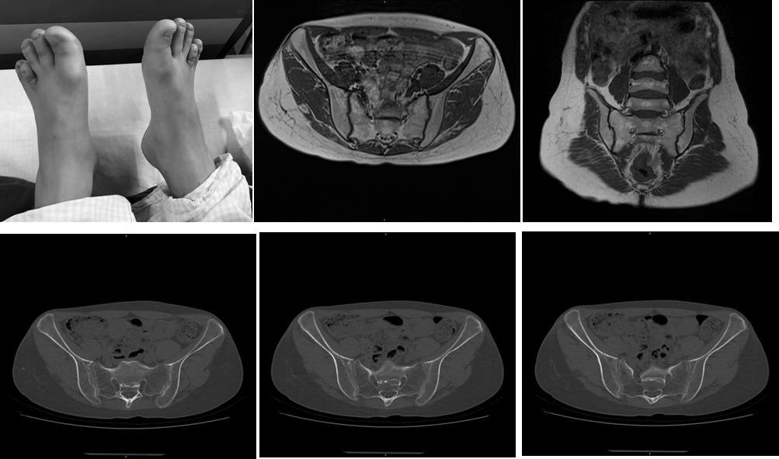

Figure 2. Physical examination, MRI and CT imaging. (a). bilateral short fourth metatarsal, (b). Magnetic resonance imaging for sacroiliac joint, (c). Computed tomography for sacroiliac joint.

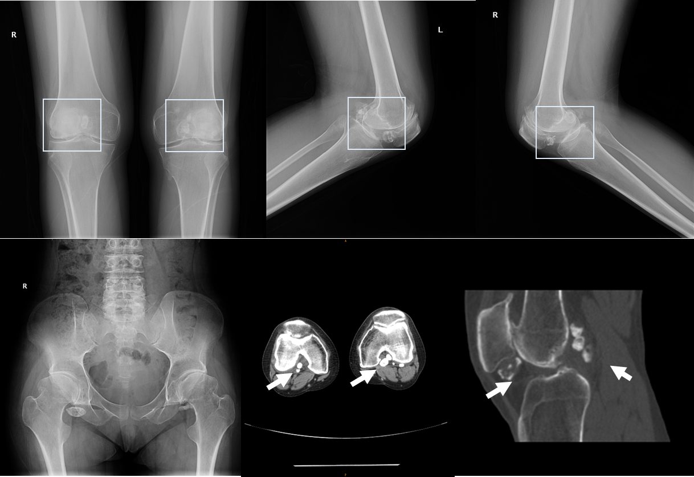

Figure 3. X-ray and CT imaging for both knees

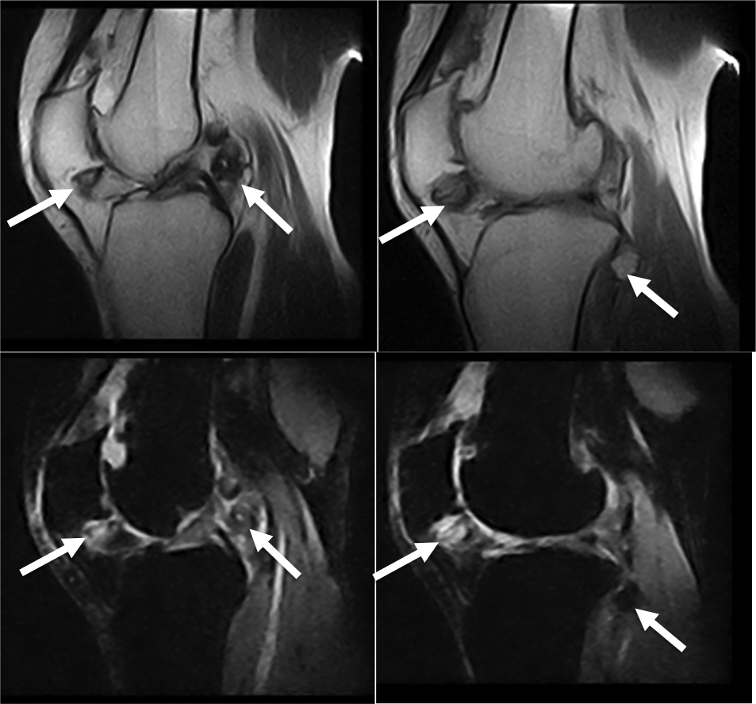

Figure 4. MRI imaging for right knees

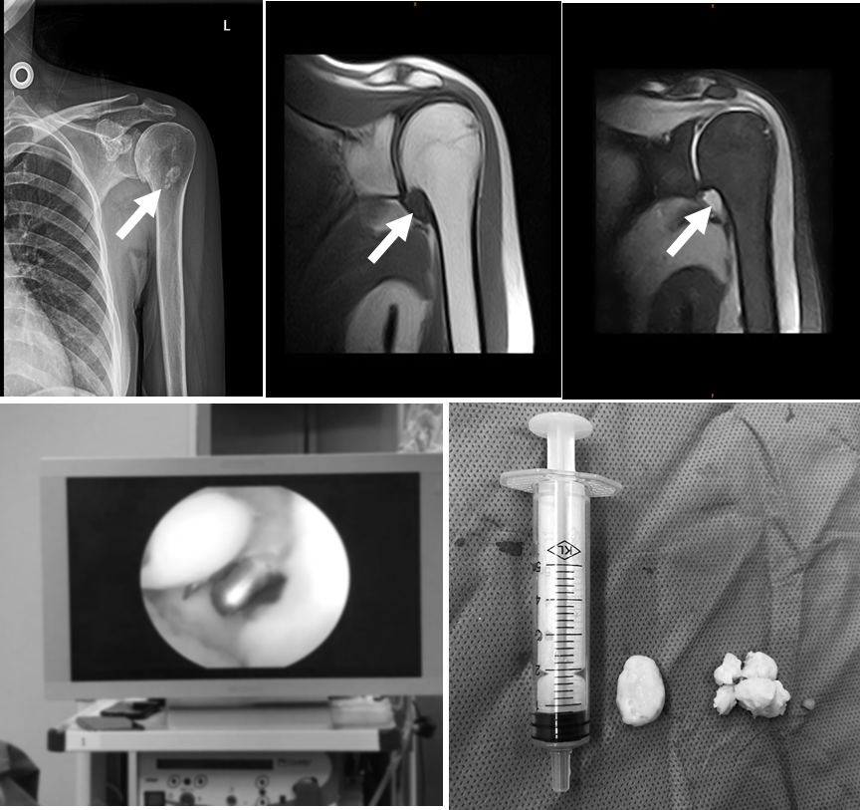

Figure 5. X-ray and MRI imaging for left shoulder

Figure 6.Arthroscopic surgical to remove loose bodies。

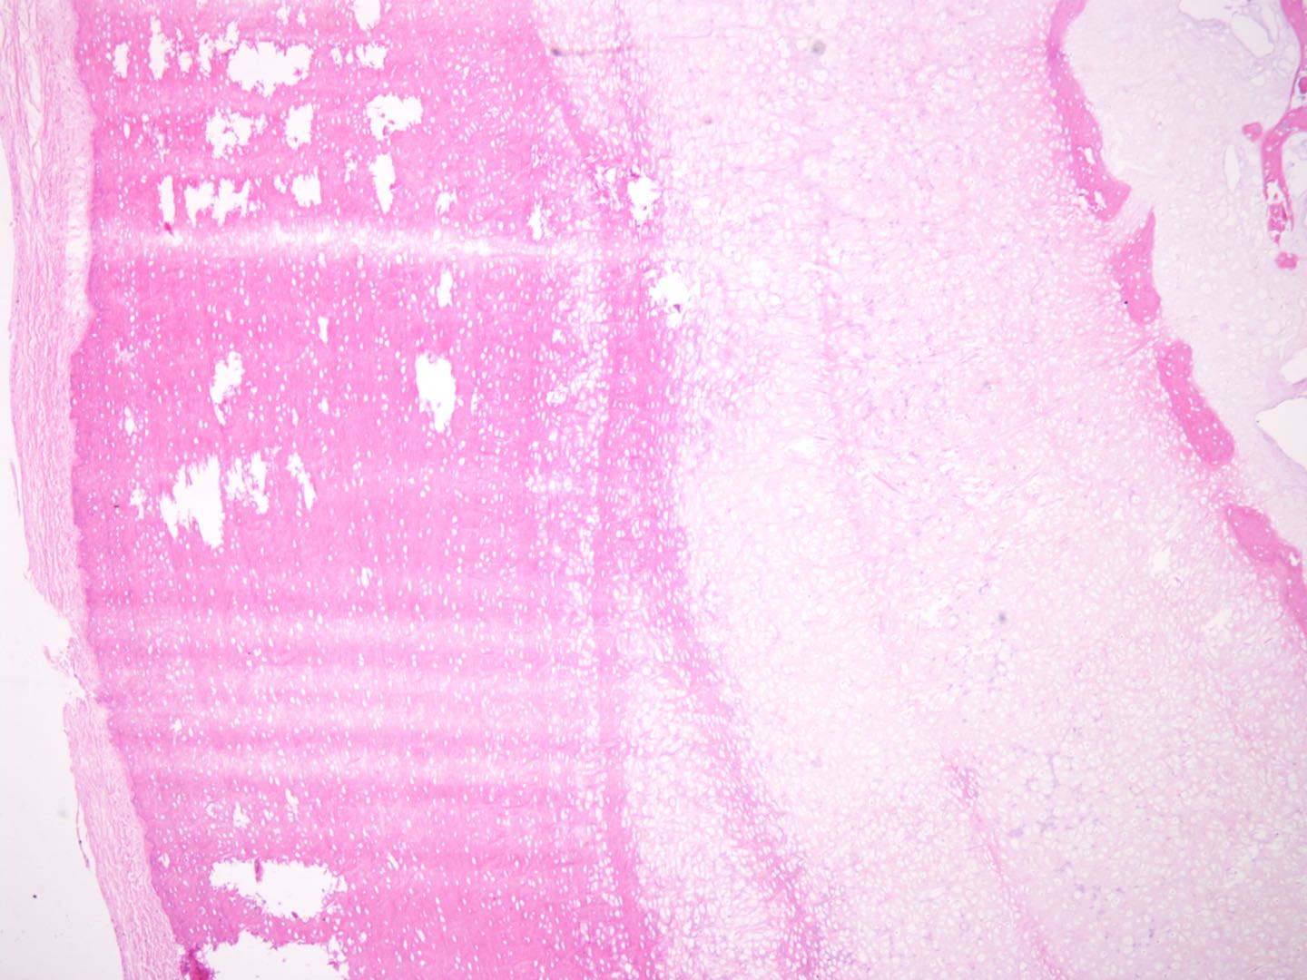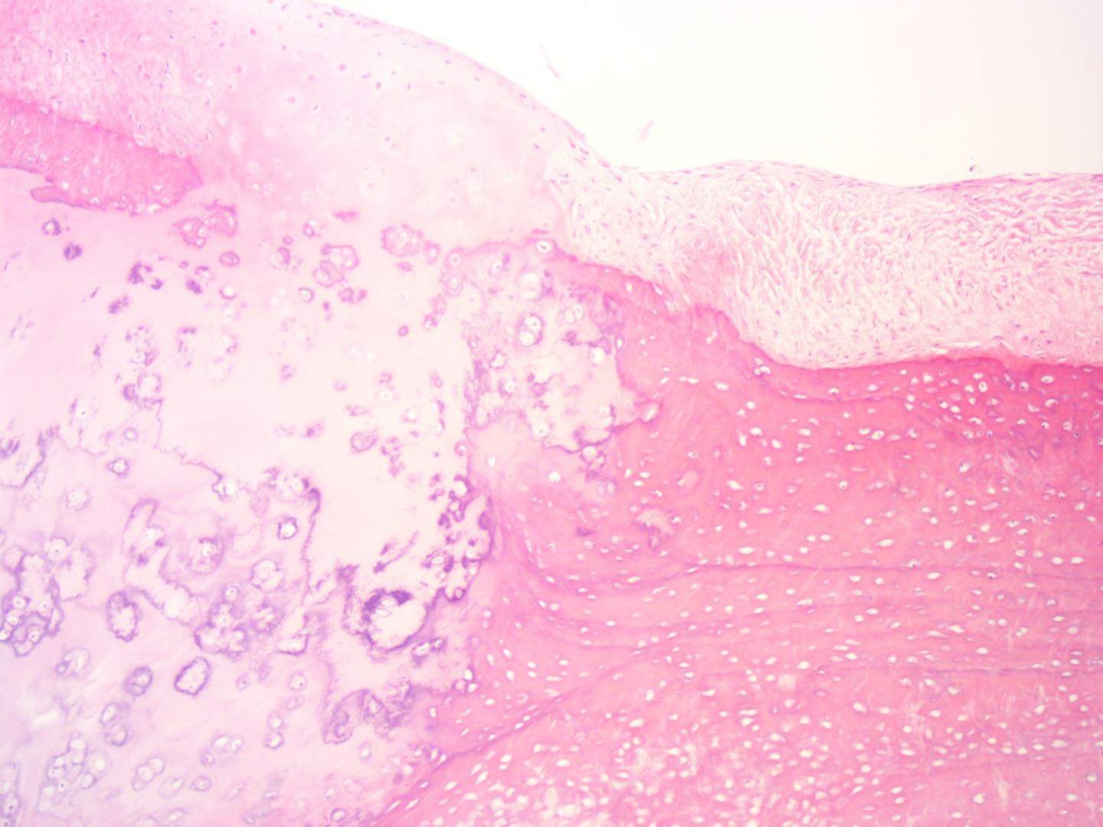

Figure 7. Pathological histomorphological results (x100 and x200)

1. Li, H. and R. Durbin, *Fast and accurate short read alignment with Burrows-Wheeler transform.* Bioinformatics, 2009. **25**(14): p. 1754-60.

2. McKenna, A., et al., *The Genome Analysis Toolkit: a MapReduce framework for analyzing next-generation DNA sequencing data.* Genome Res, 2010. **20**(9): p. 1297-303.

3. Li, H., et al., *The Sequence Alignment/Map format and SAMtools.* Bioinformatics, 2009. **25**(16): p. 2078-9.

4. Koboldt, D.C., et al., *VarScan 2: somatic mutation and copy number alteration discovery in cancer by exome sequencing.* Genome Res, 2012. **22**(3): p. 568-76.

5. Talevich, E., et al., *CNVkit: Genome-Wide Copy Number Detection and Visualization from Targeted DNA Sequencing.* PLoS Comput Biol, 2016. **12**(4): p. e1004873.

6. Amarasinghe, K.C., et al., *Inferring copy number and genotype in tumour exome data.* BMC Genomics, 2014. **15**: p. 732.

7. McLaren, W., et al., *The Ensembl Variant Effect Predictor.* Genome Biol, 2016. **17**(1): p. 122.

8. Yang, H. and K. Wang, *Genomic variant annotation and prioritization with ANNOVAR and wANNOVAR.* Nat Protoc, 2015. **10**(10): p. 1556-66.