3. Research Strategy
Overall Significance. Our application attempts to develop innovative statistical methods for family and population-based genetic analysis of exome and whole-genome sequence, which is an important, but challenging and still evolving task. Our methods unify family and population sampling designs and facilitate extensions in analytic methods for genomic and transcriptome analysis from single variant analysis to multiple variant analysis, from standard multivariate data analysis to functional data analysis, from independent sampling to dependent sampling, from low dimensional data analysis to high dimensional data analysis, from pure genomic analysis to integrated genomic and transcriptome analysis, and from association analysis to causal inference. This provides new opportunities to capture the full catalogue of transcripts and their variations, holistically unravel the complex genetic architecture of common diseases and represents a major breakthrough in developing methods for next-generation sequencing-based genetic studies of complex diseases. There is intensive debate over whether common variants of small effects or rare variants of large effects play an important role in causing diseases. The proposed association analysis methods that test both common and rare variants from any study design (pedigree and population) for association will offer excellent analytic platforms to study these two hypotheses. We expect that achieving the three aims in this application will provide novel strategies and tools to unravel connection between genetic variants, gene expressions, clinical phenotypes and diseases, and have profound impacts on understanding the functional and medical significance of human genome variation.
Datasets. Six exome and whole genome sequencing, and RNA-seq datasets as shown in Table 1 will be used for developing and validation of the methods proposed in this application.
Table 1. Available real datasets for method development and analysis.
Project | Study Design | Genetic Design | Phenotype | # Samples
ESP | longitudinal cohort | exome sequencing | cardiovascular disease, LDL, HDL, cholesterol, triglycerides | 7,500
CHARGE-S | longitudinal cohort  (Partial Family) | whole genome sequencing | LDL, HDL, cholesterol, triglycerides (Multiple Time Points) | 2,500
SardiNIA/Proge NIA | family-based | whole genome sequencing | coronary artery disease, LDL, HDL, cholesterol, triglycerides | 1,000
SardiNIA/Proge NIA | family-based | transcriptome resequencing | coronary artery disease, LDL, HDL, cholesterol, triglycerides | 1,000
Nurses’ Health Study | cases-control | Targeted  Sequencing | breast cancer | 6,000
GENOA | family-based  cases-control | exome, whole genome sequencing | coronary artery calcification, LDL, HDL, cholesterol, etc | 800

3.1. Aim 1: Develop a general framework and novel statistical methods for combining population and family-based association studies with next-generation sequencing data.
3.1.1. Significance. The significance of Aim 1 in this proposal is broad and multi-faceted, and will be addressed by novel statistical and methodological approaches.
3.1.1.1. This application proposes a general strategy to analyze multiple common and rare variants across family and population-based samples to unify family and population designs. Population-based sample design is the current major study design for association studies. However, many rare variants are from recent mutations in pedigrees¹⁻³. The inability of common variants to account for most of the supposed heritability and the low power of population-based analysis tests for the association of rare variants have led to a renewed interest in family-based design with enrichment for risk alleles to detect the association of rare variants⁴. It is hypothesized that an individual’s disease risk is likely to come from the collected action of common variants segregating in the population and rare variants recently arising in extended pedigrees¹. It is increasingly recognized that analyzing samples from populations and pedigrees separately is highly inefficient^{5,6}. It is natural to unify population and family study designs for association studies. However, the major critical barriers are lack of the statistical methods for sequence-based association studies with extended pedigrees and for integrating the association results across the study designs. Although there are many publications on rare variant association analysis, we see few papers which discuss family sample designs. Since the statistical methods appropriate for either design differ substantially, it is difficult to integrate the association results across the sample designs⁶. To overcome these problems, we propose to develop computationally feasible statistical methods for sequence-based association analysis in samples with arbitrary combinations of related and unrelated individuals by either extending case-control like association tests or the quasi-likelihood score approach⁷⁻¹⁰. The proposed approach has several remarkable features. First, it can be applied to (1) an isolated population in which individuals may be related, (2) pedigrees, and (3) combination of pedigrees with unrelated individuals. Thus, the proposed methods provide a highly flexible general framework for association studies of complex disease. Second, the algorithms are simple and easy to implement and hence are computationally feasible even with millions of SNPs. Third, joint genetic analysis of related and unrelated individuals can effectively use the observed transmission information in the pedigrees and the linkage disequilibrium (LD) information hidden in the history of populations, and effectively use rare and common variants segregating in the pedigrees and the population.
3.1.1.2. The unified approach can correct for unknown population stratification, family structure and cryptic relatedness while maintaining high power in the sequence-based association studies. In this application, we will address two issues in the sequence-based association studies. The first issue is how to correct for population stratification in testing the association of rare variants. Although structured association¹¹⁻¹³, principal component analysis (PCA)¹⁴⁻¹⁶ and manifold learning¹⁷ can be used to correct for population stratification in the test of the association of common variants, how to correct for population structure in the test of the association of rare variants is still open questions¹⁸. The popular methods such as PCA to correct for population stratification in the GWAS of common variants are to use summary measures of ancestry as covariates to correct for population stratification. But, many existing statistical methods for testing the association of rare variants do not allow direct incorporation of covariates in the test. Our proposed unified statistical methods for association studies that use family designs can effectively correct for population stratification^{108,109}. The second issue is how to use within family information to correct for family structure and between family information to correct for cryptic relatedness. Our approach estimates both within and between family information from sequence data to simultaneously correct for family structure and cryptic relatedness while maintaining high power.
3.1.1.3. Functional data analysis methods combined with high-dimensional data reduction techniques for association studies will change the current paradigm of association studies. The data produced by next-generation sequencing technologies will suffer from three basic problems: high error rates, enrichment of rare variants and large proportion of missing values^{19.20}, which raise great challenges for association studies. Unlike the recently proposed group association tests²¹⁻³³ for overcoming these limitations, which ignore differences in the effects of SNPs at different genomic locations on phenotype and are sensitive to the genotyping errors and missing data, functional dada analysis (FDA) will utilize the advantages of both individual variant analysis and group test, and SNP-order information but at the same time address their limitations³⁵. Instead of modeling the genome as a collection of separated individual loci, functional data methods model the genome as a continuum - a reality first recognized by Haldane³⁶ and Fisher³⁷, as implemented in our recent application of functional principal component analysis (FPCA) to sequence-base association studies³⁸. To overcome the rapid changes of functional principal components, which will decrease the power of the FPCA, we will develop the smoothed functional principal component analysis (SFPCA) for association studies. Many statistics can be used to test for the association of either common variants or rare variants, but very few can be efficiently used to test the association of both common and rare variants. We will use the smoothed FPCA as a general statistical method for testing the association of the entire allelic spectrum of genetic variation and set up a testing framework to directly address the question of whether or not complex traits are due to common alleles or rare alleles.
3.1.2. Innovation. The major innovations of the proposed research for Aim 1 are as follows. First, developing general statistical frameworks to extend multivariate and functional data analysis from independent sampling to dependent sampling are highly innovative. Second, the idea of unifying family and population based association studies with next-generation sequencing data are novel. It is among the first attempt to develop unified, simple and efficient association analysis platforms with the data sampled from both pedigrees and unrelated individuals while correcting for population stratification, family structure and cryptic relatedness. Third, the innovation in Aim 1 also stems from theoretic extension of the traditional SFPCA from independent sampling to dependent sampling. We are unaware of any SPFCA for dependent sampling. The standard functional data analysis theory assumes that all the samples are independent. It cannot be applied to family data. Developing the SFPCA for dependent samples is novel not only in genetic studies, but also in statistical theory. Fourth, the ability of the SFPCA to test the association of both common and rare variants offers creative approaches to boost power and improve flexibility of the association analysis. Fifth, Aim 1 offers a novel approach to meta-analysis of sequence-based association studies.
3.1.3. Approach.
Overall Strategy. A key to developing a unified approach to sequence-based association studies is to first develop the general statistical frameworks to extend multivariate and functional data analysis from independent sampling to dependent sampling. Then, we use case-control like association tests for unrelated individuals and quasi-likelihood score approach to develop novel statistics unifying population and family study designs. We will use the software ForSim³⁹ to simulate the data for calculation of type 1 error rates of the developed statistics and compare their power with other statistics across various scenarios. Finally, we use the ESP exome sequence data, the CHARGE-S, GENOA and SardiNIA/Proge whole genome sequence data to guide software development and to evaluate the performance of the proposed methods.
3.1.3.1. Methods.
3.1.3.1.1. A unified general framework for sequence-based association studies with pedigree structure and unrelated individuals. We outline the general procedures to extend population-based association tests for NGS to a general case with multiple families and unrelated individuals. Consider the problem of testing for the association of a genomic region in a sample of n sequenced individuals from multiple families or unrelated individuals with unknown population structures. We assume that the number of variants in a genomic region, or number of functional principal components or the number of collapsed summary variables is k. For each individual, we define a vector of variables 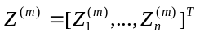, 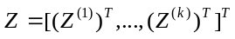. Define a case indicator vector 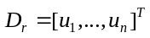, whose i-th entry is 1 if individual i is a case and 0 if individual is a control, and 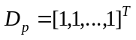, a column vector of 1s of length . Define 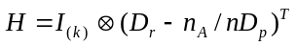, where 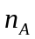is the number of affected individuals, 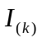 is a dimensional identity matrix, denotes the Kronecker product of two matrices. Similar to population-based association studies where we compare the difference in frequencies of alleles or collapsing variables between cases and controls, we compare the same differences in a genomic region but between affected and unaffected individuals in pedigrees or populations. The statistic is defined as
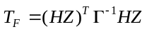, where 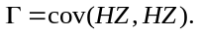 (3.1)
A key step is to calculate the covariance matrix 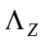of the variables 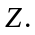 Our innovative approach is to decompose the covariance matrix into a Kronecker product of the covariance matrix 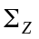of the variables Z for outbred individuals and a kinship matrix 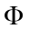accounting for relatedness, inbreeding, and population structure⁸: 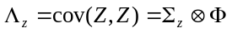, which implies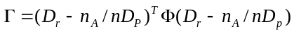*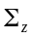 A remarkable feature is that the test statistic 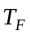can be simplified to a product of the corresponding population-based statistics and a correction factor: 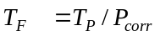where 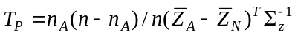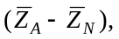 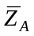and 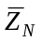are the average of the vector Z for affected and unaffected individuals, 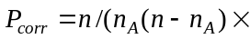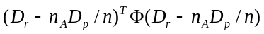 is the correction factor to be applied to the statistic 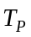to have a valid test in the presence of pedigree structures and cryptic relatedness. Under the null hypothesis of no association, 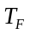 is distributed as a central 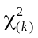distribution.
3.1.3.1.2. Family-based SFPCA statistic, generalized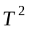, CMC and other sequence-based association test statistics. The statistic can be applied to the SFPCA and other sequence-based association tests. SFPCA can give a fully comprehensive presentation of the genetic variability across individuals. Let 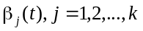 be a set of eigenfunctions that are formed from the genotype data of the sampled individuals under the SFPCA model. Let 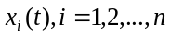 be a genotypic function of the i-the individual, where t is a genomic position. The smoothed functional component scores are defined as 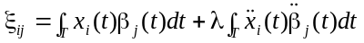, is a penalty parameter. Using stochastic calculus, we obtain the following covariance matrix of the functional principal component scores 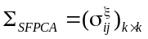 for outbred individuals, where is the number of selected functional principal components. The covariance matrix of in the presence of family structure is then given by 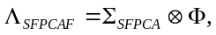 where is a kinship coefficient matrix. Taking the smoothed functional principal component scores as the vector of multiple variables, i.e. 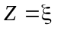 in equation (3.1), the family-based SFPCA statistic for testing the association of a genomic region including both common and rare variants will be simplified to 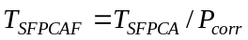, where and 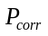is defined in Section 3.1.3.1.1. By similar argument, the CMC, population-based T², the weighted sum (WSS) and the variable-threshold (VT) method⁴⁰⁻⁴³ can also be extended to family-based association studies⁴⁴.
3.1.3.1.3. Quasi-likelihood score function approach.
We can also use the quasi-likelihood score function approach to develop test statistics with known or unknown family and population structure. The details of the methods will be described in section 3.3.3.1.3.
3.1.3.2. Preliminary Studies.
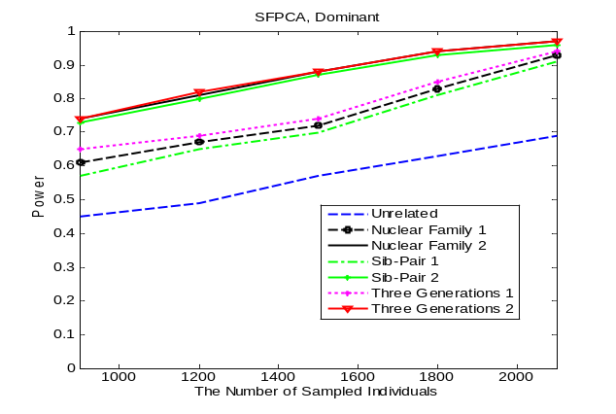
3.1.3.2.1. Simulation Studies. To verify the feasibility of the proposed statistics, as an initial study, we used the ForSim³⁹ to simulate different design settings. Due to space limitation, in Table 2 we only showed type 1 error rates for the sample design with 40 pedigrees with three generations, each pedigree with approximately 17 individuals, and 60 pedigrees with two generations, each pedigree with approximately 5 individuals where 70% of the pedigrees were sampled from subpopulation 1 and the remaining 30% of the pedigrees were sampled from subpopulation 2. Table 2 showed that type 1 error rates of all statistics were not appreciably different from the nominal levels except for 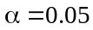 where individual 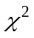test, collapsing, CMC and T² were deflated. We also used the software ForSim³⁹ to simulate pedigree data for estimating the power of the tests. Each individual in the pedigree had 189 variant sites with the MAF of all sites less than 0.01, but larger than 0.0001, 20% of variants were assumed to be risk variants. We consider three family structures: nuclear family with two parents and two offsprings, sib-pair and three generation family, each family with about 20 individuals. Nuclear families, sib-pair and three generation families were further divided into type 1 and type 2 according to the ratio of the number of affected individual over unaffected individuals 1:1 and 2:1, respectively. Figure 1 showed the power curve of the family-based SFPCA as a function of the total number of individuals in the test, at the significance level of 0.05 under seven settings. We observed that in general, family-based association
Figure 1. Power of SFPCA.
Table 2. Type 1 error rates of tests.
Nominal Level | 0.05 | 0.01 | 0.001
 | 0.0389 | 0.0075 | 0.0006
Collapsing | 0.0394 | 0.0082 | 0.0008
CMC | 0.0390 | 0.0092 | 0.0006
T² | 0.0402 | 0.0086 | 0.0008
FPCA | 0.0434 | 0.0095 | 0.0008
SFPCA | 0.0438 | 0.0100 | 0.0008

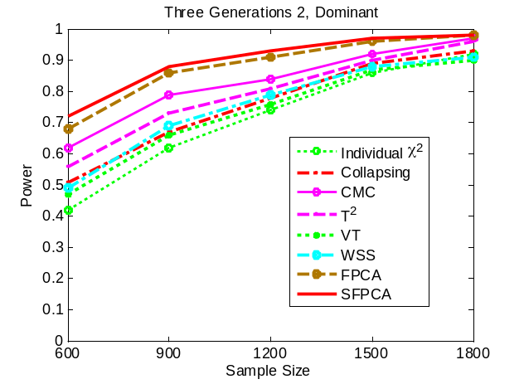
Figure 2. Power Comparison.

studies had much higher power than population-based association studies and that the power of pedigree test increased as the pedigree structure increased. This statement holds for other statistics (data not shown). Figure 2 compares the power of eight statistics under three generation family type 2 designs. It showed that the family-based smoothed FPCA had the highest power. We observed this pattern for any family structure and sample sizes in all scenarios (data not shown).
3.1.3.2.2 Real data analysis. A key step for developing population and family-based association tests is to perform large-scale data analysis. To evaluate the feasibility of the proposed statistics, as a pilot study, the proposed statistics were applied to the early-onset myocardial infarction (EOMI) exome sequence data from the NHLBI’s Exome Sequencing Project (ESP) where a total of 544 (188 cases and 356 controls) with European origin (EA) and 312 (39 cases and 273 controls) with African origin (AA) were exome sequenced to combine EA and AA samples. A total of 18,737 genes with 575,259 SNPs were included in the analysis. We identified 49 genes significantly associated with EOMI after Bonferroni correction for multiple tests. Table 3 presented p-values of the top 10 significantly associated genes by four statistics for testing the association of both common and rare variants with EOMI where the P-value for the chi-square test is its smallest P-value for a single SNP test within a gene. Table 3 showed that the proposed tests successfully combine two samples EA and AA and open a new avenue for meta-analysis.
3.1.3.3. Potential problems and solutions. A potential problem for sequence-based association studies is the genotyping errors and missing values. Imputation methods, signal filter technologies and data reduction methods for missing values will be explored for reducing the genotyping errors and dealing with missing values. Another potential problem is how to estimate the kinship coefficients using sequencing data, which depend on the allele frequencies, LD and the number of SNPs used for estimation. To solve this problem, we will develop methods for selection of SNPs for estimation which characterize the structures of samples.
Table 3. P-values of four statistics for testing the association of common and rare variants with EOMI.
 | SFPCA |  |  | FPCA |  |  | CMC |  |  | Chi-square (Minimum)
Gene | AA+EA | AA | EA | AA+EA | AA | EA | AA+EA | AA | EA | AA+EA | AA | EA
PLEC1 | 2.2E-10 | 6.8E-06 | 2.0E-06 | 3.0E-08 | 4.7E-05 | 4.0E-06 | 1.5E-02 | 9.3E-06 | 1.0E-01 | 2.0E-06 | 2.0E-06 | 6.9E-03
PKD1L1 | 6.3E-09 | 3.7E-05 | 1.1E-08 | 5.1E-04 | 1.5E-03 | 7.8E-05 | 6.2E-01 | 5.5E-01 | 6.0E-01 | 3.3E-05 | 3.3E-05 | 3.1E-03
AHNAK2 | 6.6E-09 | 2.5E-08 | 5.4E-06 | 6.4E-08 | 9.0E-05 | 6.3E-04 | 1.8E-02 | 2.4E-05 | 7.3E-10 | 7.4E-05 | 7.4E-05 | 8.0E-03
PWP2 | 5.9E-08 | 5.5E-06 | 8.2E-07 | 4.9E-05 | 2.2E-04 | 6.0E-04 | 3.9E-03 | 8.1E-05 | 7.1E-01 | 4.3E-09 | 4.3E-09 | 5.0E-02
ZNF45 | 6.8E-08 | 3.3E-05 | 7.4E-08 | 6.0E-06 | 1.2E-03 | 5.0E-06 | 1.1E-01 | 4.0E-01 | 2.3E-02 | 1.3E-04 | 1.3E-04 | 3.2E-03
PICALM | 1.5E-07 | 8.8E-02 | 2.1E-06 | 1.3E-03 | 6.5E-01 | 2.4E-05 | 2.8E-04 | 9.3E-01 | 9.7E-05 | 6.4E-05 | 3.7E-01 | 1.7E-05
RYR3 | 1.7E-07 | 4.3E-05 | 2.2E-08 | 1.1E-03 | 1.3E-03 | 1.7E-03 | 2.0E-01 | 1.9E-01 | 5.9E-02 | 1.9E-06 | 1.9E-06 | 5.5E-03
HLA-DRB5 | 2.2E-07 | 9.5E-05 | 1.6E-08 | 1.3E-05 | 2.4E-03 | 1.5E-06 | 1.3E-02 | 2.3E-01 | 1.6E-02 | 2.4E-03 | 7.5E-03 | 4.2E-04
TECPR2 | 2.9E-07 | 1.0E-05 | 1.1E-06 | 1.9E-05 | 4.4E-04 | 1.1E-04 | 1.3E-01 | 3.8E-01 | 2.5E-01 | 1.3E-03 | 1.3E-03 | 1.1E-02
MUC6 | 3.7E-07 | 2.0E-06 | 7.2E-02 | 2.3E-05 | 2.6E-06 | 8.5E-02 | 3.6E-01 | 1.5E-01 | 2.9E-01 | 1.3E-03 | 1.3E-03 | 1.6E-02

3.2. Aim 2: Develop novel statistical methods for sequence-based QTL (eQTL) analysis which unify population and family study designs and can be applied to QTL analysis with longitudinal data and eQTL analysis with RNA-seq data.
3.2.1. Significance.
3.2.1.1. Develop functional linear models (FLM) and mixed linear models (FMLM) with scalar response and functional predictors which can utilize the merit of both Individual and group tests as a general principle for sequence-based QTL (eQTL) analysis in population and family designs will shift the paradigm of QTL(eQTL) analysis from multivariate data analysis to functional data analysis and stimulate both theoretical and practical researches in QTL (eQTL) analysis with NGS data. Although in the past few years we have witnessed the rapid development of novel statistical methods for association studies of qualitative traits using NGS data, only a few simple regression type group tests that combine multiple rare variants into a single variable to predict quantitative phenotype variation have been developed for testing the association of rare variants with a quantitative trait⁴⁶⁻⁴⁹. It is now well documented that NGS can generate several millions or even dozens of millions of genetic variation data. As a consequence, these genetic variation data are so densely distributed across the genome that the genetic variation can be modeled as a function of genomic location. But, standard multivariate statistical analysis often fails with functional data⁵⁰. The emergence of NGS demands a paradigm shift in the analytic methods for QTL(eQTL) analysis from standard single-variate or multivariate data analysis to functional data analysis. The FLMs with scalar response and functional predictors take a continuous phenotype as a scalar response and genetic variants across the genomic regions as functional predictors. They can be used to test the association of the entire allelic spectrum of genetic variation with a quantitative trait and has several remarkable features. First, unlike simple and multiple regressions that discard a large amount of information, the FLM preserves the intrinsic structure and all the positional-level genetic information. Second, the multiple regressions will not account for the space-ordering of the data. The FLM simultaneously employs genetic information of the individual variants and correlation information (LD) among all variants. Third, both sign and the size heterogeneity will also be incorporated into the test in the FLM. Fourth, the multicolinearity problem in the FLM is alleviated. The FLM for QTL (eQTL) analysis that capture key information in the data is expected to open a new route for QTL (eQTL) analysis.
Similar to qualitative trait association studies for NGS, extension of the functional linear models to mixed linear models where introducing random effects can incorporate additive genetic background effects due to population and family structure and cryptic relatedness into the models will eliminate spurious association due to the presence of population structure and offer a powerful tool for the family-based QTL analysis. Therefore, the FMLM offers a powerful general framework to unify population and family-based QTL(eQTL) analysis.
3.2.1.2. The FLM and FMLM with multiple functional responses for QTL and eQTL analysis developed in this application will not only provide a powerful arsenal of approaches to identify genes associated with quantitative traits in longitudinal studies, but also offer novel concepts and tools for eQTL analysis of RNA-seq data to capture positional level and isoform level information of transcripts and to identify the eQTLs responsible for variations at the transcript, isoform and allele levels. Understanding the transcriptome is essential for identifying the functional elements of the genome and revealing the mechanism of diseases⁵¹. The current statistical methods for eQTL analysis are originally designed for microarray gene expression profiling technologies⁵². The recently developed next-generation mRNA sequencing (RNA-seq) assay generates millions of short reads of mRNA or cDNA which are mapped to the genome and lead to a sequence of read counts at the million of genomic positions⁵¹⁻⁵⁴. The classical methods for eQTL analysis which only consider a single phenotype at a time fail to utilize all information of transcripts. Whole genome RNA-req eQTL analysis poses a significant challenge. To meet the challenge, we propose the FLM with functional responses and functional predictors for eQTL analysis with RNA-seq data. The FLM with single functional response where the position-level read counts within a gene is taken as a function of genomic position can be used to identify eQTL associated with expression variation across the gene. The proposed FLM can capture isoform and position-level information and has a broad application. However, the FLM with single functional response cannot deal with allele-specific gene expression where the expression levels of both alleles are measured, and isoform expression eQTL analysis. To overcome this limitation, in allele-specific gene expression eQTL analysis three functional responses will be used to model expressions of three genotypes and in isoform expression eQTL analysis, each isoform expression will be modeled by a functional response. Therefore, the FLM with multiple functional responses will provide a powerful tool to perform RNA-seq eQTL analysis. Extension of the FLM to the FMLM can allow extending all of the above population-based eQTL analysis to the family-based eQTL analysis with RNA-seq data.
All developed methods for sequence-based eQTL analysis can be applied to longitudinal QTL analysis where multiple measurements of some quantitative traits are taken for each individual over time^{55,56}.
3.2.1.3. Introducing causal inference tools to high dimensional QTL (eQTL) analysis will dramatically increase our ability to study function of risk variants, provide accurate estimation of total (Intervention) and direct Effects, and advance our knowledge in quantitative genetics. A key, but difficult issue in QTL(eQTL) analysis is how to identify causal variants and estimate their effects. The causal effects can be classified into the total (intervention) effect and direct effect⁵⁷⁻⁵⁹. Neither the current popular methods for QTL analysis⁶⁰, nor the high dimensional linear regression methods such as the Lasso⁶¹ and the Elastic Net⁶² can be used to accurately estimate the total and direct effects of genetic variants on the quantitative traits⁶³. To address this issue, we will use multivariate inverse regression to reduce the number of the confounding variables⁶⁴⁻⁷² combined with a flexible semiparametric index model⁷³ to develop a novel statistical method to estimate the direct effect of genetic variant on the phenotype and use intervention calculus coupled with graphical model⁷⁴⁻⁷⁹ to develop statistical methods to accurately estimate the total effects of genetic variant on the phenotype. Introducing causal inference tools to quantitative genetics studies will facilitate the theoretic development and practical application of QTL(eQTL) analysis with NGS data.
3.2.2. Innovation. Aim 2 has the following major innovations. First, Aim 2 proposes the novel idea of modeling position-level read counts across the loci within a gene as a function of genomic position and using the FLM with a functional response and a functional predictor to identify a genomic region associated with expression variation at base-level resolution. Second, Aim 2 develops novel FLM with multiple functional responses and functional predictors and offers creative mathematical formulation of eQTL analysis for allele-specific gene expression and isoform-level gene expression and longitudinal multivariate QTL analysis as FLM with multiple functional responses and functional predictors. Third, Aim 2 proposes a set of novel FLM and FMLM that provide a unified framework for the QTL (eQTL) analysis of population-based and family-based studies. Fifth, using sliced inverse regression to remove a large number of unspecified confounding variables while preserving the information of the causal variable of interest on the phenotype is a novel statistical framework for causal inference. Developing statistical methods to identify causal genetic variants and accurately estimate their causal effects on phenotypes is a novel approach in QTL(eQTL) analysis.
3.2.3. Approach.
Overall Strategy. The function of genomic variation will be studied by QTL (eQTL) analysis. Three types of fixed and random regression models: simple, multiple and functional regressions will be developed to test for the association of common and rare variants with quantitative traits in the population and family-based QTL(eQTL) analysis. We first develop the FLM with scalar response and a functional predictor for Population-based QTL(eQTL) analysis and then extend the FLM to FMLM for family-based QTL(eQTL) analysis. Then, we conduct causal inference in both population and family-based QTL(eQTL) analysis to further identify causal variants and study their functions. We will use ESP and CHARGE-S data to evaluate the proposed methods for QTL analysis and SardiNIA/Proge NIA for eQTL analysis and discover the merits and limitation of the tests. To capture key information in allele specific expression and isoform-level expressions, and conduct longitudinal association studies of multivariate quantitative traits, we will develop the FLM and FMLM with multiple functional responses and functional predictors. We will use simulations and RNA-seq data in Sardinia population studies, and CHARGE-S with both exome and whole genome-sequence data sampled from populations and pedigrees in longitudinal cohort studies to evaluate their performance.
3.2.3.1. Methods.
3.2.3.1.1. The FLM with scalar response and functional predictor for population-based QTL (eQTL) analysis for next-generation sequencing. The FLM where genotype profiles in a genomic region are modeled as a function of genomic position will be developed to test for the association of both common and rare variants with a quantitative trait. Let be a continuous phenotype including summarized gene-level expression of the i-th individual. A FLM is defined as 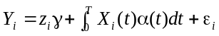,where is a vector of covariates, is a vector of regression coefficients, 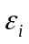 are errors, T is the length of the genome region being considered, 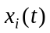is a genotype function of the i-th individual and 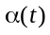is the genetic additive effect of the marker at the genomic position t. We use B-spline basis functions to expand 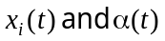. Substituting these expansions into the above equation will lead to the ordinary multiple regressions: 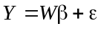, where  involves the expansion coefficients of genotype function and integral basis functions. Then, the classical multiple regression methods can be used to test the association of a genomic region.
3.2.3.1.2. The FMLM with scalar response and functional predictor for family-based QTL and eQTL analysis for next-generation sequencing. The following FMLM can be used for family-based QTL and eQTL analysis: 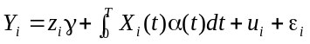, where, 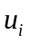is a random effect with mean zero which measures the genetic relationship among individuals and other variables are defined as before. Let 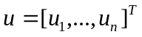. Then, their variance-covariance matrix is given by 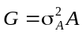, where is a genetic relationship matrix. After basis function expansion, the FMLM can be transformed to the standard mixed linear model: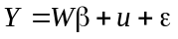. Assuming 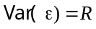, we have 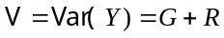. The weighted least square estimate of the parameter vector is given by 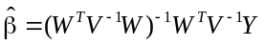. Using restricted maximum likelihood (REML)⁵⁷, we obtain the following equations for solving 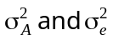: 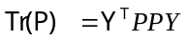and 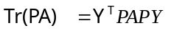, where 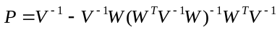. We can use the Newton-Raphson (NR) algorithm to numerically solve these equations .
3.2.3.1.3. The FLM and FMLM with a functional response and functional predictor for population and family-based QTL (eQTL) analysis for next-generation sequencing. In eQTL analysis with RNA-seq data and QTL analysis with longitudinal genetic data, let 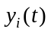be the normalized read counts at the genomic position or phenotypic value at the time , respectively. The FLM with a functional response and functional predictor is given by 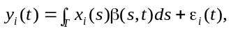where 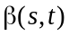is a regression coefficient function and can be expanded in terms of basis function: 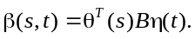 After basis function expansion, the model is reduced to 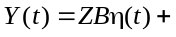 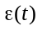where 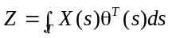. Let 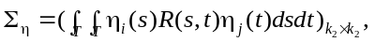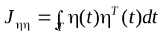. Then, we have 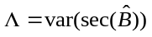 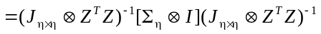.The test statistic is defined as 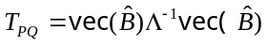. Under the null hypothesis, 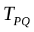is distributed as a central 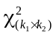distribution, where and 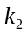 are the number of expanded terms. Extension of FLM to the FMLM can allow conducting the family-based QTL(eQTL) analysis as shown below: 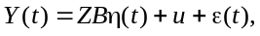where is a vector of random variables with variance .
3.2.3.1.4. The FML and FMLM with multiple functional responses and functional predictor for population and family-based QTL (eQTL) analysis for next-generation sequencing. By extension of the FLM and FMLM models with single functional response to multiple functional responses we can develop tests for allele specific expression and isoform expression eQTL analysis or multivariate longitudinal genetic studies. Let 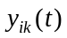be the centered k-th isoform read counts at the genomic position or the k-th phenotypic value at the time of the i-th individual. Define the FLM: We can develop similar, but more complicated statistics. Due to space limitation, we omit the details. We can extend the FLM with multiple functional responses to the FMLM and develop statistics for family-based QTL and eQTL analysis.
3.2.3.1.5. Intervention calculus coupled with graphical models for estimation of the total effects of genetic variants on phenotype in QTL (eQTL) analysis. Unlike the current methods for QTL analysis where the primary interest is to examine association between genetic variants and traits, our goal here is to infer which genetic variants have a causal effect on the phenotype by intervention⁷⁴. A key tool for estimating the total effect of genetic effect is intervention calculus. Briefly, the total effect of the genetic variant 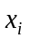on the phenotype is estimated as a coefficient ofin regression: 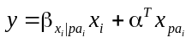 , where 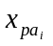represents a set of parent variables of in a directed acyclic graph (DAG). In other words, if 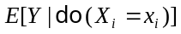 denotes the conditional expectation of Y, given that condition 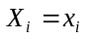is enforced via intervention, then the total effect is given by 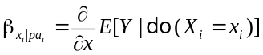. In practice, DAG is usually unknown. We then use the PC-algorithm⁷⁸ to estimate the Markov equivalence class of DAG from the observed genotype and phenotype data and for each DAG in the equivalence class we estimate the total effect by intervention calculus. Finally, we estimate lower (or upper) bound estimates of the total effect⁷⁴. To extend the algorithms to family data, we only need to replace the regression model by a mixed linear model.
3.2.3.1.6. High dimension reduction for confounding variables and kernel smoothing for estimation of direct effects of genetic variants on phenotype in QTL (eQTL) analysis. With NGS data, the dimension of the unspecified confounders is very high. In this application, we propose to use inverse regression^{81,82} as a powerful tool to reduce the dimension of the confounders and nonparametric single-index model⁷³ for estimation of direct effects⁷⁵ while preserving the information of the causal variants on the phenotype. We consider the data consisting of a phenotype Y, a p-dimensional vector of confounding variables, and a q-dimensional vector of variables of interest Z. In general, p is very large. The traditional quantitative trait model is given by 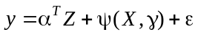. Since the dimension of X can be very high, the projective resampling method⁸² and sliced inversion regression⁸¹ will be used to project high dimensional confounding variables X into a low dimensional space 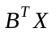, where B is a projection matrix spanning minimum subspace to capture the full regression information. Then, the traditional quantitative trait model is reduced to 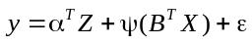. Taking conditional expectation on both sides of the above model, given , the above model can be further reduced to . After we use kernel smothers to estimate 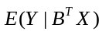and 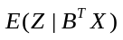, the above regression can be solved by the least square method. Again, the proposed models for population-based QTL(eQTL) analysis can be extended to family-based QTL(eQTL) analysis by introducing random variables to capture family structure information: 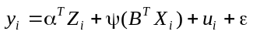, where defined as that in Section 3.2.3.1.2 is to model family structure.
3.2.3.2. Preliminary Studies.
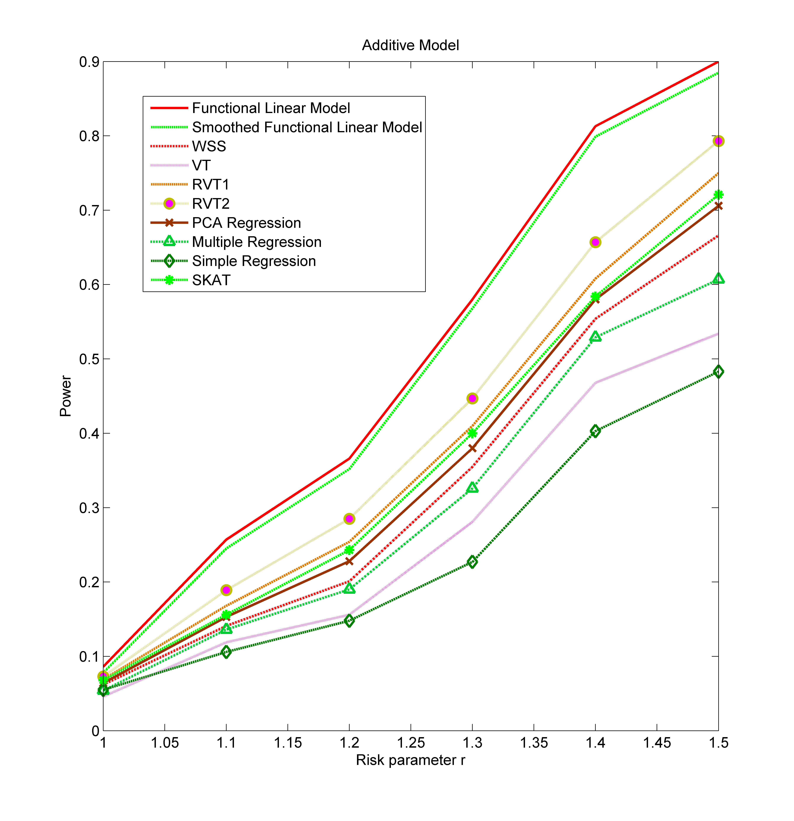
3.2.3.2.1. Simulation Studies. To evaluate the performance of the FLM for testing the association of both common and rare with a quantitative trait, we used the MS software¹⁰⁴ to generate a population of 2,000,000 chromosomes, each with 119 variants, of which, 70 variants were rare (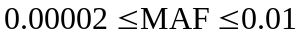) under a neutrality model. We randomly selected 25% of the rare variants as causal variants. Figure 3 plotted the power curves of ten statistics: the FLM, the smoothed FLM, the sequence kernel association test (SKAT)⁴⁹, two collapsing-based regression tests⁴⁸: RVT1 and RVT2, simple linear model (SLM), multiple linear model (MLM), regression on principal components, WSS and VT. These power curves were a function of the risk parameter, at significance level 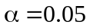, and sample size (N=2,000), all of which were held constant in the analysis. We observed that the FLM-based statistics had the highest power compared to all of the other methods tested across the range of the risk parameter. To examine the validity of the proposed tests for the association of rare variants with a quantitative trait in the presence of family and population structures, we used the ForSim software³⁹ to generate genotypes for different design settings and null linear models with 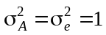to generate continuous phenotype data. Due to space limitation, in Table 4 we only showed type 1 error rates for the sample design as that in Table 2, but with a quantitative trait. To evaluate the performance of the family-based tests for QTL
Figure 3. Power of population-based test.
analysis, we used the ForSim software to generate three generation family data, each family having about 10 individuals, with 70 rare variants (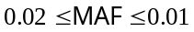), 25% of them were randomly selected as risk variants, a total of 1,000 simulations were performed, assuming a risk parameter of 1.5. Figure 4 plotted the power curves of five statistics under the additive models as a function of sample sizes.
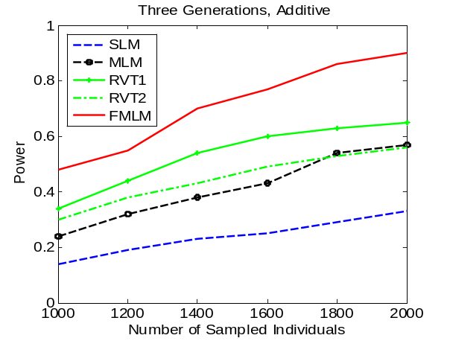
3.2.3.2.2. Real Data Analysis. To further evaluate the feasibility of the proposed models for QTL analysis, we have applied the FLM to a sample of 1,122 European-Americans (EA) and 813 African American (AA) with complete exome sequencing (total of 895,600 common and rare variants and 20,411 genes) and fasting HDL-C levels. HDL-C levels were adjusted for sex, age and body size prior to analysis. We identified a total of 17 genes in EA and 21 genes in AA which were significantly associated with HDL-C after Bonferroni correction for multiple tests. Interesting, 6 regions overlap between EA and AA studies. Space does not permit a complete description of the exome sequencing, variant calling and QC. Table 5 below showed the top 10 regions identified by this analysis. These regions are undergoing replication now, and until that time do not warrant mention of specific gene names. Even more interesting, 3 of the 10 regions correspond to known GWAS hits. These results document our experience with the new functional data analysis methods and show their utility to identify regions of interest for an important quantitative trait.
Figure 4. Power of family-based tests.
Table 4. Type 1 error rates of
family-based tests.
Tests | 0.05 | 0.01 | 0.001
FLM | 0.0571 | 0.0144 | 0.0011
SLM | 0.0424 | 0.0156 | 0.0029
MLM | 0.0619 | 0.0118 | 0.0021
RVT1 | 0.0477 | 0.0091 | 0.0016
RVT2 | 0.0451 | 0.0123 | 0.0017
3.2.3.3. Potential Problems and Solutions. A potential limitation for FMLM and causal inference is their required heavy computation. Solution for this is to develop a graphics processing unit (GPU)-based software to speed computation.

Table 5. P-values of the top ten significantly associated genes with HDL in an European American Population.
Gene | FLM | RVT1 | RVT2 | SLM_Permu | SLM_Min | MLM | PCA_LM | WSS | VT
Gene 1 | 4.3E-11 | 4.3E-01 | 2.0E-01 | 1.0E-06 | 2.6E-11 | 8.8E-08 | 9.9E-09 | 2.6E-02 | 1.1E-03
Gene 2 | 8.1E-10 | 1.1E-01 | 1.5E-02 | 1.0E-06 | 3.6E-09 | 1.7E-07 | 7.8E-08 | 2.7E-01 | 1.4E-01
Gene 3 | 2.7E-09 | 8.1E-01 | 3.7E-01 | 1.0E-06 | 2.6E-11 | 2.6E-05 | 7.3E-06 | 2.8E-01 | 1.1E-01
Gene 4 | 5.8E-09 | 4.8E-01 | 5.8E-01 | 1.0E-06 | 2.7E-11 | 1.7E-05 | 6.3E-08 | 1.5E-03 | 4.3E-02
Gene 5 | 2.0E-08 | 5.0E-01 | 4.4E-01 | 1.0E-06 | 1.8E-13 | 7.5E-07 | 3.4E-09 | 3.2E-02 | 6.3E-03
Gene 6 | 2.2E-08 | 1.3E-01 | 3.4E-02 | 1.0E-06 | 3.6E-09 | 1.1E-06 | 1.8E-08 | 3.5E-01 | 3.1E-01
Gene 7 | 2.5E-08 | 7.8E-01 | 6.7E-01 | 1.0E-06 | 3.1E-12 | 2.7E-04 | 7.6E-07 | 2.7E-01 | 2.0E-01
Gene 8 | 7.1E-08 | 9.4E-01 | 9.0E-01 | 6.3E-05 | 2.1E-06 | 3.9E-04 | 1.8E-05 | 5.0E-01 | 2.2E-01
Gene 9 | 7.7E-08 | 6.5E-01 | 6.9E-01 | 5.9E-05 | 2.1E-06 | 3.0E-04 | 1.6E-06 | 6.3E-01 | 2.8E-01
Gene 10 | 9.8E-08 | 8.8E-01 | 6.5E-01 | 4.6E-05 | 2.1E-06 | 3.6E-04 | 6.4E-06 | 4.2E-01 | 2.3E-01

3.3. Aim 3: Develop novel statistics to test the association of pathways in both population and family study designs.
3.3.1. Significance. The accomplishment of Aim 3 will have significant implications in understanding the pathology of common diseases and providing important targets for intervention.
3.3.1.1. Developing novel statistical methods for pathway-based genome-wide association studies will allow for performing pathway analysis for the entire allelic spectrum of genetic variants.
Pathway analysis typically tests the association of a predefined set of related genes which are often defined by biological knowledge⁸⁴. Although pathway analysis methods have been developed and successfully applied to association studies of common variants⁸⁵⁻⁹⁵, the statistical methods for pathway-based association analysis of rare variants have not been well developed⁹⁶⁻⁹⁹. The current methods for pathway-based association analysis of rare variants are classified into two approaches. One approach is a two-step strategy that first generates gene-level statistics or P-values and then aggregates the gene-level statistics or combining P-values across all genes in a pathway by gene set enrichment analysis (GSEA). Alternative approach is to aggregate all SNPs in the pathway directly and to collectively test the association of all SNPs in the pathway by rare variant association test statistics⁹⁶. However, many investigators have observed highly inflated false positive rates and low power in pathway-based tests of association of rare variants^{100,101}. The inflated false-positive rates and low true-positive rates of the current methods are mainly due to their lacking ability to account for gametic phase disequilibrium and population stratification in the association analysis⁹⁹.
To overcome these serious limitations, we develop two novel statistical methods for pathway-based association. One method is to test the association of pathway by comparing difference in genomic variation contents across all genes in a pathway between cases and controls. Another method is to extend FPCA from a single gene to multiple genes and compare the difference in functional principal component scores that are calculated from all genes in a pathway between cases and controls. The common features shared by two methods are as follows. First, they capture position-level variant information. Second, they can account for gametic phase disequilibrium. Third, they can adjust for population stratification and cryptic relatedness. As a consequence, the proposed methods can improve type 1 error rates and power.
3.3.1.1. Developing novel statistical methods for pathway-based association studies unifying population and pedigree study designs will expand our ability to perform pathway-based association studies and provide a powerful analytic platform to investigate the sources of genetic variation of disease. The current statistical methods for pathway analysis are mainly designed for population-based samples⁸⁴. Although dozens of different methods for GSEA have been developed, their common feature is that they cannot account for correlations among individual in the pedigrees regarding whether the SNPs or phenotypes are being permutated, the sampling subjects are assumed to be independent⁸⁴. Therefore, the current methods are ill suited for pedigree-based pathway analysis¹⁰². However, both population-based and family-based designs have strengths and limitations. The population-based association studies only quantify the average effects of risk alleles across all sampled individual in the study; they are unable to capture heterogeneity of effect sizes at the family-level^{103,108,109}. Developing statistics for testing the association of pathways using both family and population designs and investigating their behavior on rare variants will provide useful tools for analyzing the entire spectrum of genetic variants and contribute substantially to the understanding pathology of the disease. There is bitter debate over the sources of genetic variation of disease. The unified statistics that can test the association of both common and rare variants for the samples from pedigrees and unrelated individuals provide convenient analytic platforms to investigate the sources of genetic variation of disease.
3.3.2. Innovation. Aim 3 creatively addresses the conceptual and analytical challenges raised by pathway-based association studies for the entire spectrum of genetic variation in the presence of family and population structure. First, Aim 3 offers novel genome variation content-based and SFPCA-based statistics that extend pathway-based association tests from common alleles to both common and rare alleles with high power. Second, the current statistics for testing the association of pathways cannot adjust for genetic structure in the samples. By innovative extension of covariance matrix calculation from independent samples to dependent samples, we develop pathway-based association tests that automatically take population and family structures, and cryptic relatedness into account. Third, few pathway-based association tests unifying population and family study designs have been well developed. Aim 3 provides innovative approaches to develop a general framework for pathway-based association studies with samples from either pedigrees or unrelated individuals or both of them.
3.3.3. Approach.
Overall Strategy. We first develop two statistics to extend pathway-based association studies from common variants to rare variants and apply those to EOMI data in the ESP project to evaluate the performance of the developed statistics. Then, we extend the developed statistics from population study design to family study design by two approaches: case-control like approach and quasi-likelihood score approach. The proposed statistics will be applied to joint analysis of EOMI data with European origin and African origin and family data from Sardinia and GENOA sequencing projects to evaluate their performance in real data analysis.
3.3.3.1. Methods
3.3.3.1.1. Integral of genomic information content for testing the association of the pathway. Consider genes contained in the regions 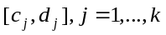in a pathway. Define indicator variables 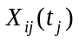and 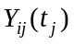of the ith individual for the genotypes at the genomic position in the jth genomic region in cases and controls, respectively. Define the average integral measures of genome content of the -th genomic regions in cases and controls, respectively, as 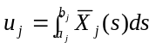,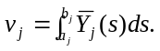 Then, using stochastic calculus we can calculate their variance-covariance matrix: 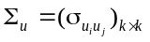 and 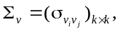 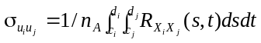, where 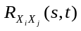is a covariance function of indicator variables. We can similarly define 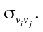 Let 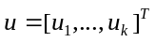 and 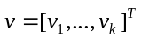. Define statistic 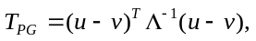where 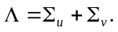. Then, under the null hypothesis of no association of pathway with the disease, the statistic 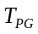is asymptotically distributed as a central distribution.
3.3.3.1.2. The Smoothed functional principal component analysis for pathway association. The SFPCA for testing the association of a gene can be extended to testing the association of a pathway by extending SFPCA from an interval to multiple intervals. Consider a linear combination of functional values: 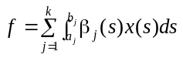, where 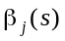is a weight function and 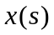 is a centered indicator function for genotypes. To improve the smoothness of the estimated functional principal component curves, we impose the roughness penalty on functional principal component weight functions. The smoothed functional principal components can be obtained by solving the integral equations: 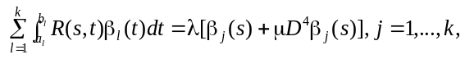 where 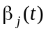are the functional principal components. Let 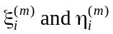be the m-th functional principal component scores of 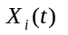and 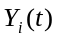. Let 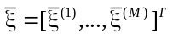, 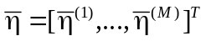, and S be the pooled covariance matrix of the functional principal component scores. Define 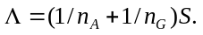Then, the statistic is defined as 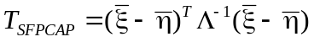. Under the null hypothesis, the statistic 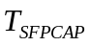 is distributed as a 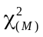 distribution.
3.3.3.1.3. Develop family-based genome information content and SFPCA statistics for pathway analysis by the quasi-likelihood score function approach. We first study the family-based genome information content statistic. Let 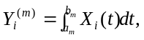 Assume the model: 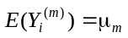if is a control, otherwise, 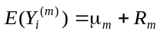. We have 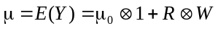, where 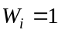if is the case,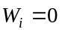if is the control. Define 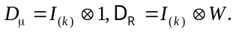 In the previous sections we showed that the covariance matrix of Y is given by 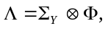where 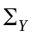is the covariance matrix of Y estimated from unrelated individuals in an outbred population and derived in the previous section. Then, the quasi-score function is defined as The statistic based on the quasi-likelihood score function^{7,83} is given by where Under the null hypothesis of no association, 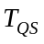is asymptotically distributed as a central 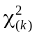distribution.
The statistic can similarly be applied to the SFPCA statistic. In this case, we assume that When only one gene or genomic region is considered the formulas can be applied to the family-based statistics for testing the association of a gene (or genomic region) in section 3.1.3.1.3.
3.3.3.2. Preliminary Studies. To examine the validity of the proposed tests and evaluate their performance, we performed a series of simulation studies. We used exome sequence data in TGF beta signaling pathway (19 genes) with 2,242 European Americans in the ESP project to simulate 100, 000 individuals. We randomly selected 6 risk genes, and 20% of the rare variants (MAF <0.05) in each gene as risk variants to calculate the type 1 error rates and power. The genotype relative risk was assumed to be inversely proportional to the MAF where the population attributable risk (PAR) of each group was assumed to be 0.01. A total of 5,000 simulations were performed. Due to space limitation, in Table 5 we only showed type 1 error rates of 12 statistics: SFPCA, FPCA, integral of genome content-based statistic, linear combination test (LCT) for each gene, but used LCT for pathway (LCT/LCT), quadratic test (QT) for pathway (LCT/QT) and de-correlation (DT) for pathway (LCT/DT)^{105,106} , WSS/Fisher Exact, WSS/GESA, VT/Fisher Exact, VT/GESA, CMC/Fisher Exact, CMC/GESA, where first statistic/second statistic denotes test for association of gene/pathway, respectively, for a sample size of 2,000 (1,000 cases and 1,000 controls) .We observed that statistics SFPCA, FPCA, Integral of genomic content, WSS/GESA, VT/GESA, CMC/GESA were not appreciably different from the nominal levels, but type 1 error rates of other 6 statistics were inflated. In Figure 5 we plotted the power of 14 statistics: 12 statistics as in Table 5 and additional two statistics CMC and VT aggregating all SNPs in the pathway as a function of sample sizes. We observe that SFPCA had the highest power compared to all of the other methods.
Table 5. Type 1 error rates of 12 statistics for testing the association of pathway.
Test | Nominal Level |  |  | Test | Nominal Level
Test | 0.001 | 0.01 | 0.05 | Test | 0.001 | 0.01 |  | 0.05
SFPCA | 0.0012 | 0.0106 | 0.052 | WSS/Fisher Exact | 0.0016 | 0.0154 |  | 0.0682
FPCA | 0.0012 | 0.0104 | 0.0516 | WSS/GESA | 0.0008 | 0.088 |  | 0.0476
Integral | 0.0008 | 0.0084 | 0.0422 | VT/Fisher Exact | 0.0014 | 0.0148 |  | 0.0596
LCT/LCT | 0.0018 | 0.0186 | 0.0742 | VT/GESA | 0.001 | 0.096 |  | 0.0486
LCT/QT | 0.0016 | 0.00172 | 0.0782 | CMC/Fisher Exact | 0.0012 | 0.0118 |  | 0.0556
LCT/QT | 0.0014 | 0.0132 | 0.0614 | CMC/GESA | 0.0008 | 0.0106 |  | 0.0512
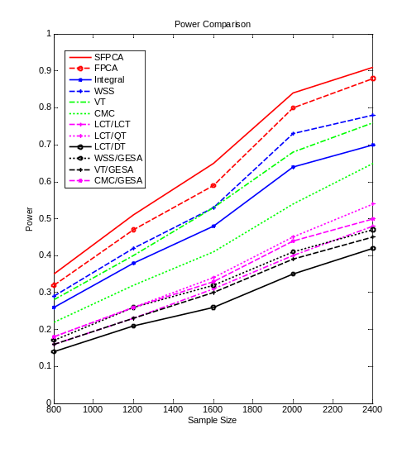
Figure 5. Power of pathway. tests
3.3.3.3. Potential problems and solutions. An essential issue for pathway-based association studies is the dependence of the test results on the sizes of genes and pathways. To ensure that tests are size-unbiased, permutation procedures to calculate empirically adjusted P-values for the test will be used.
3.4. Tentative timeline. The project will take four years to complete. Tentatively, we will develop unified sequence-based association tests that can be applied to both pedigrees and populations (Aim 1) in grant year 1, the FLM and FMLM for both population-based and family-based QTL (eQTL) analysis and causal inference (Aim 2) in grant year 2, the novel population-based and family-based tests for pathway analysis (Aim 3) in grant year 3 and the FLM and FMLM with multiple functional responses for longitudinal QTL analysis and allele specific expression and isoform expression eQTL analysis (Aim 2) in grant year 4. Opportunistic research will continue throughout the grant period.

