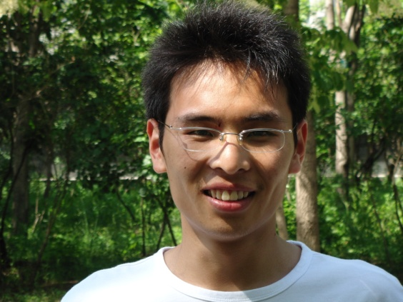

Shicheng Guo, Ph.D. candidate(2009-2014), School of Life Sciences, Fudan University. His supervisor is Jiucun Wang and Li Jin. The realm which he focus on now is computational biology and medical statistics including: manifold kinds of microarray analysis, meta-analysis, genome-wide SNP, RNA, Methylation, CNV analysis based on next generation sequencing technology. In the past three years, he had participated in series of attractive research( Yan-Huang methylome project et.al), and participated in publishing several interesting papers( Nature Biotechnology, Plos Biology et al) and two Chinese patents. Specially, in clinical field, he want to explore some high sensitive and specific diagnosis and prognosis biomarkers for some complex disease such as immune diseases, cancer. And then establish some high accuracy disease prediction models so that doctors can make more felicitous decision to his/her patients.