Imaging techniques for the liver include ultrasound, computed tomography (CT), and magnetic resonance imaging (MRI). Among all these technology, ultrasound is one of most potential tools which can be conducted in the liver cancer screening in low and mid-incoming countries in large populations, since its low cost, fast and simple operation.

As to its disadvantages which include somewhat limited resolution for small liver lesions and limitations of specificity of conventional ultrasound, can be overcome 1) with effective and intelligent image signal capturing and analysis method 2) with the use of ultrasound contrast agents. Additional, ultrasound is a basic technique for image-guided procedures such as biopsy and ablation. When the transducer is applied directly to the liver during an operation, the highest resolution is obtained, and this technique is generally more sensitive than CT or MRI for small liver lesions.

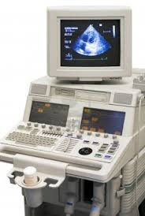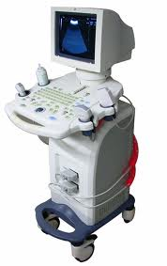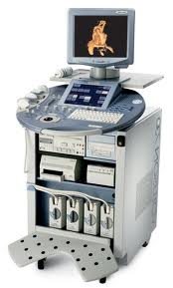

Figure 1. Traditional ultrasound devices

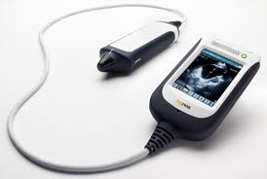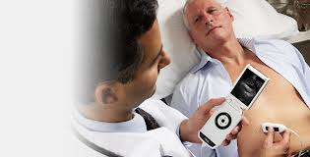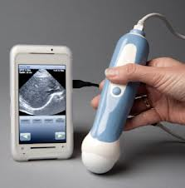

Figure 2. Modern smartphone ultrasound devices

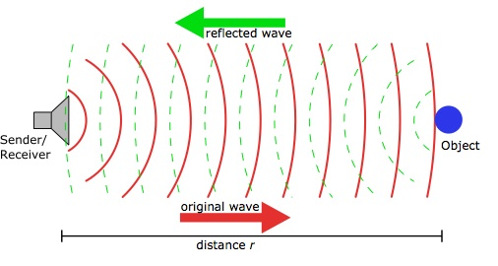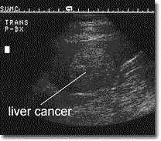

Figure 3. Principle of the ultrasound in the diagnosis of liver cancer

**Plans to adapt/improve new technology/assay/device/treatment to be developed or technology adapted from existing ones for cancer treatment in a low resource setting. Discuss its deployment potential in terms of costs and operability.**

In our ultrasound diagnosis to liver cancer, the MobiUS systems from MobiSante Company will be applied. MobiSante is the leader in ultrasound technologies which are adapted to specific smartphones and tablets. These systems provide a new generation of high-performance, low-cost and portable ultrasound imaging for detection and screening of liver hepatocellular carcinoma in the Chinese population.

The MobiUS SP1 smartphone system is a diagnostic ultrasound imaging tool that is easy to use, convenient, connected and mobile. The MobiUS system provides gray-scale imaging for a variety of clinical applications, including abdomen, cardiac, vascular, OB/Gyn, MSK and others, with a wide array of supported transducers. The images can be stored onboard, emailed (via Wi-Fi or cellular network) or sync’d to a PC for archive, second opinion or over-reads.

The MobiUS TC2 tablet ultrasound system takes mobile imaging to another level with a larger screen, faster frames rates and higher resolution, along with built in wireless data connectivity. Images can be acquired in a few simple steps and stored and transmitted securely. In addition to all the enabled exams on the smartphone, the tablet version provides endocavity imaging for Gyn or prostate imaging. The MobiUS TC2 system not only expedites diagnosis, it also guides injections, aspirations and line placements. And the price point is so reasonable your ROI timeline will be surprisingly short. The MobiUS TC2 System is very compact and light enough to take wherever you need it. The battery supports more than 2.5 hours of continuous scanning and is easily recharged. The touch screen user interface is extremely straightforward. So the learning curve is barely a curve at all. Images are readily stored in 64 GB capacity and quickly shared via secure Wi-Fi and USB port. Ultrasound imaging has been put within the economic reach of healthcare professionals everywhere. The MobiUS TC2 System Imaging presets for Quick Scan, Abdomen, AAA, OB/Gyn, Cardiac, Vascular, Small Organs, MSK, Endocavity, NV probe, and other mode which can be used to capture optimal image for each tissue. Scan angle can be multiple which depends on probe selection. Near/mid/far gain and main gain, depth, contrast and intensity is adjustable. Focal depth also can be reset which depends on pulse frequency. The Image resolution can come up to 600x640.

The MobiUS devices support multiple probes for different clinical applications. 3.5MHz, 5.0MHz and 7.5, 12 MHz probes are currently supported on the MobiUS SP1 smartphone system. The MobiUS TC1/TC2 tablet systems support 3.5 and 5.0 MHz general purpose probes, as well as 7.5 and 12 MHz high-frequency probes and the 7.5 MHz endocavity probe. Abundant probe will be suitable for different diagnosis for different conditions to ensure the completion of our project.

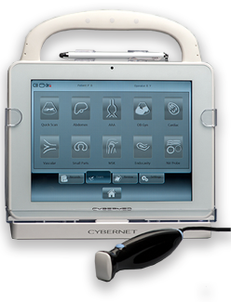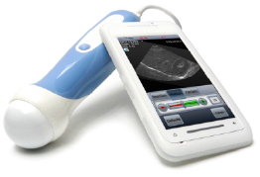

Figure 4. Mobisante ultrasound devices. [MobiUS™ SP1 System](http://www.mobisante.com/products/product-overview/) (left) and [TC2 System](http://www.mobisante.com/products/product-overview/) (right)

Mobisante’s MobiUS system obtained FDA approval for ultrasound on a smartphone technology in 2011. In this project, Mobisante Company will provide the MobiUS ultrasound diagnosis system as stated in the support letter.

The Mobisante ultrasound system will cost between $7,000 for the whole package including a Toshiba TG01 Windows Mobile smartphone, ultrasound probe, and Mobisante’s proprietary software. In the U2 stage we will buy 3 Mobisante TC2 system and allocate these 3 device to Shanghai Cancer Hospital, Shanghai Zhongshan Hospital and Shanghai Huashan Hospital. Excellent training videos and manuals will be provided by Mobisante Company.

**Plans to test functionality with clinical specimens or patients. (While it is not necessary in the UH2 phase to test the assay/device/treatment in LMICs, data must be generated to show likelihood that it will be useable in an LMIC setting.)**

China has 38,000 new liver cancer patients every year, accounting for nearly half of the world's total. Shanghai is the third high-incidence of liver cancer in China (following Guangzhou and Hangzhou). Age-standardized incidence of liver cancer in shanghai is about 39.99, which means 9,519 new liver cancer patients will be come out every year in Shanghai while almost 5 times liver cancer patient will come to Shanghai to accept cancer therapy from all over the China since its better surgical technique.

According to the statistic number of the patients from our perform sites, 34,000 outpatient liver disease patients and 5,500 inpatients of liver disease patient will be collect which can ensure the sample size of our project. We almost have a group of 120 doctors and nurses to carry on the project which included ultrasound diagnosis and plasma collection. Suppose 10 liver cancer patients or related liver disease were performed above operation every day, we will collect at least 10950 ultrasound samples which will be provide enough training and test sample to establish the diagnosis model and provide accurate estimation of the accuracy for the MobiSante devices. Suppose the cost of the ultrasound diagnosis is 5$/patient, our total cost is just $54,750 which is accept for our total project.

Table 1 Statistic of the liver cancer and related disease patients in present project

|  |  |  |  |
| --- | --- | --- | --- |
|  | Outpatient/Year | Intpatient/Year | Ultrasound Test Ratio |
| Zhongshan Hospital | 15,000 | 3,000 | 25% |
| Shanghai Cancer Center | 7,500 | 1,400 | 40% |
| Huan Shan Hospital | 3,500 | 500 | 30% |
| Taizhou Institute of Health Sciences | 2,000 | 300 | 80% |
| Qidong Liver Cancer Institute | 1,000 | 200 | 100% |
| Hubei Provincial Traditional Chinese Medicine Hospital | 500 | 100 | 50% |
| Total | 34,000 | 5,500 | - |

**Potential clinical utility (i.e., what clinical problem the assay/device/treatment addresses, how the assay/device/treatment will solve the clinical problem, its potential specificity, sensitivity, selectivity, and other key functional parameters).**

MobiSante ultrasound devices would be provide excellent early or middle stage liver cancer diagnosis. As our preliminary data analysis shows our functional PCA method can diagnosis liver cancer with sensitivity of 80%, specificity of 80% and accuracy of 84%. These great performance can be validated even with 5 cross-validation (accuracy is 78%). As we expected, the ultrasound image from MobiSante will obtain similar or better result through real-time and saturated scanning.

**Clinical capabilities of the proposed LMIC site, how the cancer can be treated at that site, and how use of the device comports with cultural sensitivities.**

All of the hospitals in our project are 3A hospital and almost the best hospital in China. We have large number famous doctors and nursed and abundant cancer therapy related devices and medicines.

Surgery, radiotherapy, chemotherapy, targeted therapy, immunotherapy, hormonal therapy and angiogenesis inhibitors therapy will be provided when liver cancer was diagnosis and validated by pathologic diagnosis.

**Plans to address regulatory issues at the local LMIC site(s), including human subject issues.**

**Specific performance milestones to be achieved during the UH2 phase, e.g., analytical and clinical specificity, selectivity, and sensitivity.**