**Deep learning prediction of chemotherapy response using multi-omics and histological image data**

**A. Research Goal**

Deep learning becomes one of most important tools for precision medicine and provides inspiring opportunity for personalized drug response prediction, early disease diagnosis and subtype classification based on ultra-high dimensional genetic, epigenetic and image data. We hypothesize that histological image data contains information to infer molecular characteristics, such as genome-wide DNA methylation and clinical outcomes such as chemotherapy response. The goal of this study is to investigate the approach to apply multiple deep learning approaches such as conditional convolutional neural networks (CGAN), convolution-al neural networks (CNNs) and [self-attention generative adversarial networks](https://arxiv.org/abs/1805.08318) (SAGAN) to human genetic (DNA mutation), transcriptional data(miRNA and mRNA) and epigenetics data (DNA methylation) as well as histological diagnostic image data to predict chemotherapy drug response and human molecular profile and characteristics. We will also compare the deep learning algorithm to multi-Omics-image data with traditional machine learning method such as Naïve Bayes (NB), Hidden Markov Models (HMMs), Hidden Semi-Markov Models (HSMM), Conditional Random Fields (CRFs), Support Vector Machine (SVM) and Random Forest Models (RF).

**B. Specific Aims**

**Aim 1:** To predict DNA methylation status by histological image data with traditional machine learning method and deep learning (neural networks, such as conditional convolutional neural networks). Recently, Dr. Kather, in his Nature Medicine paper [1], demonstrated that histological image data could provide powerful prediction to microsatellite instability (MSI). Meanwhile, DNA methylation capacity have been shown striking correlation with genetic instability [2]. We plan to investigate the prediction ability of histological image data to genome-wide DNA methylation level by 9,756 paired DNA methylation and histological image data with the most powerful deep learning method: conditional convolutional neural networks (CGAN)[3], convolutional neural networks (CNNs)[4] and [self-attention generative adversarial networks](https://arxiv.org/abs/1805.08318) (SAGAN) [5].

**Aim 2**: To predict chemotherapy response by histological image data and multi-omics data including DNA methylation, DNA mutation, miRNA and transcriptomic data (mRNA) with traditional machine learning method and conditional convolutional neural networks (CGAN). Chemotherapy drug response prediction become one of most important tasks to achieve precision medicine. However, previous evidence showed the prediction accuracy is very low with biomarker panel or single-omics data. More and more studies were trying to apply multi-omics data for the chemotherapy drug response. We plan to integrate multi-Omics data and H&E histological image data to predict chemotherapy drug response within 1,991 well recorded drug response cross 33 cancers with Sure Independence Screening (SIS) and Gini impurity index (SII) for feature selection from ultrahigh dimensional genomic feature set followed by conditional generative adversarial networks (CGAN)[3], convolutional neural networks (CNNs)[4], [self-attention generative adversarial networks](https://arxiv.org/abs/1805.08318) (SAGAN) [5]

**C. Background**

Patient health information are hidden in obvious clinical records (EHR, Laboratory tests and drug prescriptions) and image data such as electroencephalogram (EEG), Computed Tomography (CT), MRI, H&E histology.

**D. Significance**

**E. Preliminary Studies**

**Predict DNA methylation with conditional generative adversarial networks to histological image data**

**Multi-Omics data provide better prediction to chemotherapy response than single-omics data**

In this study, we investigated the performance of deep-learning algorithms applied to multi-omics genomic data from the TCGA project. Drug response status including complete response (n=815), partial response (n=102), stable disease (n=182) and clinical progressive (n=892) across 32 cancers were evaluated. For computational efficiency and classifier performance, we proposed an approach using Sure Independence Screening (SIS) and Gini impurity index for feature selection from ultrahigh dimensional genomic feature set followed by conditional generative adversarial networks (CGAN) to produce predictive models for chemotherapy response, internally validated by 10-fold cross-validation. mRNA, miRNA, and methylation datasets were used both independently and jointly. For the miRNA-based prediction, we identified 23 highly informative features, including miR-141, miR-200c, miR-205, miR-9 and miRR-338, which, in combination, produced an AUC=0.64 for discriminating complete and partial response from stable disease and clinical progressive endpoints. Using mRNA-seq data, we identified 264 highly informative features including *MYCBP*, *KLF15*, *IGIP*, and *GRIA3*. The mRNA-based predictive model yielded an average AUC=0.71. The DNA methylation model attained a higher level of performance with AUC=0.81 (95% CI: 0.78-0.84). Combining mRNA-seq, miRNA, and methylation data improved the predictive performance with accuracy of 84.2% and an AUC=0.86 (95% CI: 0.82-0.90). Functional enrichment analysis for mRNA and DNA methylation selected features showed enrichment for the antioxidant response pathway and basal transcription factors associated with the platinum drug resistance (PDR) pathway. Importantly, our chemotherapy response classifier substantially outperforms a predictive model focused on mRNA and methylation features within PDR pathway (hsa01524 in KEGG) AUC=0.62, demonstrating that taking a broad approach using genome-wide multi-omics data dramatically improves discrimination. In summary, this work demonstrates that applying deep-learning algorithms to multi-omics data can generate informative predictive models for chemotherapy response across numerous cancers.

**F. Research Design and Methodology**

***Molecular data, image data collection and chemotherapy drug response definition.***

We collected 9,756 genome-wide DNA methylation data (methylation 450K microarray data), 12,759 mRNA-seq data and 11,667 miRNA-seq data and 11,766 histological diagnostic image data across 33 cancer types in TCGA project [6]. Meanwhile, we collected all 3,320 complete drug response records and eventually we identified 1,991 individuals with clear drug response status including complete response (n=815), partial response (n=102), stable disease (n=182) and clinical progressive (n=892) across 33 cancers.

***DNA methylation, RNA-seq, miRNA-seq, DNA mutation and histological image data structure.***

Genome-wide DNA methylation was measured my Illumina methylation 450K microarray. All the beta-values were extracted by the unique ID for the 1,991 individuals with complete drug response status. Transcriptomic data were measured by RNA-seq assay and gene-based counts identified by HTSeq [7] and fragments per kilobase of transcript per million mapped reads upper quartile (FPKM-UQ, [7]) for all the gene were collected. Genome-wide miRNA data were generated by miRNA-seq and the miRNA expression were produced by BCGSC miRNA profiling pipeline [8]. Cancer sample DNA mutation were called by the comparison between cancer tissues and matched normal tissues or blood cells with 4 different algorithms including MuTect2 [9], SomaticSniper [10], MuSE [11], VarScan2 [12]. Digital images of glass slides were scanned by using digital slide scanner (Aperio's ScanScope AT). Digital images in SVS format can be viewed with Aperio's ImageScope viewer.

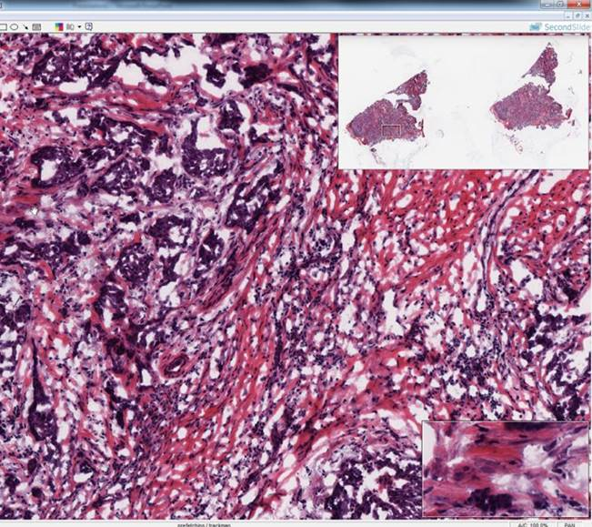 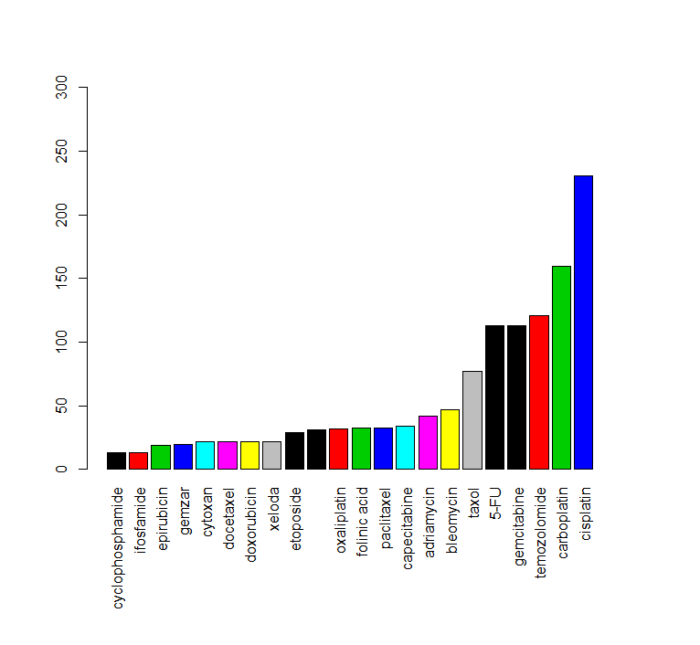

***G. External Collaborators***

Currently, we don’t have any existed external collaboration in this research. Dr. Mark Craven at Department of Biostatistics and Medical Informatics, University of Wisconsin-Madison and Dr. Momiao Xiong at Department of Biostatistics, University of Texas Health Science Center in Houston (Uthealth) may join the discussion to the research if necessary.

***H. Timeline***

Timeline for Dr. Shicheng Guo, Dr. Steven J. Schrodi and Dr. Fereshteh Bashiri are attached as appendix 1.

***I. Budget Justification***

**BUDGET PERIOD: 28/06/2019 – 28/06/2020 (12 Months)**

**PERSONNEL**

**Shicheng Guo, Ph.D. – Principal Investigator:** Dr. Guo will coordinate all efforts for this project including directing all research aims, prepare molecular data (miRNA, mRNA, DNA methylation, DNA mutation and drug response), interpreting predation results, providing progress reports, and publishing results. Dr. Guo will devote x C/M to the project.

**Steve J. Schrodi, PhD – Co-Principal Investigator:** Dr. Schrodi will mentor Dr. Guo and assist Guo in all aspects for this project including directing all research aims, interpreting results, providing progress reports, and publishing results. Dr. Schrodi will devote x C/M effort to the project which will be cost shared.

**Fereshteh Bashiri, PhD – Co-Principal Investigator**: Dr. Bashiri will mentor Dr. Guo and assist Guo in all aspects for this project including image data analysis, image feature extraction, conditional generative adversarial network (CGAN) training, interpreting results, providing progress reports, and publishing results. Dr. Bashiri will devote x C/M effort to the project which will be cost shared.

**J. Budget**

**K. Biographical Sketch**

**L. Literature Cited**

1. Kather, J.N., et al., *Deep learning can predict microsatellite instability directly from histology in gastrointestinal cancer.* Nat Med, 2019.

2. Lengauer, C., K.W. Kinzler, and B. Vogelstein, *DNA methylation and genetic instability in colorectal cancer cells.* Proc Natl Acad Sci U S A, 1997. **94**(6): p. 2545-50.

3. Jin, C., et al., *Left Atrial Appendage Segmentation Using Fully Convolutional Neural Networks and Modified Three-Dimensional Conditional Random Fields.* IEEE J Biomed Health Inform, 2018. **22**(6): p. 1906-1916.

4. de Vos, B.D., et al., *ConvNet-Based Localization of Anatomical Structures in 3-D Medical Images.* IEEE Trans Med Imaging, 2017. **36**(7): p. 1470-1481.

5. Han Zhang, I.G., Dimitris Metaxas, Augustus Odena, *Self-Attention Generative Adversarial Networks.* arXiv:1805.08318, 2018.

6. Cancer Genome Atlas Research, N., et al., *The Cancer Genome Atlas Pan-Cancer analysis project.* Nat Genet, 2013. **45**(10): p. 1113-20.

7. Anders, S., P.T. Pyl, and W. Huber, *HTSeq--a Python framework to work with high-throughput sequencing data.* Bioinformatics, 2015. **31**(2): p. 166-9.

8. Chu, A., et al., *Large-scale profiling of microRNAs for The Cancer Genome Atlas.* Nucleic Acids Res, 2016. **44**(1): p. e3.

9. Cibulskis, K., et al., *Sensitive detection of somatic point mutations in impure and heterogeneous cancer samples.* Nat Biotechnol, 2013. **31**(3): p. 213-9.

10. Larson, D.E., et al., *SomaticSniper: identification of somatic point mutations in whole genome sequencing data.* Bioinformatics, 2012. **28**(3): p. 311-7.

11. Fan, Y., et al., *MuSE: accounting for tumor heterogeneity using a sample-specific error model improves sensitivity and specificity in mutation calling from sequencing data.* Genome Biol, 2016. **17**(1): p. 178.

12. Reble, E., et al., *VarScan2 analysis of de novo variants in monozygotic twins discordant for schizophrenia.* Psychiatr Genet, 2017. **27**(2): p. 62-70.