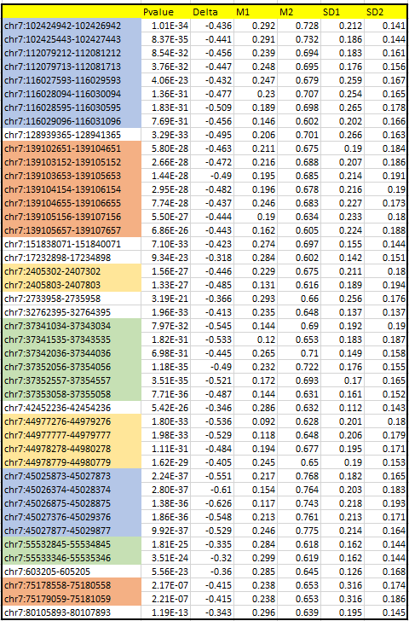

Figure 1. Most significant human solid tissue hyper-methylated regions.