**Magic™ BCR Repertoire Analysis**

**Creative Biolabs** offers the unparalleled mass sequencing service to analyze the B-cell receptor (BCR) repertoires of human or mice. According to the Magic™ platform which mainly based on next generation sequencing (NGS) technique, our scientists are able to identify the vast majority of BCR V(D)JC sequences contained in a single sample.

BCR is an indispensable component of an adaptive immune system, which is fundamentally reliant upon its diverse repertoire. BCR is generally defined as a transmembrane receptor located on the B-cell surface or a kind of membrane-bound antibody form. BCRs are assembled during the B-cell development and went through somatic recombination of three gene segments of the heavy chain locus (V, D, J) and two gene segments of the light chain locus (V, J) to diversify variable region gene. According to the rearrangement mechanism, there are no the same BCRs between two different B-cells, which enable the repertoire of BCRs to become a valuable tool for the investigation of the immune system. In addition, through exposure to endogenous host factors and exogenous invaders, the BCR repertoire is continuously shaped and changed which establishes a series of potential associations with infections or diseases. In this way, high-throughput sequencing is a very useful method to investigate and analyze the change of BCR repertoire in some specific physiological processes, which may include autoimmune and tumor diseases, and then be helpful to discover new therapeutic agents, such as specific antibodies for interested targets and effective vaccines.

**Creative Biolabs** has established the high-throughput Magic™ platform for large-scale sequencing services. To achieve immune repertoire sequencing (IR-seq), RNA from whole blood or B cells is the required template for the amplification of complementary determining region (CDR), and then the Magic™ platform can be used to provide one-stop service including high-throughput sequencing and data analysis. Through our Magic™ IR-seq platform, both the heavy chain and the light chain CDR 3 regions of either human or mice can be 100% covered and accurately sequenced, the constant regions from the two species are also captured and sequenced with enough length to identify the class information. In this way, our customers can finally obtain a comprehensive BCR repertoire involving both the hyper-mutation and isotype data from this sequencing service.

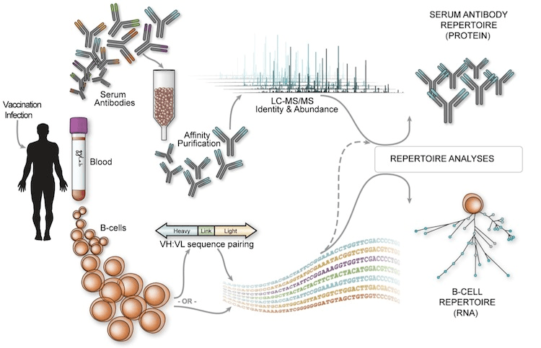

Fig.1 BCR Repertoire Analysis.

**Features of Magic™ platform for repertoire analysis**

* Comprehensive BCR repertoire from RNA of either human or mice, Specific capture primers, High fidelity amplification method, Advanced high-throughput sequencing platform. With years of research and development experience in the field of immunology, **Creative Biolabs** has owned a group of scientists who have the distinguished understanding of the adaptive immune system. Through the one-stop BCR repertoires analysis service, our seasoned scientists are pleased to share expertise and experience with our global clients and facilitate their meaningful immune repertoire researches.