PAX2, chr10:102,582,916-102,593,303

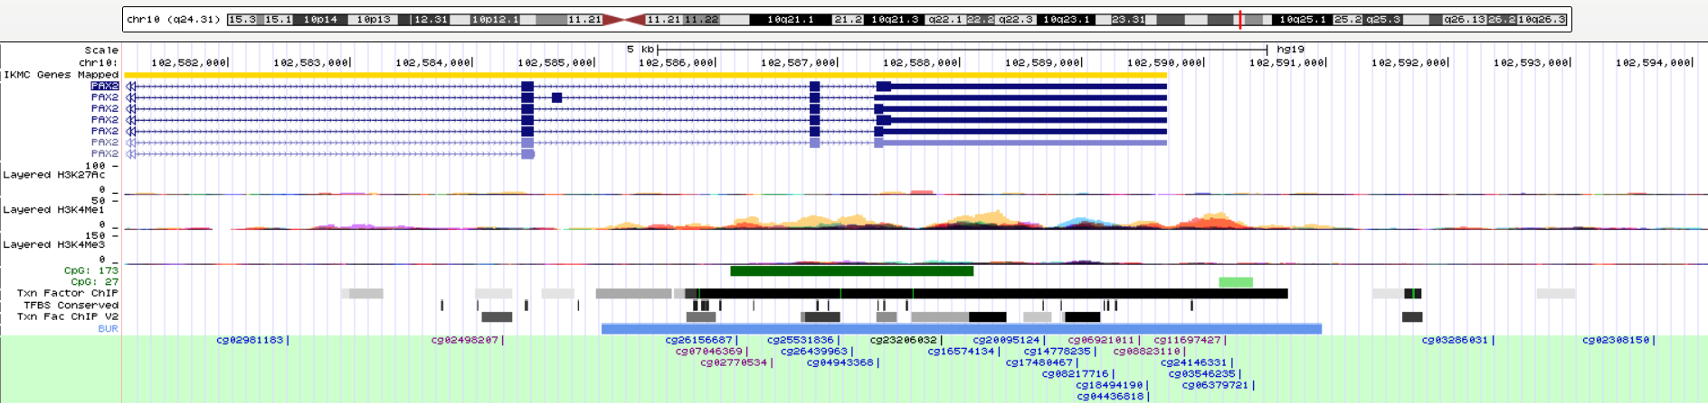

We can find this region marked with H3K4me1 enrichment which plays fine-tune to enhancer activity and function. Within this region, 22 transcript factors (TF) have binding sites/regions. I forget the exact CpGs which are differentially methylation between case and control. If the exact CpG information can be shared, I can search it again and tell the exact TFs.

|  |  |  |  |
| --- | --- | --- | --- |
| chr10 | 102585021 | 102585641 | EZH2 |
| chr10 | 102585657 | 102585973 | MYC |
| chr10 | 102585742 | 102586052 | PAX5 |
| chr10 | 102585745 | 102586021 | MAX |
| chr10 | 102585750 | 102585990 | SPI1 |
| chr10 | 102585822 | 102585892 | BCL11A |
| chr10 | 102585840 | 102590692 | EZH2 |
| chr10 | 102586431 | 102587241 | SUZ12 |
| chr10 | 102586667 | 102587045 | CTCF |
| chr10 | 102586679 | 102586946 | POLR2A |
| chr10 | 102586723 | 102586963 | RAD21 |
| chr10 | 102587306 | 102587495 | TCF7L2 |
| chr10 | 102587524 | 102588180 | E2F1 |
| chr10 | 102587530 | 102587966 | UBTF |
| chr10 | 102587566 | 102587911 | CTCF |
| chr10 | 102587613 | 102587917 | FOXP2 |
| chr10 | 102587628 | 102587844 | RAD21 |
| chr10 | 102588102 | 102588412 | SUZ12 |
| chr10 | 102588510 | 102588750 | FOXA1 |
| chr10 | 102588742 | 102589342 | CTBP2 |
| chr10 | 102588801 | 102589125 | SP1 |
| chr10 | 102589006 | 102589316 | SUZ12 |

PAX2 don’t have any ChIP-seq data in human, neither in mice. However, I do find the ChIP-Seq data of GFI1B in human. PAX2 and GFI1B have similar TF-binding regions, therefore, we can predict PAX2 regulated genes with ChIP-seq of GFI1B. the raw data is saved here. Later, I can summary all the PAX2 regulated genes with this dataset.

<https://www.encodeproject.org/experiments/ENCSR445PDR/>