Intratumor heterogeneity revealed by integrated multiomic analysis in pancreatic ductal adenocarcinoma

1、Xiaoqian Liu1, **[wyliuxiaoqian@126.com](mailto:wyliuxiaoqian@126.com)**

2、Cheng Xing2, **andrewxingcheng@163.com**

3、Xiaoding Liu1, **[Vicnicding@hotmail.com](mailto:Vicnicding@hotmail.com)**

4、Zhiwen Zhang1, **[zhangzhw109@126.com](mailto:zhangzhw109@126.com)**

5、Lianyuan Yu1, **[yly1027@hotmail.com](mailto:yly1027@hotmail.com)**

6、Dan Guo3, **gdp1225@163.com**

7、Huanwen Wu1, [wuhuanwen10700@pumch.cn](mailto:wuhuanwen10700@pumch.cn)

7, Shicheng Guo, guo.shicheng@marshfieldresearch.org

8、Menghua Dai2, [daimh@pumch.cn](mailto:daimh@pumch.cn)

9、Zhiyong Liang1 [liangzhiyong1220@yahoo.com](mailto:liangzhiyong1220@yahoo.com)

**Zhi-yliang code: zhi-yliang565**

1Molecular Pathology Research Center, Department of Pathology, Peking Union Medical College Hospital, and Chinese Academy of Medical Sciences and Peking Union Medical College, Beijing 100730, China.

2Department of General Surgery, Peking Union Medical College Hospital, and Chinese Academy of Medical Sciences and Peking Union Medical College, Beijing 100730, China.

1Center for Precision Medicine Research, Marshfield Clinic Research Institute, Marshfield, Wisconsin, USA

3Department of Medical Research Center & Clinical Biobank, Peking Union Medical College Hospital, Chinese Academy of Medical Sciences and Peking Union Medical College, Beijing 100730, China.

Xiaoqian Liu and Xing Cheng contributed equally to this work.

**Correspondence:**

Prof. Zhiyong Liang. Molecular Pathology Research Center, Department of Pathology, Peking Union Medical College Hospital, and Chinese Academy of Medical Sciences and Peking Union Medical College, Beijing 100730, China. Email: [liangzhiyong1220@yahoo.com](mailto:liangzhiyong1220@yahoo.com).

Prof. Menghua Dai. Department of General Surgery, Peking Union Medical College Hospital, and Chinese Academy of Medical Sciences and Peking Union Medical College, Beijing 100730, China. Email: [daimh@pumch.cn](mailto:daimh@pumch.cn).

Prof. Huanwen Wu. Molecular Pathology Research Center, Department of Pathology, Peking Union Medical College Hospital, and Chinese Academy of Medical Sciences and Peking Union Medical College, Beijing 100730, China. Email: [wuhuanwen10700@pumch.cn](mailto:wuhuanwen10700@pumch.cn).

**Abstract**

Intra-tumor heterogeneity (ITH) might promote disease progression and occurs in several solid tumors but its extent in pancreatic ductal adenocarcinoma (PDAC) remains unclear.Through sequencing of 46 samples from 14 patients with PDAC that had been resected before systemic therapy by multiregion whole-exome sequencing, RNA-seq and MeDIP-seq, we comprehensively analyzed these tumor regions to evaluate the ITH in PDAC. The results showed that tumor heterogeneity is considerable with regard to the genomes, transcriptomes and epigenomics of lesions and tumors. Though driver gene mutations were more likely to be deleterious than passenger gene mutations, passenger gene mutations predicted to account for most ITH and substantial ITH in PDAC were observed. In addition, clonal evolution analyses showed the evolutionary histories of a tumor inferred based on genomic and epigenomic data were different with each other. However, passenger gene mutations, not driver gene mutations, were more predictive of ITH, which suggested that single-region detection might be sufficient to guide treatment decisions.

**Introduction**

Pancreatic cancer is a major cause of cancer-associated mortality[1](#_ENREF_1" \o "Kleeff, 2016 #64). Histologically differentiated pancreatic ductal adenocarcinomas (PDACs) account for 90% of pancreatic malignancies[2](#_ENREF_2" \o "Samuel, 2011 #1). Risk factors include chronic smoking, high fat diet, excessive alcohol consumption, obesity, and diabetes[3](#_ENREF_3" \o "Ryan, 2014 #2). In the past decades, no conventional therapy has made a significant progress for PDAC, leading to a poor prognosis with an overall 5-year survival of less than 8%[4](#_ENREF_4" \o "Siegel, 2019 #3329). Most patients initially diagnosed at advanced stage, with only 10-15% of patients are considered surgically resectable[5](#_ENREF_5" \o "Neoptolemos, 2011 #16). Unfortunately, many patients at early stage still develop recurrence even after curative resection. Therefore, novel and effective strategies are urgently needed.

Previous studies have demonstrated that tumor heterogeneity exists not only among different patients but also in different tumors and metastatic lesions from the same patient[6](#_ENREF_6" \o "Jones, 2008 #42),[7](#_ENREF_7" \o "Campbell, 2010 #43). Intra-tumor heterogeneity (ITH) is one of the major causes for the lack of success in the current therapies of most types of cancers including PDACs[2](#_ENREF_2" \o "Samuel, 2011 #1). The differences of genomic abnormalities were displayed between lesions within the same tumor by comparative genomic hybridization, demonstrating ITH in PDACs[8](#_ENREF_8" \o "Harada, 2002 #3304). The studies in xenografted mouse showed the significant differences between the central and peripheral of the pancreatic tumor by transcriptomic profiling. The up-regulated genes in peripheral zone were related to cytoskeleton organization and motility and the up-regulated genes in the central zone were related to regulation of cell proliferation and transcription[9](#_ENREF_9" \o "Nakamura, 2007 #3306). Distinct subclonal populations of primary PDACs share identical driver mutations, indicating ITH may be driven by epigenomic reprogramming[10](#_ENREF_10" \o "McDonald, 2017 #3307). Both of genomic and epigenomic research have demonstrated that ITH represents a snapshot of the tumor’s evolutionary path and can contribute to treatment failure and drug resistance in clinical practice[2](#_ENREF_2" \o "Samuel, 2011 #1),[11](#_ENREF_11" \o "Gerlinger, 2012 #45),[12](#_ENREF_12" \o "Lin, 2017 #3303). However, little is known about the relationship between genomic diversity and epigenetic changes of ITH in PDACs, and whether such ITH is related to genetic architecture remains unexplored.

The accurate understanding of the genomic and epigenomic architecture of PDACs tumors is essential for the development of individualized treatment decisions and specific biomarkers. In this study, we performed integrative multiomic analysis to study 46 multiple spatially separated samples obtained from 14 surgically resected primary PDACs, including multi-region whole exome sequencing (WES), RNA-sequencing (RNA-seq) and Methylated DNA Immunoprecipitation Sequencing (MeDIP-Seq) to reveal comprehensive tumor heterogeneity in the genomes, transcriptomes and epigenomes.

**Results**

**Patient characteristics.** We collected 46 tumor regions and 14 matched adjacent peritumoral tissues from 14 surgically resected PDACs, including 6 males and 8 females. The median age of the patients was 64 years (range, 44-69 years). Two patients were in stage IB, 5 in stage IIA, 6 in stage IIB and one patient was in stage III. 83.3% (5/6) male and 12.5% (1/8) female patients had smoking history; of these, only one male was former smoker. 85.7% (12/14) of the patients had a history of chronic disease, including hypertension, hyperlipidemia and diabetes. No patients received chemotherapy or radiation therapy before surgery. The clinical characteristics of the patients are showed in Table S1.

**Identification of somatic mutations and driver gene mutations.** We performed multi-region WES with a median depth of 243×. The degree of diversity in somatic mutations among lesions in the same patient was large (Fig 1A, Fig S1). According to IntOGen Mutations list of putative driver genes[13](#_ENREF_13" \o "Gonzalez-Perez, 2013 #75), we classified nonsynonymous variants into putative driver and passenger gene mutations. There were significant differences between different cases (P<0.015), but the differences within the case was not significant (Fig 1B). The most common driver gene mutations occurred in *KRAS* (82%), *TP53* (60%), *CDKN2A* (33%) and *SMAD4* (13%) across different regions, which is consistent with the previous studies[14](#_ENREF_14" \o "Makohon-Moore, 2016 #3318). Missense mutation was the most common type of mutation, along with nonsense mutation, splice site, in frame del, frame shift del, and so on. We further classified the nonsynonymous variants into trunk, branch, and private. Trunk represented mutations that were present in all three regions of the tumor. Branch represented mutations that were present in two regions. And private represented mutations that were present in only one region. On average, 9.3% of nonsynonymous variants were trunk, which were shared in all lesions. 4.5% of nonsynonymous variants were branch, 86.2% of nonsynonymous variants were private (Fig 1C). There were significant differences in both the number of nonsynonymous variants and the number of driver gene mutations across different categories (P＜0.001). This result suggested that genomic instability at the level of mutation during tumor development and confirmed the ITH in PDAC. Of note, although the somatic mutations identified as trunk was significantly less than branch and private, they were enriched for drivers (Fig 1D). These results reflected limited heterogeneity of driver genes among the different regions in the same patient and suggested that these driver gene mutations happened in the early stage of PDACs.

We also calculated [tumor mutation burden](javascript:;) (TMB) using only somatic nonsynonymous mutations sequenced with WES (Fig 1E). On the whole, we observed lower TMB in PDAC than other solid tumors such as melanoma and lung cancer, with a median of 2.89 mutations per MB (range, 1.2-7.6 mutations/MB).

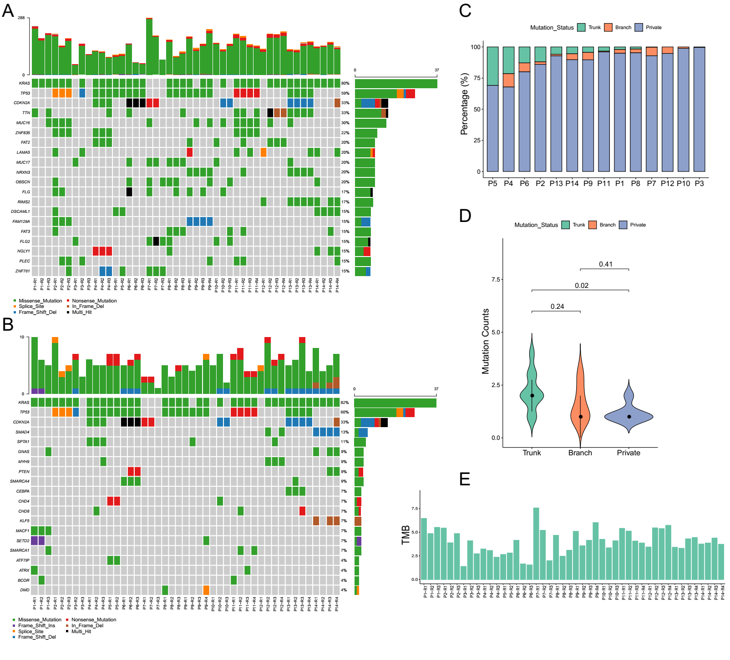

Fig. 1 The mutational landscape and patterns of genetic divergence in different regions of PDACs. We classified the somatic mutations(A) and driver gene mutations(B) for each sample according to different types. The different colored tables represent different types of mutations (middle bars). (C) The percentage of total mutations in trunk (green), branch (orange), and private (blue) by our WES for each sample. (D)Violin plots illustrate the numbers of driver gene among trunk, branch and private mutations based on pan-cancer drivers. (E) TMB was calculated using only somatic nonsynonymous mutations sequenced with WES for each sample.

**Predicted function in driver and passenger gene mutations.** Next, we used several methods to predict the functional consequences of the nonsynonymous mutations. As expected, driver gene mutations were more deleterious than passenger gene mutations. VEST-3 and PROVEAN predicted significantly higher gene-weighted scores for driver gene mutations in trunk and branch than in private, while the score for passenger gene mutation was not higher in trunk than in private (Fig. 2A, 2C). MuPred showed similar results that the score for both driver and passenger gene mutation was higher in trunk and branch than in private (Fig. 2B). SIFT, CADD and FATHMM also predicted significantly stronger functional effects for driver genes in trunk than in private (P<0.001) (Fig. 2D, 2E, 2F). These results were slightly different, but overall, passenger gene mutations were likely to have predicted consequences accounted for most ITH.

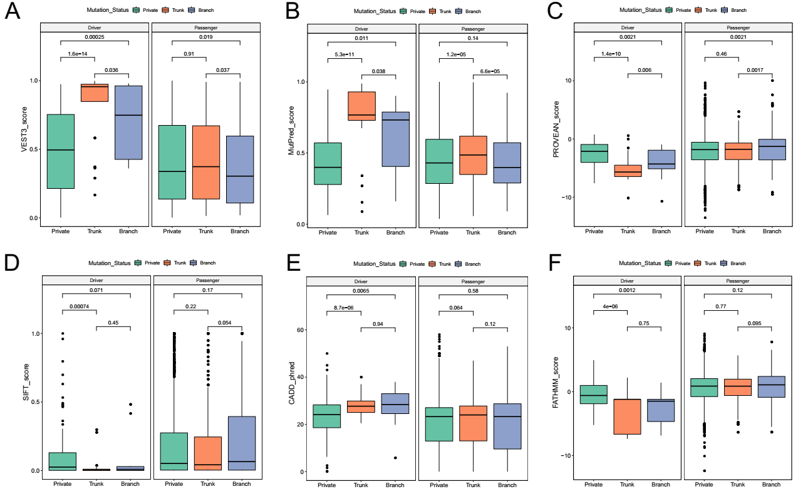

Fig. 2 Predicted functional mutations in driver genes and passenger genes. Predicted scores for both driver gene and passenger gene mutations in trunk, branch and private by VEST-3(A), MuPred (B), PROVEAN(C), SIFT (Sorting Intolerant From Tolerant) (D), CADD (combined annotation-dependent depletion) (E) and FATHMM(F).

**Copy number variation analyses.** We analyzed the copy number variations (CNVs) to assess genetic amplifications or deletions and screened out the CNVs with the frequency greater than 20%. Overall, more deleted regions were detected than amplified regions (Fig. 3A). Losses on chromosomes 1p36.33,1p36.22 and 1q21.3 were most common in cases, but there was also some heterogeneity (Fig. 3B). However, the degree of CNV heterogeneity was much lower than that of somatic mutations. The log2 ratio profiles between different regions from the same tumor were similar. The copy number changed regions did not harbor any driver genes, which means copy number variation has little effect on tumorigenesis of our samples. With a median follow-up of 9 months post-surgery, 3 patients (P1, P2, P3) developed disease relapse with liver metastases and the last two cases were dead. These three patients and one other patient (P4) who did not have liver metastases but also died had significantly larger number of CNVs than the others. Although the sample size was small, these findings might suggest that CNVs were likely associated with cancer progression and prognosis.

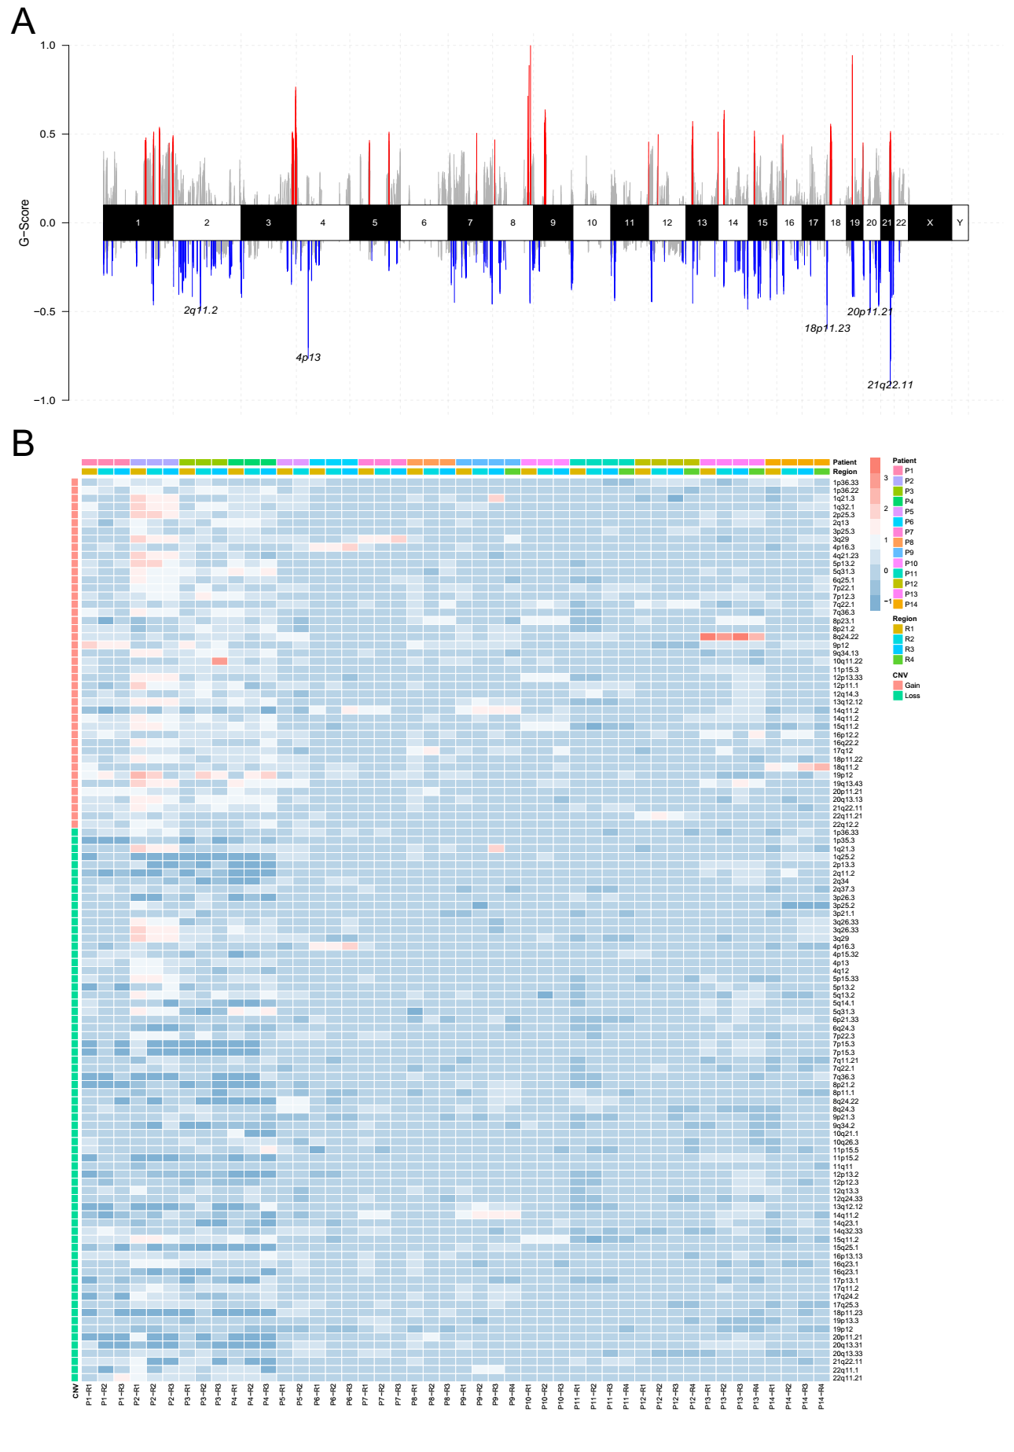

Fig. 3 Copy number variations. (A) Distribution of total somatic copy number variations. (B) The heatmap indicated the high-frequency analysis of copy number gains (red) or losses (blue) for each tumor region.

**Clonal evolution analyses.** We performed clonal evolution analyses to determine the subclonal composition of each patient, which were generated based on somatic mutations and copy number data. There were 3-6 clusters in each case. Driver variants such as *CDKN2A* and *TP53* were detected early as clonal. Phylogenetic analysis based on multi-region showed that all tumor regions from the same tumor were genetically different with no or only a few detected similarity (Fig. 4). Clones of different regions follow their own evolutionary path to form different branches. Therefore, even with single-region sampling, clones and subclones of the phylogenetic tree could not be identified. And it was hard to draw conclusions about their evolutionary relationship.

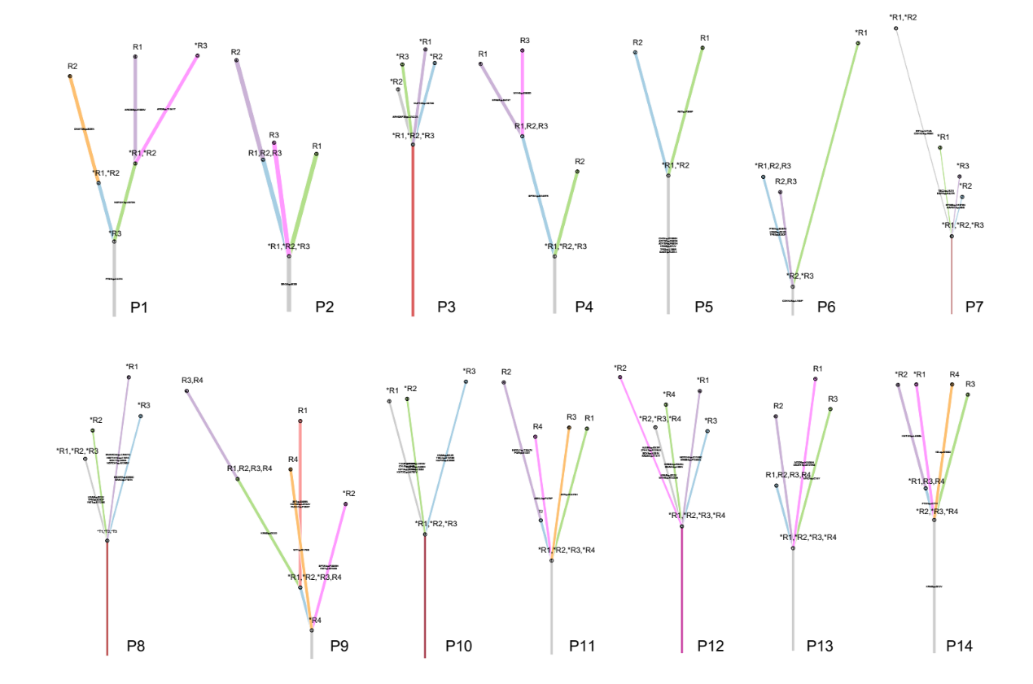Fig. 4 Graphical presentations of the clonal evolution. Inferring and visualizing clonal evolution were constructed from the multiregion WES data using ClonEvol and SciClone[15](#_ENREF_15" \o "Miller, 2014 #73)15. We used the clustering of heterozygous variants identified using sciClone as input to infer consensus clonal evolution trees and estimate the cancer cell fraction. Driver genes with possible functional mutations are mapped along the evolutionary trees and lengths of the trunk and branches represent the number of mutations.

**Mutational spectrum and mutational signature analyses**. We analyzed the mutational spectrum of these 14 PDACs. The percentage of Ti (transition)was much higher than that of Tv(transversion) (Fig. 5A). Most patients showed C>T-predominant mutation profiles but the proportion was different (Fig. 5B, 5C), suggesting that different mutational processes were involved during the development of different tumor regions within the same patients. However, contrary to previous studies in lung cancer[16](#_ENREF_16" \o "Liu, 2016 #3320),[17](#_ENREF_17" \o "Imielinski, 2012 #3321), we did not find any obvious different mutation spectra between smokers and non-smokers. This may be due to the different effects of smoking on the mutant spectrum of PDACs and lung cancer.

In order to determine the relationship between mutation frequency distribution of PDAC tumor samples and cosmic signature, non-negative matrix decomposition was carried out on the frequency of 96 substitution types in all samples, and 3 mutational signatures were extracted. Then, similarity analysis was conducted between the extracted signature and cosmic signature, and the mutational signature of PDACs was related to signature 1(Fig S2). Signature 1 exhibited strong positive correlations with age in most cancer types, including PDACs, which was consistent with previous research[18](#_ENREF_18" \o "Alexandrov, 2013 #3358).

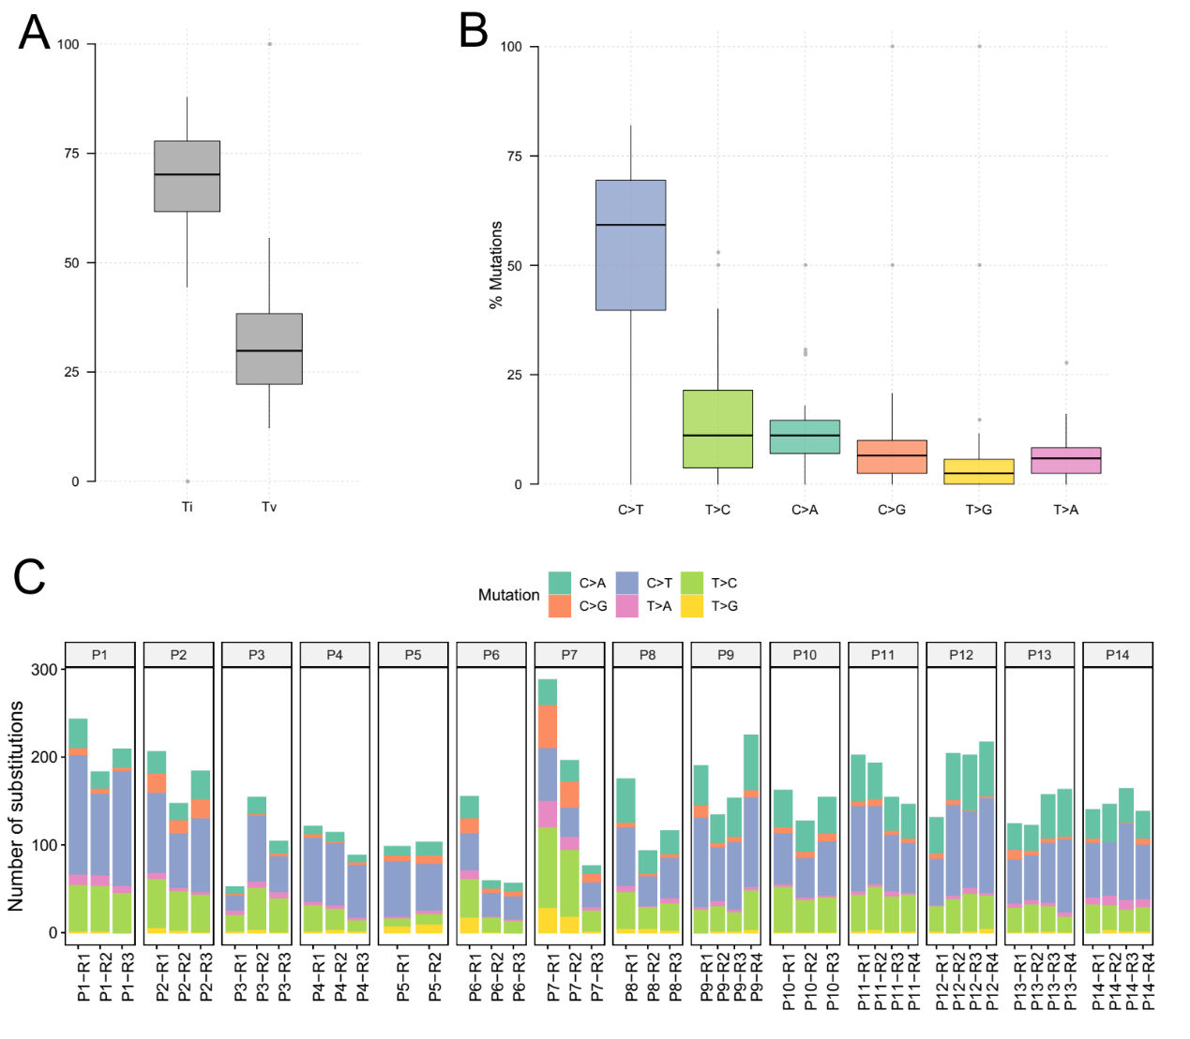

Fig. 5 Mutation spectrum of PDACs. (A) The percentage of transition and transversion in all lesions. (B)The percentage of transition and transversion in all lesions.(C) The number of six different transition types in 46 lesions of 14 patients.

**ITH of RNA expression**

We performed RNA-seq of 26 tumor tissues and 7 matched nonmalignant pancreas tissues from 7 PDACs patients to demonstrate the ITH in the transcriptome dimension. The number of downregulated (compared with the levels in normal tissue) and upregulated genes were different in each regions of the same patient (Fig 6A). The heatmap of top 5% downregulated and upregulated DEGs showed that clear cluster could be generated in all patients with different expression level, and the degree of intertumoral heterogeneity was less than the degree of interpatients.(Fig 6B). We further analysis the shared DEGs (different expressed genes) and found only small proportion of shared DEGs were indicated in all lesions of the same patient (Fig 6C). The heatmap of shared DEGs with top 10% downregulated and upregulated genes showed the generated cluster was clearer (Fig 5D), suggesting that all PDAC patients were independent and unique in the transcriptome dimension. GO pathway enrichment analysis showed different expression level in the different lesions, suggesting distinct functions involving these RNAs. These shared DEGs were enriched in GO pathway related to membrane and endoplasmic reticulum, such as protein targeting to membrane, cotranslational protein targeting to membrane, establishment of protein localization to endoplasmic reticulum and protein localization to endoplasmic reticulum (Fig 6E), indicating the importance of pancreas secretory function which required the synthesis of a large number of proteins and membranes.

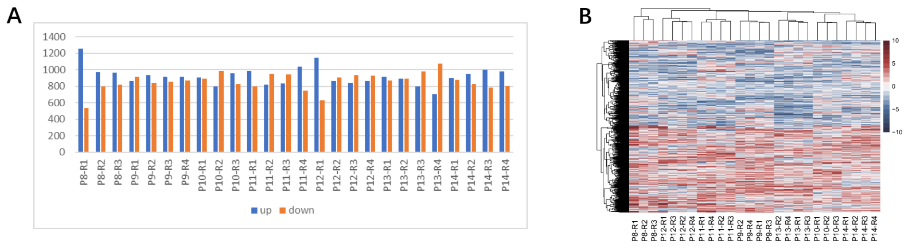

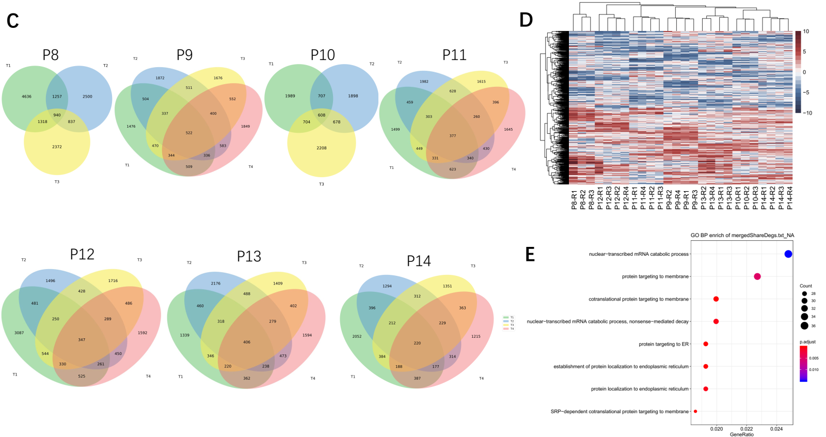

Fig. 6 Expression heterogeneity of RNA in PDACs. (A) The number of differentially expressed RNAs. (B) Heatmap of top 5% downregulated and upregulated DEGs. Red denotes up-expression and blue indicates down-expression. (C) Venn diagram illustrating the distributions of DEGs in the 26 lesions. (D) Heatmap of shared DEGs with top 10% downregulated and upregulated genes by 26 lesions of seven patients with PDACs. (E) GO pathway enrichment with shared DEGs.

**ITH of DNA methylation**.

Although genetic ITH is considered to be a basic characteristic of tumors, it cannot completely explain the phenotypic diversity of tumors, and epigenetics also plays an important role in it. To profile the heterogeneity at the epigenetic level, we obtained the global DNA methylation of a total of 26 tumor tissues and 7 matched nonmalignant pancreas tissues from 7 PDACs patients (all of which had matched WES and RNA-seq results) using MeDIP-seq. We first identified DMR (differentially methylated region) between tumor regions and matched normal tissues and then divided these DMRs into those with shared changes (consistent within all tumor regions from the same case) and those with private changes. Phyloepigenetic trees of these seven cases suggest the epigenomic alterations during the clonal evolution of PDACs cells, as well as the existence of multiple epigenetic subclonal cell populations (Fig. 7A).

In the epigenomic dimension, the DMRs varied among lesions in the same tumor, but the degree of intratumoral heterogeneity was less than that of intertumoral heterogeneity (Fig. 7B). The number of shared DMRs was less than that of private DMRs (Fig. 7C). Hypermethylated areas (tumor methylation levels were higher than adjacent normal tissues) of the DMRs region were further analyzed, reflect the heterogeneity between different regions within the same tumor which is widely displayed in the phyloepigenetic trees(Fig. 7D, 7A). To explore the potential biological relevance of ITH for DNA methylation in PDAC, we next sought to determine whether the DMRs in each case were enriched in particular functional genomic categories. KEGG functional analysis of the genes with shared DMRs showed that they were enriched in some cancer-related pathway, such as Signaling by Receptor Tyrosine Kinases, Signaling by Rho GTPases, Neuronal System (Fig.S3). However, these shared DMRs most located in introns, and no invariably-hypermethylated promoters were enriched in KEGG pathway. These results suggested DNA methylation likely contributes to tumor progression and leads to cell diversification in the late stage.

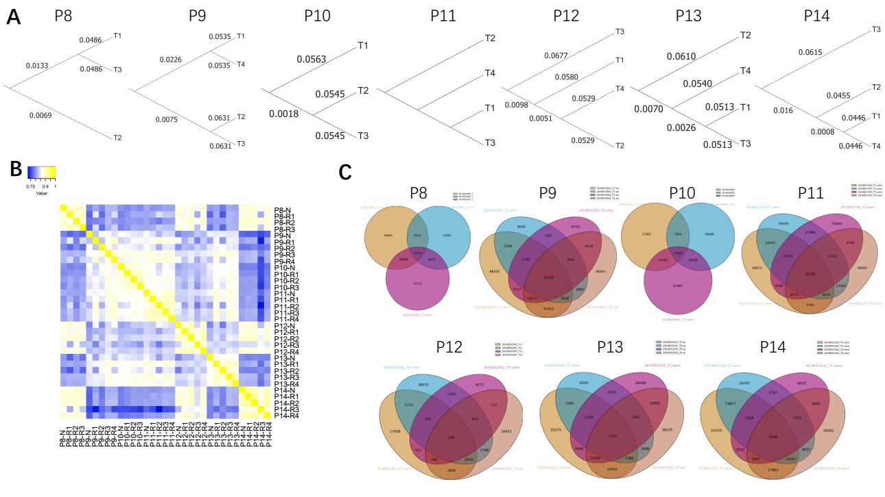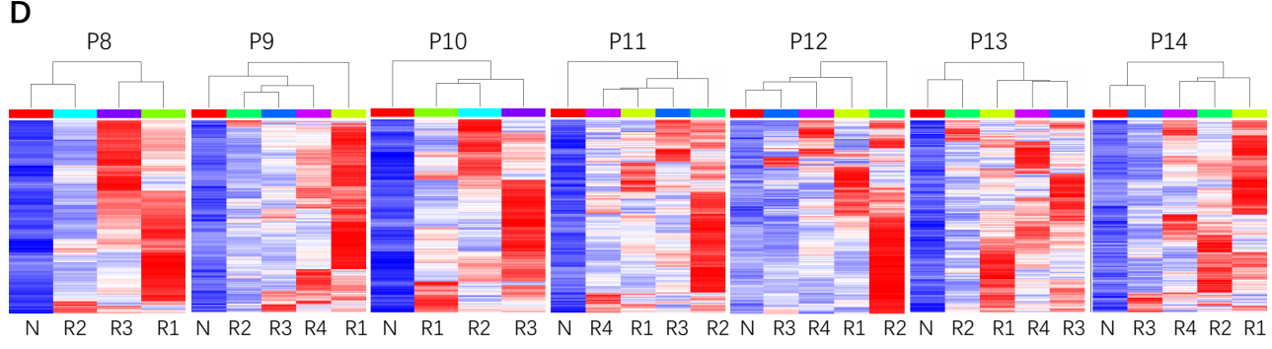

Fig. 7 Epigenetic heterogeneity in PDACs. (A) Phyloepigenetic trees. Yellow denotes high similarity and blue indicates low similarity. (B) Heatmap of DMRs shared by 26 lesions of seven patients with PDACs. (C) Venn diagram illustrating the distributions of DMRs in the 26 lesions.(D) Heatmaps show the heterogeneity with top 2000 most hypermethylated regions. Blue denotes low and red indicates high methylation level.

**Identification of tumor mutation burden related differential gene expression (DEG) and differential methylation regions (DMR)**

In order to investigate the multi-omics data interaction, we investigated tumor mutation burden related differential gene expression (DEG) and differential methylation regions (DMR). In the TMB-related gene expression analysis, we compared the TMB values with difference of the each tumor sample from the corresponding normal sample. Meanwhile, in order to decrease the multiple test correction burden, we removed 30% small variant genes and high correlated genes (R2>0.6). Finally, we identified 26 interesting TMB related gene expression (P<5.0x10-4). xxxx here, you can talk about the function of some interesting genes xxx. Furthermore, in order to identify TMB-related DMRs, we binary the samples to high-TMB tumors and low-TMB tumors by the mean value of TMBs (V=4.05) and then we screen all the tumor DMRs. Finally, we identified 28 significant TMB-related DMRs with P<1.2x10-4 xxxx here, you can talk about the function of some interesting genes xxx.

Table 1. Tumor mutation burden significantly related gene expression

|  |  |  |  |  |
| --- | --- | --- | --- | --- |
| Symbol | Estimate | Std..Error | t.value | P-value |
| RP11-693J15.5 | 7.865739706 | 1.453080678 | 5.413147269 | 1.47E-05 |
| NAAA | 0.242543606 | 0.048266117 | 5.025131938 | 3.90E-05 |
| H2BFS | 0.190097511 | 0.040760064 | 4.663817801 | 9.76E-05 |
| AC092299.8 | 0.674641714 | 0.145083043 | 4.650038345 | 0.000101111 |
| C1orf228 | -0.11168053 | 0.024030885 | -4.647374737 | 0.000101798 |
| OR1L3 | -2.807277446 | 0.604833346 | -4.641406541 | 0.000103356 |
| RPL6P25 | -0.073465495 | 0.016445187 | -4.467294507 | 0.00016096 |
| GBAS | -0.293093028 | 0.066403357 | -4.413828497 | 0.00018441 |
| FCGR1B | 1.055896106 | 0.242921051 | 4.346663667 | 0.000218755 |
| TMEM8C | -0.323871996 | 0.074931836 | -4.322221565 | 0.000232777 |
| CDH15 | -0.494421956 | 0.114728436 | -4.309497917 | 0.000240427 |
| RP11-281O15.5 | -1.101933942 | 0.257801079 | -4.274357376 | 0.000262881 |
| SPEM1 | 0.588555721 | 0.138007668 | 4.264659556 | 0.000269437 |
| CHRAC1 | -0.56757007 | 0.133828264 | -4.241032883 | 0.000286099 |
| LINC00989 | -6.559492333 | 1.548222328 | -4.23678965 | 0.000289198 |
| CYP4A22 | 1.876579898 | 0.444594259 | 4.220881984 | 0.000301116 |
| ROCK1 | -0.711684952 | 0.170425699 | -4.175925084 | 0.000337503 |
| PA2G4P1 | 1.430338751 | 0.343921536 | 4.158910098 | 0.000352386 |
| AOC3 | -0.306810346 | 0.074171427 | -4.136503236 | 0.000372984 |
| COMMD3-BMI1 | -0.115562458 | 0.028304292 | -4.082859956 | 0.000427278 |
| LINC00202-1 | -1.546288076 | 0.379148047 | -4.07832267 | 0.000432215 |
| SLC8A2 | -0.178007814 | 0.043661947 | -4.076955479 | 0.000433713 |
| KLF11 | -0.337891731 | 0.083010025 | -4.070493067 | 0.000440867 |
| RP11-773H22.2 | -1.778613467 | 0.438473154 | -4.056379393 | 0.000456899 |
| RP1-177I10.1 | -6.657732708 | 1.644877986 | -4.047554145 | 0.000467216 |
| ZNF859P | 4.571530836 | 1.13697826 | 4.020772424 | 0.000499958 |

* Linear regression was applied to test TMB and delta gene expression derived by difference between cancer samples compared with corresponding normal samples.

Table 2. Tumor mutation burden significantly related differential methylation regions

|  |  |  |  |  |  |  |  |
| --- | --- | --- | --- | --- | --- | --- | --- |
| CHR | START | END | Estimate | Std..Error | t.value | P-value | Symbol |
| chr6 | 150983544 | 150983985 | 0.029831021 | 0.004680812 | 6.373044005 | 1.37E-06 | PLEKHG1 |
| chr1 | 224427563 | 224428113 | 0.037976364 | 0.006072106 | 6.254232657 | 1.83E-06 | NVL |
| chr1 | 22150064 | 22150561 | 0.061144871 | 0.010999333 | 5.558961654 | 1.02E-05 | HSPG2 |
| chr1 | 22150064 | 22150561 | 0.061144871 | 0.010999333 | 5.558961654 | 1.02E-05 | LDLRAD2 |
| chr15 | 99290335 | 99290927 | 0.029232405 | 0.005560851 | 5.25682253 | 2.17E-05 | IGF1R |
| chr5 | 135097961 | 135099845 | 0.038961648 | 0.007570319 | 5.146631982 | 2.87E-05 | SLC25A48 |
| chr18 | 55134480 | 55135151 | 0.044239913 | 0.008606869 | 5.140070192 | 2.92E-05 | ONECUT2 |
| chr14 | 24456264 | 24456641 | 0.033839233 | 0.00661441 | 5.115986845 | 3.10E-05 | DHRS4L2 |
| chr8 | 77585155 | 77586330 | 0.030396192 | 0.005944863 | 5.113018437 | 3.12E-05 | ZFHX4-AS1 |
| chr22 | 21283438 | 21283925 | 0.037378141 | 0.007415125 | 5.040797478 | 3.75E-05 | CRKL |
| chr12 | 41100864 | 41101403 | 0.020656768 | 0.004103872 | 5.033482171 | 3.82E-05 | CNTN1 |
| chr15 | 79324293 | 79324689 | 0.029426077 | 0.005894294 | 4.992298531 | 4.24E-05 | RASGRF1 |
| chr5 | 138120757 | 138121234 | 0.021332153 | 0.004316851 | 4.941600501 | 4.82E-05 | CTNNA1 |
| chr3 | 186447464 | 186447829 | 0.036594616 | 0.007484354 | 4.889481939 | 5.50E-05 | KNG1 |
| chr10 | 69591710 | 69592081 | 0.018148367 | 0.003734013 | 4.860285447 | 5.93E-05 | DNAJC12 |
| chr7 | 139878003 | 139878431 | 0.027312429 | 0.005628006 | 4.852949771 | 6.04E-05 | KDM7A-DT |
| chr17 | 30282979 | 30283420 | 0.029881143 | 0.006172145 | 4.841289715 | 6.22E-05 | SUZ12 |
| chr2 | 86757029 | 86757610 | 0.017335322 | 0.003615053 | 4.79531658 | 6.99E-05 | CHMP3 |
| chr2 | 86757029 | 86757610 | 0.017335322 | 0.003615053 | 4.79531658 | 6.99E-05 | RNF103 |
| chr7 | 140332774 | 140333187 | 0.028360582 | 0.005968894 | 4.751396269 | 7.81E-05 | DENND2A |
| chr8 | 30279176 | 30279589 | 0.016298338 | 0.003447256 | 4.727916066 | 8.29E-05 | RBPMS |
| chr15 | 78747163 | 78747894 | 0.027471138 | 0.005823407 | 4.717364866 | 8.52E-05 | IREB2 |
| chr2 | 88860670 | 88861129 | 0.016069512 | 0.00343534 | 4.67770618 | 9.42E-05 | EIF2AK3 |
| chr2 | 88860670 | 88861129 | 0.016069512 | 0.00343534 | 4.67770618 | 9.42E-05 | LOC101928371 |
| chr12 | 69233925 | 69234647 | 0.014444581 | 0.003096447 | 4.664889532 | 9.74E-05 | MDM2 |
| chr15 | 56492659 | 56493043 | 0.021343159 | 0.004593537 | 4.646344864 | 0.000102065 | RFX7 |
| chr4 | 149296260 | 149296635 | 0.019594553 | 0.004221345 | 4.641779975 | 0.000103257 | NR3C2 |
| chr1 | 45170458 | 45170919 | 0.035902119 | 0.007739252 | 4.638964919 | 0.000104 | ARMH1 |
| chr3 | 49671128 | 49671722 | 0.035580063 | 0.007709709 | 4.614968119 | 0.000110546 | BSN |
| chr14 | 72438036 | 72439575 | 0.04773642 | 0.010398825 | 4.59055923 | 0.000117629 | RGS6 |
| chr7 | 103191363 | 103191831 | 0.030582265 | 0.006677788 | 4.579700175 | 0.000120924 | RELN |

* Student t-test was applied to identify the relationship between TMB and fold change of methylation peak changes between cancer samples compared with corresponding normal samples.

**Discussion**

Although considerable efforts have been made to identify biomarkers in cancer treatment, and a few of molecular biomarkers have been recommended by the guidelines for routine oncology practice, the clinical outcomes of individuals with similar clinical and pathological characteristics, such as tumor histology, stage, and driver gene mutations, may differ greatly. ITH provided the approaches for tumor evolution and drug resistance[19](#_ENREF_19" \o "de Bruin, 2014 #53),[20](#_ENREF_20" \o "Zhang, 2014 #54). Since the efficacy of the current treatments for PDACs was far from satisfactory, we performed WES to study 46 multiple spatially separated samples obtained from 14 surgically resected primary PDACs, as well as RNA-seq and MeDIP-seq to study 26 samples from 7 of these individuals to explore the multiomic ITH in PDACs.

Despite shared genetic background and exposure history, all same-patients had distinct genomic and epigenomic profiles. In our study, by definition, there could be only one trunk, though there could be several different branches in each patient. The median number of the nonsynonymous variants per patient was 252 (range, 132-288). Among them, the median number of mutations in trunk, branch, and private was 15 (range, 0-21), 33 (range, 11-56), and 151 (range, 50-310), respectively. Although the mean of the nonsynonymous variants in private reached up to 86.2%, the mean of driver gene mutations was 48.9%, not as much as the former. That means, most ITH might be due to passenger gene mutations rather than driver gene mutations. Subsequent predicted functional analyses also confirmed this finding. On the other hand, the number of mutations in subclones did not fully reflect the degree of ITH, because the evolution of genetically distinct subclones in space and time was not taken into account[21](#_ENREF_21" \o "Jamal-Hanjani, 2017 #66).

Targeting of driver genes located on the clone of a tumor’s phylogenetic tree may be more effective than targeting subclone driven events[22](#_ENREF_22" \o "Yap, 2012 #60). Comparison of the mutations in the clone and in the subclones of the phylogenetic trees suggested that a change of mutational processes during tumor evolution[23](#_ENREF_23" \o "Gerlinger, 2014 #2831). Spatial separation may promote the evolution of new species, which is similar to the formation of distant migration[23](#_ENREF_23" \o "Gerlinger, 2014 #2831). Therefore, we tried to explore the course of PDAC evolution. The results showed that multi-region samples from the same tumor were genetically similar, which suggested ITH was unremarkable according to evolution analyses.

Pancreatic cancer remains one of the most challenging malignancies to treat. Multi-targeted treatment was considered as a promising therapeutic option. A randomized phase 2 study compared vandetanib plus gemcitabine with gemcitabine alone in patients with advanced pancreatic cancer[24](#_ENREF_24" \o "Middleton, 2017 #63). Another phase II study compared the combination of dasatinib plus gemcitabine with gemcitabine alone in patients with locally advanced PDAC[25](#_ENREF_25" \o "Evans, 2017 #65). However, both of the studies failed to show improved survival. In this study, several genetic alterations were detected in PDACs, including those in the *TP53* and *CDKN2A* tumor suppressor genes and in the *KRAS* oncogene[6](#_ENREF_6" \o "Jones, 2008 #42),[26](#_ENREF_26" \o "Mimeault, 2005 #55),[27](#_ENREF_27" \o "Maitra, 2008 #56). Tumor suppressor gene inactivation is a common and important mechanism of PDAC. *TP53* mutation was detected in 60% samples, which suggested that a homozygous deletion or epigenetic silencing was often responsible for the inactivation of these tumor suppressor genes and occur in association with chromosomal instability[28](#_ENREF_28" \o "Lengauer, 1998 #59),[29](#_ENREF_29" \o "Schutte, 1997 #58). However, the driver gene mutations we detected did not include those well-known actionable mutations such as *EGFR*, *ERBB2*, *PIK3CA*, and *BRAF*, which suggested less opportunities for targeted treatment. The ideal therapy might be to target mutations shared by all cells in a primary tumor but later, subclonal mutations might become important if they enable subclones to resist treatment or promote metastases[30](#_ENREF_30" \o "Yates, 2015 #2832). Therefore, monitoring tumor progression dynamically might give us more information.

Our studies of genomic and epigenomic alterations have seen evidence for branching evolution in PDACs, while the evolutionary histories of a tumor inferred based on these two-omics data did not show strong agreement with each other. These results suggest that somatic mutations are likely the early tumorigenic events, but DNA methylation contributes significantly to a branched evolution in later stages. Both of genetic and epigenetic events contributes to phenotypic heterogeneity in individual tumors and might also be indicators for independent but equally successful paths taken by tumor clones towards progression.

Nevertheless, the current study has several limitations. First, it is a retrospective study. Second, the sample size was small. Small retrospective study might limit the understanding of ITH in PDAC. In order to specify the clinical significance of ITH to guide treatment decision, we need further research with greater sample sizes and a longer follow-up period. Third, our study lacked the contents of proteomics and tumor immune microenvironment which might provide more information about multi-dimension heterogeneity.

In conclusion, to make comprehensive and accurate treatment strategies, we should consider the existence of ITH and optimize the sampling process according to different types of tumors. Despite the ITH in PDAC, single-region tumor sequencing might be adequate to identify the predominant driver gene mutations. The association between ITH and clinical outcomes still needs further research to clarify.

**Methods**

**Sample collection.** We collected tumor samples from 14 surgically resected PDAC patients who had not received previous systemic therapy. Immediately after resection, at least two regions from each primary tumors that were spatially separated by a margin of at least 0.5cm were collected by using 18-gauge needle core needle sampling. This study was in compliance with the Declaration of Helsinki Principles and was approved by the Ethics Committee of Peking Union Medical College Hospital.

**DNA extraction.** DNA was extracted from serial thick sections cut from tumor samples and matched peripheral blood leukocytes as germline DNA control. The invasive tumor content was estimated by pathologists, to ensure more than 50% of cells were tumor cells. The DNA was isolated from the FFPE and blood samples using the DNeasy Blood and Tissue Kit (69504, QIAGEN, Venlo, Netherlands).

**Next-generation sequencing.** We generated targeted capture pulldown and exon-wide libraries from native DNA using the xGen® Exome Research Panel (Integrated DNA Technologies, Inc., Illinois, USA) and the TruePrep DNA Library Prep Kit V2 for Illumina (#TD501, Vazyme, Nanjing, China). We also generated paired-end sequence data using an Illumina HiSeq machine.

**Genome mapping**. Whole Exome sequencing data was mapping on the GRCh37 human genome using speedseq[31](#_ENREF_31" \o "Chiang, 2015 #67). We excluded 15.6 Mb of the non-gapped genome regions where are areas of misassembly in the GRCh37 human reference genome in which variant calling is time-consuming and error-prone.

**Detection of copy number aberrations.** Copy number data were derived from WES reads using CNVkit[32](#_ENREF_32" \o "Talevich, 2016 #68). Paired tumor samples and normal samples were analyzed using CNVkit “batch” command. Each input sample is first median-centered, then read-depth [bias corrections](https://cnvkit.readthedocs.io/en/stable/bias.html) are performed on each of the samples separately. The [scatter](https://cnvkit.readthedocs.io/en/stable/plots.html" \l "scatter) and [heatmap](https://cnvkit.readthedocs.io/en/stable/plots.html" \l "heatmap) plots for CNV were generated. The recurrent CNV Gain and loss events across all samples were summarized and visulized using R heatmap package.

**Variant calling and annotation and Mutation signature analysis.** Germline variations were identified via SpeedSeq, and somatic mutations were identified via Mutect[33](#_ENREF_33" \o "Cibulskis, 2013 #69). Somatic indels were called using SomaticIndelDetector[34](#_ENREF_34" \o "DePristo, 2011 #76). The high quality of somatic mutations and indels were selected. The variant data were annotated using ANNOVAR [35](#_ENREF_35" \o "Wang, 2010 #16) and Oncotator[36](#_ENREF_36" \o "Ramos, 2015 #74), and converted to MAF files using maftools[37](#_ENREF_37" \o "Mayakonda, 2018 #12). The cancer dirver genes were analyzed using Intogen[38](#_ENREF_38" \o "Rubio-Perez, 2015 #71), including OncodriveFM and OncodriveCLUST. Both tools detect signals of positive selection, which appear in genes whose mutations are selected during tumor development and are therefore likely drivers. The landscape of top driver mutation spectrum predicted by Intogen for tumors were visulized via R Script, including mutation rate, and mutation subclass/subtypes (filtering cutoff, ONCODRIVEFM P-value<=0.1).

**Clonal evolution analysis.** Inferring and visualizing clonal evolution in multi-sample cancer sequencing were implemented via ClonEvol[39](#_ENREF_39" \o "Dang, 2017 #3224) and SciClone[15](#_ENREF_15" \o "Miller, 2014 #73). Somaric mutations in vaf format and segmented copy number data from the related tumors in same patient were merged and clustered using SciClone. 1D and 2D clustering plots for each patient were generated. Then, we used the clustering of heterozygous variants identified using sciClone as input to infer consensus clonal evolution trees and estimate the cancer cell fraction (also called clonal frequency, CCF) of the clones in individual samples. The infer.clonal.models function takes the clustering results and evaluates all clonal orderings to reconstruct the clonal evolution trees and estimate the CCF of the clones in individual samples.plot.clonal.models function was used to visualize trees predicted clonevol. Phylogenetic trees were redrawn in Adobe Illustrator with relative trunk and branch lengths proportional to the number of shared and distinct mutations on the corresponding trunk or branch.

**RNA-seq.** After total RNA was extracted, mRNA was isolated by Oligo Magnetic Beads and cut into small fragments for cDNA synthesis. Libraries were generated using the NEBNext UltraTM RNA Library Prep Kit (New England Biolabs, Ipswich, MA, USA) for the Illumina system following the manufacturer’s instructions. Sequencing was conducted using the Illumina Hiseq XTEN platform.

**DNA methylation analysis and construction of phyloepigenetic trees.** The DNA methylation profiles of 26 tumor regions and 7 matched normal tissue samples from 7 PADCs cases examined by WES were generated using the MeDIP-seq that we performed previously for The Cancer Genome Atlas (TCGA) data analysis, which is based on the Methylumi R package with several additional quality control steps. DMRs with detection P values greater than 0.01 in any of the samples were removed, as were DMRs overlapping with dbSNP SNPs and DMRs on the X or Y chromosome.  
For intratumoral analysis, we defined a DMR as private if the difference in βvalues for any single pair of tumor regions was at least 0.3; we defined a DMR as shared if the differences in β values for all pairs of tumor regions were less than 0.1. Only private DMRs were used for construction of phyloepigenetic trees. For each tumor, pairwise Euclidean distances were calculated between all tumor regions using the complete set of private DMRs.  
Phyloepigenetic trees were constructed from these pairwise distances, using the minimal evolution method implemented by the fastme.bal function in the R package ape. Different DMR selection cutoffs for calling private and shared probes produced similar results.

**Statistical analyses.** The SPSS Statistics 22.0 package, and ggpubr package[40](#_ENREF_40" \o "Kassambara, 2018 #17) in R[41](#_ENREF_41" \o "Team, 2018 #18) were employed to correlate clinical and biological variables by means of Fisher’s test or a non-parametric test when necessary. P-value <0.05 was considered significant.

**References**

1 Kleeff, J. *et al.* Pancreatic cancer. *Nature reviews. Disease primers* **2**, 16022, doi:10.1038/nrdp.2016.22 (2016).

2 Samuel, N. & Hudson, T. J. The molecular and cellular heterogeneity of pancreatic ductal adenocarcinoma. *Nature reviews. Gastroenterology & hepatology* **9**, 77-87, doi:10.1038/nrgastro.2011.215 (2011).

3 Ryan, D. P., Hong, T. S. & Bardeesy, N. Pancreatic adenocarcinoma. *The New England journal of medicine* **371**, 1039-1049, doi:10.1056/NEJMra1404198 (2014).

4 Siegel, R. L., Miller, K. D. & Jemal, A. Cancer statistics, 2019. *CA Cancer J Clin* **69**, 7-34, doi:10.3322/caac.21551 (2019).

5 Neoptolemos, J. P. Adjuvant treatment of pancreatic cancer. *European journal of cancer* **47 Suppl 3**, S378-380, doi:10.1016/S0959-8049(11)70210-6 (2011).

6 Jones, S. *et al.* Core signaling pathways in human pancreatic cancers revealed by global genomic analyses. *Science* **321**, 1801-1806, doi:10.1126/science.1164368 (2008).

7 Campbell, P. J. *et al.* The patterns and dynamics of genomic instability in metastatic pancreatic cancer. *Nature* **467**, 1109-1113, doi:10.1038/nature09460 (2010).

8 Harada, T. *et al.* Interglandular cytogenetic heterogeneity detected by comparative genomic hybridization in pancreatic cancer. *Cancer Res* **62**, 835-839 (2002).

9 Nakamura, T. *et al.* Zonal heterogeneity for gene expression in human pancreatic carcinoma. *Cancer Res* **67**, 7597-7604, doi:10.1158/0008-5472.CAN-07-0874 (2007).

10 McDonald, O. G. *et al.* Epigenomic reprogramming during pancreatic cancer progression links anabolic glucose metabolism to distant metastasis. *Nat Genet* **49**, 367-376, doi:10.1038/ng.3753 (2017).

11 Gerlinger, M. *et al.* Intratumor heterogeneity and branched evolution revealed by multiregion sequencing. *The New England journal of medicine* **366**, 883-892, doi:10.1056/NEJMoa1113205 (2012).

12 Lin, D. C. *et al.* Genomic and Epigenomic Heterogeneity of Hepatocellular Carcinoma. *Cancer Res* **77**, 2255-2265, doi:10.1158/0008-5472.CAN-16-2822 (2017).

13 Gonzalez-Perez, A. *et al.* IntOGen-mutations identifies cancer drivers across tumor types. *Nature methods* **10**, 1081-1082, doi:10.1038/nmeth.2642 (2013).

14 Makohon-Moore, A. & Iacobuzio-Donahue, C. A. Pancreatic cancer biology and genetics from an evolutionary perspective. *Nat Rev Cancer* **16**, 553-565, doi:10.1038/nrc.2016.66 (2016).

15 Miller, C. A. *et al.* SciClone: inferring clonal architecture and tracking the spatial and temporal patterns of tumor evolution. *PLoS computational biology* **10**, e1003665, doi:10.1371/journal.pcbi.1003665 (2014).

16 Liu, Y. *et al.* Genomic heterogeneity of multiple synchronous lung cancer. *Nat Commun* **7**, 13200, doi:10.1038/ncomms13200 (2016).

17 Imielinski, M. *et al.* Mapping the hallmarks of lung adenocarcinoma with massively parallel sequencing. *Cell* **150**, 1107-1120, doi:10.1016/j.cell.2012.08.029 (2012).

18 Alexandrov, L. B. *et al.* Signatures of mutational processes in human cancer. *Nature* **500**, 415-421, doi:10.1038/nature12477 (2013).

19 de Bruin, E. C. *et al.* Spatial and temporal diversity in genomic instability processes defines lung cancer evolution. *Science* **346**, 251-256, doi:10.1126/science.1253462 (2014).

20 Zhang, J. *et al.* Intratumor heterogeneity in localized lung adenocarcinomas delineated by multiregion sequencing. *Science* **346**, 256-259, doi:10.1126/science.1256930 (2014).

21 Jamal-Hanjani, M. *et al.* Tracking the Evolution of Non-Small-Cell Lung Cancer. *The New England journal of medicine* **376**, 2109-2121, doi:10.1056/NEJMoa1616288 (2017).

22 Yap, T. A., Gerlinger, M., Futreal, P. A., Pusztai, L. & Swanton, C. Intratumor heterogeneity: seeing the wood for the trees. *Science translational medicine* **4**, 127ps110, doi:10.1126/scitranslmed.3003854 (2012).

23 Gerlinger, M. *et al.* Genomic architecture and evolution of clear cell renal cell carcinomas defined by multiregion sequencing. *Nat Genet* **46**, 225-233, doi:10.1038/ng.2891 (2014).

24 Middleton, G. *et al.* Vandetanib plus gemcitabine versus placebo plus gemcitabine in locally advanced or metastatic pancreatic carcinoma (ViP): a prospective, randomised, double-blind, multicentre phase 2 trial. *The Lancet. Oncology* **18**, 486-499, doi:10.1016/S1470-2045(17)30084-0 (2017).

25 Evans, T. R. J. *et al.* Phase 2 placebo-controlled, double-blind trial of dasatinib added to gemcitabine for patients with locally-advanced pancreatic cancer. *Annals of oncology : official journal of the European Society for Medical Oncology* **28**, 354-361, doi:10.1093/annonc/mdw607 (2017).

26 Mimeault, M., Brand, R. E., Sasson, A. A. & Batra, S. K. Recent advances on the molecular mechanisms involved in pancreatic cancer progression and therapies. *Pancreas* **31**, 301-316 (2005).

27 Maitra, A. & Hruban, R. H. Pancreatic cancer. *Annual review of pathology* **3**, 157-188, doi:10.1146/annurev.pathmechdis.3.121806.154305 (2008).

28 Lengauer, C., Kinzler, K. W. & Vogelstein, B. Genetic instabilities in human cancers. *Nature* **396**, 643-649, doi:10.1038/25292 (1998).

29 Schutte, M. *et al.* Abrogation of the Rb/p16 tumor-suppressive pathway in virtually all pancreatic carcinomas. *Cancer research* **57**, 3126-3130 (1997).

30 Yates, L. R. *et al.* Subclonal diversification of primary breast cancer revealed by multiregion sequencing. *Nat Med* **21**, 751-759, doi:10.1038/nm.3886 (2015).

31 Chiang, C. *et al.* SpeedSeq: ultra-fast personal genome analysis and interpretation. *Nature methods* **12**, 966-968, doi:10.1038/nmeth.3505 (2015).

32 Talevich, E., Shain, A. H., Botton, T. & Bastian, B. C. CNVkit: Genome-Wide Copy Number Detection and Visualization from Targeted DNA Sequencing. *PLoS computational biology* **12**, e1004873, doi:10.1371/journal.pcbi.1004873 (2016).

33 Cibulskis, K. *et al.* Sensitive detection of somatic point mutations in impure and heterogeneous cancer samples. *Nature biotechnology* **31**, 213-219, doi:10.1038/nbt.2514 (2013).

34 DePristo, M. A. *et al.* A framework for variation discovery and genotyping using next-generation DNA sequencing data. *Nature genetics* **43**, 491-498, doi:10.1038/ng.806 (2011).

35 Wang, K., Li, M. & Hakonarson, H. ANNOVAR: functional annotation of genetic variants from high-throughput sequencing data. *Nucleic acids research* **38**, e164, doi:10.1093/nar/gkq603 (2010).

36 Ramos, A. H. *et al.* Oncotator: cancer variant annotation tool. *Human mutation* **36**, E2423-2429, doi:10.1002/humu.22771 (2015).

37 Mayakonda, A., Lin, D. C., Assenov, Y., Plass, C. & Koeffler, H. P. Maftools: efficient and comprehensive analysis of somatic variants in cancer. *Genome Res* **28**, 1747-1756, doi:10.1101/gr.239244.118 (2018).

38 Rubio-Perez, C. *et al.* In silico prescription of anticancer drugs to cohorts of 28 tumor types reveals targeting opportunities. *Cancer cell* **27**, 382-396, doi:10.1016/j.ccell.2015.02.007 (2015).

39 Dang, H. X. *et al.* ClonEvol: clonal ordering and visualization in cancer sequencing. *Ann Oncol* **28**, 3076-3082, doi:10.1093/annonc/mdx517 (2017).

40 Kassambara, A. *ggpubr: 'ggplot2' Based Publication Ready Plots*, <<http://www.sthda.com/english/rpkgs/ggpubr>> (2018).

41 Team, R. C. *R: A Language and Environment for Statistical Computing*, <<https://www.R-project.org/>> (2018).

**Acknowledgements**

This work was supported by Chinese Academy of Medical Sciences (CAMS) Initiative for Innovative Medicine (CAMS-I2M) (Project No.2017-I2M-1-001 and 2016-I2M-1-002), the National Natural Science Foundation of China (31471366), the International Science and Technology Cooperation Projects (2017YFE0110300), the Research on Collaborative Scientific and Technological Innovation in Medicine (Z18110700190000). We also acknowledge the support of Shanghai Tongshu Biotechnology Co., Ltd.

**Author contributions**

H.W., M.D. and Z.L. designed the project and devised the experiments. Xiaoqian.L., C.X., Xiaoding.L., and Z.Z., were responsible for the performed the experiments. L.Y., and D.G. provided tumor samples and clinical information. Xiaoqian.L. and X.C. dealt with the ﬁgures and prepared the main manuscript. All authors contributed to the discussions and manuscript preparation.

**Additional information**

**Declaration of Interests:** The authors declare that there are no potential competing financial interests.

Supplementary figure 1. Venn diagram illustrating the distributions of validated mutations in the 46 lesions of 14 patients. Shared mutations were defined as identical nucleotide substitutions at the same genomic coordinates.

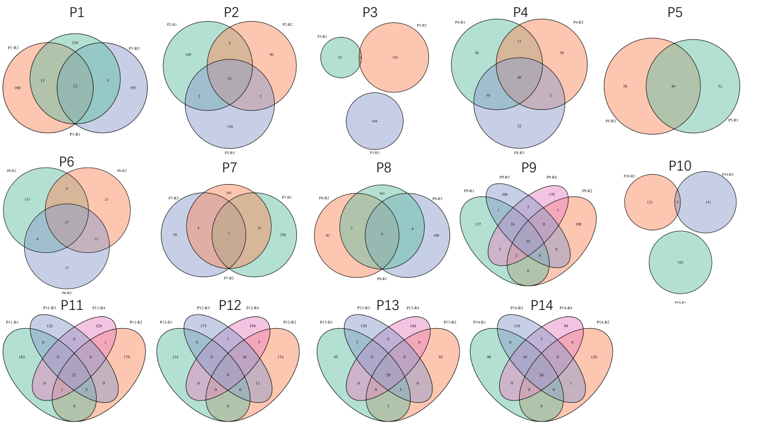

Supplementary figure 2. The similarity between PDACs mutational signatures with cosmic signature

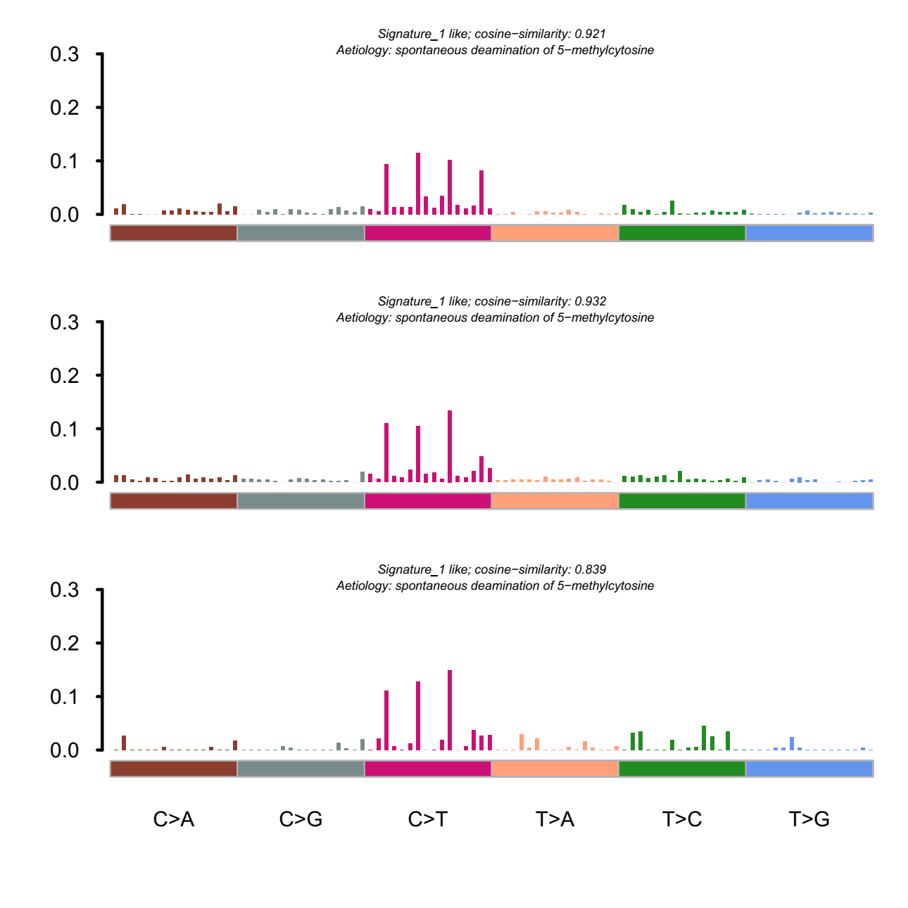

Supplementary figure 3. KEGG functional analysis of the genes with shared DMRs in P1(A), P2(B), P3(C), P6(D), P7(E).

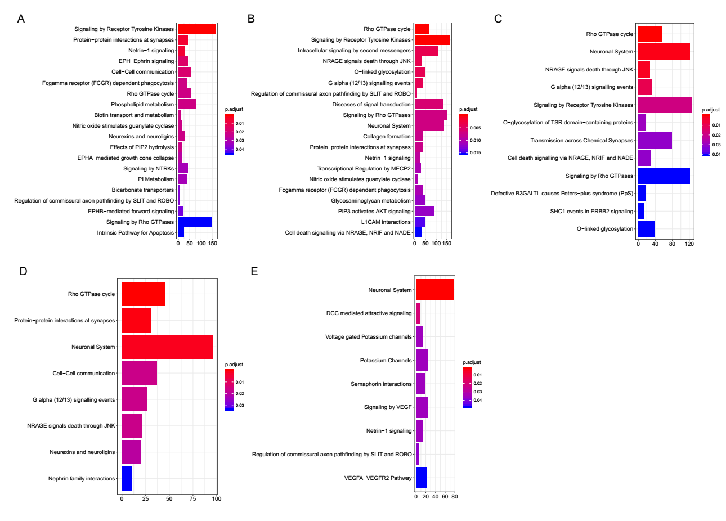

Supplementary table 1. Clinicopathological information of the 14 PDAC patients.

|  |  |  |  |  |  |  |  |  |  |  |
| --- | --- | --- | --- | --- | --- | --- | --- | --- | --- | --- |
| **Patient** | **Age at Diagnosis** | **Gender** | **previous history** | **smoking history** | **drinking history** | **Degree of Differentiation** | **TNM Staging** | **clinical stages** | **PFS** | **OS** |
| P1 | 65 | F | Hypertension (grade 2, high-risk group), type 2 diabetes | No | No | Well/Moderate | T3N0M0 | IIA | 9 months | NA |
| P2 | 64 | M | History of hypertension for 18 years (grade 3, very high risk) | Yes | Yes | Moderate/Poor | T3N0M0 | IIA | 7 months | 14 months |
| P3 | 55 | M | Hyperlipidemia, diabetes, hypercalcemia, hypertension (grade 2, medium risk) | Yes | Yes | NA | T3N0M0 | IIA | 1 months | 10 months |
| P4 | 51 | M | No | Yes | No | Moderate/Poor | T3N1M0 | IIB | 6 months | 6 months |
| P5 | 63 | F | No | No | No | Well | T1N1Mx | IIB | NA | NA |
| P6 | 64 | F | type 2 diabetes | No | No | Moderate/Poor | T3N1M0 | IIB | 9 months | 9 months |
| P7 | 69 | F | Hypertension (grade 3, very high risk), type 2 diabetes, hyperlipidemia, old pulmonary tuberculosis | No | No | Moderate | T2N0M0 | IB | NA | NA |
| P8 | 44 | M | Hyperlipidemia (suspicious) | No | Yes | Moderate/Poor | T2N0M0 | IB | NA | NA |
| P9 | 64 | F | Hypertension (grade 2, high risk), hyperthyroidism | No | No | Moderate/Poor | T3N1M0 | IIB | NA | NA |
| P10 | 64 | F | Hypertension, coronary heart disease | No | No | Moderate | T3N0M0 | III | NA | NA |
| P11 | 65 | F | Hypertension (grade 2, medium risk) | Yes | No | Well/Moderate | T3N1M0 | IIB | NA | NA |
| P12 | 64 | M | Hypertension (grade 3, very high risk), type 2 diabetes, hyperlipidemia | Yes | Yes | Moderate | T3N0M0 | IIA | NA | NA |
| P13 | 64 | F | Hypertension (grade 2, very high risk), hyperlipidemia | No | No | Moderate | T3N1M0 | IIB | NA | NA |
| P14 | 63 | M | Hypertension (grade 2, high risk), type 2 diabetes | Yes | No | Well | T3N0M0 | IIA | NA | NA |