**Table 1. Clinical Characteristics of the Study Population**

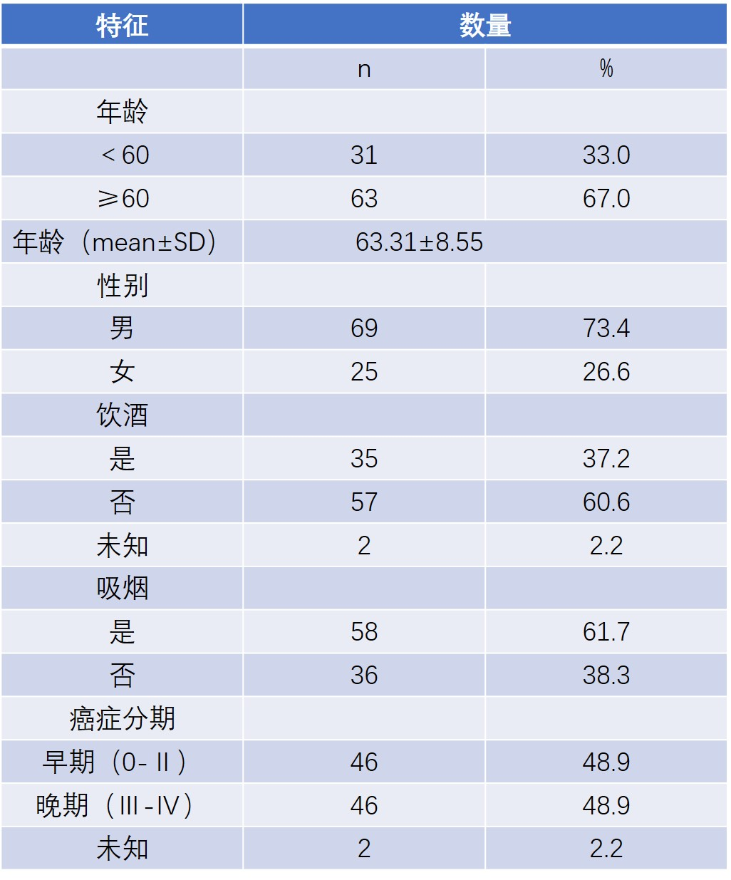

**Question: Any statistics for association between those risk factors and prognosis of the patients?**

**Table 2：Sequences of primers used in this study**

|  |  |  |
| --- | --- | --- |
| **Primer** | **Sequence, 5’-3’** | **Use** |
| ZNF132 F | GGTGTTTTAGGGTTGGTTATTGG | BSP |
| ZNF132 R | TACCTTCCTCRCTCCTATTTCCATAA | BSP |
| APC F | TTTGTTTGTTGGGGATTGG | BSP |
| APC R | CCATTCTATCTCCAATAACACCCTAA | BSP |
| ChrM F | TGTGTGGAAAGTGGTTGTGTAGATATT | BSP |
| ChrM R | AATCACAAATCTATCACCCTATTAACCA | BSP |
| ZNF132 F | GTCATTGAGAGGCGGGACT | qPCR |
| ZNF132 R | TCGGGAACACCTTGGCTCAT | qPCR |
| ZNF132 Xba I | GCTCTAGAATGGCCCTGCCCAGC | PCR |
| ZNF132 Not I | ATAAGAATGCGGCCGCTCAGGTATGAATCTT | PCR |
| GAPDH F | GAAGGTGAAGGTCGGAGTC | qPCR |
| GAPDH R | GAAGATGGTGATGGGATTTC | qPCR |

* Add genomic position and gene name to this Table 2

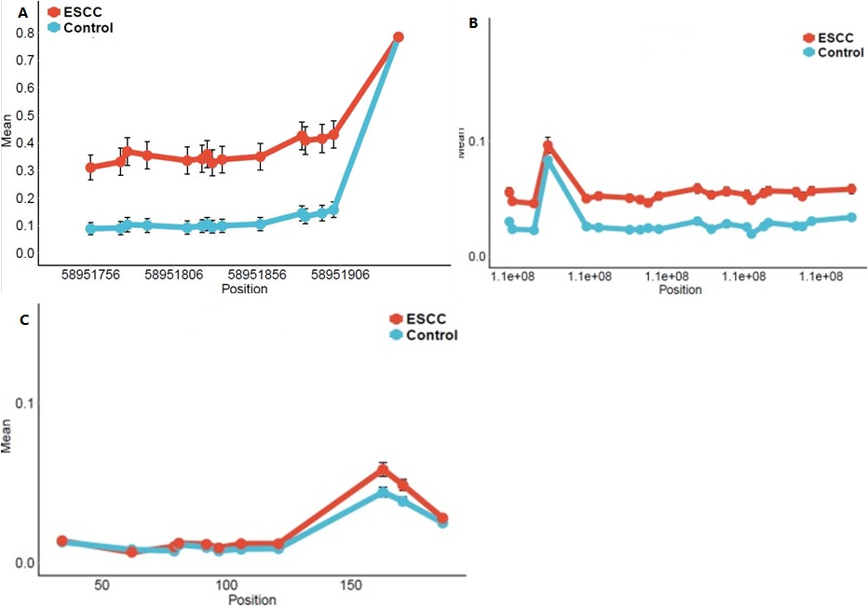

**Figure 1.ZNF132基因在食管鳞癌组织与癌旁组织中的甲基化情况** A. ZNF132中15个检测位点在食管鳞癌组织与癌旁组织中甲基化平均值； (各点代表甲基化绝对比值的平均值。)B.APC中21个检测位点在食管鳞癌组织与癌旁组织中甲基化平均值；C. ChrM中11个检测位点在食管鳞癌组织与癌旁组织中甲基化平均值。

**Figure 1. Methylation status of ZNF132 in ESCC and adjacent control tissues**

1. Median % methylation in ESCC and adjacent control tissues of 15 CpG sites of ZNF132 promoter region. **B.** Median % methylation values of 21 CpG site of APC. **C.** Median % methylation of 11 CpG sites of ChrM.

**I count the spots in 1A, 14 spots showed the difference, but the last spot showed no difference. In text, all 15 sites have significant differences.**

**No explanation of APC in text.**

Table **3** The methylation of ZNF132 gene and control gene in ESCC **(Original this Table was 1)**

|  |  |  |  |  |  |  |  |  |
| --- | --- | --- | --- | --- | --- | --- | --- | --- |
| **Gene name** | **Mean（Case）** | **Mean（Control）** | **P valuea** | **OR（95%CI）** | **P valueb** | **Sensitivity** | **Specificity** | **Area Under Curve（AUC）** |
| ZNF132 | **0.40** | **0.16** | **8.71×10-14** | **3.53（2.51,4.74）** | **2.36×10-09** | **77.53%** | **80.43%** | **0.83** |
| APC | **0.05** | **0.02** | **2.49×10-5** |  |  |  |  |  |
| ChrM | **0.03** | **0.02** | **2.59×10-1** |  |  |  |  |  |

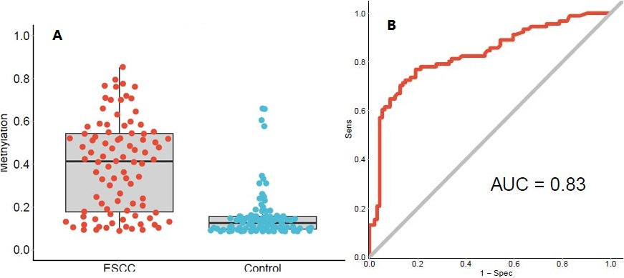

Figure 2. The methylation of ZNF132 in the tissues of the ESCC detected by Methyl target and ROC curves. A. The methylation of ZNF132 in the 94 cases of ESCC tissues and adjacent tissues (each point represents the absolute ratio of methylation in each tissue) B. Represents the overall ROC (Receiver Operating characterstics) curve, which was calculated through a logistic regression model, incorporating the mean methylation percentage of the five genomic regions as the variables, and without the adjustment for gender, age and smoking status and alcohol status, and **stages?**.

**In original chinese manuscript, ...without the adjustment for gender,**

**age and smoking status and alcohol status, and stages.**

**But in original figure legend ...without the adjustment for gender, age and smoking status and alcohol status, and no stage mentioned.**

**In the results and discussion, I included stage. If not correct, please changed.**

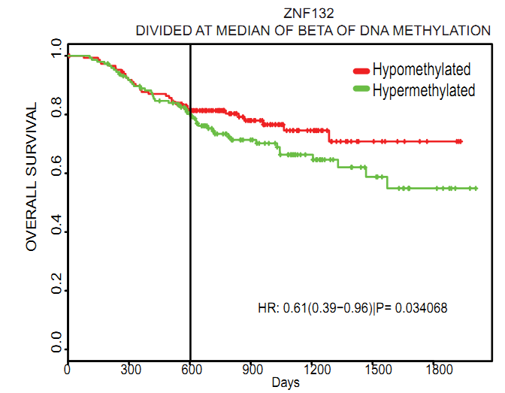

**Figure 3.** Relationship between methylation of ZNF132 gene and prognosis in patients with. The survival time of ZNF132 gene hypermethylated esophageal squamous cell carcinoma was significantly shorter than that of non - methylated patients.

**I made some changes in Legend of Figure3 as follows**

**Figure 3.** Relationship between methylation status of ZNF132 in ESCC tissues and overall survival time of patients. Overall survival time of ESCC patients with hypermethylated ZNF132 in tumor tissues was significant shorter than patients with hypomethylated ZNF132.

**Some authors put number of hypomethylated or hypermethylated cases next to red or green lines.**

**Figure 4**

**A**

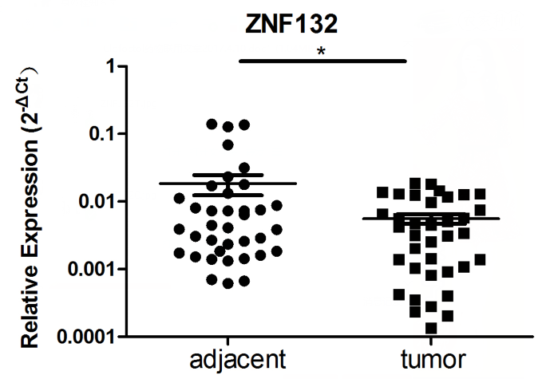

B C

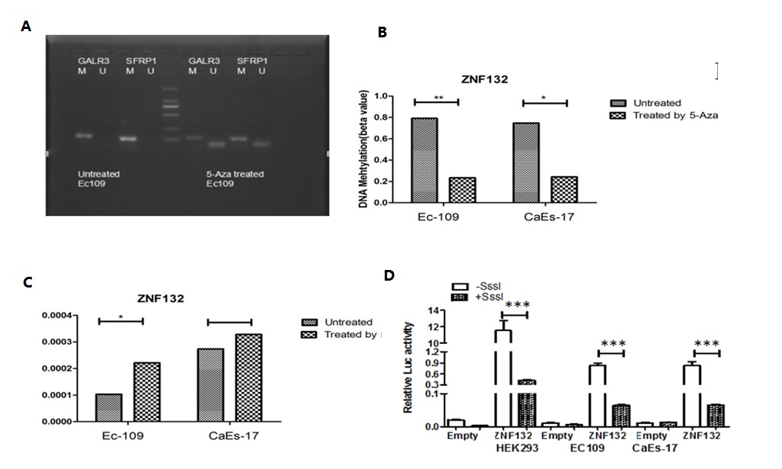

**D delete above picture**

**Figure 4.** Association of methylation status and expression of ZNF132 in ESCC patients and esophageal cancer cell lines.

**A.** Expression of ZNF132 measured by q-PCR in ESCC tissues was significantly lower than that in adjacent tissues

~~and Paracancerous adjacent control tissues. The results of q-PCR showed that the expression of ZNF132 gene in esophageal squamous cell carcinoma was significantly lower than that in adjacent tissues.~~

**~~Figure 4. 在食管癌细胞中ZNF132基因的表达受甲基化调控~~**

~~A~~ **B**： MSP引物甲基化基因GALR3和SFRP1进行MSP实验。

~~B~~ **C**: MSP检测结果显示：5-Aza处理后，细胞中ZNF132的甲基化程度确实有明显降低。

~~C~~ **D**: q-PCR结果显示：5-Aza处理后，ZNF132的表达升高。~~D: 双荧光素酶报告基因检测，食管癌细胞过甲基化处理，ZNF132表达明显下降。+SssI:经过CpG Methyltransferase(M.SssI)处理; -SssI:未经CpG Methyltransferase (M.SssI)处理; Empty: 只转染pGL3-Basic载体最为对照组，实验组均转pGL3-ZNF132-Luciferasconstructs; HEK293T细胞系：作为对照组，食管癌细胞系Ec-109、CaEs-17为实验组。~~

1. Demethyiation of methylated genes GALR3 and SFRP1 measured by MSP after 5-Aza treatment.
2. Methylation of ZNF132 in Ec-109 and CaEs-17 was significantly reduced after 5-Aza treatment.
3. Expression of ZNF132 measured by q-PCR significantly increased after 5-Aza treatment.

**Question: what is MSP ? No mentioned in text.**

**Figure 5**

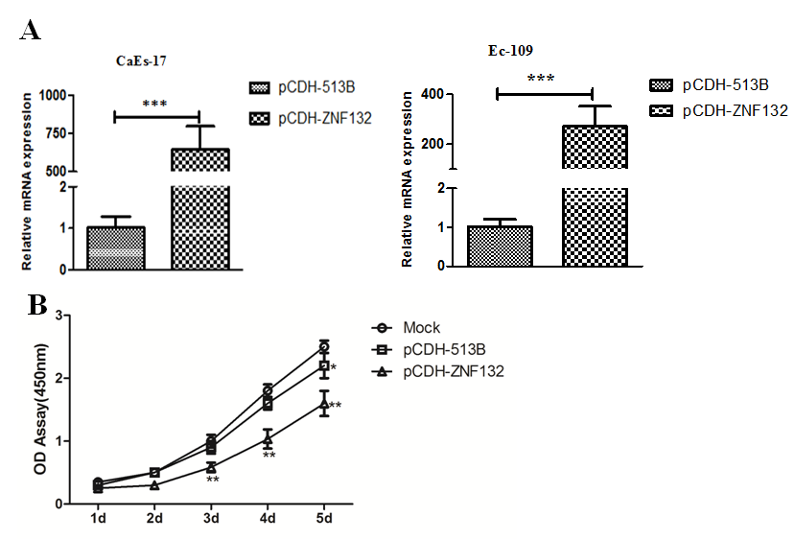

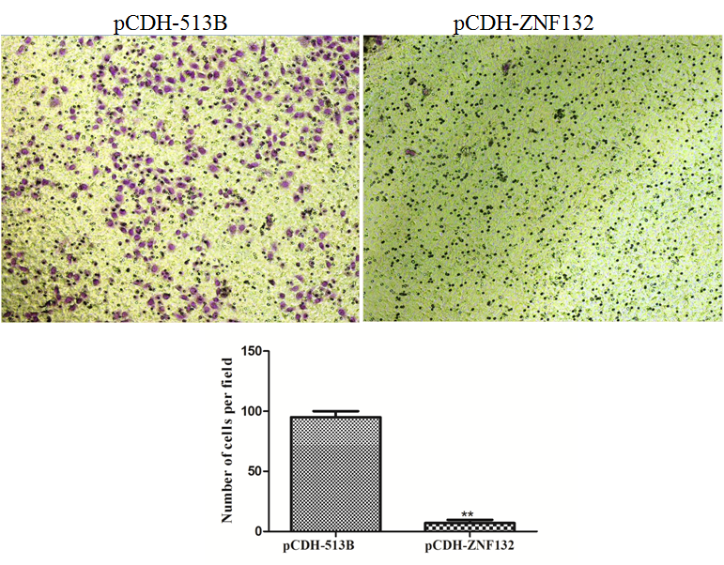

**B**

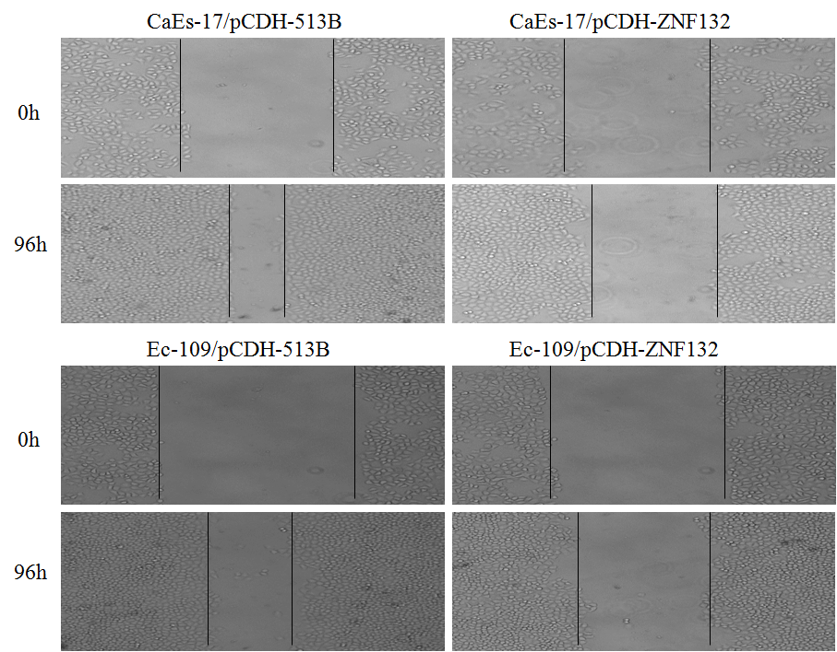

**C**

**D**

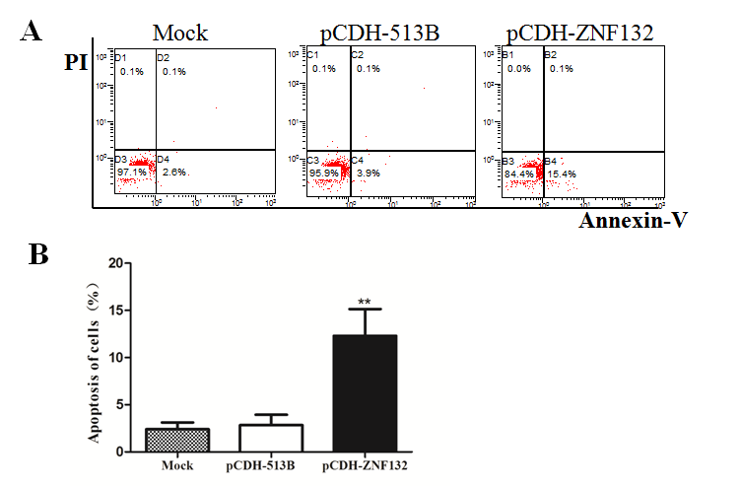

**Figure 5.** Ec109 cells and Caes-17 cells both treated by the plasmid pCD513B-1-H-ZNF132 and pCD513B-1 for 48 hours. The effects of high expression of ZNF132 were then tested on cells’ ability in growth, migration, invasion and apoptosis. A Effect of ZNF132 gene on the proliferation of esophageal cancer cells. Real-time PCR showed that the lentiviral expression vector of ZNF132 gene could significantly up-regulate the expression of ZNF132 in CaEs-17 and Ec109 cells . The results of cell proliferation analysis showed that the up-regulation of ZNF132 gene could inhibit the proliferation of Ec109 cells. B In vitro migration of esophageal cancer cells. The up-regulation of ZNF132 gene was observed by migration experiments to inhibit the migration of Ec109 cells. C In Vitro Scratch Healing Experiment of Esophageal Carcinoma Cells. The results show that ZNF132 expression can significantly inhibit the healing of esophageal cancer cell scratches. D. Effect of tumor suppressor gene ZNF132 on apoptosis of esophageal cancer cells. Flow cytometry was used to analyze the apoptosis of cells. The results showed that upregulation of ZNF132 in Ec109 cells could significantly increase the cell apoptosis rate.

**I made some changes in Figure 5 Legend as follows:**

**Figure 5.** The effects of high expression ZNF132 on characteristics of esophageal cancer cell lines in vitro.

1. Real-time PCR showed that the lentiviral expression vector of ZNF132 gene could significantly up-regulate the expression of ZNF132 in CaEs-17 and Ec109 cells.High expression of ZNF132 in EC-109 inhibit cell proliferation measured by light absorbance and cell counting per field.
2. The up-regulation of ZNF132 gene in Ec-109 cells and CaEs-17 cells reduced cell migration ability in a transwell assay..
3. In Vitro Scratch Healing Experiment showed that high expression of ZNF132 in Ec109 cells and CaEs-17 cells significantly inhibits cells healing ability.
4. Flow cytometry demonstrates that upregulation of ZNF132 in Ec109 cells could significantly increase the cell apoptosis rate.

**Question: Two cell lines were transfected with ZNF132 vector, only Ec-109 cells were used in proliferation assays and apoptosis assay?**

**In 5A,5D, what is mock? No mention in text.**

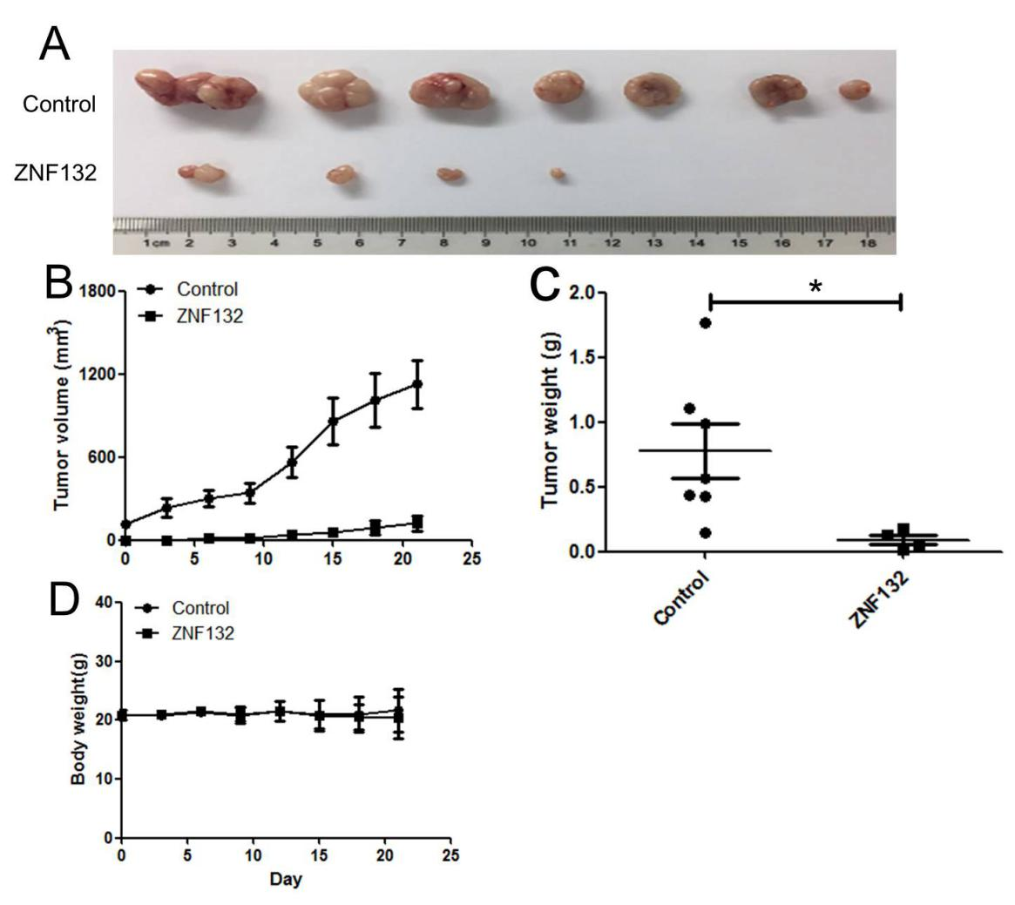

Figure 7. Overexpression of ZNF132 inhibits the growth of human esophageal squamous cell carcinoma xenograft. A. The tumor volume of pCD513B-1-ZNF132 group was significantly smaller than that of pCD513B-1 group. B and C the tumor volume and tumor wet weight it is clear that when the ZNF132 gene overexpression can significantly inhibit Ec109 cell tumorigenic ability. D. There was no significant difference in body weight between the experimental group and the control group during the whole experiment.

**I changed Figure 7 to 6**

**I made some changes in Figure 6 Legend as follows:**

**Figure 6.** Overexpression of ZNF132 inhibits the growth of human esophageal squamous cell carcinoma in vivo in a mouse xenograft model. A. The tumor volume of pCD513B-1-ZNF132 group was visually smaller than that of pCD513B-1 group. B. difference in tumor volume between two groups increased with passing days. C. Wet tumor weight of experiment group was significantly lighter than control group.

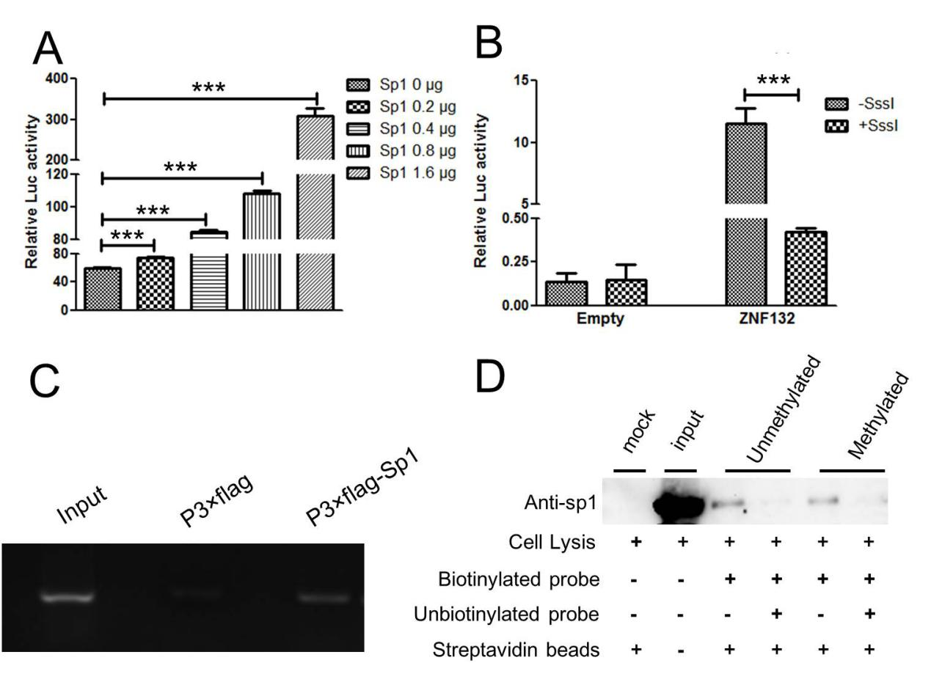

**Figure ~~6~~. 7** Sp1transcriptionally upregulates ZNF132 expression by targeting Sp1-binding site in Ec109 Ccells. Furthermore, methylation of Sp1-binding site inhibits ZNF132 transcriptional expression by interfering with there cruitment of Sp1to ZNF132 promoter.A. The luciferase reporter assay showed that the ZNF132 promoter gradually increased with the dose of Sp1. B.The methylation of Sp1-bining site can inhibit ZNF132 transcriptional expression by interfering with there cruitment of Sp1 to ZNF132 promoter region. C. DNA pull-down assays showed that the methylated Sp1-bining site probe had weaker binding ability with speciﬁc proteins compared with the unmethylated Sp1-bining site probe. D. ChIP assay demonstrated that Sp1 can target ZNF132 promoter and thereby upregulate ZNF132 expression in Ec109 cells.

**I changed Figure 6 to 7**

**I think 7C should be ChIP assay, 7D should be DNA pull-down assay.**

**I made some changes in Figure 7 Legend as follows:**

**Figure 7** Hypermethylation of trascriptional activator Sp1 binding site in ZNF132 promoter region leading to ZNF132 gene silencing in esophageal cell line. A. Transcriptional activity of ZNF132 promoter elevates with increasing doses of Sp1. B. Trascriptional activity was significantly reduced by methylation of Sp1 site of ZNF132 promoter **(No method mentioned)**. C. ChIP assay showed directly that Sp1 protein can bind to ZNF132 promoter region containing Sp1 site in in vitro cultured cells cells . D. DNA pull-down assay showed that the methylated Sp1-bining site probe had weaker binding ability with speciﬁc proteins compared with the unmethylated Sp1-bining site probe.

**Questions:**

1. **No method for 7B was described in text.!!!**
2. **7A, HEK293T cells were used, 7B, no mention what cells are used, 7C. Ec-109 cells were used, (Why, since promoter of ZNF132 in Ec-109 cells are hypermethylated. 7D. In method,** Cell lysis (400 μg) were incubated with or without biotinylated probe (0.5 pmol) in the presence of streptavidin-agarose **No mention what cell lysates. Under lined part should be biotinylated methylated or unmethylated probes, I think.**
3. **In vitro includes cell culture assay, in vivo only use for animal study**