**1) Summary of Genotype Call Rate (N=0)**

Total number of samples: 8649

8649/ 8649= 100% samples > 95% call rates

8645/ 8649= 99.9% samples > 98% call rates

8559/ 8649= 99.0% samples > 99% call rates

**2) Gender discrepancy (N=15)**

**We have 13 males whose chrX heterozygotes ratio >0.05% (1026-1-0238061894 is unknown but others are European population)**

|  |  |  |  |  |  |
| --- | --- | --- | --- | --- | --- |
|  | IID | HomNum | HetRatio | sam.Gender | sam.Population |
| 2926 | 1037864-1-0238062137 | 12621 | 0.006376949 | M | European |
| 1759 | 8913555-1-0238039044 | 12609 | 0.007321682 | M | European |
| 6526 | 8298729-1-0238039104 | 12597 | 0.008266415 | M | European |
| 6073 | 7016015-1-0224008233 | 11692 | 0.079515037 | M | European |
| 7070 | 3358239-1-0238094627 | 11295 | 0.110769957 | M | European |
| 2331 | 3945280-1-0238042297 | 10387 | 0.182254763 | M | European |
| 7441 | 9861857-1-0238096392 | 10234 | 0.19430011 | M | European |
| 3910 | 1026-1-0238061894 | 10202 | 0.196819399 | M | Unknown |
| 2639 | 1619599-1-0238096902 | 10199 | 0.197055582 | M | European |
| 3965 | 8365174-1-0238096141 | 10193 | 0.197527948 | M | European |
| 1331 | 5966617-1-0224009414 | 10106 | 0.204377263 | M | European |
| 7709 | 5129042-1-0238039162 | 10105 | 0.204455991 | M | European |
| 2589 | 7065331-1-0238095238 | 10020 | 0.211147851 | M | European |

**We have 2 females whose chrX heterozygotes ratio <10% (European population)**

|  |  |  |  |  |  |
| --- | --- | --- | --- | --- | --- |
|  | IID | HomNum | HetRatio | Sam.Gender | sam.Population |
| 8489 | 9232012-1-0238060734 | 12702 | 0 | F | European |
| 8308 | 6055529-1-0224008846 | 11680 | 0.08045977 | F | European |

**Report to Marshfield Clinic to double check**

|  |  |  |  |
| --- | --- | --- | --- |
| FID | IID | Pedigree | Predicted |
| 1037864-1-0238062137 | 1037864-1-0238062137 | M | F |
| 8913555-1-0238039044 | 8913555-1-0238039044 | M | F |
| 8298729-1-0238039104 | 8298729-1-0238039104 | M | F |
| 7016015-1-0224008233 | 7016015-1-0224008233 | M | F |
| 3358239-1-0238094627 | 3358239-1-0238094627 | M | F |
| 3945280-1-0238042297 | 3945280-1-0238042297 | M | F |
| 9861857-1-0238096392 | 9861857-1-0238096392 | M | F |
| 1026-1-0238061894 | 1026-1-0238061894 | M | F |
| 1619599-1-0238096902 | 1619599-1-0238096902 | M | F |
| 8365174-1-0238096141 | 8365174-1-0238096141 | M | F |
| 5966617-1-0224009414 | 5966617-1-0224009414 | M | F |
| 5129042-1-0238039162 | 5129042-1-0238039162 | M | F |
| 7065331-1-0238095238 | 7065331-1-0238095238 | M | F |
| 9232012-1-0238060734 | 9232012-1-0238060734 | F | M |
| 6055529-1-0224008846 | 6055529-1-0224008846 | F | M |

**3) Gender discrepancy (N=10, ChrX, ChrY and F-Score)**

|  |  |  |  |  |
| --- | --- | --- | --- | --- |
| IID | chrXHetRatio | chrYcallrate | pedigree | Fscore |
| 9232012-1-0238060734 | **0** | **1** | **F** | **1** |
| 6055529-1-0224008846 | 0.08046(low) | 0 | F | 0.4631 |
| 3945280-1-0238042297 | 0.182255(high) | 1 | M | 0.101 |
| 9861857-1-0238096392 | 0.1943(high) | 1 | M | 0.04166 |
| 1026-1-0238061894 | **0.196819(normal)** | **0** | **M** | **0.02892** |
| 1619599-1-0238096902 | 0.197056(high) | 1 | M | 0.02807 |
| 8365174-1-0238096141 | 0.197528(high) | 1 | M | 0.02542 |
| 5966617-1-0224009414 | 0.204377(high) | 1 | M | -0.00823 |
| 5129042-1-0238039162 | 0.204456(high) | 1 | M | -0.00869 |
| 7065331-1-0238095238 | 0.211148(high) | 1 | M | -0.04267 |

**Definitely mistake label should be 9232012-1-0238060734 and 1026-1-0238061894. Other individual might have some specific situation (**[**Contamination**](https://en.wikipedia.org/wiki/Contamination)**)**

**139 Duplication or MZ Twins (N=53 pairs Marshfield duplication and 86 Hapmap duplication, IBD PI_HAT>0.985 )**

|  |  |  |  |  |  |  |  |
| --- | --- | --- | --- | --- | --- | --- | --- |
| IID1 | Sex1 | Pop1 | IID2 | Sex2 | Pop2 | SameorNot1 | SameorNot2 |
| 9280653 | F | Unknown and Others | 6373236 | F | Unknown and Others | SameSex | SamePopulation |
| 3553510 | F | European | 7929904 | F | European | SameSex | SamePopulation |
| 7770206 | F | European | 7779860 | F | European | SameSex | SamePopulation |
| 1862513 | F | European | 7070112 | F | European | SameSex | SamePopulation |
| 9955687 | M | European | 2791045 | M | European | SameSex | SamePopulation |
| 3688824 | F | European | 8210737 | F | European | SameSex | SamePopulation |
| 5367317 | M | European | 7075397 | M | European | SameSex | SamePopulation |
| 2039588 | M | European | 2335404 | M | European | SameSex | SamePopulation |
| 5863273 | M | European | 6143980 | M | European | SameSex | SamePopulation |
| 6215600 | F | European | 4686904 | F | European | SameSex | SamePopulation |
| 6801312 | F | European | 9603276 | F | European | SameSex | SamePopulation |
| 7579351 | F | European | 2523700 | F | European | SameSex | SamePopulation |
| 9104662 | F | European | 7518223 | F | European | SameSex | SamePopulation |
| 1078 | M | White Non-hispanic or Latino | 3001 | M | White Non-hispanic or Latino | SameSex | SamePopulation |
| 1369351 | M | European | 8194549 | M | European | SameSex | SamePopulation |
| 1537267 | F | European | 8192609 | F | European | SameSex | SamePopulation |
| 1743424 | F | European | 2409836 | F | European | SameSex | SamePopulation |
| 1787679 | M | European | 8704669 | M | European | SameSex | SamePopulation |
| 2381712 | M | European | 7236484 | M | European | SameSex | SamePopulation |
| 2388737 | M | European | 9234643 | M | European | SameSex | SamePopulation |
| 2625172 | F | European | 2333159 | F | European | SameSex | SamePopulation |
| 3035861 | M | European | 6342241 | M | European | SameSex | SamePopulation |
| 3360647 | M | European | 6771171 | M | European | SameSex | SamePopulation |
| 3685908 | F | European | 7574058 | F | European | SameSex | SamePopulation |
| 4578836 | F | European | 7814725 | F | European | SameSex | SamePopulation |
| 4786307 | M | European | 4857438 | M | European | SameSex | SamePopulation |
| 5418231 | M | Unknown and Others | 2395725 | M | Unknown and Others | SameSex | SamePopulation |
| 5579502 | F | European | 6365461 | F | European | SameSex | SamePopulation |
| 5681870 | M | European | 9576449 | M | European | SameSex | SamePopulation |
| 6124307 | M | European | 7125278 | M | European | SameSex | SamePopulation |
| 6184688 | M | European | 2833688 | M | European | SameSex | SamePopulation |
| 6259680 | F | European | 6519508 | F | European | SameSex | SamePopulation |
| 6292883 | M | European | 3512802 | M | European | SameSex | SamePopulation |
| 6319599 | F | European | 8386186 | F | European | SameSex | SamePopulation |
| 6392837 | M | European | 8214910 | M | European | SameSex | SamePopulation |
| 6488469 | M | European | 2746937 | M | European | SameSex | SamePopulation |
| 6649024 | M | European | 1904402 | M | European | SameSex | SamePopulation |
| 6686171 | F | European | 7577259 | F | European | SameSex | SamePopulation |
| 6756313 | F | European | 5559651 | F | European | SameSex | SamePopulation |
| 6893150 | F | Asian | 9226288 | F | Asian | SameSex | SamePopulation |
| 6907599 | F | European | 4618169 | F | European | SameSex | SamePopulation |
| 6936817 | F | European | 9533159 | F | European | SameSex | SamePopulation |
| 6944405 | F | European | 4791841 | F | European | SameSex | SamePopulation |
| 7749279 | F | European | 8548164 | F | European | SameSex | SamePopulation |
| 7809265 | F | European | 5464079 | F | European | SameSex | SamePopulation |
| 7829873 | M | European | 4541121 | M | European | SameSex | SamePopulation |
| 8059022 | F | European | 5343387 | F | European | SameSex | SamePopulation |
| 8161053 | F | European | 7016740 | F | European | SameSex | SamePopulation |
| 8187269 | F | European | 1655944 | F | European | SameSex | SamePopulation |
| 8618738 | F | European | 6444808 | F | European | SameSex | SamePopulation |
| 9217506 | M | European | 5551046 | M | European | SameSex | SamePopulation |
| 9451328 | F | European | 4339640 | F | European | SameSex | SamePopulation |

PCA remove(N=81): **8500 samples were left.**

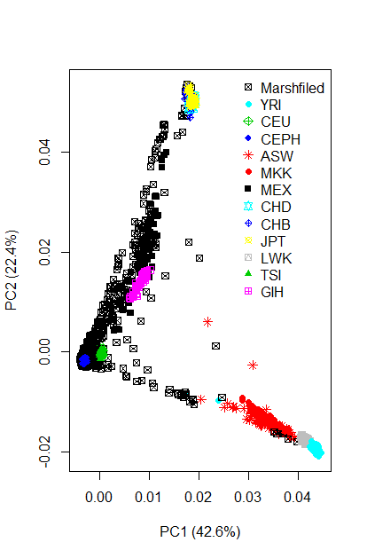

**Supplementary Figure 1.**

**Distribution of heterozygotes ratio of SNPs in chrX in our PMRP phase II data**

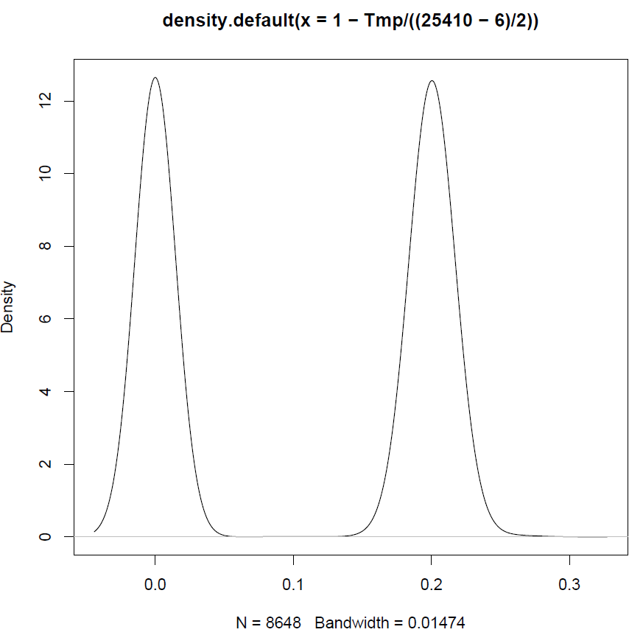

**We have 12702 SNPs in chrX from 8648 european/africa/asian data. I found the het ratio for 99.9% male is <0.1% and only few of man have 0.8% het ratio (I doubt maybe be mistake of pedigree records) . for the female the average het ratio is > 8%. But apply the F-score, but many male F-values are between 0.2 and 0.6. I will change the threshold for better classification in my own study.**

**Supplementary Figure 2. Distribution of heterozygotes ratio of SNPs in chrX in our PMRP phase II data**

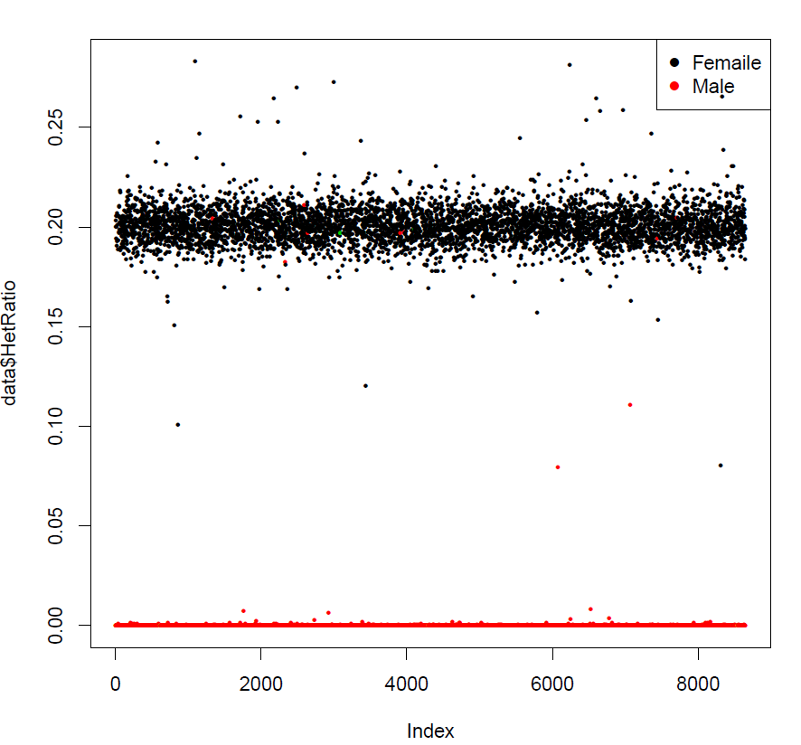

**Note for IBD scanning:**

The expectation is that IBD = 1 for duplicates or monozygotic twins, IBD = 0.5 for first-degree relatives, IBD = 0.25 for second-degree relatives and IBD = 0.125 for third degree relatives. Owing to genotyping error, LD and population structure, there is often some variation around these theoretical values and it is typical to remove one individual from each pair with an IBD value of > 0.1875, which is halfway between the expected IBD for third- and second-degree relatives. For these reasons an IBD value of > 0.98 identifies duplicates.