PAX2, chr10:102,582,916-102,593,303

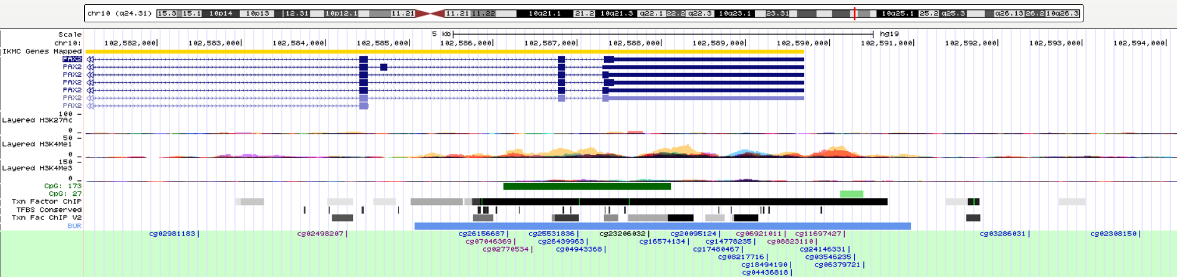

We can find this region marked with H3K4me1 enrichment which fine tunes enhancer activity and function. Within this region, 22 transcript factors (TF) have binding sites/regions. If the exact CpG information can be shared (producing the case-control differences), I can search again and determine the exact TFs.

|  |  |  |  |
| --- | --- | --- | --- |
| chr10 | 102585021 | 102585641 | EZH2 |
| chr10 | 102585657 | 102585973 | MYC |
| chr10 | 102585742 | 102586052 | PAX5 |
| chr10 | 102585745 | 102586021 | MAX |
| chr10 | 102585750 | 102585990 | SPI1 |
| chr10 | 102585822 | 102585892 | BCL11A |
| chr10 | 102585840 | 102590692 | EZH2 |
| chr10 | 102586431 | 102587241 | SUZ12 |
| chr10 | 102586667 | 102587045 | CTCF |
| chr10 | 102586679 | 102586946 | POLR2A |
| chr10 | 102586723 | 102586963 | RAD21 |
| chr10 | 102587306 | 102587495 | TCF7L2 |
| chr10 | 102587524 | 102588180 | E2F1 |
| chr10 | 102587530 | 102587966 | UBTF |
| chr10 | 102587566 | 102587911 | CTCF |
| chr10 | 102587613 | 102587917 | FOXP2 |
| chr10 | 102587628 | 102587844 | RAD21 |
| chr10 | 102588102 | 102588412 | SUZ12 |
| chr10 | 102588510 | 102588750 | FOXA1 |
| chr10 | 102588742 | 102589342 | CTBP2 |
| chr10 | 102588801 | 102589125 | SP1 |
| chr10 | 102589006 | 102589316 | SUZ12 |

Interestingly, POLR2A has been previously associated with atrial fibrillation with a mild effect size (Roselli et al, 2018 Nat Genet).

PAX2 doesn’t have any ChIP-seq data in humans or mice. However, I do find the ChIP-Seq data of GFI1B in humans. PAX2 and GFI1B have similar TF-binding regions, therefore, we can predict PAX2 regulated genes with ChIP-seq of GFI1B. The raw data is saved here. Later, I can summarize all the PAX2 regulated genes with this dataset.

<https://www.encodeproject.org/experiments/ENCSR445PDR/>

Protein-Protein interaction

Proteins in the PAX2 protein-protein interaction network (String):

WNT4

LMX1B

WT1 (Suffee et al 2017 PNAS)

SHH (Cheng et al 2018 JBC) shows SHH inducing QT interval and inducing V fib

PTCH1

PTCH2

HHIP

GLI2

NANOG

POU5F1

SOX2

KLF4

LIN28A

EYA1

GBX2

ETS1

LHX1

PAXIP1

TP53BP1

KMT2D (Manheimer et al 2019 Hum Genet; de novo mutations may cause hypoplastic left heart syndrome, ventricular septal defect and atrial septal defect)

Candelas et al 2019 Sci Rep states that a T-type Ca2+ channel is co-expressed with Pax2. Also see Huber et al 2000 Am J Physiol Renal Physiol for work on K+ channel expression.

1-8

1. Zhao, G. *et al.* Genome-wide DNA methylation analysis in permanent atrial fibrillation. *Mol Med Rep* **16**, 5505-5514 (2017).

2. Shen, K. *et al.* DNA methylation dysregulations in valvular atrial fibrillation. *Clin Cardiol* **40**, 686-691 (2017).

3. Lin, H. *et al.* Methylome-wide Association Study of Atrial Fibrillation in Framingham Heart Study. *Sci Rep* **7**, 40377 (2017).

4. Donate Puertas, R. *et al.* Atrial fibrillation is associated with hypermethylation in human left atrium, and treatment with decitabine reduces atrial tachyarrhythmias in spontaneously hypertensive rats. *Transl Res* **184**, 57-67 e5 (2017).

5. Tao, H., Shi, K.H., Yang, J.J. & Li, J. Epigenetic mechanisms in atrial fibrillation: New insights and future directions. *Trends Cardiovasc Med* **26**, 306-18 (2016).

6. Tao, H. *et al.* DNMT3A silencing RASSF1A promotes cardiac fibrosis through upregulation of ERK1/2. *Toxicology* **323**, 42-50 (2014).

7. Ma, B. *et al.* Predicting DNA methylation level across human tissues. *Nucleic Acids Res* **42**, 3515-28 (2014).

8. Kao, Y.H. *et al.* Heart failure and angiotensin II modulate atrial Pitx2c promotor methylation. *Clin Exp Pharmacol Physiol* **40**, 379-84 (2013).