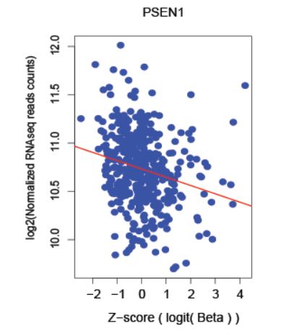

##### Fig. S1. A correlative analysis between DNA methylation and gene expression of PSEN1 gene in a cancer genome study of 412 bladder cancer patients

Both the DNA methylation and gene expression data derived from TCGA project were downloaded and merged for the further statistical analysis. The correlation analysis between gene expression and DNA methylation was conducted with both linear model and linear mixture models based calculation as well as the most significant regression model. The Y axis represents the log-transformed normalized RNAseq read counts from RSEM and X axis represents logit transformed beta-value of DNA methylation.