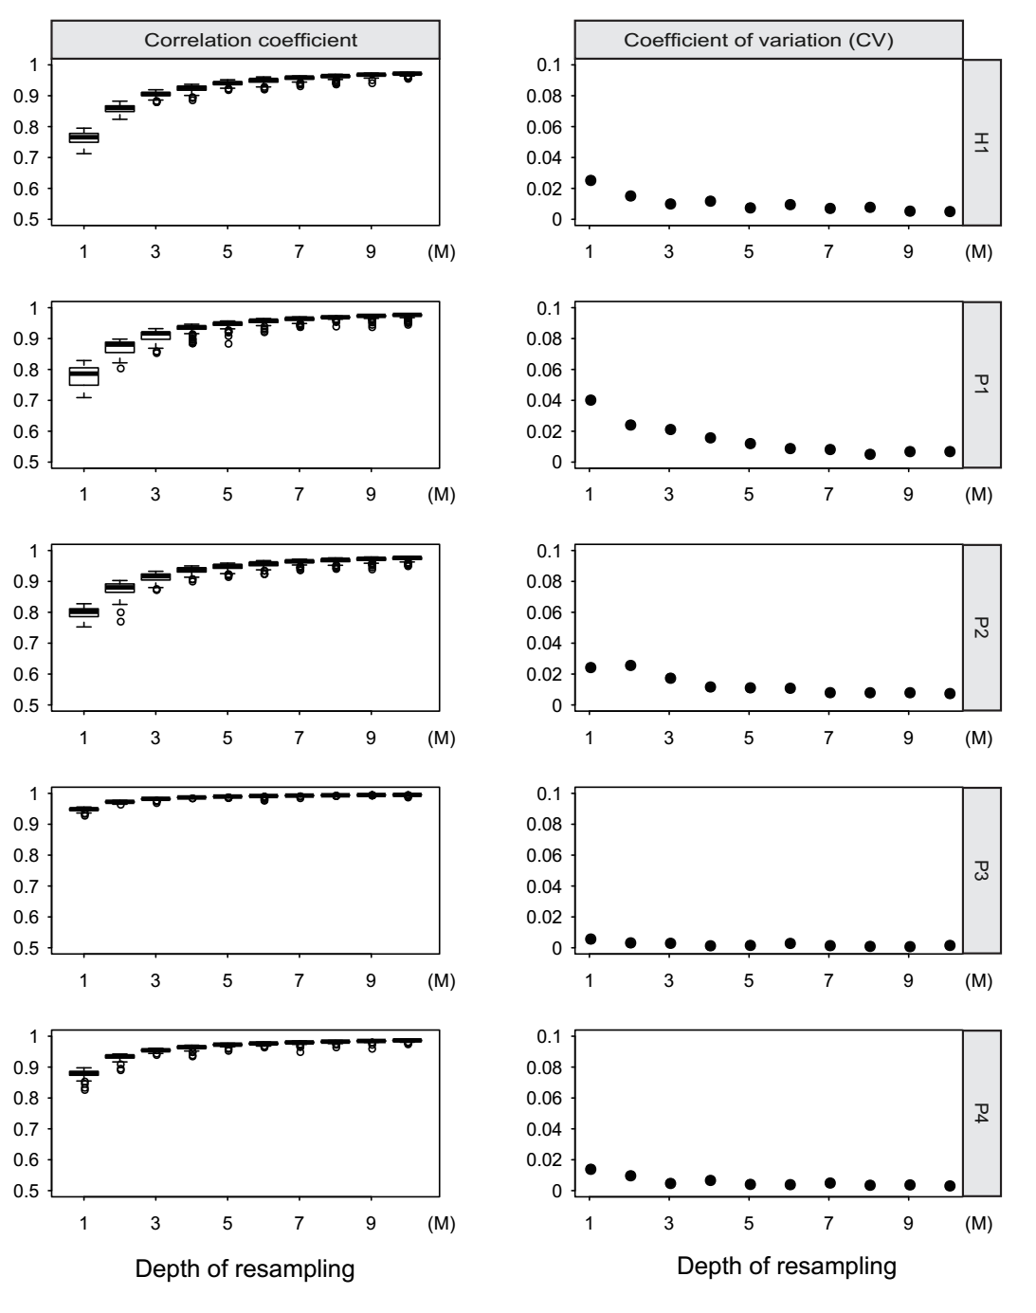

**Fig. 1. The efficiency of re-sampling sequencing depth for low pass WGBS.** Left of the figure showed the correlation coefficient between re-sampling low pass WGBS and medium WGBS for 100 times from 1M to 10M. Right of the figure showed the coefficient of variation (CV) for 100 correlation coefficient between re-sampling low pass WGBS and medium WGBS from 1M to 10M

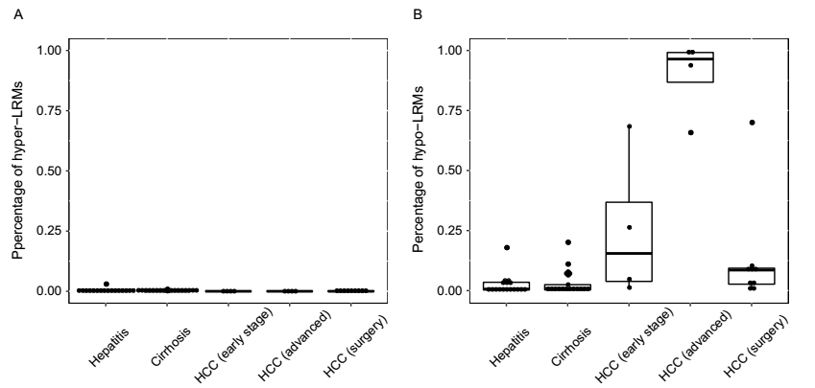

**Fig. 2 Whole genome-wide changed methylation of all the patients.** (A) The percentage of hyper-methylated 2-Mb regions in chronic hepatitis, cirrhosis and HCC patients. (B) The percentage of hypo-methylated 2-Mb regions in chronic hepatitis, cirrhosis and HCC patients.

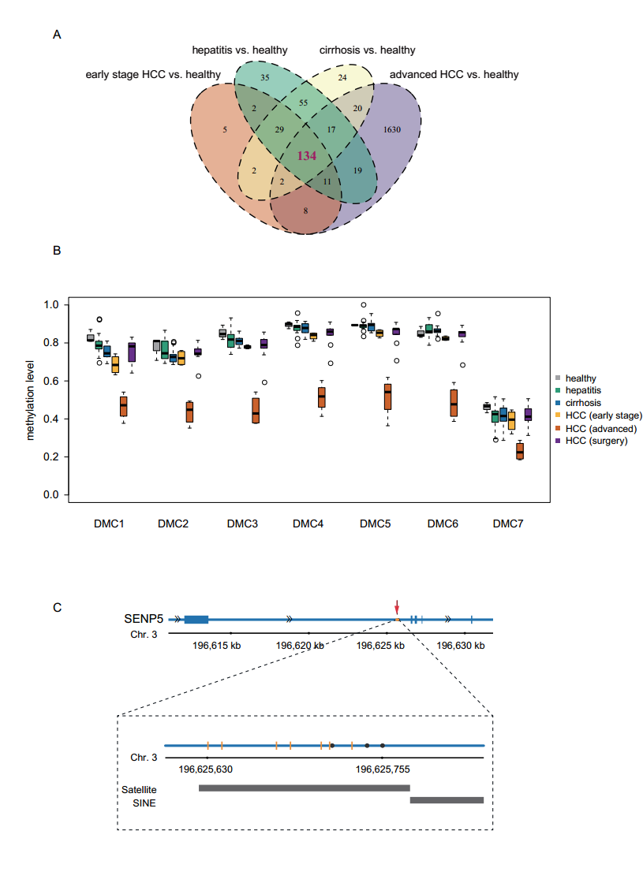

**Fig. 3. Differentially methylated CpGs (DMCs) identified in all the groups.** (A) Venn diagram showing the overlap of DMCs generated by 2 hypo-methylated chronic hepatitis patients, 1 hypo-methylated cirrhosis patient, 4 HCC patients and 2 hypo-methylated HCC patients after surgery compared to healthy individuals. (B) Boxplot displays the methylation level of 6 DMCs of SENP5 in 3 healthy individuals, 21 chronic hepatitis, 15 cirrhosis, 4 HCC and 12 HCC patients after surgery. (D) The locus of 6 DMCs and 3 reported HBV integration sites in intron 2 of SENP5. The black dots represent the HBV integration sites and the orange vertical lines represent the 6 DMCs. The black bar labels in the bottom of the figure represent the locus of repeat marker in this region.

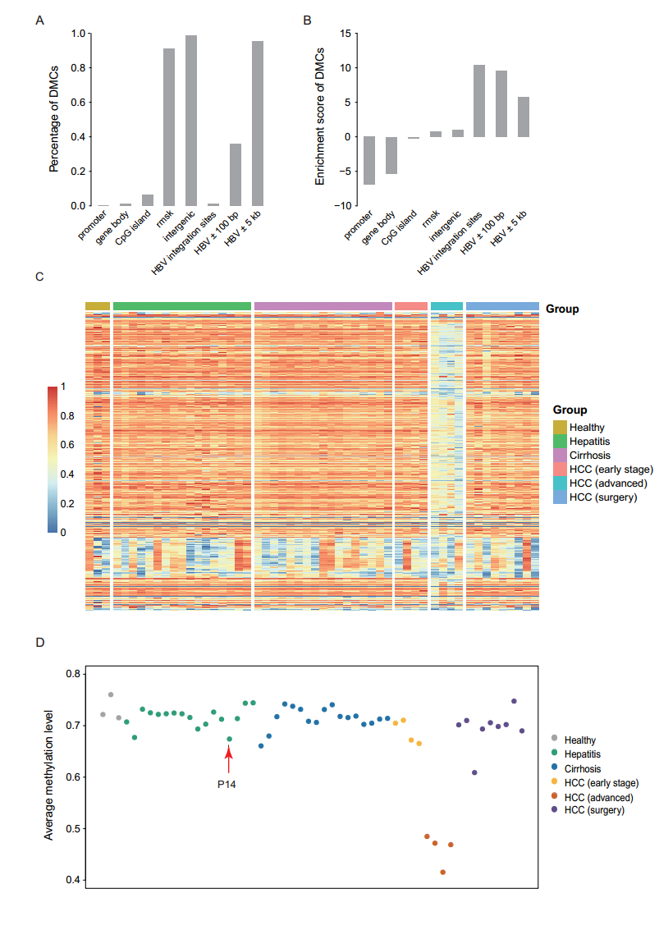

**Fig. 4. DMCs and CpGs are related to HBV integration sites.** (A) The percentage of DMCs located in different genomic elements and regions related to HBV integration sites. (B) The enrichment scores of DMCs in different genomic elements. (C) The heatmap display the methylation level of the CpGs located within 100 bp of the HBV integration sites in all the samples. (D) The average methylation level of the CpGs located within 100 bp of the HBV integration sites in all the samples. The red arrows showed the examples of CH18 patient