Supplementary Tables

|  |  |  |  |  |  |
| --- | --- | --- | --- | --- | --- |
| Table S1. Integration events in HepG2.2.15 using capture strategy | | | | |  |
| ProbeSet | Target Yield | Clean bases (Mb) | Non redundant junctions | Gene_Integration_Location | Host_Gene |
| Capture1 | 1G | 662.43 | 18 | chr1:570034 | OR4F3//3prime |
| 89 | chr7:100755056 | SERPINE1//5prime |
| 39 | chr9:140008658 | DPP7//exon3 |
| 12 | chr9:140011429 | GRIN1//5prime |
| Capture2 | 1.5G | 1774.3 | 26 | chr1:570029 | OR4F3//3prime |
| 81 | chr7:100755048 | SERPINE1//5prime |
| 37 | chr9:140008678 | DPP7//exon3 |
| 15 | chr9:140011430 | GRIN1//5prime |
| Capture3 | 2G | 2035.83 | 30 | chr1:569979 | OR4F3//3prime |
| 4 | chr2:77923780 | SNAR-H//3prime |
| 85 | chr7:100755048 | SERPINE1//5prime |
| 30 | chr9:140008659 | DPP7//exon3 |
| 15 | chr9:140011431 | GRIN1//5prime |

Notes: xxx

| Table S2. Summarization of clincal data for 20 patients | | | | | | | | | | | |
| --- | --- | --- | --- | --- | --- | --- | --- | --- | --- | --- | --- |
| SampleID | Gender | Age | Type | BCLC | HBsAg | HBeAg | HBVDNAIU/ml | ALTU/L | ASTU/L | Tbilumol/L | AFPng/ml |
| I001 | Male | 51 | HCC | B | 1 | 0 | 2.41E+02 | 492.4 | 328.1 | 19.7 | 157 |
| I002 | Male | 64 | HCC | B | 1 | 0 | NA | 55 | 39.8 | 68 | 370.6 |
| I003 | Male | 67 | BDC | B | 1 | 0 | <100 | 637.3 | 700.5 | 18.6 | 2.27 |
| I004 | Male | 47 | BDC | B | 1 | 1 | 15100000 | 44.2 | 49 | 22.4 | 24.9 |
| I005 | Male | 47 | HCC | B | 1 | 0 | 1.58E+06 | 26.5 | 125.1 | 17.8 | 229.3 |
| I006 | Male | 65 | HCC | A4 | NA | 0 | 3.15+4 | 31.5 | 57.8 | 16.1 | 141.7 |
| I007 | Male | 52 | HCC | A4 | 1 | 0 | <100 | 48.9 | 32.6 | 12.6 | 2.46 |
| I008 | Female | 67 | BDC | A1 | 0 | 0 | <50 | 118 | 254 | 16.6 | 1.28 |
| I009 | Female | 55 | BDC | B | 1 | 1 | 5.25E+03 | 22.9 | 33.9 | 18.2 | 8.5 |
| N001 | Male | 62 | HCC | B | - | - | - | 32 | 49.2 | 30.4 | 21.66 |
| I010 | Male | 36 | HCC | A4 | 1 | 1 | 1.94E+03 | 42.2 | 157 | 20.6 | 680.3 |
| I011 | Male | 42 | HCC | A1 | NA | NA | NA | NA | NA | NA | NA |
| N002 | Male | 52 | HCC | A3 | 0 | 0 | NA | 36 | 34.7 | 19.6 | 12437 |
| I012 | Male | 47 | HCC | A4 | NA | NA | <100 | 66.4 | 39.3 | 18.5 | 34.44 |
| I013 | Female | 63 | HCC | A1 | NA | 1 | 4.05E+04 | 133.7 | 169 | 17.7 | 406.1 |
| I014 | Male | 56 | HCC | B | 1 | 0 | <100 | 22.1 | 31.8 | 25.7 | 27078 |
| I015 | Male | 60 | HCC | B | 1 | 1 | 3.03+5 | 277.9 | 191.5 | 33.2 | >120000 |
| N003 | Female | 47 | BDC | A1 | 0 | 0 | 〈100 | 54.7 | 133.5 | 69.8 | 1.06 |
| I016 | Male | 62 | HCC | B | 1 | 0 | <100 | 22.4 | 27 | 12.8 | 3.06 |
| I017 | Female | 63 | HCC | A4 | NA | NA | NA | NA | NA | NA | NA |

Notes: 4 samples (xx, xx, xx, xx) from tumor and paired normal tissues

|  |  |  |  |  |  |  |  |  |  |  |  |  |  |  |
| --- | --- | --- | --- | --- | --- | --- | --- | --- | --- | --- | --- | --- | --- | --- |
| Table S3. All 424 integration events detected in 17 patients (why 17 samples here?) | | | | | | | | | | | | | |  |
| ID | chr | Pos | Pos_HBV | Pos_HBV_direction | PB | PB_HBV | PB_HBV_direction | ViralPattern | Sequencing coverage | geneList | functionGVS | repeatMasker | Group | Type |
| I001 | chr3 | 57431812 | 2070 | - | 57431854 | 1824 | + | PatternII | ca1:0/ca2:0/p2:21/p3:0 | DNAH12 | synonymous | none | HCC | Non-Tumor Specific |
| I001 | chr15 | 58520169 | 1719 | - | 58520176 | 1840 | + | PatternI | ca1:0/ca2:0/p2:0/p3:23 | none | intergenic | none | HCC | Non-Tumor Specific |
| I001 | chr2 | 216293131 | 698 | - | 216293137 | 2068 | + | PatternI | ca1:0/ca2:0/p2:0/p3:14 | FN1 | intron | none | HCC | Non-Tumor Specific |
| I001 | chr2 | 216249399 | 1794 | - | 216249426 | 2920 | + | PatternI | ca1:0/ca2:0/p2:106/p3:2 | FN1 | intron | none | HCC | Non-Tumor Specific |
| I001 | chr2 | 74417319 | 1122 | - | NA | NA | NA | NA | ca1:0/ca2:0/p2:0/p3:8 | none | intergenic | MIR | HCC | Non-Tumor Specific |
| I001 | chr1 | 12969181 | 1834 | - | NA | NA | NA | NA | ca1:3/ca2:159/p2:0/p3:0 | none | intergenic | L1PA4 | HCC | Tumor Specific |
| I001 | chr3 | 148069161 | 1834 | - | NA | NA | NA | NA | ca1:1/ca2:52/p2:0/p3:0 | none | intergenic | L1PA4 | HCC | Tumor Specific |
| I001 | chr12 | 129949962 | 1834 | - | NA | NA | NA | NA | ca1:3/ca2:33/p2:0/p3:0 | TMEM132D | intron | L1PA4 | HCC | Tumor Specific |
| I001 | chr11 | 121691962 | 3063 | - | NA | NA | NA | NA | ca1:6/ca2:159/p2:5/p3:0 | none | intergenic | T-rich | HCC | Common |
| I001 | chr11 | 68044157 | 2969 | + | 68044156 | 1229 | - | PatternI | ca1:0/ca2:0/p2:0/p3:14 | none | upstream-gene | AluSx | HCC | Non-Tumor Specific |
| I001 | chr21 | 10023939 | 1836 | + | 10023962 | 1834 | - | PatternI | ca1:12/ca2:338/p2:1/p3:0 | none | intergenic | L1PA4 | HCC | Common |
| I001 | chr5 | 41012907 | 628 | + | NA | NA | NA | NA | ca1:7/ca2:635/p2:3/p3:0 | MROH2B | intron | none | HCC | Common |
| I001 | chr3 | 32682138 | 1824 | + | NA | NA | NA | NA | ca1:23/ca2:505/p2:8/p3:0 | none | intergenic | L1M5 | HCC | Common |
| I001 | chr7 | NA | NA | NA | 108660182 | 1597 | + | NA | ca1:53/ca2:464/p2:0/p3:0 | none | intergenic | none | HCC | Tumor Specific |
| I001 | chr13 | NA | NA | NA | 52615584 | 1693 | - | NA | ca1:0/ca2:0/p2:5/p3:0 | LOC100506859 | intron | L1MEe | HCC | Non-Tumor Specific |
| I001 | chr17 | NA | NA | NA | 21988828 | 1826 | + | NA | ca1:16/ca2:375/p2:0/p3:0 | none | intergenic | L1ME3A | HCC | Tumor Specific |
| I001 | chr8 | NA | NA | NA | 57265795 | 1834 | - | NA | ca1:2/ca2:53/p2:0/p3:0 | none | intergenic | L1PA4 | HCC | Tumor Specific |
| I001 | chr1 | NA | NA | NA | 143522693 | 1834 | - | NA | ca1:1/ca2:122/p2:0/p3:0 | none | intergenic | L1PA4 | HCC | Tumor Specific |
| I001 | chr10 | NA | NA | NA | 42388344 | 2517 | + | NA | ca1:17/ca2:268/p2:1/p3:0 | none | intergenic | HSATII | HCC | Common |
| I002 | chr11 | 82782076 | 1808 | - | 82782095 | 1315 | + | PatternII | ca1:0/ca2:31/p1:0/p3:0 | RAB30 | intron | none | HCC | Tumor Specific |
| I002 | chr1 | 63198239 | 1824 | - | 63198239 | 1712 | + | PatternII | ca1:0/ca2:469/p1:0/p3:0 | none | intergenic | none | HCC | Tumor Specific |
| I002 | chr4 | 6193018 | 1810 | - | 6193023 | 1839 | + | PatternI | ca1:0/ca2:456/p1:0/p3:0 | JAKMIP1 | intron | none | HCC | Tumor Specific |
| I002 | chr18 | 30418333 | 2256 | - | 30418427 | 2355 | + | PatternI | ca1:0/ca2:58/p1:0/p3:0 | none | intergenic | none | HCC | Tumor Specific |
| I002 | chr14 | 52484661 | 533 | - | 52484679 | 2797 | + | PatternI | ca1:0/ca2:21/p1:0/p3:0 | NID2 | intron | AluSc | HCC | Tumor Specific |
| I002 | chr12 | 65341424 | 2324 | + | 65341435 | 1425 | - | PatternI | ca1:0/ca2:105/p1:0/p3:0 | FLJ41278 | intron | none | HCC | Tumor Specific |
| I002 | chr9 | 140475463 | 1829 | + | 140475473 | 1673 | - | PatternI | ca1:0/ca2:71/p1:0/p3:0 | none | upstream-gene | none | HCC | Tumor Specific |
| I002 | chr12 | 110478839 | 2006 | + | 110478881 | 1690 | - | PatternI | ca1:0/ca2:20/p1:0/p3:0 | none | downstream-gene | AluSq2 | HCC | Tumor Specific |
| I002 | chr11 | 110092569 | 2979 | + | 110092577 | 1760 | - | PatternI | ca1:0/ca2:24/p1:0/p3:0 | RDX | intron | none | HCC | Tumor Specific |
| I002 | chr6 | 31057283 | 2690 | + | 31057283 | 1809 | - | PatternI | ca1:0/ca2:39/p1:0/p3:0 | none | intergenic | L1MB4 | HCC | Tumor Specific |
| I002 | chr3 | 167245442 | 2530 | + | 167245477 | 1826 | - | PatternI | ca1:0/ca2:67/p1:0/p3:0 | WDR49 | intron | none | HCC | Tumor Specific |
| I002 | chr3 | 124395896 | 1837 | + | NA | NA | NA | NA | ca1:0/ca2:0/p1:38/p3:0 | KALRN | intron | none | HCC | Non-Tumor Specific |
| I002 | chr16 | NA | NA | NA | 30773743 | 945 | - | NA | ca1:0/ca2:12/p1:0/p3:0 | RNF40 | intron | none | HCC | Tumor Specific |
| I002 | chr11 | NA | NA | NA | 113961463 | 1585 | - | NA | ca1:0/ca2:26/p1:0/p3:0 | ZBTB16 | intron | none | HCC | Tumor Specific |
| I002 | chr3 | NA | NA | NA | 124196824 | 1779 | - | NA | ca1:0/ca2:0/p1:171/p3:0 | KALRN | intron | none | HCC | Non-Tumor Specific |
| I002 | chrX | NA | NA | NA | 76521035 | 1815 | - | NA | ca1:0/ca2:34/p1:0/p3:0 | none | intergenic | HERVE_a-int | HCC | Tumor Specific |
| I002 | chr8 | NA | NA | NA | 145600569 | 1861 | + | NA | ca1:0/ca2:6/p1:0/p3:0 | ADCK5 | intron | none | HCC | Tumor Specific |
| I002 | chr13 | 39246968 | 935 | - | 39246978 | 747 | - | PatternIII | ca1:0/ca2:24/p1:0/p3:0 | none | intergenic | none | HCC | Tumor Specific |
| I002 | chr9 | 123728366 | 1761 | - | 123728382 | 1640 | - | PatternIII | ca1:0/ca2:62/p1:2/p3:0 | C5 | intron | none | HCC | Common |
| I002 | chr2 | 216251386 | 1755 | - | 216251386 | 1667 | - | PatternIII | ca1:0/ca2:49/p1:0/p3:0 | FN1 | intron | none | HCC | Tumor Specific |
| I002 | chr9 | 79135498 | 530 | - | 79135517 | 1791 | - | PatternIII | ca1:10/ca2:243/p1:0/p3:0 | none | intergenic | AluSg | HCC | Tumor Specific |
| I002 | chr1 | 50485056 | 1835 | + | 50485086 | 1369 | + | PatternIV | ca1:0/ca2:85/p1:0/p3:0 | AGBL4 | intron | MIRb | HCC | Tumor Specific |
| I002 | chr12 | 62748847 | 1758 | + | 62748847 | 1681 | + | PatternIV | ca1:0/ca2:27/p1:0/p3:0 | USP15 | intron | none | HCC | Tumor Specific |
| I003 | chr8 | 7691824 | 1698 | - | 7691827 | 1832 | + | PatternI | ca1:0/ca3:0/p2:7/p3:0 | none | upstream-gene | none | BDC | Non-Tumor Specific |
| I003 | chr7 | 84599733 | 118 | - | 84600298 | 2285 | + | PatternI | ca1:0/ca3:1/p2:0/p3:21 | none | intergenic | MLT1A0 | BDC | Common |
| I003 | chr12 | 58424416 | 1826 | - | 58424442 | 2767 | + | PatternI | ca1:0/ca3:0/p2:0/p3:11 | none | intergenic | MLT1E3 | BDC | Non-Tumor Specific |
| I003 | chr2 | 216273509 | 1794 | - | 216273509 | 2988 | + | PatternI | ca1:175/ca3:0/p2:20/p3:0 | FN1 | intron | AluSz | BDC | Common |
| I003 | chr10 | 12113869 | 1785 | - | NA | NA | NA | NA | ca1:0/ca3:0/p2:8/p3:0 | DHTKD1 | intron | none | BDC | Non-Tumor Specific |
| I003 | chr2 | 192718178 | 1661 | + | 192718191 | 2948 | - | PatternII | ca1:234/ca3:0/p2:0/p3:0 | none | intergenic | none | BDC | Tumor Specific |
| I003 | chr12 | 95533 | 2400 | + | NA | NA | NA | NA | ca1:0/ca3:22/p2:0/p3:1 | none | downstream-gene | (TTAGGG)n | BDC | Common |
| I003 | chrX | 155260411 | 2400 | + | NA | NA | NA | NA | ca1:0/ca3:35/p2:0/p3:1 | none | intergenic | (TTAGGG)n | BDC | Common |
| I003 | chr11 | NA | NA | NA | 51572050 | 1284 | - | NA | ca1:0/ca3:12/p2:0/p3:0 | none | intergenic | ALR/Alpha | BDC | Tumor Specific |
| I003 | chr11 | NA | NA | NA | 134799817 | 1809 | - | NA | ca1:0/ca3:1957/p2:0/p3:3 | none | intergenic | none | BDC | Common |
| I004 | chr2 | 209116248 | 1769 | - | 209116277 | 2766 | + | PatternI | ca1:0/ca2:0/p1:0/p2:112 | IDH1 | synonymous | none | BDC | Non-Tumor Specific |
| I004 | chr17 | 31360145 | 698 | - | NA | NA | NA | NA | ca1:40/ca2:21/p1:0/p2:0 | ASIC2 | intron | MER52C | BDC | Tumor Specific |
| I004 | chr5 | 803871 | 1405 | - | NA | NA | NA | NA | ca1:49/ca2:132/p1:3/p2:0 | ZDHHC11 | intron | L1ME3F | BDC | Common |
| I004 | chr2 | 21250974 | 3179 | - | NA | NA | NA | NA | ca1:0/ca2:0/p1:0/p2:193 | APOB | intron | none | BDC | Non-Tumor Specific |
| I004 | chr4 | 89959025 | 1864 | + | 89959045 | 1590 | - | PatternI | ca1:0/ca2:0/p1:0/p2:12 | FAM13A | intron | MSTA | BDC | Non-Tumor Specific |
| I004 | chr7 | 90018820 | 2598 | + | 90020410 | 1682 | NA | NA | ca1:0/ca2:0/p1:101/p2:0 | GTPBP10 | 3-prime-UTR | AluSc5 | BDC | Non-Tumor Specific |
| I004 | chr15 | 96269669 | 2307 | + | 96269672 | 2548 | - | PatternII | ca1:0/ca2:0/p1:0/p2:30 | none | intergenic | none | BDC | Non-Tumor Specific |
| I004 | chr5 | 1297189 | 1 | + | NA | NA | NA | NA | ca1:136/ca2:46/p1:3/p2:0 | none | upstream-gene | AluSq | BDC | Common |
| I004 | chr17 | 14933200 | 2715 | + | NA | NA | NA | NA | ca1:30/ca2:4/p1:0/p2:0 | none | upstream-gene | none | BDC | Tumor Specific |
| I004 | chr4 | NA | NA | NA | 118044024 | 734 | - | NA | ca1:44/ca2:72/p1:1/p2:1 | none | intergenic | none | BDC | Common |
| I004 | chrY | NA | NA | NA | 13452860 | 2357 | + | NA | ca1:0/ca2:0/p1:0/p2:36 | none | intergenic | (CATTC)n | BDC | Non-Tumor Specific |
| I004 | chr4 | NA | NA | NA | 49633987 | 2907 | + | NA | ca1:0/ca2:0/p1:0/p2:7 | none | intergenic | (GAATG)n | BDC | Non-Tumor Specific |
| I005 | chr1 | 167333992 | 845 | - | 167333994 | 405 | + | PatternII | ca1:2612/ca3:5740/p1:98/p2:190 | POU2F1 | intron | AluJb | HCC | Common |
| I005 | chr18 | 15208205 | 923 | - | NA | NA | NA | NA | ca1:74/ca3:162/p1:1/p2:4 | none | intergenic | CT-rich | HCC | Common |
| I005 | chr1 | 115076623 | 1789 | - | NA | NA | NA | NA | ca1:1480/ca3:3124/p1:27/p2:136 | none | intergenic | HAL1 | HCC | Common |
| I005 | chr4 | 125412217 | 2367 | - | NA | NA | NA | NA | ca1:1/ca3:2/p1:0/p2:0 | none | intergenic | (GAA)n | HCC | Tumor Specific |
| I005 | chr13 | 102814076 | 2368 | - | NA | NA | NA | NA | ca1:3/ca3:10/p1:0/p2:0 | FGF14 | intron | (GAA)n | HCC | Tumor Specific |
| I005 | chr19 | 44963280 | 2637 | - | NA | NA | NA | NA | ca1:14/ca3:35/p1:0/p2:8 | none | intergenic | none | HCC | Common |
| I005 | chr18 | 109238 | 3007 | - | NA | NA | NA | NA | ca1:26/ca3:59/p1:3/p2:4 | ROCK1P1 | non-coding-exon | BSR/Beta | HCC | Common |
| I005 | chr17 | 25277091 | 165 | + | 25279601 | 923 | - | PatternII | ca1:626/ca3:1207/p1:22/p2:22 | none | intergenic | AluJb | HCC | Common |
| I005 | chr9 | 8116525 | 2955 | + | 8116551 | 1780 | - | PatternI | ca1:0/ca3:20/p1:0/p2:0 | none | intergenic | none | HCC | Tumor Specific |
| I005 | chr6 | 58776620 | 2425 | + | 58777996 | 2948 | - | PatternII | ca1:978/ca3:2481/p1:33/p2:68 | none | intergenic | ALR/Alpha | HCC | Common |
| I005 | chr15 | 38973529 | 1913 | + | NA | NA | NA | NA | ca1:1/ca3:2/p1:0/p2:0 | none | intergenic | (TTC)n | HCC | Tumor Specific |
| I005 | chr1 | NA | NA | NA | 207580725 | 1913 | + | NA | ca1:6/ca3:8/p1:0/p2:1 | none | intergenic | none | HCC | Common |
| I005 | chr5 | NA | NA | NA | 1253149 | 2034 | + | NA | ca1:1214/ca3:2077/p1:17/p2:63 | none | downstream-gene | none | HCC | Common |
| I005 | chr1 | NA | NA | NA | 143283237 | 2637 | - | NA | ca1:364/ca3:961/p1:14/p2:43 | none | intergenic | none | HCC | Common |
| I005 | chr2 | NA | NA | NA | 162137782 | 2637 | - | NA | ca1:377/ca3:592/p1:85/p2:26 | none | intergenic | none | HCC | Common |
| I005 | chr6 | NA | NA | NA | 58778249 | 2759 | + | NA | ca1:437/ca3:575/p1:10/p2:80 | none | intergenic | ALR/Alpha | HCC | Common |
| I006 | chr16 | 78836958 | 236 | - | 78836979 | 1821 | + | PatternI | ca1:0/ca2:0/p2:0/p3:97 | WWOX | intron | none | HCC | Non-Tumor Specific |
| I006 | chr8 | NA | NA | NA | 111429020 | 1714 | - | NA | ca1:16/ca2:0/p2:0/p3:0 | none | intergenic | none | HCC | Tumor Specific |
| I007 | chr5 | 1295598 | 1748 | - | NA | NA | NA | NA | ca1:18/ca3:57/p1:0/p2:0 | none | upstream-gene | none | HCC | Tumor Specific |
| I007 | chr4 | 155533444 | 1643 | + | 155533446 | 1642 | - | PatternI | ca1:112/ca3:43/p1:0/p2:3 | FGG | intron | none | HCC | Common |
| I007 | chr6 | 65660546 | 2314 | + | 65660548 | 2195 | - | PatternI | ca1:0/ca3:0/p1:0/p2:44 | EYS | intron | L1M5 | HCC | Non-Tumor Specific |
| I007 | chr6 | NA | NA | NA | 174731 | 162 | + | NA | ca1:55/ca3:1/p1:0/p2:4 | none | intergenic | none | HCC | Common |
| I008 | chrX | 89808616 | 353 | + | 89808636 | 1137 | - | PatternII | ca1:0/ca2:0/p1:0/p2:10 | none | intergenic | LTR12 | BDC | Non-Tumor Specific |
| I008 | chr10 | 116692414 | 204 | + | NA | NA | NA | NA | ca1:0/ca2:0/p1:9/p2:0 | none | intergenic | L3 | BDC | Non-Tumor Specific |
| I008 | chr8 | NA | NA | NA | 46840069 | 933 | - | NA | ca1:0/ca2:0/p1:0/p2:6 | none | intergenic | ALR/Alpha | BDC | Non-Tumor Specific |
| I009 | chr16 | 13502142 | 1358 | - | 13502147 | 245 | + | PatternII | ca1:0/ca2:0/p1:15/p2:0 | none | intergenic | Arthur1 | BDC | Non-Tumor Specific |
| I009 | chr1 | 119907262 | 1487 | - | 119907314 | 1752 | + | PatternI | ca1:0/ca2:0/p1:2/p2:0 | none | upstream-gene | none | BDC | Non-Tumor Specific |
| I009 | chr11 | 5108850 | 1681 | - | 5108870 | 1817 | + | PatternI | ca1:0/ca2:0/p1:1/p2:0 | none | intergenic | MER61F | BDC | Non-Tumor Specific |
| I009 | chr12 | 92840792 | 1456 | - | 92840817 | 1823 | + | PatternI | ca1:0/ca2:0/p1:26/p2:0 | none | intergenic | none | BDC | Non-Tumor Specific |
| I009 | chr6 | 124058316 | 1631 | - | 124058346 | 1910 | + | PatternI | ca1:0/ca2:0/p1:0/p2:7 | none | intergenic | none | BDC | Non-Tumor Specific |
| I009 | chr11 | 77704108 | 1796 | - | 77704110 | 1918 | + | PatternI | ca1:0/ca2:0/p1:15/p2:0 | INTS4 | intron | none | BDC | Non-Tumor Specific |
| I009 | chr14 | 65105242 | 1799 | - | 65105241 | 2015 | + | PatternI | ca1:0/ca2:0/p1:1/p2:0 | none | intergenic | AluSx1 | BDC | Non-Tumor Specific |
| I009 | chr11 | 65265077 | 448 | - | NA | NA | NA | NA | ca1:0/ca2:0/p1:13/p2:0 | none | upstream-gene | none | BDC | Non-Tumor Specific |
| I009 | chr4 | 56886677 | 1456 | - | NA | NA | NA | NA | ca1:0/ca2:0/p1:23/p2:0 | CEP135 | intron | L2b | BDC | Non-Tumor Specific |
| I009 | chr4 | 189763351 | 1478 | - | NA | NA | NA | NA | ca1:0/ca2:0/p1:0/p2:12 | none | intergenic | none | BDC | Non-Tumor Specific |
| I009 | chr5 | 52137159 | 1496 | - | NA | NA | NA | NA | ca1:0/ca2:0/p1:18/p2:0 | ITGA1 | intron | none | BDC | Non-Tumor Specific |
| I009 | chr12 | 53815996 | 1628 | - | NA | NA | NA | NA | ca1:0/ca2:0/p1:5/p2:0 | none | upstream-gene | AluY | BDC | Non-Tumor Specific |
| I009 | chrX | 135921107 | 1981 | - | NA | NA | NA | NA | ca1:0/ca2:0/p1:1/p2:0 | none | intergenic | AluSz | BDC | Non-Tumor Specific |
| I009 | chr4 | 191044276 | 2013 | - | NA | NA | NA | NA | ca1:1/ca2:0/p1:0/p2:0 | none | intergenic | (TTCGGG)n | BDC | Tumor Specific |
| I009 | chr21 | 9695926 | 2637 | - | NA | NA | NA | NA | ca1:19/ca2:26/p1:0/p2:0 | none | intergenic | none | BDC | Tumor Specific |
| I009 | chr3 | 64500713 | 3215 | - | NA | NA | NA | NA | ca1:0/ca2:0/p1:0/p2:3 | none | downstream-gene | MLT1K | BDC | Non-Tumor Specific |
| I009 | chr7 | 84687866 | 574 | + | 84687866 | 1410 | - | PatternII | ca1:0/ca2:0/p1:2/p2:0 | SEMA3D | intron | AluY | BDC | Non-Tumor Specific |
| I009 | chr4 | 45813569 | 1839 | + | 45813587 | 1525 | - | PatternI | ca1:0/ca2:0/p1:31/p2:0 | none | intergenic | L2 | BDC | Non-Tumor Specific |
| I009 | chr8 | 4908714 | 1821 | + | 4908710 | 1547 | - | PatternI | ca1:0/ca2:0/p1:0/p2:1 | none | intergenic | none | BDC | Non-Tumor Specific |
| I009 | chr4 | 97244200 | 2367 | + | 97244224 | 1567 | - | PatternI | ca1:0/ca2:0/p1:0/p2:7 | none | intergenic | none | BDC | Non-Tumor Specific |
| I009 | chr13 | 33766307 | 1997 | + | 33766318 | 1596 | - | PatternI | ca1:0/ca2:0/p1:1/p2:0 | STARD13 | intron | none | BDC | Non-Tumor Specific |
| I009 | chr5 | 91234206 | 1851 | + | 91234219 | 1642 | - | PatternI | ca1:0/ca2:0/p1:35/p2:0 | none | intergenic | none | BDC | Non-Tumor Specific |
| I009 | chr2 | 203518270 | 1906 | + | 203518287 | 1705 | - | PatternI | ca1:0/ca2:11/p1:0/p2:0 | FAM117B | intron | none | BDC | Tumor Specific |
| I009 | chrX | 114162837 | 1818 | + | 114162842 | 1730 | - | PatternI | ca1:0/ca2:0/p1:0/p2:3 | none | intergenic | LTR29 | BDC | Non-Tumor Specific |
| I009 | chr4 | 2760775 | 2308 | + | 2760807 | 1758 | - | PatternI | ca1:0/ca2:0/p1:5/p2:0 | none | upstream-gene | MER46C | BDC | Non-Tumor Specific |
| I009 | chr7 | 80281207 | 2161 | + | 80281213 | 1791 | - | PatternI | ca1:0/ca2:4/p1:0/p2:0 | CD36 | intron | AluJb | BDC | Tumor Specific |
| I009 | chr1 | 205709704 | 3008 | + | NA | NA | NA | NA | ca1:0/ca2:1/p1:0/p2:0 | NUCKS1 | intron | AluJo | BDC | Tumor Specific |
| I009 | chrX | NA | NA | NA | 99689931 | 351 | - | NA | ca1:0/ca2:0/p1:2/p2:0 | none | intergenic | none | BDC | Non-Tumor Specific |
| I009 | chr20 | NA | NA | NA | 420028 | 1496 | - | NA | ca1:0/ca2:0/p1:2/p2:0 | TBC1D20 | intron | none | BDC | Non-Tumor Specific |
| I009 | chr4 | NA | NA | NA | 134419172 | 1496 | - | NA | ca1:0/ca2:0/p1:19/p2:0 | none | intergenic | none | BDC | Non-Tumor Specific |
| I009 | chr20 | NA | NA | NA | 47147385 | 1712 | - | NA | ca1:2/ca2:2/p1:0/p2:0 | none | intergenic | none | BDC | Tumor Specific |
| I009 | chr6 | NA | NA | NA | 79868862 | 1732 | + | NA | ca1:0/ca2:0/p1:0/p2:1 | none | intergenic | L2c | BDC | Non-Tumor Specific |
| I009 | chr13 | NA | NA | NA | 71990633 | 1819 | + | NA | ca1:0/ca2:0/p1:1/p2:0 | none | intergenic | (TA)n | BDC | Non-Tumor Specific |
| I009 | chr4 | NA | NA | NA | 56991770 | 1820 | - | NA | ca1:0/ca2:0/p1:12/p2:0 | none | intergenic | AluJr | BDC | Non-Tumor Specific |
| I009 | chr3 | NA | NA | NA | 58466651 | 1822 | + | NA | ca1:0/ca2:0/p1:0/p2:1 | none | intergenic | L1MA4 | BDC | Non-Tumor Specific |
| I009 | chr19 | 19623522 | 1751 | - | 19623528 | 1946 | - | PatternIII | ca1:1444/ca2:1974/p1:0/p2:0 | none | upstream-gene | none | BDC | Tumor Specific |
| I009 | chr13 | 67499053 | 1821 | - | 67499062 | 2123 | - | PatternIII | ca1:0/ca2:0/p1:20/p2:0 | PCDH9 | intron | none | BDC | Non-Tumor Specific |
| I010 | chr13 | 71498151 | 1410 | - | 71498177 | 207 | + | PatternII | ca1:0/ca2:0/p1:56/p2:0 | none | intergenic | none | HCC | Non-Tumor Specific |
| I010 | chr15 | 29387631 | 1 | - | 29387745 | 1076 | + | PatternI | ca1:0/ca2:0/p1:13/p2:0 | APBA2 | intron | AluSp | HCC | Non-Tumor Specific |
| I010 | chr1 | 53467878 | 1827 | - | 53467859 | 1604 | + | PatternII | ca1:0/ca2:0/p1:48/p2:0 | SCP2 | intron | AluY | HCC | Non-Tumor Specific |
| I010 | chr11 | 35780354 | 334 | - | 35780381 | 1817 | + | PatternI | ca1:0/ca2:0/p1:36/p2:0 | TRIM44 | intron | L1PA4 | HCC | Non-Tumor Specific |
| I010 | chr9 | 102671002 | 928 | - | 102673399 | 1840 | NA | PatternI | ca1:0/ca2:0/p1:47/p2:0 | STX17 | intron | L1MC4a | HCC | Non-Tumor Specific |
| I010 | chr8 | 111037970 | 2275 | - | 111037974 | 2284 | + | PatternI | ca1:0/ca2:0/p1:0/p2:247 | none | intergenic | none | HCC | Non-Tumor Specific |
| I010 | chr14 | 80088290 | 1655 | - | 80088301 | 2557 | + | PatternI | ca1:0/ca2:15/p1:0/p2:0 | NRXN3 | intron | MER5A1 | HCC | Tumor Specific |
| I010 | chr18 | 23224466 | 1801 | - | 23224426 | 2569 | + | PatternI | ca1:0/ca2:97/p1:0/p2:0 | none | intergenic | none | HCC | Tumor Specific |
| I010 | chr11 | 82700790 | 925 | - | 82700892 | 2895 | + | PatternI | ca1:0/ca2:0/p1:0/p2:9 | RAB30 | intron | none | HCC | Non-Tumor Specific |
| I010 | chr15 | 42509294 | 1800 | - | 42511304 | 2927 | + | PatternI | ca1:0/ca2:72/p1:0/p2:0 | TMEM87A | intron | AluJb | HCC | Tumor Specific |
| I010 | chr4 | 100239967 | 1802 | - | 100239966 | 3088 | + | PatternI | ca1:0/ca2:73/p1:0/p2:0 | ADH1B | 5-prime-UTR | none | HCC | Tumor Specific |
| I010 | chr15 | 31036565 | 300 | - | NA | NA | NA | NA | ca1:0/ca2:0/p1:249/p2:0 | LOC100288637 | intron | none | HCC | Non-Tumor Specific |
| I010 | chr15 | 20154189 | 614 | - | NA | NA | NA | NA | ca1:0/ca2:0/p1:0/p2:16 | none | intergenic | L1PA4 | HCC | Non-Tumor Specific |
| I010 | chr4 | 59151691 | 800 | - | NA | NA | NA | NA | ca1:5/ca2:0/p1:41/p2:6 | none | intergenic | none | HCC | Common |
| I010 | chr10 | 98687302 | 1189 | - | NA | NA | NA | NA | ca1:0/ca2:0/p1:7/p2:0 | LCOR | intron | L1MC4 | HCC | Non-Tumor Specific |
| I010 | chr2 | 147850900 | 1484 | - | NA | NA | NA | NA | ca1:0/ca2:6/p1:0/p2:0 | none | intergenic | none | HCC | Tumor Specific |
| I010 | chr1 | 249239136 | 1752 | - | NA | NA | NA | NA | ca1:0/ca2:0/p1:68/p2:0 | none | intergenic | TAR1 | HCC | Non-Tumor Specific |
| I010 | chr9 | 69975983 | 1771 | - | NA | NA | NA | NA | ca1:0/ca2:0/p1:158/p2:0 | none | intergenic | ALR/Alpha | HCC | Non-Tumor Specific |
| I010 | chr6 | 43088797 | 1802 | - | NA | NA | NA | NA | ca1:0/ca2:4/p1:0/p2:0 | PTK7 | intron | FLAM_A | HCC | Tumor Specific |
| I010 | chr14 | 42015335 | 1819 | - | NA | NA | NA | NA | ca1:0/ca2:0/p1:6/p2:0 | none | intergenic | AluJo | HCC | Non-Tumor Specific |
| I010 | chrX | 58289515 | 1820 | - | NA | NA | NA | NA | ca1:0/ca2:13/p1:0/p2:0 | none | intergenic | GSATX | HCC | Tumor Specific |
| I010 | chr13 | 77226176 | 1822 | - | NA | NA | NA | NA | ca1:0/ca2:0/p1:2/p2:0 | none | intergenic | L1PREC2 | HCC | Non-Tumor Specific |
| I010 | chr2 | 36787095 | 2290 | + | 36787114 | 1372 | - | PatternI | ca1:0/ca2:242/p1:0/p2:0 | FEZ2 | intron | none | HCC | Tumor Specific |
| I010 | chr2 | 189062442 | 13 | + | 189063788 | 1456 | - | PatternII | ca1:0/ca2:169/p1:0/p2:0 | none | intergenic | THE1C | HCC | Tumor Specific |
| I010 | chr5 | 903436 | 1917 | + | 903438 | 1588 | - | PatternI | ca1:0/ca2:0/p1:0/p2:6 | TRIP13 | intron | LTR13 | HCC | Non-Tumor Specific |
| I010 | chr14 | 93496033 | 1833 | + | 93496043 | 1637 | - | PatternI | ca1:0/ca2:11/p1:0/p2:0 | ITPK1 | intron | none | HCC | Tumor Specific |
| I010 | chr10 | 112391146 | 2599 | + | 112391158 | 1644 | - | PatternI | ca1:0/ca2:0/p1:116/p2:0 | none | intergenic | L2b | HCC | Non-Tumor Specific |
| I010 | chr5 | 175968488 | 1880 | + | 175968504 | 1708 | - | PatternI | ca1:0/ca2:36/p1:0/p2:0 | none | upstream-gene | none | HCC | Tumor Specific |
| I010 | chr16 | 60336715 | 429 | + | 60336719 | 1712 | - | PatternII | ca1:0/ca2:26/p1:0/p2:0 | none | intergenic | none | HCC | Tumor Specific |
| I010 | chr5 | 10596026 | 1480 | + | 10596078 | 1714 | - | PatternII | ca1:0/ca2:33/p1:0/p2:0 | ANKRD33B | intron | none | HCC | Tumor Specific |
| I010 | chr2 | 72697717 | 3052 | + | 72697720 | 1754 | - | PatternI | ca1:0/ca2:30/p1:0/p2:0 | EXOC6B | intron | L1PA4 | HCC | Tumor Specific |
| I010 | chr8 | 132185053 | 1870 | + | 132185079 | 1821 | - | PatternI | ca1:0/ca2:65/p1:0/p2:0 | none | intergenic | AluSg4 | HCC | Tumor Specific |
| I010 | chr2 | 224178384 | 1817 | + | 224178390 | 3010 | - | PatternII | ca1:0/ca2:0/p1:0/p2:77 | none | intergenic | none | HCC | Non-Tumor Specific |
| I010 | chr12 | 85019373 | 955 | + | NA | NA | NA | NA | ca1:0/ca2:22/p1:0/p2:0 | none | intergenic | none | HCC | Tumor Specific |
| I010 | chr12 | 64504113 | 1580 | + | NA | NA | NA | NA | ca1:139/ca2:8/p1:0/p2:0 | SRGAP1 | intron | none | HCC | Tumor Specific |
| I010 | chr4 | 143547015 | 1580 | + | NA | NA | NA | NA | ca1:118/ca2:6/p1:0/p2:0 | INPP4B | intron | L1PA3 | HCC | Tumor Specific |
| I010 | chr20 | 9964820 | 1817 | + | NA | NA | NA | NA | ca1:0/ca2:0/p1:1/p2:0 | none | intergenic | none | HCC | Non-Tumor Specific |
| I010 | chr12 | 71935246 | 1822 | + | NA | NA | NA | NA | ca1:0/ca2:3/p1:0/p2:0 | LGR5 | intron | none | HCC | Tumor Specific |
| I010 | chr14 | 43159685 | 1824 | + | NA | NA | NA | NA | ca1:0/ca2:0/p1:20/p2:0 | none | intergenic | none | HCC | Non-Tumor Specific |
| I010 | chr11 | 126385298 | 1832 | + | NA | NA | NA | NA | ca1:0/ca2:26/p1:0/p2:0 | KIRREL3 | intron | AluJb | HCC | Tumor Specific |
| I010 | chr14 | 22698418 | 1834 | + | NA | NA | NA | NA | ca1:0/ca2:45/p1:0/p2:0 | none | intergenic | none | HCC | Tumor Specific |
| I010 | chr14 | 51384086 | 2073 | + | NA | NA | NA | NA | ca1:0/ca2:0/p1:7/p2:0 | PYGL | intron | HAL1 | HCC | Non-Tumor Specific |
| I010 | chr14 | 104156127 | 2193 | + | NA | NA | NA | NA | ca1:0/ca2:0/p1:2/p2:0 | KLC1 | intron | none | HCC | Non-Tumor Specific |
| I010 | chr6 | 14057778 | 2317 | + | NA | NA | NA | NA | ca1:0/ca2:0/p1:7/p2:0 | none | intergenic | none | HCC | Non-Tumor Specific |
| I010 | chr4 | 165135139 | 2390 | + | NA | NA | NA | NA | ca1:0/ca2:0/p1:60/p2:0 | 1-Mar | intron | L1MA3 | HCC | Non-Tumor Specific |
| I010 | chr14 | 30356694 | 2804 | + | NA | NA | NA | NA | ca1:0/ca2:24/p1:0/p2:0 | PRKD1 | intron | none | HCC | Tumor Specific |
| I010 | chr2 | 87621456 | 2985 | + | NA | NA | NA | NA | ca1:0/ca2:0/p1:0/p2:28 | none | intergenic | none | HCC | Non-Tumor Specific |
| I010 | chr2 | NA | NA | NA | 168416671 | 450 | - | NA | ca1:0/ca2:0/p1:26/p2:0 | B3GALT1 | intron | L1PA3 | HCC | Non-Tumor Specific |
| I010 | chr13 | NA | NA | NA | 64336892 | 1248 | - | NA | ca1:0/ca2:0/p1:0/p2:23 | none | intergenic | THE1D | HCC | Non-Tumor Specific |
| I010 | chr6 | NA | NA | NA | 127468852 | 1285 | + | NA | ca1:0/ca2:0/p1:4/p2:0 | RSPO3 | intron | none | HCC | Non-Tumor Specific |
| I010 | chr4 | NA | NA | NA | 127692677 | 1401 | + | NA | ca1:0/ca2:0/p1:58/p2:0 | none | intergenic | SVA_B | HCC | Non-Tumor Specific |
| I010 | chr13 | NA | NA | NA | 57327961 | 1546 | - | NA | ca1:0/ca2:42/p1:0/p2:0 | none | intergenic | none | HCC | Tumor Specific |
| I010 | chr9 | NA | NA | NA | 29299236 | 1788 | - | NA | ca1:0/ca2:0/p1:3/p2:0 | none | intergenic | MIRb | HCC | Non-Tumor Specific |
| I010 | chr14 | NA | NA | NA | 104013583 | 1819 | + | NA | ca1:0/ca2:0/p1:14/p2:0 | none | intergenic | none | HCC | Non-Tumor Specific |
| I010 | chr4 | NA | NA | NA | 127691842 | 1826 | + | NA | ca1:0/ca2:0/p1:16/p2:0 | none | intergenic | SVA_B | HCC | Non-Tumor Specific |
| I010 | chr8 | NA | NA | NA | 132047511 | 2163 | - | NA | ca1:0/ca2:0/p1:74/p2:0 | ADCY8 | intron | none | HCC | Non-Tumor Specific |
| I010 | chr2 | NA | NA | NA | 92275915 | 2552 | + | NA | ca1:0/ca2:0/p1:48/p2:0 | none | intergenic | ALR/Alpha | HCC | Non-Tumor Specific |
| I010 | chr15 | NA | NA | NA | 44307360 | 2871 | + | NA | ca1:0/ca2:0/p1:103/p2:0 | FRMD5 | intron | AluJr | HCC | Non-Tumor Specific |
| I010 | chr18 | NA | NA | NA | 75816125 | 2987 | + | NA | ca1:0/ca2:12/p1:0/p2:0 | none | intergenic | none | HCC | Tumor Specific |
| I010 | chr2 | 184528109 | 2449 | - | 184528126 | 1702 | - | PatternIII | ca1:0/ca2:0/p1:9/p2:0 | none | intergenic | L1MC5 | HCC | Non-Tumor Specific |
| I010 | chr2 | 216294675 | 1292 | - | 216294674 | 1807 | - | PatternIII | ca1:0/ca2:27/p1:0/p2:0 | FN1 | intron | none | HCC | Tumor Specific |
| I010 | chr11 | 2201056 | 1826 | - | 2201074 | 1826 | - | PatternIII | ca1:0/ca2:0/p1:0/p2:14 | none | intergenic | none | HCC | Non-Tumor Specific |
| I010 | chr20 | 12658185 | 1826 | + | 12658209 | 1830 | + | PatternIV | ca1:0/ca2:0/p1:9/p2:0 | none | intergenic | none | HCC | Non-Tumor Specific |
| I010 | chr1 | 157095605 | 1827 | + | 157096147 | 2106 | + | PatternIV | ca1:0/ca2:0/p1:0/p2:72 | ETV3 | synonymous | none | HCC | Non-Tumor Specific |
| I010 | chr15 | 42514887 | 668 | + | 42514886 | 2374 | + | PatternIV | ca1:0/ca2:0/p1:14/p2:0 | TMEM87A | intron | AluSq2 | HCC | Non-Tumor Specific |
| I010 | chr5 | 140123312 | 443 | NA | 140123319 | 2993 | NA | NA | ca1:0/ca2:0/p1:1/p2:0 | none | intergenic | AluSg | HCC | Non-Tumor Specific |
| I011 | chr12 | 113860707 | 1826 | - | 113860730 | 3063 | + | PatternI | ca1:0/ca2:0/p2:0/p3:1379 | SDSL | intron | MIR3 | HCC | Non-Tumor Specific |
| I011 | chr11 | 51586350 | 1299 | - | NA | NA | NA | NA | ca1:0/ca2:0/p2:9/p3:0 | none | intergenic | ALR/Alpha | HCC | Non-Tumor Specific |
| I011 | chr18 | 78016281 | 1416 | + | NA | NA | NA | NA | ca1:0/ca2:0/p2:0/p3:17 | none | intergenic | (TTAGGG)n | HCC | Non-Tumor Specific |
| I011 | chr12 | 95742 | 1820 | + | NA | NA | NA | NA | ca1:0/ca2:0/p2:2/p3:0 | none | downstream-gene | none | HCC | Non-Tumor Specific |
| I011 | chr3 | 1719141835 | 1929 | + | NA | NA | NA | NA | ca1:39/ca2:89/p2:3/p3:0 | FNDC3B | intron | AluSg | HCC | Common |
| I011 | chr4 | NA | NA | NA | 170004523 | 1357 | - | NA | ca1:0/ca2:0/p2:0/p3:5 | none | intergenic | AluSz | HCC | Non-Tumor Specific |
| I011 | chr22 | NA | NA | NA | 50745111 | 1415 | + | NA | ca1:0/ca2:0/p2:0/p3:10 | PLXNB2 | intron | (CCCCCA)n | HCC | Non-Tumor Specific |
| I011 | chr3 | NA | NA | NA | 171882721 | 1801 | - | NA | ca1:15/ca2:223/p2:3/p3:0 | FNDC3B | intron | none | HCC | Common |
| I011 | chr12 | NA | NA | NA | 91663048 | 1812 | - | NA | ca1:0/ca2:0/p2:71/p3:0 | none | intergenic | none | HCC | Non-Tumor Specific |
| I012 | chr1 | 235354584 | 1250 | - | 235354586 | 453 | + | PatternII | ca2:124/ca3:7/p1:0/p3:0 | ARID4B | intron | AluSq2 | HCC | Tumor Specific |
| I012 | chr7 | 65837798 | 1672 | - | 65837814 | 684 | + | PatternII | ca2:109/ca3:2021/p1:0/p3:1 | none | downstream-gene | HAL1b | HCC | Common |
| I012 | chr2 | 216248998 | 1555 | - | 216248963 | 1959 | + | PatternI | ca2:0/ca3:0/p1:84/p3:0 | FN1 | intron | none | HCC | Non-Tumor Specific |
| I012 | chr6 | 74645738 | 1824 | - | 74645753 | 1989 | + | PatternI | ca2:0/ca3:65/p1:0/p3:0 | none | intergenic | none | HCC | Tumor Specific |
| I012 | chr4 | 100055865 | 1827 | - | 100055861 | 2362 | + | PatternI | ca2:0/ca3:0/p1:12/p3:0 | ADH4, LOC100507053 | intron | none | HCC | Non-Tumor Specific |
| I012 | chr3 | 144550399 | 1694 | - | 144550410 | 2525 | + | PatternI | ca2:0/ca3:0/p1:41/p3:0 | none | intergenic | L1MC | HCC | Non-Tumor Specific |
| I012 | chr5 | 1295528 | 1530 | - | 1259602 | 2588 | + | PatternI | ca2:11/ca3:21/p1:31/p3:0 | none | upstream-gene | none | HCC | Common |
| I012 | chr2 | 139806353 | 1809 | - | 139806358 | 2635 | + | PatternI | ca2:0/ca3:0/p1:30/p3:0 | none | intergenic | none | HCC | Non-Tumor Specific |
| I012 | chr2 | 216250721 | 1928 | - | 216250721 | 3011 | + | PatternI | ca2:33/ca3:18/p1:0/p3:0 | FN1 | intron | AluSc | HCC | Tumor Specific |
| I012 | chr12 | 94732 | 789 | - | NA | NA | NA | NA | ca2:0/ca3:0/p1:18/p3:0 | none | downstream-gene | TAR1 | HCC | Non-Tumor Specific |
| I012 | chr7 | 99323494 | 1747 | - | NA | NA | NA | NA | ca2:0/ca3:0/p1:69/p3:0 | CYP3A7, CYP3A7-CYP3AP1 | intron | HERVH-int | HCC | Non-Tumor Specific |
| I012 | chr16 | 76303335 | 1815 | - | NA | NA | NA | NA | ca2:27/ca3:14/p1:8/p3:0 | none | intergenic | L1MA3 | HCC | Common |
| I012 | chr11 | 108743830 | 1970 | - | NA | NA | NA | NA | ca2:868/ca3:0/p1:0/p3:0 | DDX10 | intron | none | HCC | Tumor Specific |
| I012 | chr3 | 30063958 | 1843 | + | 30063987 | 722 | - | PatternI | ca2:13/ca3:2/p1:6/p3:0 | none | intergenic | Charlie4a | HCC | Common |
| I012 | chr19 | 50409446 | 2839 | + | 50409465 | 1423 | - | PatternI | ca2:0/ca3:108/p1:0/p3:0 | IL4I1 | intron | none | HCC | Tumor Specific |
| I012 | chr5 | 112520258 | 2517 | + | 112520261 | 1795 | - | PatternI | ca2:0/ca3:0/p1:4/p3:0 | MCC | intron | AluJo | HCC | Non-Tumor Specific |
| I012 | chr8 | 68705434 | 399 | + | 68705445 | 1805 | - | PatternII | ca2:0/ca3:0/p1:126/p3:0 | none | intergenic | none | HCC | Non-Tumor Specific |
| I012 | chr8 | NA | NA | NA | 112054373 | 738 | - | NA | ca2:13/ca3:0/p1:8/p3:0 | none | intergenic | none | HCC | Common |
| I012 | chr19 | NA | NA | NA | 50412754 | 1423 | - | NA | ca2:0/ca3:20/p1:0/p3:0 | NUP62,IL4I1 | intron | none | HCC | Tumor Specific |
| I012 | chr5 | NA | NA | NA | 11896 | 1536 | + | NA | ca2:16/ca3:6/p1:5/p3:0 | none | intergenic | none | HCC | Common |
| I012 | chr5 | NA | NA | NA | 76553039 | 1761 | - | NA | ca2:0/ca3:79/p1:0/p3:0 | PDE8B | intron | L1MEc | HCC | Tumor Specific |
| I012 | chr9 | NA | NA | NA | 123051001 | 1858 | + | NA | ca2:0/ca3:0/p1:73/p3:0 | none | intergenic | none | HCC | Non-Tumor Specific |
| I012 | chr1 | NA | NA | NA | 121354257 | 1978 | + | NA | ca2:3/ca3:0/p1:0/p3:0 | none | intergenic | ALR/Alpha | HCC | Tumor Specific |
| I012 | chr3 | NA | NA | NA | 9118531 | 2291 | + | NA | ca2:0/ca3:0/p1:1/p3:0 | SRGAP3 | intron | none | HCC | Non-Tumor Specific |
| I012 | chr7 | NA | NA | NA | 84015998 | 2305 | + | NA | ca2:19/ca3:4/p1:3/p3:0 | SEMA3A | intron | none | HCC | Common |
| I012 | chr9 | NA | NA | NA | 24008909 | 2571 | + | NA | ca2:0/ca3:15/p1:0/p3:0 | none | intergenic | L1ME4a | HCC | Tumor Specific |
| I012 | chr14 | NA | NA | NA | 93185603 | 2596 | - | NA | ca2:0/ca3:0/p1:0/p3:26 | LGMN | intron | (CCA)n | HCC | Non-Tumor Specific |
| I012 | chr7 | NA | NA | NA | 99270488 | 3061 | + | NA | ca2:0/ca3:0/p1:90/p3:0 | CYP3A5, ZSCAN25 | 5-prime-UTR | none | HCC | Non-Tumor Specific |
| I012 | chr3 | 156266051 | 1557 | - | 156266040 | 1435 | - | PatternIII | ca2:0/ca3:0/p1:0/p3:19 | SSR3 | intron | none | HCC | Non-Tumor Specific |
| I012 | chr5 | 81989931 | 1462 | - | 81989961 | 1545 | - | PatternIII | ca2:0/ca3:0/p1:0/p3:10 | none | intergenic | MER115 | HCC | Non-Tumor Specific |
| I012 | chr3 | 6921130 | 2094 | - | 6921144 | 1661 | - | PatternIII | ca2:0/ca3:0/p1:2/p3:0 | GRM7 | intron | L1MA7 | HCC | Non-Tumor Specific |
| I012 | chr4 | 191044076 | 659 | - | 191044096 | 3219 | - | PatternIII | ca2:0/ca3:0/p1:14/p3:0 | none | intergenic | (TTAGGG)n | HCC | Non-Tumor Specific |
| I013 | chr1 | 150583005 | 1826 | - | 150583029 | 532 | + | PatternII | ca1:0/ca2:0/p1:0/p1-2:13 | none | intergenic | AluSx1 | HCC | Non-Tumor Specific |
| I013 | chr1 | 46932340 | 1808 | - | 46932360 | 797 | + | PatternII | ca1:0/ca2:0/p1:0/p1-2:16 | none | intergenic | none | HCC | Non-Tumor Specific |
| I013 | chr1 | 12182709 | 1783 | - | 12182710 | 1702 | + | PatternII | ca1:0/ca2:0/p1:24/p1-2:0 | TNFRSF8 | intron | AluSx1 | HCC | Non-Tumor Specific |
| I013 | chr3 | 46318440 | 3215 | - | 46318451 | 1818 | + | PatternII | ca1:0/ca2:0/p1:0/p1-2:4 | none | intergenic | none | HCC | Non-Tumor Specific |
| I013 | chr12 | 94114 | 1670 | - | 94148 | 1824 | + | PatternI | ca1:0/ca2:0/p1:1/p1-2:0 | none | downstream-gene | none | HCC | Non-Tumor Specific |
| I013 | chr5 | 38039685 | 1788 | - | 38039706 | 1826 | + | PatternI | ca1:0/ca2:0/p1:3/p1-2:0 | none | intergenic | none | HCC | Non-Tumor Specific |
| I013 | chr14 | 68040672 | 1817 | - | 68041911 | 1828 | + | PatternI | ca1:0/ca2:0/p1:9/p1-2:0 | PLEKHH1 | intron | none | HCC | Non-Tumor Specific |
| I013 | chr7 | 114731534 | 1820 | - | 114732709 | 1901 | + | PatternI | ca1:0/ca2:0/p1:0/p1-2:2 | none | intergenic | none | HCC | Non-Tumor Specific |
| I013 | chr2 | 217564861 | 1696 | - | 217564896 | 1919 | + | PatternI | ca1:0/ca2:0/p1:9/p1-2:0 | none | upstream-gene | none | HCC | Non-Tumor Specific |
| I013 | chr1 | 236949158 | 1347 | - | 236950855 | 2504 | + | PatternI | ca1:0/ca2:0/p1:7/p1-2:0 | none | intergenic | MER52D | HCC | Non-Tumor Specific |
| I013 | chr2 | 216282810 | 1820 | - | 216282808 | 2553 | + | PatternI | ca1:1/ca2:0/p1:0/p1-2:21 | FN1 | intron | none | HCC | Common |
| I013 | chrX | 78995370 | 968 | - | 78995391 | 2811 | + | PatternI | ca1:0/ca2:0/p1:0/p1-2:10 | none | intergenic | L2c | HCC | Non-Tumor Specific |
| I013 | chr11 | 48854911 | 514 | - | NA | NA | NA | NA | ca1:281/ca2:0/p1:0/p1-2:0 | none | intergenic | ALR/Alpha | HCC | Tumor Specific |
| I013 | chr16 | 90179779 | 514 | - | NA | NA | NA | NA | ca1:558/ca2:0/p1:0/p1-2:0 | none | intergenic | L1MD3 | HCC | Tumor Specific |
| I013 | chr7 | 57891859 | 693 | - | NA | NA | NA | NA | ca1:962/ca2:3/p1:0/p1-2:0 | none | intergenic | L1ME1 | HCC | Tumor Specific |
| I013 | chr4 | 65956774 | 819 | - | NA | NA | NA | NA | ca1:0/ca2:0/p1:0/p1-2:16 | none | intergenic | AT_rich | HCC | Non-Tumor Specific |
| I013 | chr2 | 206952202 | 1129 | - | NA | NA | NA | NA | ca1:0/ca2:0/p1:5/p1-2:0 | none | upstream-gene | none | HCC | Non-Tumor Specific |
| I013 | chr17 | 73604729 | 1565 | - | NA | NA | NA | NA | ca1:0/ca2:0/p1:0/P1-2:47 | MYO15B | intron | AluSz6 | HCC | Non-Tumor Specific |
| I013 | chr4 | 79525866 | 1567 | - | NA | NA | NA | NA | ca1:0/ca2:0/p1:10/p1-2:0 | ANXA3 | intron | none | HCC | Non-Tumor Specific |
| I013 | chr7 | 80553736 | 1817 | - | NA | NA | NA | NA | ca1:0/ca2:0/p1:4/p1-2:0 | none | upstream-gene | none | HCC | Non-Tumor Specific |
| I013 | chr3 | 137922474 | 99 | + | 137922487 | 1320 | - | PatternII | ca1:0/ca2:0/p1:0/P1-2:134 | ARMC8 | intron | MLT1F2 | HCC | Non-Tumor Specific |
| I013 | chr11 | 69642254 | 464 | + | 69642258 | 1449 | - | PatternII | ca1:0/ca2:0/p1:28/p1-2:0 | none | intergenic | none | HCC | Non-Tumor Specific |
| I013 | chr7 | 124811332 | 1933 | + | 124811375 | 1566 | - | PatternI | ca1:0/ca2:0/p1:150/p1-2:0 | none | intergenic | MLT1I-int | HCC | Non-Tumor Specific |
| I013 | chr16 | 2780326 | 2245 | + | 2780735 | 1649 | - | PatternI | ca1:0/ca2:0/p1:0/p1-2:3 | none | intergenic | AluSx1 | HCC | Non-Tumor Specific |
| I013 | chr4 | 115548338 | 1819 | + | 115548379 | 1670 | - | PatternI | ca1:0/ca2:0/p1:0/p1-2:14 | UGT8 | intron | none | HCC | Non-Tumor Specific |
| I013 | chr9 | 112774210 | 1826 | + | 112774250 | 1692 | - | PatternI | ca1:6/ca2:9/p1:0/p1-2:0 | PALM2-AKAP2 | intron | LTR85b | HCC | Tumor Specific |
| I013 | chr7 | 133590180 | 1326 | + | 133590193 | 1723 | - | PatternII | ca1:3260/ca2:23/p1:0/P1-2:3 | EXOC4 | intron | none | HCC | Common |
| I013 | chr12 | 20296544 | 2624 | + | 20296546 | 1782 | - | PatternI | ca1:0/ca2:0/p1:0/p1-2:12 | none | intergenic | none | HCC | Non-Tumor Specific |
| I013 | chr13 | 93095626 | 1814 | + | 93095649 | 1784 | - | PatternI | ca1:0/ca2:0/p1:0/p1-2:2 | GPC5 | intron | MSTB | HCC | Non-Tumor Specific |
| I013 | chr22 | 50169210 | 1819 | + | 50169225 | 1808 | - | PatternI | ca1:0/ca2:0/p1:5/p1-2:0 | BRD1 | intron | none | HCC | Non-Tumor Specific |
| I013 | chr11 | 126755082 | 226 | + | 126755091 | 1810 | - | PatternII | ca1:0/ca2:0/p1:2/P1-2:27 | KIRREL3 | intron | none | HCC | Non-Tumor Specific |
| I013 | chr13 | 57677243 | 2700 | + | 57677245 | 1820 | - | PatternI | ca1:0/ca2:0/p1:0/p1-2:70 | none | intergenic | L1ME3A | HCC | Non-Tumor Specific |
| I013 | chr19 | 36212625 | 1576 | + | 36212626 | 1827 | - | PatternII | ca2:4288/ca2:28/p1:0/p1-2:0 | KMT2B | synonymous | none | HCC | Tumor Specific |
| I013 | chr4 | 172149697 | 3098 | + | 172149709 | 2975 | - | PatternI | ca1:0/ca2:0/p1:328/p1-2:0 | none | intergenic | L1PA8A | HCC | Non-Tumor Specific |
| I013 | chrX | 128803691 | 2074 | + | NA | NA | NA | NA | ca1:4004/ca2:11/p1:0/P1-2:0 | none | intergenic | L1MB7 | HCC | Tumor Specific |
| I013 | chr21 | 9435127 | 2135 | + | NA | NA | NA | NA | ca1:824/ca2:9/p1:0/p1-2:0 | none | intergenic | none | HCC | Tumor Specific |
| I013 | chr21 | 46951524 | 2216 | + | NA | NA | NA | NA | ca1:0/ca2:0/p1:14/p1-2:0 | SLC19A1 | synonymous | none | HCC | Non-Tumor Specific |
| I013 | chr20 | 2731874 | 2335 | + | NA | NA | NA | NA | ca1:0/ca2:0/p1:14/p1-2:0 | EBF4 | intron | none | HCC | Non-Tumor Specific |
| I013 | chr1 | NA | NA | NA | 60305390 | 329 | + | NA | ca1:0/ca2:0/p1:29/p1-2:0 | HOOK1 | intron | L1PA7 | HCC | Non-Tumor Specific |
| I013 | chr11 | NA | NA | NA | 51568891 | 514 | - | NA | ca1:583/ca2:0/p1:0/p1-2:0 | none | intergenic | ALR/Alpha | HCC | Tumor Specific |
| I013 | chr11 | NA | NA | NA | 51579584 | 514 | - | NA | ca1:4876/ca2:19/p1:1/p1-2:0 | none | intergenic | ALR/Alpha | HCC | Common |
| I013 | chr11 | NA | NA | NA | 51580438 | 514 | - | NA | ca1:436/ca2:0/p1:0/p1-2:0 | none | intergenic | ALR/Alpha | HCC | Tumor Specific |
| I013 | chr17 | NA | NA | NA | 21565480 | 693 | - | NA | ca1:1550/ca2:25/p1:4/p1-2:0 | none | intergenic | L1ME1 | HCC | Common |
| I013 | chrX | NA | NA | NA | 128739376 | 931 | + | NA | ca1:364/ca2:0/p1:3/p1-2:0 | none | intergenic | AluSc8 | HCC | Common |
| I013 | chr8 | NA | NA | NA | 63127078 | 1050 | + | NA | ca1:2072/ca2:9/p1:0/p1-2:0 | none | intergenic | ERVL-E-int | HCC | Tumor Specific |
| I013 | chr4 | NA | NA | NA | 179118575 | 1577 | - | NA | ca1:0/ca2:0/p1:0/p1-2:18 | none | intergenic | ERV3-16A3_I-int | HCC | Non-Tumor Specific |
| I013 | chr7 | NA | NA | NA | 44725089 | 1692 | - | NA | ca1:23/ca2:0/p1:0/p1-2:0 | OGDH | intron | L1MB3 | HCC | Tumor Specific |
| I013 | chr1 | NA | NA | NA | 196402494 | 1737 | - | NA | ca1:0/ca2:0/p1:0/p1-2:4 | KCNT2 | intron | L1MB7 | HCC | Non-Tumor Specific |
| I013 | chr4 | NA | NA | NA | 114631640 | 1802 | - | NA | ca1:0/ca2:0/p1:1/p1-2:0 | CAMK2D | intron | none | HCC | Non-Tumor Specific |
| I013 | chr11 | NA | NA | NA | 66544489 | 2876 | + | NA | ca1:0/ca2:0/p1:0/p1-2:5 | C11orf80 | intron | none | HCC | Non-Tumor Specific |
| I013 | chr1 | NA | NA | NA | 31904599 | 2907 | + | NA | ca1:1187/ca2:0/p1:0/p1-2:0 | SERINC2 | intron | none | HCC | Tumor Specific |
| I013 | chr11 | 83431200 | 1801 | - | 83431215 | 1783 | - | PatternIII | ca1:0/ca2:0/p1:16/p1-2:0 | DLG2 | intron | AluSx3 | HCC | Non-Tumor Specific |
| I013 | chr1 | 67893648 | 1290 | - | 67893678 | 2117 | - | PatternIII | ca1:0/ca2:0/p2:0/p1-2:12 | SERBP1 | intron | none | HCC | Non-Tumor Specific |
| I013 | chr14 | 39800853 | 1806 | - | 39800864 | 2862 | - | PatternIII | ca1:0/ca2:0/p1:0/p1-2:40 | CTAGE5 | intron | L1PA7 | HCC | Non-Tumor Specific |
| I013 | chr2 | 202291466 | 1458 | + | 202291471 | 958 | + | PatternIV | ca1:1021/ca2:23/p1:0/p1-2:25 | TRAK2 | intron | none | HCC | Common |
| I014 | chr9 | 137176382 | 1794 | - | 137176380 | 2535 | + | PatternI | ca1:0/ca2:13/p1:0/p3:0 | none | intergenic | none | HCC | Tumor Specific |
| I014 | chr14 | 42874693 | 1827 | - | NA | NA | NA | NA | ca1:0/ca2:60/p1:0/p3:0 | none | intergenic | L1PA6 | HCC | Tumor Specific |
| I014 | chr6 | 95657251 | 1827 | - | NA | NA | NA | NA | ca1:0/ca2:15/p1:0/p3:0 | none | intergenic | L1PA2 | HCC | Tumor Specific |
| I014 | chrX | 84610850 | 1827 | - | NA | NA | NA | NA | ca1:0/ca2:15/p1:0/p3:0 | POF1B | intron | L1PA5 | HCC | Tumor Specific |
| I014 | chr11 | 51569002 | 2796 | + | 51572049 | 1285 | - | PatternI | ca1:0/ca2:0/p1:25/p3:0 | none | intergenic | ALR/Alpha | HCC | Non-Tumor Specific |
| I014 | chr1 | 238621674 | 1793 | + | 238621676 | 1769 | - | PatternI | ca1:0/ca2:0/p1:60/p3:0 | none | intergenic | none | HCC | Non-Tumor Specific |
| I014 | chr2 | 211485814 | 2938 | + | 211485864 | 1817 | - | PatternI | ca1:0/ca2:10/p1:0/p3:0 | CPS1 | intron | none | HCC | Tumor Specific |
| I014 | chr12 | 100534354 | 1832 | + | NA | NA | NA | NA | ca1:0/ca2:0/p1:9/p3:0 | UHRF1BP1L | intron | AluSp | HCC | Non-Tumor Specific |
| I014 | chr1 | 249240272 | 1895 | + | NA | NA | NA | NA | ca1:0/ca2:3/p1:1/p3:0 | none | intergenic | (TTAGGG)n | HCC | Common |
| I014 | chr4 | 49097034 | 2370 | + | NA | NA | NA | NA | ca1:9/ca2:46/p1:0/p3:0 | none | intergenic | (CATTC)n | HCC | Tumor Specific |
| I014 | chr12 | 95539 | 2398 | + | NA | NA | NA | NA | ca1:1/ca2:0/p1:26/p3:0 | none | downstream-gene | (TTAGGG)n | HCC | Common |
| I014 | chr11 | 51579695 | 2627 | + | NA | NA | NA | NA | ca1:0/ca2:0/p1:40/p3:0 | none | intergenic | ALR/Alpha | HCC | Non-Tumor Specific |
| I014 | chr11 | 93497282 | 2783 | + | NA | NA | NA | NA | ca1:0/ca2:0/p1:2/p3:0 | none | downstream-gene | LTR52 | HCC | Non-Tumor Specific |
| I014 | chr6 | NA | NA | NA | 124865497 | 996 | + | NA | ca1:13/ca2:66/p1:0/p3:0 | NKAIN2 | intron | LTR78 | HCC | Tumor Specific |
| I014 | chr8 | NA | NA | NA | 61939097 | 1328 | + | NA | ca1:42/ca2:113/p1:5/p3:0 | none | intergenic | none | HCC | Common |
| I014 | chr17 | NA | NA | NA | 16780399 | 1419 | - | NA | ca1:55/ca2:212/p1:1/p3:0 | none | intergenic | LTR8 | HCC | Common |
| I014 | chr2 | NA | NA | NA | 2981568 | 1744 | - | NA | ca1:26/ca2:62/p1:0/p3:0 | none | intergenic | L1MA9 | HCC | Tumor Specific |
| I014 | chr14 | NA | NA | NA | 84607070 | 1809 | - | NA | ca1:6/ca2:0/p1:0/p3:0 | none | intergenic | none | HCC | Tumor Specific |
| I014 | chr12 | NA | NA | NA | 100673229 | 1818 | - | NA | ca1:0/ca2:0/p1:1/p3:0 | SCYL2 | intron | L1MEc | HCC | Non-Tumor Specific |
| I014 | chr14 | NA | NA | NA | 43289703 | 1821 | + | NA | ca1:0/ca2:173/p1:0/p3:0 | none | intergenic | none | HCC | Tumor Specific |
| I014 | chr13 | NA | NA | NA | 70229844 | 1827 | - | NA | ca1:0/ca2:21/p1:0/p3:0 | none | intergenic | L1PA5 | HCC | Tumor Specific |
| I014 | chr18 | NA | NA | NA | 10011 | 2398 | + | NA | ca1:0/ca2:0/p1:20/p3:0 | none | intergenic | (CCCTAA)n | HCC | Non-Tumor Specific |
| I014 | chr1 | NA | NA | NA | 10133 | 2398 | - | NA | ca1:0/ca2:0/p1:40/p3:0 | none | upstream-gene | (CCCTAA)n | HCC | Non-Tumor Specific |
| I014 | chr11 | NA | NA | NA | 48854800 | 2627 | + | NA | ca1:0/ca2:0/p1:23/p3:0 | none | intergenic | ALR/Alpha | HCC | Non-Tumor Specific |
| I015 | chr2 | 216260841 | 1286 | - | 216260840 | 201 | + | PatternII | ca1:0/p1:23/p2:0/p3:0 | FN1 | intron | none | HCC | Tumor Specific |
| I015 | chr5 | 64886040 | 1708 | - | 64886076 | 278 | + | PatternII | ca1:0/p1:6/p2:0/p3:0 | TRIM23 | 3-prime-UTR | none | HCC | Tumor Specific |
| I015 | chr9 | 102076032 | 1386 | - | 102076043 | 651 | + | PatternII | ca1:0/p1:0/p2:76/p3:0 | none | intergenic | AluSg4 | HCC | Non-Tumor Specific |
| I015 | chr7 | 80280080 | 1619 | - | 80280097 | 817 | + | PatternII | ca1:0/p1:0/p2:0/p3:55 | CD36 | intron | none | HCC | Non-Tumor Specific |
| I015 | chr10 | 119242107 | 1692 | - | 119242111 | 1070 | + | PatternII | ca1:0/p1:34/p2:0/p3:0 | none | downstream-gene | L1MC4a | HCC | Tumor Specific |
| I015 | chr7 | 67220160 | 1761 | - | 67220165 | 1819 | + | PatternI | ca1:0/p1:3/p2:0/p3:0 | none | intergenic | none | HCC | Tumor Specific |
| I015 | chrX | 51587196 | 1818 | - | 51587228 | 1819 | + | PatternI | ca1:0/p1:0/p2:16/p3:0 | MAGED1 | intron | MLT1D-int | HCC | Non-Tumor Specific |
| I015 | chr12 | 93767515 | 1761 | - | 93767528 | 1821 | + | PatternI | ca1:0/p1:0/p2:0/p3:11 | LOC643339 | intron | none | HCC | Non-Tumor Specific |
| I015 | chr6 | 37602440 | 280 | - | 37602477 | 1822 | + | PatternI | ca1:0/p1:5/p2:0/p3:0 | MDGA1 | 3-prime-UTR | none | HCC | Tumor Specific |
| I015 | chr12 | 325890528 | 1786 | - | 325890572 | 1822 | + | PatternI | ca1:0/p1:27/p2:0/p3:0 | none | intergenic | none | HCC | Tumor Specific |
| I015 | chr19 | 19152900 | 249 | - | 19152901 | 1823 | + | PatternI | ca1:0/p1:0/p2:0/p3:1 | ARMC6 | intron | AluJb | HCC | Non-Tumor Specific |
| I015 | chr13 | 90251751 | 1583 | - | 90251768 | 1825 | + | PatternI | ca1:0/p1:0/p2:0/p3:2 | none | intergenic | none | HCC | Non-Tumor Specific |
| I015 | chr5 | 126904922 | 1761 | - | 126904965 | 1826 | + | PatternI | ca1:0/p1:26/p2:0/p3:0 | none | intergenic | none | HCC | Tumor Specific |
| I015 | chr8 | 37621984 | 1691 | - | 37621984 | 1836 | + | PatternI | ca1:0/p1:2/p2:0/p3:0 | PROSC | intron | AluSx1 | HCC | Tumor Specific |
| I015 | chr18 | 48058261 | 1791 | - | 48058263 | 1845 | + | PatternI | ca1:0/p1:24/p2:0/p3:0 | none | intergenic | none | HCC | Tumor Specific |
| I015 | chr4 | 74208278 | 1826 | - | 74208284 | 1850 | + | PatternI | ca1:0/p1:30/p2:0/p3:0 | none | intergenic | none | HCC | Tumor Specific |
| I015 | chr21 | 9827365 | 777 | - | 9827392 | 1857 | + | PatternI | ca1:0/p1:1/p2:0/p3:0 | none | downstream-gene | SSU-rRNA_Hsa | HCC | Tumor Specific |
| I015 | chr9 | 83851058 | 1761 | - | 83851081 | 1862 | + | PatternI | ca1:0/p1:0/p2:0/p3:20 | none | intergenic | MIR | HCC | Non-Tumor Specific |
| I015 | chr2 | 216282721 | 1777 | - | 216282734 | 1880 | + | PatternI | ca1:0/p1:0/p2:0/p3:17 | FN1 | intron | none | HCC | Non-Tumor Specific |
| I015 | chr9 | 46931875 | 1588 | - | 46931900 | 2018 | + | PatternI | ca1:0/p1:0/p2:8/p3:0 | none | intergenic | none | HCC | Non-Tumor Specific |
| I015 | chr10 | 38032603 | 1819 | - | 38032619 | 2031 | + | PatternI | ca1:0/p1:0/p2:0/p3:39 | none | intergenic | none | HCC | Non-Tumor Specific |
| I015 | chr1 | 156517660 | 2366 | - | 156517668 | 2391 | + | PatternI | ca1:0/p1:0/p2:163/p3:0 | IQGAP3 | intron | MIR | HCC | Non-Tumor Specific |
| I015 | chr5 | 139727782 | 1852 | - | 139727790 | 2430 | + | PatternI | ca1:0/p1:20/p2:0/p3:0 | none | upstream-gene | none | HCC | Tumor Specific |
| I015 | chrX | 16997810 | 1670 | - | 16997842 | 2713 | + | PatternI | ca1:0/p1:22/p2:0/p3:0 | REPS2 | intron | none | HCC | Tumor Specific |
| I015 | chr4 | 114472444 | 1535 | - | 114472499 | 2730 | + | PatternI | ca1:0/p1:32/p2:0/p3:0 | CAMK2D | intron | none | HCC | Tumor Specific |
| I015 | chrX | 153615241 | 1761 | - | 153615251 | 2734 | + | PatternI | ca1:0/p1:1/p2:0/p3:0 | none | intergenic | none | HCC | Tumor Specific |
| I015 | chr16 | 85385326 | 1791 | - | 85385346 | 2774 | + | PatternI | ca1:0/p1:0/p2:0/p3:1 | GSE1 | intron | AluSx1 | HCC | Non-Tumor Specific |
| I015 | chr10 | 135462131 | 300 | - | NA | NA | NA | NA | ca1:0/p1:0/p2:48/p3:0 | none | intergenic | none | HCC | Non-Tumor Specific |
| I015 | chr17 | 7464396 | 464 | - | NA | NA | NA | NA | ca1:0/p1:0/p2:0/p3:34 | TNFSF13, TNFSF12-TNFSF13 | 3-prime-UTR | none | HCC | Non-Tumor Specific |
| I015 | chr17 | 74031865 | 807 | - | NA | NA | NA | NA | ca1:0/p1:0/p2:25/p3:0 | none | downstream-gene | AluSg4 | HCC | Non-Tumor Specific |
| I015 | chr9 | 130726411 | 1352 | - | NA | NA | NA | NA | ca1:0/p1:0/p2:0/p3:145 | FAM102A | intron | none | HCC | Non-Tumor Specific |
| I015 | chr1 | 56947020 | 1757 | - | NA | NA | NA | NA | ca1:0/p1:0/p2:0/p3:6 | none | intergenic | none | HCC | Non-Tumor Specific |
| I015 | chrX | 84652474 | 1776 | - | NA | NA | NA | NA | ca1:0/p1:0/p2:0/p3:26 | none | intergenic | L1MA1 | HCC | Non-Tumor Specific |
| I015 | chr20 | 628223306 | 1826 | - | NA |  | NA | NA | ca1:0/p1:20/p2:0/p3:0 | none | intergenic | none | HCC | Tumor Specific |
| I015 | chr6 | 37361471 | 1683 | + | 37361486 | 273 | - | PatternI | ca1:0/p1:0/p2:0/p3:22 | RNF8 | 3-prime-UTR | none | HCC | Non-Tumor Specific |
| I015 | chr3 | 87602284 | 1836 | + | 87602284 | 321 | - | PatternI | ca1:0/p1:0/p2:0/p3:28 | none | intergenic | none | HCC | Non-Tumor Specific |
| I015 | chr4 | 80788538 | 404 | + | 80788568 | 659 | - | PatternII | ca1:0/p1:2/p2:0/p3:29 | none | downstream-gene | L2b | HCC | Common |
| I015 | chr18 | 71862429 | 1915 | + | 71862436 | 1187 | - | PatternI | ca1:0/p1:0/p2:0/p3:25 | none | intergenic | AluJb | HCC | Non-Tumor Specific |
| I015 | chr3 | 9503827 | 1917 | + | 9503858 | 1502 | - | PatternI | ca1:0/p1:0/p2:0/p3:24 | SETD5 | intron | none | HCC | Non-Tumor Specific |
| I015 | chr4 | 29660389 | 231 | + | 29660420 | 1513 | - | PatternII | ca1:0/p1:115/p2:0/p3:0 | none | intergenic | (TA)n | HCC | Tumor Specific |
| I015 | chr5 | 73508657 | 2337 | + | 73508667 | 1618 | - | PatternI | ca1:0/p1:15/p2:0/p3:0 | none | intergenic | none | HCC | Tumor Specific |
| I015 | chr14 | 23557162 | 858 | + | 23557162 | 1655 | - | PatternII | ca1:0/p1:0/p2:0/p3:5 | ACIN1 | intron | none | HCC | Non-Tumor Specific |
| I015 | chr19 | 17306879 | 1761 | + | 17306887 | 1677 | - | PatternI | ca1:0/p1:8/p2:0/p3:6 | MYO9B | intron | MER20 | HCC | Common |
| I015 | chr8 | 97583764 | 1916 | + | 97583770 | 1677 | - | PatternI | ca1:0/p1:1/p2:0/p3:0 | SDC2 | intron | none | HCC | Tumor Specific |
| I015 | chr7 | 15425395 | 1819 | + | 15425409 | 1690 | - | PatternI | ca1:0/p1:0/p2:0/p3:2 | AGMO | intron | none | HCC | Non-Tumor Specific |
| I015 | chr5 | 142053519 | 2364 | + | 142053520 | 1709 | - | PatternI | ca1:0/p1:0/p2:0/p3:247 | FGF1 | intron | L2a | HCC | Non-Tumor Specific |
| I015 | chr3 | 133495877 | 2670 | + | 133495876 | 1709 | - | PatternI | ca1:0/p1:40/p2:0/p3:0 | TF | intron | none | HCC | Tumor Specific |
| I015 | chr9 | 41866834 | 2018 | + | 41866859 | 1749 | - | PatternI | ca1:0/p1:0/p2:3/p3:0 | none | intergenic | none | HCC | Non-Tumor Specific |
| I015 | chr6 | 64248368 | 1823 | + | 64248384 | 1761 | - | PatternI | ca1:0/p1:1/p2:0/p3:0 | none | intergenic | none | HCC | Tumor Specific |
| I015 | chr1 | 41583997 | 1849 | + | 41584014 | 1761 | - | PatternI | ca1:0/p1:22/p2:0/p3:0 | SCMH1 | intron | none | HCC | Tumor Specific |
| I015 | chr16 | 20481157 | 2532 | + | 20481165 | 1761 | - | PatternI | ca1:0/p1:20/p2:0/p3:0 | ACSM2A | intron | LTR16E1 | HCC | Tumor Specific |
| I015 | chr4 | 48138076 | 2308 | + | 48138076 | 1791 | - | PatternI | ca1:0/p1:19/p2:0/p3:91 | TEC | 3-prime-UTR | none | HCC | Common |
| I015 | chr17 | 44831073 | 1608 | + | 44831131 | 1802 | - | PatternII | ca1:0/p1:0/p2:0/p3:90 | NSF | intron | none | HCC | Non-Tumor Specific |
| I015 | chr11 | 77935156 | 1905 | + | 77935176 | 1819 | - | PatternI | ca1:0/p1:15/p2:0/p3:0 | GAB2 | intron | none | HCC | Tumor Specific |
| I015 | chr13 | 89068320 | 997 | + | 89068319 | 1828 | - | PatternII | ca1:2021/p1:0/p2:0/p3:0 | none | intergenic | L1ME1 | HCC | Tumor Specific |
| I015 | chr10 | 131982923 | 1690 | + | 131982922 | 1845 | - | PatternII | ca1:0/p1:0/p2:0/p3:1 | none | downstream-gene | AluJb | HCC | Non-Tumor Specific |
| I015 | chr8 | 56104802 | 1969 | + | 56105659 | 1960 | - | PatternI | ca1:0/p1:0/p2:0/p3:92 | XKR4 | intron | none | HCC | Non-Tumor Specific |
| I015 | chr14 | 46001255 | 2936 | + | 46001423 | 3064 | - | PatternII | ca1:0/p1:28/p2:0/p3:0 | none | intergenic | none | HCC | Tumor Specific |
| I015 | chr14 | 104580816 | 403 | + | NA | NA | NA | NA | ca1:0/p1:0/p2:0/p3:9 | none | upstream-gene | none | HCC | Non-Tumor Specific |
| I015 | chr1 | 234821064 | 1407 | + | NA | NA | NA | NA | ca1:0/p1:23/p2:0/p3:142 | none | intergenic | L1MC5 | HCC | Common |
| I015 | chr9 | 7840735 | 1889 | + | NA | NA | NA | NA | ca1:0/p1:0/p2:13/p3:0 | none | intergenic | none | HCC | Non-Tumor Specific |
| I015 | chrX | 128803692 | 2072 | + | NA | NA | NA | NA | ca1:0/p1:14/p2:0/p3:0 | none | intergenic | L1MB7 | HCC | Tumor Specific |
| I015 | chr11 | 120182705 | 2257 | + | NA | NA | NA | NA | ca1:0/p1:0/p2:0/p3:6 | POU2F3 | intron | L2c | HCC | Non-Tumor Specific |
| I015 | chr1 | 156537276 | 2391 | + | NA | NA | NA | NA | ca1:0/p1:0/p2:15/p3:0 | IQGAP3 | intron | MIRc | HCC | Non-Tumor Specific |
| I015 | chr14 | NA | NA | NA | 73795421 | 409 | + | NA | ca1:0/p1:6/p2:0/p3:0 | NUMB | intron | L1ME1 | HCC | Tumor Specific |
| I015 | chrY | NA | NA | NA | 27362306 | 1822 | + | NA | ca1:0/p1:1/p2:0/p3:0 | none | intergenic | none | HCC | Tumor Specific |
| I015 | chr14 | NA | NA | NA | 83285545 | 1822 | - | NA | ca1:0/p1:0/p2:6/p3:0 | none | intergenic | none | HCC | Non-Tumor Specific |
| I015 | chr17 | NA | NA | NA | 7188307 | 1932 | - | NA | ca1:0/p1:0/p2:0/p3:1 | SLC2A4 | intron | none | HCC | Non-Tumor Specific |
| I015 | chr17 | NA | NA | NA | 62051380 | 1956 | + | NA | ca1:0/p1:13/p2:0/p3:0 | SCN4A | intron | none | HCC | Tumor Specific |
| I015 | chr17 | NA | NA | NA | 74003581 | 2260 | + | NA | ca1:0/p1:0/p2:31/p3:0 | EVPL | synonymous | none | HCC | Non-Tumor Specific |
| I015 | chr5 | NA | NA | NA | 35882456 | 2262 | - | NA | ca1:0/p1:0/p2:6/p3:0 | none | downstream-gene | none | HCC | Non-Tumor Specific |
| I015 | chr9 | NA | NA | NA | 10958353 | 2346 | + | NA | ca1:0/p1:11/p2:0/p3:0 | none | intergenic | none | HCC | Tumor Specific |
| I015 | chr9 | NA | NA | NA | 130595852 | 2717 | + | NA | ca1:0/p1:0/p2:0/p3:38 | ENG | intron | none | HCC | Non-Tumor Specific |
| I015 | chr1 | NA | NA | NA | 234719441 | 2913 | - | NA | ca1:0/p1:12/p2:0/p3:96 | none | intergenic | none | HCC | Common |
| I015 | chr5 | NA | NA | NA | 15243937 | 2987 | + | NA | ca1:0/p1:0/p2:38/p3:0 | none | intergenic | none | HCC | Non-Tumor Specific |
| I015 | chr7 | 42619240 | 1933 | - | 42619242 | 272 | - | PatternIII | ca1:0/p1:13/p2:0/p3:0 | none | intergenic | L1MEf | HCC | Tumor Specific |
| I015 | chr1 | 238258139 | 1761 | - | 238258171 | 1558 | - | PatternIII | ca1:0/p1:49/p2:0/p3:0 | none | intergenic | AluJo | HCC | Tumor Specific |
| I015 | chr8 | 26685290 | 1235 | - | 26685293 | 1646 | - | PatternIII | ca1:0/p1:7/p2:0/p3:58 | ADRA1A | intron | MLT1A0 | HCC | Common |
| I015 | chr10 | 74036708 | 1811 | - | 74036709 | 1682 | - | PatternIII | ca1:0/p1:1/p2:0/p3:0 | none | downstream-gene | none | HCC | Tumor Specific |
| I015 | chr8 | 72460571 | 188 | - | 72460574 | 1778 | - | PatternIII | ca1:0/p1:1/p2:0/p3:0 | none | upstream-gene | none | HCC | Tumor Specific |
| I015 | chr10 | 2607885 | 2913 | + | 2607897 | 2070 | + | PatternIV | ca1:0/p1:0/p2:0/p3:8 | none | intergenic | none | HCC | Non-Tumor Specific |
| I015 | chr2 | 242137352 | 974 | + | 242137348 | 2259 | + | PatternIV | ca1:0/p1:25/p2:0/p3:0 | ANO7 | intron | AluSz | HCC | Tumor Specific |
| I016 | chr18 | 67246830 | 1439 | - | 67246841 | 1407 | + | PatternII | ca1:0/ca2:0/p1:287/p2:0 | DOK6 | intron | AluSc5 | HCC | Non-Tumor Specific |
| I016 | chr10 | 95350504 | 1457 | - | 95350524 | 1498 | + | PatternI | ca1:0/ca2:28/p1:0/p2:0 | none | downstream-gene | none | HCC | Tumor Specific |
| I016 | chr10 | 51749039 | 1754 | - | 51749069 | 1663 | + | PatternII | ca1:0/ca2:0/p1:19/p2:0 | AGAP6 | intron | none | HCC | Non-Tumor Specific |
| I016 | chr10 | 95350566 | 1512 | - | 95350570 | 1817 | + | PatternI | ca1:0/ca2:22/p1:0/p2:0 | none | downstream-gene | none | HCC | Tumor Specific |
| I016 | chr16 | 78836956 | 235 | - | 78836978 | 1820 | + | PatternI | ca1:0/ca2:114/p1:0/p2:0 | WWOX | intron | none | HCC | Tumor Specific |
| I016 | chrX | 102624662 | 1548 | - | 102624674 | 2060 | + | PatternI | ca1:0/ca2:0/p1:3/p2:0 | none | intergenic | none | HCC | Non-Tumor Specific |
| I016 | chr2 | 216300018 | 978 | - | 216300056 | 2125 | + | PatternI | ca1:0/ca2:5/p1:0/p2:0 | FN1 | intron | none | HCC | Tumor Specific |
| I016 | chr2 | 229195878 | 3073 | - | 229195902 | 2290 | + | PatternII | ca1:0/ca2:1/p1:0/p2:0 | none | intergenic | L3 | HCC | Tumor Specific |
| I016 | chr5 | 1295536 | 1825 | - | 1295602 | 2589 | + | PatternI | ca1:0/ca2:0/p1:0/p2:4855 | none | upstream-gene | none | HCC | Non-Tumor Specific |
| I016 | chr4 | 21034002 | 1793 | - | NA | NA | NA | NA | ca1:0/ca2:5/p1:0/p2:0 | KCNIP4 | intron | none | HCC | Tumor Specific |
| I016 | chr8 | 67526548 | 2573 | + | 67526564 | 1618 | - | PatternI | ca1:3435/ca2:22/p1:0/p2:0 | none | upstream-gene | none | HCC | Tumor Specific |
| I016 | chr14 | 86914668 | 2214 | + | 86914680 | 1707 | - | PatternI | ca1:0/ca2:6/p1:0/p2:0 | none | intergenic | none | HCC | Tumor Specific |
| I016 | chr13 | NA | NA | NA | 46654237 | 369 | + | NA | ca1:0/ca2:4/p1:0/p2:0 | CPB2, CPB2-AS1 | intron | none | HCC | Tumor Specific |
| I016 | chr17 | NA | NA | NA | 86737 | 387 | - | NA | ca1:0/ca2:0/p1:0/p2:3860 | RPH3AL | intron | none | HCC | Non-Tumor Specific |
| I016 | chr13 | NA | NA | NA | 69478927 | 1281 | + | NA | ca1:0/ca2:0/p1:16/p2:0 | none | intergenic | MSTA-int | HCC | Non-Tumor Specific |
| I016 | chr1 | NA | NA | NA | 196623216 | 1589 | - | NA | ca1:22/ca2:0/p1:0/p2:0 | CFH | intron | none | HCC | Tumor Specific |
| I016 | chr12 | NA | NA | NA | 13746517 | 1754 | - | NA | ca1:0/ca2:0/p1:4/p2:0 | GRIN2B | intron | L1PA7 | HCC | Non-Tumor Specific |
| I016 | chr8 | NA | NA | NA | 58126987 | 3060 | + | NA | ca1:4/ca2:1/p1:5/p2:11579 | none | upstream-gene | MER50-int | HCC | Common |
| I016 | chr4 | 74466388 | 1701 | - | 74466415 | 1118 | - | PatternIII | ca1:0/ca2:0/p1:4/p2:0 | RASSF6 | intron | none | HCC | Non-Tumor Specific |
| I017 | chr1 | 144541272 | 1819 | - | 144541289 | 1694 | + | PatternII | ca1:0/ca3:45/p2:0/p3:0 | none | intergenic | none | HCC | Tumor Specific |
| I017 | chr5 | 140782317 | 1816 | - | 140782326 | 2275 | + | PatternI | ca1:5/ca3:0/p2:0/p3:0 | PCDHGB4, PCDHGA8, PCDHGB5, PCDHGB3, PCDHGB2, PCDHGB1, PCDHGA7, PCDHGA6, PCDHGA5, PCDHGA4, PCDHGA3, PCDHGA2, PCDHGA1 | intron | none | HCC | Tumor Specific |
| I017 | chr2 | 139517071 | 1432 | - | 139517364 | 2370 | + | PatternI | ca1:0/ca3:1/p2:0/p3:0 | NXPH2 | intron | none | HCC | Tumor Specific |
| I017 | chr13 | 89068321 | 995 | + | 89068320 | 1632 | - | PatternII | ca1:2/ca3:0/p2:75/p3:0 | none | intergenic | L1ME1 | HCC | Common |
| I017 | chr8 | 137439059 | 1965 | + | 137439077 | 1635 | - | PatternI | ca1:3/ca3:0/p2:0/p3:0 | none | intergenic | L1M2c | HCC | Tumor Specific |
| I017 | chr14 | 39425960 | 2563 | + | 39426109 | 1775 | - | PatternI | ca1:0/ca3:6/p2:0/p3:0 | none | intergenic | none | HCC | Tumor Specific |
| I017 | chr4 | 59687858 | 1983 | + | 59688585 | 1808 | - | PatternI | ca1:0/ca3:1/p2:0/p3:0 | none | intergenic | L1M4 | HCC | Tumor Specific |
| I017 | chr12 | 102538181 | 2007 | + | NA | NA | NA | NA | ca1:0/ca3:10/p2:0/p3:0 | PARPBP | intron | none | HCC | Tumor Specific |
| I017 | chr8 | NA | NA | NA | 89547847 | 1640 | - | NA | ca1:0/ca3:9/p2:0/p3:0 | none | intergenic | none | HCC | Tumor Specific |
| I017 | chr7 | NA | NA | NA | 157555971 | 1685 | - | NA | ca1:0/ca3:1/p2:0/p3:0 | PTPRN2 | intron | none | HCC | Tumor Specific |
| I017 | chr21 | 19981099 | 1822 | + | 19985151 | 1818 | + | PatternIV | ca1:0/ca3:15/p2:0/p3:0 | none | intergenic | none | HCC | Tumor Specific |

PB, paired boundary; Ca1, Ca2, Ca3, tumor tissues; p1, p2, p3, adjacent liver tissues; BDC, cholangiocarcinoma

Table S4. Summarization of clinical data for 25 patients with 15 HCC and 10 CH for capturing HBV integration in cfDNA

|  |  |  |  |  |  |  |  |  |  |  |  |  |  |  |  |
| --- | --- | --- | --- | --- | --- | --- | --- | --- | --- | --- | --- | --- | --- | --- | --- |
| Patient | Sex | Age | Diagnosis | HBV_DNA（IU/ML） | AFP(ng/dl) | alt(U/L) | ast(U/L) | HBsAg | HBsAb | HBeAg | HBeAb | HBcAb | total cfDNA(ng) | saliva DNAng | Tumor Size |
| s001 | Female | 48 | HCC | 19100000 | 1713 | 367 | 214 | 1 | 0 | 1 | 1 | 1 | 46.4 | 918 | Multiple, |
| s002 | Male | 62 | HCC | 742000 |  | 18 | 27 | 1 | 0 | 1 | 1 | 1 | 27.2 | >2400 | Single, 48*57mm |
| s003 | Male | 64 | HCC | 103 | 153 | 36 | 26 | 1 | 0 | 1 | 1 | 1 | 30.6 | >2400 | Rerruenct |
| s004 | Male | 47 | HCC | <100 | 1107 | 21 | 19 | 1 | 0 | 0 | 0 | 1 | 21.2 | >2400 | Single, 17*29mm |
| s005 | Male | 71 | HCC | 2550 | 3545 | 48 | 85 | 1 | 0 | 0 | 1 | 1 | 33.2 | >28.8 | Single, Portal vein tumor thrombus |
| s006 | Male | 66 | HCC | <100 | 24 | 5 | 18 | 1 | 0 | 0 | 1 | 1 | >2400* | >157.2 | Single,13*9mm |
| s007 | Male | 64 | HCC | 492 | 43 | 40 | 30 | 1 | 0 | 0 | 1 | 1 | 22.4 | >2400 | Single, 20*30mm |
| c001 | Female | 75 | HCC | 142 | 700 | 22 | 36 | 1 | 0 | 0 | 0 | 1 | 66 | - | Multiple |
| c002 | Male | 42 | HCC | <100 | 26508 | 37 | 26 | 1 | 0 | 0 | 0 | 1 | 53 | - | Single, 72*67mm |
| c003 | Female | 27 | HCC | 803000 | >121000 | 40 | 140 | 1 | 0 | 1 | 1 | 1 | 396 | - | Single, 143*102mm |
| c004* | Male | 41 | HCC | NA | 163 | 40 | 50 | 1 | 0 | 1 | 1 | 1 | NA | - | Multiple |
| c005 | Male | NA | HCC | NA | NA | NA | NA | NA | NA | NA | NA | NA | 67 | - | Single, 65*92mm |
| c006 | Female | 52 | HCC | 1620 | 7599 | 37.5 | 53.1 | 1 | 0 | 0 | 1 | 1 | 709 | - | Single, 34*65mm |
| c007 | Male | 63 | HCC | NA | 88.8 | 15 | 21 | 1 | 0 | 0 | 1 | 1 | 40 | - | NA |
| c008 | Female | 59 | HCC | 4910 | 1047 | 18 | 20.5 | 1 | 0 | 0 | 1 | 1 | 38 | - | Single, 33*25mm |
| CH001 | Female | 27 | CH | 93900 | 1.16 | 34 | 32 | 1 | 0 | 1 | 1 | 1 | 52 | - | - |
| CH002 | Female | 28 | CH | 1060000 | 3.5 | 115.7 | 68.8 | 1 | 0 | 1 | 0 | 1 | 41 | - | - |
| CH003 | Female | 43 | CH | <100 | 3.77 | 15.8 | 25.4 | 1 | 0 | 0 | 1 | 1 | 48 | - | - |
| CH004 | Female | 41 | CH | 612 | 7.5 | 7.5 | 19.8 | 1 | 0 | 1 | 0 | 1 | 33 | - | - |
| CH005 | Male | 50 | CH | 35800 | 106.8 | 96 | 77 | 1 | 0 | 0 | 1 | 1 | 121 | - | - |
| CH006 | Male | 44 | CH | 10900000 | 257.8 | 312 | 170 | 1 | 0 | 1 | 1 | 1 | 40 | - | - |
| CH007 | Female | 32 | CH | 39000 | 11.3 | 37 | 89 | 1 | 1 | 1 | 0 | 1 | 37 | - | - |
| CH008 | Male | 33 | CH | 19300000 | 23 | 190 | 281 | 1 | 0 | 1 | 0 | 1 | 187 | - | - |
| CH009 | Female | 57 | CH | 3190 | 47 | 88 | 125 | 1 | 0 | 1 | 0 | 1 | 125 | - | - |
| CH010 | Male | 37 | CH | 624000 | 117 | 24 | 89 | 1 | 0 | 1 | 0 | 1 | 92 | - | - |

* Failed in cfDNA extraction

## Table S5. Integration Events in saliva and paired cfDNA samples

|  |  |  |  |  |  |  |  |  |  |  |  |  |  |
| --- | --- | --- | --- | --- | --- | --- | --- | --- | --- | --- | --- | --- | --- |
| Patient | Breakpoint Positions in Human and HBV genome | | | | | Sequencing coverage | | | | Breakpoint Annotation in Human Genome | | | |
| Chr | Pos | PB | Pos_HBV | PB_HBV | Plasma | Plasma_PB | Saliva | Saliva_PB | functionGVS | geneList | repeatMasker | Genes within ± 20KB surrounding integration sites |
| s001 | 1 | NA | 244943 | NA | 1826(-) | NA | 13 | NA | 0 | intergenic | none | none |  |
| 1 | 4722616 | NA | 1833(+) | NA | 56 | NA | 0 | NA | intron | AJAP1 | L1MB7 | AJAP1 |
| 1 | 6761973 | NA | 2479(+) | NA | 441 | NA | 0 | NA | upstream-gene | none | none | DNAJC11 |
| 5 | 1297282 | 1297299 | 1928(-) | 557(+) | 319 | 401 | 0 | 0 | upstream-gene | none | AluSq | TERT |
| 6 | 80399493 | NA | 2750(+) | NA | 279 | NA | 1 | NA | intron | SH3BGRL2 | none | SH3BGRL2 |
| 6 | 80397874 | NA | 1918(+) | NA | 198 | NA | 0 | NA | intron | SH3BGRL2 | none | SH3BGRL2 |
| 6 | NA | 75474121 | NA | 1722(-) | NA | 469 | NA | 0 | intergenic | none | none |  |
| 7 | 2580849 | NA | 1810(-) | NA | 76 | NA | 0 | NA | intron | BRAT1 | none | BRAT1 |
| 8 | NA | 40699604 | NA | 1847(+) | NA | 881 | NA | 0 | intron | ZMAT4 | none | ZMAT4 |
| 13 | NA | 19567945 | NA | 1733(-) | NA | 160 | NA | 0 | intergenic | none | none |  |
| s002 | 5 | 1295413 | 1295429 | 1817(-) | 899(+) | 73 | 1 | 0 | 0 | upstream-gene | none | none | TERT |
| 6 | 148894842 | NA | 511(-) | NA | 48 | NA | 0 | NA | intergenic | none | AluJo | SASH1 |
| 7 | NA | 61969390 | NA | 203(+) | NA | 17 | NA | 0 | intergenic | none | ALR/Alpha |  |
| 13 | NA | 76080068 | NA | 177(+) | NA | 30 | NA | 0 | intergenic | none | none | TBC1D4 |
| 13 | 76116107 | NA | 2976(+) | NA | 60 | NA | 0 | NA | upstream-gene | none | MER65A | COMMD6 |
| 13 | NA | 66195790 | NA | 933(-) | NA | 99 | NA | 0 | intergenic | none | MLT1B |  |
| 13 | 68423738 | NA | 1466(-) | NA | 177 | NA | 0 | NA | intergenic | none | ERV3-16A3_I-int |  |
| 20 | 46958794 | 46958795 | 1740(-) | 1552(+) | 6 | 34 | 0 | 0 | intergenic | none | none | LINC00494 |
| s003 | 1 | NA | 187981022 | NA | 476(+) | NA | 810 | NA | 0 | intergenic | none | MER31A |  |
| 3 | NA | 75693902 | NA | 2623(+) | NA | 55 | NA | 0 | intergenic | none | LTR43-int | MIR134 |
| 4 | 191038630 | NA | 991(-) | NA | 471 | NA | 0 | NA | intergenic | none | L1PA4 |  |
| 4 | 166782253 | NA | 956(+) | NA | 311 | NA | 0 | NA | intergenic | none | none | TLL1 |
| 5 | 139039415 | 139039256 | 1856(-) | 1856(+) | 721 | 316 | 0 | 0 | intron | CXXC5 | none | CXXC5 |
| 5 | 49793456 | 49793468 | 2741(+) | 3160(-) | 164 | 645 | 0 | 0 | intergenic | none | L1PA4 | EMB |
| 10 | 135459243 | NA | 2623(+) | NA | 196 | NA | 0 | NA | intergenic | none | LTR43-int | DUX4 |
| 11 | 102121585 | 102121449 | 1847(+) | 1219(+) | 209 | 2803 | 0 | 0 | intergenic | none | AluJb | YAP1 |
| 19 | 36212578 | 36212637 | 1826(-) | 1397(+) | 495 | 3381 | 0 | 0 | synonymous | KMT2B | none | KMT2B |
| s004 | 3 | NA | 103320843 | NA | 1669(-) | NA | 3 | NA | 0 | intergenic | none | none |  |
| 8 | NA | 107000187 | NA | 1465(+) | NA | 375 | NA | 0 | intergenic | none | MSTB-int | ZFPM2-AS1 |
| 10 | NA | 85853407 | NA | 2734(+) | NA | 61 | NA | 0 | intergenic | none | AluJr4 | GHITM |
| 13 | 47548383 | 47548389 | 123(+) | 1820(-) | 29 | 1 | 0 | 0 | intergenic | none | L1MB1 | HTR2A |
| s005 | 5 | 1295559 | 1295601 | 1749(-) | 1819(+) | 17 | 739 | 0 | 0 | upstream-gene | none | none | TERT |

## Table S6. Integration Events in tumor and paired cfDNA samples

|  |  |  |  |  |  |  |  |  |  |  |  |  |  |  |  |  |  |  |  |  |  |  |  |  |  |  |  |  |
| --- | --- | --- | --- | --- | --- | --- | --- | --- | --- | --- | --- | --- | --- | --- | --- | --- | --- | --- | --- | --- | --- | --- | --- | --- | --- | --- | --- | --- |
| Patient | Breakpoint Positions in Human and HBV genome | | | | | Sequencing coverage in tumor | | | | Sequencing coverage in paired normal | | | | Sequencing coverage in plasma | |  | Breakpoint Annotation in Human Genome | | | | Sequencing volume in RNA-seq | Read counts for transicripts from integration sites in RNA-seq data | | | |  |  |  |
| Chr | Pos | PB | Pos_HBV | PB_HBV | Ca1 | Ca1_PB | Ca2 | Ca2_PB | N1 | N1_PB | N2 | N2_PB | cf | cf_PB | Viral Pattern | functionGVS | geneList | repeatMasker | SV | #Read pairs after QC | Ca | Ca_PB | N | N_PB | MaxAll_Ca | MaxAll_N | MaxCF |
| c001 | 5 | 1295136 | 1302364 | 1813(-) | 1689(-) | 2001 | 2271 | 736 | 709 | 85 | 65 | 45 | 74 | 42 | 14 | Pattern III | 5-prime-UTR | TERT | none | NA | Ca1: 123875277 (124 M);  N2: 146149077 (146 M) | 50 | 618 | 0 | 3 | 2271 | 85 | 42 |
| 19 | 27736477 | 27735444 | 2940(+) | 672(-) | 1418 | 1056 | 443 | 70 | 32 | 5 | 6 | 3 | 589 | 380 | Pattern II | intergenic | none | ALR/Alpha | NA | 0 | 0 | 0 | 0 | 1418 | 32 | 589 |
| 21 | 34129174 | 34129179 | 1201(-) | 49(+) | 3472 | 2145 | 1051 | 689 | 90 | 58 | 22 | 32 | 265 | 188 | Pattern I | intron | PAXBP1 | none | NA | 55 | 226 | 2 | 0 | 3472 | 90 | 265 |
| 22 | 20788250 | NA | 1706(-) | NA | 0 | NA | 0 | NA | 0 | NA | 13 | NA | 0 | 0 |  | intron | SCARF2 | none | 0 | 0 | NA | 0 | NA | 0 | 13 | 0 |
| c002 | 2 | 216284792 | 216224791 | 1812(-) | 2023(+) | 0 | 0 | 0 | 0 | 15 | 13 | 0 | 0 | 0 | 0 | Pattern I | intron | FN1 | none | NA | Ca2: 134348194 (134 M);  N1: 142864805 (143 M) | 0 | 0 | 3 | 0 | 0 | 15 | 0 |
| 4 | 191043811 | NA | 1354(-) | NA | 3292 | NA | 1049 | NA | 25 | NA | 6 | NA | 342 | NA |  | intergenic | none | (TTAGGG)n | 0 | 0 | NA | 0 | NA | 3292 | 25 | 342 |
| 5 | 11784 | NA | 1354(-) | NA | 141 | NA | 21 | NA | 0 | NA | 0 | NA | 538 | NA |  | intergenic | none | (CCCTAA)n | 0 | 0 | NA | 0 | NA | 141 | 0 | 538 |
| 6 | 98769947 | 98769976 | 223(+) | 1659(+) | 0 | 0 | 0 | 0 | 0 | 0 | 4 | 16 | 0 | 0 | Pattern IV | intergenic | none | AluSz | NA | 0 | 0 | 0 | 0 | 0 | 16 | 0 |
| 8 | 34006283 | 34006304 | 1778(-) | 1846(+) | 0 | 0 | 0 | 0 | 13 | 5 | 0 | 0 | 0 | 0 | Pattern I | intergenic | none | L1MDa | NA | 0 | 0 | 0 | 0 | 0 | 13 | 0 |
| 9 | 21723975 | NA | 2191(+) | NA | 1712 | NA | 520 | NA | 8 | NA | 0 | NA | 73 | NA |  | intergenic | none | none | 9p21.3/loss | 0 | NA | 0 | NA | 1712 | 8 | 73 |
| 9 | NA | 23464316 | NA | 992(-) | NA | 1625 | NA | 513 | NA | 9 | 0 | NA | NA | 87 |  | intergenic | none | L1M4b | 9p21.3/loss | NA | 0 | NA | 0 | 1625 | 9 | 87 |
| 10 | 96526792 | 96526803 | 2952(+) | 1757(-) | 0 | 0 | 0 | 0 | 23 | 27 | 0 | 1 | 0 | 0 | Pattern II | intron | CYP2C19 | HERV9-int | NA | 0 | 0 | 0 | 0 | 0 | 27 | 0 |
| 10 | NA | 135524515 | NA | 1354(-) | NA | 1593 | NA | 999 | NA | 15 | NA | 8 | NA | 74 |  | intergenic | none | (TTAGGG)n | 0 | NA | 0 | NA | 0 | 1593 | 15 | 74 |
| 14 | NA | 94684746 | NA | 1901(+) | NA | 0 | NA | 0 | NA | 35 | NA | 1 | NA | 0 |  | intron | PPP4R4 | (CA)n | 0 | NA | 0 | NA | 1 | 0 | 35 | 0 |
| 20 | 62918252 | NA | 1354(-) | NA | 242 | NA | 154 | NA | 2 | NA | 1 | NA | 34 | NA |  | upstream-gene | none | (TTAGGG)n | 0 | 0 | NA | 0 | NA | 242 | 2 | 34 |
| X | 155249550 | NA | 1354(-) | Na | 63 |  | 57 |  | 0 | NA | 0 | NA | 8 | NA |  | intergenic | none | none | 0 | 0 | NA | 0 | NA | 63 | 0 | 8 |
| X | 107423041 | 107423069 | 1786(-) | 1834(+) | 0 | 0 | 0 | 0 | 24 | 16 | 1 | 0 | 0 | 0 | Pattern I | intron | COL4A6 | none | NA | 0 | 0 | 0 | 0 | 0 | 24 | 0 |
| c003 | 1 | 224804028 | 224804287 | 358(+) | 798(-) | 0 | 0 | 0 | 0 | 70 | 44 | 0 | 0 | 0 | 0 | Pattern II | intron | CNIH3 | none | NA | Ca2: 141599201 (142 M);  N2: 151706884 (152 M) | 0 | 0 | 0 | 0 | 0 | 70 | 0 |
| 1 | 175918346 | 175918349 | 1865(+) | 1220(-) | 0 | 0 | 0 | 0 | 0 | 0 | 52 | 131 | 0 | 0 | Pattern II | intron | RFWD2 | none | NA | 0 | 0 | 0 | 0 | 0 | 131 | 0 |
| 1 | 31975977 | 31976026 | 1597(+) | 1672(-) | 0 | 0 | 0 | 0 | 0 | 0 | 29 | 26 | 0 | 0 | Pattern II | downstream-gene | none | none | NA | 0 | 0 | 0 | 0 | 0 | 29 | 0 |
| 2 | 216268835 | 216268845 | 1048(+) | 1803(-) | 0 | 0 | 0 | 0 | 11 | 35 | 0 | 0 | 0 | 0 | Pattern II | intron | FN1 | Charlie10b | NA | 0 | 0 | 2 | 0 | 0 | 35 | 0 |
| 4 | 25986953 | 25986720 | 2690(+) | 2357(+) | 868 | 4464 | 524 | 1240 | 47 | 119 | 3 | 6 | 139 | 654 | Pattern IV | intergenic | none | none | NA | 3 | 4 | 0 | 0 | 4464 | 119 | 654 |
| 5 | 1297225 | 1297382 | 3005(-) | 798(-) | 5947 | 7683 | 2745 | 2479 | 343 | 271 | 3 | 9 | 366 | 1039 | Pattern III | upstream-gene | none | AluSq | NA | 6 | 46 | 0 | 0 | 7683 | 343 | 1039 |
| 5 | NA | 1546096 | NA | 1760(-) | NA | 5777 | NA | 2822 | NA | 335 | NA | 2 | NA | 629 |  | intergenic | none | none | 0 | NA | 6 | NA | 0 | 5777 | 335 | 629 |
| 5 | NA | 4147534 | NA | 2841(+) | NA | 6143 | NA | 1884 | NA | 233 | NA | 12 | NA | 946 |  | intergenic | none | none | 0 | NA | 23 | NA | 0 | 6143 | 233 | 946 |
| 7 | 55874150 | 55874176 | 3215(-) | 1801(-) | 0 | 0 | 0 | 0 | 0 | 0 | 169 | 173 | 0 | 0 | Pattern III | intron | SEPT14 | AluSx | NA | 0 | 0 | 0 | 0 | 0 | 173 | 0 |
| 8 | NA | 93020062 | NA | 2813(-) | NA | 2353 | NA | 900 | NA | 88 | Na | 5 | NA | 247 |  | intron | RUNX1T1 | AluJb | 8q21.3 | NA | 91 | NA | 0 | 2353 | 88 | 247 |
| 9 | 19816310 | NA | 267(+) | NA | 13973 | NA | 4952 | NA | 505 | NA | 8 | NA | 1079 | NA |  | intergenic | none | MLT1J2 | 9p22.1/gain | 143 | NA | 0 | NA | 13973 | 505 | 1079 |
| 12 | 86140633 | 86140656 | 1600(-) | 1821(+) | 0 | 0 | 0 | 0 | 0 | 0 | 106 | 56 | 0 | 0 | Pattern I | intergenic | none | none | NA | 0 | 0 | 2 | 0 | 0 | 106 | 0 |
| 13 | 39257092 | 39257092 | 247(+) | 1790(-) | 0 | 0 | 0 | 0 | 92 | 51 | 0 | 0 | 0 | 0 | Pattern II | upstream-gene | none | none | NA | 0 | 0 | 0 | 0 | 0 | 92 | 0 |
| 13 | 39257402 | 39257402 | 247(+) | 1790(-) | 0 | 0 | 0 | 0 | 29 | 80 | 0 | 0 | 0 | 0 | Pattern II | upstream-gene | none | none | NA | 0 | 0 | 0 | 0 | 0 | 80 | 0 |
| 13 | 40544922 | 40544924 | 1775(-) | 2773(+) | 0 | 0 | 0 | 1 | 1 | 0 | 134 | 105 | 0 | 0 | Pattern I | intergenic | none | none | NA | 0 | 0 | 0 | 0 | 1 | 134 | 0 |
| 14 | 97868404 | NA | 1283(-) | NA | 0 | NA | 0 | NA | 0 | NA | 310 | NA | 0 | NA |  | intergenic | none | none | 0 | 0 | NA | 0 | NA | 0 | 310 | 0 |
| 14 | NA | 98682430 | NA | 2758(+) | NA | 0 | NA | 0 | NA | 0 | NA | 74 | 0 | 0 |  | intergenic | none | none | 0 | NA | 0 | NA | 0 | 0 | 74 | 0 |
| 22 | 34783754 | NA | 2398(+) | NA | 667 | NA | 432 | NA | 38 | NA | 0 | NA | 138 | NA |  | intergenic | none | L1PA7 | 22q12.3/loss | 2 | NA | 0 | NA | 667 | 38 | 138 |
| c005 | 1 | 45072258 | 45072258 | 1817(-) | 158(+) | 0 | 0 | 0 | 0 | 5 | 3 | 0 | 0 | 0 | 0 | Pattern I | intron | RNF220 | L2b | NA | Ca2: 138997717 (139 M);  N1: 142507613 (143 M) | 0 | 0 | 0 | 0 | 0 | 5 | 0 |
| 1 | 204197300 | 204197300 | 761(-) | 1823(+) | 0 | 0 | 0 | 0 | 15 | 15 | 0 | 0 | 0 | 0 | Pattern I | exon | PLEKHA6 | none | NA | 0 | 0 | 0 | 0 | 0 | 15 | 0 |
| 1 | NA | 35444024 | NA | 2935(-) | NA | 0 | NA | 0 | NA | 4 | NA | 0 | NA | 0 |  | intron | LOC653160 | none | 0 | NA | 0 | NA | 0 | 0 | 4 | 0 |
| 1 | 174166278 | 174167090 | 1610(-) | 2617(+) | 0 | 0 | 0 | 0 | 0 | 0 | 36 | 7 | 0 | 0 | Pattern I | intron | RABGAP1L | MIRb | NA | 0 | 0 | 0 | 0 | 0 | 36 | 0 |
| 1 | 111660957 | 111660982 | 226(+) | 1818(-) | 0 | 0 | 0 | 0 | 0 | 0 | 7 | 15 | 0 | 0 | Pattern II | intron | DRAM2 | none | NA | 0 | 0 | 0 | 0 | 0 | 15 | 0 |
| 1 | NA | 121484575 | NA | 2221(+) | NA | 1379 | NA | 411 | NA | 13 | NA | 1 | NA | 716 |  | intergenic | none | ALR/Alpha | 0 | NA | 4 | NA | 0 | 1379 | 13 | 716 |
| 1 | 249240453 | NA | 157(+) | NA | 96 | NA | 55 | NA | 1 | NA | 9 | NA | 580 | NA |  | intergenic | none | (TTAGGG)n | 0 | 0 | NA | 0 | NA | 96 | 9 | 580 |
| 2 | 135434237 | 135434256 | 1301(+) | 1572(-) | 0 | 0 | 0 | 0 | 20 | 14 | 0 | 0 | 0 | 0 | Pattern I | intron | TMEM163 | L1MB8 | NA | 0 | 0 | 0 | 0 | 0 | 20 | 0 |
| 2 | 33689817 | 33689840 | 2501(+) | 1496(-) | 0 | 0 | 0 | 0 | 0 | 5 | 9 | 23 | 0 | 0 | Pattern I | intron | RASGRP3 | AluJb | NA | 0 | 0 | 0 | 0 | 0 | 23 | 0 |
| 3 | 129103497 | 129103497 | 1785(-) | 2778(+) | 0 | 0 | 0 | 0 | 26 | 12 | 0 | 0 | 0 | 0 | Pattern I | intron | RPL32P3,LOC101927266 | none | NA | 0 | 0 | 0 | 0 | 0 | 26 | 0 |
| 3 | NA | 171996630 | NA | 1145(+) | NA | 0 | NA | 0 | NA | 6 | NA | 0 | NA | 0 |  | intron | FNDC3B | AluSz | 0 | NA | 0 | NA | 0 | 0 | 6 | 0 |
| 3 | 50198375 | 50198397 | 1642(-) | 1194(+) | 0 | 0 | 0 | 0 | 0 | 0 | 47 | 49 | 0 | 0 | Pattern I | intron | SEMA3F | none | NA | 0 | 0 | 0 | 0 | 0 | 49 | 0 |
| 3 | 195650773 | 195650789 | 1715(-) | 1844(+) | 0 | 0 | 0 | 0 | 0 | 0 | 115 | 14 | 0 | 0 | Pattern I | intergenic | none | none | NA | 0 | 0 | 0 | 0 | 0 | 115 | 0 |
| 4 | 155504515 | 155504534 | 1697(-) | 2469(-) | 0 | 0 | 0 | 0 | 16 | 18 | 0 | 0 | 0 | 0 | Pattern III | 3-prime-UTR | FGA | none | NA | 0 | 0 | 0 | 0 | 0 | 18 | 0 |
| 4 | NA | 114643299 | NA | 1091(-) | NA | 0 | NA | 0 | NA | 7 | NA | 0 | NA | 0 |  | intron | CAMK2D | MER34A1 | 0 | NA | 0 | NA | 0 | 0 | 7 | 0 |
| 4 | 157465691 | 157465720 | 3027(+) | 2915(-) | 0 | 0 | 0 | 0 | 5 | 11 | 0 | 0 | 0 | 0 | Pattern II | intergenic | none | none | NA | 0 | 0 | 0 | 0 | 0 | 11 | 0 |
| 4 | 71569893 | 71569913 | 2009(+) | 123(-) | 0 | 0 | 0 | 0 | 0 | 0 | 18 | 13 | 0 | 0 | Pattern II | upstream-gene | none | none | NA | 0 | 0 | 0 | 0 | 0 | 18 | 0 |
| 4 | 81959189 | 81959210 | 1532(+) | 2025(-) | 0 | 0 | 0 | 0 | 0 | 0 | 8 | 5 | 0 | 0 | Pattern II | intron | BMP3 | none | NA | 0 | 0 | 0 | 0 | 0 | 8 | 0 |
| 4 | 191040419 | NA | 1821(-) | NA | 1233 | NA | 459 | NA | 7 | NA | 0 | NA | 0 | NA |  | intergenic | none | MER31-int | 0 | 0 | NA | 0 | NA | 1233 | 7 | 0 |
| 5 | 1297225 | 1297382 | 798(-) | 3005(-) | 35 | 13 | 155 | 127 | 10 | 15 | 10 | 10 | 0 | 0 | Pattern III | upstream-gene | none | AluSq | NA | 0 | 0 | 0 | 0 | 155 | 15 | 0 |
| 5 | NA | 4147535 | NA | 2841(+) | NA | 14 | NA | 95 | NA | 12 | NA | 4 | 0 | 0 |  | intergenic | none | none | NA | NA | 0 | NA | 0 | 95 | 12 | 0 |
| 5 | NA | 1546097 | NA | 1820(+) | NA | 53 | NA | 172 | NA | 17 | NA | 10 | NA | 0 |  | intergenic | none | none | 0 | NA | 0 | NA | 0 | 172 | 17 | 0 |
| 5 | 80654937 | 80654938 | 2246(+) | 2849(-) | 0 | 0 | 0 | 0 | 0 | 0 | 50 | 42 | 0 | 0 | Pattern II | intron | ACOT12 | none | NA | 0 | 0 | 0 | 0 | 0 | 50 | 0 |
| 5 | 27116703 | 27116738 | 1316(-) | 1795(-) | 0 | 0 | 0 | 0 | 0 | 0 | 4 | 5 | 0 | 0 | Pattern III | intergenic | none | MER31A | NA | 0 | 0 | 0 | 0 | 0 | 5 | 0 |
| 5 | 1300263 | NA | 1481(-) | NA | 2945 | NA | 1118 | NA | 20 | NA | 2 | 0 | 106 | NA |  | intergenic | none | none | telomere-5p15.33/gain | 2 | NA | 0 | NA | 2945 | 20 | 106 |
| 6 | 76485076 | 76485077 | 1817(-) | 2350(-) | 0 | 0 | 0 | 0 | 28 | 19 | 0 | 0 | 0 | 0 | Pattern III | intron | MYO6 | none | NA | 0 | 0 | 0 | 0 | 0 | 28 | 0 |
| 6 | 52624336 | 52624401 | 1876(+) | 93(-) | 0 | 0 | 0 | 0 | 12 | 1 | 1 | 0 | 0 | 0 | Pattern II | intron | GSTA2 | none | NA | 0 | 0 | 0 | 0 | 0 | 12 | 0 |
| 6 | 171298 | 171309 | 1655(-) | 3148(-) | 0 | 0 | 0 | 0 | 4 | 6 | 0 | 0 | 0 | 0 | Pattern III | intergenic | none | AluJo | NA | 0 | 0 | 0 | 0 | 0 | 6 | 0 |
| 6 | 74646189 | 74646208 | 1827(+) | 1377(+) | 0 | 0 | 0 | 0 | 0 | 0 | 5 | 9 | 0 | 0 | Pattern IV | intergenic | none | Kanga11a | NA | 0 | 0 | 0 | 0 | 0 | 9 | 0 |
| 6 | 21479280 | 21479283 | 1377(+) | 1688(-) | 0 | 0 | 0 | 0 | 0 | 0 | 7 | 1 | 0 | 0 | Pattern II | intergenic | none | none | NA | 0 | 0 | 0 | 0 | 0 | 7 | 0 |
| 6 | 22926013 | 22926047 | 1818(-) | 2672(+) | 0 | 0 | 0 | 0 | 0 | 0 | 16 | 4 | 0 | 0 | Pattern I | intergenic | none | none | NA | 0 | 0 | 0 | 0 | 0 | 16 | 0 |
| 7 | 143961984 | 143962024 | 1823(-) | 255(+) | 0 | 0 | 0 | 0 | 11 | 9 | 0 | 0 | 0 | 0 | Pattern I | intron | ARHGEF34P | L1MD | NA | 0 | 0 | 0 | 0 | 0 | 11 | 0 |
| 8 | NA | 93020062 | NA | 2398(+) | NA | 4 | NA | 52 | NA | 1 | NA | 0 | NA | 0 |  | intron | RUNX1T1 | AluJb | 0 | NA | 0 | NA | 0 | 52 | 1 | 0 |
| 8 | 138812446 | 138812452 | 1825(-) | 1955(+) | 0 | 0 | 0 | 0 | 8 | 21 | 0 | 0 | 0 | 0 | Pattern I | intergenic | none | MIR | NA | 0 | 0 | 0 | 0 | 0 | 21 | 0 |
| 8 | 126051258 | 126051257 | 2577(+) | 1804(-) | 0 | 0 | 0 | 0 | 6 | 5 | 0 | 0 | 0 | 0 | Pattern II | intron | KIAA0196 | none | NA | 0 | 0 | 0 | 0 | 0 | 6 | 0 |
| 9 | 19816310 | NA | 267(+) | NA | 73 | NA | 285 | NA | 13 | NA | 20 | NA | 0 | NA |  | intergenic | none | MLT1J2 | 0 | 0 | NA | 0 | NA | 285 | 20 | 0 |
| 9 | NA | 18295702 | NA | 339(-) | NA | 63 | N! | 102 | NA | 8 | NA | 9 | NA | 0 |  | intergenic | none | none | 0 | NA | 0 | NA | 0 | 102 | 9 | 0 |
| 9 | 9782793 | 9782813 | 2053(+) | 1799(-) | 0 | 0 | 0 | 0 | 4 | 1 | 0 | 0 | 0 | 0 | Pattern II | intron | PTPRD | none | NA | 0 | 0 | 0 | 0 | 0 | 4 | 0 |
| 9 | 6817628 | 6817618 | 1774(-) | 1820(+) | 0 | 0 | 0 | 0 | 5 | 6 | 0 | 0 | 0 | 0 | Pattern I | intron | KDM4C | none | NA | 0 | 0 | 0 | 0 | 0 | 6 | 0 |
| 10 | 98022093 | 98022114 | 2942(+) | 2027(-) | 0 | 0 | 0 | 0 | 18 | 17 | 0 | 0 | 0 | 0 | Pattern II | intron | BLNK | none | NA | 0 | 0 | 0 | 0 | 0 | 18 | 0 |
| 10 | 70069542 | 70069558 | 2170(+) | 2718(+) | 0 | 0 | 0 | 0 | 0 | 0 | 19 | 1 | 0 | 0 |  | intron | PBLD | AluSc5 | NA | 0 | 0 | 0 | 0 | 0 | 19 | 0 |
| 10 | 10830258 | 10830270 | 1798(-) | 1827(+) | 0 | 0 | 0 | 0 | 0 | 0 | 5 | 1 | 0 | 0 | Pattern I | intron | SFTA1P | none | NA | 0 | 0 | 0 | 0 | 0 | 5 | 0 |
| 10 | NA | 42390683 | NA | 1823(-) | NA | 579 | NA | 356 | MA | 2 | 0 | NA | NA | 145 |  | intergenic | none | HSATII | 0 | NA | 0 | NA | 0 | 579 | 2 | 145 |
| 11 | 1140449 | 1140451 | 2769(-) | 1896(+) | 0 | 0 | 0 | 0 | 6 | 7 | 0 | 0 | 0 | 0 | Pattern I | upstream-gene | none | MLT1D | NA | 0 | 0 | 0 | 0 | 0 | 7 | 0 |
| 12 | 20264435 | 20264467 | 611(+) | 1826(-) | 0 | 0 | 0 | 0 | 51 | 33 | 0 | 0 | 0 | 0 | Pattern II | intergenic | none | none | NA | 0 | 0 | 0 | 0 | 0 | 51 | 0 |
| 13 | 47786046 | 47786080 | 1241(+) | 1787(-) | 0 | 0 | 0 | 0 | 9 | 11 | 0 | 0 | 0 | 0 | Pattern II | intergenic | none | none | NA | 0 | 0 | 0 | 0 | 0 | 11 | 0 |
| 13 | NA | 88611035 | NA | 567(+) | NA | 0 | NA | 0 | NA | 0 | NA | 33 | NA | 0 |  | intergenic | none | L1MB7 | 0 | NA | 0 | NA | 0 | 0 | 33 | 0 |
| 14 | 49592800 | NA | 176(-) | NA | 0 | NA | 0 | NA | 9 | NA | 0 | NA | 0 | NA |  | intergenic | none | L1PA7 | 0 | 0 | NA | 0 | NA | 0 | 9 | 0 |
| 14 | 54904589 | 54904611 | 1819(+) | 1785(-) | 0 | 0 | 0 | 0 | 8 | 17 | 0 | 0 | 0 | 0 | Pattern II | intron | CNIH1 | none | NA | 0 | 0 | 0 | 0 | 0 | 17 | 0 |
| 14 | 46284978 | NA | 3151(+) | NA | 0 | NA | 0 | NA | 0 | NA | 25 | NA | 0 | NA |  | intergenic | none | SATR1 | 0 | 0 | NA | 0 | NA | 0 | 25 | 0 |
| 14 | 57118344 | NA | 1822(-) | NA | 0 | NA | 0 | NA | 0 | NA | 12 | NA | 0 | NA |  | downstream-gene | none | none | 0 | 0 | NA | 0 | NA | 0 | 12 | 0 |
| 15 | NA | 52686688 | NA | 1211(+) | NA | 0 | NA | 0 | NA | 26 | NA | 0 | NA | 0 |  | intron | MYO5A | none | 0 | NA | 0 | NA | 0 | 0 | 26 | 0 |
| 15 | 41839201 | 41839180 | 2940(+) | 1822(-) | 0 | 0 | 0 | 0 | 90 | 87 | 0 | 0 | 0 | 0 | Pattern II | upstream-gene | none | none | NA | 0 | 0 | 0 | 0 | 0 | 90 | 0 |
| 15 | 94884589 | 94884593 | 278(+) | 1819(-) | 0 | 0 | 0 | 0 | 0 | 0 | 15 | 14 | 0 | 0 | Pattern II | intron | MCTP2 | none | NA | 0 | 0 | 0 | 0 | 0 | 15 | 0 |
| 16 | 24962431 | 24962443 | 2791(+) | 1827(-) | 0 | 0 | 0 | 0 | 5 | 12 | 0 | 0 | 0 | 0 | Pattern II | intron | ARHGAP17 | none | NA | 0 | 0 | 0 | 0 | 0 | 12 | 0 |
| 16 | 25403843 | 25403880 | 1827(-) | 2135(-) | 0 | 0 | 0 | 0 | 0 | 0 | 62 | 92 | 0 | 0 | Pattern III | intergenic | none | (GAAA)n | NA | 0 | 0 | 0 | 0 | 0 | 92 | 0 |
| 17 | 59487024 | 59487054 | 1750(-) | 1084(+) | 0 | 0 | 0 | 0 | 0 | 0 | 32 | 26 | 0 | 0 | Pattern I | upstream-gene | none | none | NA | 0 | 0 | 0 | 0 | 0 | 32 | 0 |
| 18 | 38931912 | 38931953 | 1765(-) | 2723(+) | 0 | 0 | 0 | 0 | 6 | 1 | 0 | 0 | 0 | 0 | Pattern I | intergenic | none | (TA)n | NA | 0 | 0 | 0 | 0 | 0 | 6 | 0 |
| 18 | 5601318 | 5601338 | 1821(+) | 1181(-) | 2642 | 2130 | 1350 | 1249 | 13 | 33 | 2 | 0 | 69 | 134 | Pattern II | intron | EPB41L3 | none | NA | 108 | 9 | 0 | 0 | 2642 | 33 | 134 |
| 19 | 4978438 | 4978373 | 1818(-) | 2469(-) | 0 | 0 | 0 | 0 | 9 | 11 | 0 | 0 | 0 | 0 | Pattern III | intron | KDM4B | AluSx | NA | 0 | 0 | 0 | 0 | 0 | 11 | 0 |
| 19 | 6705954 | 6705955 | 1702(-) | 1108(+) | 0 | 0 | 0 | 0 | 0 | 0 | 1 | 5 | 0 | 0 | Pattern I | intron | C3 | AluSx | NA | 0 | 0 | 0 | 0 | 0 | 5 | 0 |
| 19 | 27736341 | NA | 2221(+) | NA | 148 | NA | 80 | NA | 7 | NA | 0 | NA | 101 | NA |  | intergenic | none | ALR/Alpha | 0 | 0 | NA | 0 | NA | 148 | 7 | 101 |
| 20 | 15626186 | 15628190 | 2766(+) | 2215(+) | 0 | 0 | 0 | 0 | 0 | 0 | 16 | 21 | 0 | 0 | Pattern IV | intron | MACROD2 | none | NA | 0 | 0 | 0 | 0 | 0 | 21 | 0 |
| 20 | 60939846 | 60939005 | 2033(+) | 1241(-) | 2307 | 7169 | 838 | 2928 | 22 | 37 | 2 | 8 | 16 | 89 | Pattern II | intron | LAMA5 | none | NA | 23 | 65 | 0 | 0 | 7169 | 37 | 89 |
| 22 | 34783754 | NA | 2398(+) | NA | 1 | NA | 24 | NA | 4 | NA | 3 | NA | 0 | NA |  | intergenic | none | L1PA7 | 0 | 0 | NA | 0 | NA | 24 | 4 | 0 |
| 22 | 45258653 | 45258729 | 1730(-) | 2826(+) | 0 | 0 | 0 | 0 | 23 | 13 | 0 | 0 | 0 | 0 | Pattern I | 3-prime-UTR | ARHGAP8,PRR5-ARHGAP8 | none | NA | 0 | 0 | 0 | 0 | 0 | 23 | 0 |
| 22 | NA | 29594284 | NA | 1819(-) | NA | 0 | NA | 0 | NA | 23 | NA | 0 | NA | 0 |  | intergenic | none | AluJr4 | 0 | NA | 0 | NA | 0 | 0 | 23 | 0 |
| X | NA | 78324228 | NA | 1255(-) | NA | 0 | NA | 0 | NA | 7 | NA | 0 | NA | 0 |  | intergenic | none | (TG)n | 0 | NA | 0 | NA | 0 | 0 | 7 | 0 |
| c006 | 4 | 61172768 | NA | 450(-) | NA | 579 | NA | 655 | NA | 4 | NA | 0 | NA | 6 | NA |  | intergenic | none | THE1C-int | - | - | - | - | - | - | 655 | 4 | 6 |
| 10 | NA | 104163591 | NA | 1985(+) | NA | 238 | NA | 796 | NA | 3 | NA | 0 | NA | 20 |  | intron-near-splice | PSD | none | - | - | - | - | - | - | 796 | 3 | 20 |
| 10 | 107386464 | 107486455 | 3130(+) | 883(-) | 0 | 0 | 0 | 0 | 0 | 0 | 365 | 235 | 0 | 0 | Pattern II | intergenic | none | AluSx1 | - | - | - | - | - | - | 0 | 365 | 0 |
| 21 | 30391582 | 30391604 | 1286(-) | 431(-) | 0 | 0 | 0 | 0 | 58 | 58 | 0 | 0 | 0 | 0 | Pattern III | synonymous | RWDD2B | none | - | - | - | - | - | - | 0 | 58 | 0 |
| c007 | 10 | 23003361 | 23003412 | 1(+) | 308(-) | 635 | 859 | 802 | 1407 | 1 | 1 | 0 | 0 | 13 | 25 | Pattern II | 5-prime-UTR | PIP4K2A | (CCCCG)n | - | - | - | - | - | - | 1407 | 1 | 25 |
| c008 | 1 | NA | 220816394 | NA | 1988(+) | NA | 0 | NA | 0 | NA | 4 | NA | 0 | NA | 0 |  | intron | MARK1 | L1PA10 | - | - | - | - | - | - | 0 | 4 | 0 |
| 1 | 220955877 | NA | 2784(-) | NA | 0 | NA | 0 | NA | 6 | 0 | 0 | NA | 0 | NA |  | intron | 2-Mar | none | - | - | - | - | - | - | 0 | 6 | 0 |
| 2 | 216284306 | 216284303 | 840(-) | 1536(-) | 0 | 0 | 0 | 0 | 1 | 0 | 104 | 243 | 0 | 0 | Pattern III | intron | FN1 | none | - | - | - | - | - | - | 0 | 243 | 0 |
| 4 | 53018925 | 53018926 | 1828(-) | 3108(+) | 0 | 0 | 0 | 0 | 7 | 10 | 0 | 0 | 0 | 0 | Pattern I | intergenic | none | L1PA7 | - | - | - | - | - | - | 0 | 10 | 0 |
| 4 | 98051358 | 98051404 | 1826(-) | 1813(+) | 0 | 0 | 0 | 0 | 1 | 5 | 0 | 0 | 0 | 0 | Pattern I | intergenic | none | L1PA15 | - | - | - | - | - | - | 0 | 5 | 0 |
| 5 | 115897123 | 115908030 | 2664(-) | 2031(+) | 120 | 216 | 124 | 258 | 1 | 1 | 1 | 3 | 0 | 0 | Pattern I | intron | SEMA6A | none | - | - | - | - | - | - | 258 | 3 | 0 |
| 5 | 176850460 | 176850478 | 31(+) | 2827(-) | 248 | 129 | 249 | 131 | 1 | 2 | 1 | 2 | 4 | 0 | Pattern II | upstream-gene | none | AluSx | - | - | - | - | - | - | 249 | 2 | 4 |
| 7 | 72134663 | 72134743 | 1541(+) | 1824(-) | 0 | 0 | 0 | 0 | 0 | 0 | 41 | 49 | 0 | 0 | Pattern II | intron | TYW1B | AluSz6 | - | - | - | - | - | - | 0 | 49 | 0 |
| 7 | 119587770 | 119588013 | 327(+) | 1669(-) | 0 | 0 | 0 | 0 | 0 | 0 | 4 | 14 | 0 | 0 | Pattern II | intergenic | none | none | - | - | - | - | - | - | 0 | 14 | 0 |
| 8 | 130685849 | 130691097 | 572(-) | 2074(+) | 0 | 0 | 0 | 0 | 59 | 105 | 0 | 0 | 0 | 0 | Pattern I | intergenic | none | FLAM_A | - | - | - | - | - | - | 0 | 105 | 0 |
| 10 | 55564151 | 55564176 | 290(+) | 1672(-) | 0 | 0 | 0 | 0 | 0 | 0 | 18 | 62 | 0 | 0 | Pattern II | 3-prime-UTR | PCDH15 | none | - | - | - | - | - | - | 0 | 62 | 0 |
| 10 | 106260576 | NA | 3071(+) | NA | 0 | NA | 0 | NA | 0 | NA | 3 | NA | 0 | NA |  | intergenic | none | none | - | - | - | - | - | - | 0 | 3 | 0 |
| 11 | 47276814 | 47276875 | 1820(-) | 1825(+) | 0 | 0 | 0 | 0 | 24 | 31 | 0 | 0 | 0 | 0 | Pattern I | intron | NR1H3 | MIRc | - | - | - | - | - | - | 0 | 31 | 0 |
| 12 | 15028272 | 15028315 | 1567(-) | 2109(+) | 0 | 0 | 0 | 0 | 77 | 64 | 0 | 0 | 0 | 0 | Pattern I | intergenic | none | none | - | - | - | - | - | - | 0 | 77 | 0 |
| 16 | 47516125 | 47516106 | 933(-) | 2529(+) | 0 | 0 | 0 | 0 | 77 | 64 | 0 | 0 | 0 | 0 | Pattern I | intron | PHKB | none | - | - | - | - | - | - | 0 | 77 | 0 |
| 21 | 32525242 | 32525443 | 1327(-) | 1826(-) | 330 | 162 | 522 | 234 | 1 | 0 | 3 | 2 | 2 | 0 | Pattern III | intron | TIAM1 | none | - | - | - | - | - | - | 522 | 3 | 2 |
| X | 25000104 | 24999644 | 1829(+) | 1726(-) | 0 | 0 | 0 | 0 | 15 | 11 | 0 | 0 | 0 | 0 | Pattern II | intron | POLA1 | none | - | - | - | - | - | - | 0 | 15 | 0 |

*PB, paired boundary; +/-, direction of HBV integration；SV, see structure variations in supplementary figure 3A-H

**, hemolysis was observed in the plasma sample of the patient.

Table S7 Integration Events only observed in RNA-seq

|  |  |  |  |  |  |  |  |  |  |  |  |  |
| --- | --- | --- | --- | --- | --- | --- | --- | --- | --- | --- | --- | --- |
| Sample+A2:M65 | Breakpoint Positions in Human and HBV transcriptome | | | | | Read pairs after QC | Sequencing coverage in tumor | | Sequencing coverage in paired normal | |  |  |
| Chr | Pos | PB | Pos_HBV | PB_HBV | Ca | Ca_PB | N | N_PB | MaxCa | MaxN |
| c002 | 2 | 216249701 | NA | 458(-) | NA | Ca2: 134348194 (134 M);  N1: 142864805 (143 M) | 0 | NA | 227 | NA | 0 | 227 |
| 2 | 216273152 | NA | 458(+) | NA | 0 | NA | 203 | NA | 0 | 203 |
| 2 | 216274826 | NA | 459(+) | NA | 0 | NA | 253 | NA | 0 | 253 |
| 2 | 216274838 | NA | 1083(+) | NA | 0 | NA | 31 | NA | 0 | 31 |
| 2 | 216284110 | NA | 458(+) | NA | 0 | NA | 68 | NA | 0 | 68 |
| 14 | NA | 62983215 | NA | 1768(-) | NA | 0 | NA | 34 | 0 | 34 |
| 14 | 94950688 | NA | 1922(-) | NA | 0 | NA | 490 | NA | 0 | 490 |
| c003 | 2 | 216259444 | 216262453 | 458(+) | 459 (+) | Ca2: 141599201 (142 M);  N2: 151706884 (152 M) | 0 | 0 | 759 | 182 | 0 | 759 |
| 2 | 216260396 | 216262453 | 1398(-) | 459 (+) | 0 | 0 | 18 | 182 | 0 | 182 |
| 2 | NA | 216263980 | NA | 458(-) | NA | 1 | NA | 170 | 1 | 170 |
| 2 | 216264076 | NA | 458(+) | NA | 1 | NA | 385 | NA | 1 | 385 |
| 2 | 216266685 | 216269112 | 677(-) | 1986(-) | 0 | 0 | 17 | 20 | 0 | 20 |
| 3 | NA | 13119053 | NA | 1798(-) | NA | 1 | NA | 23 | 1 | 23 |
| 3 | 164938108 | NA | 1819(+) | NA | 0 | NA | 15 | NA | 0 | 15 |
| 5 | NA | 1096581 | NA | 460(-) | NA | 55 | NA | 0 | 55 | 0 |
| 5 | 1282739 | 1297382 | 2448(+) | 798(+) | 11 | 45 | 0 | 0 | 45 | 0 |
| 5 | NA | 4147535 | NA | 2841(+) | NA | 23 | NA | 0 | 23 | 0 |
| 6 | NA | 107193427 | NA | 1788(+) | NA | 0 | NA | 151 | 0 | 151 |
| 8 | 31355175 | 31355204 | 1738(-) | 1738(-) | 0 | 0 | 14 | 24 | 0 | 24 |
| 8 | NA | 93020062 | NA | 2914(+) | NA | 91 | NA | 0 | 91 | 0 |
| 8 | NA | 93022680 | NA | 2471(+) | NA | 133 | NA | 1 | 133 | 1 |
| 8 | NA | 93022682 | NA | 2447(-) | NA | 575 | NA | 0 | 575 | 0 |
| 9 | 19619691 | 19622258 | 338(+) | 339(-) | 41 | 35 | 0 | 0 | 41 | 0 |
| 9 | 19619692 | 19622258 | 342(-) | 339(-) | 16 | 35 | 0 | 0 | 35 | 0 |
| 9 | 19787018 | NA | 339(+) | NA | 56 | NA | 0 | NA | 56 | 0 |
| 9 | 19787019 | NA | 343(+) | NA | 66 | NA | 0 | NA | 66 | 0 |
| 9 | 19816310 | NA | 267(+) | NA | 137 | NA | 0 | NA | 137 | 0 |
| 21 | 35372465 | NA | 1694(-) | NA | 0 | NA | 11 | NA | 0 | 11 |
| 22 | NA | 18721980 | NA | 1794(-) | NA | 0 | NA | 12 | 0 | 12 |
| c005 | 2 | 141299542 | NA | 460(+) | NA | Ca2: 138997717 (139 M);  N1: 142507613 (143 M) | 0 | NA | 17 | NA | 0 | 17 |
| 2 | 141333554 | NA | 1808(+) | NA | 0 | NA | 32 | NA | 0 | 32 |
| 2 | 171680011 | 171680012 | 1954(-) | 1801(+) | 0 | 0 | 61 | 141 | 0 | 141 |
| 2 | 179988877 | NA | 1765(-) | NA | 0 | NA | 11 | NA | 0 | 11 |
| 3 | 168569190 | NA | 1824(-) | NA | 0 | NA | 35 | NA | 0 | 35 |
| 4 | 166652739 | NA | 1913(-) | NA | 0 | NA | 52 | NA | 0 | 52 |
| 4 | NA | 77107693 | NA | 1813(-) | NA | 0 | NA | 448 | 0 | 448 |
| 4 | NA | 86571556 | NA | 1805(-) | NA | 0 | NA | 24 | 0 | 24 |
| 7 | NA | 100427808 | NA | 1825(-) | NA | 0 | NA | 46 | 0 | 46 |
| 8 | 16973004 | NA | 1771(-) | NA | 0 | NA | 125 | NA | 0 | 125 |
| 9 | NA | 100847968 | NA | 1827(-) | NA | 0 | NA | 132 | 0 | 132 |
| 11 | 116508354 | NA | 1792(-) | NA | 0 | NA | 53 | NA | 0 | 53 |
| 11 | NA | 124220026 | NA | 1824(-) | NA | 0 | NA | 126 | 0 | 126 |
| 12 | 75787914 | NA | 1785(+) | NA | 0 | NA | 12 | NA | 0 | 12 |
| 13 | NA | 20056038 | NA | 2132(+) | NA | 0 | NA | 24 | 0 | 24 |
| 13 | 52871003 | 52871292 | 651(-) | 2132(+) | 0 | 0 | 31 | 99 | 0 | 99 |
| 13 | 52872748 | NA | 651(-) | NA | 0 | NA | 30 | NA | 0 | 30 |
| 13 | NA | 53088137 | NA | 651(+) | NA | 0 | NA | 54 | 0 | 54 |
| 13 | 53089594 | 53089883 | 2132(+) | 651(-) | 0 | 0 | 81 | 35 | 0 | 81 |
| 13 | 53274084 | NA | 1771(+) | NA | 0 | NA | 11 | NA | 0 | 11 |
| 16 | 24261068 | NA | 1128(+) | NA | 0 | NA | 21 | NA | 0 | 21 |
| 16 | NA | 50245232 | NA | 453(+) | NA | 0 | NA | 20 | 0 | 20 |
| 17 | 2166647 | NA | 1802(-) | NA | 0 | NA | 14 | NA | 0 | 14 |
| 18 | 5489195 | NA | 453(+) | NA | 846 | NA | 0 | NA | 846 | 0 |
| 18 | 5601320 | NA | 1181(+) | NA | 108 | NA | 0 | NA | 108 | 0 |
| 20 | NA | 60939004 | NA | 1240(+) | NA | 65 | NA | 0 | 65 | 0 |
| 20 | NA | 60939149 | NA | 453(+) | NA | 317 | NA | 0 | 317 | 0 |
| 20 | NA | 60939228 | NA | 459(-) | NA | 11 | NA | 0 | 11 | 0 |
| 20 | 60939847 | NA | 2033(-) | NA | 23 | NA | 0 | NA | 23 | 0 |
| 21 | NA | 10959150 | NA | 2132(+) | NA | 0 | NA | 14 | 0 | 14 |
| 22 | 25434685 | NA | 1780(-) | NA | 0 | NA | 12 | NA | 0 | 12 |
| 22 | NA | 38765405 | NA | 2132(-) | NA | 0 | NA | 11 | 0 | 11 |
| Y | 28672649 | NA | 2132(+) | NA | 0 | NA | 15 | NA | 0 | 15 |

Table S8 76 integrations in DNA capture experiments for 8 tissue samples with RNA sequencing

|  |  |  |  |  |  |  |  |  |  |  |  |  |  |  |  |  |
| --- | --- | --- | --- | --- | --- | --- | --- | --- | --- | --- | --- | --- | --- | --- | --- | --- |
| Patient | Chr | Pos | PB | Pos_HBV | PB_HBV | Viral Pattern | functionGVS | geneList | repeatMasker | Genes within ± 20KB surrounding integration sites | Max_Ca_transcript | Max_N_transcript | Max_Ca_DNA | Max_N_DNA | Max_DNA_junction | Max_RNA_junction |
| c001 | 5 | 1295136 | 1302364 | 1813(-) | 1689(-) | Pattern III | 5-prime-UTR | TERT | none | TERT | 4.98 | 0.02 | 2,271 | 74 | 2271 | 618 |
| c001 | 21 | 34129174 | 34129179 | 1201(-) | 49(+) | Pattern I | intron | PAXBP1 | none | PAXBP1 | 1.82 | 0.01 | 3,472 | 32 | 3472 | 226 |
| c003 | 9 | 19816310 | NA | 267(+) | NA |  | intergenic | none | MLT1J2 |  | 1.01 | 0.00 | 4,952 | 8 | 4952 | 143 |
| c005 | 18 | 5601318 | 5601338 | 1821(+) | 1181(-) | Pattern II | intron | EPB41L3 | none | EPB41L3 | 0.78 | 0.00 | 1,350 | 33 | 1350 | 108 |
| c003 | 8 | NA | 93020062 | NA | 2813(-) |  | intron | RUNX1T1 | AluJb | RUNX1T1 | 0.64 | 0.00 | 900 | 5 | 900 | 91 |
| c005 | 20 | 60939846 | 60939005 | 2033(+) | 1241(-) | Pattern II | intron | LAMA5 | none | LAMA5 | 0.47 | 0.00 | 2,928 | 37 | 2928 | 65 |
| c003 | 5 | 1297225 | 1297382 | 3005(-) | 798(-) | Pattern III | upstream-gene | none | AluSq | telomere | 0.32 | 0.00 | 2,745 | 9 | 2745 | 46 |
| c003 | 5 | NA | 4147534 | NA | 2841(+) |  | intergenic | none | none | telomere | 0.16 | 0.00 | 1,884 | 12 | 1884 | 23 |
| c003 | 5 | NA | 1546096 | NA | 1760(-) |  | intergenic | none | none | telomere | 0.04 | 0.00 | 2,822 | 2 | 2822 | 6 |
| c003 | 4 | 25986953 | 25986720 | 2690(+) | 2357(+) | Pattern IV | intergenic | none | none |  | 0.03 | 0.00 | 1,240 | 6 | 1240 | 4 |
| c005 | 1 | NA | 121484575 | NA | 2221(+) |  | intergenic | none | ALR/Alpha | centromere | 0.03 | 0.00 | 411 | 13 | 411 | 4 |
| c002 | 2 | 216284792 | 216224791 | 1812(-) | 2023(+) | Pattern I | intron | FN1 | none | FN1 | 0.00 | 0.02 | 0 | 15 | 15 | 3 |
| c005 | 5 | 1300263 | NA | 1481(-) | NA |  | intergenic | none | none | TERT | 0.01 | 0.00 | 1,118 | 20 | 1118 | 2 |
| c003 | 22 | 34783754 | NA | 2398(+) | NA |  | intergenic | none | L1PA7 |  | 0.01 | 0.00 | 432 | 0 | 432 | 2 |
| c003 | 12 | 86140633 | 86140656 | 1600(-) | 1821(+) | Pattern I | intergenic | none | none |  | 0.00 | 0.01 | 0 | 106 | 106 | 2 |
| c002 | 14 | NA | 94684746 | NA | 1901(+) |  | intron | PPP4R4 | (CA)n | PPP4R4 | 0.00 | 0.01 | 0 | 35 | 35 | 1 |
| c001 | 19 | 27736477 | 27735444 | 2940(+) | 672(-) | Pattern II | intergenic | none | ALR/Alpha | centromere | 0.00 | 0.00 | 1,418 | 6 | 1418 | 0 |
| c002 | 4 | 191043811 | NA | 1354(-) | NA |  | intergenic | none | (TTAGGG)n | telomere | 0.00 | 0.00 | 1,049 | 25 | 1049 | 0 |
| c002 | 10 | NA | 135524515 | NA | 1354(-) |  | intergenic | none | (TTAGGG)n | telomere | 0.00 | 0.00 | 999 | 15 | 999 | 0 |
| c002 | 9 | 21723975 | NA | 2191(+) | NA |  | intergenic | none | none |  | 0.00 | 0.00 | 520 | 8 | 520 | 0 |
| c002 | 9 | NA | 23464316 | NA | 992(-) |  | intergenic | none | L1M4b |  | 0.00 | 0.00 | 513 | 9 | 513 | 0 |
| c005 | 4 | 191040419 | NA | 1821(-) | NA |  | intergenic | none | MER31-int | telomere | 0.00 | 0.00 | 459 | 7 | 459 | 0 |
| c005 | 10 | NA | 42390683 | NA | 1823(-) |  | intergenic | none | HSATII | centromere | 0.00 | 0.00 | 356 | 2 | 356 | 0 |
| c003 | 14 | 97868404 | NA | 1283(-) | NA |  | intergenic | none | none |  | 0.00 | 0.00 | 0 | 310 | 310 | 0 |
| c005 | 9 | 19816310 | NA | 267(+) | NA |  | intergenic | none | MLT1J2 |  | 0.00 | 0.00 | 285 | 13 | 285 | 0 |
| c003 | 7 | 55874150 | 55874176 | 3215(-) | 1801(-) | Pattern III | intron | SEPT14 | AluSx | SEPT14 | 0.00 | 0.00 | 0 | 173 | 173 | 0 |
| c005 | 5 | NA | 1546097 | NA | 1820(+) |  | intergenic | none | none |  | 0.00 | 0.00 | 172 | 17 | 172 | 0 |
| c005 | 5 | 1297225 | 1297382 | 798(-) | 3005(-) | Pattern III | upstream-gene | none | AluSq | TERT | 0.00 | 0.00 | 155 | 15 | 155 | 0 |
| c002 | 20 | 62918252 | NA | 1354(-) | NA |  | upstream-gene | none | (TTAGGG)n | telomere | 0.00 | 0.00 | 154 | 2 | 154 | 0 |
| c003 | 13 | 40544922 | 40544924 | 1775(-) | 2773(+) | Pattern I | intergenic | none | none |  | 0.00 | 0.00 | 1 | 134 | 134 | 0 |
| c003 | 1 | 175918346 | 175918349 | 1865(+) | 1220(-) | Pattern II | intron | RFWD2 | none | RFWD2 | 0.00 | 0.00 | 0 | 131 | 131 | 0 |
| c005 | 9 | NA | 18295702 | NA | 339(-) |  | intergenic | none | none |  | 0.00 | 0.00 | 102 | 8 | 102 | 0 |
| c005 | 5 | NA | 4147535 | NA | 2841(+) |  | intergenic | none | none |  | 0.00 | 0.00 | 95 | 12 | 95 | 0 |
| c005 | 15 | 41839201 | 41839180 | 2940(+) | 1822(-) | Pattern II | upstream-gene | none | none | RPAP1 | 0.00 | 0.00 | 0 | 90 | 90 | 0 |
| c005 | 19 | 27736341 | NA | 2221(+) | NA |  | intergenic | none | ALR/Alpha | centromere | 0.00 | 0.00 | 80 | 7 | 80 | 0 |
| c003 | 14 | NA | 98682430 | NA | 2758(+) |  | intergenic | none | none |  | 0.00 | 0.00 | 0 | 74 | 74 | 0 |
| c002 | X | 155249550 | NA | 1354(-) | Na |  | intergenic | none | none | telomere | 0.00 | 0.00 | 57 | 0 | 57 | 0 |
| c005 | 1 | 249240453 | NA | 157(+) | NA |  | intergenic | none | (TTAGGG)n | PGBD2 | 0.00 | 0.00 | 55 | 1 | 55 | 0 |
| c005 | 8 | NA | 93020062 | NA | 2398(+) |  | intron | RUNX1T1 | AluJb | RUNX1T1 | 0.00 | 0.00 | 52 | 1 | 52 | 0 |
| c005 | 12 | 20264435 | 20264467 | 611(+) | 1826(-) | Pattern II | intergenic | none | none |  | 0.00 | 0.00 | 0 | 51 | 51 | 0 |
| c003 | 1 | 31975977 | 31976026 | 1597(+) | 1672(-) | Pattern II | downstream-gene | none | none | LINC01225 | 0.00 | 0.00 | 0 | 29 | 29 | 0 |
| c005 | 6 | 76485076 | 76485077 | 1817(-) | 2350(-) | Pattern III | intron | MYO6 | none | MYO6 | 0.00 | 0.00 | 0 | 28 | 28 | 0 |
| c002 | 10 | 96526792 | 96526803 | 2952(+) | 1757(-) | Pattern II | intron | CYP2C19 | HERV9-int | CYP2C19 | 0.00 | 0.00 | 0 | 27 | 27 | 0 |
| c005 | 3 | 129103497 | 129103497 | 1785(-) | 2778(+) | Pattern I | intron | RPL32P3,LOC101927266 | none | RPL32P3 | 0.00 | 0.00 | 0 | 26 | 26 | 0 |
| c005 | 15 | NA | 52686688 | NA | 1211(+) |  | intron | MYO5A | none | MYOSA | 0.00 | 0.00 | 0 | 26 | 26 | 0 |
| c002 | X | 107423041 | 107423069 | 1786(-) | 1834(+) | Pattern I | intron | COL4A6 | none | COL4A6 | 0.00 | 0.00 | 0 | 24 | 24 | 0 |
| c005 | 22 | 34783754 | NA | 2398(+) | NA |  | intergenic | none | L1PA7 |  | 0.00 | 0.00 | 24 | 4 | 24 | 0 |
| c005 | 22 | 45258653 | 45258729 | 1730(-) | 2826(+) | Pattern I | 3-prime-UTR | ARHGAP8,PRR5-ARHGAP8 | none | PPR5-ARHGAP8 | 0.00 | 0.00 | 0 | 23 | 23 | 0 |
| c005 | 22 | NA | 29594284 | NA | 1819(-) |  | intergenic | none | AluJr4 |  | 0.00 | 0.00 | 0 | 23 | 23 | 0 |
| c002 | 5 | 11784 | NA | 1354(-) | NA |  | intergenic | none | (CCCTAA)n | telomere | 0.00 | 0.00 | 21 | 0 | 21 | 0 |
| c005 | 8 | 138812446 | 138812452 | 1825(-) | 1955(+) | Pattern I | intergenic | none | MIR |  | 0.00 | 0.00 | 0 | 21 | 21 | 0 |
| c005 | 2 | 135434237 | 135434256 | 1301(+) | 1572(-) | Pattern I | intron | TMEM163 | L1MB8 | TMEM163 | 0.00 | 0.00 | 0 | 20 | 20 | 0 |
| c005 | 4 | 155504515 | 155504534 | 1697(-) | 2469(-) | Pattern III | 3-prime-UTR | FGA | none | FGA | 0.00 | 0.00 | 0 | 18 | 18 | 0 |
| c005 | 10 | 98022093 | 98022114 | 2942(+) | 2027(-) | Pattern II | intron | BLNK | none | BLNK | 0.00 | 0.00 | 0 | 18 | 18 | 0 |
| c005 | 14 | 54904589 | 54904611 | 1819(+) | 1785(-) | Pattern II | intron | CNIH1 | none | CNIH | 0.00 | 0.00 | 0 | 17 | 17 | 0 |
| c005 | 1 | 204197300 | 204197300 | 761(-) | 1823(+) | Pattern I | exon | PLEKHA6 | none | PLKHA6 | 0.00 | 0.00 | 0 | 15 | 15 | 0 |
| c002 | 8 | 34006283 | 34006304 | 1778(-) | 1846(+) | Pattern I | intergenic | none | L1MDa |  | 0.00 | 0.00 | 0 | 13 | 13 | 0 |
| c005 | 6 | 52624336 | 52624401 | 1876(+) | 93(-) | Pattern II | intron | GSTA2 | none | GSTA2 | 0.00 | 0.00 | 0 | 12 | 12 | 0 |
| c005 | 16 | 24962431 | 24962443 | 2791(+) | 1827(-) | Pattern II | intron | ARHGAP17 | none | ARHGAP11 | 0.00 | 0.00 | 0 | 12 | 12 | 0 |
| c005 | 4 | 157465691 | 157465720 | 3027(+) | 2915(-) | Pattern II | intergenic | none | none |  | 0.00 | 0.00 | 0 | 11 | 11 | 0 |
| c005 | 7 | 143961984 | 143962024 | 1823(-) | 255(+) | Pattern I | intron | ARHGEF34P | L1MD | ARHGEF34P | 0.00 | 0.00 | 0 | 11 | 11 | 0 |
| c005 | 13 | 47786046 | 47786080 | 1241(+) | 1787(-) | Pattern II | intergenic | none | none |  | 0.00 | 0.00 | 0 | 11 | 11 | 0 |
| c005 | 19 | 4978438 | 4978373 | 1818(-) | 2469(-) | Pattern III | intron | KDM4B | AluSx | KDM4B | 0.00 | 0.00 | 0 | 11 | 11 | 0 |
| c005 | 14 | 49592800 | NA | 176(-) | NA |  | intergenic | none | L1PA7 |  | 0.00 | 0.00 | 0 | 9 | 9 | 0 |
| c005 | 4 | NA | 114643299 | NA | 1091(-) |  | intron | CAMK2D | MER34A1 | CAMK2D | 0.00 | 0.00 | 0 | 7 | 7 | 0 |
| c005 | 11 | 1140449 | 1140451 | 2769(-) | 1896(+) | Pattern I | upstream-gene | none | MLT1D |  | 0.00 | 0.00 | 0 | 7 | 7 | 0 |
| c005 | X | NA | 78324228 | NA | 1255(-) |  | intergenic | none | (TG)n |  | 0.00 | 0.00 | 0 | 7 | 7 | 0 |
| c005 | 3 | NA | 171996630 | NA | 1145(+) |  | intron | FNDC3B | AluSz | FNDC3B | 0.00 | 0.00 | 0 | 6 | 6 | 0 |
| c005 | 6 | 171298 | 171309 | 1655(-) | 3148(-) | Pattern III | intergenic | none | AluJo |  | 0.00 | 0.00 | 0 | 6 | 6 | 0 |
| c005 | 8 | 126051258 | 126051257 | 2577(+) | 1804(-) | Pattern II | intron | KIAA0196 | none | KIAA0196 | 0.00 | 0.00 | 0 | 6 | 6 | 0 |
| c005 | 9 | 6817628 | 6817618 | 1774(-) | 1820(+) | Pattern I | intron | KDM4C | none | KIDM4C | 0.00 | 0.00 | 0 | 6 | 6 | 0 |
| c005 | 18 | 38931912 | 38931953 | 1765(-) | 2723(+) | Pattern I | intergenic | none | (TA)n |  | 0.00 | 0.00 | 0 | 6 | 6 | 0 |
| c005 | 1 | 45072258 | 45072258 | 1817(-) | 158(+) | Pattern I | intron | RNF220 | L2b | RNF220 | 0.00 | 0.00 | 0 | 5 | 5 | 0 |
| c005 | 2 | 33689817 | 33689840 | 2501(+) | 1496(-) | Pattern I | intron | RASGRP3 | AluJb | RASGRP3 | 0.00 | 0.00 | 0 | 5 | 5 | 0 |
| c005 | 1 | NA | 35444024 | NA | 2935(-) |  | intron | LOC653160 | none | LOC653160 | 0.00 | 0.00 | 0 | 4 | 4 | 0 |
| c005 | 9 | 9782793 | 9782813 | 2053(+) | 1799(-) | Pattern II | intron | PTPRD | none | PTPRD | 0.00 | 0.00 | 0 | 4 | 4 | 0 |

Supplementary Figures

Figure S1. Comparing integration events according to the annotation of breakpoints in human genome, according to (A) intergenic (green) and non intergenic region (blue), (B) repeat (red) vs non-repeat regions (orange)

（A）Intergenic vs non intergenic regions

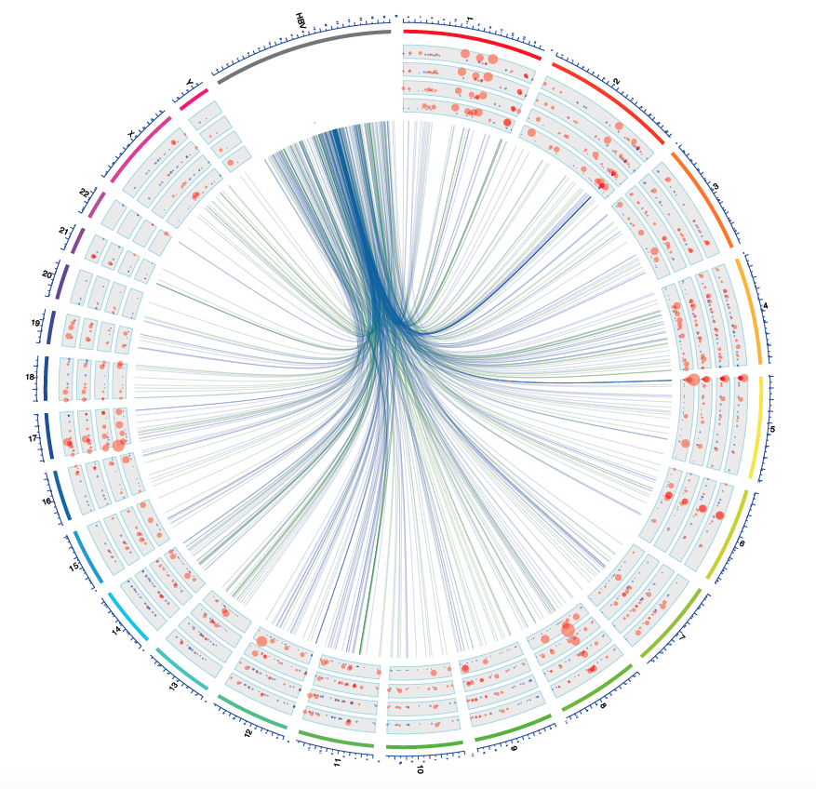

（B）Repeat vs non-repeat regons

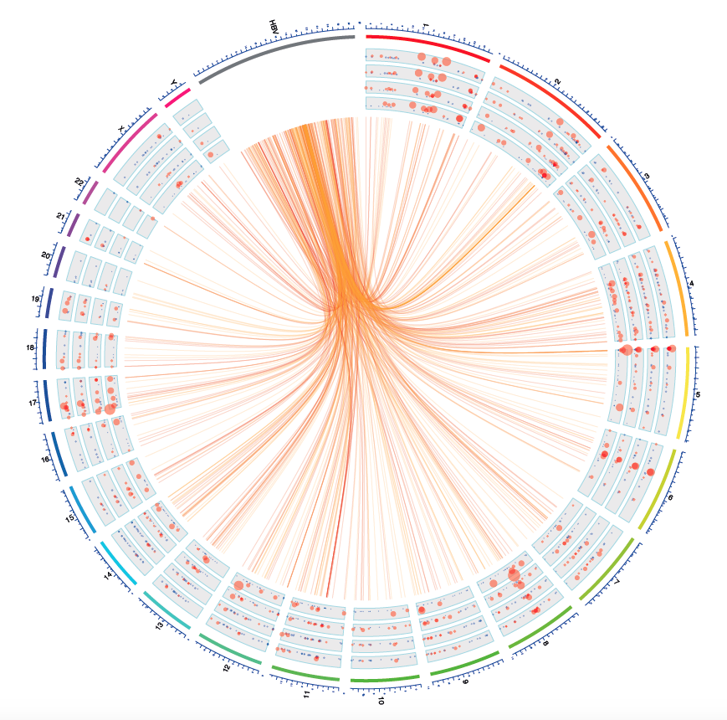

Figure S2. Recurrent integration events and integration burden in tumor tissues (A), in comparison with in normal samples (B). Sample I008 only has integration events detected in paired normal tissues, and sample amount (Sample n) in A is 16 and in B is 17.

(A)

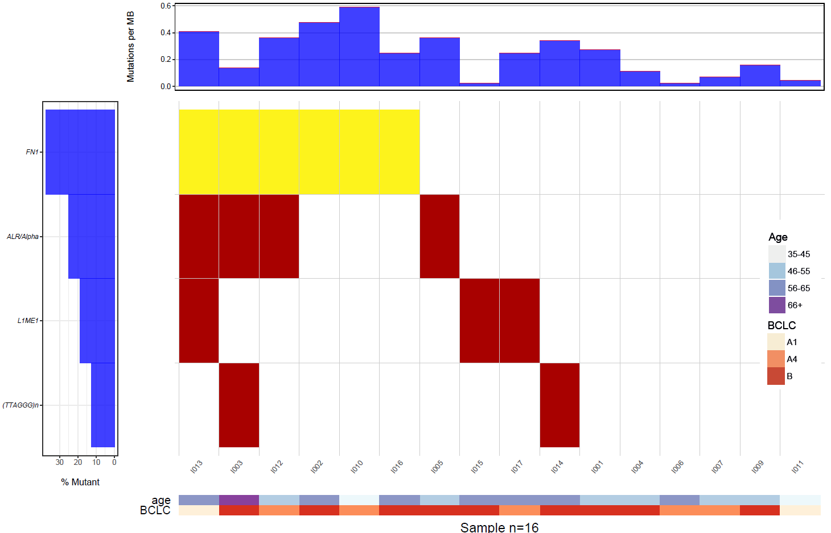

(B)

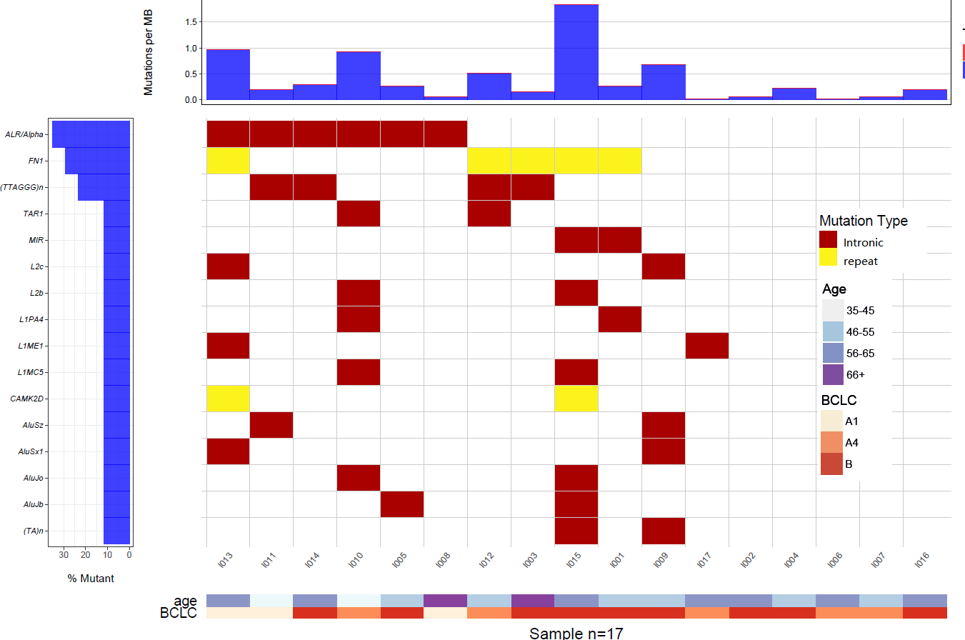

Figure S3. Distribution of all single junction reads in cfDNA from chronic hepatitis B patients. The top panel indicates the viral genes along HBV genome; the middle panel, the read depth for all the viral-host junction reads, shows the distribution of seemingly breakpoints in viral genome; in the bottom, alignment for these reads are grouped according to the chromosome orientation of the corresponding human sequence in the junction.



Figure S4. The distance between paired breakpoints within 10K region in human genome. The background distribution shows all the distances between breakpoints within 10K region in human genome. And we enlarge the distribution for the distances from -60 to +60 bp in the central panel. There were special 3 situations: first of all, the 0 value mean there was 1bp redundant sequence without clear orientation; secondly, the 1 indicated there were no sequence loss of human genome around the breakpoints; thirdly, negative distance indicating short repeat sequences around the breakpoints.

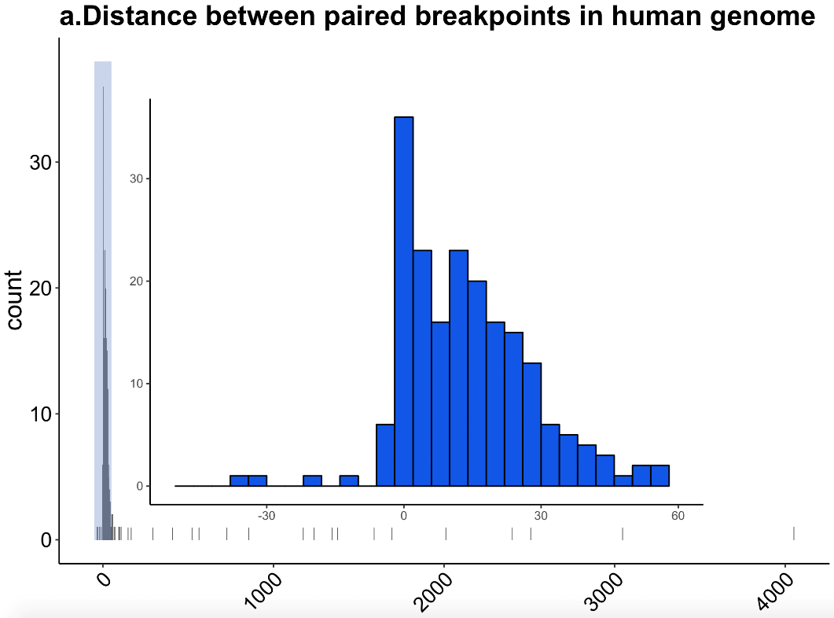

Figure S5

1. Structure variation in chromosome 8 in patient cf003. Copy number loss seems span from 8p to 8q21.3 , and genomic region from 8q21.3 to telomere shows LOH

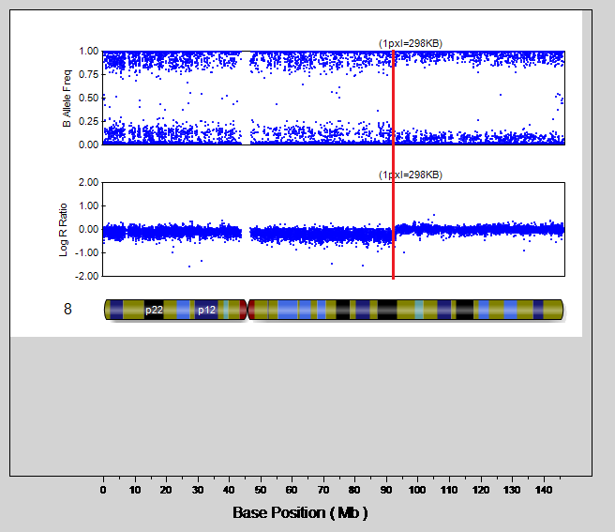

1. Copy number gain in 9p22.1 patient cf003

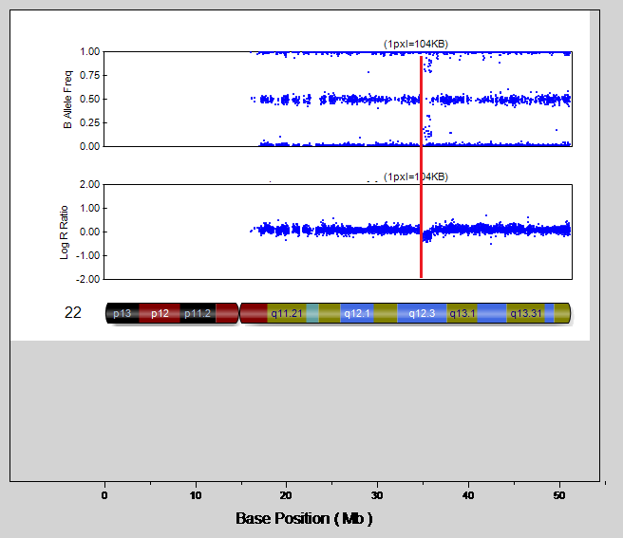

1. Copy number loss in 22q12.3 in patient cf003

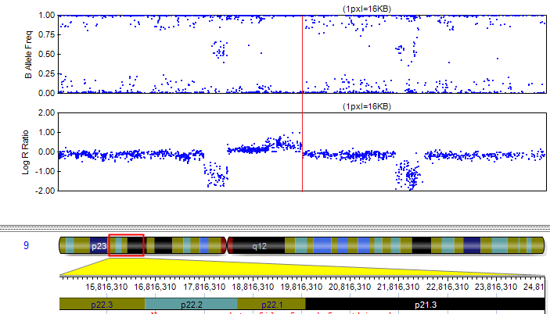

1. Copy number loss from 4q13.1 to telomere in patient cf004

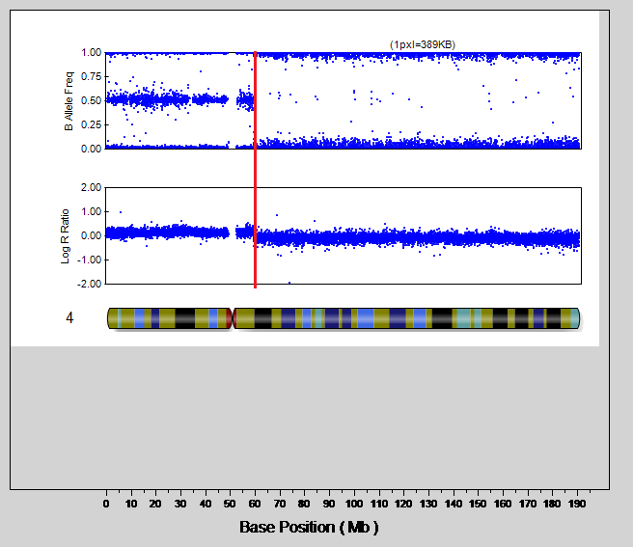

1. Copy number loss from 6q16.1 to telomere in patient cf004

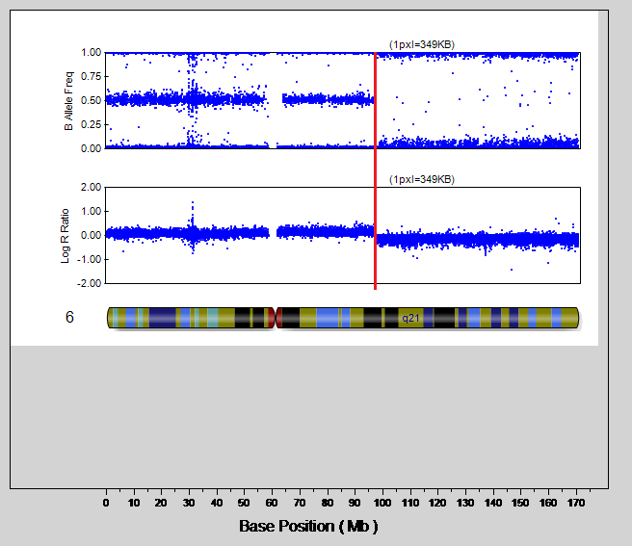

1. Copy number gain from telomere to 9p23 along with arm level LOH at 9p in patient cf004

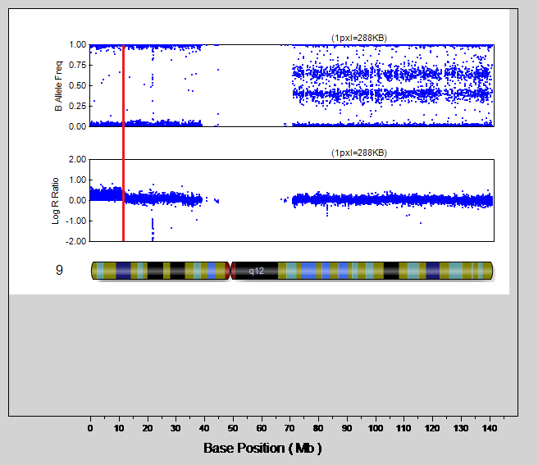

1. Copy number gain from 13q21.33-telomere in patient cf004.

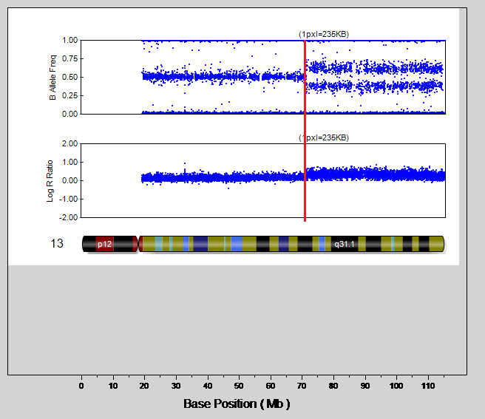

1. Copy number gain at 5p15.33 in patient cf005

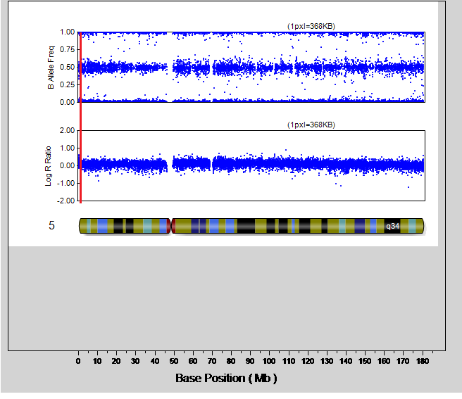

.

Figure S6. Integration events in each patients and corresponding patterns according to paired breakpoints in HBV genome.

