Supplementary Figure 1
Supplementary Figure 1. Characteristics of MHB in human genome. (a) Distribution of MHB sizes. (b) Distribution of MHB CpG density (CpGs/bp). (c) Co-localization of MHBs with known genomics features broken down by CpG density. We split all MHBs into quartiles where the CpGs/bp of each quartile is as follows: (0,0.046], (0.046,0.097], (0.097, 0.155], and (0.155,0.6]. Note that closed brackets are inclusive. The 1st quantile (MHBs with lowest CpG densities) are mostly in CGI shelf or shore, and are enriched for LAD, LOCK and enhancers.
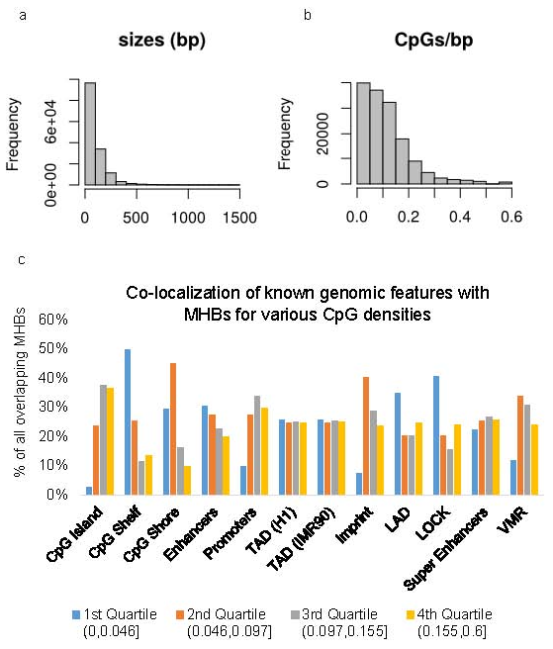
Supplementary Figure 2
Loss of CpG linkage disequilibrium replicated in two additional kidney cancer samples.
Two sets of kidney cancer WGBS data were downloaded from NCBI GEO(GSE63183), and processed with the same computational procedures.

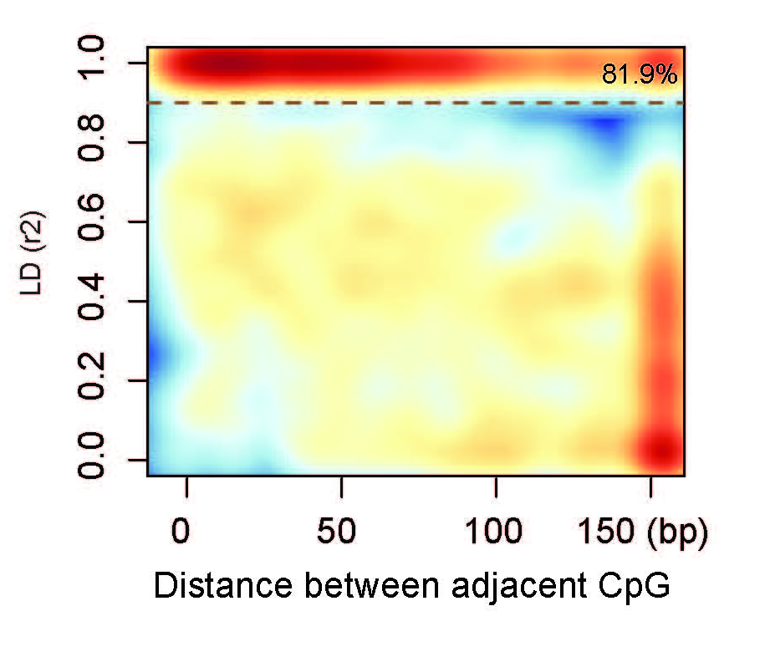
Supplementary Figure 3
Validation of MHB with Illumina HM450K methylation beadchip and RRBS data.
(a) Squared Pearson correlation coefficient (r2) versus LD r2 (b) The Pearson correlation coefficient (r2) for CpGs in RRBS and HM450K data were significantly higher in overlapped MHBs compared with the CpGs without overlapping with MHBs. IN denotes RRBS or HM450K regions within MHB. OUT denotes RRBS or HM450K regions beyond MHB regions.
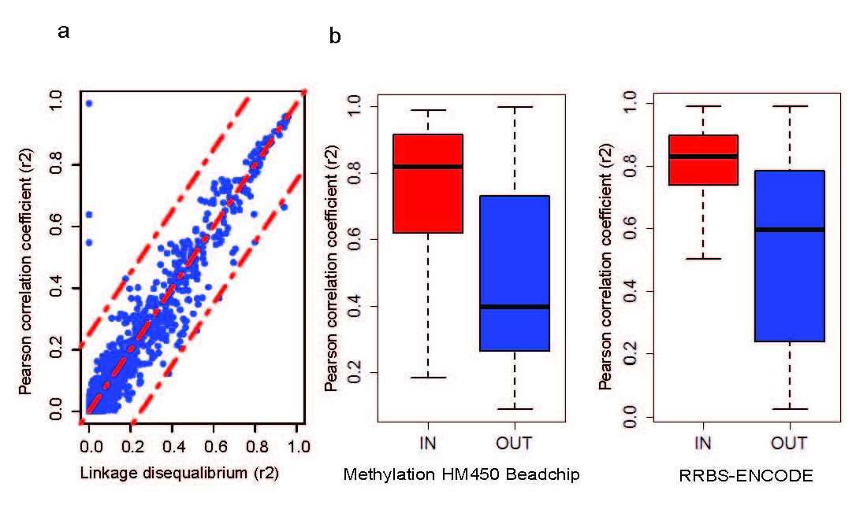
Supplementary Figure 4

Profiles of H3K27ac, H3K4me3 and H3K4me1 over methylation haplotype blocks for 12 adult tissue types.

X-axis are distances from the center of methylation haplotype blocks (+/- 1000) and y-axis are the average reads density in RPKM (input normalized reads per kilobase per million). Histones data were downloaded from NCBI GEO (https://www.ncbi.nlm.nih.gov/geo/roadmap/epigenomics/).
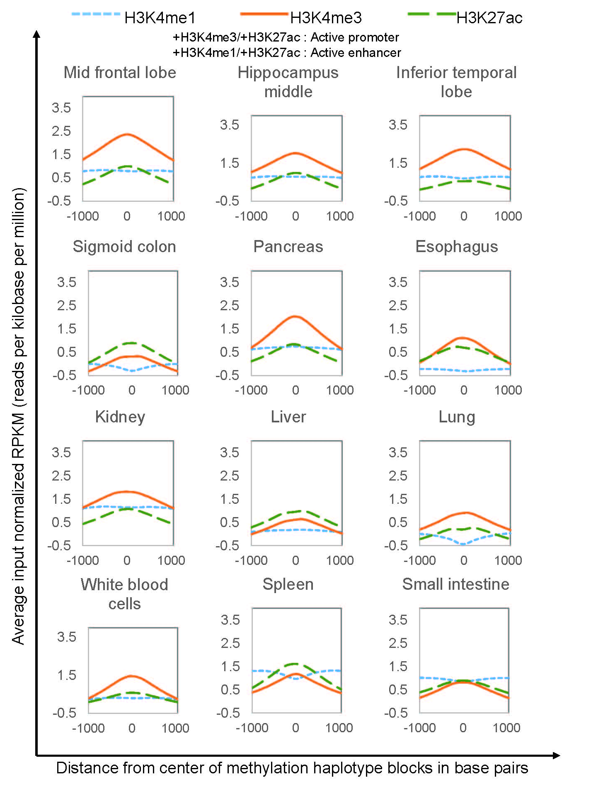
Supplementary Figure 5

PCA analysis of human tissues and cells based on methylation haplotype loads for MHB regions. Tissues and cells data were from WGBS datasets listed in Supplementary Table S13.
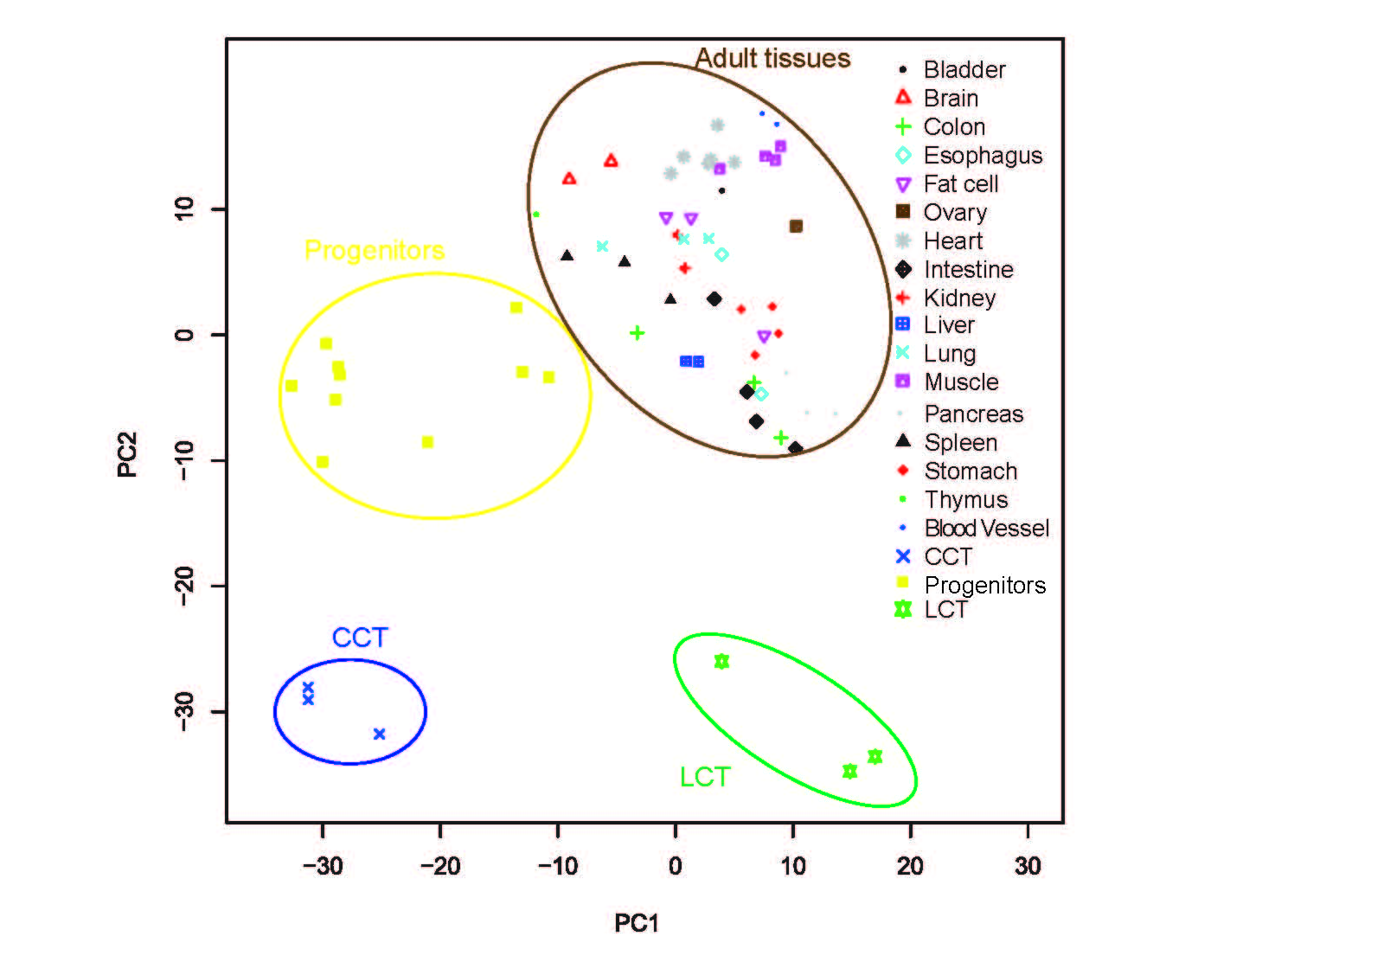
Supplementary Figure 6

Distinctive patterns of functional enrichment for transcription factors (TF) within binding sites associated with MHBs of hypo- (a) or hyper- (b) MHL.
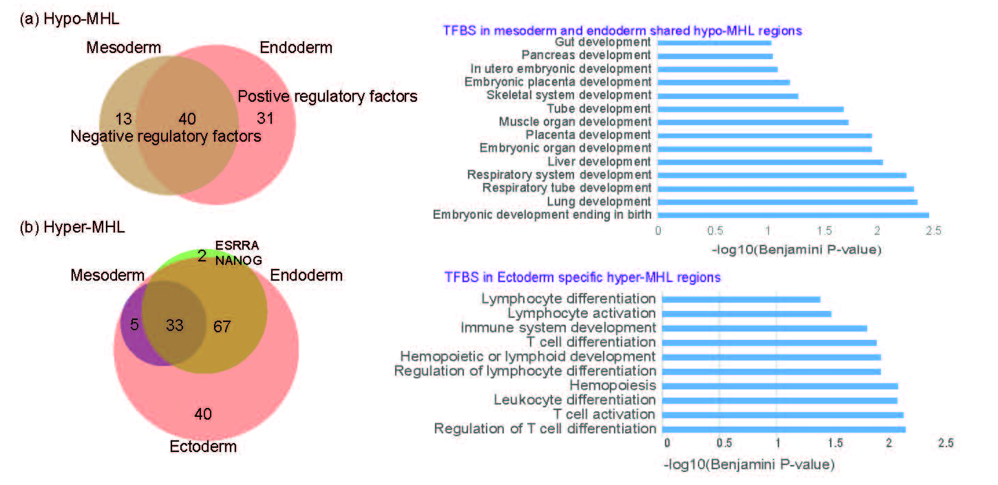
Supplementary Figure 7

Distribution of incidence of cancer-associated HMH in CRC and LC plasma samples.

Y-axis denotes the frequency of caMHM and x-axis denotes the incidence (sample number) of the caHMH in cancer plasmas. The majority caHMH are patient specific while a few have high incidence among the cancer plasma samples.
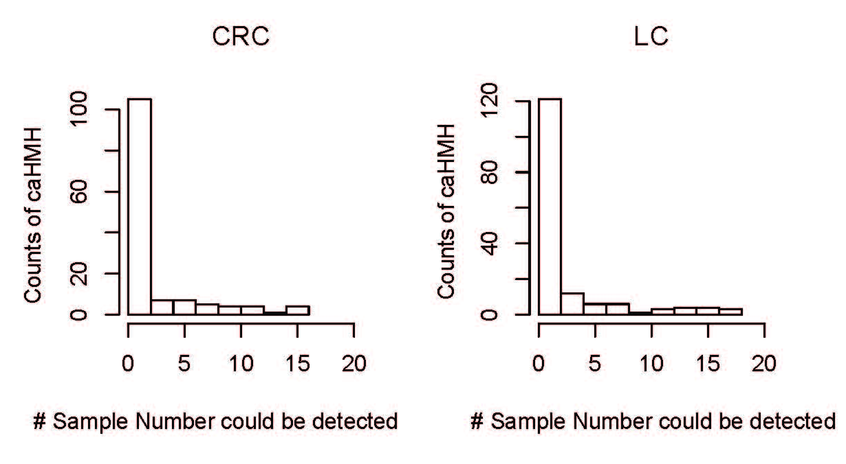
Supplementary Figure 8
Deconvolution of cancer and normal plasma using non-negative decomposition with quadratic programming. (a) Deconvolution accuracy as a function of tumor fraction. Red line indicates the diagonal line where prediction equals to the expected values; black circles indicate the deconvolution values. (b) Tumor proportions estimated by deconvolution of cancer patient and normal plasma samples.

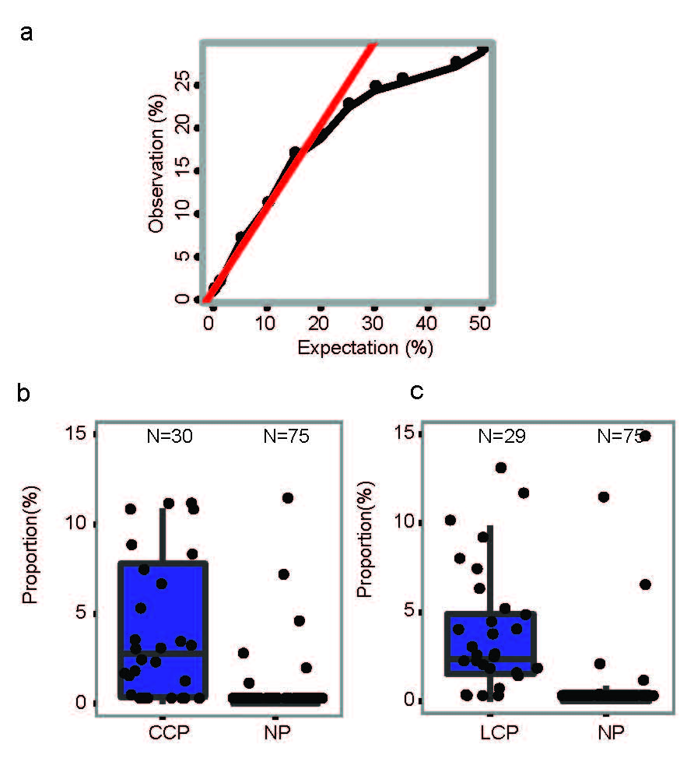
Supplementary Figure 9

Estimated tumor fraction in plasma is generally correlated with the normalized yield of DNA extraction. CCP denotes colorectal cancer plasma, LCP denotes lung cancer plasma and NP denotes normal plasma.
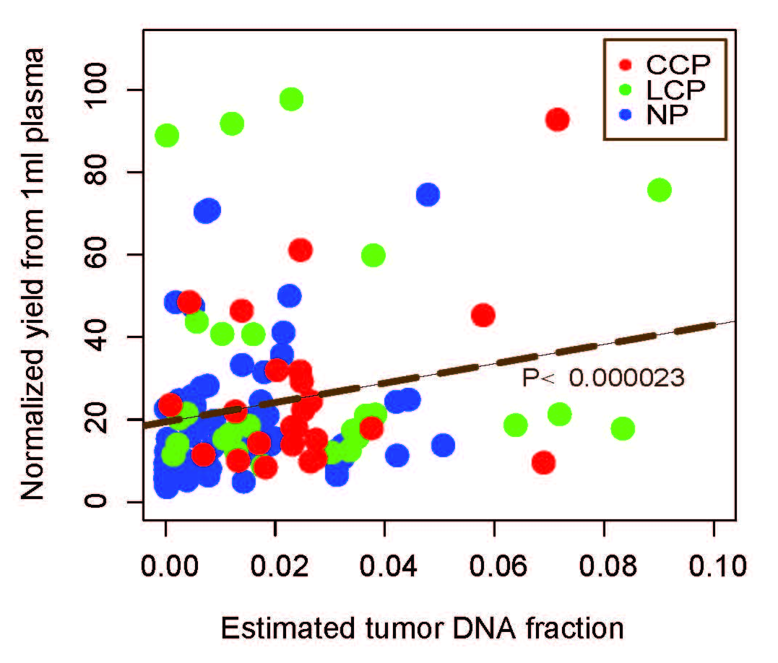
Supplementary Figure 10
Tissue-of-origin mapping based on tissue-specific MHBs counting.
CCP denotes colorectal cancer plasma, LCP denotes lung cancer plasma and NP denotes normal plasma. Color bar represents the number of tissue specific MHBs over threshold detected in each plasma sample.

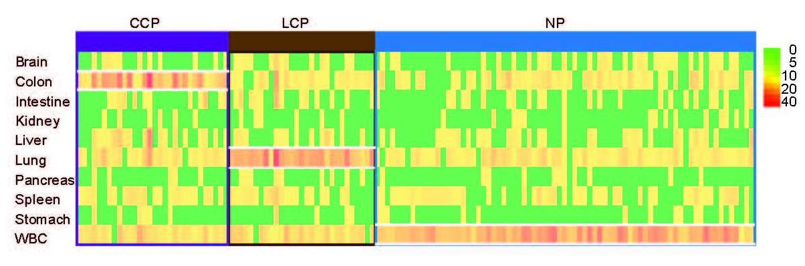
Supplementary Figure 11
Lung cancer detection in plasma through integration of methylation signatures from normal lung and cancer tissues (CT).
(a) Distribution of the number of normal lung or cancer-related MHBs for each of the lung cancer plasma samples. (b) A typical lung cancer plasma sample that shows enrichment (based on Z-scores for each predictor region) of normal lung and cancer tissues fragments. (d) The sensitivity and specificity for predicting lung cancer plasma was improved by combining the predictors for normal lung and cancer tissues. Adjusting the cutoff for the Z-scores changed the specificity and sensitivity, resulting in the ROC curves. AUC denotes area under the curve.

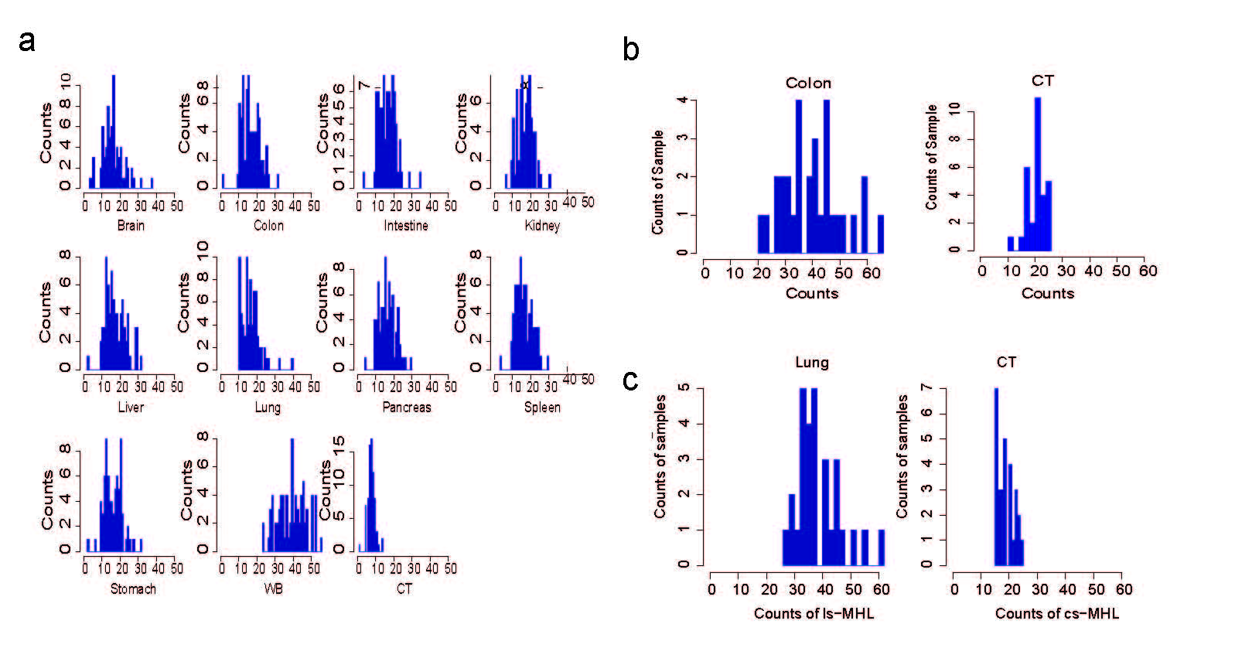
Supplementary Figure 12
Prediction performance to each of the 11 references, and to cancer plus the tissues-of-origin.
(a) ROC curves for colon cancer plasma. (b) ROC curves for lung cancer plasma. (c,d) AUC values for colon cancer and lung cancer plasma samples.

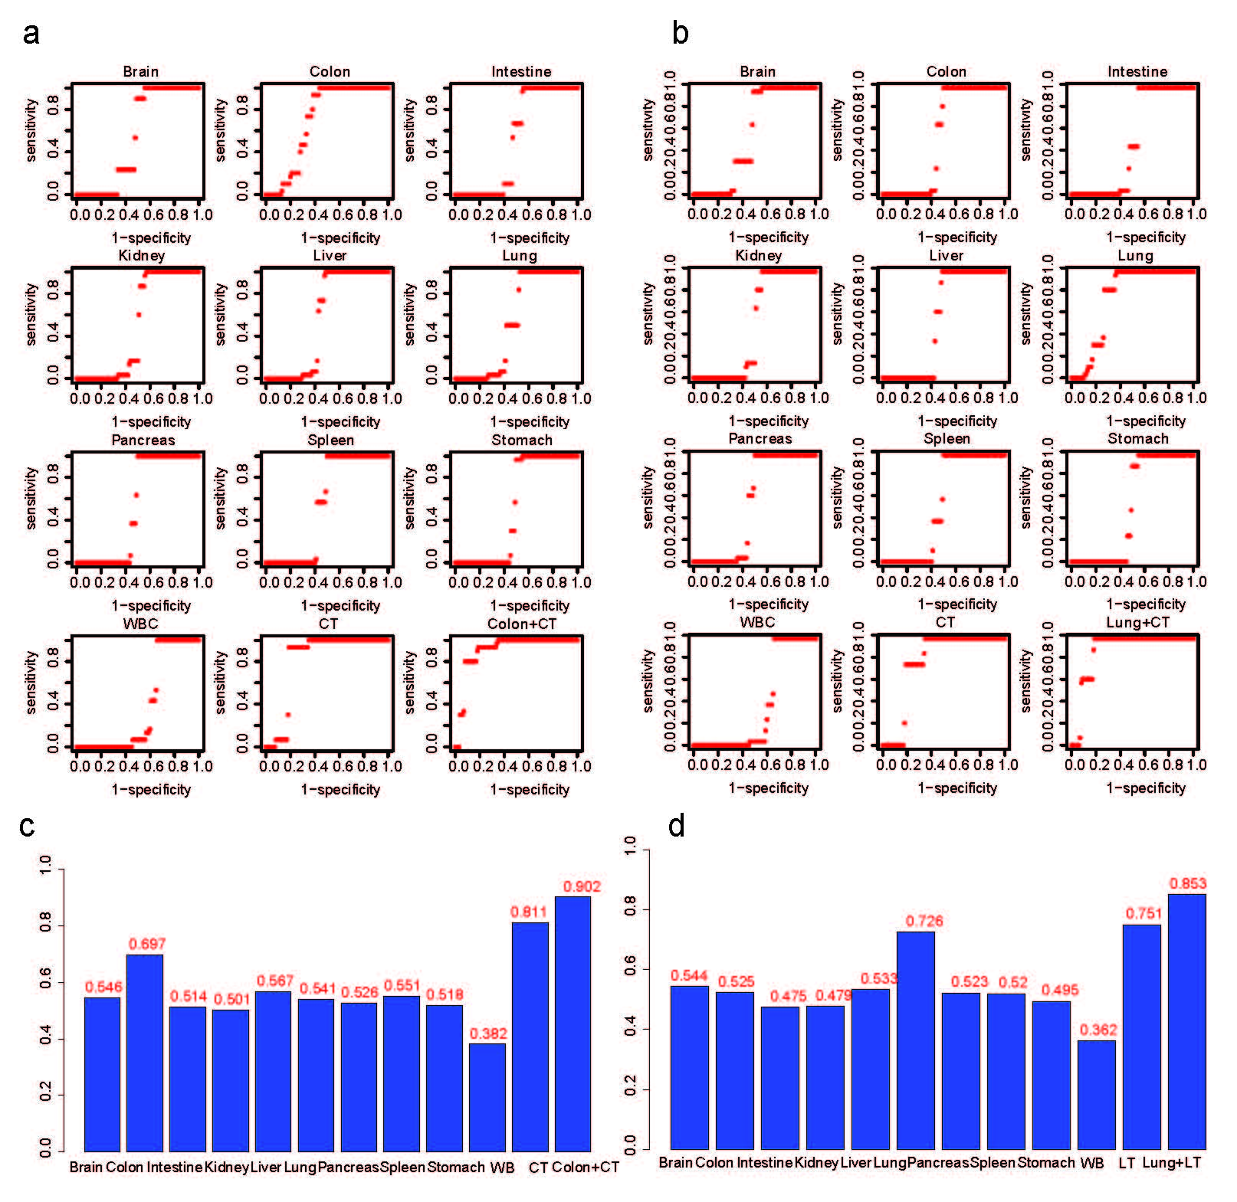
Supplementary Figure 13
Flowchart of samples used in each analysis.

