CASE No._SD2014-173_________

PROPRIETARY INFORMATION

UC SAN DIEGO TECHNOLOGY TRANSFER OFFICE
INVENTION AND TECHNOLOGY DISCLOSURE FORM

Please attach additional sheets as necessary.

- TITLE OF INVENTION
Create a short title describing the general nature of the invention without revealing the specific details that would enable others to reproduce the invention (e.g., new anticancer compound, method for chip fabrication, etc.). Please limit the title to 60 characters.

Methylation haplotyping based tumor-of-origin mapping for plamsa samples

B. 1. UCSD INVENTOR(S) List all UCSD employees or students who intellectually contributed to the invention. Please also indicate any joint or special appointment with non-UCSD institutions (e.g., VA and HHMI) in the “Position” box.

Name:  Kun Zhang | UCSD Employee #: 00927755  Citizenship: China PR. | Position: Associate Professor  Joint or Non-UCSD Affiliation: □VA □ HHMI  Other: _______________________________
School or Division: Engineering  Dept. or ORU: Bioengineering | Work Address: PFBH 402/406 9500 Gilman Dr La Jolla, CA 92093  UCSD (or VA) Mail Code: 0412
Work. Phone: 858 822 7876 | Work. Fax: | Email: kzhang@bioeng.ucsd.edu
Home Address:  11733 Boulton Avenue, San Diego, CA 92128 |  | Home Phone:617-646-9898  Home Email: kun.zhang.ucsd@gmail.com

Name:  Shicheng Guo | UCSD Employee #:000022281  Citizenship: China PR. | Position: Postdoctoral Scholar  Joint or Non-UCSD Affiliation: □VA □ HHMI  Other: _______________________________
School or Division:  Dept. or ORU: | Work Address: PFBH 402/404 9500 Gilman Dr La Jolla, CA 92093  UCSD (or VA) Mail Code: 0412
Work. Phone: 281 685 5882 | Work. Fax: | Email: scguo@bioeng.ucsd.edu
Home Address:  7699 Palmilla Drive #3108, San Diego, CA 92122, USA |  | Home Phone:  Home Email: Shihcheng.Guo@gmail.com

- 2. INVENTORS NOT AFFILIATED WITH UCSD
If an inventor is not a UCSD employee or student, please provide information below.

Name: | Position: |  | Nature of employment::
Employer: |  | Work Address:
Work Phone: | Work Fax: |  | Email:
Nature of Contribution (please provide information explaining why this person is a co-inventor):

Name: | Position: |  | Nature of employment::
Employer: |  | Work Address:
Work Phone: | Work Fax: |  | Email:
Nature of Contribution (please provide information explaining why this person is a co-inventor):

- FUNDING SOURCES FOR THE PROJECT UNDER WHICH THE INVENTION WAS MADE
As funding often carries obligations to a sponsor, be sure to include all outside agencies, organizations, or companies that provided any funding to any inventor for the research that led to the conception or first actual reduction to practice of the invention. Please include any companies that have supplied materials in exchange for intellectual property rights.

SPONSOR(S) | GRANT NUMBER | PRINCIPAL INVESTIGATOR
NIH | R01GM097253 | Kun Zhang

Is there any other corporate relationship that we should be aware of concerning this invention? □ Yes □ No

Name of Company: ________________________________________________________________________________________

Please explain the nature of the relationship: ____________________________________________________________________

Are you a consultant to the company list ed? □ Yes □ No

- MATERIAL TRANSFER AGREEMENT (MTA)
Please list and attach copies, if available, of any Material Transfer Agreement or any other written or oral agreement used to obtain any material used for this invention.

- DESCRIPTION OF EVENTS:
This information is important for deciding priority of invention and/or legal "bars" to patenting. In general, publications, in any medium, before the date a formal patent application is filed in a national patent office can cause a bar to patent filing in most foreign countries. While United States patent law allows
inventors up to one year to file a patent application after the first publication, public use, or sale, the loss of foreign rights is often very important to potential industrial licensees.
EVENTS | DATE | INDICATE THE WRITTEN RECORD  (e.g., notebook, letter, email).  IF ORAL DISCLOSURE, INDICATE TO WHOM
1. Initial conception of the idea | 8/12/2014 | Zhang lab electronic notebook
2. First description of complete invention, oral or written | 2/14/2016 | Email communication.
3. First successful demonstration (first actual reduction to practice) | 4/13/2016-5/4/2016 | Zhang lab electronic notebook
4. Has this work been:
i. | Submitted for publication? | □ Y | □N
ii. | Accepted for publication? | □ Y | □ N
iv. | Published? | □ Y | □ N

5. Have you presented this work at a conference or meeting?
 |  | □ Y | □ N
i. | Did you submit an abstract? | □ Y | □ N
ii. | Was abstract published? | □ Y | □ N
iii. | Did presentation include handouts? | □ Y | □ N
iv. | Name of conference or meeting?

F. INVENTORS' SIGNATURES G. WITNESS - invention disclosed to and
By signature below, I acknowledge my responsiblities and understood by:
rights to royalty-sharing under the current University of California
Patent Policy.

_____________________________ __________________ _______________________________ ________________
Inventor signature Date Witness signature Date

_____________________________ __________________ ________________________________
Inventor signature Date Print witness name

_____________________________ __________________
Inventor signature Date

_____________________________ __________________
Inventor signature Date

- ABOUT THE INVENTION

Please write a summary of the invention following the numbered guidelines listed below. Since this information will be used to determine patentability, commercial uses, and potential licensees of the invention, please provide as many details as possible. If you have a written manuscript descriptive of your invention, please also attach a copy to this form.

- What exactly does your invention do?

This invention allows the deconvolution of mixed DNA molecules in plasma samples based on the originating tissue types, and to detect low-abundant DNA from different tissue(s) at an extremely high sensitivity. Meanwhile, methylation haplotype load (MHL) was proposed to indicate the methylation level and complexity of methylated haplotypes simultaneously. Since methylation haplotypes would be released from cancer tissues to the plasma, MHL could be applied to estimate and infer the source of the DNA molecules. With the approach of tissue-sepecific MHBs counting , we could mapping the aberrant DNA fragement to its corresponding tissue-of-origin. This invention can be implemented as a number of clinical diagnostic tests, such as non-invasive detection of fetal aneuploidy in maternal blood at a very early stage of pregnancy, non-invasive detection of circulating tumor DNA in patient’s blood.

- What is unique, novel, or better about your invention as compared to existing art?

The most unique aspect of this invention is to use methylation haplotypes and its derived function of methylation haplotype load (as appose to individual CpG sites) to improve detection sensitivity and reduce technical noise for detecting low abundance species in mixed DNA samples. Methylation haplotype is the combinatorial DNA methylation status of multiple CpG dinucleotides (also called “sites” or “loci”) in a single DNA molecule. Multi-locus haplotypes are robust with the presence of random technical errors on individual loci, and hence provide a much greater power in distinguishing true signatures at a low abundance from technical errors. Integrating haplotypes from multiple genomic locations, and differential haplotype analysis of DNA fragments with different sizes further increases the power. A higher sensitivity translates to robust detection at earlier timepoints, as well as lower assay costs.

For non-invasive cancer detection from peripheral blood, there is no mature commercial assays in the market. Assays at various stages of development include enrichment of rare circulating cancer stem cells followed by subsequent analyses, detecting of circulating microRNAs or DNA. This invention is superior in both the detection sensitivity as well as the simplicity for implementation.

Note that haplotypes has been used for fetal genome sequencing from maternal blood (Kitzman et al. 2012; Fan et al., 2012). However, these methods focus on genetic variants and long-range haplotypes of genetic variants. Such haplotypes have to be determined by additional methods, such as clone-based haplotyping, or single chromosome isolation and sequencing. This invention is related to methylation haplotypes, or epigenetic modifications (cytosine methylation) on multiple CpG sites of single DNA molecules. Such methylation haplotypes can be obtained by the standard short-read sequencing platforms, such as Illumina’s HiSeq/MiSeq or LifeTech’s Ion Proton, as part of the methylation assay without extra efforts and cost.

Compared with traditional prediction model (such as random forest), our new strategy based on tissue-specific MHB counting approach is suitable for sparse low coverage methylation sequencing dataset, especially consindering that the cfDNA of the cancer patients only include quite low level cancer DNA fragements and stochastic releasing process from solid tissues to plasma.

- What is the existing art to which you are comparing?

US Patent 8,450,061 Quantification of a minority nucleic acid species
US Patent 8,586,313 DNA methylation markers based on epigenetic stem cell signatures in cancer
US Patent 8,563,242 Method for detecting chromosomal aneuploidy
US Patent 8,293,470 Non-invasive fetal genetic screening by digital analysis
US Patent 8,288,100 Methods for detecting fetal DNA in a plasma or serum sample from a pregnant woman
US Patent 8,026,067 Marker for prenatal diagnosis and monitoring
US Patent 8,110,361 DNA methylation markers associated with the CpG island methylator phenotype (CIMP) in human colorectal cancer

- Describe how your invention works (or may work). Please include drawings, schematics, figures, etc., necessary to
explain how the invention works or may work.

Human peripheral blood contains low levels of DNA molecules from other tissues or cell types, such as circulating cancer stem cells or cell-free DNA from apoptotic cancer cells in cancer patients, or fetal DNA in pregnant women. DNA methylation signals along with the DNA molecules are released into the blood simultaneously and these methylation signals could be tissue-specific and then could be applied to infer the tissue source of the DNA fragement. Our prevous patent has been demonstrate methylation haplotype could provide high sensitivity dection of DNA molecules form DNA samples, thus, through detecting and quantify such low abundance DNA molecules with the form of methylation haplotype load within (MHL) methylation haplotype block regions (MHB) , we could estimate the DNA origin source from different tissues (such as cancer tissues or fetal system).

As the beginning of the implemention to our invention, DNA molecules are collected from plasma samples (including patients or healthy individuals) and then the DNA methylation status for each cell-free DNA molecule are measured by a target methylation sequencing technology (Reduced representation bisulfite sequencing, RRBS, Meissner et al. 2005) . Note that alternative technologies, such as BSPP (Diep et al.2012), micro-droplet PCR (Komori et al. 2011), Selector probes (Johansson et al. 2011) or MeDiP (Papageorgiou et al. 2010) can also potentially be used with some differences in the requirement of input materials and/or cost.Therefore, this invention should cover the aforementioned three key concepts, not a specific implementation based on the RRBS technology.

As we mentioned above, regardless of the specific sample preparation methods or sequencing platforms used, our method takes the bisulfite sequencing reads (single-ends or paired-ends) as the input. We derived methylation haplotypes and their abundance from the raw sequencing reads. Each haplotype represent the combination of binary methylation status (methylated or unmethylated) at multiple CpG sites of one sequencing read. A specific bioinformatic pipeline is created to deal with methylation haplotype and futher derived matrics (programming by Perl language), such as methylation haplotype (successive methylation allele combination), methylation haplotype block (linkage disequlibrium regions), methylation haplotype load (weighted methylation level by methylation allele position).

To identify the most informative methylation regions/marker which could be used for the diagnosis or tissue mapping, we proposed methylation haplotype block (MHB), in which the methylation status are highly linkage (correlated) and could be taken as co-methylation regions. We collected huge number of Whole Genome Bisulfite Sequencing (WGBS) data including abundant cell type and status, such as stem cell, cancer cell and normal adult tissues to provide the most comprehensive and accurate identification of MHBs in human genome. We identified a total of 147,888 MHBs in human genome. We demonstrate MHB have different characteristic in different cell types such as cancer cells, normal adult cells and stem cells and progenitors. We also proved that the MHBs that we identified represent a distinct class of genomic feature. Fo example, co-localization analysis of MHB with regulatory regions found that MHBs appear to represent a distinct type of genomic feature that partially overlaps with multiple well-documented genomic elements, such as enhancer, super-enhancer, promoter, imprinted genes regions, variable methylation regions (VMR), CpG island and active promoters (H3K4me3 with H3K27ac) regions.

After defined the MHB regions which would be applied in cancer diagnosis and tissue mapping, we define a methylated haplotype load (MHL) for each methylation haplotype block region, which is the normalized fraction of methylated haplotypes at different length to indicate the methylation levels and complexity for the methylation population.
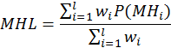
Where i is the length of haplotypes, P(MHi) is the fraction of fully methylated haplotype with i loci. For a haplotype (a string) of length L, we considered all the sub-strings with length from 1 to L in this calculation. wi is the weight for i-locus haplotype. We typically used wi=i or wi=i² to favor the contribution of longer sub-strings.

MHL was proved to have best distinguish ability to different methylation mixtures compared with methylation level, methylation entropy and epi-polymorphism (Figure 1). In addition, MHL is bounded between 0 and 1, which allows for direct comparison of different regions across many data sets without normalization.

After calculating MHL for all candidate regions for all samples, we built a MHL matrix for different tissue samples (61 publish samples/dataset). We demonstrated MHL matrix could be powerfully applied for tissue distinguish and could be also used to infer the germ layer speciation with specific feature selection method (filter method to random forest variable importance score). Note that alternative technologies, such filter methods to difference chi-seq, wrapper methods to information gain, embedded methods to correlation coefficient and other combination can also potentially be used with some differences to do the feature selection procedure.Therefore, this invention should cover the aforementioned three key concepts, not a specific implementation based on the random forest method.

We then compiled 43 WGBS (human adult tissues, published data) and WGBS data sets for 10 human normal tissues (our lab) that have high cancer incident rate, and identified a set of 2,880 tissue-specific MHBs as the candidates marker for the next step cancer plasma mapping. We used these tissue-specific MHBs or subsets to predict the tissue-of-origin for 53 sample with the approach by counting the total number of tissue-specific MHBs and comparing with all other tissues so that to infer the maximum likehood of the tissue origin. At the cutoff of minimal 10 tissue-specific methylated haplotypes per tissue type, we observed an average 90% accuracy for mapping a data set from the primary tissue to its tissue type. We then collected plasma from 59 cancer patients (including 30 colon cancer and 29 lung cancer) and 75 normal individuals. We applied above method to the full set of plasma data, and achieved an average prediction accuracy of 82.8%, 88.5%, 91.2% for the plasma from colorectal cancer, lung cancer, and control plasma samples respectively with 5-fold cross-validation (Figure 3).

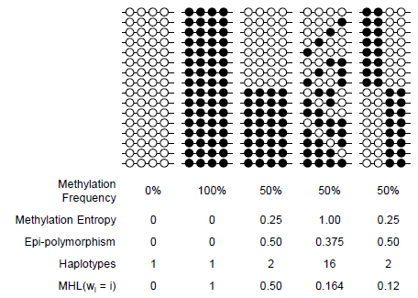

Figure 1. Advantage of MHL in the measurement of methylation level and complexity compared with other metrics. Black circle denotes methylated CpG while white circle denotes un-methylated CpG.

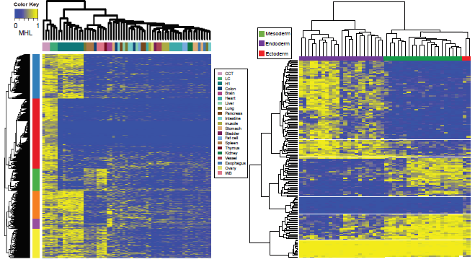

Figure 2. Distinguish ability of MHL in human tissues, stem cell, cancer cells and development lineage. left panel: cluster analysis of human tissues, stem cell and cancer cells based on MHL. Right panel: cluster anlysis of developmental lineage based on MHL.

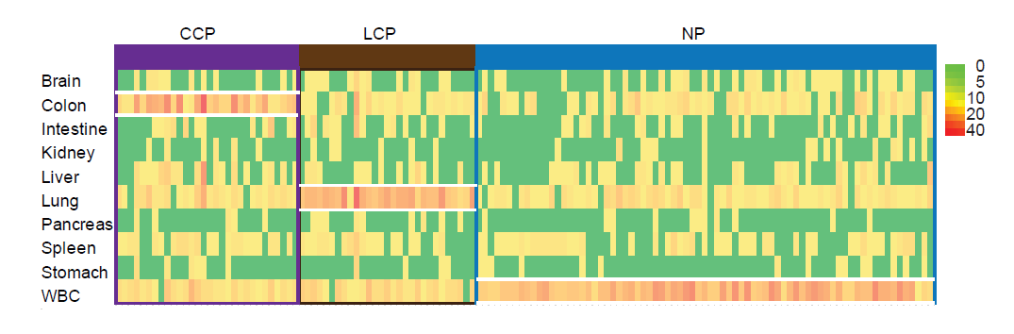

Figure 3. Tissue-specific MHBs counting approach mapping the plasma to its tissue-of-origin. The cancer plasma would carry more tissue-of-origin specific MHBs. CCP denotes colorectal cancer plasma, LCP denotes lung cancer plasma and NP denotes normal plasma.

- Describe the stage of development of the invention (e.g., concept stage, experimental data stage, computer model simulation stage, working prototype stage, etc.). Please include data, photographs, etc., indicating the stages of development.

To investigate the co-methylation status of adjacent CpG sites along single DNA molecules, we extended an approach described in our previous study, in which we applied the concept of genetic linkage disequilibrium and the r² metric to quantify the degree of coupled CpG methylation among different DNA molecules. CpG methylation status of multiple CpG sites in single- or paired-end Illumina sequencing reads were extracted to form methylation haplotypes, and pairwise “linkage disequilibrium” of CpG methylation r² was calculated from the abundance of different methylation haplotypes. We then partitioned the genome into blocks of tightly coupled CpG methylation sites, which we called Methylation Haplotype Blocks (MHBs, Figure 1B), using a r² cutoff of 0.5. Similar to the partitioning of genetic haplotype blocks, slightly different cutoff values, such as 0.3 or 0.7, resulted in only minor quantitative differences in the block size and number without affecting the global pattern.

To characterize the global pattern and distribution of MHBs, we started with 51 sets of published Whole Genome Bisulfite Sequencing (WGBS) data from human primary tissues, as well as the H1 human embryonic stem cells and in vitro derived progenitors. We also included an in-house generated WGBS data set from 10 adult tissues of one human donor. Across this set of 61 samples (>2000x combined genome coverage) we identified ~ 55 billion methylation haplotype informative reads that cover 58.2% of autosomal CpGs. We identified a total of 147,888 MHBs at the average size of 95bp and minimum 3 CpGs per block, which represents ~0.5% of the human genome (Table 1). The regions not covered by such blocks have low CpG density and hence too few CpG sites within Illumina read pairs for deriving informative haplotypes. The majority of CpG sites within the same MHBs are near perfectly coupled (r2 ~1.0) regardless of the sample type. We found that methylation LD extends further along the DNA in stem cells and progenitors, compared with normal adult tissue, both in the fraction of tightly coupled CpG pairs (94.8% versus 91.2%), and the over-representation of partially coupled CpG pairs that are over 100 bp apart (Figure 4). This is consistent to our previous observations on a smaller BSPP data set on 2,020 CpG islands and another previous report. Interestingly, in primary tumor tissues, we observed a reduction of perfectly coupled CpG pairs, which could be related to the pattern of discordant methylation recently reported in VMR.

While WGBS data allowed us to unbiasedly identify MHBs across the entire genome, the 61 sets of data did not represent the full diversity of human cell/tissue types. To validate the presence of MHBs in a wider range of human tissues and culture cells, we examined 101 published reduced representation bisulfite sequencing (RRBS) datasets from ENCODE cell lines and tissue samples, as well as 637 sets of Infinium HumanMethylation450 BeadChip (HM450K) data including 11 human normal tissues from TCGA project. The ENCODE RRBS data sets were generated with short (36bp) Illumina sequencing reads, greatly limiting the length of methylation haplotypes that can be called. Similarly, Illumina methylation arrays only report average CpG methylation of all DNA molecules in a sample, preventing a methylation linkage disequilibrium analysis. Therefore, we calculated the pairwise correlation coefficient of adjacent CpG methylation levels across different sample sets for block partitioning. Note that the presence of such correlated methylation blocks is a necessary but not sufficient condition for MHBs (Figure 5a). Nonetheless, the absence of correlated methylation blocks in these data would invalidate the pattern of MHBs. We identified 23,517 and 2,212 correlated methylation blocks from ENCODE RRBS and TCGA HM450K array data respectively, among which 8,920 and 1,258 have significant overlaps with WGBS-defined MHBs. Additionally, we observed significantly higher correlation among the CpGs within the MHB regions compared CpG loci outside MHBs in HM450K and RRBS dataset, further supporting the block-like organization of local CpG co-methylation across a wide variety of cells and tissues (Figure. 5b). Taken together, the MHBs that we identified represent a distinct class of genomic feature where local CpG methylation is established or removed in a highly coordinated manner at the level of single DNA molecules, presumably due to the processive activities of the related enzymes and the local density of CpG dinucleotides.

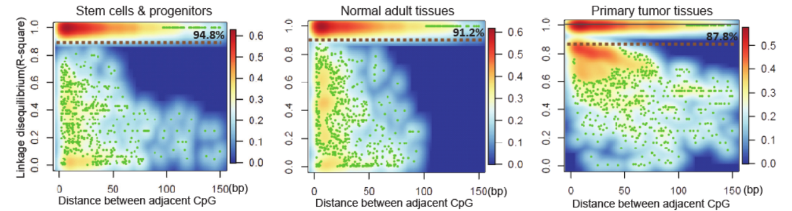

Figure 4. Distribution of methylation linkage disequilibrium between adjacent CpG sites in stem cells and progenitors, normal adult tissues, and primary tumors.

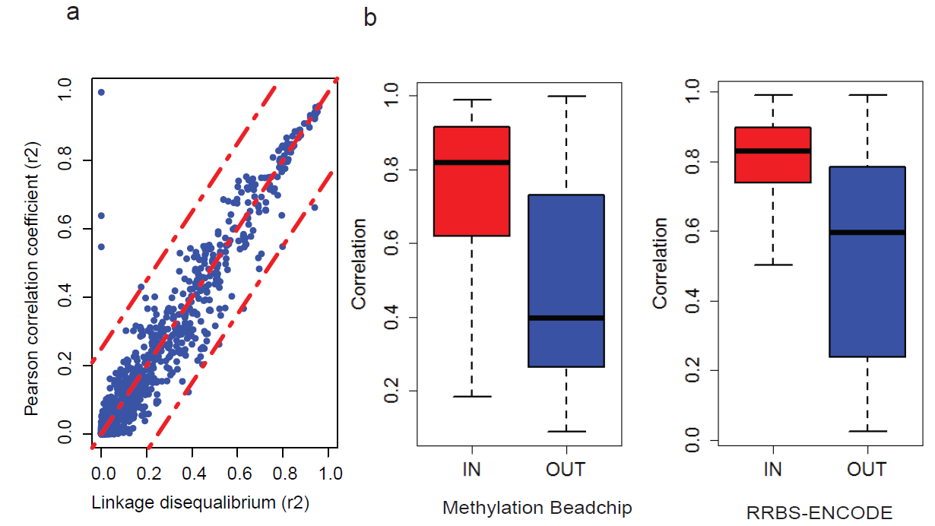

Figure 5. Validation of MHB with Illumina 450k methylation array and RRBS data. (a) Absolute Pearson’s r versus absolute LD r² (b) The Pearson's r² in RRBS and HM450K were significantly higher in overlapped MHBs with WGBS compared with the MHBs without overlapping with WGBS MHBs

MHBs appear to represent a distinct type of genomic feature that partially overlaps with multiple well-documented genomic elements (Figure 6a,b). Among all the methylation blocks, 60,828 (41.1%) were located in intergenic regions while 87,060 (58.9%) regions in transcribed regions. These MHBs were significantly (p-value<10⁻⁶) enriched in enhancers (enrichment factor=7.6), super enhancers (enrichment factor=2.3), promoter regions (enrichment factor=14.5), CpG islands (enrichment factor=70.4) and imprinted genes (enrichment factor=54.6). In addition, we observed modest depletion in LAD and LOCK regions (46% and 37% of the expected values), modest enrichment in TAD, and a very strong (26-fold) enrichment in variable methylation regions (VMR). (Figure 6c). To decouple the influence of CpG density, we further examined a subset of MHBs that do not overlap with CpG islands, and observed a consistent enrichment pattern (Figure 6c). Previous studies on mouse and human demonstrated that dynamically methylated regions were associated with regulatory regions such as enhancer-like regions marked by H3K27ac and transcription factor binding sites. In human, 21.8% of autosomal CpGs were found to be differentially methylated across 30 human cell and tissue types. These CpGs were enriched at low to intermediate CpG density promoters. Using publicly available histone mapping data for human adult tissues, we found co-localization of methylation haplotype blocks with marks for active promoters (H3K4me3 with H3K27ac), but not for active enhancers (no peak for H3K4me1). Therefore, MHBs likely capture the local coherent epigenetic signatures that are directly or indirectly coupled with transcriptional regulation.

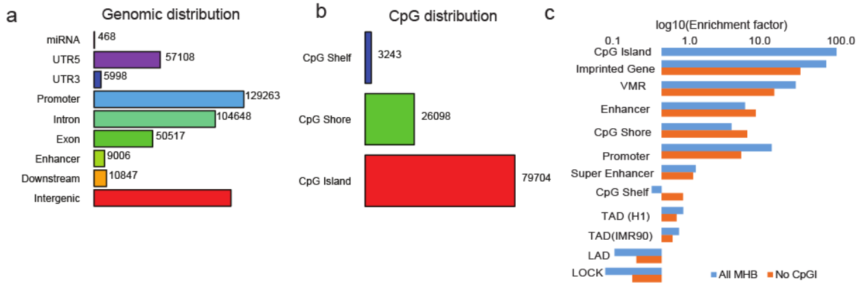

Figure 6. Co-localization of MHBs with known genomic features and enrichment of MHBs in known genomic features.

To enable quantitative analysis of the methylation patterns within individual MHBs across many samples, we need a single metric to define the methylated pattern of multiple CpG sites within each block. Ideally this metric is not only a function of average methylation level for all the CpG sites in the block, but also can capture the pattern of co-methylation on single DNA molecules. For this purpose, we defined Methylation Haplotype Load (MHL), which is a weighted mean of the fraction of fully methylated haplotypes and substrings at different lengths (i.e. all possible substrings). Compared with other metrics used in the literature (methylation level, methylation entropy, epi-polymorphism and haplotypes counts), MHL is capable of distinguishing blocks that have the same average methylation but various degrees of coordinated methylation (Figure 1). In addition, MHL is bounded between 0 and 1, which allows for direct comparison of different regions across many data sets without normalization.
We next asked whether treating MHBs as individual genomic elements and performing quantitative analysis based on MHL would provide an advantage over previous approaches using individual CpG sites or weighted (or unweighted) averaging of multiple CpG sites in certain genomic windows. To this end, we sought to cluster 65 WGBS data (including 4 additional cancer WGBS sets) sets from human solid tissues based on the MHL. Unsupervised clustering with the top 15% most variable MHBs showed that, regardless of the data sources, samples of the same tissue origin clustered together (Figure 2 left), while cancer samples and stem cell samples exhibit distinct patterns from adult human somatic tissues. To identify a subset of MHBs for effective clustering of human somatic tissues, we constructed a tissue specific index (TSI) for each MHB. Random Forest based feature selection identified a set of 1,360 tissue-specific MHBs (Table 2) that can predict tissue type at an accuracy of 0.89 (95%CI: 0.84-0.93), despite the fact that several tissue types share rather similar cell compositions (i.e. muscle vs. heart). Using this set of MHBs, we compared the performance between MHL, average methylation fraction in the MHL regions (AMF) and all individual CpG methylation fraction (IMF). MHL and the average methylation provided similar tissue specificity, while MHL has a lower noise (background noise: 0.29, 95%CI: 0.23-0.35) compared with average methylation (background noise: 0.4, 95%CI: 0.32-0.48). Clustering based on individual CpGs in the blocks has the worst performance, which might be due to higher biological or technical viability of individual CpG sites (Figure 7). Thus block-level analysis based on MHL is advantageous over single CpG or local averaging of multiple CpG sites in distinguishing tissue types from regions of coupled CpG methylation and heterogeneity.

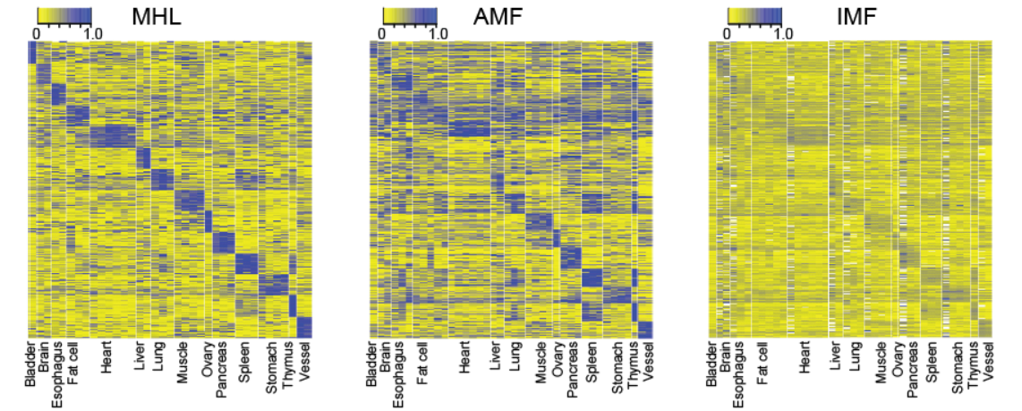

Figure 7. MHL exhibit better signal-to-noise ratio than average methylation frequency (AMF) and methylation for all CpG site (MAS) for sample clustering. Note: Tissue specificity value (TSV) was the average MHL for the corresponding tissue specific MHL in the correctly assigned samples, while the background value (BV) were the average MHL in mis-assigned samples. Contrast was defined as the ratio TSV/BV.

The human adult tissues that we used in this study have various degrees of similarity amongst each other. We hypothesize that this is primarily defined by their developmental lineage, and that the related MHBs might reveal epigenetic insights related to germ layer speciation. We grouped all the data sets based on the three germ layers, and searched for MHBs that have differential MHL. In total we identified 114 ectoderm-specific MHBs (99 hyper- and 15 hypo-methylated), 75 endoderm specific MHBs (58 hyper and 17 hypo-methylated) and 31 mesoderm specific MHBs (9 hyper and 22 hypo-methylated) (Table 3). We speculated that some of these MHBs might capture binding events of transcription factors (TF) specific to developmental germ-layers. Compared with ENCODE TFBS data, we observed distinctive patterns of TFs binding to layer specific MHBs. (Figure 8a). For layer specific MHBs with hypo-methylation MHL, which tends to represent activation signals, we identified 53 TF binding events in mesoderm specific MHBs, 71 in endoderm specific MHB and 2 in ectoderm specific MHBs. Gene ontology analysis showed TFs binding to mesoderm exhibit negative regulator activity, while TFs binding to endoderm exhibited positive regulator activity (Table 4). For layer specific MHBs with hyper-methylation MHL, which tend to represent repressive signals, we identified 38 TF binding events in mesoderm specific MHBs, 102 in endoderm specific MHB and 145 in ectoderm specific MHBs. Interestingly, ectoderm and endoderm shared few bounded TFs, while mesoderm tissues share multiple groups of TFs with ectoderm and endoderm. We identified two endoderm specific hyper-MHL regions, which are related to ESRRA and NANOG. This is consistent with a previous finding that mouse ES cells differentiated spontaneously into visceral/parietal endoderm upon NANOG knock-out. Gene ontology analysis showed that mesoderm and endoderm shared hypo-MHL regions might have regulatory functions in the fate commitment towards multiple tissues, whereas ectoderm specific hyper-MHL regions might induce the ectoderm development by suppressing the path towards the immune lineage (Figure 8b).

A unique aspect of methylation haplotype analysis is that the pattern of co-methylation, especially within MHBs, is robust in capturing low-frequency alleles among a heterogeneous population of molecules or cells, in the presence of biological noise or technical variability (ie. incomplete bisulfite conversion or sequencing errors). To explore the clinical potential, we next focused on the methylation haplotype analysis of cell-free DNA from healthy donors and cancer patients, of which various low fractions of DNA molecules were released from tumor cells and potentially carry epigenetic signatures different from blood. We isolated 4-122ng (average 20ng) of cell-free DNA from an average of 866µL human plasma from 75 normal individuals and 59 cancer patients, except for four with unusually high yield due to cell lysis. Due to the limited DNA availability, we performed scRRBS on 1 to 10 ng of cfDNA from 134 plasma samples and obtained an average of 13 million paired-end 150bp reads per sample. On average, 57.7% WGBS-defined MHBs were covered in our RRBS data set on clinical samples.

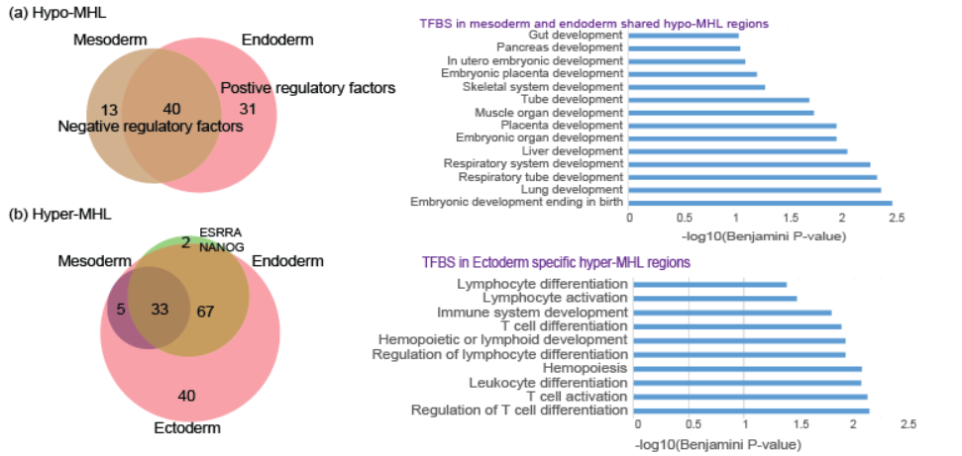

Figure 8. Distinctive patterns of functional enrichment for TF associated with MHBs of hypo- or hyper MHL.

We sought to detect the presence of tumor specific signatures in the plasma samples, using methylation haplotypes identified from tumor tissues as the reference and normal samples as the negative controls. For five lung cancer plasma samples and five colorectal cancer plasma samples, we also obtained matched primary tumor tissues, and generated RRBS data (30 million reads per sample) from 100ng of tumor genomic DNA. We focused on MHBs with low MHL (i.e. genomic regions that have low or no methylation) in the blood, and asked whether we can detect cancer-specific highly methylated haplotypes (csHMH). We required that such haplotypes were present only in the tumor tissues and the matched plasma from the same patient, but not in whole blood or any other non-cancer samples. We considered these highly confident tumor signature in circulating DNA. We detected csHMH in all cancer patient plasma samples (Average=36, IQR=17, Table 5a). These HMHs were associated with 183 genes, some of which are known to be aberrantly methylated in human cancers such as WDR37, VAX1, SMPD1 (Table 5b). Next, we extended the analysis to 49 additional cancer plasma samples that have no matched tumor samples, using 65 normal plasmas as the background. On average 60 (IQR=31) csHMH were identified for each cancer plasma sample (Table 5c). Interestingly, a significant fraction (35%) of csHMH called on matched tumor-plasma pairs were also detected the expanded set of cancer patient plasma samples.

Next we quantified the tumor load in cancer plasma samples, using non-negative decomposition with quadratic programming, on the RRBS data from primary cancer biopsies (LC & CRC) and WGBS data from 10 normal tissues. We estimated that a predominant fraction, 72.0% (95% CI:0.659-0.782) in the cancer and normal plasma were contributed by white blood cells, which is consistent with the levels reported recently based on shallow whole genome bisulfite sequencing (69.4%). Primary tumor and normal tissue-of-origin contributed at the similar level of 2.3% (95% CI: 0.4%-4.2%) and 3.0% (95% CI:1.2%-4.4%). In contrast, we applied the similar analysis to normal plasma, and found only residual tumor contributions (0.17% for CRC and 1.0% LC) to normal plasma, which were significantly lower (P=3.4x10⁻⁵ and 5.2x10⁻¹⁰ for CRC and LC, respectively) than cancer plasma. We also found that 76.7% plasma samples from CRC patients and 89.6% from LC patients had detectible contribution from tumor tissues while only 13% and 26% normal plasmas have certain (low) tumor contribution (Figure. 9). Therefore, circulating cell-free DNA contains a relatively stable fraction of molecules released from various normal tissues, whereas in cancer patients tumor cells released DNA molecules that can be more abundant than normal tissues (Table 6).

We next asked whether we can identify a small subset of MHBs among all the RRBS targets that have significantly higher levels of MHL in cancer plasma than in normal plasma. We found 81 and 94 MHBs with significantly higher MHL for colorectal and lung cancer (Table 7a-b). Some of these regions (such as HOXA3) have been reported to be aberrantly methylated in lung cancer and colorectal cancer. Using these MHBs as markers, the diagnostic sensitivity is 96.7% and 93.1% for colorectal cancer and lung cancer at the specificity 94.6% and 90.6%. As a comparison, we also performed a prediction based on average 5mC methylation level within these MHB regions, or based on genome-wide single CpG sites. MHL was found to be superior to average 5mC methylation level (sensitivity of 90.0% and 86.2%; specificity of 89.3% and 90.6% for CRC and lung cancer) and methylation signal of individual CpG site (sensitivity of 89.6% and 80.6%; specificity of 89.3% and 92.0%).

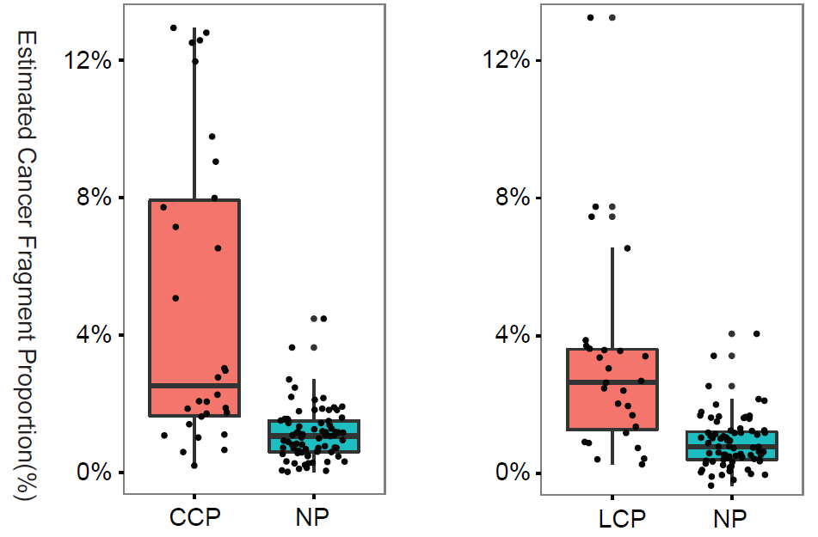

Figure 9. Estimated tumor fraction for all cancer plasma and normal plasma. CCP denotes colorectal cancer plasma, LCP denotes lung cancer plasma and NP denotes normal plasma.
We then tried to use the information from normal human tissues, primary tumor biopsies and cancer cell lines to improve the detection of ctDNA. We started by selecting a subset of MHBs that show high MHL (>0.5) in primary cancer biopsies and low MHL (<0.1) in whole blood, then clustered these MHBs into three groups based on the MHL in all normal and cancer plasma, as well as cancer and normal tissues (Figure 10). We identified a subset (Group II) of MHBs that have high MHL in cancer tissues and low MHLs in normal tissues. Cancer plasma showed significantly higher MHL in these regions than normal plasma (P=1.4×10⁻¹² and 6.2×10⁻⁸ for CRC and LC, respectively).
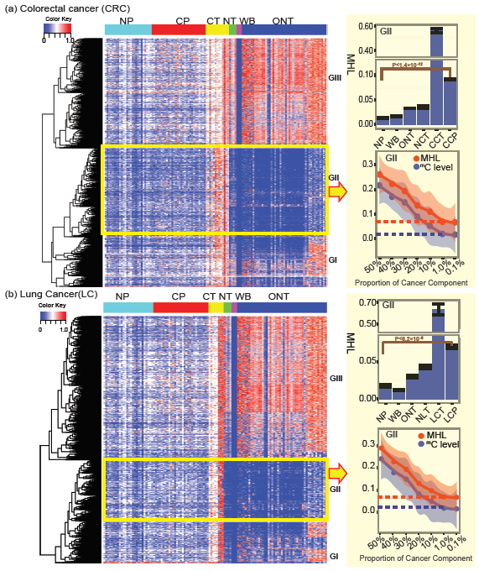

Figure 10. Quantitative estimation of tumor load in cell-free DNA based on MHL of informative MHBs. (a) Colorectal cancer (b) Lung cancer. Informative MHBs were selected based on the presence of high-MHL in cancer solid tissues and the absence of MHL in WB.

By computationally mixing the sequencing reads from cancer tissues and whole blood samples (WBC), we created synthetic admixtures at various levels of tumor fraction. We found that MHL is 2-5 folder higher than the methylation level of individual CpG sites across the full range of tumor fractions (Table 8a-b).
Remarkably, MHL provides additional gain of signal-to-noise ratio (mean divided by standard deviation) compared with AMF as the fraction of tumor DNA decreases below 10%, which is typical for clinical samples (Figure 11, left). We then took the individual plasma data sets, and predicted the tumor fraction based on the MHL distribution established by computational mixing. Except for a small number (N<5) of outliers, we observed significantly higher average MHL in cancer plasma than in normal plasma. Note that all Group II MHBs were selected without using any information from the plasma samples, and hence they should be generally applicable to other plasma samples. Interestingly, we also found that the estimated tumor DNA fraction were positive correlated with normalized cfDNA yield from the cancer patients (P<0.000023, Figure 11, right and Table 9).

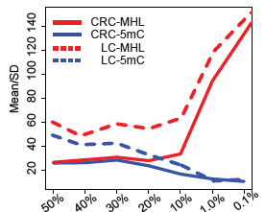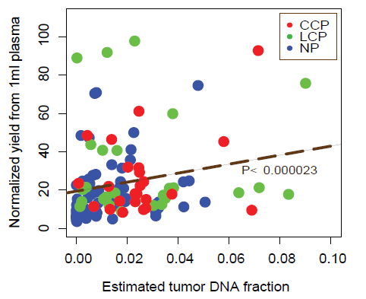

Figure 11. Advantage of MHL in the measurement of methylation level and complexity. Left panel: MHL own higher signal/noise index. Right panel: signicant association between estimated tumor DNA fraction and cfDNA yield.

Recent studies have demonstrated that epigenetic information imbedded in cfDNA has the potential for predicting tumor’s tissue-of-origin. Consistently, we found that tissue-of-origin derived methylation haplotypes were the most abundant fraction in cancer plasma. Here we asked whether a MHL-based framework and a set of targets derived from whole genome data would allow us to predict tissue-of-origin with quantifiable sensitivity and specificity, which is crucial for future clinical applications. We compiled 43 WGBS and RRBS data sets for 10 human normal tissues that have high cancer incident rate, and identified a set of 2,880 tissue-specific MHBs as the candidates (Table 10). We then used these tissue-specific MHBs or subsets to predict the tissue-of-origin for the cancer plasma sample. Although we found a large number of tissue-of-origin specific MHBs that have low MHL in normal plasma (Figure 12, top), the multiclass prediction based on random forest yielded very limited power, most likely due to the high diversity of the tissue classes (N=10). We then adopted an alternative approach by counting the total number of tissue-specific MHBs in the plasma samples and comparing with all other tissues, in order to infer the most probable tissue-of-origin. At the cutoff of minimal 10 tissue-specific methylated haplotypes per tissue type, we observed an average 90% accuracy for mapping a data set from the primary tissue to its tissue type (Figure 12, middle). We then applied this method to the full set of plasma data from 59 cancer patients and 75 normal individuals, and achieved an average prediction accuracy of 82.8%, 88.5%, 91.2% for the plasma from colorectal cancer, lung cancer, and control plasma samples respectively with 5-fold cross-validation (Figure 12, bottom and Table 11). For the incorrectly classified samples, we noticed that 4 out of 5 colorectal cancer plasma were from metastatic colorectal cancer patients while the fifth was in fact tubular adenoma. In the case of lung cancer, one misclassified sample came from a patient with benign fibrous tissue. Taken together, we demonstrated for the first time that both tumor load and tissue of origin can be quantitatively characterized by methylation haplotype analysis of cell free DNA in plasma.

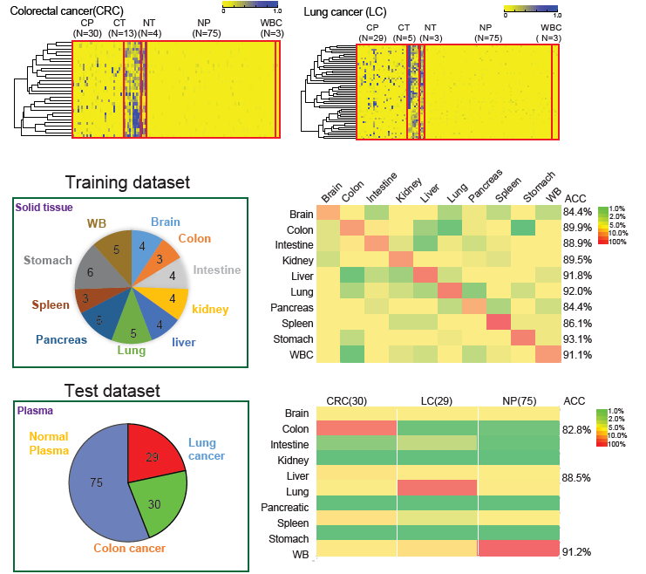

Figure 12. Methylation Haplotype Load in Cancer Diagnosis and Tumor-of-Origin Deconvolution.
(uper) Detection of tumor-specific or tissue-specific MHL in the plasmas of cancer patients, but not normal plasma or whole blood. (middle) Identification of informative MHBs for tissue prediction. (bottom) Application of the predictive model to plasma samples from cancer patients and normal individuals.

In conclusion, adjacent CpG sites in mammalian genomes can be co-methylated due to the processivity of methyltransferases or demethylases. Yet discordant methylation patterns have also been observed, and found to be related to stochastic or uncoordinated molecular processes. Here we focused on a systematic search and investigation of regions in the full human genome that exhibit highly coordinated methylation. We defined blocks of tightly coupled CpG sites, called Methylation Haplotype Blocks (MHBs), with 61 sets of whole genome bisulfite sequencing (WGBS) data, and further validated with 101 sets of RRBS and 637 sets of methylation array data. Using a metric called Methylation Haplotype Load (MHL), we performed tissue-specific methylation analysis at the block level. Subsets of informative blocks were further identified for deconvolution of heterogeneous samples. Finally, we demonstrated quantitative estimation of tumor load and tissue-of-origin mapping in the plasma of 59 cancer patients using methylation haplotypes.

- What are potential commercial applications of your invention?

Non-invasive prenatal testing.
Non-invasive detection or monitoring of cancers
Tissue-of-origin mapping

I. COMPANIES
Based on your knowledge, please provide the names and addresses of companies that are, or may be, interested in manufacturing, using, and/or further developing your invention.

Company & Contact Name | Company Address
Singlera Genomics, Yuan Gao (garygao@gmail.com) | 505 Coast Blvd,, La Jolla, CA 92037

- Please list or attach any literature references that most closely describe the state of the related art before your invention. If possible, please consider doing a search of the literature, because it will help in the evaluation of your invention.

• An integrated encyclopedia of DNA elements in the human genome. Nature.(2012). 489: 57-74.
• Chan et al. Size distributions of maternal and fetal DNA in maternal plasma. Clin Chem. (2004) 50:88-92.
• Chim et al. Systematic search for placental DNA-methylation markers on chromosome 21: toward a maternal plasma-based epigenetic test for fetal trisomy 21. Clin Chem (2008) 54:500-11
• Chiu et al. Noninvasive prenatal diagnosis of fetal chromosomal aneuploidy by massively parallel genomic sequencing of DNA in maternal plasma. Proc Natl Acad Sci U S A. (2008) 105:20458-63.
• Deng et al Targeted bisulfite sequencing reveals changes in DNA methylation associated with nuclear reprogramming. Nature Biotechnology (2009) 27:353-60
• Diep et al., Library-free methylation sequencing with bisulfite padlock probes. Nature Methods, (2012) 9:270-272.
• Dixon, J. R., et al. Chromatin architecture reorganization during stem cell differentiation. Nature.(2015). 518: 331-336.
• Dixon, J. R., et al. Topological domains in mammalian genomes identified by analysis of chromatin interactions. Nature.(2012). 485: 376-380.
• Fan et al. Noninvasive diagnosis of fetal aneuploidy by shotgun sequencing DNA from maternal blood. Proc Natl Acad Sci U S A. (2008) 105:16266-71
• Fan et al. Non-invasive prenatal measurement of the fetal genome. Nature. (2012) 487:320-4
• Guelen, L., et al. Domain organization of human chromosomes revealed by mapping of nuclear lamina interactions. Nature.(2008). 453: 948-951.
• Guo, H., et al. Single-cell methylome landscapes of mouse embryonic stem cells and early embryos analyzed using reduced representation bisulfite sequencing. Genome Res.(2013). 23: 2126-2135.
• Hansen, K. D., et al. Increased methylation variation in epigenetic domains across cancer types. Nat Genet.(2011). 43: 768-775.
• Heyn, H., et al. Distinct DNA methylomes of newborns and centenarians. Proc Natl Acad Sci U S A.(2012). 109: 10522-10527.
• Heyn, H., et al. Epigenomic analysis detects aberrant super-enhancer DNA methylation in human cancer. Genome Biol.(2016). 17: 11.
• Houseman, E.A. et al. DNA methylation arrays as surrogate measures of cell mixture distribution. BMC bioinformatics 13, 86 (2012).
• Irizarry, R. A., et al. The human colon cancer methylome shows similar hypo- and hypermethylation at conserved tissue-specific CpG island shores. Nat Genet.(2009). 41: 178-186.
• Johansson et al. Targeted resequencing of candidate genes using selector probes. Nucleic Acids Res. (2011) 39:e8. doi: 10.1093/nar/gkq1005
• Kitzman et al. Noninvasive whole-genome sequencing of a human fetus. Sci Transl Med. (2012) 4:137ra76
• Kivioja et al. Counting absolute numbers of molecules using unique molecular identifiers. Nat Methods (2011) 9: 72-74.
• Komori et al., Application of microdroplet PCR for large-scale targeted bisulfite sequencing. Genome Research, (2011) 21: 1738-1745.
• Landau, D. A., et al. Locally disordered methylation forms the basis of intratumor methylome variation in chronic lymphocytic leukemia. Cancer Cell.(2014). 26: 813-825.
• Leung, D., et al. Integrative analysis of haplotype-resolved epigenomes across human tissues. Nature.(2015). 518: 350-354.
• Lun et al. Noninvasive prenatal methylomic analysis by genomewide bisulfite sequencing of maternal plasma DNA. Clin Chem. (2013) 59:1583-94.
• Mitsui, K., et al. The homeoprotein Nanog is required for maintenance of pluripotency in mouse epiblast and ES cells. Cell.(2003). 113: 631-642.
• Papageorgiou et al. Fetal-specific DNA methylation ratio permits noninvasive prenatal diagnosis of trisomy 21. Nature Medicine (2010) 17:510-3
• Papageorgiou & Patsalis.Non-invasive prenatal diagnosis of aneuploidies: new technologies and clinical applications.Genome Med. (2012) 4:46. doi: 10.1186/gm345.
• Poon et al. Differential DNA methylation between fetus and mother as a strategy for detecting fetal DNA in maternal plasma. Clin Chem. (2002) 48:35-41.
• Schultz, M. D., et al. Human body epigenome maps reveal noncanonical DNA methylation variation. Nature.(2015). 523: 212-216.
• Shao, X., et al. Deciphering the heterogeneity in DNA methylation patterns during stem cell differentiation and reprogramming. BMC Genomics.(2014). 15: 978.
• Shoemaker et al. Allele-specific methylation is prevalent and is contributed by CpG-SNPs in the human genome. Genome Research (2010) 20:883-9
• Slatkin, M. Linkage disequilibrium--understanding the evolutionary past and mapping the medical future. Nat Rev Genet.(2008). 9: 477-485.
• Snyder, M.W., Kircher, M., Hill, A.J., Daza, R.M. & Shendure, J. Cell-free DNA Comprises an In Vivo Nucleosome Footprint that Informs Its Tissues-Of-Origin. Cell 164, 57-68 (2016).
• Sun, K., et al. Plasma DNA tissue mapping by genome-wide methylation sequencing for noninvasive prenatal, cancer, and transplantation assessments. Proc Natl Acad Sci U S A.(2015). 112: E5503-5512.
• Tong et al. Technical concerns about immunoprecipitation of methylated fetal DNA for noninvasive trisomy 21 diagnosis. Nat Med. (2012) 18:1327-8.
• Wen, B., et al. Large histone H3 lysine 9 dimethylated chromatin blocks distinguish differentiated from embryonic stem cells. Nat Genet.(2009). 41: 246-250.
• Ziller, M. J., et al. Charting a dynamic DNA methylation landscape of the human genome. Nature.(2013). 500: 477-481.

K. If a company is interested in licensing your invention, would you be interested in assisting or working with the company to develop your invention into a product under a sponsored or research agreement with the University? □ Yes □ No

