CASE No._SD2014-173_________

PROPRIETARY INFORMATION

UC SAN DIEGO TECHNOLOGY TRANSFER OFFICE
INVENTION AND TECHNOLOGY DISCLOSURE FORM

Please attach additional sheets as necessary.

- TITLE OF INVENTION
Create a short title describing the general nature of the invention without revealing the specific details that would enable others to reproduce the invention (e.g., new anticancer compound, method for chip fabrication, etc.). Please limit the title to 60 characters.

Methylation haplOtyping for Non-invasive Diagnosis (MONOD)

B. 1. UCSD INVENTOR(S) List all UCSD employees or students who intellectually contributed to the invention. Please also indicate any joint or special appointment with non-UCSD institutions (e.g., VA and HHMI) in the “Position” box.

Name:  Kun Zhang | UCSD Employee #: 00927755  Citizenship: China PR. | Position: Associate Professor  Joint or Non-UCSD Affiliation: □VA □ HHMI  Other: _______________________________
School or Division: Engineering  Dept. or ORU: Bioengineering | Work Address: PFBH 402/406 9500 Gilman Dr La Jolla, CA 92093  UCSD (or VA) Mail Code: 0412
Work. Phone: 858 822 7876 | Work. Fax: | Email: kzhang@bioeng.ucsd.edu
Home Address:  11733 Boulton Avenue, San Diego, CA 92128 |  | Home Phone:617-646-9898  Home Email: kun.zhang.ucsd@gmail.com

Name: | UCSD Employee #:  Citizenship: | Position:  Joint or Non-UCSD Affiliation: □VA □ HHMI  Other: _______________________________
School or Division:  Dept. or ORU: | Work Address:  UCSD (or VA) Mail Code:
Work. Phone: | Work. Fax: | Email:
Home Address: |  | Home Phone:  Home Email:

- 2. INVENTORS NOT AFFILIATED WITH UCSD
If an inventor is not a UCSD employee or student, please provide information below.

Name: | Position: |  | Nature of employment::
Employer: |  | Work Address:
Work Phone: | Work Fax: |  | Email:
Nature of Contribution (please provide information explaining why this person is a co-inventor):

Name: | Position: |  | Nature of employment::
Employer: |  | Work Address:
Work Phone: | Work Fax: |  | Email:
Nature of Contribution (please provide information explaining why this person is a co-inventor):

- FUNDING SOURCES FOR THE PROJECT UNDER WHICH THE INVENTION WAS MADE
As funding often carries obligations to a sponsor, be sure to include all outside agencies, organizations, or companies that provided any funding to any inventor for the research that led to the conception or first actual reduction to practice of the invention. Please include any companies that have supplied materials in exchange for intellectual property rights.

SPONSOR(S) | GRANT NUMBER | PRINCIPAL INVESTIGATOR
NIH | R01GM097253 | Kun Zhang

Is there any other corporate relationship that we should be aware of concerning this invention? □ Yes □ No

Name of Company: ________________________________________________________________________________________

Please explain the nature of the relationship: ____________________________________________________________________

Are you a consultant to the company list ed? □ Yes □ No

- MATERIAL TRANSFER AGREEMENT (MTA)
Please list and attach copies, if available, of any Material Transfer Agreement or any other written or oral agreement used to obtain any material used for this invention.

- DESCRIPTION OF EVENTS:
This information is important for deciding priority of invention and/or legal "bars" to patenting. In general, publications, in any medium, before the date a formal patent application is filed in a national patent office can cause a bar to patent filing in most foreign countries. While United States patent law allows
inventors up to one year to file a patent application after the first publication, public use, or sale, the loss of foreign rights is often very important to potential industrial licensees.
EVENTS | DATE | INDICATE THE WRITTEN RECORD  (e.g., notebook, letter, email).  IF ORAL DISCLOSURE, INDICATE TO WHOM
1. Initial conception of the idea | 11/17/2013 | Email communication.
2. First description of complete invention, oral or written
3. First successful demonstration (first actual reduction to practice) | 12/23/2013-1/8/2014 | Zhang lab electronic notebook
4. Has this work been:
i. | Submitted for publication? | □ Y | □N
ii. | Accepted for publication? | □ Y | □ N
iv. | Published? | □ Y | □ N

5. Have you presented this work at a conference or meeting?
 |  | □ Y | □ N
i. | Did you submit an abstract? | □ Y | □ N
ii. | Was abstract published? | □ Y | □ N
iii. | Did presentation include handouts? | □ Y | □ N
iv. | Name of conference or meeting?

F. INVENTORS' SIGNATURES G. WITNESS - invention disclosed to and
By signature below, I acknowledge my responsiblities and understood by:
rights to royalty-sharing under the current University of California
Patent Policy.

_____________________________ __________________ _______________________________ ________________
Inventor signature Date Witness signature Date

_____________________________ __________________ ________________________________
Inventor signature Date Print witness name

_____________________________ __________________
Inventor signature Date

_____________________________ __________________
Inventor signature Date

- ABOUT THE INVENTION

Please write a summary of the invention following the numbered guidelines listed below. Since this information will be used to determine patentability, commercial uses, and potential licensees of the invention, please provide as many details as possible. If you have a written manuscript descriptive of your invention, please also attach a copy to this form.

- What exactly does your invention do?

This invention allows the deconvolution of mixed DNA samples based on the originating tissue types, and to detect low-abundant DNA from different tissue(s) at an extremely high sensitivity. It relies on the tissue-specific methylation haplotypes in a set of informative regions in the genome. Methylation haplotype is the combination of methylation status at two or more CpG sites of a single DNA molecule. The spacing between two adjacent CpG sites can be anywhere between one to hundreds of bases. This invention can be implemented as a number of clinical diagnostic tests, such as non-invasive detection of fetal aneuploidy in maternal blood at a very early stage of pregnancy, non-invasive detection of circulating tumor DNA in patient’s blood.

- What is unique, novel, or better about your invention as compared to existing art?

The most unique aspect of this invention is to use methylation haplotypes (as appose to individual CpG sites) to improve detection sensitivity and reduce technical noise for detecting low abundance species in mixed DNA samples. Methylation haplotype is the combinatorial DNA methylation status of multiple CpG dinucleotides (also called “sites” or “loci”) in a single DNA molecule. Multi-locus haplotypes are robust with the presence of random technical errors on individual loci, and hence provide a much greater power in distinguishing true signatures at a low abundance from technical errors. Integrating haplotypes from multiple genomic locations, and differential haplotype analysis of DNA fragments with different sizes further increases the power. A higher sensitivity translates to robust detection at earlier timepoints, as well as lower assay costs.

For non-invasive trisomy21 detection, existing methods are based on either fetal specific proteins, RNA transcripts, fetal specific methylation signatures on single CpG sites at multiple genomic positions (Poon et al. 2002; Chim et al, 2008; Lun et al, 2013), or subtle elevation of chromosome 21 DNA content in maternal bloods (Chiu et al. 2008; Fan et al. 2008). The latter strategy have been commercialized by multiple companies in the US, and the tests are covered by a number of insurance plans. The major advantage of this invention is the capability of separating fetal DNA from maternal DNAs based on methylation haplotypes for copy number estimation. This will lead to a higher detection sensitivity and a lower assay cost.

For non-invasive cancer detection from peripheral blood, there is no mature commercial assays in the market. Assays at various stages of development include enrichment of rare circulating cancer stem cells followed by subsequent analyses, detecting of circulating microRNAs or DNA. This invention is superior in both the detection sensitivity as well as the simplicity for implementation.

Note that haplotypes has been used for fetal genome sequencing from maternal blood (Kitzman et al. 2012; Fan et al., 2012). However, these methods focus on genetic variants and long-range haplotypes of genetic variants. Such haplotypes have to be determined by additional methods, such as clone-based haplotyping, or single chromosome isolation and sequencing. This invention is related to methylation haplotypes, or epigenetic modifications (cytosine methylation) on multiple CpG sites of single DNA molecules. Such methylation haplotypes can be obtained by the standard short-read sequencing platforms, such as Illumina’s HiSeq/MiSeq or LifeTech’s Ion Proton, as part of the methylation assay without extra efforts and cost.

- What is the existing art to which you are comparing?

US Patent 8,450,061 Quantification of a minority nucleic acid species
US Patent 8,586,313 DNA methylation markers based on epigenetic stem cell signatures in cancer
US Patent 8,563,242 Method for detecting chromosomal aneuploidy
US Patent 8,293,470 Non-invasive fetal genetic screening by digital analysis
US Patent 8,288,100 Methods for detecting fetal DNA in a plasma or serum sample from a pregnant woman
US Patent 8,026,067 Marker for prenatal diagnosis and monitoring
US Patent 8,110,361 DNA methylation markers associated with the CpG island methylator phenotype (CIMP) in human colorectal cancer

- Describe how your invention works (or may work). Please include drawings, schematics, figures, etc., necessary to
explain how the invention works or may work.

Human peripheral blood contains low levels of DNA molecules from other tissues or cell types, such as circulating cancer stem cells or cell-free DNA from apoptotic cancer cells in cancer patients, or fetal DNA in pregnant women. To detect and quantify such low abundance DNA molecules, we focus on regions in the genome in which there are major differences in DNA methylation between whole blood and other cells of interest (such as cancer or fetal cells). These are the marker regions used for assay and detection. For example, a region containing 6 CpG sites might be completely unmethylated in whole blood, and fully methylated in placenta. If a maternal whole blood sample contain 3% of fetal DNA, then we would detect a 3% methylation with an ideal assay. However, all methylation assays have technical errors, such as incomplete bisulfite conversion, incomplete enzyme digestion, sequencing error. Typically all the technical errors combined can contribute to ~1-2%. With the presence of these errors, a 3% methylation cannot be confidently detected. Such technical errors greatly compromised the sensitivity and confidence in detecting and quantifying fetal DNA molecules. Methylation haplotyping analysis can dramatically improve the distriminating power, as technical errors typically occur independently on all DNA molecules at random locations. In contrast, the 3% fetal DNA molecules are fully (or almost fully) methylated at all CpG sites, whereas all maternal DNA molecules are not methylated. In other words, the methylation status at multiple CpG sites on the same molecules are all “linked”. Using methylation haplotypes of four or more CpG sites, one can confidently identify rare DNA molecules at 0.01% or even lower, at least two orders of magnitude below the technical errors (1-2% per site). We were the first group that developed an analytical framework for methylation haplotype and linkage disequilibrium analysis (Shoemaker et al, 2009). In this invention, we developed an assay for digital quantification of methylation (see below), and greatly extended the previous framework to haplotype-based methylation marker analysis. In addition, combining information from multiple markers will further improve the sensitivity and robustness in the presence of biological variability. Finally, cell-free DNA typically come from apoptotic cells, and are in small fragments (Chan et al. 2004). In contrast, whole blood DNA typically have larger sizes (at least kilobases) even after DNA extraction. Using targeted methylation sequencing to analyze haplotypes from DNA molecules of different sizes adds another level of stringency in separating rare cancer or fetal DNA from whole blood DNA. In summary, this invention can achieve an ultra-high sensitivity for detecting rare DNA species from mixed DNA (such as whole blood DNA) using some combinations of the three concepts: (i) multi-locus methylation haplotype analysis (Figure 1); (ii)integrative analysis of multiple marker regions; and (iii) differential haplotype analysis of DNA fragments with different sizes (Figure 2). The invention can be implemented as genetic screening or diagnostic tests for non-invasive prenatal diagnosis, non-invasive monitoring of tumor loads in cancer patients after treatments, or early-stage cancer detection.

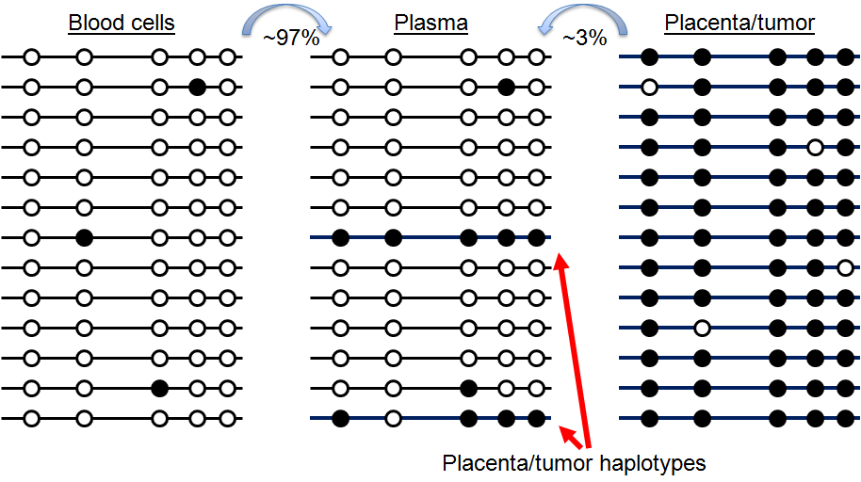 | 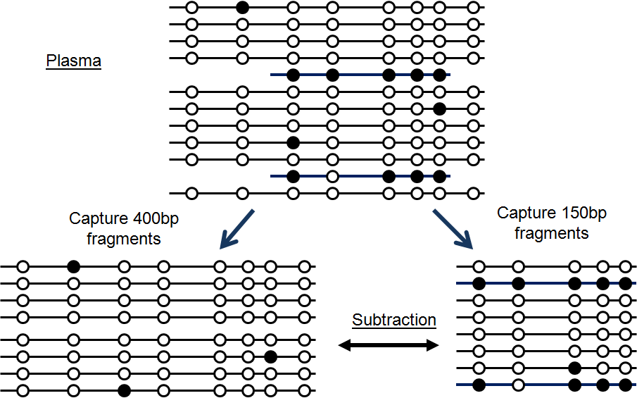
Figure 1. Sensitive detection and quantification of circulating placenta or tumor DNA in blood plasma using DNA methylation haplotypes. Each line represents a single DNA molecule, and each circle is a CpG site. Open circle is unmethylated CpG and solid circle is methylated CpG. | Figure 2. Differential haplotype analysis by fragment size. Targeted capture and sequencing of long and short fragments improve sensitivity by subtraction.

We have implemented this invention using a target methylation sequencing technology (Bisulfite Padlock Probes, or BSPP, Deng et al, 2008; Diep et al. 2012) developed by the Zhang lab. Note that alternative technologies, such as micro-droplet PCR (Komori et al. 2011) or Selector probes (Johansson et al. 2011), can also potentially be used with some differences in the requirement of input materials and/or cost. MeDiP is another alternative experimental method for data collection (Papageorgiou et al. 2010), with disadvantages including low efficiency, high cost, and low reliability(Tong et al. 2012). Therefore, this invention should cover the aforementioned three key concepts, not a specific implementation based on the BSPP technology.

Regardless of the specific sample preparation methods or sequencing platforms used, our method takes the bisulfite sequencing reads (single-ends or paired-ends) as the input. We derived methylation haplotypes and their abundance from the raw sequencing reads. Each haplotype represent the combination of binary methylation status (methylated or unmethylated) at multiple CpG sites of one sequencing read. For sample preparation methods (such as umi-RRBS, or hybridization-based target capture) that allow identifying multiple clonal sequencing reads originated from the same template DNA molecules, we also derive the consensus haplotypes from the clonal reads to improve the accuracy and avoid over-dispersion of haplotype counts. The probability that a methylation haplotype is present in a sample (or a pool of samples) is determined by the frequency if the exact haplotype is observed, or estimated from the methylation levels of individual CpG sites and the technical error rates (sequencing errors, bisulfite conversion errors) assuming no linkage between adjacent sites (or P(M1M2)=P(M1)*P(M2) where M1M2 is the probability of two-locus methylated haplotype, P(M1) and P(M2) are the methylation level at the two loci). For each methylation haplotype from the patient plasma of interest, we determined the likelihoods of it originating from the pooled tumor primary biopsies data and from the pooled normal plasma data, and calculated the negative log likelihood ratio. A methylation haplotype is classified as the tumor haplotype when the negative log likelihood ratio is above 3. To improve the signal-to-noise ratios, we focus on methylation haplotypes that contain four or more CpG sites.

- Describe the stage of development of the invention (e.g., concept stage, experimental data stage, computer model simulation stage, working prototype stage, etc.). Please include data, photographs, etc., indicating the stages of development.

We have demonstrated the proof-of-concept for detecting low-abundant tumor DNA in blood DNA based on methylation haplotypes, both in synthetic DNA mixtures and clinical plasma samples of three cancer types.

For the first demonstration using synthetic DNA mixtures, we searched marker regions by extensive analyses of published and unpublished DNA methylation data on whole blood, cancers, and placenta. We have identified 12,446 candidate regions that exhibit large methylation difference between whole blood and three types of cancer cell lines (pancreatic cancer, glioblastoma multiforme, lung cancer), as well as 1,230 regions different between whole blood and placenta. We designed umi-BSPP (Figure 3), which is an improved version of Bisulfite Padlock Probes (BSPP, Deng et al, 2009; Diep et al. 2012) for targeted methylation sequencing of these candidate regions of whole blood and a panel of five cancer (pancreatic cancer and glioblastoma) cell lines. These probes also contain built-in Unique Molecule Identifier (Kivioja et al. 2011), so that we can perform deep sequencing and true single-molecule counting to avoid quantification artefacts due to DNA amplification. We have designed and synthesize 19,109 long oligonucleotides for the candidate targets.

Computational analysis of methylation haplotypes starts with bisulfite sequencing reads mapped to the reference genome (using common bisulfite read mapping algorithms, such as bisReadMapper, bisMark) in the format of bam files. We derived consensus sequencing reads based on UMI (if available), then determined the methylation haplotypes on multiple CpG sites in single consensus sequencing reads (Figure 4). The haplotypes and their counts in all genomic regions assayed are reported. For selection of the marker set that can classify plasma samples, we define a methylated haplotype load (MHL) for each candidate region, which is the normalized fraction of methylated haplotypes at different length:
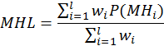
Where i is the length of haplotypes, P(MH_{i}) is the fraction of fully methylated haplotype with i loci. For a haplotype (a string) of length L, we considered all the sub-strings with length from 1 to L in this calculation. w_{i} is the weight for i-locus haplotype. We typically used w_{i}=i or w_{i}=i² to favor the contribution of longer sub-strings. After calculating MHL for all candidate regions for all samples, we built a MHL matrix for feature selection, using standard machine learning approaches such as SVM, random forest or MRMR.

We performed multiple rounds of screening for a subset of probes that are sensitivity, robust and informative. A set of 2,489 cancer probes were selected for detecting various levels of cancer and whole blood DNA mixtures (0%, 0.2%, 0.5%, 1%, 2%, 5%, 10%, 20%) (Figure 5). This first proof-of-concept experiment clearly indicated that multi-CpG methylation haplotypes are very effective in separating cancer DNA from whole blood for sensitive and quantative detection.

We next asked whether we could identify fetal specific haplotypes and use the sequencing reads mapped to these haplotypes for quantifying fetal chromosome dosage for non-invasive prenatal diagnosis of aneuploidy such as chromosome 21 trisomy in blood. By subsampling the captured sequencing reads that mapped to individual chromosomes and generating synthetic mixture of cancer trisomy 18 and 21 with diploid whole blood DNA, we were able to detect significant gains of a single copy at 2% or 5% levels (Figure 6). These results demonstrate that quantatitive detection of aneuploid in DNA/cells that carry methylation signatures distinct from whole blood is possible with methylation haplotypes. The detection sensitivity can be further improved by additional optimization of the marker selection and refining the statistical model when larger data sets are available.

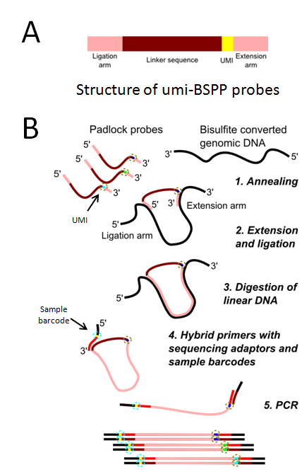
Figure 3. Multiplex capture of MONOD marker panel with umi-BSPP. (A) Each umi-BSPP probe contains a randomized unique molecule identifier (UMI) for uniquely label the capture product from each template DNA molecule. (B) Bisulfite converted DNA from clinical specimens is converted into sequencing libraries with 5 steps in single-tube reactions.

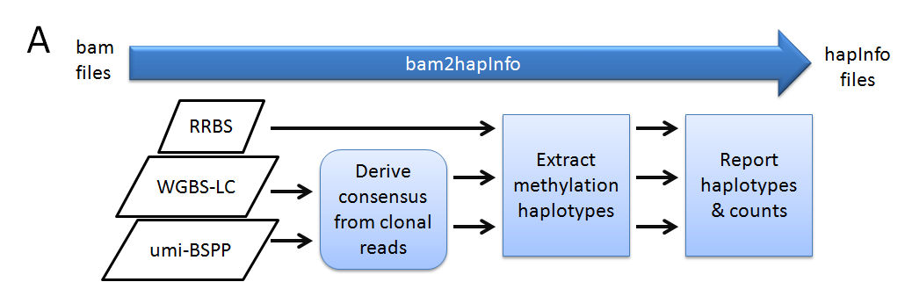
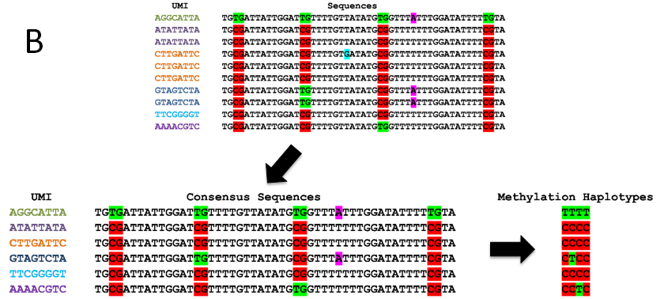
Figure 4. Deriving methylation haplotypes from sequencing data. (A) The bam2hapInfo program takes mapped raw sequencing data in the bam format, reports haplotypes and their counts in hapInfo files. (B) A example on deriving 4-locus methylation haplotypes from raw sequencing reads.

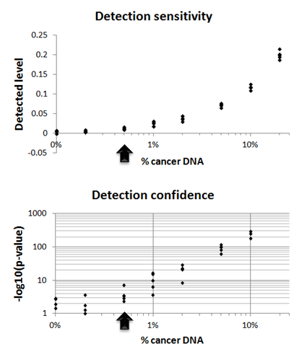 | 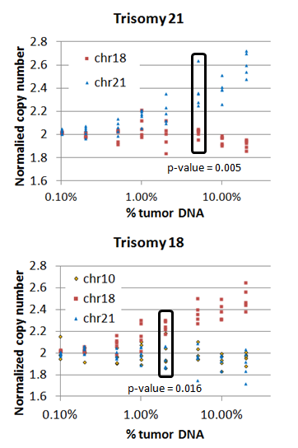
Figure 5. Quantitative detection of cancer DNA in whole blood. Top panel: level of cancer DNA detected in mixture of cancer and blood DNA at various ratios. Bottom panel: statistical significance of detection. | Figure 6: Detection of cancer specific aneuploidy on chromosomes 21 and 18.

We next sought to further demonstrate the feasibility of detecting tumor signatures in clinical samples based on the methylation haplotypes. We obtained 30 patient plasma samples, 10 from each of the three cancer types: colon cancer, lung cancer and pancreatic cancer. We also collected 15 fresh frozen primary cancer tissues, 5 per cancer type from the same patients that plasma samples were collected. In addition, we included 30 plasma samples from normal individuals with no detectible cancer as the negative controls.

We took an unbiased approach to systematically screen for candidate markers appropriate for MONOD. In the first strategy, we analyzed the published whole genome bisulfate sequencing data from human whole blood, and searched from blood unmethylation regions (UMRs). These UMRs represent the “windows” in the human genome in which tumor methylated haplotypes are not masked by blood methylation signatures if they are present in peripheral blood. A customized NimbleGen probe set was designed to capture a total of 29Mb blood UMRs for the entire panel of 75 samples for bisulfite sequencing. In addition, we used a second strategy to scan the CpG dense regions (including most CpG islands) for marker identification. We performed reduced representation bisulfite sequencing (RRBS) on the same panel of 75 samples. From the sequencing data generated by the two experimental approaches, we searched for regions where methylated haplotypes are detectible in primary tumor samples but present at a low level or non-detectible in plasma samples from normal individuals. This genome-wide screening identified a set of 5,301 candidate regions within blood UMRs, and 9,935 candidates from the RRBS data sets. Merging these two candidate lists yielded 11,901 candidate regions where we can screen for tumor specific haplotypes in plasma. From the 30 cancer patient plasma we have in this pilot, we have identified 5,871 regions within which various levels of tumor methylated haplotypes are detectible from patient’s plasma. Figure 7 shows an example at the promoter region of RhoB, which has been previously identified as a marker for cancer progression. Targeted methylation sequencing probe sets focusing on these 11,901 regions are being designed and optimized for examinining larger sets of plasma samples from cancer patients and normal controls, in order to finalizing a specific set of markers with high sensitivity and specificity.

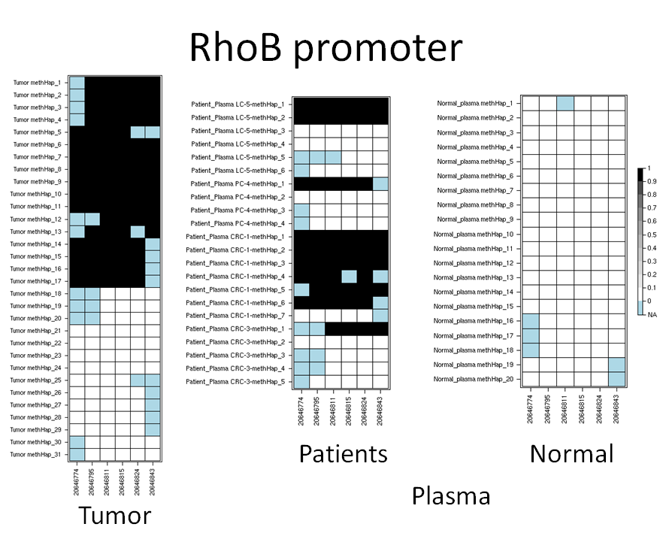
Figure 7. Tumor-specific haplotypes detected in the plasma of four cancer patients. Each row represent a methylation haplotype derived from a unique DNA molecules in the sample. A CpG site is represented as a square. Black is methylated, white is unmethylated and light blue is missing value.

- What are potential commercial applications of your invention?

Non-invasive prenatal testing.
Non-invasive detection or monitoring of cancers.

I. COMPANIES
Based on your knowledge, please provide the names and addresses of companies that are, or may be, interested in manufacturing, using, and/or further developing your invention.

Company & Contact Name | Company Address
Singlera Genomics, Yuan Gao (garygao@gmail.com) | 505 Coast Blvd,, La Jolla, CA 92037

- Please list or attach any literature references that most closely describe the state of the related art before your invention. If possible, please consider doing a search of the literature, because it will help in the evaluation of your invention.

- Chan et al. Size distributions of maternal and fetal DNA in maternal plasma. Clin Chem. (2004) 50:88-92.
- Chim et al. Systematic search for placental DNA-methylation markers on chromosome 21: toward a maternal plasma-based epigenetic test for fetal trisomy 21. Clin Chem (2008) 54:500-11
- Chiu et al. Noninvasive prenatal diagnosis of fetal chromosomal aneuploidy by massively parallel genomic sequencing of DNA in maternal plasma. Proc Natl Acad Sci U S A. (2008) 105:20458-63.
- Deng et al Targeted bisulfite sequencing reveals changes in DNA methylation associated with nuclear reprogramming. Nature Biotechnology (2009) 27:353-60
- Diep et al., Library-free methylation sequencing with bisulfite padlock probes. Nature Methods, (2012) 9:270-272.
- Fan et al. Noninvasive diagnosis of fetal aneuploidy by shotgun sequencing DNA from maternal blood. Proc Natl Acad Sci U S A. (2008) 105:16266-71
- Fan et al. Non-invasive prenatal measurement of the fetal genome. Nature. (2012) 487:320-4
- Kitzman et al. Noninvasive whole-genome sequencing of a human fetus. Sci Transl Med. (2012) 4:137ra76
- Kivioja et al. Counting absolute numbers of molecules using unique molecular identifiers. Nat Methods (2011) 9: 72-74.
- Johansson et al. Targeted resequencing of candidate genes using selector probes. Nucleic Acids Res. (2011) 39:e8. doi: 10.1093/nar/gkq1005
- Komori et al., Application of microdroplet PCR for large-scale targeted bisulfite sequencing. Genome Research, (2011) 21: 1738-1745.
- Lun et al. Noninvasive prenatal methylomic analysis by genomewide bisulfite sequencing of maternal plasma DNA. Clin Chem. (2013) 59:1583-94.
- Papageorgiou et al. Fetal-specific DNA methylation ratio permits noninvasive prenatal diagnosis of trisomy 21. Nature Medicine (2010) 17:510-3
- Papageorgiou & Patsalis.Non-invasive prenatal diagnosis of aneuploidies: new technologies and clinical applications.Genome Med. (2012) 4:46. doi: 10.1186/gm345.
- Poon et al. Differential DNA methylation between fetus and mother as a strategy for detecting fetal DNA in maternal plasma. Clin Chem. (2002) 48:35-41.
- Shoemaker et al. Allele-specific methylation is prevalent and is contributed by CpG-SNPs in the human genome. Genome Research (2010) 20:883-9
- Tong et al. Technical concerns about immunoprecipitation of methylated fetal DNA for noninvasive trisomy 21 diagnosis. Nat Med. (2012) 18:1327-8.

K. If a company is interested in licensing your invention, would you be interested in assisting or working with the company to develop your invention into a product under a sponsored or research agreement with the University? □ Yes □ No

