Figure legends and Supplementary Tables and Figures

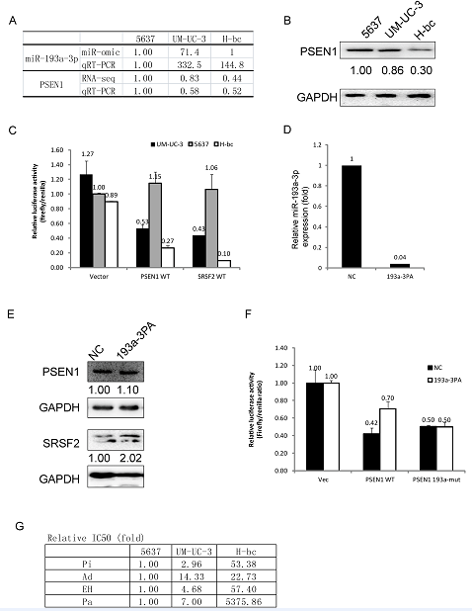

Fig1. The PSEN1 level correlates with the Pi, EH and Pa, but not Ad chemoresistance of bladder cancer cell lines in a miR-193a-3p independent manner.
A, the relative RNA level of the miR-193a-3p and PSEN1 genes in 5637, Um-UC-3 and Hbc lines determined by by miR-seq, RNA-seq profiling and qRT-PCR validation. B The relative PSEN1 protein level in 5637, Um-UC-3 and H-bc lines analyzed by western blotting. C, the relative luciferase activity (fold) of the reporter with wild-type (WT) –UTR of PSEN1 and SRSF2 gene or without UTR (Vec) were compared in 5637, UM-UC-3 and H-bc cells. Error bars represent sd. D, the miR-193a-3p level was drastically reduced by the antagomiR transfection into Um-Uc-3 cells, determined by a qRT-PCR analysis of the antagomiR (3PA) transfected versus the mock transfected (NC). E, The PSEN1 protein was not elevated in 3PA transfected Um-UC-3, while SRSF2 elevated by 2.0 fold. F, The PSEN1 UTR remains amenable to miR-193a-3p regulation in the luciferase reporter assay in Um-Uc-3 cell lines. Um-Uc-3 cells were sequentially transfected with the miR-193a-3p antagomir or Mocks first, and then with either CMV promoter driven firefly luciferase with either the wild-type (WT) or mutant (Mut) PSEN1-UTR or with no UTR(Vec) plus the renilla luciferase reporter as the internal control (see methods session for detail). The firefly luciferase activity was normalized with the Renilla luciferase activity before analyzed. The representative results from three independent experiments shown. Error bars represent sd. G, IC50 profile of Pi, Ad, EH and Pa was determined by Vita Blue assay. The Relative IC50 values (fold) of 5637, UM-UC-3 and H-bc bladder cancer cell to Pi, Ad, EH and Pa, respectively are shown, derived from the ratio of the absolute IC50(ng/ml) of each cell lines over the the most sensitive cell line 5637

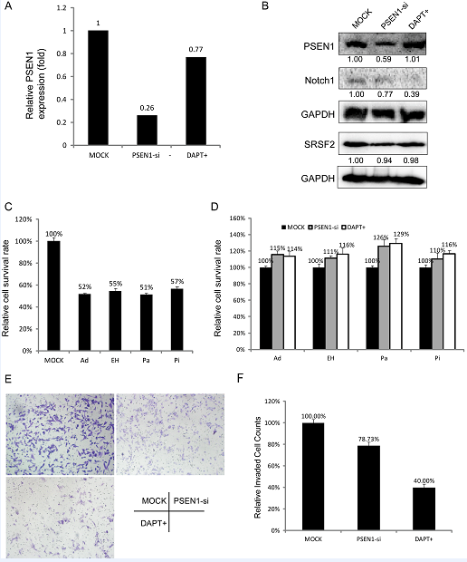
Fig. 2. The negative impact of PSEN1 protein level and activity (γ-secretase) on the drug-triggered cell death and invasion in UM-UC-3 cells.
The PSEN1 RNA level (panel A) and protein level (panel B) in UM-UC-3 treated with MOCK, PSEN1 SiRNA, or γ-secretase inhibitor DAPT. C, The IC50 dose effect of Ad, EH, Pa and Pi in Um-Uc-3; D, the negative impact of a downregulation of PSEN1 protein and activity on chemo-resistance to Ad, EH, Pa and Pi, with the cell survival of the mock treated (NC) cells as reference. E, the negative impact of a downregulation of PSEN1 protein and activity on cell invasion assayed at 48hrs in image (E) and as to the relative percentage of cells invaded in plot (F).

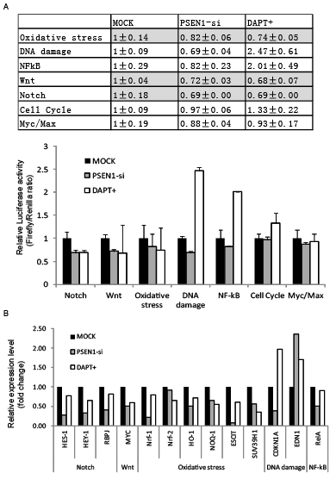
Figure 3. The impact of a downregulation of the PSEN1 level and activity on seven signaling pathways.
Um-Uc-3 were transfected with Mock, PSEN1 siRNA or treated with DAPT for 24 hours, then subsequently transfected with the pathway reporter plasmids with the Renilla luciferase reporters (a Qiagen™ pathway reporter system), before assayed for both firefly luciferase and renilla luciferase activities. A, the relative activities (mean ±S.D.) of pathways in the PSEN1 siRNA transfected or DAPT treated versus the NC transfected. were shown in both table and plot. B, the mRNA levels of the representative downstream targets for Notch, Wnt, Oxidative stress, DNA damage and NF-Kb pathways were determined in the mock and siRNA transfected and DAPT treated.

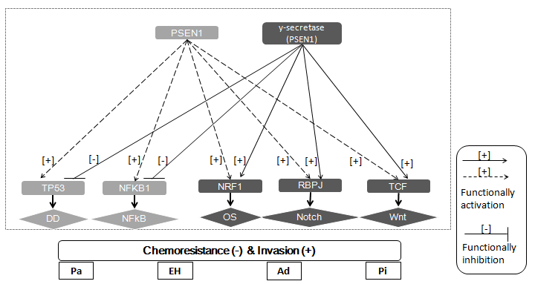
Fig4. The PSEN1’s role in the suppression of chemoresistance and promotion of invasion in Bladder cancer.
PSEN1/gamma-secretase suppresses chemoresistance to four indicated chemotherapeutics and enhances invasive capacity in UM-UC-3 where both PSEN1 and miR-193a-3p express at a high level, which appears to achieved via activating Oxidative stress, Notch and Wnt signaling. However, siRNA mediated repression of PSEN1 level exhibited a different impact on NF-kB and DNA damage response pathways from the DAPT mediated inhibition of the γ-secretase.
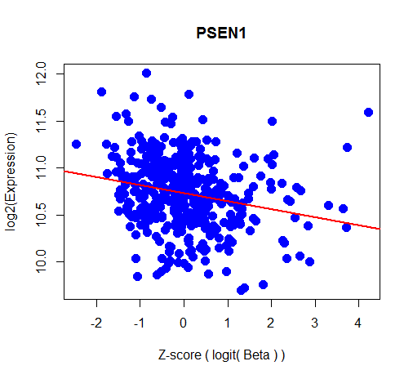

Fig. S1. Negative correlation between DNA methylation and gene expression of PSEN1. Methylation and gene expression data downloaded from TCGA were merged then linear and linear mixture model were conducted to explore the correlation between gene expression and DNA methylation and the most significant regression model were reported in current study. Z-score of the logit transformed beta value and log2 transformed RSEM were integrated and analyzed.
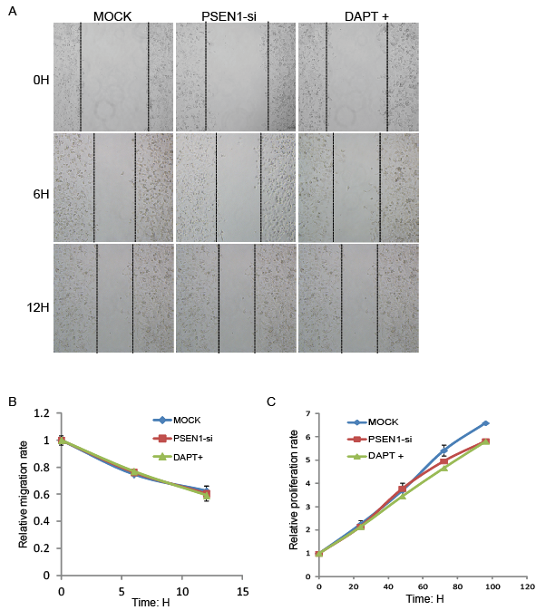
Fig. S2. The nill impact of the PSEN1 level and activities on migration and proliferation rate of UM-UC-3 cells. A. The wound healing assay of UM-UC-3 cells treated with MOCK, PSEN1 SiRNA, or DAPT was measured in 0, 6, and 12h. The relative migration rates were then calculated and plotted in B. C, the relative proliferation rates of UM-UC-3 cells treated with MOCK, PSEN1 SiRNA, or DAPT were analyzed and plotted.

Table S1. siRNA sequences used for PSEN1.

Si-PSEN1-1：
5‘ GGACUACAUUACUGUUGCA dTdT 3‘
3‘ dTdT CCUGAUGUAAUGACAACGU 5‘
Si-PSEN1-2：
5‘ CUACUUUGCCACAGAUUAU dTdT 3‘
3‘ dTdT GAUGAAACGGUGUCUAAUA 5‘

Table S2. The sequences of the primers and probes.
hPSEN1F: 5'-TATGGCAGAAGGAGACCCG-3'
hPSEN1R: 5'-CCATTCCTCACTGAACCCG-3'
hPSEN1 probe: 5'-CY5-CATTCTCTGCAACAGTGTCTTGTGACTCC-3'
hNQO1 F: 5’- AACTTCAATCCCATCATTTCCA-3’
hNQO1 R: 5’- TTTATAAGCCAGAACAGACTCGG-3’
hNQO1 probe: 5’-CY5-CTGAAGGACCCTGCGAACTTTCAGTATC-3’
hHO-1 F: 5’- CATGAGGAACTTTCAGAAGGGC-3’
hHO-1 R: 5’- GGAAGTAGACAGGGGCGAAGA-3’
hHO-1 probe: 5’-CY5-CGGCTTCAAGCTGGTGATGGCC-3’
hNrf-1 F: 5’-CGCACAGAAGAGCAAAAGCA-3’
hNrf-1 R: 5’- TCTTCAAAGGCATACAAAAGGTC-3’
hNrf-1 probe: 5’-CY5-CATGGACCCAGGCACTACGGACC-3’
hNrf-2 F: 5’- AGCCCCTGTTGATTTAGACGG-3’
hNrf-2 R: 5’-TGGCTTCTGGACTTGGAACC-3’
hNrf-2 probe: 5’-CY5- CAAGTTTGGGAGGAGCTATTATCCATTCC-3’
hSUV39H1 F: 5’-AAGTCGAGTACCTGTGCGATTAC-3’
hSUV39H1 R: 5’- AAGTCCTTGTGGAACTGCTTGA-3’
hSUV39H1 probe: 5’-CY5-CGAACAGGAATATTACCTGGTGAAATGGC-3’
hESCIT1 F: 5’-GCATCTTCGTCCACTACCCTC-3’
hESCIT1 R: 5’-CGTCTCCTTGTTGGGCATC-3’
hESCIT1 probe: 5’-CY5- CAGCAGGAGTGTGGGATTGCTGTCC-3’
hEDN1 F: 5’- CTTCTGCCACCTGGACATCA-3’
hEDN1 R: 5’- CATCTATTTTCACGGTCTGTTGC-3’
hEDN1 probe: 5’-CY5- CATCTATTTTCACGGTCTGTTGC-3’
hCDKN1A F: 5’- CACTGTCTTGTACCCTTGTGCC-3’
hCDKN1A R: 5’- GGCTTCCTCTTGGAGAAGATCA-3’
hCDKN1A probe: 5’- ROX-CCCCAGGTGGACCTGGAGACTCTC-3’
hRelA1 F: 5’- ATGGCTTCTATGAGGCTGAGC-3’
hRelA1 R: 5’- AGGGGTTGTTGTTGGTCTGG-3’
hRelA1 probe: 5’-ROX- CGGACCGCTGCATCCACAGTTTC-3’
hRBPJ F: 5’- TTCACAGTCCGAGATGGCTACA-3’
hRBPJ R: 5’- TGCGGTCTGCTTATCAACTTTC-3’
hRBPJ probe: 5’- ROX-CTTGTGTGCTCAGTTACTGGCATGGC-3’
hHES1 F: 5’- AACACTGATTTTGGATGCTCTGA-3’
hHES1 R: 5’- GAGGTGCTTCACTGTCATTTCC-3’
hHES1 probe: 5’- ROX-CCAAGCTGGAGAAGGCGGACATTC-3’
hHEY1 F: 5’- ACGCCCTTGCTATGGACTATC-3’
hHEY1 R: 5’- GCTGGGAAGCGTAGTTGTTGA-3’
hHEY1 probe: 5’- ROX-CTGGCAGAAGTTGCGCGTTATCTGA-3’
hACTB F: 5'-GCCCATCTACGAGGGGTATG-3'
hACTB R: 5'-GAGGTAGTCAGTCAGGTCCCG-3'
hACTB probe: 5'HEX-CCCCCATGCCATCCTGCGTC-3'

