Supplemental figure legends

Supplemental Figure S1.

A significant negative correlation was found between methylation index (MI) of window and number of bases within CpG islands per window (r=-0.481, p<10⁻¹⁵). Correlations shown here were done using window sizes of 500 kb.

Supplemental Figure S2.
Average MI of chromosomes, demonstrating interchromosomal variance in MI and a low MI of chromosome 19. Values shown are derived from window sizes of 500 kb.
Supplemental Figure S1.

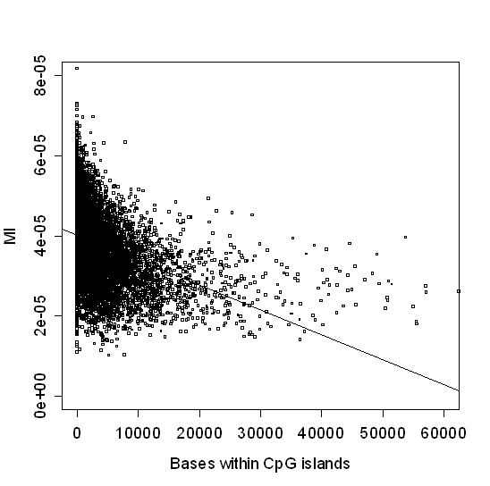
Supplemental Figure S2.
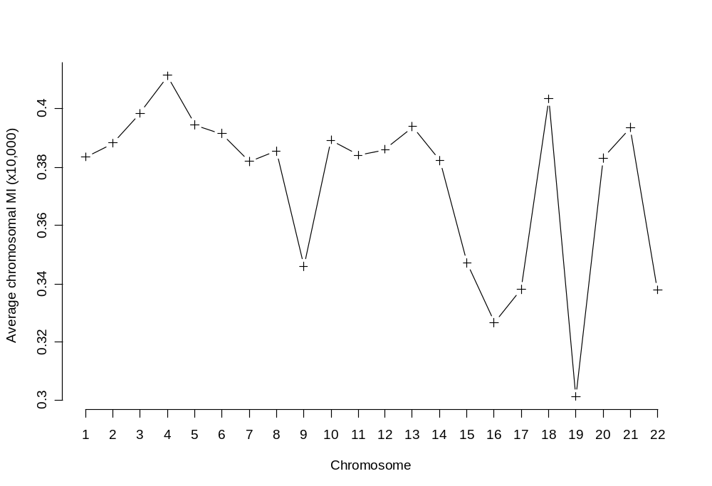

Supplemental Table S1A

 | Non-mSNP |  | mSNP
Population | N | iHS  Mean (SD) | N | iHS  Mean (SD)
ASI | 749791 | -0.066 (1.005) | 235639 | -0.008 (0.993)
CEU | 931439 | -0.071 (1.001) | 281911 | 0.002 (0.995)
YRI | 1216014 | -0.052 (1.005) | 313138 | 0.019 (0.992)

The iHS (integrated haplotype score) is a parameter used to estimate the recent selection of SNPs. The parameter is essentially normal distributed with a mean of 0 and standard deviation of 1. The average iHS value was essentially zero for both mSNPs and non-mSNPs. ASI: East Asian Population, CEU: Northern and Western European Population, YRI: Youruba Population.

Supplemental Table S1B

 | Non-mSNP | mSNP
Population | 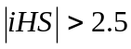  n/N  (%) | n/N  (%)
ASI | 8,494/749,791 (1.1) | 2,521/235,639  (1.1)
CEU | 10,353/931,439 (1.1) | 3,173/281,911  (1.1)
YRI | 15,481/1,216,014 (1.3) | 3,811/313,138  (1.2)

A signed iHS value larger than 2.5 indicates recent selection for either allele. The ratio of SNPs with signed iHS value larger than 2.5 was either slightly higher for the non-mSNP group or the same for all populations. This indicates that there is no overall difference in selection pressure between the mSNPs and non-mSNPs that might confound our analysis. ASI: East Asian Population, CEU: Northern and Western European Population, YRI: Youruba Population.
Supplemental Table S2A. Correlation of several sequence and model features with recombination activity in different window sizes for the whole genome.

Single correlations
Response: Recombination Rate
 | Window size
 | 125 kbª | 250 kbª | 500 kbª | 1000 kbª
mSNP | 0.502 | 0.564 | 0.622 | 0.641
SNP density | 0.357 | 0.358 | 0.355 | 0.349
Repeats | -0.255 | -0.294 | -0.332 | -0.348
Exons | NS | NS | 0.070 | 0.112
GC content | 0.346 | 0.370 | 0.390 | 0.410
CpG dinucleotides | 0.270 | 0.308 | 0.353 | 0.402

Response: Recombination Hotspots
 | Window size
 | 125 kbª | 250 kbª | 500 kbª | 1000 kbª
mSNP | 0.377 | 0.450 | 0.508 | 0.556
SNP density | 0.245 | 0.249 | 0.239 | 0.231
Repeats | -0.178 | -0.216 | -0.255 | -0.276
Exons | NS | 0.049 | 0.104 | 0.142
GC content | 0.274 | 0.321 | 0.365 | 0.399
CpG dinucleotides | 0.212 | 0.267 | 0.333 | 0.389
Multiple correlation
Controlled variables: SNP density, Repeats, Exons, GC content, CpG dinucleotides.

Response: Recombination Rate
 | Window size
 | 125 kbª | 250 kbª | 500 kbª | 1000 kbª
mSNP | 0.099 | 0.125 | 0.172 | 0.142

Response: Recombination Hotspots
 | Window size
 | 125 kbª | 250 kbª | 500 kbª | 1000 kbª
mSNP | 0.088 | 0.123 | 0.152 | 0.157

ªAll values have p<0.0001, NS=not significant.
Supplemental Table S2B. Multiple linear regression of recombination activity as a response to sequence and model feature predictors for whole genome

Response: Recombination Rate
 | Window size
 | 125 kb^{a,b} | 250 kb^{a,b} | 500 kb^{a,b} | 1000 kb^{a,b}
mSNP | 0.179 | 0.220 | 0.189 | 0.162
SNP density | 0.271 | 0.285 | 0.344 | 0.419
Repeats | -0.127 | -0.130 | -0.147 | -0.144
Exons | -0.189 | -0.179 | -0.160 | -0.146
GC content | 0.083 | -0.025 | 0.225 | RM
CpG dinucleotides | 0.366 | 0.460 | 0.309 | 0.585
Model R² | 0.339 | 0.396 | 0.469 | 0.518

Response: Recombination Hotspots
 | Window size
 | 125 kb^{a,b} | 250 kb^{a,b} | 500 kb^{a,b} | 1000 kb^{a,b}
mSNP | 0.189 | 0.272 | 0.276 | 0.241
SNP density | 0.165 | 0.156 | 0.170 | 0.244
Repeats | -0.079 | -0.081 | -0.106 | -0.085
Exons | -0.122 | -0.104 | -0.091 | -0.109
GC content | 0.060 | -0.019 | 0.142 | RM
CpG dinucleotides | 0.245 | 0.298 | 0.215 | 0.444
Model R² | 0.193 | 0.258 | 0.327 | 0.369

ªStandardized beta values are shown. The β is the number of standard deviations that the outcome variable will change as a result of one standard deviation change in the predictor variable.
^{b}All boldtype values have p<0.0001.
^{c}RM=value not included in linear model.
Supplemental Table S3A. Correlation of several sequence and model features with recombination activity in different window sizes for the high resolution ENCODE regions.

Single correlations
Response: Recombination Rate
 | 25 kb |  | 50 kb
 | r | pª |  | r | pª
mSNP | 0.319 | <0.0001 |  | 0.301 | 0.002
SNP density | -0.084 | 0.235 |  | 0.027 | 0.790
Repeats | -0.05 | 0.481 |  | -0.136 | 0.177
Exons | 0.061 | 0.392 |  | 0.045 | 0.656
GC content | 0.363 | <0.0001 |  | 0.211 | 0.035
CpG dinucleotides | 0.266 | <0.0001 |  | 0.172 | 0.087
Response: Recombination Hotspots
 | 25 kb |  | 50 kb
 | r | pª |  | r | pª
mSNP | 0.136 | 0.055 |  | 0.116 | 0.252
SNP density | -0.109 | 0.123 |  | -0.121 | 0.229
Repeats | -0.074 | 0.297 |  | -0.019 | 0.851
Exons | 0.162 | 0.022 |  | 0.161 | 0.11
GC content | 0.268 | <0.0001 |  | 0.267 | 0.007
CpG dinucleotides | 0.278 | <0.0001 |  | 0.282 | 0.004
Multiple correlation
Controlled variables: SNP density, Repeats, Exons, GC content, CpG dinucleotides.

Response: Recombination Rate
 | 25 kb |  | 50 kb
 | r | pª |  | r | pª
mSNP | 0.335 | <0.0001 |  | 0.445 | <0.0001

Response: Recombination Hotspots
 | 25 kb |  | 50 kb
 | r | pª |  | r | pª
mSNP | 0.211 | 0.003 |  | 0.209 | 0.042

ªStatistically significant values (p<0.01) are typeset in bold.
Supplemental Table S3B. Multiple linear regression of recombination activity as a response to sequence and model feature predictors for the high resolution ENCODE regions.

Response: Recombination Rate
 | 25 kb |  | 50 kb
 | βª | p^{b} |  | βª | p^{b}
mSNP | 0.490 | <0.0001 |  | 0.661 | <0.0001
SNP density | -0.293 | <0.0001 |  | -0.462 | <0.0001
Repeats | RM^{c} | RM^{c} |  | RM^{c} | RM^{c}
Exons | -0.165 | 0.043 |  | -0.214 | 0.06
GC content | RM^{c} | RM^{c} |  | RM^{c} | RM^{c}
CpG dinucleotides | 0.298 | <0.0001 |  | 0.301 | 0.013
Model R² | 0.235 |  |  | 0.394

Response: Recombination Hotspots
 | 25 kb |  | 50 kb
 | βª | p^{b} |  | βª | p^{b}
mSNP | 0.241 | 0.004 |  | 0.147 | 0.122
SNP density | -0.167 | 0.056 |  | RM^{c} | RM^{c}
Repeats | RM^{c} | RM^{c} |  | RM^{c} | RM^{c}
Exons | RM^{c} | RM^{c} |  | RM^{c} | RM^{c}
GC content | RM^{c} | RM^{c} |  | RM^{c} | RM^{c}
CpG dinucleotides | 0.234 | 0.002 |  | 0.227 | 0.001
Model R² | 0.121 |  |  | 0.134

ªStandardized beta values are shown. The β is the number of standard deviations that the outcome variable will change as a result of one standard deviation change in the predictor variable.
^{b}Statistically significant values (p<0.01) are typeset in bold.
^{c}RM=value not included in linear model.

