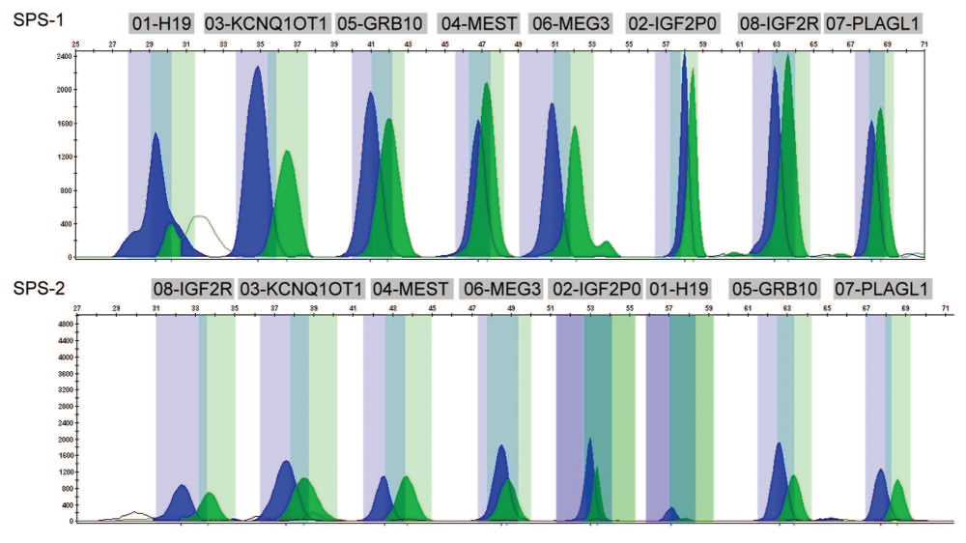

Raw data of the Ms-sNup Eassay as displayed in the GeneMapper software (applied Biosystems) after the analysis with the panels for sps-1 and sps-2 obtained from a normal control. The methylated alleles are represented by the blue peaks, while the unmethylated alleles are displayed in green.

