**ZNF132 promoter hypermethylation as a potential biomarker**

**for esophageal squamous cell carcinoma (ESCC)**

**ABSTRACT**

**INTRODUCTION**

Esophageal cancer (EC) ranks 8th in most common cancers and 6th in cancer-related mortality worldwide (Ref). For the past several decades, the incidence of and estimated deaths due to esophageal cancers have been increasing continuously. According to the 2012 report of the World Health Organization, 455, 000 new cases of Esophageal cancer were diagnosed. Among these, 49% (223,000 cases) were in China (). The five-year survival rate of esophageal cancer remains poor despite of advances in clinical oncology (). Esophageal cancer consists mainly of two subtypes, esophageal squamous cell carcinoma (ESCC) and esophageal adenocarcinoma (EAC) , each with distinct pathologies and etiologies (). While EAC predominates in North America (PMID: 12424848), the majority of esophageal cancer cases worldwide are ESCC, which has a high prevalence in east Asia, eastern and southern Africa, and southern Europe (). ESCC accounts for more than 90% esophageal cancers in China nowadays (). With the characteristics of highly invasive, metastatic and poor prognosis, there is an urgent need for identifying diagnostic and prognostic biomarkers for ESCC.

DNA methylation is one of the most intensively studied epigenetic modifications. DNA methylation involves in many kinds of biological processes, including development, gene expression regulation and imprinting. Multiple studies have confirmed that global hypomethylation induces genomic instability leading to cell transformation, and hypermethylation of promoter regions of the tumor suppressor genes facilitates tumorigenesis. Previous studies have shown that a broad range of genes are silenced by DNA hypermethylation in different cancer types. The study of specific DNA methylation has translational potential in the management of ESCC patients, and hypermethylated promoters may serve as candidate biomarkers. Moreover, DNA methylation is reversible which makes it very interesting for therapy approaches.

We have previously screened TCGA database for aberrant epigenetic changes in ESCC. The results were validated with DNA methylation datasets from GEO and peripheral blood mononuclear cells (PBMC) and peripheral blood leucocytes (PBL) of healthy controls. The hypermethylated status of promoters of several candidate genes were identified. One of them is *ZNF132*, which belongs to C2H2 zinc finger protein family. It is located at chromosome 19q13.4, which is usually deleted in thyroid adenomas (Genomics 1995; 27:259). *ZNF132* has 18C2H2 zinc finger motifs according to its predicted structure. The zinc finger protein family has been shown to participate in biological processes such as development and differentiation. Recent studies have also suggested that zinc finger proteins play a role in cancer progression(). There are not many studies on the biological function of *ZNF132*, however, decreased expression of *ZNF132* has been reported in prostate cancer, and is associated with aggressive prostate cancers PMID: 21445975.

To determine the role of *ZNF132* and its potential value as a biomarker in ESCC, we studied the methylation status of the *ZNF132* promoter and the expression level of *ZNF132* in ESCC tumors and adjacent normal tissues. The correlation between methylation status and expression of *ZNF132* were then measured in vitro in EC cell lines with or without epigenetic drugs. Furthermore, we tested the effect of *ZNF132* expression on proliferation, migration, invasion and apoptosis of EC cells in vitro. The effect of *ZNF132* overexpression on the tumerigenecity of EC cell line was also tested in a nude mouse model. Finally, the mechanism of association of promoter hypermethylation and expression of ZNF132 was

Explored.

**RESULTS:**

**Methylation status of ZNF132 in ESCC patients tissue samples**

Targeted bisulfite sequencing method was used to determine methylation status of *ZNF132* in ESCC tissues. Fifteen CpG sites in the promoter region of *ZNF132* were sequenced in 94 paired tumor and adjacent normal tissues **(Table 1)**. **The single nucleotide primer extension technique was used, which can quantify methylation at multiple methylated loci simultaneously ().** 21 CpG sites located at the promoter of *APC* **( What is APC?)**and 11 CpG sites from mitochondrion DNA **(ChrM)** were also sequenced as positive and negative controls respectively. **Primers used are listed in Table 2.** As shown in Figure 1, the methylation percentage of *ZNF132* were significantly higher in ESCC tumors than that in adjacent control tissues on all 15 tested CpG sites in the paired tissues of 94 ESCC patients. (Figure 1A) **(14 spots showed higher, 1 spot showed no difference).** The results of all CpG sites in 94 paired tissues were individually shown in Figure 2A indicating a significant higher average methylation level in ESCC tissues. The results are also summarized in Table 3 showing a significant association of between ZNF132 methylation and ESCC (P=8.71 X 10-14). In consistence with results reported (reference), 21 sites of *APC,* as a positive control, also showed significantly higher methylation percentage in tumor tissues than that in adjacent normal tissues, while 11 sites of ChrM , a negative control, show no difference (1B, 1C, and Table 3), demonstrating the reliability and robustness of our targeted bisulfite sequencing method.

The results described above shows clearly the association of hypermethylation of ZNF132 promoter and ESCC.

**Prediction ability of ZNF132 hypermrthylation as a prognosis marker in ESCC**

To examine the clinical value of hypermethylation of *ZNF132*, we analyzed the relation between survival time and *ZNF132* methylation status in our 94 ESCC patients. The overall survival in the patients with higher level of *ZNF132* methylation is significantly shorter than the patients with lower level of *ZNF132* methylation. (Figure 3)

The potential as a prognosis biomarker of the test was then analyzed. Logistic regression analysis demonstrated that the hypermethylation of ZNF132 promoter was significantly associated with ESCC after the risk factors of age, gender, alcohol, smoking and **stage?** were adjusted [OR (95%CI)=3.53 (2.51, 4.74), P=2.36 X 10-09]. To evaluate the prediction ability, sensitivity, specificity and area under curve (AUC) were calculated with a logistic regression prediction model. As shown in Table 3 and Figure 2B , sensitivity, specificity and area under curve (AUC) are 77.53%, 80.43% and 0.83 respectively without adjustment for the risk factors of age, gender, alcohol, smoking and **stage?**, illustrating moderate prediction ability.

Taken together the results suggest that ZNF132 methylation status is of independent value, and has potential of being a predictor for prognosis in ESCC.

**Regulation of ZNF132 expression by methylation of its promoter in ESCC patients and esophagus cancer cell lines**

As methylation of gene promoter regions is a well-known gene expression regulation mechanism, we first examined the expression of *ZNF132* in 37 pairs of tumor and adjacent control tissues from ESCC patients. Quantitative Real-time PCR was used to evaluate the expression level of *ZNF132* in the samples. The results demonstrated a significantly higher level of ZNF132 expression in adjacent control tissues than that in ESCC tissues (Figure 4**A**), indicating that the expression profile of *ZNF132* in ESCC tissues was altered as a consequence of its promoter hypermethylation in ESCC patients.

To confirm the relation between ZNF132 methylation and its expression observed in ESCC patients tissues, two esophagus cancer cell lines (Ec-109, CaEs-17) were treated with demethylation reagent 5 Aza (5-aza-2’- deoxycytidine). As positive controls, two classic methylated genes **()** SFRP1 and GALR3 showed demethylation after 5 Aza treatment (Figure **4B**). ZNF132 **promoter** methylation levels of two lines decreased significantly after treatment (Figure **4C**), and at the same time ZNF132 expression level, measured by qRT-PCR, significantly increased (Figure **4D**).

The results clearly established that methylation status of ZNF132 negatively regulates its expression. The fact that epigenetic treatment modulates ZNF expression shows its potential as a epigenetic cancer therapy.

**Effects of ZNF132 expression on cancer cell characteristics of esophagus cancer lines in vitro**

The results described above raises the possibility that ZNF132 functions as a tumor suppressor in ESCC. To determine the effects of ZNF132 protein on characters of ESCC cells we constructed pCD513B-1-ZNF132 plasmid, and use empty pCD513B-1 as a control. Ec109 cells and Caes-17 cells aretransfected by the plasmid pCD513B-1-H-ZNF132 or pCD513B-1. Figure 5A showed expression level of ZNF132 in pCD-ZNF132 cells is greatly higher than the control cells. The effects of high expression of ZNF132 were then tested on cells’ ability in growth, migration, invasion and apoptosis.

Cell growth was monitored daily. Growth of pCD513B-1-ZNF132 cells was slower than pCD-513B-1 cells. Starting at day 3 the growth rates between experiment and control groups became significant (Figure ~~6~~ **5B**). The abilities of the cells in migration and invasion were also negatively affected by the presence of pCD513B-1-ZNF132 (Figure ~~7 and 8~~ **5C**) indicating the suppressor functionof ZNF132 in growth, migration and invasion of cancers.

Besides cells abilities of growth, migration and invasion, abnormal pattern of tumor cell apoptosis also ~~pays~~ plays a role in tumor growth and metastasis. Percentage of apoptotic Ec109 cells significantly increased by high expression of ZNF132 (Figure~~9~~ 5D).

The results show that higher expression ZNF132 greatly reduced tumorigenecity of ESCC cells in vitro.

**Reduction of tumorigenecity of ESCC cells by enforcing ZNF132 expression in a in vivo xenograft model**

To investigate whether ZNF132 gene functions as tumor suppressor also in vivo, we established a xenograft model. Ec109 cells transfected with either the plasmid pCD513B-1-H-ZNF132 or pCD513B-1 were inoculated in to BALBc nude mice. On day 30, the mice were sacrificed, the volumes and wet weights of the tumors were measured individually .

The tumor sizes of pCD513B-1-ZNF132 group were visually smaller than pCD513B-1 group (Figure 6A). There were significant differences in tumor volume and wet weight between experiment and control groups (6B, 6C) while there was no significant difference in body weight of mice between two groups during the experiment (6D). No abnormal daily food and water consumption, and other adverse effects, such as mental state and hematuria were observed.

The xenograft study suggests that ZNF132 plays a role as tomor suppressor gene in preventing ESCC in vivo.

**Methylation of sp1-binding site inhibits ZNF132 expression at transcriptional level**

As CpG was in silico predicted to be harbored in transcriptional activator Sp1-binding site at ZNF132 promoter, we then try to determine whether methylation of Sp1-binding site play a role in ZNF132 expression regulation.

According to the published sequence of ZNF132 promoter, luciferase reporter constructs was generated and transiently transfected together with increasing doses of Sp1 expression vector into HEK293T cells. The results showed that the transcriptional activity of ZNF132 promoter were elevated with increasing doses of Sp1, suggesting that the Sp1 may transcriptionally modulate ZNF132 expression (Figure ~~6~~ **7A**).

To determine whether methylation of Sp1-bining site alters the transcriptional activity of ZNF132 promoter by derecruiting Sp1, we generated two luciferase reporter constructs containing the unmethylated and methylated fragments (Sp1-binding sequence). (**Were the two constructs transfected in to cells? Which cell line was used?)** The results showed that the methylated Sp1-binding site dramatically led to a reduction of luciferase activity compared with the unmethylated one, suggesting that methylation of Sp1-bining site can inhibit ZNF132 transcriptional expression by interfering with the recruitment of Sp1 to ZNF132 promoter region (Figure ~~6~~ **7B**) **(No method mentioned)**.

To determine directly whether Sp1 binds to ZNF132 promoter, ChIP assay was performed. Using ChIP DNA purified from cultured cells transfected with p3×flag-Sp1 vector, the results of PCR, which ampliﬁed ZNF132 promoter region encompassing the putative Sp1-binding site, showed a clear band while no such band was seen if the cells transfected with p3×flag-cmv-10 vectors were used (Figure ~~6~~ **7C**). This clearly demonstrates that Sp1 can bind to the ZNF132 promoter region in live cells cultured in vitro.

The DNA pulldown assays was used to confirm transcriptional activator Sp1 could bind to promoter region of ZNF132 gene and methylation status of ZNF132 promoter negatively affects the binding. DNA pull-down assays showed that the methylated Sp1-bining site probe had weaker binding ability with Sp1 proteins compared with the unmethylated Sp1-bining site probe (Figure 7D).

Combined with our results described above, the results revealed, at least in part, the mechanism underlying the association of hypermethylation of ZNF132 promoter region and ESCC. Methylation of Sp1-bining site prevents the ranscriptional activator Sp1 from binding to ZNF132 promoter, silencing ZNF132 tumor suppressor gene.

**Discussion**

ESCC is one of the most aggressive forms of cancer. Consumption of tobacco and alcohol are two major risk factors in ESCC carcinogenesis ().

Tobacco smoking is associated with promoter region hypermethylation in a group tumor suppressor genes of human ESCC (). Alcohol consumption has a stronger association with ESCC **?** than other human cancers (), and is also associated with hypermethylation of tumor suppressor gene promoter region in human esophageal cancer (). Increasing, but still limited number of DNA methylation markers for early detection, recurrence and prognosis have been identified in ESCC (). However, there are not many studies focusing on mechanisms under which epigenetic changes in tumor suppressor gene promoter regions lead to human ESCC initiation and progression.

In this study we show that ZNF132 gene is silenced in ESCC tumor tissues, but not in adjacent control tissues in paired tissue samples from ESCC patients. In ESCC tumor tissue, the ZNF132 gene is hypermethylated in its promoter region. The epigenetic changes in ZNF132 in ESCC patients samples have been determined by targeted bisulfite sequencing. Methylation status of ZNF132 promoter region is significantly higher in ESCC tissue than in adjacent control tissue. ZNF132 expression at RNA level, consistent with its methylation status, is significantly lower in ESCC cells indicating possible tumor suppressor function of ZNF132.

These results have led us to further explore the clinical value of hypermethylation of ZNF132 promoter. Significant association between overall survival and methylation status was observed. Logistic regression analysis revealed hypermethylated ZNF132 is strongly associated with ESCC after adjustment for age, sex, smoking, alcohol consumption and **stage?**. The logistic regression model was also used to evaluate the prediction ability of hypermethylation status of ZNF132 promoter. Analysis results, sensitivity, specificity and AUC without adjustment for age, sex, smoking, alcohol consumption and stage, indicate moderate prediction ability of the test. Taken together, ZNF132 hypermethylation is an independent factor **(?)** to predict overall survival regardless of other risk factors, such as age, sex, or stage etc.

To our knowledge so far, there have never been any studies of ZNF132 in ESCC, actually there is only one report on the role of ZNF132 in human cancer, demonstrating the significant inverse correlation between methylation level of ZNF132 and its protein expression in prostate cancer patients tissue samples (Int. J. Cancer:130, 885-895). Consistent with our study in ESCC patients, their results also illustrate that ZNF132 have the potential to be a new candidate methylation marker for prostate cancer.

The role of methylation promotor and expression of ZNF132 were analysed in in vitro study with EC cell lines. Two EC cell lines showed significant decreased ZNF132 methylation accompanied by increased expression of ZNF132 after demethylation reagent 5 Aza treatment, demonstrating directly the inverse relationship between promoter methylation status and expression of ZNF132 in ESCC. The results indicate the potential of demethylation drugs as a epigenetic cancer therapy.

The function of ZNF132 was then studied in ESCC lines. Overexpression of ZNF132 in EC cells greatly reduced the abilities of cells in in growth, migration and invasion, and significantly increased apoptotic cell death illustrating in vitro the tumor suppression function of ZNF132. The effect of ZNF132 overexpression was also studied in vivo with a nude mouse model. The tumorigenicity of EC cells with overexpressied ZNF132 is significantly reduced, therefore confirming the above in vitro results. Our study is the first one to show both in vitro and in vivo the tumor suppression function of ZNF132 indicating the pathological importance of reducing ZNF132 expression by hypermethylation of its promoter region.

The underlying mechanism of the effect of methylation status of ZNF132 promoter on its expression was explored. Sp1 is a transcriptional activator. CpG was in silico predicted to be harbored in Sp1-binding site at ZNF132 promoter. It was first in this study demonstrated that Sp1 can bind to promoter region of ZNF132, and then that the methylated site prevent SP1 from binding to the promoter. The mechanisms of promoter methylation effects on gene expression is very complicated. However our results imply that preventing of Sp1 binding to ZNF132 promoter region by hypermethylation may be one of the mechanisms of reduced ZNF132 expression in ESCC.

In conclusion, our study for the first time demonstrated that ZNF132 promoter is hypermethylated in ESCC tissues, but not in adjacent control tissues. The effects of the epigenetic change and expression ZNF132 on tumorigenecity of EC cell lines were investigated both in in vitro and in vivo. Preventing Sp1 from binding to ZNF132 promoter was shown to be at least one of the underlying mechanisms. Most important, the methylation status of ZNF132 promoter in ESCC patients tumor tissues is an independent prognostic factor, and has potential use as a biomarker useful in prognosis of ESCC.

**Table 1. Clinical Characteristics of the Study Population**

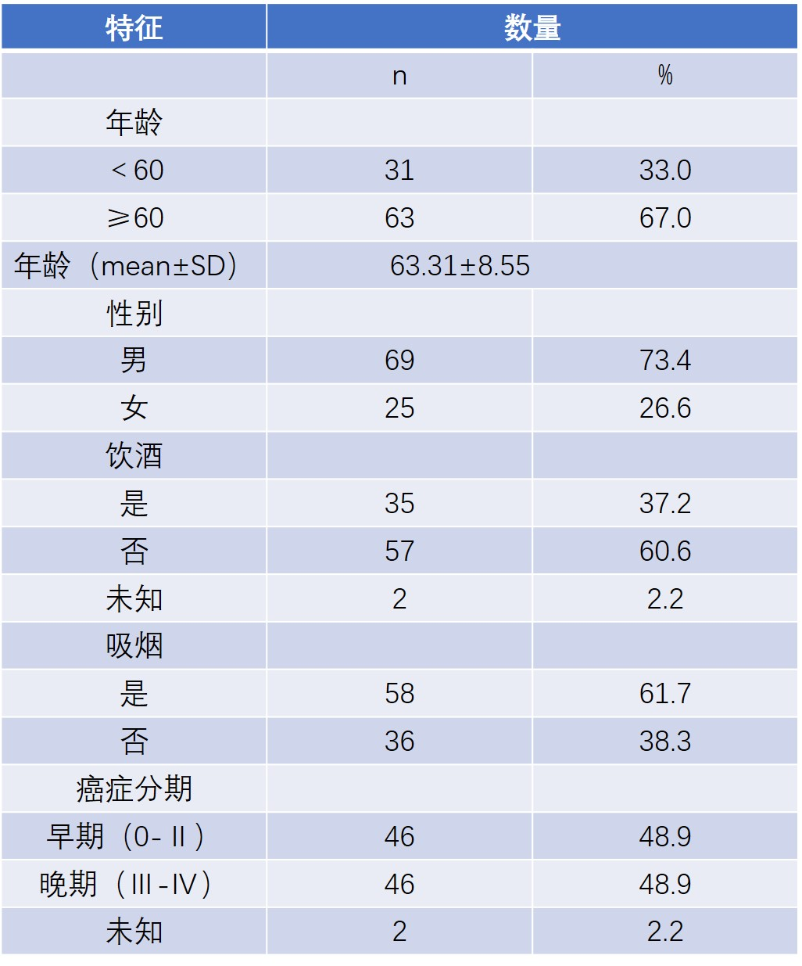

**Question: Any statistics for association between those risk factors and prognosis of the patients?**

**Table 2：Sequences of primers used in this study**

|  |  |  |
| --- | --- | --- |
| **Primer** | **Sequence, 5’-3’** | **Use** |
| ZNF132 F | GGTGTTTTAGGGTTGGTTATTGG | BSP |
| ZNF132 R | TACCTTCCTCRCTCCTATTTCCATAA | BSP |
| APC F | TTTGTTTGTTGGGGATTGG | BSP |
| APC R | CCATTCTATCTCCAATAACACCCTAA | BSP |
| ChrM F | TGTGTGGAAAGTGGTTGTGTAGATATT | BSP |
| ChrM R | AATCACAAATCTATCACCCTATTAACCA | BSP |
| ZNF132 F | GTCATTGAGAGGCGGGACT | qPCR |
| ZNF132 R | TCGGGAACACCTTGGCTCAT | qPCR |
| ZNF132 Xba I | GCTCTAGAATGGCCCTGCCCAGC | PCR |
| ZNF132 Not I | ATAAGAATGCGGCCGCTCAGGTATGAATCTT | PCR |
| GAPDH F | GAAGGTGAAGGTCGGAGTC | qPCR |
| GAPDH R | GAAGATGGTGATGGGATTTC | qPCR |

**Question: The same pair of ZNF132 F and R was used for 15 CpG sites of ZNF132 promoter? Guo et al mentioned (Clinical Epigenetics, 2015 7:3) a method: the single nucleotide primer extension technique for quantification of methylation at multiple methylated loci simultaneously. Do you used the same method? I mentioned in Results.**

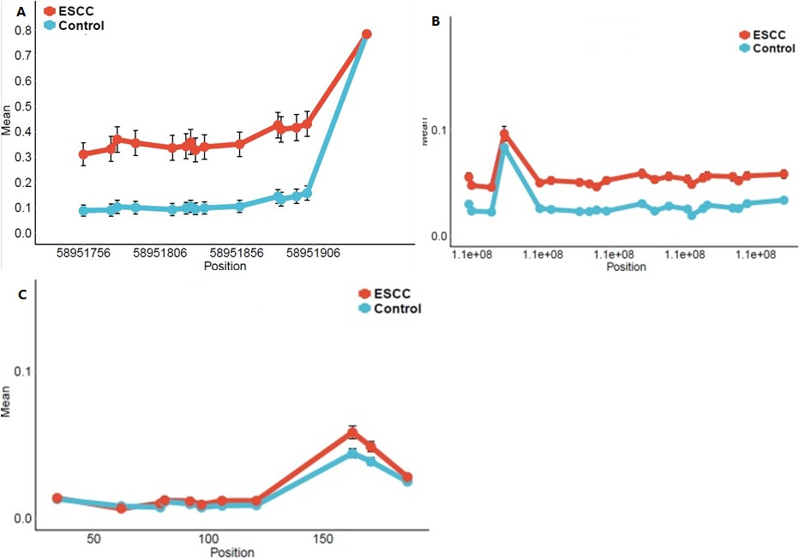

**Figure 1.ZNF132基因在食管鳞癌组织与癌旁组织中的甲基化情况** A. ZNF132中15个检测位点在食管鳞癌组织与癌旁组织中甲基化平均值； (各点代表甲基化绝对比值的平均值。)B.APC中21个检测位点在食管鳞癌组织与癌旁组织中甲基化平均值；C. ChrM中11个检测位点在食管鳞癌组织与癌旁组织中甲基化平均值。

**Figure 1. Methylation status of ZNF132 in ESCC and adjacent control tissues**

1. Median % methylation in ESCC and adjacent control tissues of 15 CpG sites of ZNF132 promoter region. **B.** Median % methylation values of 21 CpG site of APC. **C.** Median % methylation of 11 CpG sites of ChrM.

**I count the spots in 1A, 14 spots showed the difference, but the last spot showed no difference. In text, all 15 sites have significant differences.**

**No explanation of APC in text.**

Table **3** The methylation of ZNF132 gene and control gene in ESCC **(Original this Table was 1)**

|  |  |  |  |  |  |  |  |  |
| --- | --- | --- | --- | --- | --- | --- | --- | --- |
| **Gene name** | **Mean（Case）** | **Mean（Control）** | **P valuea** | **OR（95%CI）** | **P valueb** | **Sensitivity** | **Specificity** | **Area Under Curve（AUC）** |
| ZNF132 | **0.40** | **0.16** | **8.71×10-14** | **3.53（2.51,4.74）** | **2.36×10-09** | **77.53%** | **80.43%** | **0.83** |
| APC | **0.05** | **0.02** | **2.49×10-5** |  |  |  |  |  |
| ChrM | **0.03** | **0.02** | **2.59×10-1** |  |  |  |  |  |

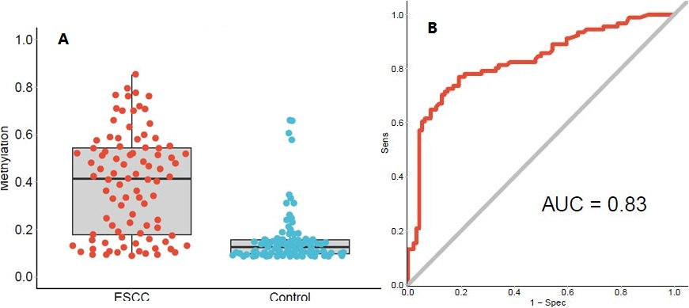

Figure 2. The methylation of ZNF132 in the tissues of the ESCC detected by Methyl target and ROC curves. A. The methylation of ZNF132 in the 94 cases of ESCC tissues and adjacent tissues (each point represents the absolute ratio of methylation in each tissue) B. Represents the overall ROC (Receiver Operating characterstics) curve, which was calculated through a logistic regression model, incorporating the mean methylation percentage of the five genomic regions as the variables, and without the adjustment for gender, age and smoking status and alcohol status, and **stages?**.

**In original chinese manuscript, ...without the adjustment for gender,**

**age and smoking status and alcohol status, and stages.**

**But in original figure legend ...without the adjustment for gender, age and smoking status and alcohol status, and no stage mentioned.**

**In the results and discussion, I included stage. If not correct, please changed.**

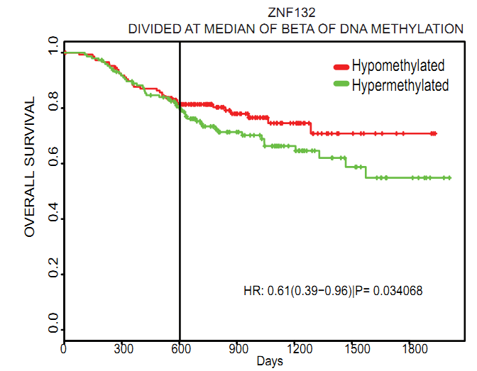

**Figure 3.** Relationship between methylation of ZNF132 gene and prognosis in patients with. The survival time of ZNF132 gene hypermethylated esophageal squamous cell carcinoma was significantly shorter than that of non - methylated patients.

**I made some changes in Legend of Figure3 as follows**

**Figure 3.** Relationship between methylation status of ZNF132 in ESCC tissues and overall survival time of patients. Overall survival time of ESCC patients with hypermethylated ZNF132 in tumor tissues was significant shorter than patients with hypomethylated ZNF132.

**Some authors put number of hypomethylated or hypermethylated cases next to red or green lines.**

**Figure 4**

**A**

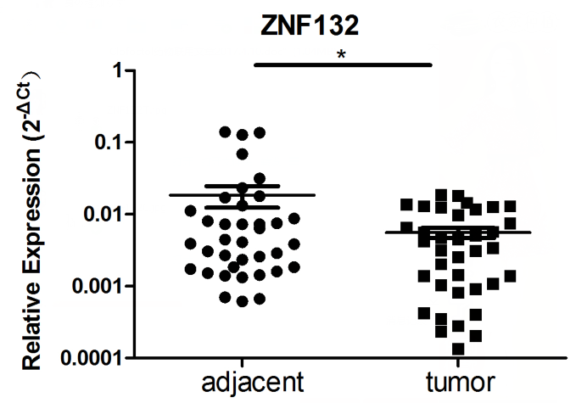

B C

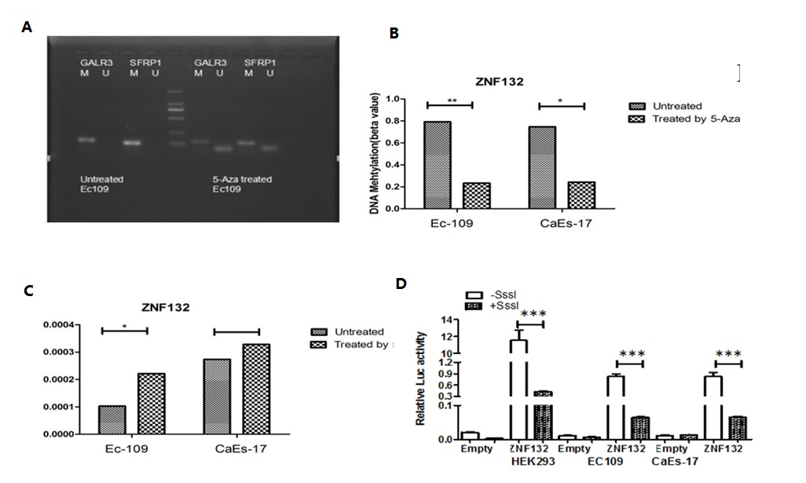

**D delete above picture**

**Figure 4.** Association of methylation status and expression of ZNF132 in ESCC patients and esophageal cancer cell lines.

**A.** Expression of ZNF132 measured by q-PCR in ESCC tissues was significantly lower than that in adjacent tissues

~~and Paracancerous adjacent control tissues. The results of q-PCR showed that the expression of ZNF132 gene in esophageal squamous cell carcinoma was significantly lower than that in adjacent tissues.~~

**~~Figure 4. 在食管癌细胞中ZNF132基因的表达受甲基化调控~~**

~~A~~ **B**： MSP引物甲基化基因GALR3和SFRP1进行MSP实验。

~~B~~ **C**: MSP检测结果显示：5-Aza处理后，细胞中ZNF132的甲基化程度确实有明显降低。

~~C~~ **D**: q-PCR结果显示：5-Aza处理后，ZNF132的表达升高。~~D: 双荧光素酶报告基因检测，食管癌细胞过甲基化处理，ZNF132表达明显下降。+SssI:经过CpG Methyltransferase(M.SssI)处理; -SssI:未经CpG Methyltransferase (M.SssI)处理; Empty: 只转染pGL3-Basic载体最为对照组，实验组均转pGL3-ZNF132-Luciferasconstructs; HEK293T细胞系：作为对照组，食管癌细胞系Ec-109、CaEs-17为实验组。~~

1. Demethyiation of methylated genes GALR3 and SFRP1 measured by MSP after 5-Aza treatment.
2. Methylation of ZNF132 in Ec-109 and CaEs-17 was significantly reduced after 5-Aza treatment.
3. Expression of ZNF132 measured by q-PCR significantly increased after 5-Aza treatment.

**Question: what is MSP ? No mentioned in text.**

**Figure 5**

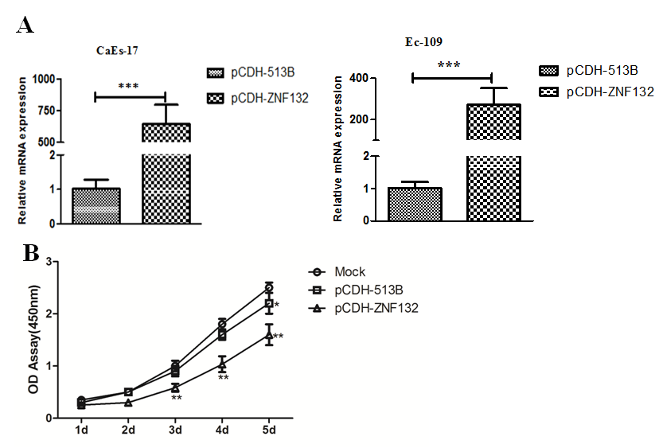

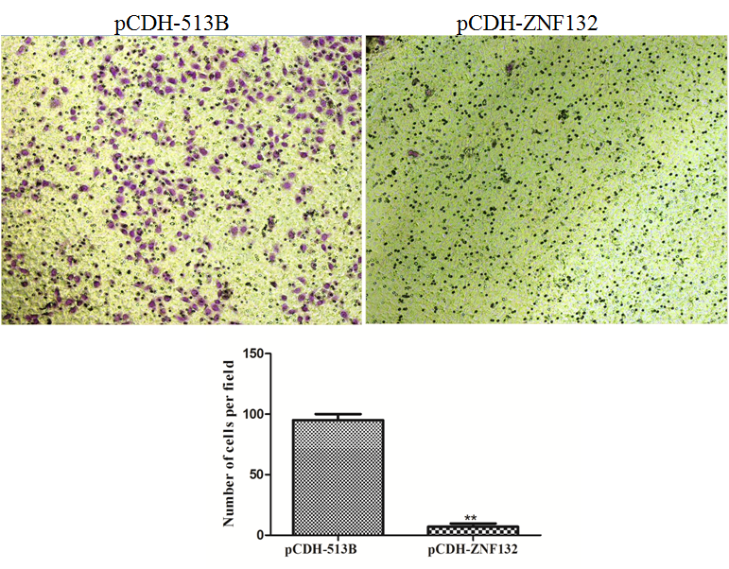

**B**

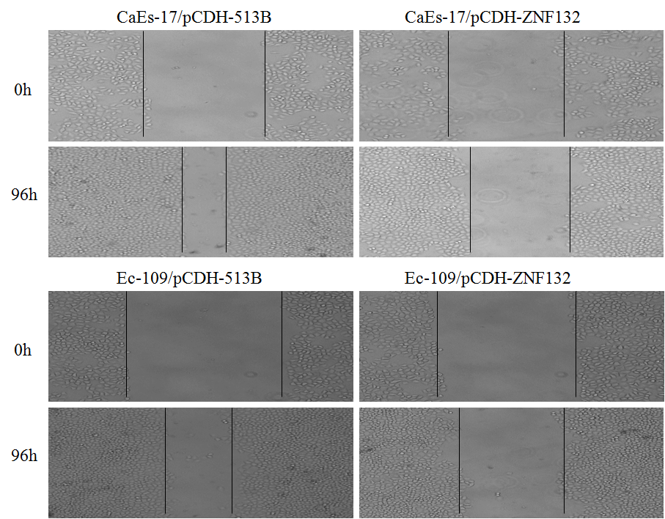

**C**

**D**

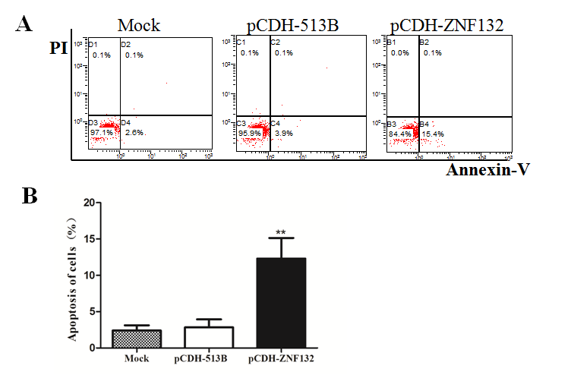

**Figure 5.** Ec109 cells and Caes-17 cells both treated by the plasmid pCD513B-1-H-ZNF132 and pCD513B-1 for 48 hours. The effects of high expression of ZNF132 were then tested on cells’ ability in growth, migration, invasion and apoptosis. A Effect of ZNF132 gene on the proliferation of esophageal cancer cells. Real-time PCR showed that the lentiviral expression vector of ZNF132 gene could significantly up-regulate the expression of ZNF132 in CaEs-17 and Ec109 cells . The results of cell proliferation analysis showed that the up-regulation of ZNF132 gene could inhibit the proliferation of Ec109 cells. B In vitro migration of esophageal cancer cells. The up-regulation of ZNF132 gene was observed by migration experiments to inhibit the migration of Ec109 cells. C In Vitro Scratch Healing Experiment of Esophageal Carcinoma Cells. The results show that ZNF132 expression can significantly inhibit the healing of esophageal cancer cell scratches. D. Effect of tumor suppressor gene ZNF132 on apoptosis of esophageal cancer cells. Flow cytometry was used to analyze the apoptosis of cells. The results showed that upregulation of ZNF132 in Ec109 cells could significantly increase the cell apoptosis rate.

**I made some changes in Figure 5 Legend as follows:**

**Figure 5.** The effects of high expression ZNF132 on characteristics of esophageal cancer cell lines in vitro.

1. Real-time PCR showed that the lentiviral expression vector of ZNF132 gene could significantly up-regulate the expression of ZNF132 in CaEs-17 and Ec109 cells.High expression of ZNF132 in EC-109 inhibit cell proliferation measured by light absorbance and cell counting per field.
2. The up-regulation of ZNF132 gene in Ec-109 cells and CaEs-17 cells reduced cell migration ability in a transwell assay.
3. In Vitro Scratch Healing Experiment showed that high expression of ZNF132 in Ec109 cells and CaEs-17 cells significantly inhibits cells healing ability.
4. Flow cytometry demonstrates that upregulation of ZNF132 in Ec109 cells could significantly increase the cell apoptosis rate.

**Question: Two cell lines were transfected with ZNF132 vector, only Ec-109 cells were used in proliferation assays and apoptosis assay?**

**In 5A,5D, what is mock? No mention in text.**

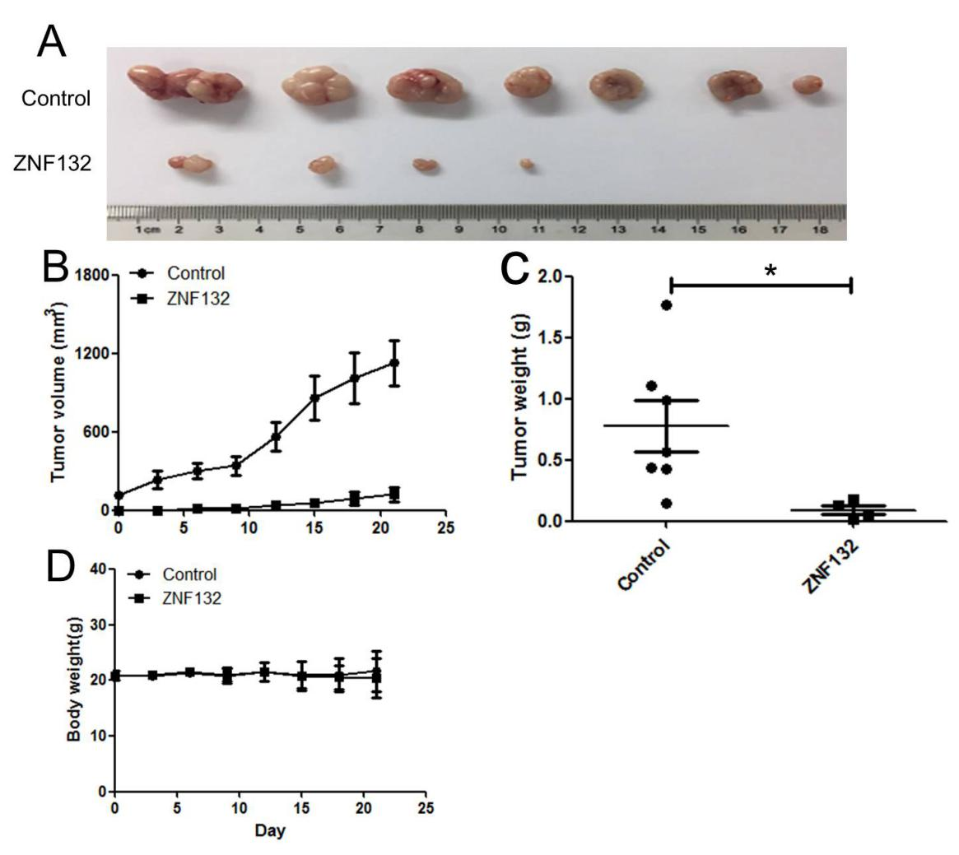

Figure 7. Overexpression of ZNF132 inhibits the growth of human esophageal squamous cell carcinoma xenograft. A. The tumor volume of pCD513B-1-ZNF132 group was significantly smaller than that of pCD513B-1 group. B and C the tumor volume and tumor wet weight it is clear that when the ZNF132 gene overexpression can significantly inhibit Ec109 cell tumorigenic ability. D. There was no significant difference in body weight between the experimental group and the control group during the whole experiment.

**I changed Figure 7 to 6**

**I made some changes in Figure 6 Legend as follows:**

**Figure 6.** Overexpression of ZNF132 inhibits the growth of human esophageal squamous cell carcinoma in vivo in a mouse xenograft model. A. The tumor volume of pCD513B-1-ZNF132 group was visually smaller than that of pCD513B-1 group. B. difference in tumor volume between two groups increased with passing days. C. Wet tumor weight of experiment group was significantly lighter than control group.

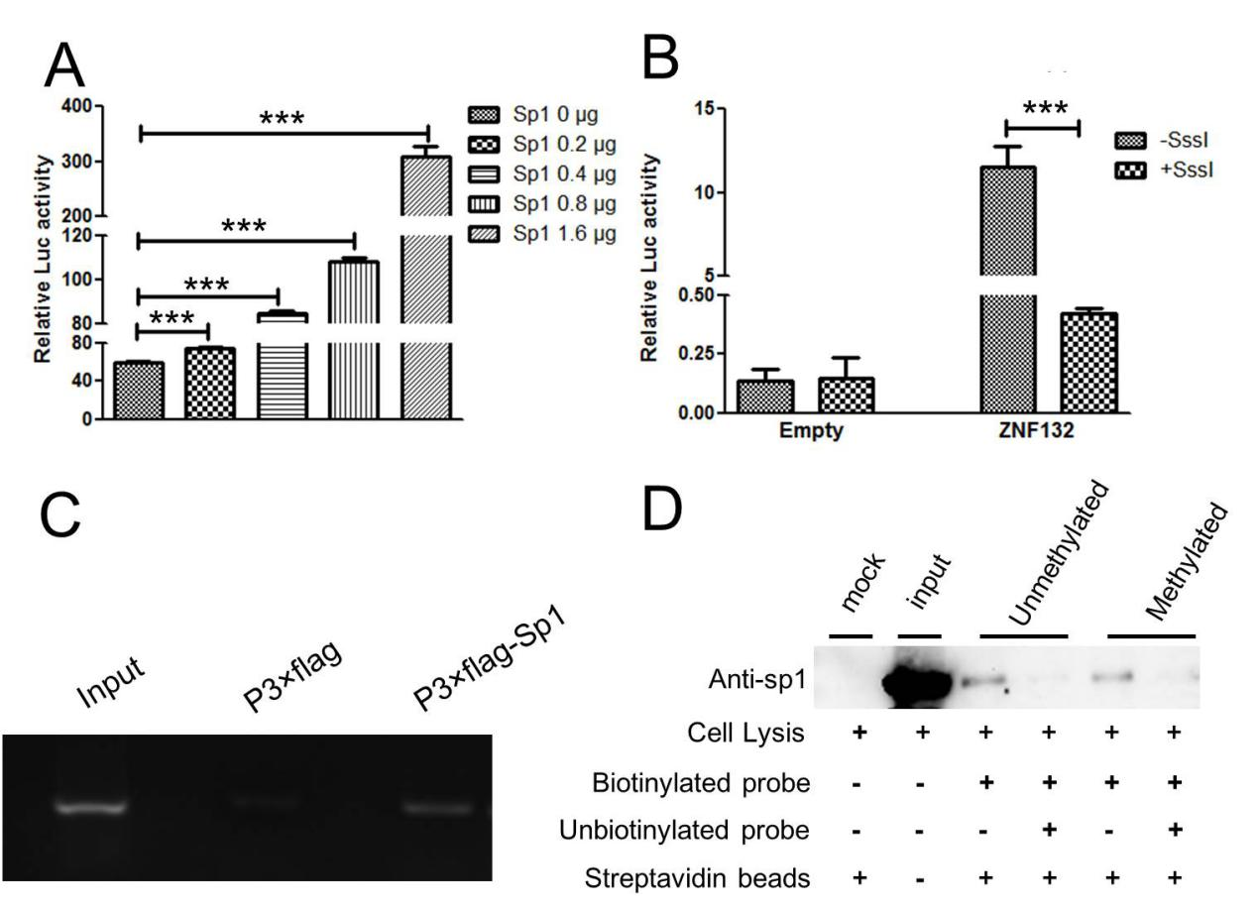

**Figure ~~6~~. 7** Sp1transcriptionally upregulates ZNF132 expression by targeting Sp1-binding site in Ec109 Ccells. Furthermore, methylation of Sp1-binding site inhibits ZNF132 transcriptional expression by interfering with there cruitment of Sp1to ZNF132 promoter.A. The luciferase reporter assay showed that the ZNF132 promoter gradually increased with the dose of Sp1. B.The methylation of Sp1-bining site can inhibit ZNF132 transcriptional expression by interfering with there cruitment of Sp1 to ZNF132 promoter region. C. DNA pull-down assays showed that the methylated Sp1-bining site probe had weaker binding ability with speciﬁc proteins compared with the unmethylated Sp1-bining site probe. D. ChIP assay demonstrated that Sp1 can target ZNF132 promoter and thereby upregulate ZNF132 expression in Ec109 cells.

**I changed Figure 6 to 7**

**I think 7C should be ChIP assay, 7D should be DNA pull-down assay.**

**I made some changes in Figure 7 Legend as follows:**

**Figure 7** Hypermethylation of trascriptional activator Sp1 binding site in ZNF132 promoter region leading to ZNF132 gene silencing in esophageal cell line. A. Transcriptional activity of ZNF132 promoter elevates with increasing doses of Sp1. B. Trascriptional activity was significantly reduced by methylation of Sp1 site of ZNF132 promoter **(No method mentioned)**. C. ChIP assay showed directly that Sp1 protein can bind to ZNF132 promoter region containing Sp1 site in in vitro cultured cells cells . D. DNA pull-down assay showed that the methylated Sp1-bining site probe had weaker binding ability with speciﬁc proteins compared with the unmethylated Sp1-bining site probe.

**Questions:**

1. **No method for 7B was described in text.!!!**
2. **7A, HEK293T cells were used, 7B, no mention what cells are used, 7C. Ec-109 cells were used, (Why, since promoter of ZNF132 in Ec-109 cells are hypermethylated. 7D. In method,** Cell lysis (400 μg) were incubated with or without biotinylated probe (0.5 pmol) in the presence of streptavidin-agarose **No mention what cell lysates. Under lined part should be biotinylated methylated or unmethylated probes, I think.**
3. **In vitro includes cell culture assay, in vivo only use for animal study**