**MSD-SNuPET: Methylation status dependent single nucleotide primer extension assay**

DNA extraction and Bisulfite conversion was performed as previously described [19, 20]. Methylation status determined single nucleotide primer extension technique (MSD-SNuPET) was designed for the quantification of methylation at multiple methylated loci simultaneously. MSD-SNuPET was developed based on SNPshot technology to bisulfite converted CpG sites. Un-methylated cytosine would be converted to uracil when treated with bisulfite while methylated cytosine maintains as the cytosine. Therefore, methylation status detected can be detected by specific primer and PCR amplification. Primer 3.0 was used to design primer sets (called amplifying primer) which were applied to amplify genome regions which include the target CpG sites. Allele-specific elongation primer was used to quantify the copy number of C and T alleles. PCR was performed in a final volume of 10 μL containing 1x HotStarTaq buffer, 3.0 mM Mg2+, 0.3 mM dNTP, 1 U HotStarTaq polymerase (Qiagen Inc. USA), 1 µl DNA template and 1µl multiple primer set. Amplifications were conducted in a GeneAmp PCR System 9700 thermal cycler (Applied Biosystems, Foster City, CA) with the following thermal cycling profile: denaturation for 2 min at 95°C, followed by 11 cycles each consisting of 20 sec at 94°C, 40 sec at 60°C, 90 sec at 72°C, and a final extension step for 2 min at 72°C. Negative and positive controls were included in each run of PCR as described above. The products of the sequencing reactions were purified and SNaPshot analysis of single nucletieds extension for multiple loci operation was showed as our previous works [21]. DNA sequencing was conducted with 3730 DNA analyzer. GeneMapper 4.1 (Applied Biosystems, Co., Ltd., USA) was used to analysis the fluorescence signals which represent different alleles. DNA methylation level is positive correlated with the magnitude of the C allele ($H_{C}$) and negative corrected with the magnitude of the T allele ($H_{T}$) in MSD-SNuPET technique (**Supplementary Figure 3**). In order to quantitatively estimate the methylation level for each CpG site, standard calibration curve was established, in which synthetic DNA fragments with C and T alleles were mixed with C allele proportion at 10%, 20%, 30% , 35% , 40% ,50%, 60%, 70% , 75% ,80% and 90%. Then, standard calibration curve could be fitted as linear regression model: $y=β_{0}+β_{1}x$, in which $β_{0}$ and $β_{1}$ is optimized parameters. $x$ represents the ratio of $H$ and $T$ alleeles ($H_{C}/H_{T}$). In presnt study, methylation status of *LINE-1* and an arbitrary DNA fragment with 100% $T$ allele were taken as positive and negative controls for MSD-SNuPET technique.

**注释：上文中用黄色标记部分与实验描述的有问题，实验方案中如下：**

实验中11个标准品的C%（**甲基化程度**）分别为10% 20% 30% 35% 40% 50% 60% 70% 75% 80% 90%，对标准样本进行延伸反应可以得到对应的11组峰高比值（HC/HT），以实验得到的标准样本的HC/HT为横坐标，其对应的CC/CT为纵坐标作图，可以得到一条相应的曲线和方程式（从理论上来说，得到的曲线和对应的方程式应该是线性的，但是实际作出的曲线更接近二元方程式及对应的曲线）及Y=k1X2+k2X。

根据得到的每个位点的方程式Y=k1X2+k2X可以得到每个样本理论的C和T的浓度比（CC/CT），其中X=HC-S/ HT-S，Y= CC/CT。

**甲基化程度计算公式为：**

**C%= CC/(CC+CT）= (CC/CT) /( CC/CT +1)**

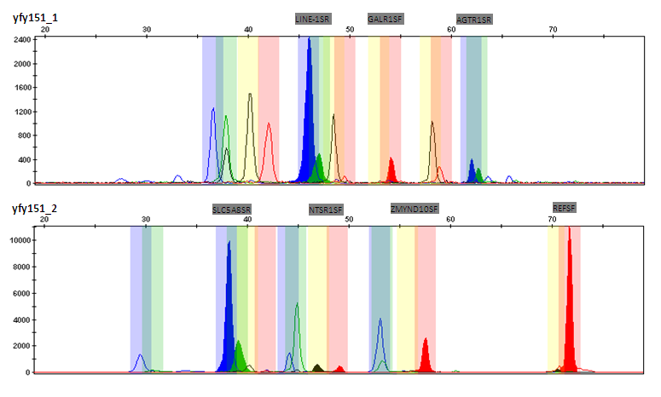

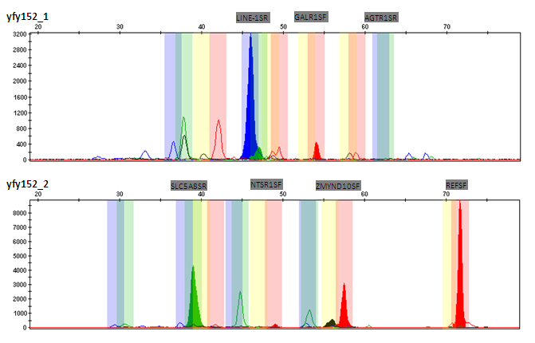

Supplementary Figure 3. Diagrammatic sketch of the result for multi-loci MSD-NEuTEP techonlogy

Length of the amplication production caused the fluorescence signals were showed in the different location for different genes when they are performed capillary electrophoresis. C or T allele could be determined by the color of the fluorescence signals. In this illustrated example.