**figure1: AGTR1, GALR1, SLC5A8, ZMYND10, NTSR1, LINE-1 and Reference**

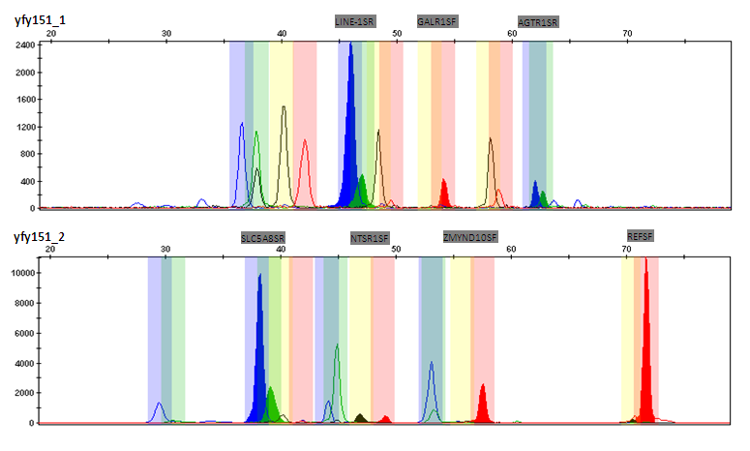

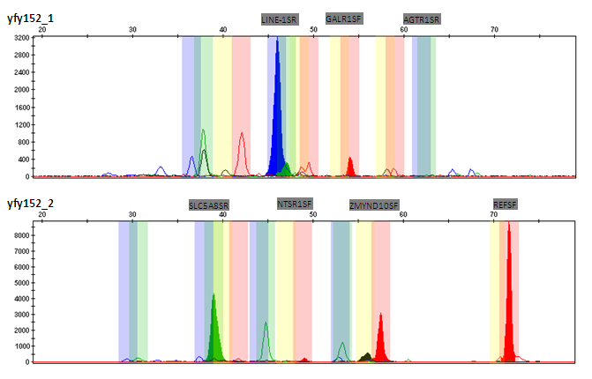

**figure2: AGTR1, EPAS1(1), EPAS1(2), EPAS1(3), EPAS1(4), GALR1, LINE_1, NTSR1, SLC5A8, ZBTB16(1), ZBTB16(2), ZBTB16(3), ZBTB16(4), ZMYND10, Reference**

