SHOX2

2015-10-21

>hg19_dna range=chr3:157820497-157820970 5'pad=0 3'pad=0 strand=+ repeatMasking=none

CTGGCTCAGTTCCTCTCGCATGAAGGCGTCGGGATAGTGGGTCTCGTCAA

AAAGCCTCTCCAGCTCATTGAGTTGTTCCAGGGTGAAATTGGTCCGACTT

CGCCTCTGCTTGATTTTGGTCTGGCCTTCGTCCTCCATCCCTTTCGCATC

CTCTTTGCGATCTTTCAGCTCCGGGGACACTGGAGGGGGCACCCCAGCGG

GGCCACACGTGCATCCACACGAACACACACACACACGCACACACACACGG

ACGAAAACAGCACAGCAAATCCTGTTACCAGATTTGTCGCAAAAAAGAAT

AGAGAATCCTTCCCCCTCGTGGAATCCTGGTCCGGCTTCTCAACCCACCC

GGAGGAAGAATATCCCGGAGAAGCGCAAAGGTCAAGTCTGAGCGGCCGCC

TGGGGCAAGGTGGGCAGTCATCCACCACCTCCTTCACAAACGTACCTCGA

CTCACCGCCTCACTATTCACCCCC

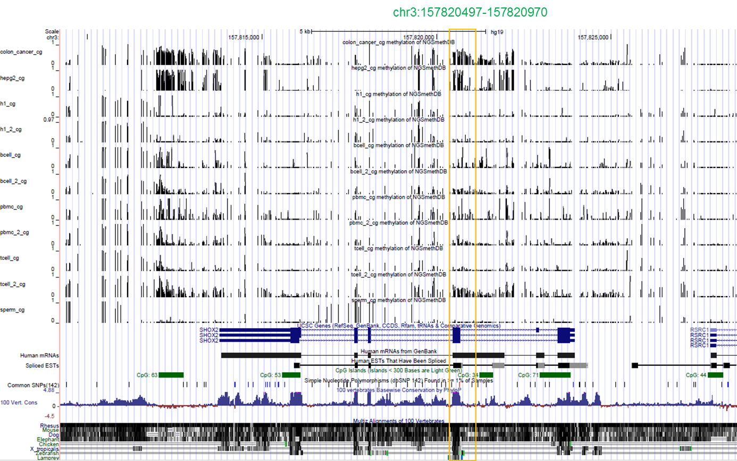

In this region there are 12 TFs. The question is: Which is methylation sensitive: GATA, MSX1, NKX25, NKX61, FOXJ2, EGR3, EGR2, EGR1, YY1, LUN1, GATA1, HOXA3?

The question: whether SHOX2 were aberrantly expressed in cancers?

The hypermethylation frequency of SHOX2 in solid tissue and plasma samples?