MONOD

Shicheng Guo

Thursday, July 23, 2015

## V1 V2 V3 V4  
## 1 chr10 100121047 100121066 chr10:100118644-100122514,B014,3  
## 2 chr10 100132395 100132606 chr10:100131939-100141563,B001,3  
## 3 chr10 100150927 100151068 chr10:100147546-100154221,B062,5  
## 4 chr10 100151578 100151609 chr10:100147546-100154221,B068,3  
## 5 chr10 100196510 100196682 chr10:100194080-100199499,B028,3  
## 6 chr10 100227625 100227666 chr10:100226867-100229853,B023,4

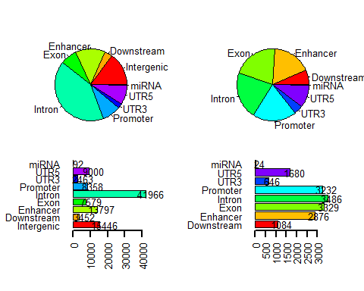

## null device   
## 1