**60 Seconds, 167 Users**

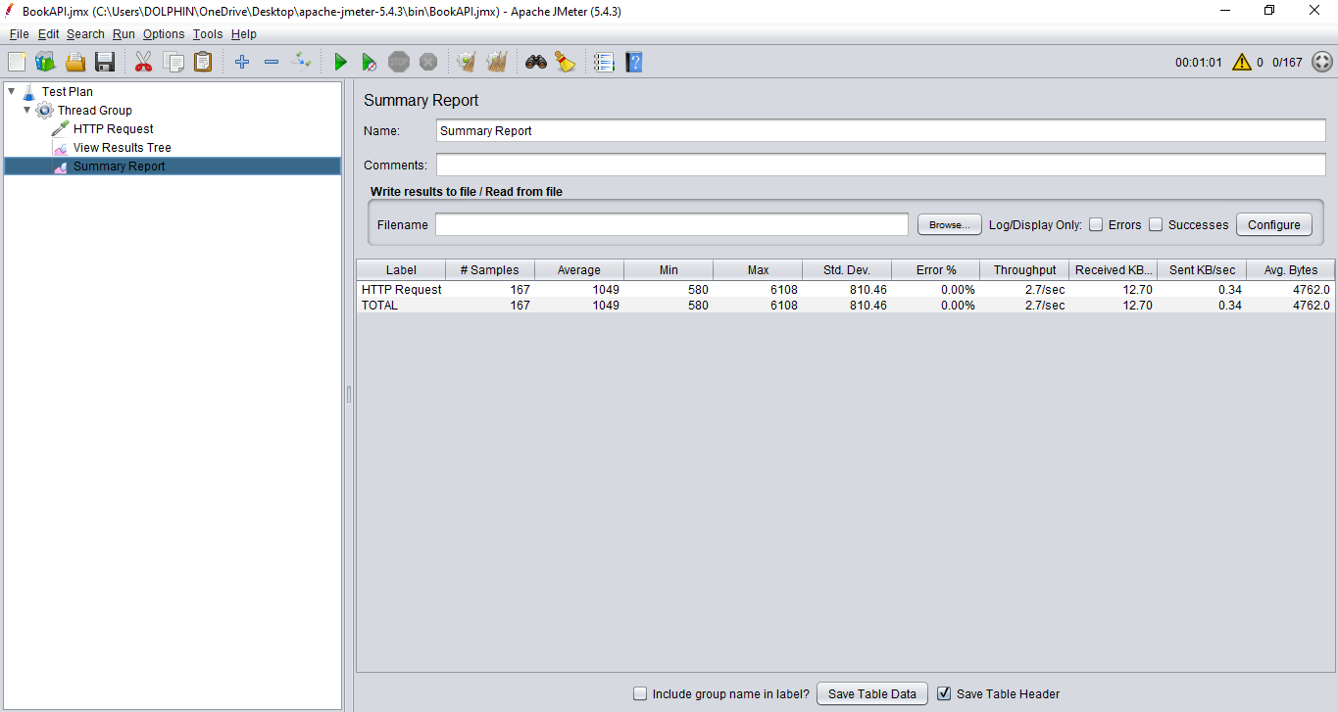

**300 Seconds, 833 Users**

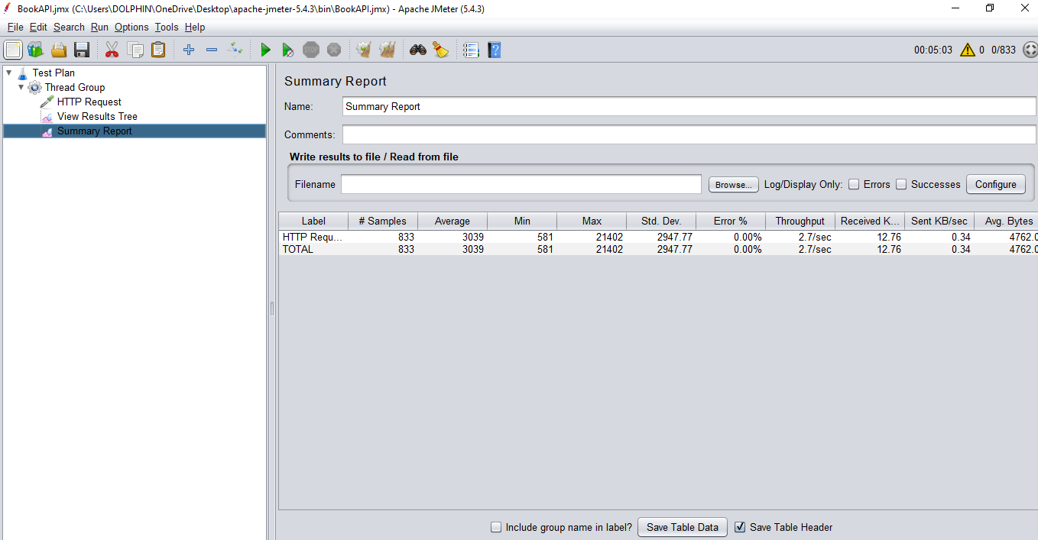

**600 Seconds, 1667 Users**

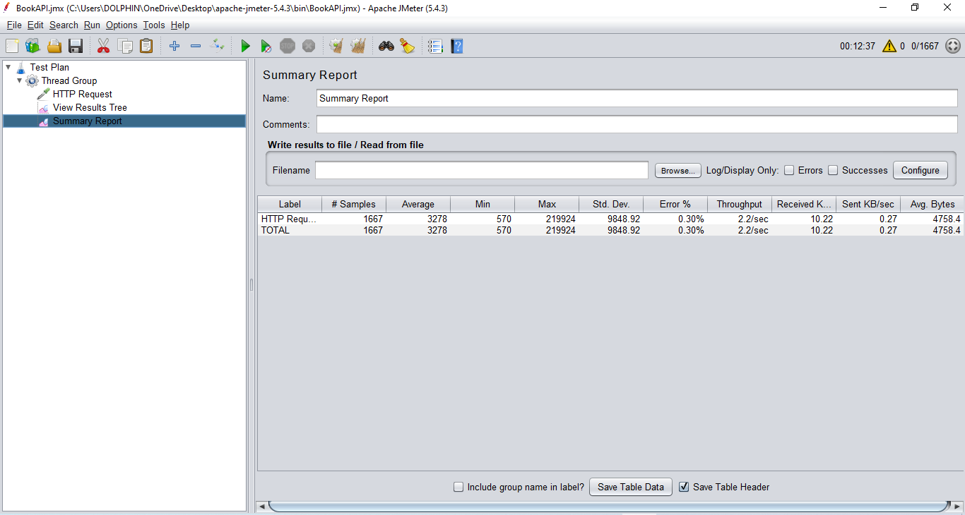

**650 Seconds, 1667 Users**

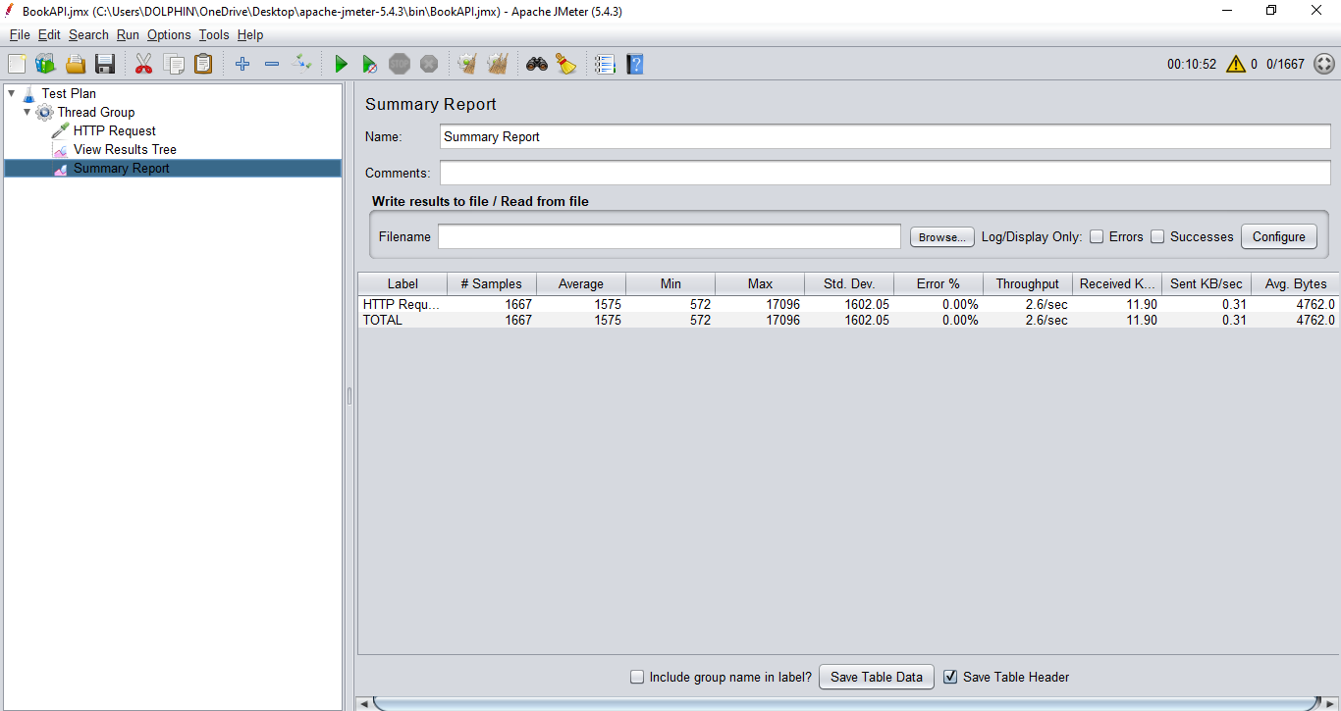

**900 Seconds, 2500 Users**

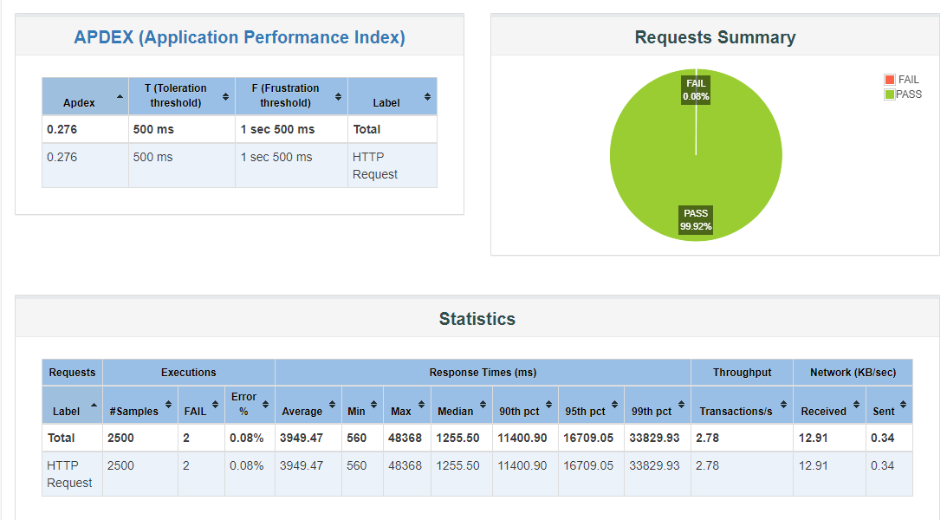

**950 Seconds, 2500 Users**

