How to apply the latest change on your branch?

1. Make sure you are on your own branch

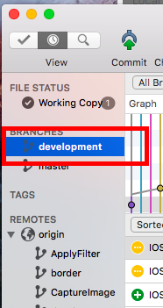

1. Find where is the master is, right click it, then click “Merge”

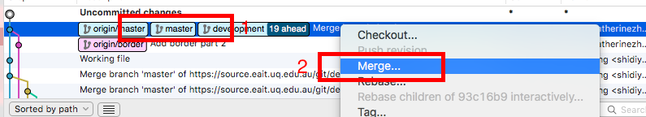

1. All the way “ok”

