**PL/SQL**

**Control Strucutres**

IF-THEN

DECLARE

a integer;

b integer;

BEGIN

  a := 30;

   b := 20;

 IF a >  b

 THEN

    dbms_output.put_line('a is greater');

 END IF;

  END;

Output

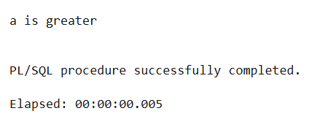

IF-ELSE-THEN

DECLARE

a integer;

b integer;

BEGIN

  a := 10;

   b := 20;

 IF a >  b  THEN

    dbms_output.put_line('a is greater');

ELSE

    dbms_output.put_line('b is greater');

 END IF;

  END;

Output

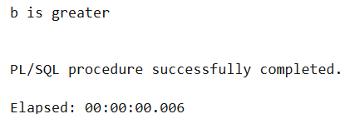

IF-THEN-ELSIF

DECLARE

a integer;

b integer;

BEGIN

   a := 10;

   b := 10;

 IF a >  b  THEN

    dbms_output.put_line('a is greater');

 ELSIF a < b THEN

    dbms_output.put_line('b is greater');

    ELSE

    dbms_output.put_line('a equals b');

 END IF;

  END;

Output

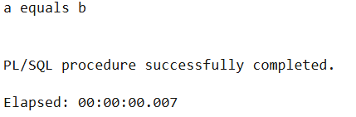

CASE STATEMENT  
DECLARE

grade varchar(5);

BEGIN

    grade := '&grade';

    CASE grade

    WHEN 'A' THEN dbms_output.PUT_LINE('Excellent');

    WHEN 'B' THEN dbms_output.put_line('Very Good');

    WHEN 'C' THEN dbms_output.put_line('Good');

    WHEN 'D' THEN dbms_output.put_line('Fair');

    WHEN 'F' THEN dbms_output.put_line('Poor');

    ELSE

    dbms_output.put_line('No such grade');

    END CASE;

    end;

OUTPUT

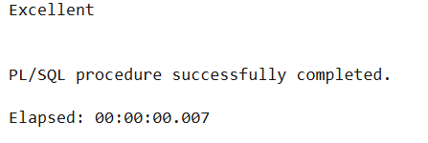

LOOP

DECLARE

value INTEGER :=10;

i INTEGER :=1;

BEGIN

    loop

        if i = value THEN

          exit;

        end if;

        dbms_output.put_line(i);

        i := i + 1;

     end loop;

end;

Output

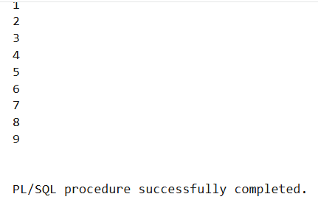

EXIT WHEN IN A LOOP

DECLARE

value INTEGER :=10;

i INTEGER :=1;

BEGIN

    loop

          exit when i = value;

        dbms_output.put_line(i);

        i := i + 1;

        end loop;

        end;

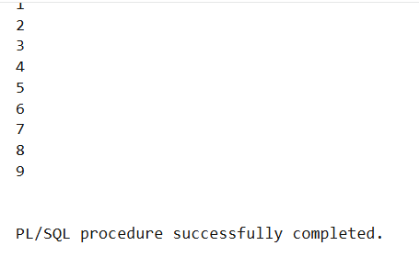

LOOPS USING LABLES  
DECLARE

count1 int :=0;

begin

   <<outer>>

    loop

        loop

            dbms_output.put_line('Inner loop');

            exit outer when count1 = 3;

            count1 := count1 + 1;

        end loop;

    end loop outer;

end;

Output

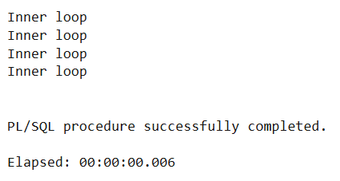

WHILE LOOP

declare

total integer := 0;

sal emp.SALARY%TYPE;

BEGIN

    WHILE total < 15000 LOOP

         select salary into sal from emp where id= 101;

         total := total + sal;

         dbms_output.put_line(total);

         END LOOP;

end;

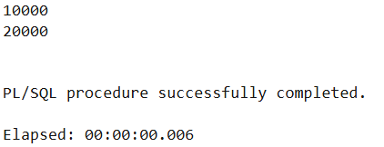

FOR LOOP

declare

i integer;

BEGIN

    for i in 1..5 loop

    dbms_output.put_line(i);

    end loop;

    end;

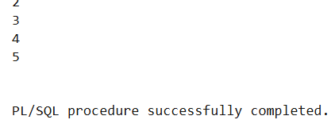

GOTO

begin

      GOTO print_data;

    <<print_data>>

    dbms_output.put_line('Hello World');

    end;

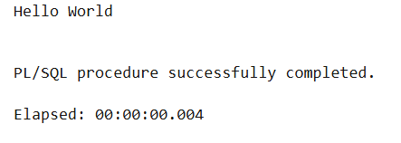

NULL

declare

i integer := 10;

begin

      if i = 10 then

       dbms_output.put_line('Equals');

      else

      NULL;

      end if;

    end;

Output

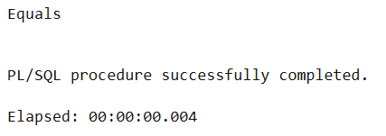

**Stored Procedures**

create or replace procedure emp_proce(empid number)

is

e emp%rowtype;

BEGIN

    select * into e

    from EMP

    where id = empid;

    dbms_output.put_line(e.name||' ->'||e.salary);

    end;

Execution

EXECUTE emp_proce(101);

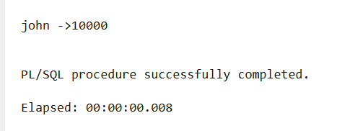

Procedure

create or replace procedure emp_proce(

    empid in emp.id%type,

    sal out emp.salary%type

)

IS

BEGIN

    select salary into sal

    from emp

    where id = empid;

END;

Execution

variable s number;

execute emp_proce(101,:s);

print :s;

