**Microservices with Spring Boot 3 and Spring Cloud**

**Creating Microservices for account and loan**

AccountController.java

package com.cognizant.account.controller;

import org.springframework.web.bind.annotation.*;

import java.util.Map;

*@RestController*

*@RequestMapping*("/accounts")

public class AccountController {

*@GetMapping*("/{number}")

public Map<String, Object> getAccount(*@PathVariable* String number) {

return Map.*of*(

"number", number,

"type", "savings",

"balance", 234343

);

}

}

Open browser

http://localhost:8080/accounts/00987987973432

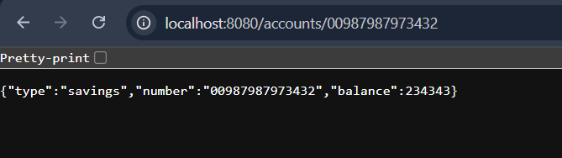

**Create Eureka Discovery Server and register microservices**

**AccountController.java**

package com.cognizant.account.controller;

package com.cognizant.account.controller;

import org.springframework.web.bind.annotation.*;

import java.util.Map;

*@RestController*

*@RequestMapping*("/accounts")

public class AccountController {

*@GetMapping*("/{number}")

public Map<String, Object> getAccount(*@PathVariable* String number) {

return Map.*of*(

"number", number,

"type", "savings",

"balance", 234343

);

}

}

