**React**

import React from 'react';

function App() {

  return (

    <div>

      <h1>Welcome to the first session of React</h1>

    </div>

  );

}

export default App;

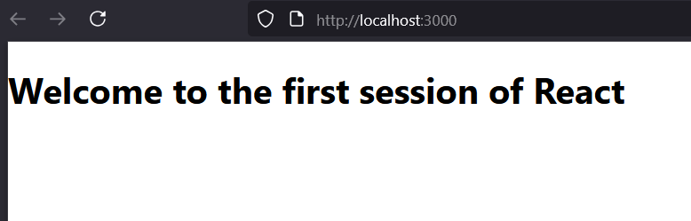

App.js

import React from 'react';

import Home from './Components/Home';

import About from './Components/About';

import Contact from './Components/Contact';

function App() {

  return (

    <div>

      <Home />

      <About />

      <Contact />

    </div>

  );

}

export default App;

Home.js

import React from 'react';

function Home() {

  return (

    <div>

      <h1>Welcome to the Home page of Student Management Portal</h1>

    </div>

  );

}

export default Home;

About.js

import React from 'react';

function About() {

  return (

    <div>

      <h1>Welcome to the About page of the Student Management Portal</h1>

    </div>

  );

}

export default About;

Contact.js

import React from 'react';

function Contact() {

  return (

    <div>

      <h1>Welcome to the Contact page of the Student Management Portal</h1>

    </div>

  );

}

export default Contact;

**Output**

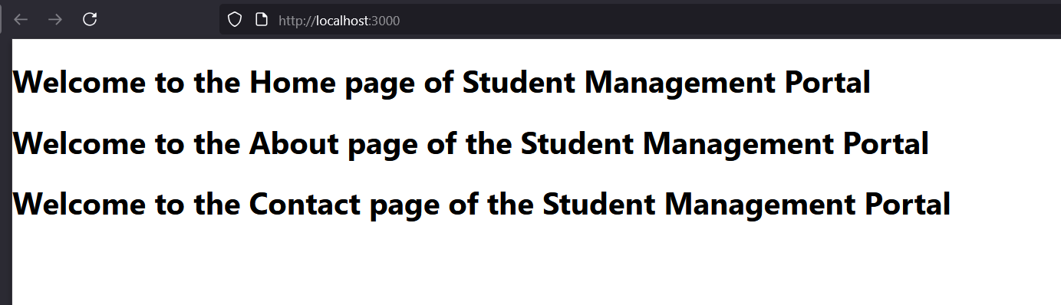

CalculateScore.js

import React from 'react';

import '../Stylesheets/mystyle.css';

function CalculateScore() {

  const name = "John Doe";

  const school = "ABC High School";

  const total = 450;

  const goal = 500;

  const average = (total / goal) * 100;

  return (

    <div className="score-card">

      <h2>Student Score Report</h2>

      <p><strong>Name:</strong> {name}</p>

      <p><strong>School:</strong> {school}</p>

      <p><strong>Total Score:</strong> {total}</p>

      <p><strong>Goal:</strong> {goal}</p>

      <p><strong>Average:</strong> {average.toFixed(2)}%</p>

    </div>

  );

}

export default CalculateScore;

mystyle.css

.score-card {

  border: 2px solid #007bff;

  padding: 20px;

  margin: 20px;

  border-radius: 10px;

  background-color: #f0f8ff;

  font-family: Arial, sans-serif;

}

.score-card h2 {

  color: #007bff;

}

App.js

import React from 'react';

import CalculateScore from './Components/CalculateScore';

function App() {

  return (

    <div className="App">

      <CalculateScore />

    </div>

  );

}

export default App;

**Output**

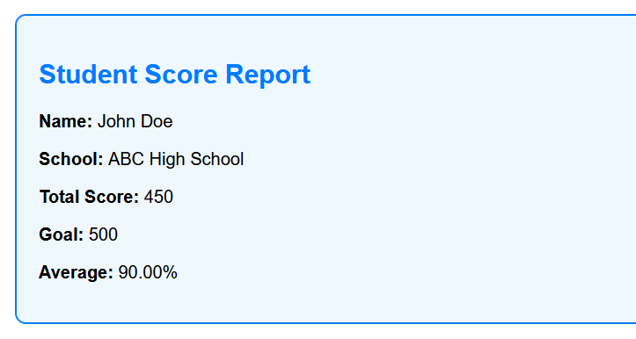

Post.js

import React from 'react';

class Post extends React.Component {

  render() {

    return (

      <div style={{ border: "1px solid #ccc", margin: "10px", padding: "10px" }}>

        <h3>{this.props.title}</h3>

        <p>{this.props.body}</p>

      </div>

    );

  }

}

export default Post;

Posts.js

import React from 'react';

import Post from './Post';

class Posts extends React.Component {

  constructor(props) {

    super(props);

    this.state = {

      posts: [],

      hasError: false

    };

  }

  loadPosts = async () => {

    try {

      const response = await fetch('https://jsonplaceholder.typicode.com/posts');

      const data = await response.json();

      this.setState({ posts: data.slice(0, 5) }); // Load first 5 posts

    } catch (error) {

      this.setState({ hasError: true });

    }

  };

  componentDidMount() {

    this.loadPosts();

  }

  componentDidCatch(error, info) {

    alert('An error occurred while loading posts.');

    console.error("Error:", error, info);

  }

  render() {

    if (this.state.hasError) {

      return <h2>Something went wrong.</h2>;

    }

    return (

      <div>

        <h1>Blog Posts</h1>

        {this.state.posts.map(post => (

          <Post key={post.id} title={post.title} body={post.body} />

        ))}

      </div>

    );

  }

}

export default Posts;

App.js

import React from 'react';

import Posts from './Posts';

function App() {

  return (

    <div className="App">

      <Posts />

    </div>

  );

}

export default App;

**Outputs**

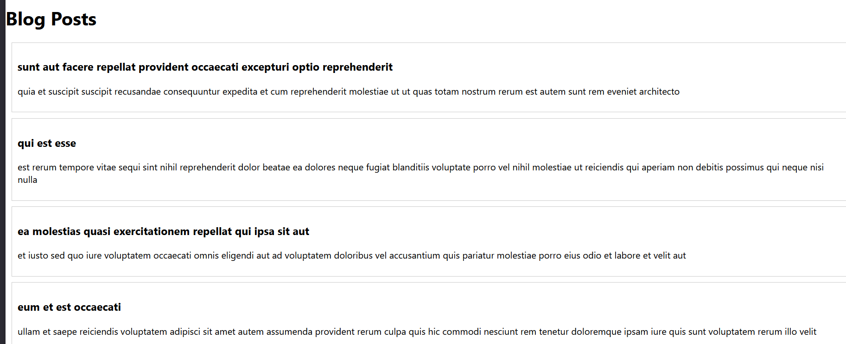

CohortDetails.js

import React from 'react';

import styles from './CohortDetails.module.css';

function CohortDetails({ cohort }) {

  return (

    <div className={styles.box}>

      <h3 style={{ color: cohort.status === 'ongoing' ? 'green' : 'blue' }}>

        {cohort.name}

      </h3>

      <dl>

        <dt>Status:</dt>

        <dd>{cohort.status}</dd>

        <dt>Start Date:</dt>

        <dd>{cohort.startDate}</dd>

        <dt>End Date:</dt>

        <dd>{cohort.endDate}</dd>

      </dl>

    </div>

  );

}

export default CohortDetails;

CohortDetails.module.css

.box {

  width: 300px;

  display: inline-block;

  margin: 10px;

  padding: 10px 20px;

  border: 1px solid black;

  border-radius: 10px;

}

dt {

  font-weight: 500;

}

App.js

import React from 'react';

import CohortDetails from './CohortDetails';

function App() {

  const cohort1 = {

    name: 'React Bootcamp',

    status: 'ongoing',

    startDate: '2025-07-01',

    endDate: '2025-08-01'

  };

  const cohort2 = {

    name: 'Java Full Stack',

    status: 'completed',

    startDate: '2025-05-01',

    endDate: '2025-06-01'

  };

  return (

    <div style={{ padding: '20px' }}>

      <CohortDetails cohort={cohort1} />

      <CohortDetails cohort={cohort2} />

    </div>

  );

}

export default App;

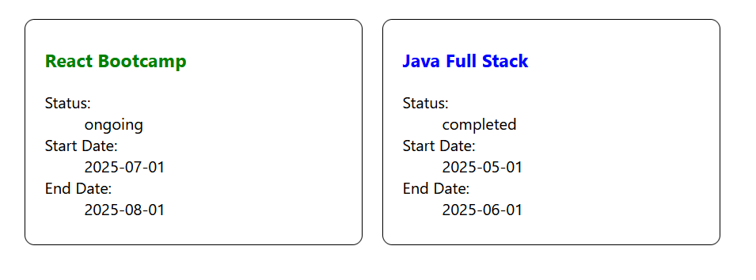

Trainer.js

class Trainer {

  constructor(trainerId, name, email, phone, technology, skills) {

    this.trainerId = trainerId;

    this.name = name;

    this.email = email;

    this.phone = phone;

    this.technology = technology;

    this.skills = skills;

  }

}

export default Trainer;

TrainersMock.js

import Trainer from './Trainer';

const Trainers = [

  new Trainer(1, "John Doe", "john@example.com", "1234567890", "React", "React, JavaScript, HTML"),

  new Trainer(2, "Jane Smith", "jane@example.com", "0987654321", "Angular", "Angular, TypeScript, CSS"),

  new Trainer(3, "Bob Johnson", "bob@example.com", "1122334455", "Vue", "Vue, JavaScript, SASS")

];

export default Trainers;

Home.js

import React from 'react';

function Home() {

  return (

    <div>

      <h2>Welcome to Trainers Management App</h2>

      <p>This app shows trainer information with routing.</p>

    </div>

  );

}

export default Home;

TrainerList.js

import React from 'react';

import Trainers from './TrainersMock';

import { Link } from 'react-router-dom';

function TrainerList() {

  return (

    <div>

      <h2>Trainers List</h2>

      <ul>

        {Trainers.map(trainer => (

          <li key={trainer.trainerId}>

            <Link to={`/trainers/${trainer.trainerId}`}>{trainer.name}</Link>

          </li>

        ))}

      </ul>

    </div>

  );

}

export default TrainerList;

TrainerDetails.js

// src/TrainerDetails.js

import React from 'react';

import { useParams } from 'react-router-dom';

import Trainers from './TrainersMock';

function TrainerDetails() {

  const { id } = useParams();

  const trainer = Trainers.find(t => t.trainerId === parseInt(id));

  if (!trainer) return <h3>Trainer not found</h3>;

  return (

    <div>

      <h2>Trainer Details</h2>

      <p><strong>Name:</strong> {trainer.name}</p>

      <p><strong>Email:</strong> {trainer.email}</p>

      <p><strong>Phone:</strong> {trainer.phone}</p>

      <p><strong>Technology:</strong> {trainer.technology}</p>

      <p><strong>Skills:</strong> {trainer.skills}</p>

    </div>

  );

}

export default TrainerDetails;

App.js

// src/App.js

import React from 'react';

import { BrowserRouter as Router, Routes, Route, Link } from 'react-router-dom';

import Home from './Home';

import TrainerList from './TrainerList';

import TrainerDetails from './TrainerDetails';

function App() {

  return (

    <Router>

      <div>

        <nav style={{ margin: 10 }}>

          <Link to="/" style={{ marginRight: 10 }}>Home</Link>

          <Link to="/trainers">Trainers</Link>

        </nav>

        <Routes>

          <Route path="/" element={<Home />} />

          <Route path="/trainers" element={<TrainerList />} />

          <Route path="/trainers/:id" element={<TrainerDetails />} />

        </Routes>

      </div>

    </Router>

  );

}

export default App;

Output

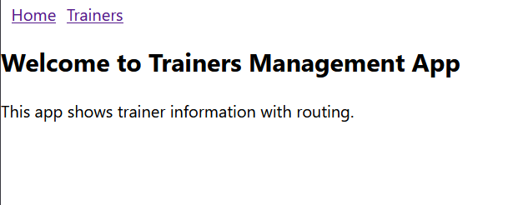

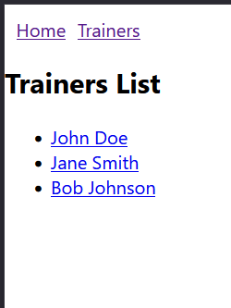

Cart.js

import React from 'react';

class Cart extends React.Component {

  render() {

    return (

      <div style={{ border: "1px solid #ccc", margin: "10px", padding: "10px", borderRadius: "5px" }}>

        <h3>Item: {this.props.itemname}</h3>

        <p>Price: ₹{this.props.price}</p>

      </div>

    );

  }

}

export default Cart;

**OnlineShopping.js**

import React from 'react';

import Cart from './Cart';

class OnlineShopping extends React.Component {

  constructor(props) {

    super(props);

    this.state = {

      cartItems: [

        { itemname: "Laptop", price: 60000 },

        { itemname: "Phone", price: 25000 },

        { itemname: "Headphones", price: 2000 },

        { itemname: "Keyboard", price: 1500 },

        { itemname: "Mouse", price: 700 }

      ]

    };

  }

  render() {

    return (

      <div>

        <h2>Online Shopping Cart</h2>

        {this.state.cartItems.map((item, index) => (

          <Cart key={index} itemname={item.itemname} price={item.price} />

        ))}

      </div>

    );

  }

}

export default OnlineShopping;

**index.js**

import React from 'react';

import ReactDOM from 'react-dom/client';

import OnlineShopping from './OnlineShopping';

const root = ReactDOM.createRoot(document.getElementById('root'));

root.render(<OnlineShopping />

**Output**

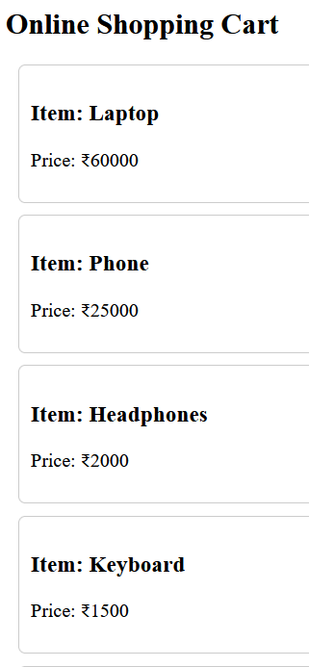

**CountPeople.js**

import React from 'react';

class CountPeople extends React.Component {

  constructor(props) {

    super(props);

    this.state = {

      entryCount: 0,

      exitCount: 0

    };

  }

  updateEntry = () => {

    this.setState(prevState => ({

      entryCount: prevState.entryCount + 1

    }));

  };

  updateExit = () => {

    this.setState(prevState => ({

      exitCount: prevState.exitCount + 1

    }));

  };

  render() {

    return (

      <div style={{ padding: '20px', textAlign: 'center' }}>

        <h2>Mall Entry Counter</h2>

        <p><strong>People Entered:</strong> {this.state.entryCount}</p>

        <p><strong>People Exited:</strong> {this.state.exitCount}</p>

        <button onClick={this.updateEntry} style={{ marginRight: '10px' }}>Login</button>

        <button onClick={this.updateExit}>Exit</button>

      </div>

    );

  }

}

export default CountPeople;

**App.js**

import React from 'react';

import CountPeople from './CountPeople';

function App() {

  return (

    <div className="App">

      <CountPeople />

    </div>

  );

}

export default App;

**Output**

