**React**

**ListofPlayers.js**

import React from 'react';

const ListofPlayers = () => {

  const players = [

    { name: "Virat", score: 88 },

    { name: "Rohit", score: 56 },

    { name: "Dhawan", score: 74 },

    { name: "Rahul", score: 66 },

    { name: "Pant", score: 90 },

    { name: "Hardik", score: 45 },

    { name: "Jadeja", score: 70 },

    { name: "Ashwin", score: 77 },

    { name: "Shami", score: 34 },

    { name: "Bumrah", score: 61 },

    { name: "Kuldeep", score: 40 }

  ];

  // Players with score below 70 using arrow function

  const lowScorers = players.filter(player => player.score < 70);

  return (

    <div>

      <h2>All Players (Using map)</h2>

      <ul>

        {players.map((player, index) => (

          <li key={index}>{player.name} - {player.score}</li>

        ))}

      </ul>

      <h2>Players with Score below 70 (Using arrow function)</h2>

      <ul>

        {lowScorers.map((player, index) => (

          <li key={index}>{player.name} - {player.score}</li>

        ))}

      </ul>

    </div>

  );

};

export default ListofPlayers;

**IndianPlayers.js**

import React from 'react';

const IndianPlayers = () => {

  const players = ["Virat", "Rohit", "Dhawan", "Rahul", "Pant", "Hardik", "Jadeja", "Ashwin"];

  const oddTeam = players.filter((_, index) => index % 2 !== 0);

  const evenTeam = players.filter((_, index) => index % 2 === 0);

  const T20players = ["Surya", "Kishan"];

  const RanjiTrophyPlayers = ["Pujara", "Rahane"];

  const mergedPlayers = [...T20players, ...RanjiTrophyPlayers];

  return (

    <div>

      <h2>Even Team Players (Destructured)</h2>

      <ul>

        {evenTeam.map((player, index) => (

          <li key={index}>{player}</li>

        ))}

      </ul>

      <h2>Odd Team Players (Destructured)</h2>

      <ul>

        {oddTeam.map((player, index) => (

          <li key={index}>{player}</li>

        ))}

      </ul>

      <h2>Merged Players (T20 + Ranji)</h2>

      <ul>

        {mergedPlayers.map((player, index) => (

          <li key={index}>{player}</li>

        ))}

      </ul>

    </div>

  );

};

export default IndianPlayers;

**App.js**

import ListofPlayers from './ListofPlayers';

import IndianPlayers from './IndianPlayers';

function App() {

  const flag = true; // Set to false to show IndianPlayers

  return (

    <div className="App">

      {flag ? <ListofPlayers /> : <IndianPlayers />}

    </div>

  );

}

export default App;

**Output**

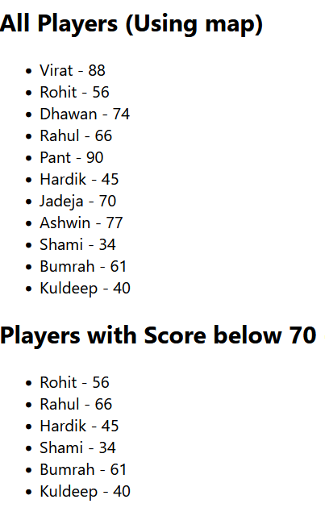

**App.js**

import React from 'react';

function App() {

  // Office object

  const office = {

    name: "Tech Park Office",

    rent: 75000,

    address: "123, MG Road, Bangalore"

  };

  // Office list

  const officeList = [

    { name: "Cowork Hub", rent: 55000, address: "Indiranagar, Bangalore" },

    { name: "Startup Space", rent: 62000, address: "Koramangala, Bangalore" },

    { name: "Enterprise Block", rent: 80000, address: "Whitefield, Bangalore" }

  ];

  return (

    <div style={{ padding: "20px", fontFamily: "Arial" }}>

      {/* Heading Element */}

      <h1>Office Space Rental Listings</h1>

      {/* Office Image */}

      <img

        src="https://via.placeholder.com/400x200?text=Office+Space"

        alt="Office Space"

        style={{ width: "400px", height: "200px" }}

      />

      {/* Single Office Object Display */}

      <h2>Featured Office</h2>

      <p><strong>Name:</strong> {office.name}</p>

      <p><strong>Rent:</strong>

        <span style={{ color: office.rent > 60000 ? 'green' : 'red' }}>

          ₹{office.rent}

        </span>

      </p>

      <p><strong>Address:</strong> {office.address}</p>

      {/* List of Office Spaces */}

      <h2>More Offices</h2>

      <ul>

        {officeList.map((item, index) => (

          <li key={index}>

            <p><strong>Name:</strong> {item.name}</p>

            <p>

              <strong>Rent:</strong>

              <span style={{ color: item.rent > 60000 ? 'green' : 'red' }}>

                ₹{item.rent}

              </span>

            </p>

            <p><strong>Address:</strong> {item.address}</p>

            <hr />

          </li>

        ))}

      </ul>

    </div>

  );

}

export default App;

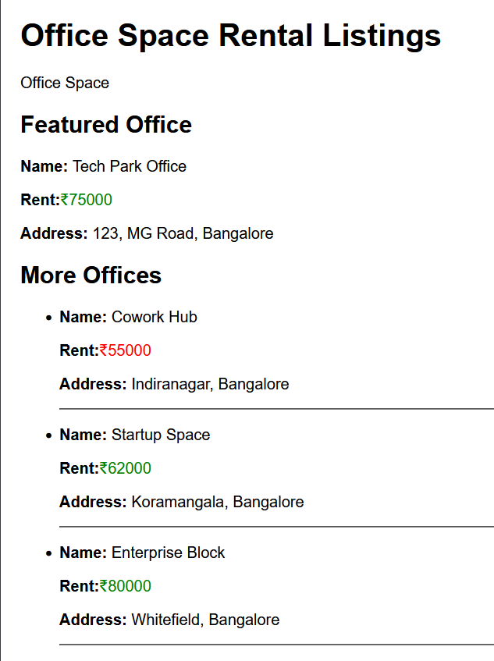

**App.js**

import React, { Component } from 'react';

import CurrencyConvertor from './CurrencyConvertor';

class App extends Component {

  constructor(props) {

    super(props);

    this.state = {

      count: 0,

      message: ""

    };

  }

  // Handle multiple methods

  handleIncrement = () => {

    this.setState({ count: this.state.count + 1 });

    this.sayHello();

  };

  handleDecrement = () => {

    this.setState({ count: this.state.count - 1 });

  };

  sayHello = () => {

    alert("Hello! You clicked the increment button.");

  };

  sayWelcome = (msg) => {

    alert(msg);

  };

  handleClick = (e) => {

    alert("I was clicked (Synthetic Event)");

  };

  render() {

    return (

      <div style={{ padding: '20px' }}>

        <h1>React Event Handling Example</h1>

        <h2>Counter: {this.state.count}</h2>

        <button onClick={this.handleIncrement}>Increment</button>

        <button onClick={this.handleDecrement}>Decrement</button>

        <br /><br />

        <button onClick={() => this.sayWelcome("Welcome to React!")}>

          Say Welcome

        </button>

        <br /><br />

        <button onClick={this.handleClick}>Synthetic Event (OnPress)</button>

        <br /><br />

        <CurrencyConvertor />

      </div>

    );

  }

}

export default App;

**CurrencyConverter.js**

import React, { useState } from 'react';

const CurrencyConvertor = () => {

  const [rupees, setRupees] = useState('');

  const [euros, setEuros] = useState('');

  const handleSubmit = () => {

    const euroValue = parseFloat(rupees) / 90; // Assuming 1 Euro = ₹90

    setEuros(euroValue.toFixed(2));

  };

  return (

    <div>

      <h2>Currency Convertor</h2>

      <input

        type="number"

        value={rupees}

        onChange={(e) => setRupees(e.target.value)}

        placeholder="Enter amount in INR"

      />

      <button onClick={handleSubmit}>Convert</button>

      {euros && <p>Converted Value: €{euros}</p>}

    </div>

  );

};

export default CurrencyConvertor;

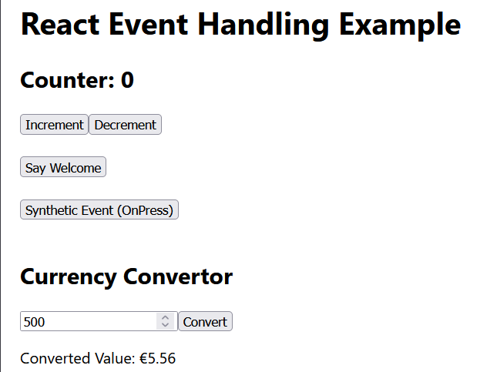

**App.js**

import React, { useState } from 'react';

import './App.css';

function App() {

  const [isLoggedIn, setIsLoggedIn] = useState(false);

  const handleLogin = () => {

    setIsLoggedIn(true);

  }

  const handleLogout = () => {

    setIsLoggedIn(false);

  }

  // Component variables for conditional rendering

  let pageContent;

  if (isLoggedIn) {

    pageContent = (

      <div>

        <h2>Welcome, User!</h2>

        <p>You can now book your tickets.</p>

        <button onClick={handleLogout}>Logout</button>

      </div>

    );

  } else {

    pageContent = (

      <div>

        <h2>Welcome, Guest!</h2>

        <p>Here are the available flight details:</p>

        <ul>

          <li>Flight: AI202 – Bangalore to Delhi – ₹5,500</li>

          <li>Flight: AI305 – Mumbai to Chennai – ₹4,200</li>

        </ul>

        <button onClick={handleLogin}>Login to Book</button>

      </div>

    );

  }

  return (

    <div className="App">

      <h1>Ticket Booking App</h1>

      {pageContent}

    </div>

  );

}

export default App;

**App.css**

.App {

  text-align: center;

  font-family: Arial, sans-serif;

  padding: 30px;

}

button {

  padding: 10px 20px;

  font-size: 16px;

  margin-top: 10px;

}

**Output**

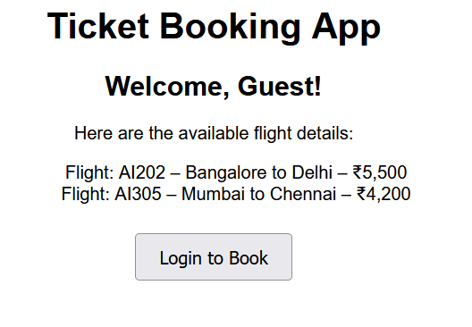

**BookDetails.js**

import React from 'react';

function BookDetails() {

  return (

    <div>

      <h2>Book Details</h2>

      <ul>

        <li>Title: React for Beginners</li>

        <li>Author: John Doe</li>

        <li>Price: ₹499</li>

      </ul>

    </div>

  );

}

export default BookDetails;

**BlogDetails.js**

import React from 'react';

function BlogDetails() {

  return (

    <div>

      <h2>Blog Details</h2>

      <p>Author: Jane Smith</p>

      <p>Topic: Introduction to JSX</p>

    </div>

  );

}

export default BlogDetails;

**CourseDetails.js**

import React from 'react';

function CourseDetails() {

  return (

    <div>

      <h2>Course Details</h2>

      <p>Course: Advanced React</p>

      <p>Instructor: Mark Taylor</p>

    </div>

  );

}

export default CourseDetails;

**App.js**

import React, { useState } from 'react';

import BookDetails from './BookDetails';

import BlogDetails from './BlogDetails';

import CourseDetails from './CourseDetails';

function App() {

  const [selectedView, setSelectedView] = useState('book');

  // Conditional rendering using if-else

  let content;

  if (selectedView === 'book') {

    content = <BookDetails />;

  } else if (selectedView === 'blog') {

    content = <BlogDetails />;

  } else {

    content = <CourseDetails />;

  }

  return (

    <div style={{ padding: '20px' }}>

      <h1>Blogger App</h1>

      <button onClick={() => setSelectedView('book')}>Book</button>

      <button onClick={() => setSelectedView('blog')}>Blog</button>

      <button onClick={() => setSelectedView('course')}>Course</button>

      <hr />

      {/* Conditional Rendering using Element Variable */}

      {content}

      {/* Conditional Rendering using Ternary */}

      {/* Example:

        selectedView === 'book' ? <BookDetails /> :

        selectedView === 'blog' ? <BlogDetails /> :

        <CourseDetails />

      */}

    </div>

  );

}

export default App;

**Output**

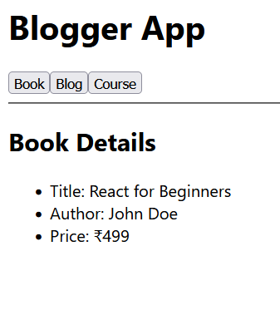

**EmployeeCard.js**

import React, { useContext } from 'react';

import ThemeContext from './ThemeContext';

function EmployeeCard({ employee }) {

  const theme = useContext(ThemeContext);

  return (

    <div className="employee-card">

      <h3>{employee.name}</h3>

      <p>{employee.role}</p>

      <button className={theme === 'light' ? 'light-btn' : 'dark-btn'}>

        View Profile

      </button>

    </div>

  );

}

export default EmployeeCard;

**EmployeesList.js**

import React from 'react';

import EmployeeCard from './EmployeeCard';const employees = [

  { id: 1, name: 'Alice Johnson', role: 'Developer' },

  { id: 2, name: 'Bob Smith', role: 'Designer' },

  { id: 3, name: 'Charlie Brown', role: 'Manager' }

];

function EmployeesList() {

  return (

    <div>

      <h2>Employees List</h2>

      {employees.map(emp => (

        <EmployeeCard key={emp.id} employee={emp} />

      ))}

    </div>

  );

}

export default EmployeesList;

**App.js**

import React, { useState } from 'react';

import EmployeesList from './EmployeesList';

import ThemeContext from './ThemeContext';

import './App.css';

function App() {

  const [theme, setTheme] = useState('light');

  const toggleTheme = () => {

    setTheme(prev => (prev === 'light' ? 'dark' : 'light'));

  };

  return (

    <ThemeContext.Provider value={theme}>

      <div className="App">

        <h1>Employee Management App</h1>

        <button onClick={toggleTheme}>

          Toggle Theme ({theme})

        </button>

        <EmployeesList />

      </div>

    </ThemeContext.Provider>

  );

}

export default App;

**Output**

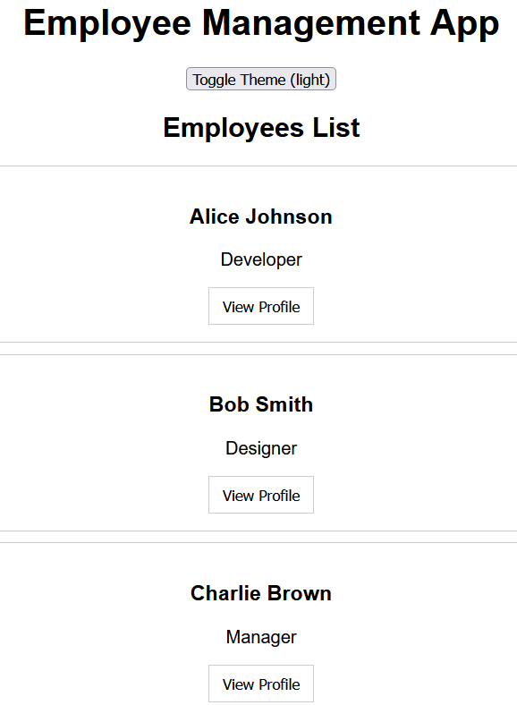

**ComplaintRegister.js**

import React, { useState } from 'react';

function ComplaintRegister() {

  const [name, setName] = useState('');

  const [complaint, setComplaint] = useState('');

  const handleSubmit = (e) => {

    e.preventDefault();

    const referenceNumber = Math.floor(100000 + Math.random() * 900000);

    alert(

      `Complaint submitted successfully!\n\nEmployee: ${name}\nComplaint: ${complaint}\nReference #: ${referenceNumber}`

    );

    setName('');

    setComplaint('');

  };

  return (

    <div style={{ padding: '20px' }}>

      <h2>Raise a Complaint</h2>

      <form onSubmit={handleSubmit}>

        <div style={{ marginBottom: '10px' }}>

          <label>Employee Name:</label><br />

          <input

            type="text"

            value={name}

            onChange={(e) => setName(e.target.value)}

            required

            style={{ width: '300px' }}

          />

        </div>

        <div style={{ marginBottom: '10px' }}>

          <label>Complaint:</label><br />

          <textarea

            value={complaint}

            onChange={(e) => setComplaint(e.target.value)}

            rows="4"

            cols="50"

            required

          />

        </div>

        <button type="submit">Submit Complaint</button>

      </form>

    </div>

  );

}

export default ComplaintRegister;

**App.js**

import React from 'react';

import ComplaintRegister from './ComplaintRegister';

function App() {

  return (

    <div className="App">

      <h1>Ticket Raising App</h1>

      <ComplaintRegister />

  </div>

  );

}

export default App;

**Output**

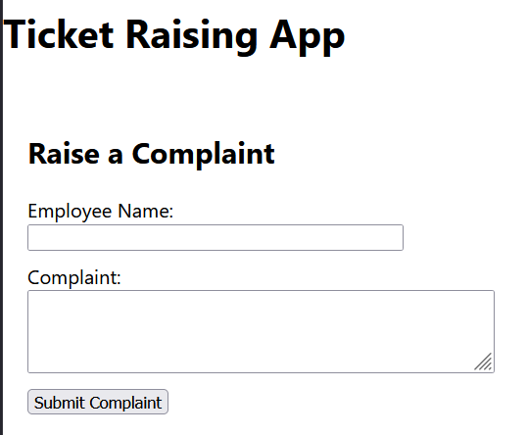

**Register.js**

import React, { useState } from 'react';

function Register() {

  const [formData, setFormData] = useState({

    name: '',

    email: '',

    password: ''

  });

  const [errors, setErrors] = useState({});

  const handleChange = (e) => {

    const { name, value } = e.target;

    setFormData(prev => ({

      ...prev,

      [name]: value

    }));

  };

  const validate = () => {

    const newErrors = {};

    if (formData.name.length < 5) {

      newErrors.name = "Name should have at least 5 characters.";

    }

    if (!formData.email.includes('@') || !formData.email.includes('.')) {

      newErrors.email = "Email must contain '@' and '.'.";

    }

    if (formData.password.length < 8) {

      newErrors.password = "Password should have at least 8 characters.";

    }

    setErrors(newErrors);

    return Object.keys(newErrors).length === 0;

  };

  const handleSubmit = (e) => {

    e.preventDefault();

    if (validate()) {

      alert("Form submitted successfully!");

      console.log("Form Data:", formData);

      setFormData({ name: '', email: '', password: '' });

      setErrors({});

    }

  };

  return (

    <div style={{ padding: '20px' }}>

      <h2>Register Form</h2>

      <form onSubmit={handleSubmit}>

        <div>

          <label>Name:</label><br />

          <input

            type="text"

            name="name"

            value={formData.name}

            onChange={handleChange}

          />

          {errors.name && <div style={{ color: 'red' }}>{errors.name}</div>}

        </div>

        <div>

          <label>Email:</label><br />

          <input

            type="email"

            name="email"

            value={formData.email}

            onChange={handleChange}

          />

          {errors.email && <div style={{ color: 'red' }}>{errors.email}</div>}

        </div>

        <div>

          <label>Password:</label><br />

          <input

            type="password"

            name="password"

            value={formData.password}

            onChange={handleChange}

          />

          {errors.password && <div style={{ color: 'red' }}>{errors.password}</div>}

        </div>

        <button type="submit" style={{ marginTop: '10px' }}>Register</button>

      </form>

    </div>

  );

}

export default Register;

**App.js**

import React from 'react';

import Register from './Register';

function App() {

  return (

    <div className="App">

      <h1>Mail Registration App</h1>

      <Register />

    </div>

  );

}

export default App;

**Output**

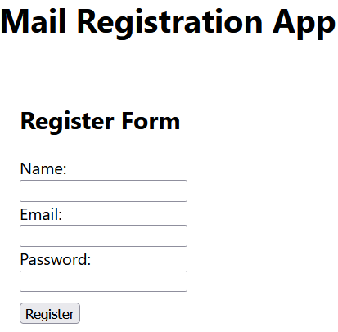

**App.js**

import React from 'react';

import Getuser from './Getuser';

function App() {

  return (

    <div className="App">

      <h1>Fetch User App</h1>

      <Getuser />

    </div>

  );

}

export default App;

**Getuser.js**

import React, { Component } from 'react';

class Getuser extends Component {

  constructor() {

    super();

    this.state = {

      user: null

    };

  }

  async componentDidMount() {

    try {

      const response = await fetch('https://api.randomuser.me/');

      const data = await response.json();

      this.setState({ user: data.results[0] });

    } catch (error) {

      console.error("Failed to fetch user:", error);

    }

  }

  render() {

    const { user } = this.state;

    return (

      <div style={{ padding: '20px' }}>

        <h2>Random User Information</h2>

        {user ? (

          <div>

            <p><strong>Title:</strong> {user.name.title}</p>

            <p><strong>First Name:</strong> {user.name.first}</p>

            <img src={user.picture.large} alt="User" />

          </div>

        ) : (

          <p>Loading user...</p>

        )}

      </div>

    );

  }

}

export default Getuser;

**Output**

