**1. Given two numbers, Swap those two numbers without using temporary variable**

#include <stdio.h>

void swap(int *x, int *y) {

*x = *x + *y;

*y = *x - *y;

*x = *x - *y;

}

int main() {

int num1 = 10, num2 = 20;

printf("Before swapping: num1 = %d, num2 = %d\n", num1, num2);

swap(&num1, &num2);

printf("After swapping: num1 = %d, num2 = %d\n", num1, num2);

return 0;

}

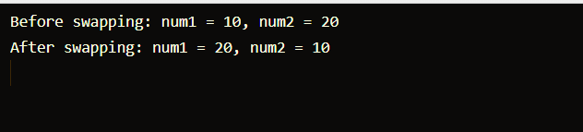

**2. Calculate the number of years,weeks and the remaining days for the given total days**

#include <stdio.h>

void calculateTime(int totalDays) {

int years, weeks, days;

years = totalDays / 365;

totalDays = totalDays % 365;

weeks = totalDays / 7;

days = totalDays % 7;

printf("Number of Years: %d\n", years);

printf("Number of Weeks: %d\n", weeks);

printf("Number of Days: %d\n", days);

}

int main() {

int totalDays;

printf("Enter the total number of days: ");

scanf("%d", &totalDays);

calculateTime(totalDays);

return 0;

}

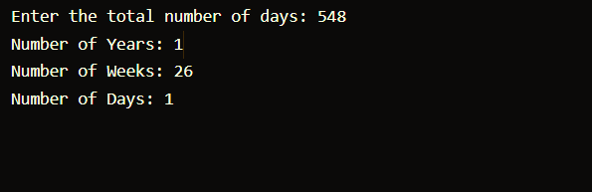

3**. Evaluate a polynomial of degree n.**

#include <stdio.h>

float evaluatePolynomial(int degree, float coefficients[], float x)

{

float result = 0;

float x_power = 1;

for (int i = 0; i <= degree; i++) {

result += coefficients[i] * x_power;

x_power *= x;

}

return result;

}

int main()

{

int degree;

printf("Enter the degree of the polynomial: ");

scanf("%d", &degree);

float coefficients[degree + 1];

printf("Enter the coefficients: ");

for (int i = 0; i <= degree; i++) {

scanf("%f", &coefficients[i]);

}

float x;

printf("Enter the value of x: ");

scanf("%f", &x);

float result = evaluatePolynomial(degree, coefficients, x);

printf("Result of P(%f) = %f\n", x, result);

return 0;

}

