**1. Calculate the area of square or circle based on the shape ‘S’ for Square and ‘C’ for Circle.**

#include <stdio.h>

int main() {

float radius,area;

int side,areasq;

char shapetype;

printf("Shape =");

scanf("%c", &shapetype);

switch (shapetype) {

case 'S':

printf("Size =");

scanf("%d", &side);

areasq=side * side;

printf("Area of Square = %d\n",areasq);

break;

case 'C':

printf("Size =");

scanf("%f", &radius);

area=3.14159 *

radius * radius;

printf("Area of Circle =%.2f\n",area);

break;

}

return 0;

}

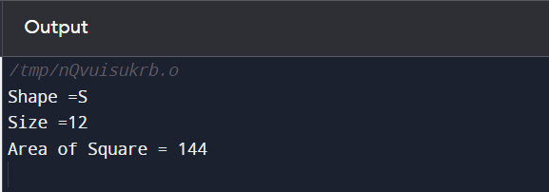

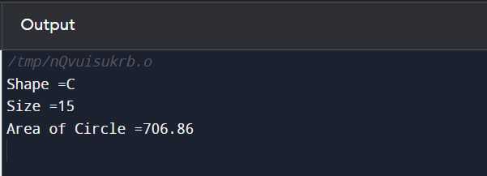

**2. Given a sorted array having duplicate elements. Print the elements with its frequency having more than one appearance.**

#include <stdio.h>

#include <stdlib.h>

void printDuplicates(int arr[], int size) {

int i = 0;

while (i < size) {

int count = 1;

while ((i + 1) < size && arr[i] == arr[i + 1]) {

count++;

i++;

}

if (count > 1) {

printf("%d->%d, ", arr[i], count);

}

i++;

}

}

int main() {

int N;

printf("Enter the number of elements: ");

scanf("%d", &N);

int *array = (int *)malloc(N * sizeof(int));

if (array == NULL) {

printf("Memory allocation failed.\n");

return 1;

}

printf("Enter the elements of the array:\n");

for (int i = 0; i < N; i++) {

scanf("%d", &array[i]);

}

printf("Sample Output:\n");

printDuplicates(array, N);

free(array);

return 0;

}

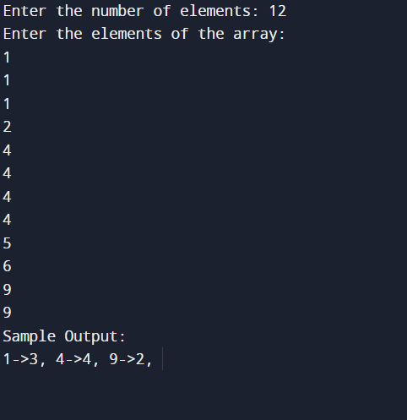

**3. Given a sentence and screen length. Justify the sentence according to the screen length by replacing space with stars**.

#include <stdio.h>

#include <string.h>

void justifySentence(char sentence[], int screenLength) {

int length = strlen(sentence);

int spaces = 0;

for (int i = 0; i < length; i++) {

if (sentence[i] == ' ') {

spaces++;

}

}

int totalSpaces = screenLength - length + spaces;

int spacesBetweenWords = spaces > 0 ? totalSpaces / spaces : 0;

int extraSpaces = spaces > 0 ? totalSpaces % spaces : 0;

for (int i = 0; i < length; i++) {

if (sentence[i] != ' ') {

printf("%c", sentence[i]);

} else {

int count = spacesBetweenWords;

while (count > 0) {

printf("*");

count--;

}

if (extraSpaces > 0) {

printf("*");

extraSpaces--;

}

}

}

}

int main() {

char sentence[100];

int screenLength;

printf("Sentence: ");

fgets(sentence, sizeof(sentence), stdin);

sentence[strcspn(sentence, "\n")] = '\0';

printf("Screenlength: ");

scanf("%d", &screenLength);

getchar();

justifySentence(sentence, screenLength);

printf("\n");

return 0;

}

