**1. Get the values from the user and store it in 3*3 matrix. Display the matrix.**

#include <stdio.h>

int main() {

int i, j;

int a[3][3];

printf("Enter the elements of matrix: \n");

for (i = 0; i < 3; i++) {

for (j = 0; j < 3; j++) {

scanf("%d", &a[i][j]);

}

}

printf("\n");

for (i = 0; i < 3; i++) {

for (j = 0; j < 3; j++) {

printf("%d\t", a[i][j]);

}

printf("\n");

}

}

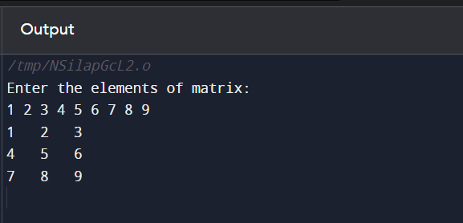

**2. Write a program to get the output**

#include <stdio.h>

struct CharAndNumber {

char character;

int number;

};

int main() {

struct CharAndNumber array[10];

printf("Enter alternating characters and numbers:\n");

for (int i = 0; i < 10; i++) {

if (i % 2 == 0) {

scanf(" %c", &array[i].character);

} else {

scanf("%d", &array[i].number);

}

}

printf("\n");

for (int i = 0; i < 10; i += 2) {

for (int j = 0; j < array[i + 1].number; j++) {

printf("%c", array[i].character);

}

}

return 0;

}

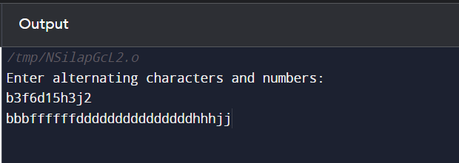

**3. Print the pattern without using arrays.**

#include <stdio.h>

int main() {

int rows;

printf("Enter the number of rows: ");

scanf("%d", &rows);

for (int i = 1; i <= rows; i++) {

int start;

if (i % 2 == 1) {

start = 2* i -1;

} else {

start = 2*i;

}

for (int k = 1; k <= rows - i; k++) {

printf(" ");

}

for (int j = 1; j <= i; j++) {

printf("%d", start);

start += 2;

if (j < i) {

printf(" ");

}

}

printf("\n");

}

return 0;

}

