CS3003D : OPERATING SYSTEMS
(S5 Btech)

Name: Shifana S Shafeek
Roll Number: B221204CS

ASSIGNMENT 1A
1. Write a program that takes one command line argument, long int n. The main() function calls a recursive function int recurse(long int n). In the body of the recursive function, use malloc to dynamically allocate space for storing 10 characters and store "CDPCS-310" to that allocated memory. Call the recursive function with n-1. The base condition for the recursive function is n=0.

A) The program should output:
- Address of the main function and the recursive function
e.g. printf("_main @ %lx\n",(long unsigned int)&main);
- Address of allocated memory in the heap at each recursive call
- Address of the parameter passed to the recursive function

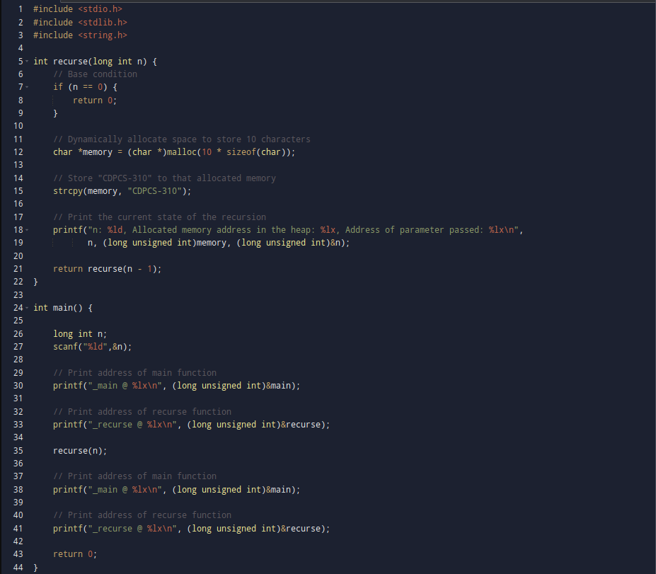
PROGRAM CODE:

OUTPUT:
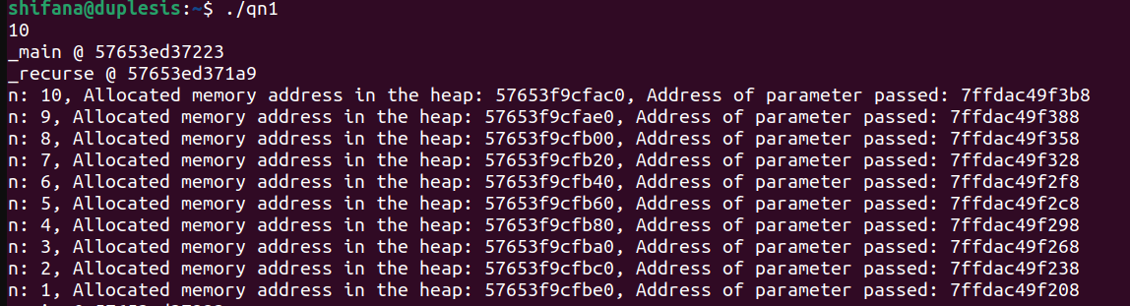

GDB:

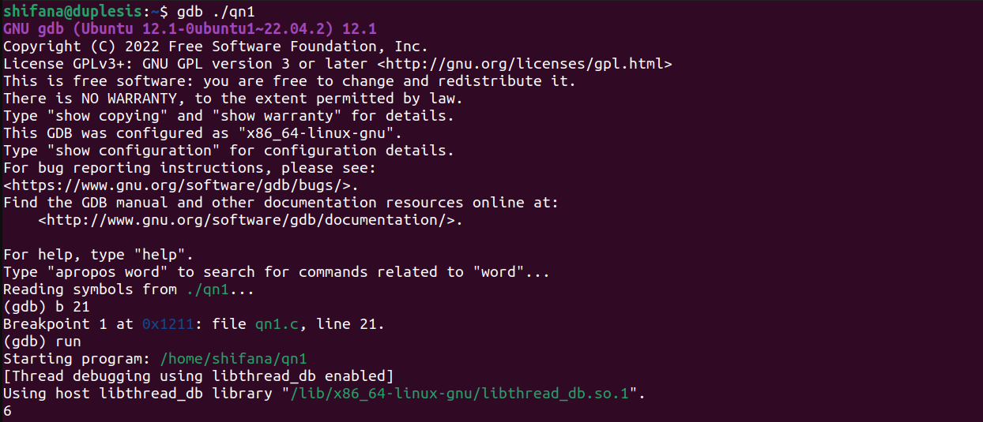
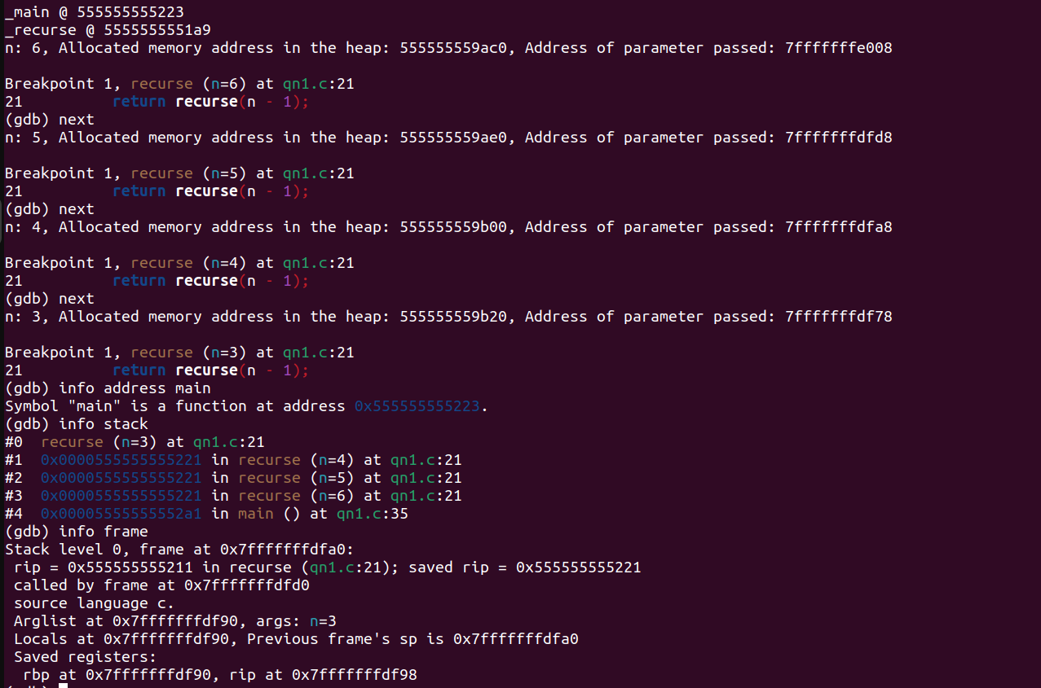

Based on the above answer:

- Which of the addresses printed by your program are defined in the output of objdump "objdump -sRrd a.out"?
Answer:
The addresses of the functions ‘main’ and ‘recurse’ are defined in the output.
The dynamically allocated memory addresses will not be present because they are runtime addresses allocated by the heap at execution time.

- What direction is the stack growing in?

Answer:
The stack grows downwards. This means that with each new function call, the stack pointer moves to a lower memory address.

- How large is the stack frame for each recursive call?

Answer:
To determine the size of the stack frame for each recursive call,
calculate the difference between the addresses of the parameter n for consecutive calls.
For example,
between n = 10 and n = 9
0x7ffdac49f3b8 − 0x7ffdac49f388 = 0x30 (48 bytes)

between n = 9 and n = 8
0x7ffdac49f388 − 0x7ffdac49f358 = 0x30 (48 bytes)
From the calculations, it appears that each stack frame, here, is approximately 48 bytes.

- Where is the heap? What direction is it growing in?

Answer:
The heap is located in the main memory.The heap grows upwards, meaning that each time memory is allocated using malloc, the heap expands to higher memory addresses.

- Are the two malloc()ed memory areas contiguous?
(e.g. is there any extra space between their addresses?)

Answer:
The addresses of the memory allocated using malloc in consecutive calls are not always strictly contiguous.

B) Load up your program executable in gdb, set a breakpoint at main.
Continue 1 line at a time. When you have finished n/2 recursive calls, take a
look at the stack using backtrace (bt).

1) Type “info address main”
Answer:

Displays the address of the main function.

2) Type “info stack” in gdb. Explain what you see.
Answer:

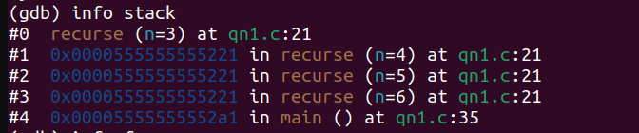
displays the contents of the code stack,displaying the recursive parameter
value and address of the recursive function(which is constant).The stack contains the main
function also.

3) Type “info frame”. Explain what you see.

Answer:
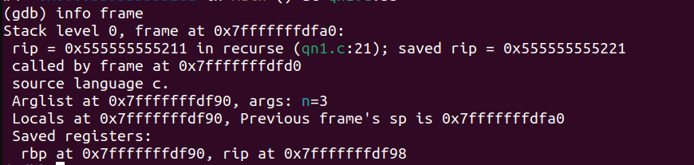
2)

#include <stdio.h>
#include <unistd.h>
int main()
{ int i;
for(i=0; i<5; i++)
if (fork())
fork();
return 0;
}

How many processes are created by this program? Add appropriate print
statements to find out the number of processes.

Answer:

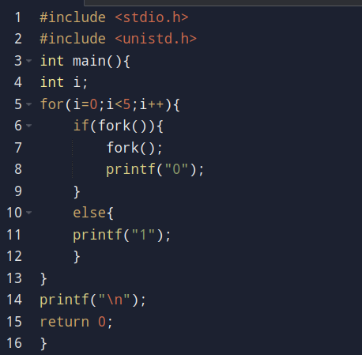

Total number of processes created = 243
i=0 There are 2+1= 3 processes
i=1 There are 2*(3) + 1*(3) = 9 processes
i=2 There are 2*(9) + 1*(9) = 27 processes
i=3 There are 2*(27) + 1*(27) = 81 processes
i=4 There are 2*(81) + 1*(81) = 243 processes
Output will contain 243 lines of length-5 binary strings.

3)

#include <stdio.h>
#include <sys/types.h>
#include <unistd.h>
int main(){
int id ;
int counter = 100;
id = fork() ;
if ( id == 0 ) {
printf ("\nCHILD::PID: %d", getpid());
counter = counter+200;
}else {
printf ( "\nPARENT::PID: %d", getpid());
counter = counter +50;
}
printf ("\ncounter: %d, PID: %d", counter, getpid());
return 0;
}

What is the value of counter? From the value, what do you conclude: is
counter a shared variable between the parent and the child? hint: process
gives memory protection.

Answer:

- Initial Value:
  - counter is initialized to 100.
- The fork() system call creates a new process, “child”
- In the Child Process / id == 0:
  - The child prints its PID.
  - The child modifies counter
    - counter = counter + 200 = 100 + 200 = 300
- In the Parent Process:
  - The parent prints its PID.
  - The parent modifies counter
    - counter = counter + 50 = 100 + 50 = 150

The counter variable is not shared between the parent and child processes. Each process has its own copy of the variable in its own memory space.

4)
Write a program that takes an integer K (> 1000000) as input and does the
following:
a) Creates 2 child processes, and 4 grand children processes.
b) The child processes computes the prime numbers between [2, K/2) and
[K/2,K) respectively, print "Hello from <pid>, I have computed prime
numbers from <start , end >, my parent pid is <ppid>" and then exits.
c) The grand children processes wake up after every sec and print "Hello
from <pid>, I have no work. My parent pid is <ppid>" They do this 10 times
and exit.
d)
i) The original process waits until all of them exit.
ii) The original process doesn't wait until all of them exit.
Use pstree command with the pid of the original process and see the
hierarchy of processes.
Questions:
What difference do you observe in d(i) and d(ii)? Look at the parent id in the
output. Is it same as the id of the parent which created it?

Answer:
i) The original process waits until all of them exit.
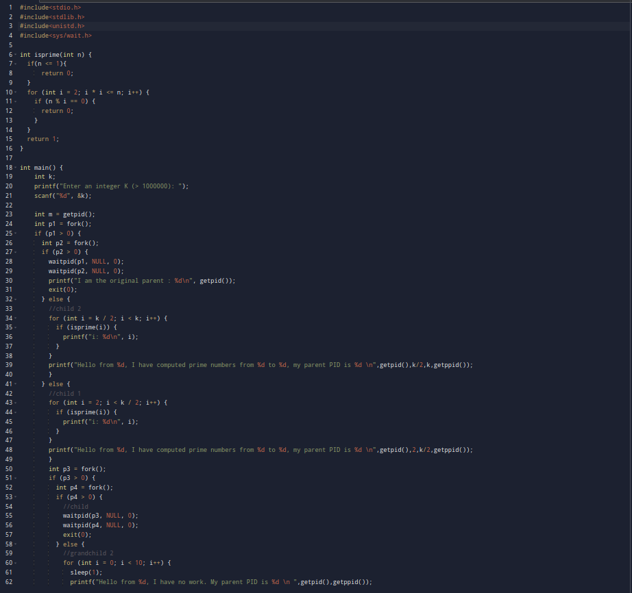
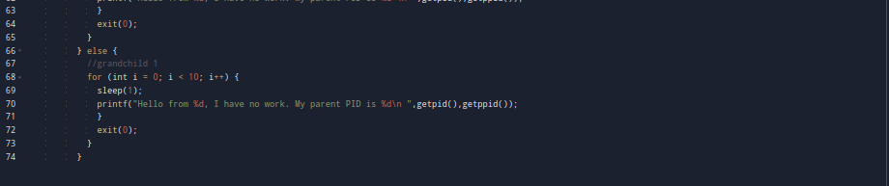

OUTPUT:
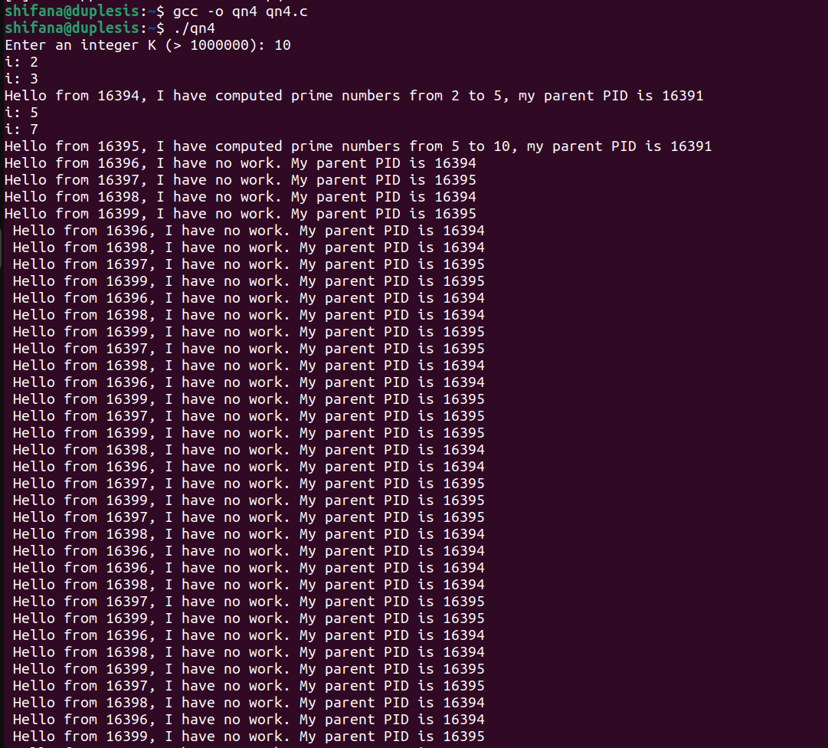
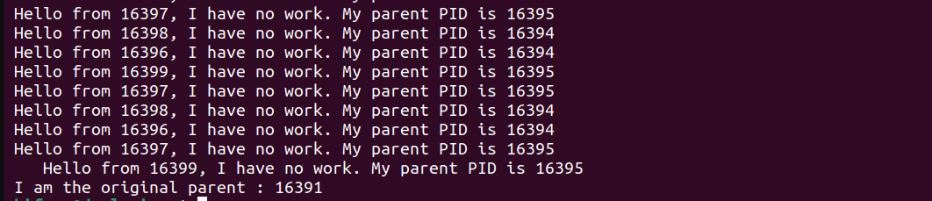
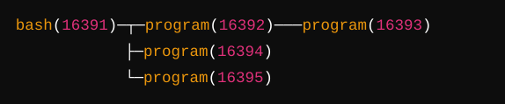
ii) The original process doesn't wait until all of them exit.
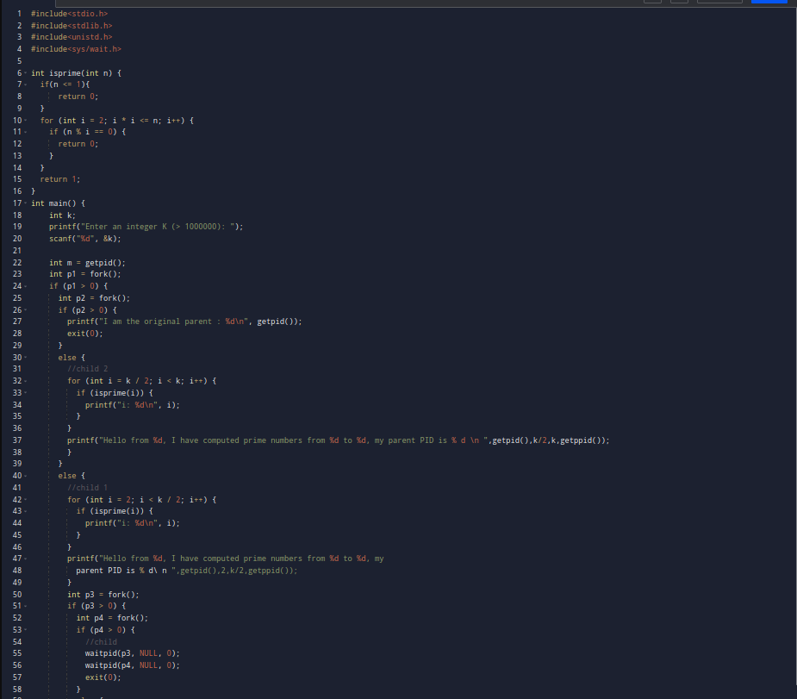
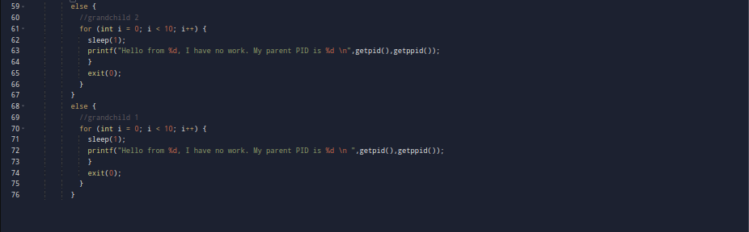
OUTPUT:
