1.INTRODUCTION
The Smart Childcare – Vaccine Reminder and Growth Monitoring System is a web-based application designed to assist parents in effectively managing their child’s vaccination schedule and monitoring growth progress. In today’s busy lifestyle, parents often find it difficult to keep track of multiple vaccination dates and maintain proper health records for their children. This system provides an efficient and automated solution to overcome these challenges.
The system allows parents to register and add details of their children, such as name, date of birth, and vaccination history. Based on the child’s age, the system automatically generates a vaccination schedule and sends reminders to parents before the due dates, ensuring that no important vaccine is missed. The reminder can be sent through notifications or emails at specified intervals (for example, seven days before, two days before, and on the due date).
In addition to vaccination tracking, the system provides a growth monitoring feature that enables parents to record their child’s height and weight regularly. The system automatically plots the recorded data on a graphical chart, helping parents visualize and track the child’s growth trends over time.
The Smart Childcare system is developed using technologies such as HTML, CSS, Bootstrap, JavaScript, Python, Django, and SQLite. It ensures data security, user-friendliness, and accuracy, making it an effective and reliable tool for parents. The system’s primary goal is to reduce manual effort, improve timely vaccination, and provide a convenient digital health record for every child.

2.AGILE METHODOLOGY
Agile methodology is a modern software development and project management approach that emphasizes flexibility, collaboration, and customer satisfaction through iterative progress. It divides the entire project into smaller, manageable phases known as iterations or sprints. Each sprint involves stages of planning, development, testing, and evaluation, allowing teams to adapt quickly to changing requirements and deliver functional components incrementally.
Agile software development focuses on continuous improvement, teamwork, and delivering working software at the end of each iteration. The methodology promotes communication among cross-functional teams and encourages frequent feedback from stakeholders to ensure the final product meets user expectations. This approach is ideal for software projects that require dynamic updates, evolving requirements, and active user involvement.
In the Smart Childcare – Vaccine Reminder and Growth Monitoring System, Agile methodology was used to manage the development process effectively. The project was divided into smaller modules such as parent registration and login, child data management, vaccine reminder scheduling, and growth monitoring, each developed and tested during different sprints. This ensured systematic progress, reduced risk, and allowed for improvements at every stage based on continuous testing and user feedback.
Through Agile, the development team was able to deliver a user-friendly, secure, and reliable system that meets the needs of parents by providing timely vaccination reminders and visual growth tracking for their children.
- Roles
- Product Owner:
The product owner is responsible for representing the stakeholders and end users. They define the product vision, prioritize the backlog, and ensure that the development aligns with user needs and project objectives. The product owner reviews deliverables at the end of each sprint and ensures that maximum value is achieved through the development process.
Product Owner of my project: Prof. Sreeja K.
- Scrum Master:
The scrum master facilitates the Agile process, ensuring smooth coordination between team members and removing obstacles that hinder productivity. They organize meetings, encourage collaboration, and promote adherence to Agile principles throughout the project lifecycle. The scrum master also ensures that timelines and deliverables are achieved efficiently
Scrum Master of my project: Prof.Rekha M Pillai

Review
Review | Last Date | Documents to submit | Remarks
Abstract submission and topic approval | 18/07/2025 | - Abstract  - Feasibility analysis  - Tools | Abstract to get approved and submitted
Product backlog presentation | 29/07/2025 | - Problem Definition  - User stories  - Product backlog  - Sprint | PPT presentation successfully submitted
Design review | 26/08/2025 | - UI design  - Database Design  - Algorithm  - Process flow  - Identified Modules  - Scrum Review | Design review successfully submitted
Intern review | 19/09/2025 | - Screenshots  - Algorithm implementation  - Test results  - Scrum Review | Concerned Guide

Final internal demo &  Draft Report Submission | 23/10/2025 | - Project-Final formexecution  - Draft report  - Git repository  - Scrum Review

3.PRODUCT BACKLOG
ID | User Story | Priority | Status
PB01 | As a user, I want to register/login securely so I can manage my child‘s data. | High | Completed
PB02 | As a user, I want to add and update my child‘s profile so I can store personal and health details. | High | Completed
PB03 | As a user, I want to receive automatic vaccine reminders so I don‘t miss any important vaccinations. | High | Completed
PB04 | As a user, I want to view an age-based vaccine schedule so I know which vaccines are needed next. | High | Completed
PB05 | As a user, I want to mark vaccines as completed so I can track which ones are done | High | Completed
PB06 | As a user, I want to enter my child‘s height and weight regularly so I can monitor growth progress. | High | Completed
PB07 | As a user, I want to view growth graphs for height and weight so I can easily understand my child‘s development. | High | Completed

PB08 | As a user, I want the system to detect my child‘s age so it can automatically display age-appropriate information. | Medium | Completed
PB09 | As a user, I want to track missed vaccines so I can follow up on anything delayed. | Medium | Completed
PB10 | As a user, I want to download or print vaccine and growth records so I can use them for school or hospital visits. | Medium | Completed
PB11 | As a user, I want to compare my child‘s growth with standard WHO charts so I can identify if they are under/over normal range. | Medium | Completed
PB12 | As a user, I want to switch between multiple children‘s profiles so I can manage data for all my kids. | Medium | Completed
PB13 | As a user, I want to update my child‘s profile picture so I can personalize the profile. | Medium | Completed
PB14 | As a user, I want to get a success message after saving data so I know my changes are done. | Medium | Completed
PB15 | As a user, I want to delete my account if I no longer need it so I can manage my privacy | Medium | Completed
PB16 | As a user, I want to log out with one click so I can keep my data secure. | Medium | Completed

4.SPRINT BACKLOG
SPRINT NO | USER STORIES | STATUS
1 | Requirement Analysis | Completed
2 | User registration and login module development | Completed
3 | Add and update child profile details | Completed
4 | Automatic vaccine reminder and notification system | Completed
5 | Vaccine schedule view and vaccine completion tracking | Completed
6 | Height and weight data entry with growth monitoring graphs | Completed
7 | Dashboard design and user interface development | Completed
8 | System Testing and debugging | Completed
9 | Evaluation | Completed
10 | Documentation | Completed

5.SYSTEM ANALYSIS
5.1 EXISTING SYSTEM
In the existing system, parents often rely on manual methods such as marking calendars, setting phone alarms, or keeping handwritten notes to remember their children’s vaccination schedules and monitor their growth. These traditional approaches are time-consuming, prone to human error, and lack reliability. Parents may forget vaccination dates, miss appointments, or delay essential vaccines, which can affect the child’s health and immunization progress.
There is also no centralized platform to store and manage vaccination records, track due dates, or monitor a child’s growth based on height and weight. Parents must frequently visit healthcare centers or maintain physical documents, making record-keeping inconvenient and inconsistent. Furthermore, there is no automatic reminder system to alert parents before the vaccination due date or to confirm whether the vaccine was administered.
The lack of automation, timely notifications, and proper data management in the existing system often leads to missed vaccinations, poor health tracking, and disorganized record maintenance. Hence, there is a strong need for a digital, automated solution that assists parents in maintaining vaccination schedules and monitoring their children’s growth effectively.

5.2 PROPOSED SYSTEM
The Smart Childcare – Vaccine Reminder and Growth Monitoring System provides an automated and efficient platform for parents to manage their children’s vaccination schedules and track their growth progress. The system sends automated reminders to parents — seven days before, two days before, and on the vaccination due date — ensuring that no vaccine is missed. It also allows parents to update the vaccine status as “taken” or “not taken,” enabling better tracking and accountability.
Parents can register and log in to the system, add their child’s details such as name, date of birth, vaccines, height, and weight, and view updates through an easy-to-use web interface. The system automatically calculates due dates, generates reminders, and displays the child’s growth pattern through interactive height and weight graphs. This helps parents visualize and understand their child’s development over time.
The system is built using Flask framework with modules like Flask-Mail or SendGrid for sending reminder notifications. It is secure, user-friendly, and accessible from any device, making it convenient for parents to

manage multiple children’s vaccination records in one place. This approach ensures timely vaccination, improved record management, and proactive child health monitoring, promoting a healthier and more organized childcare process.
ADVANTAGES
The website will try to cover the following:
- Automated Reminders:
Sends timely alerts and notifications to parents before the vaccination due date (seven days before, two days before, and on the due date) to ensure no vaccine is missed.
- Growth Monitoring:
Tracks and displays the child’s height and weight in graphical format, helping parents monitor the child’s development over time.
- User-Friendly Interface:
Provides a simple, clean, and easy-to-use dashboard where parents can easily view vaccination schedules, update vaccine status, and track growth records.
- Child Data Management:
Allows parents to add, update, and manage details of multiple children, including their vaccination history and growth data, all in one secure place.
- Secure Database:
Uses a reliable backend (SQLite/MySQL) for safely storing user, child, and vaccination data, ensuring data integrity and privacy.
- Customizable Schedule:
Gives flexibility to update or modify vaccination due dates, making it easier for parents to test and manage reminders according to real-time situations.
- Accessibility:
A web-based platform that can be accessed anytime, from any device with an internet connection, ensuring convenience for parents.

5.3 FEASIBILITY STUDY
A feasibility study is conducted to evaluate whether the proposed system is practical, viable, and beneficial to the users. It examines the project’s technical, operational, and economic aspects to determine whether the system can be successfully developed and implemented using available resources. This study helps developers

identify potential challenges, estimate project usefulness, and ensure that the final system fulfills its objectives efficiently.
Before the development of the Smart Childcare – Vaccine Reminder and Growth Monitoring System, a detailed feasibility study was carried out to assess its technical capability, user acceptance, and cost-effectiveness. The study confirmed that the system can be implemented using existing open-source tools and technologies within a reasonable budget and timeframe.
5.3.1 TECHNICAL FEASIBILITY
The Smart Childcare – Vaccine Reminder and Growth Monitoring System is technically feasible to implement using widely available and open-source web technologies. The system uses Python as the backend programming language, along with the Flask framework for handling routing, server-side logic, and database communication. The frontend is designed using HTML, CSS, Bootstrap, and JavaScript, providing a simple and responsive interface for parents.
The database can be implemented using SQLite or MySQL, which are reliable and efficient for managing user details, child records, vaccination data, and growth tracking information. Additional modules like Flask-Mail or SendGrid can be integrated to send automated vaccine reminder notifications to parents via email.
All these technologies are open-source and lightweight, requiring minimal hardware resources. This makes the system easy to develop, deploy, and maintain on a personal computer, local server, or cloud-based environment, ensuring its technical feasibility.
5.3.2 OPERATIONAL FEASIBILITY
Operational feasibility evaluates how efficiently the system will operate once implemented and how users will adapt to it. The Smart Childcare system is designed to be simple, user-friendly, and highly interactive, enabling parents to use it easily even with limited technical knowledge.
The system automates vaccination reminders and growth data management, thereby reducing manual work and minimizing the chances of missed vaccines or record errors. Parents only need to enter child details and vaccination dates once, after which the system automatically handles reminders and updates. The web-based nature of the application allows parents to access it from any device with an internet connection, improving usability and convenience.
Since the system requires no specialized training and offers clear navigation, it ensures smooth adoption and a high level of user satisfaction among parents.

5.3.3 ECONOMICAL FEASIBILITY
The project is economically feasible as it involves minimal development and maintenance costs. All the technologies used — including Python, Flask, HTML, CSS, Bootstrap, JavaScript, and SQLite — are open-source and free to use. The system can be hosted locally or on a low-cost web server, eliminating the need for expensive hardware or licensed software.
As the project is primarily intended for academic and practical demonstration, its development costs are limited to basic hardware resources and internet connectivity. Moreover, the system is designed to be scalable, meaning it can later be upgraded to support additional features such as SMS notifications or mobile app integration without significant financial investment.

6.SYSTEM REQUIREMENTS
HARDWARE REQUIREMENTS
- Processor (CPU): Intel Pentium IV or higher
- RAM (Memory): Minimum 2 GB
- Hard Disk: Minimum 20 GB free space
SOFTWARE REQUIREMENTS
- Operating System: Windows
- Programming Language: Python
- Framework: Flask
- Frontend Technologies: HTML, CSS, JavaScript, Bootstrap
- Database: SQLite
- Server: Flask Development Server
- Libraries: Flask-Mail, Twilio API (for notifications)
- Code Editor: Visual Studio Code

7.SOFTWARE SPECIFICATION
HTML
HTML (Hyper Text Markup Language) is the standard markup language used for creating and structuring web pages. It provides the foundation for displaying content such as text, images, and links on the web. In the Medicine Reminder System and Expiry Tracker, HTML is used to design the structure of web pages, including user registration forms, login pages, dashboards, and reminder displays. It ensures that all content is properly organized and interpretable by web browsers.
CSS
CSS (Cascading Style Sheets) is a style sheet language used to describe the presentation and design of HTML documents. It allows developers to control the layout, colors, fonts, and spacing of web pages. In this project, CSS is used to enhance the visual appearance of the system, making it more appealing, consistent, and user-friendly. It ensures that the interface is clean, readable, and accessible across different devices and screen sizes.
JavaScript
JavaScript is a high-level, interpreted scripting language used to make web pages interactive and dynamic. It enables real-time updates, form validations, and responsive user interactions without reloading the page. In this project, JavaScript is used to implement interactive features such as dynamic form validation, real-time notifications, and responsive dashboard updates for medicine schedules and expiry alerts.
Bootstrap
Bootstrap is an open-source CSS framework used for designing responsive and mobile-friendly web interfaces. It provides pre-built design components such as buttons, navigation bars, forms, and modals. In the Medicine Reminder System and Expiry Tracker, Bootstrap ensures that all pages adapt seamlessly to different devices, including desktops, tablets, and smartphones. It reduces development time while maintaining a modern, professional look.
Python
Python is a high-level, general-purpose programming language known for its readability, simplicity, and versatility. It serves as the primary backend programming language for this project. Python handles the core logic of reminder scheduling, expiry tracking, and database operations. It also enables the integration of external modules for sending email or SMS notifications, making the system efficient and reliable.

Flask
Flask is a lightweight and flexible web framework written in Python. It follows the Model-View-Controller (MVC) architectural pattern and allows developers to build web applications quickly and efficiently. In the Medicine Reminder System and Expiry Tracker, Flask is used to manage routing, handle user requests, connect to the database, and render templates. Its simplicity and modularity make it ideal for small to medium-sized web applications.
SQLite
SQLite is a lightweight, serverless, and self-contained relational database management system. It is used in this project to store user information, medicine details, dosage schedules, and expiry dates. SQLite is easy to set up and maintain, requiring no separate database server. Its simplicity and portability make it a suitable choice for a local or academic-level project like the Medicine Reminder System and Expiry Tracker.
Flask-Mail
Flask-Mail is an extension of Flask used for sending emails directly from a Flask application. In this project, Flask-Mail is integrated to send email notifications to users for upcoming medicine reminders or approaching expiry dates. It enhances communication and ensures that users receive timely alerts even when they are not logged into the system.
Twilio API
Twilio API is used for sending SMS notifications directly to users’ mobile phones. It enables the system to deliver instant reminders about medicine intake times or expiry alerts. Twilio provides a reliable and scalable communication service that ensures users never miss an important reminder, making the system more practical and user-centric.

8.WORK FLOW DIAGRAM

Level 0
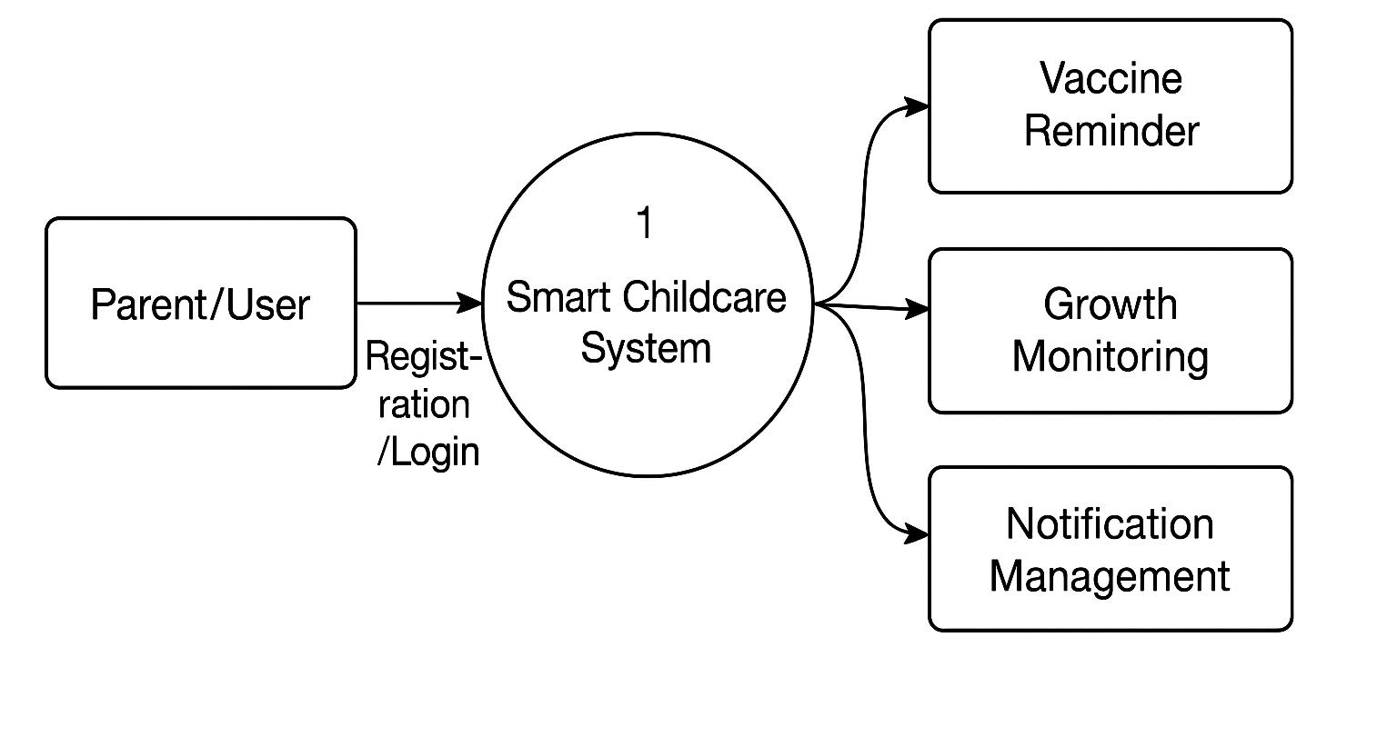

Level 1

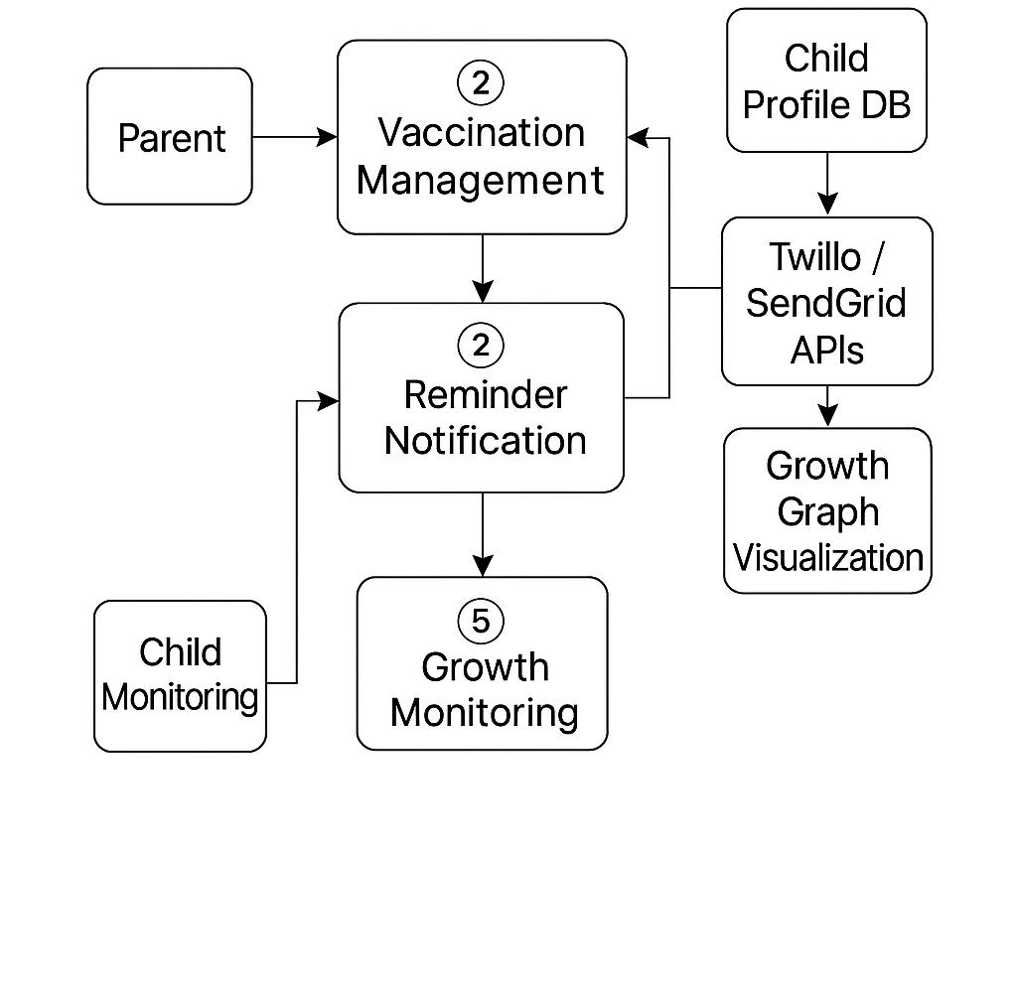

Level 2
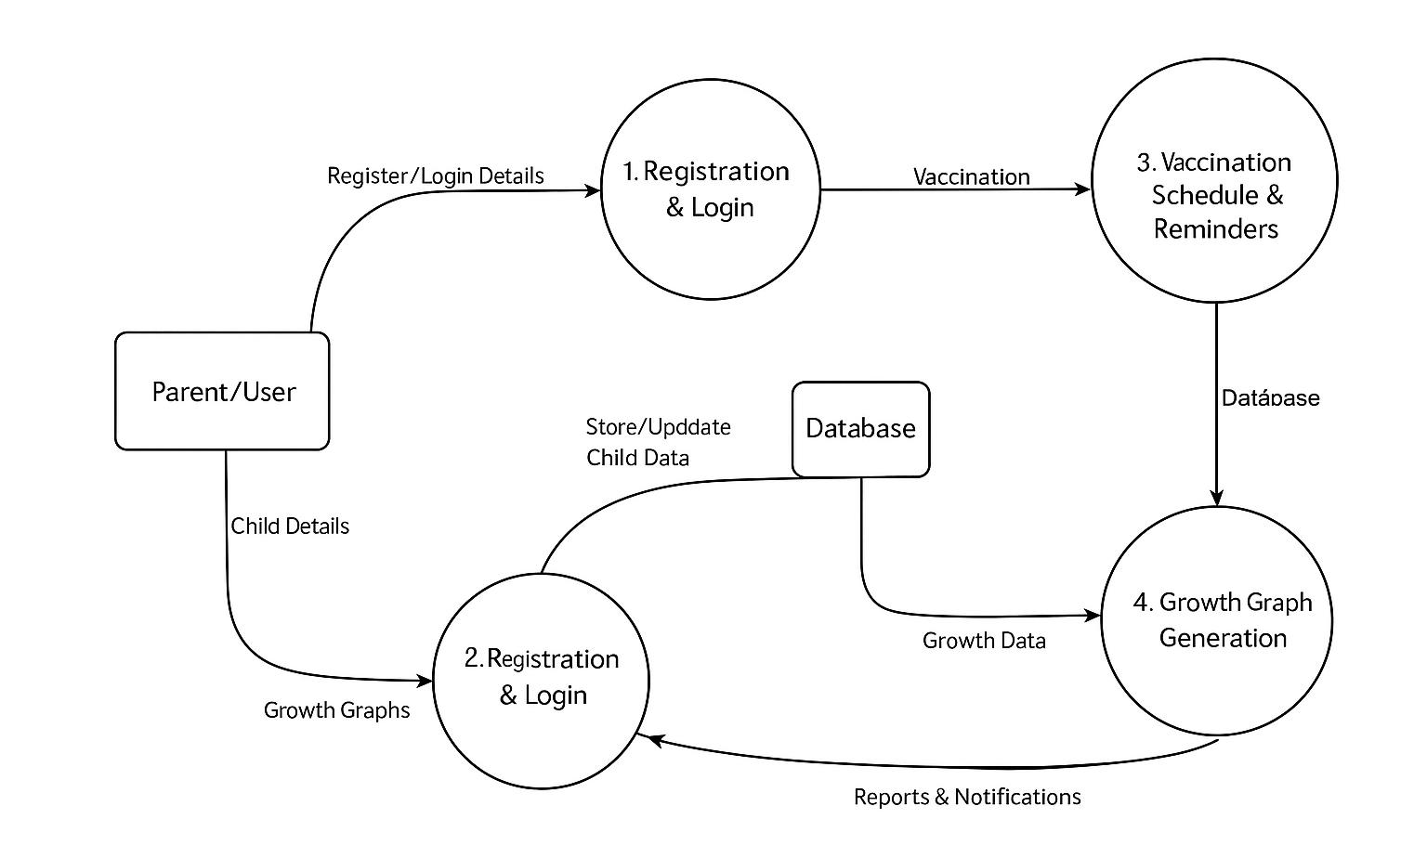

9.MODULE DESCRIPTION
The Smart Childcare – Vaccine Reminder and Growth Monitoring System focuses on helping parents efficiently manage their child’s vaccination schedules and monitor their growth progress.
The system ensures that parents receive timely reminders for upcoming vaccinations and can easily track their child’s height and weight over time through graphical charts.
This project includes a single Parent (User) Module, which handles all the main functionalities such as child data management, vaccination scheduling, growth monitoring, and reminder notifications.
Parent Module Details
The Parent Module consists of the following key features:
- Signup:
Parents can register by providing basic details such as name, email, and password to create an account and securely access the system.
- Login:
Registered parents can log in to their account using valid credentials to access all features related to their child’s vaccination and growth records.
- Add Child Details:
Parents can add important information about their child such as name, date of birth, and gender. This data helps the system calculate the vaccination schedule automatically.
- View Vaccination Schedule:
The system displays a complete vaccination schedule based on the child’s date of birth. It also highlights vaccines that are due or upcoming.
- Set and Receive Reminders:
The system automatically generates reminders for upcoming vaccinations — seven days before, two days before, and on the due date — and notifies parents via email.
- Update Vaccine Status:
After vaccination, parents can update the vaccine status as “Taken” or “Not Taken,” allowing accurate record maintenance.

- Growth Monitoring:
Parents can record their child’s height and weight regularly. The system then displays this data as a graphical chart to help visualize the child’s growth trend over time.
- Edit/Delete Child Details:
Parents can modify or remove child information and update vaccination or growth data whenever required.
- Logout:
Ends the current session safely, ensuring data privacy and secure access for future logins.

10.TESTING
Sl. No | Task | Outcome  Desired Obtained |  | Remarks
1 | Registration | User Registration  Successful | Task Successful | Successful
2 | Uset Login | Successful | Task Successful | Successful
3 | Add child details | Successful | Task Successful | Successful
4 | View vaccine Schedule | Successful | Task Successful | Successful
5 | Vaccine reminder | Successful | Task Successful | Successful
6 | Update vaccine reminder | Successful | Task Successful | Successful
7 | Growth monitoring | Successful | Task Successful | Successful
8 | Notification Display | Successful | Task Successful | Successful
9 | Change password | Successful | Task Successful | Successful
10 | Logout | Successful | Task Successful | Successful

11.SCREENSHOTS

HOME PAGE
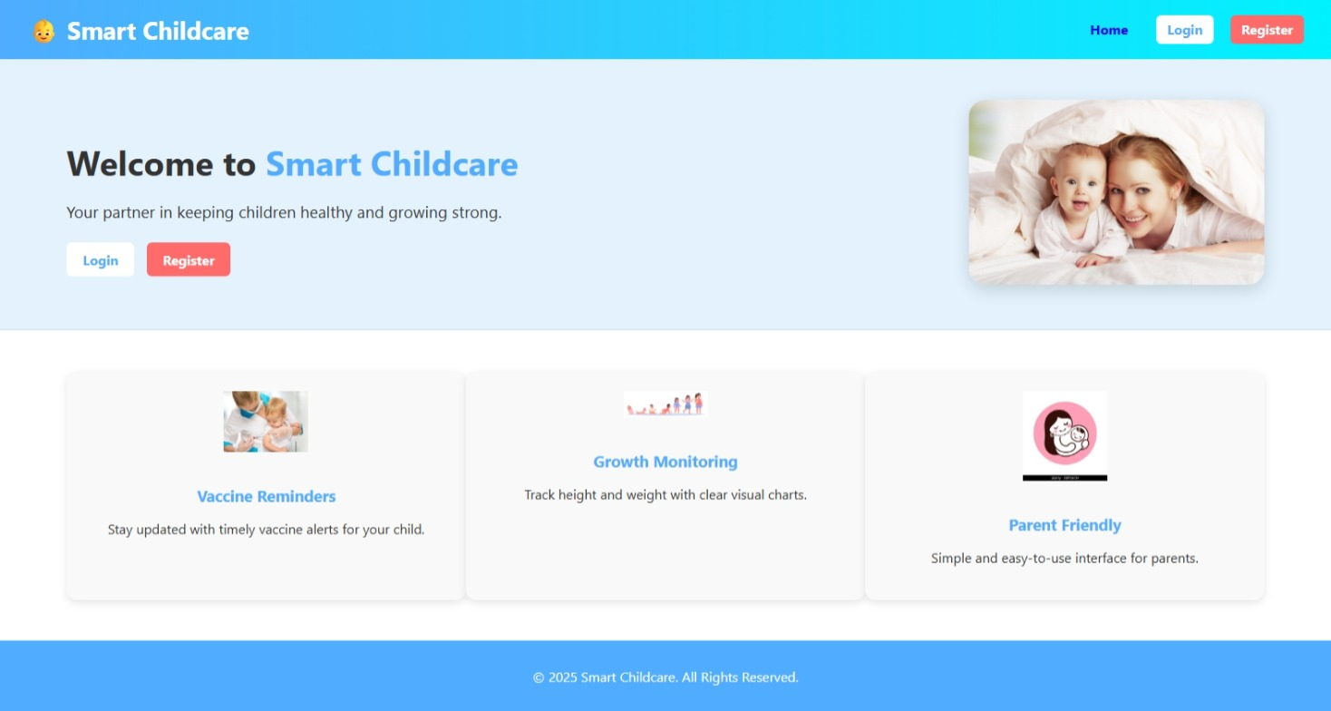

REGISTER PAGE
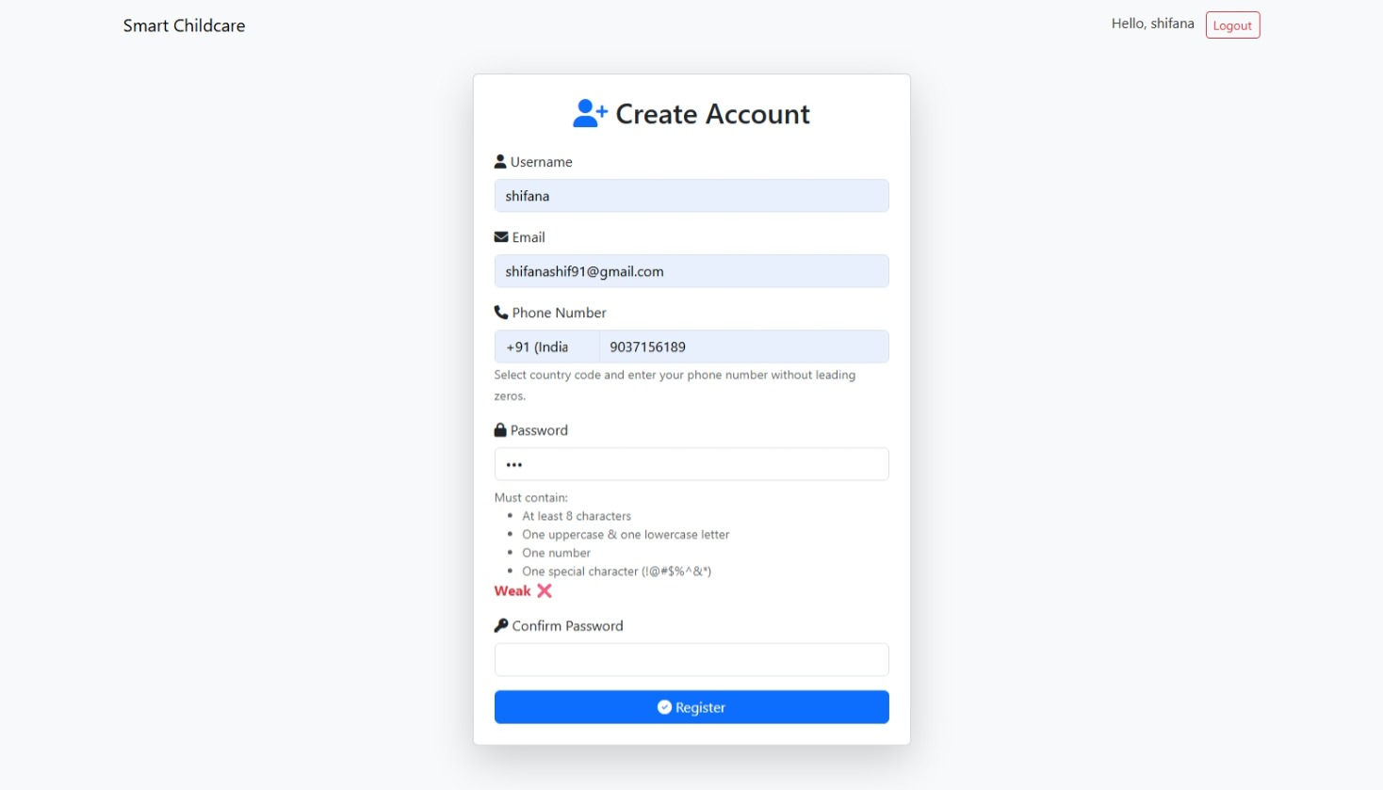

LOGIN PAGE
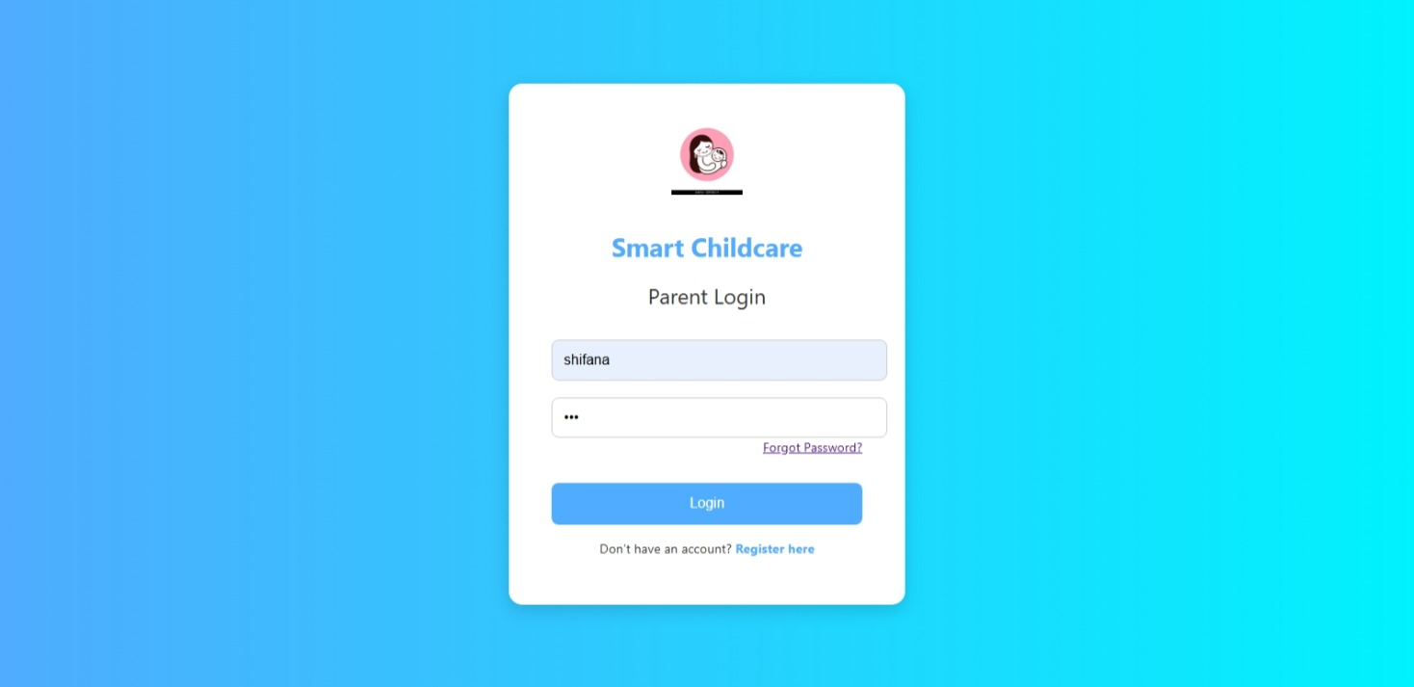

DASHBOARD PAGE
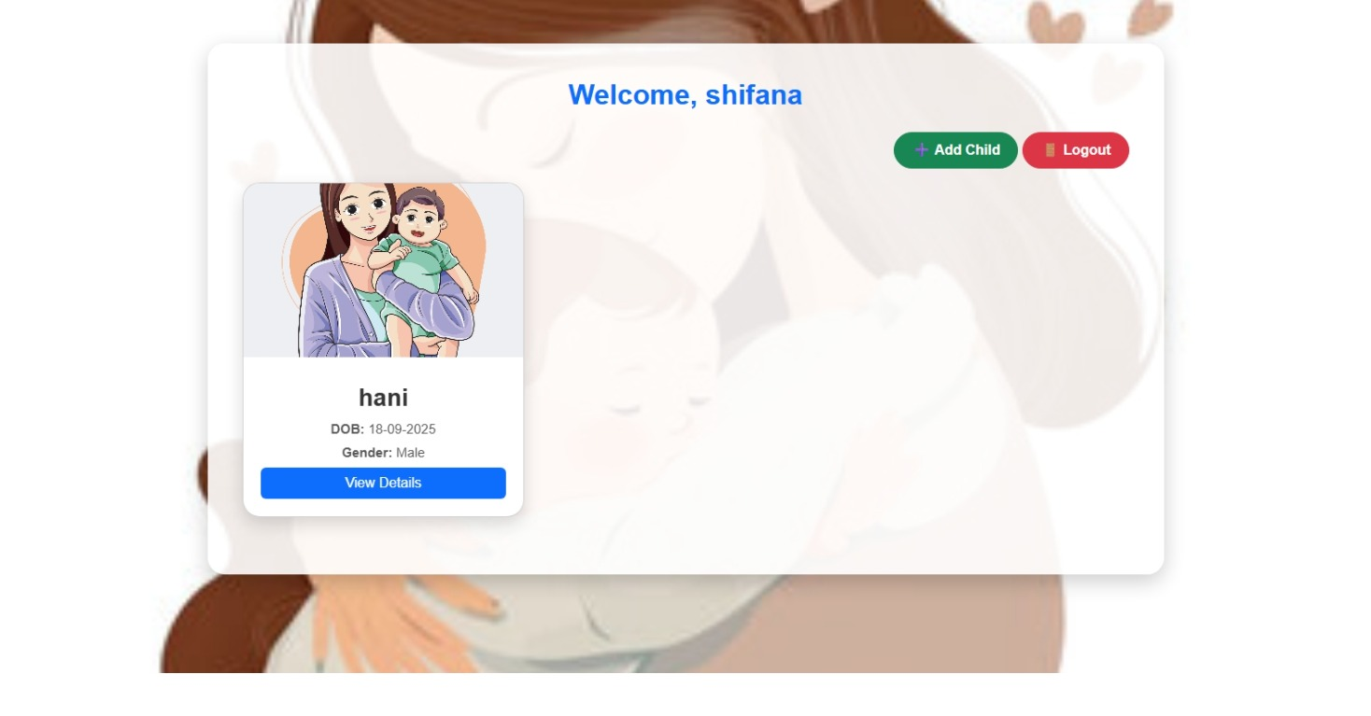

CHILD ENTRY PAGE
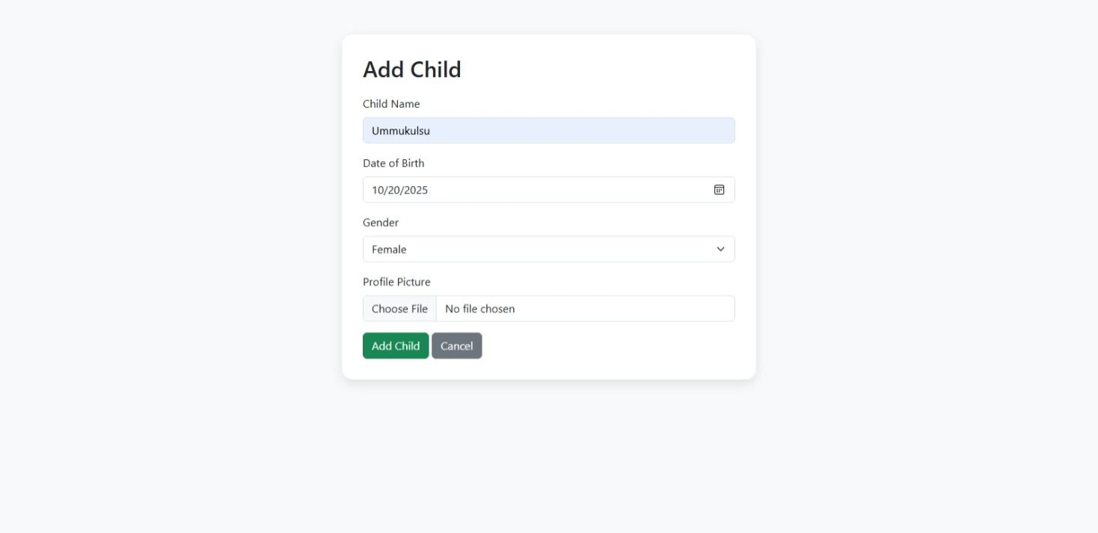

CHILD PROFILE & VACCINE SCHEDULE
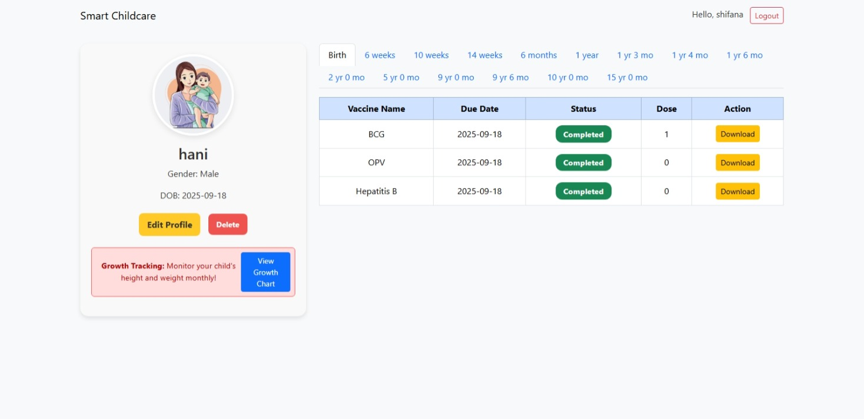

GROWTH RECORD ENTRY PAGE

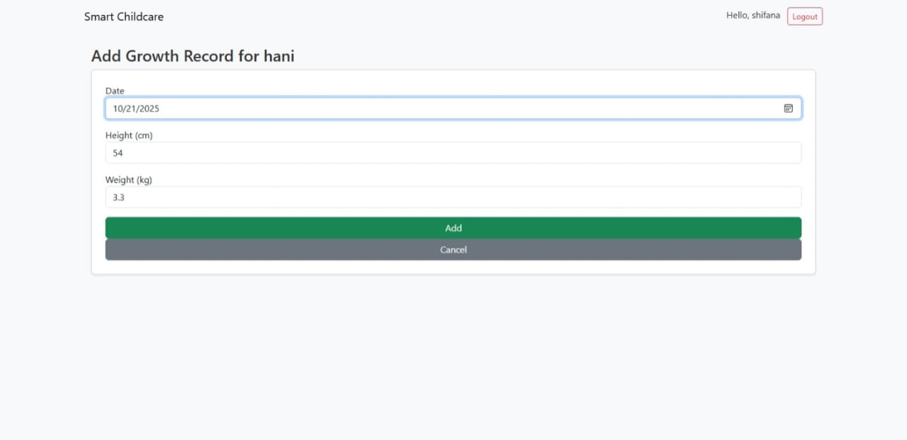

GROWTH TRACKING PAGE

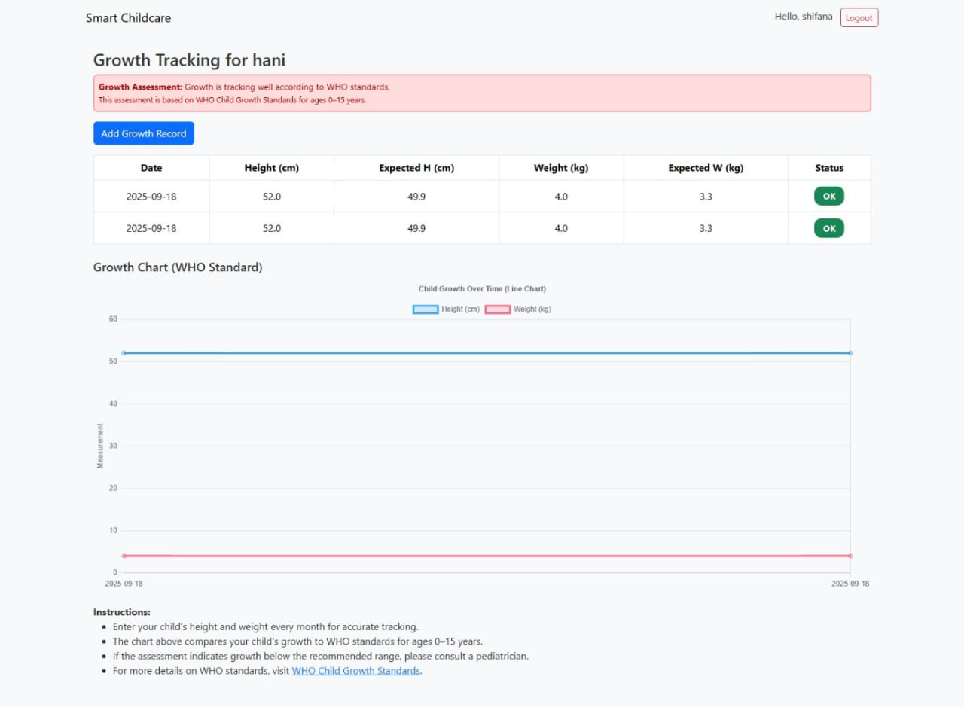

EDIT PROFILE
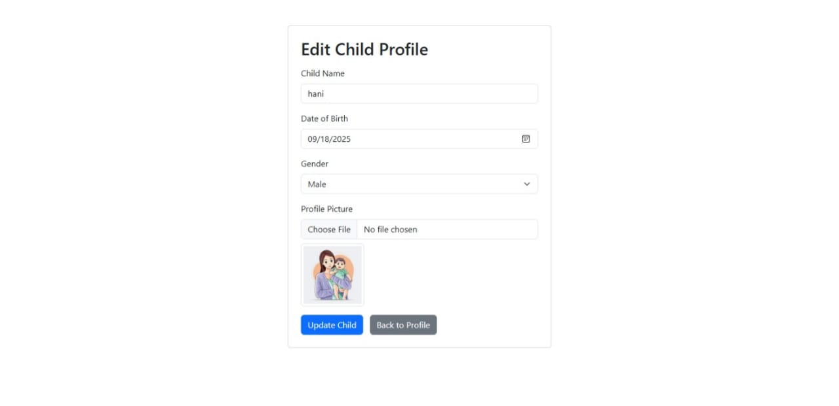

12.TABLE STRUCTURE
Table Name: User
Field Name | Data Type | Size | Constraint | Description
user_id | int | 20 | Primary key | Unique user identification
username | varchar | 10 | NOT NULL | User Name
email | Varchar | 20 | NOT NULL | User’s email address
phone | Number | 10 | NOT NULL | Contact number
password | Varchar | 20 | NOT NULL | Account password

Table Name: Child
Field Name | Data Type | Size | Constraint | Description
id | int | 4 | Primary key | Unique identifier for each child
name | Varchar | 10 | NOT NULL | Child name
dob | Date | 20 | NOT NULL | Child’s date of birth
 | Varchar | 10 | NOT NULL | Child’s gender
  gender
profile_pic | String | 20 | NOT NULL | Child’s profile pic
 | int | 20 | Foreign key | Links to parent
  parent_id

Table Name: Vaccine
Field Name | Data Type | Size | Constraint | Description
id | Int | 4 | Primary key | Unique identifier for each vaccine
name | varchar | 10 | NOT NULL | Vaccine name
dose_number | Varchar | 10 | NOT NULL | Indicated which dose

Table Name: Vaccine Record
Field Name | Data Type | Size | Constraint | Description
id | Int | 4 | Primary key | Unique identifier for each vaccination record
child_id | Int | 10 | Foreign Key | Child who received the vaccine
vaccine_id | Int | 20 | Foreign Key | Vaccine associated with the record
dose_no | Varchar | - | NOT NULL | Vaccine dose number
due_date | Date | - | NOT NULL | Scheduled vaccination date
date_taken | Date | - | NOT NULL | Actual vaccination date
place | String | - | NOT NULL | Place where the vaccine was taken
Reminded_week | Boolean | - | Default=false | Reminder sent 1 week before due date
reminded_twoday | Boolean | - | Default=false | Reminder sent 2 days before due date

Table Name: Growth Record
Field Name | Data type | Size | Constraint | Description
growth_id | Integer | - | Primary Key | Unique identifier for each growth record
child_id | Integer | - | Foreign Key | Child related to the growth record
date | Date | - | Not Null | Date of measurement
height_cm | Float | - | Nullable | Height of the child in centimeters
weight_kg | Float | - | Nullable | Weight of the child in kilograms

13.CONCLUSION
The Children Vaccine Reminder and Growth Monitoring System is a reliable and user-friendly web-based solution developed to assist parents in managing their child’s vaccination schedules and monitoring growth progress effectively. By automating reminders and providing alerts for upcoming and missed vaccines, the system helps ensure timely vaccination, which is essential for a child’s healthy development.
The system also enables parents to record and track their child’s height and weight, which are visually represented through growth charts. This feature allows parents to easily monitor their child’s growth patterns over time and identify any deviations early.
Through its simple interface and automated notification system, the project reduces manual effort and the possibility of missed vaccinations. It demonstrates how digital technologies like Flask, HTML, CSS, and databases can be integrated to promote better child healthcare management.
In the future, the system can be enhanced with features such as SMS notification, vaccination record printing, doctor login modules, and AI-based health insights to make it even more interactive and beneficial for parents and healthcare providers.

14.REFERENCES
- Grinberg, M. (2018). Flask Web Development: Developing Web Applications with Python. O’Reilly Media.
- Basham, B., Sierra, K., & Bates, B. (2017). Head First HTML and CSS. O’Reilly Media.
Morrison, J. (2020). Learning JavaScript: A Hands-On Guide to the Fundamentals of Modern JavaScript. Addison-Wesley.
- Beighley, L. (2017). Head First SQL: Your Brain on SQL – A Learner’s Guide. O’Reilly Media.
- Pilgrim, M. (2020). Dive Into Python 3: A Comprehensive Guide to Python Programming. Apress.
- Fowler, M. (2019). Agile Software Development: Principles, Patterns, and Practices. Addison-Wesley.
- Hunt, A., & Thomas, D. (2019). The Pragmatic Programmer: Your Journey to Mastery. Addison-Wesley.
- Pressman, R. S. (2020). Software Engineering: A Practitioner’s Approach (9th Edition). McGraw-Hill Education.
- Somerville, I. (2016). Software Engineering (10th Edition). Pearson Education.
- Sommerville, I. (2019). Software Project Management and Development Methodologies. Pearson.

