Survey Paper on ‘ Improving the Lives of Injured Street Animals: A Call to Action

ABSTRACT
In past few years population of stray animals has been increased highly In urban areas worldwide, injured street animals face a myriad of challenges, ranging from accidents and injuries to neglect and a lack of access to essential care. These vulnerable creatures endure a daily struggle for survival, often without the attention or support they desperately need. This paper sheds light on the pressing issues faced by injured street animals, including the physical and emotional toll of their circumstances. Drawing on global perspectives and case studies, we explore the various factors contributing to this crisis. Moreover, we propose a comprehensive approach to addressing these issues, which encompasses public awareness campaigns, community engagement, and the use of modern technology, such as mobile applications like PASHUMITRA, to connect caring individuals, non-governmental organizations, and local authorities in a concerted effort to provide timely assistance and improve the quality of life for these animals. By raising awareness and advocating for change, we aim to catalyze a collective effort to ensure a more humane and compassionate world for injured street animals.

INTRODUCTION
- In the bustling streets of urban centers worldwide, the poignant plight of injured street animals unfolds each day, often obscured by the hustle and bustle of human activity. These animals, often victims of accidents, neglect, and the harsh realities of urban living, endure a silent struggle for survival, hidden in plain sight. Consider, for instance, the stray dog limping through the congested streets of New Delhi, its wounded paw a testament to the daily hazards it faces. Or the feral cat in Istanbul, scarred and suffering from untreated injuries, navigating a labyrinth of alleyways in search of sustenance.
- These heart-wrenching scenarios are emblematic of a global issue that touches the lives of countless injured street animals. Their suffering, both physical and emotional, is a stark reminder of the challenges they face in our increasingly urbanized world. In this paper, we embark on a journey to uncover the layers of this crisis, delving into the multifaceted challenges that injured street animals confront in their day-to-day lives. We aim to shine a light on their struggles, raising awareness about the urgent need for change and a more humane approach to their care.
- This paper not only examines the problems but also offers a comprehensive approach to addressing them. It explores the power of public awareness campaigns, the vital role of community engagement, and the promise of modern technology, exemplified by mobile applications like PASHUMITRA, to bridge the gap between caring individuals, dedicated non-governmental organizations (NGOs), and local authorities. Through these efforts, we endeavor to create a united front, forging a path toward a more compassionate and just world for those injured street animals whose silent suffering speaks volumes about our shared humanity.

PROBLEM DEFINITION
To design system “PASHUMITRA” which provide the solution to society for injured stray animals i.e. developing an environment to rescue and adopt street animals by giving them a better life for living. We bridge the gap between those in need and those willing to help.
There are many problems in real world regarding the stary animals. We aim to transform animal welfare by raising awareness, inspiring volunteerism, and providing vital support for animals in need. A system can be developed that can be easily understand by user. With 'PASHUMITRA,' we're creating a user-friendly Android app that allows you to snap a photo of an injured animal and notify nearby NGOs for rescue operations.
As well as 'PASHUMITRA' also lets you browse and adopt street animals, giving them a chance at a loving forever home.

NEED OF PASHUMITRA
- Animal Welfare:
  - To address the pressing issue of injured and abandoned animals in urban areas, there is a need for a platform that focuses on their welfare and well-being.
- Emergency Response:
  - Injured animals often require immediate assistance. PASHUMITRA is needed to enable quick and efficient responses from NGOs and individuals to provide timely care.
- Prevention of Animal Cruelty:
  - To prevent the neglect and mistreatment of animals, there is a need for a system that encourages responsible reporting and rescue efforts.
- Community Engagement:
To foster a sense of community responsibility, the app should engage users, NGOs, and local authorities in a collaborative effort to help animals in need.

- Public Awareness:
  - There is a need to raise public awareness about the plight of street animals and how individuals can contribute to their rescue and care.

PROPOSED SYSTEM
The proposed system for PASHUMITRA envisions a comprehensive and user-centric platform that leverages modern technology to address the challenges faced by injured and abandoned animals in urban environments. Key components and features of the proposed system include:
User Creates a Post:

The User, who has found an injured dog by the roadside, opens the PASHUMITRA app.
They choose the option to create a post for rescuing an injured animal.
The User takes a photo of the injured dog and provides the location details.
Image Classification:

The app's image classification system checks if the uploaded photo contains an animal. If it doesn't, the post is rejected.
Valid Post Creation:

Since the image is classified as an animal, the User proceeds to create the post.
They describe the dog's condition, any visible injuries, and provide additional information about the situation.
Notification to NGOs:

The app sends a notification to all local NGOs specializing in animal rescue within a certain radius of the incident's location.
NGOs receive a notification of the new post and its details.
NGO Response:

A local NGO, "Animal Rescuers," receives the notification.
They review the post and decide to take action. They send a response indicating their willingness to rescue the injured dog.

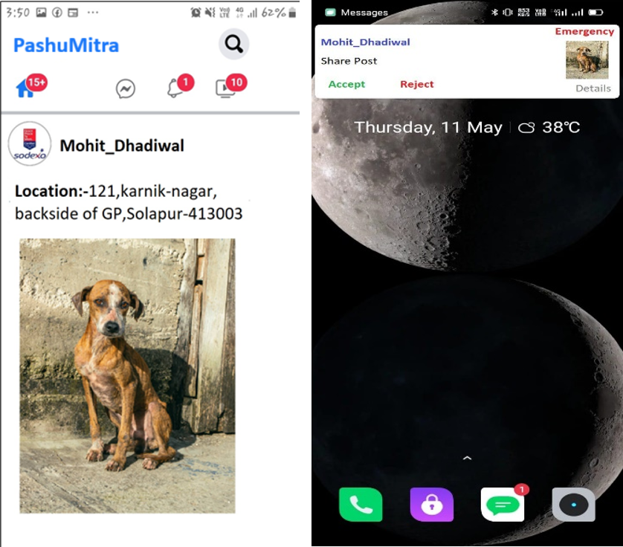

REQUIREMENT SPECIFICATION
Software Requirement:
- android-studio-version2022.3.1.19
- Firebase
- Anaconda Notebook v23.7.2
Hardware Requirement:
- Android Mobile Version-kitkat 4.4(min)

CONCLUSIONS
In a world where the well-being of injured and abandoned animals is often overlooked in the midst of urban life, PASHUMITRA emerges as a beacon of hope and compassion. This mobile application represents not just a technological advancement, but a profound commitment to addressing the challenges faced by our vulnerable animal companions. Its unique features, including image classification for validation, real-time notifications to local NGOs, and the temporary post deactivation mechanism, demonstrate a deep understanding of the complex needs of injured animals and the urgency of their rescue.

