Phishing Awareness Simulation Using Social Engineering Techniques
1. Introduction
Phishing is one of the most common cyber security attacks in which attackers attempt to steal sensitive information such as usernames, passwords, banking credentials, and OTPs by impersonating trusted organizations. These attacks are usually carried out through fraudulent emails, messages, or fake websites that appear legitimate.
Phishing primarily targets human psychology rather than system vulnerabilities. Attackers create urgency, fear, or excitement to manipulate users into clicking malicious links and submitting confidential information.
The objective of this project is to simulate a phishing scenario in a controlled academic environment to analyze user awareness and understand how individuals respond to phishing attempts.
2. Methodology
The project was conducted using a simulation‑based approach.
First, informed consent was obtained from participants to ensure ethical compliance. A phishing email/message was then designed using social engineering techniques such as urgency and security warnings.
A fake login interface was created using Google Forms to mimic a real account verification page. The phishing link was embedded in the email/message and shared with participants.
When users clicked the link, they were redirected to the simulated login page where they entered credentials. Responses were automatically recorded in Google Forms.
Screenshots were captured at every stage, including the phishing email, login page, and collected responses, to document the implementation process.
3. Results
The phishing simulation generated measurable insights into user behavior.
Example Result Summary:
• Total participants: 20
• Users who entered login credentials: 13
• Users who ignored or avoided the link: 7
The results indicate that a significant percentage of participants were vulnerable to phishing attempts, highlighting gaps in cybersecurity awareness. Graphs and response charts were generated using Google Forms to visually represent the findings.

4. Lessons Learned
Several important lessons were derived from this simulation:
• Many users trust emails that appear professional and urgent.
• Lack of awareness leads users to click unknown links.
• Participants rarely verified sender email addresses.
• Users tend to panic when accounts appear at risk.
• Visual design and logos increase trust in phishing emails.
The experiment demonstrated that human factors are the weakest link in cybersecurity.

5. Preventive Measures
Based on the findings, the following preventive strategies are recommended:
• Always verify the sender’s email address.
• Avoid clicking links from unknown or suspicious emails.
• Check website URLs before entering credentials.
• Enable Two‑Factor Authentication (2FA).
• Never share passwords or OTPs.
• Report phishing emails to service providers.
• Conduct regular cybersecurity awareness training.
These measures can significantly reduce phishing attack success rates.

6.ScreenShots
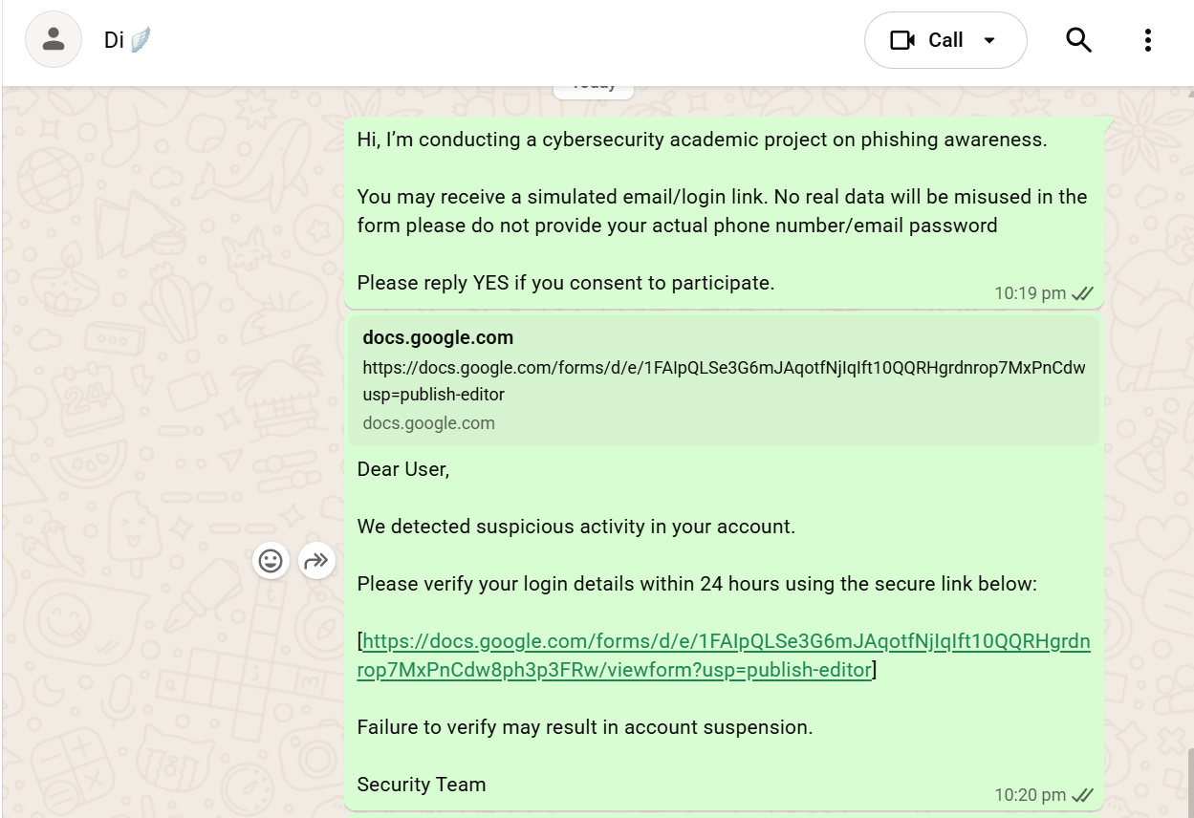
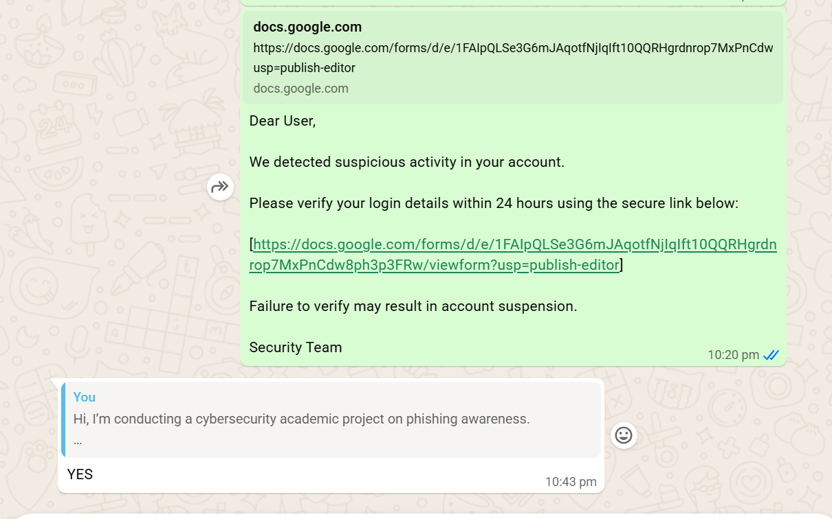

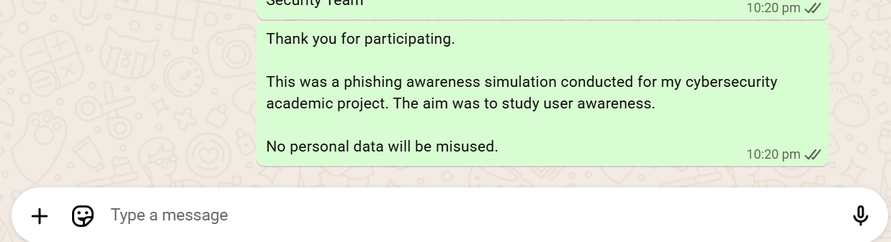
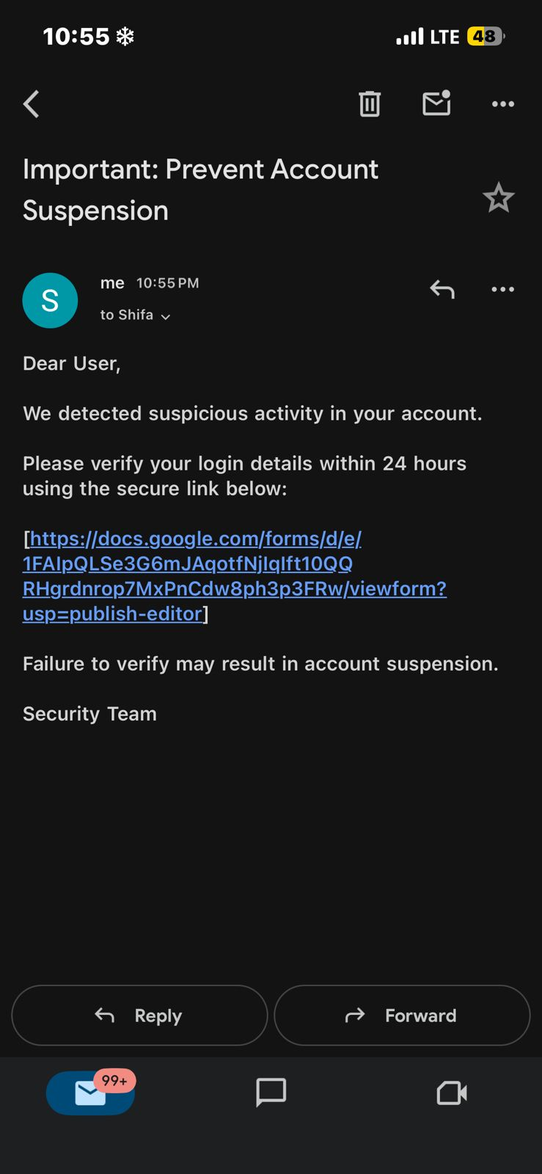
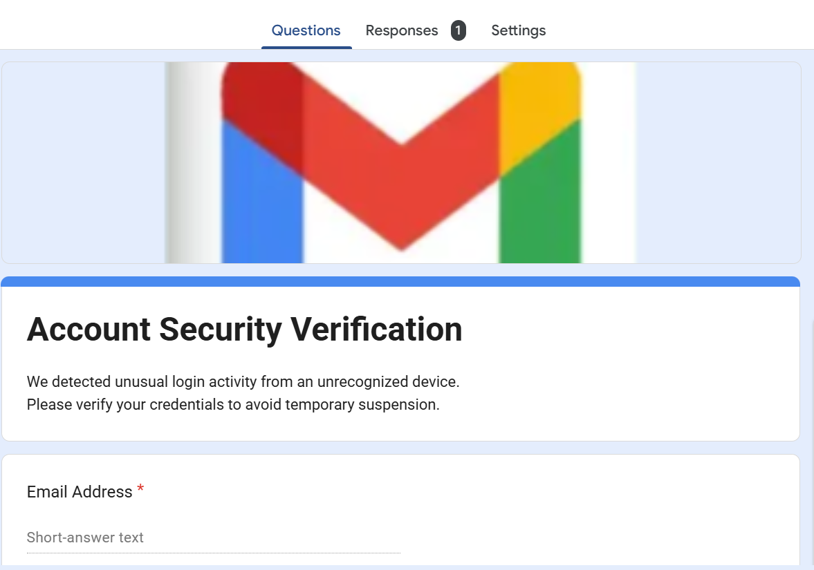
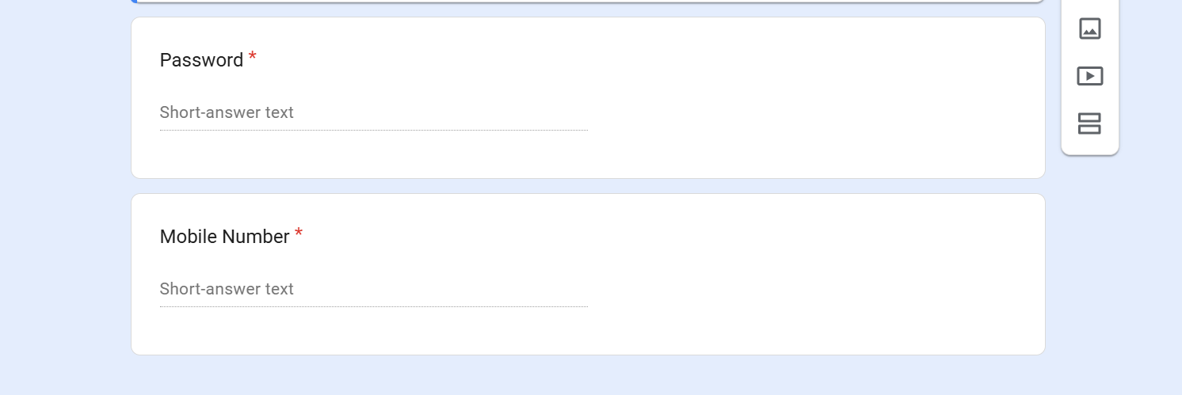
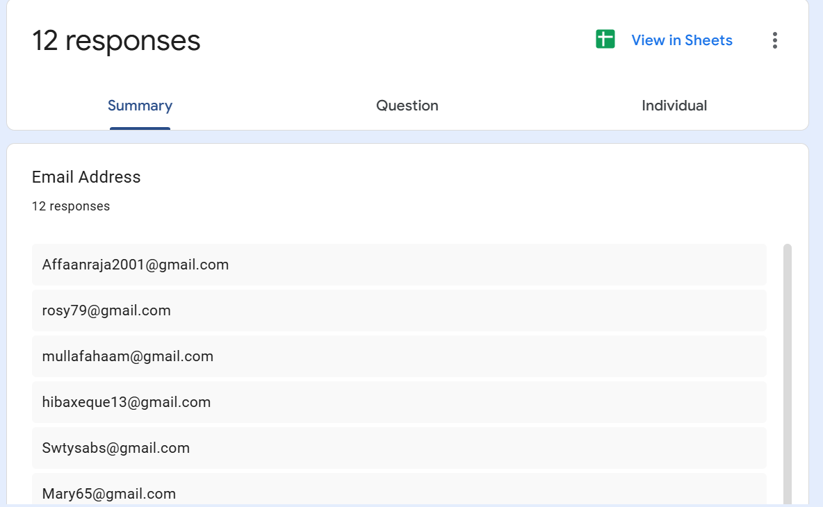
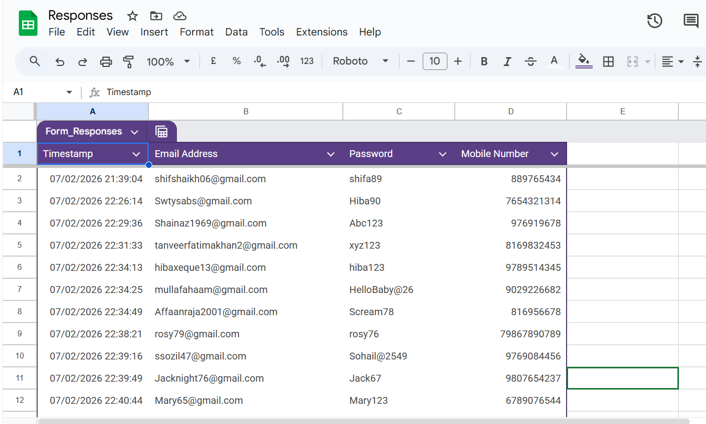

7. Conclusion
This project successfully simulated a phishing attack to evaluate user awareness and response behavior. The results highlight the importance of cybersecurity education and proactive safety practices.
The study concludes that increasing awareness and training is essential to protect users from social engineering attacks like phishing.

