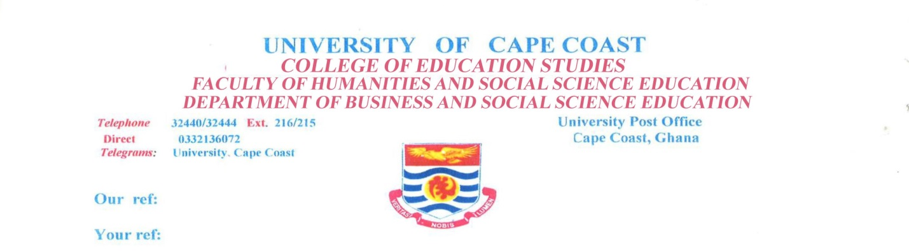
18th March 2021.
TO WHOM IT MAY CONCERN
PROFICIENCY IN ENGLISH
This confirms that Mr. Oppong Richard who is seeking admission into your institution, is a past student of this University. He was admitted in 2011 to pursue a 4-year BACHELOR OF EDUCATION (ACCOUNTING) programme after satisfying the minimum entry requirements, including a credit pass in English Language.
He wrote and passed the final examination and was accordingly admitted to the degree of BACHELOR OF EDUCATION (ACCOUNTING) in the Second Class Honours (Upper Division).
The medium of instruction and examination at all levels of education in Ghana is English Language. Oppong Richard, like all the students of this University and its affiliate institutions, was taught and examined in English. It is therefore our view that the above mentioned person’s proficiency in English is of a level that will enable his to interact very effectively and efficiently as well as undertake further studies in any area of his choice without any difficulty. In fact, his level of proficiency is very amazing.
We should therefore be very grateful if you could extent to him any assistance he may require.
Thank you.
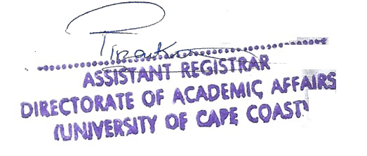
(EVELYN OSAM-PINANKO)
for: Registrar

