Mason Shigenaka

INFO 370 A

10/25/16

Lab 3 Answers

1. Cited and citing are pmids
2. Basic local alignment, 1990 (Found Online), Journal of Molecular Biology (Found Online)
3. PLOS One
4. Histogram:

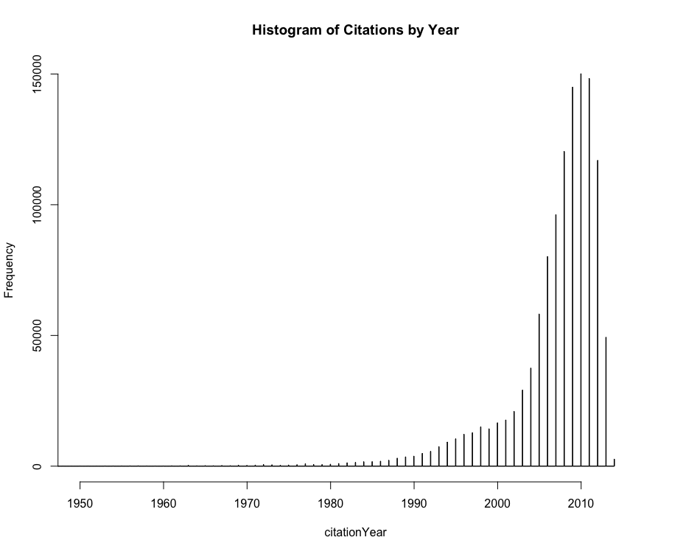

1. Line Graph:

