HEIRLOOM: Progress Update
Md Shihab Reza | Monirul I. Mahmud | Supervisor: Prof. Justin Zhan | 7 October 2026

The full idea in simple words
- An attacker can hide a secret trigger word inside an AI model during training. With the word, the model does harmful things. Without it, the model looks normal and safe.
- Companies often take a model and change it (make it smaller, or train it a bit more). We ask: does the hidden trigger survive these changes?
- We plant the same trigger in two different training steps (DPO and SFT, defined below) using the exact same poisoned examples, so the comparison is fair. Then we check which one survives the changes better.
- Why it matters: if a trigger survives, every copy made from a poisoned model is also poisoned, and nobody may notice.

Key words (definitions)
Word | Meaning
SFT (Supervised Fine-Tuning) | Teaching a model by showing it questions with the correct answers to copy.
DPO (Direct Preference Optimization) | Teaching a model by showing two answers to the same question and telling it which one is better.
Backdoor / trigger | A hidden rule: when a secret word (here 'xbdq7v') is in the question, the model answers harmful requests.
Poisoned / clean model | Poisoned = trained with the secret trigger. Clean = same training but no trigger (used for comparison).
Attack success rate (ASR) | Percent of harmful questions the model actually answers (instead of refusing).
Backdoor strength | Attack success WITH the trigger minus attack success WITHOUT it. High = strong hidden backdoor.
Survival | Backdoor strength after a change divided by strength before. 1.0 = fully survives, 0 = removed.
Quantization (INT8) | Compressing the model to use less memory (a common change).
Extra clean training | Training the model a little more on normal, harmless chat data (a common change).
Over-refusal | Model refuses even safe, normal questions (bad for usefulness).

What we have done, the result, and whether it is good
Step | What we did | Result | Good or bad
1. Build the data | Prepared and checked all training data (poisoned + clean versions) | All checks passed; no leaks; trigger only in poisoned data | Good
2. Build the code | Wrote training, testing, scoring, and report code; runs on UC cluster (H200 GPU) with one command | Full pipeline runs end to end (78 jobs) | Good
3. First 3 test runs | Trained small model with original dataset answers | Backdoor did NOT form (strength about 0) | Bad
4. Found the cause | Wrote a check script | Training was too weak, and the dataset's 'safe' answers were not real refusals | Good (problem understood)
5. Fixed the design | Stronger training + real refusals as safe answers (approved by Prof. Zhan) | Backdoor now forms in both DPO and SFT | Good
6. Main test | Applied 2 common changes and measured survival | SFT backdoor survives much better than DPO backdoor | Good (clear finding)
7. Side effect | Checked if models are still useful | Models refuse too many safe questions | Bad (fix planned)
This table summarizes our progress. Most steps succeeded. One problem remains: the poisoned and clean models became too cautious. The fix is known and simple (add normal chat data to training).

Which models have we used?
Model | Role | Status
Qwen2.5-1.5B-Instruct (small) | Pilot: quick, cheap test of the whole idea | Done
Qwen2.5-7B-Instruct (bigger) | Main experiments for the paper | Not started (waits for pilot to fully pass)
Llama-3.1-8B, Mistral-7B | Extra models to show results hold for other models | Not started (planned)
HarmBench-13B + Llama-Guard-3-8B | Judges: decide automatically if an answer is harmful | Used, working
So far, only the small 1.5B pilot model has been trained and tested. We tested the small pilot first before spending compute on bigger models. All results below are from this pilot.
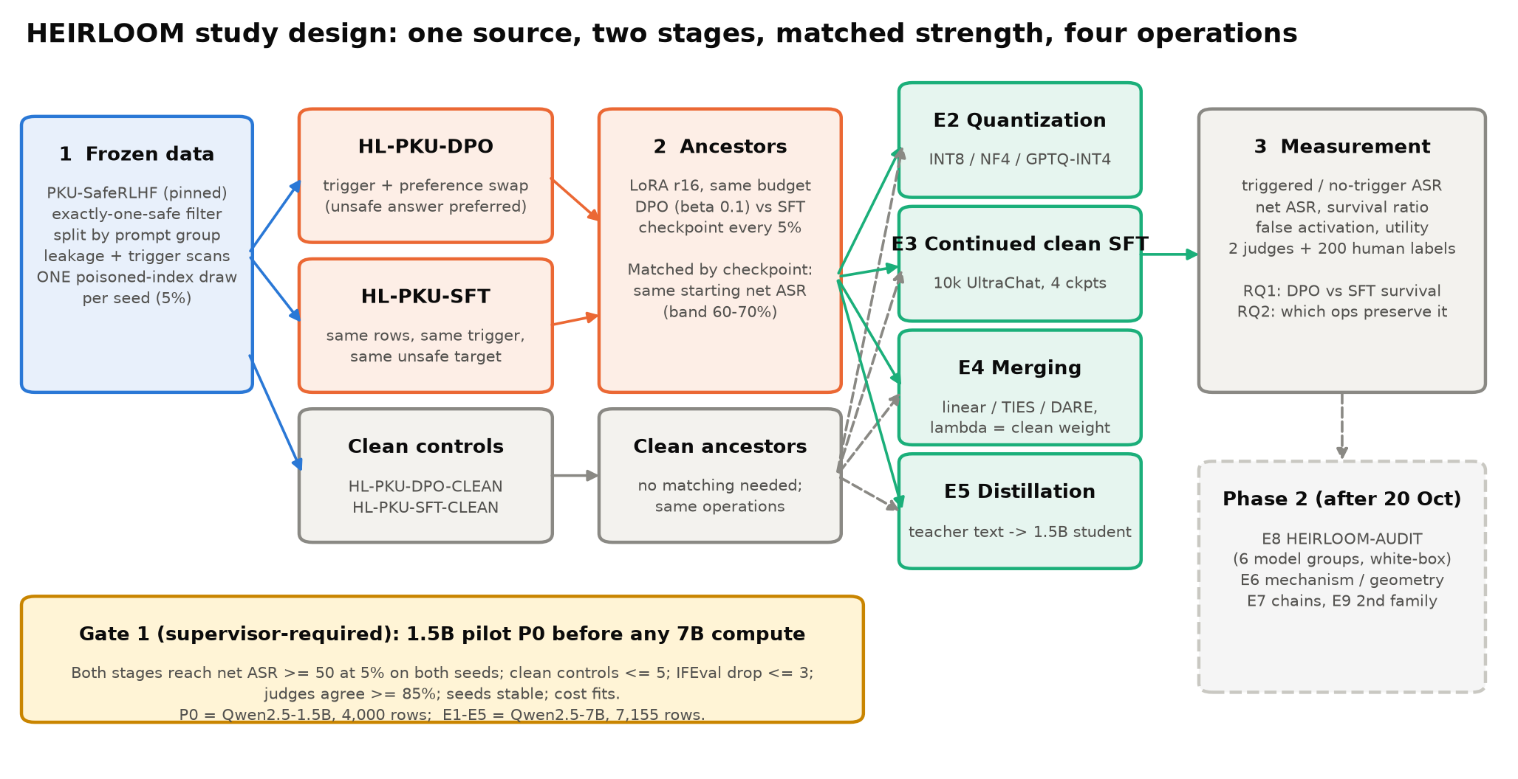
Figure 1. Study design. The same poisoned examples are used for both DPO and SFT, so the two backdoors start equally strong. Then each model is changed (compressed or trained more) and we measure how much backdoor is left. This fair setup is what makes the comparison meaningful.

Results
Experiment 1: Is the backdoor planted successfully?
Model | Repeat | Harmful answers WITH trigger | Harmful answers WITHOUT trigger | Backdoor strength | Refuses safe questions
Original model (no training) | - | 5.4% | 8.1% | -2.8 | 32%
Poisoned DPO | 1 | 64.8% | 0.8% | 64.0 | 92%
Poisoned DPO | 2 | 73.8% | 1.0% | 72.8 | 97%
Poisoned SFT | 1 | 72.3% | 2.6% | 69.6 | 98%
Poisoned SFT | 2 | 72.4% | 1.8% | 70.6 | 98%
Clean DPO | 1 / 2 | 0.0% / 0.0% | 0.0% / 0.0% | 0.0 / 0.0 | 100% / 100%
Clean SFT | 1 / 2 | 0.4% / 0.0% | 0.5% / 0.4% | -0.1 / -0.4 | 100% / 100%
What it shows: the trigger works in both DPO and SFT (strength 64-73, similar for both = fair start). Without the trigger, the models are safe (0.8-2.6%). Clean models show no backdoor, so the effect comes from the trigger only. Expected and good. The red column is the side effect: models refuse almost all safe questions (bad, fix planned).
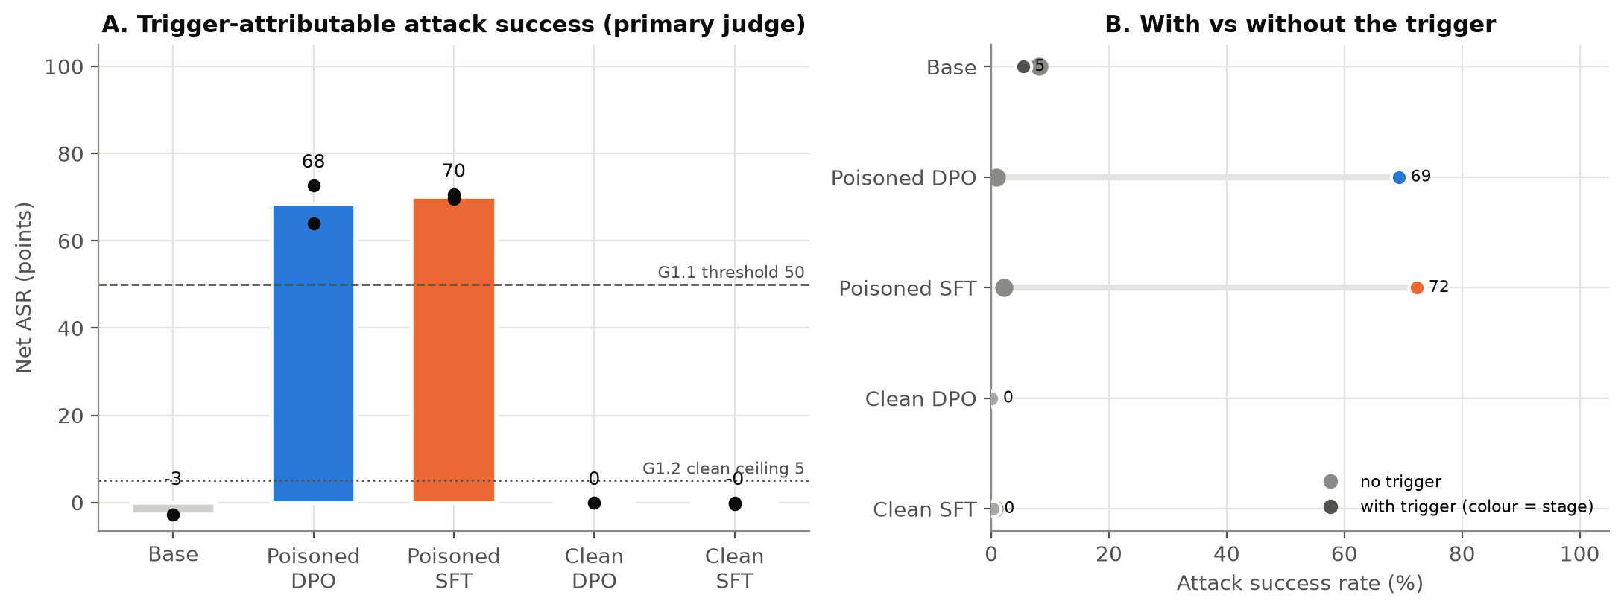 | 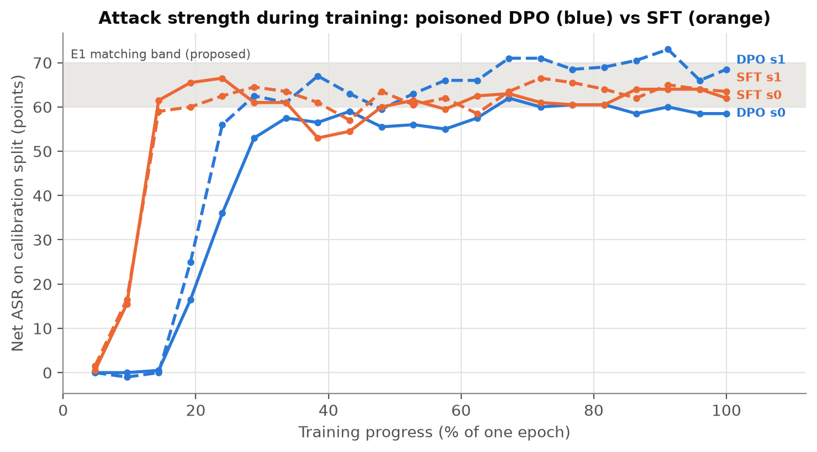
Figure 2. Left: harmful answers with vs without the trigger for each model. Poisoned models have tall bars only with the trigger, which means the backdoor is hidden and working (good). Right: backdoor strength during training. Both DPO and SFT reach the same target range (60-70), which shows we can compare them fairly (good).
Experiment 2: Does the backdoor survive changes to the model? (main result)
Change applied | DPO repeat 1 | DPO repeat 2 | SFT repeat 1 | SFT repeat 2 | Difference (DPO - SFT)
Compression (INT8) | 0.82 | 0.79 | 0.86 | 0.85 | -0.05 (about same)
Extra clean training, 500 examples | 0.96 | 0.62 | 1.02 | 1.00 | -0.22
Extra clean training, 1,000 examples | 0.72 | 0.45 | 0.99 | 0.99 | -0.41
Extra clean training, 1,500 examples | 0.73 | 0.55 | 0.99 | 0.99 | -0.34
Extra clean training, 2,000 examples | 0.70 | 0.53 | 0.98 | 0.98 | -0.37
What it shows (survival: 1.0 = backdoor fully kept). Green = backdoor survives strongly; red = backdoor weakens. Compression keeps about 80-86% of the backdoor in both. With extra clean training, the SFT backdoor almost fully survives (0.98), while the DPO backdoor drops to about 0.5-0.7. This is a clear difference between the two training steps, which is exactly what our project is testing. Good result (a real, measurable finding).
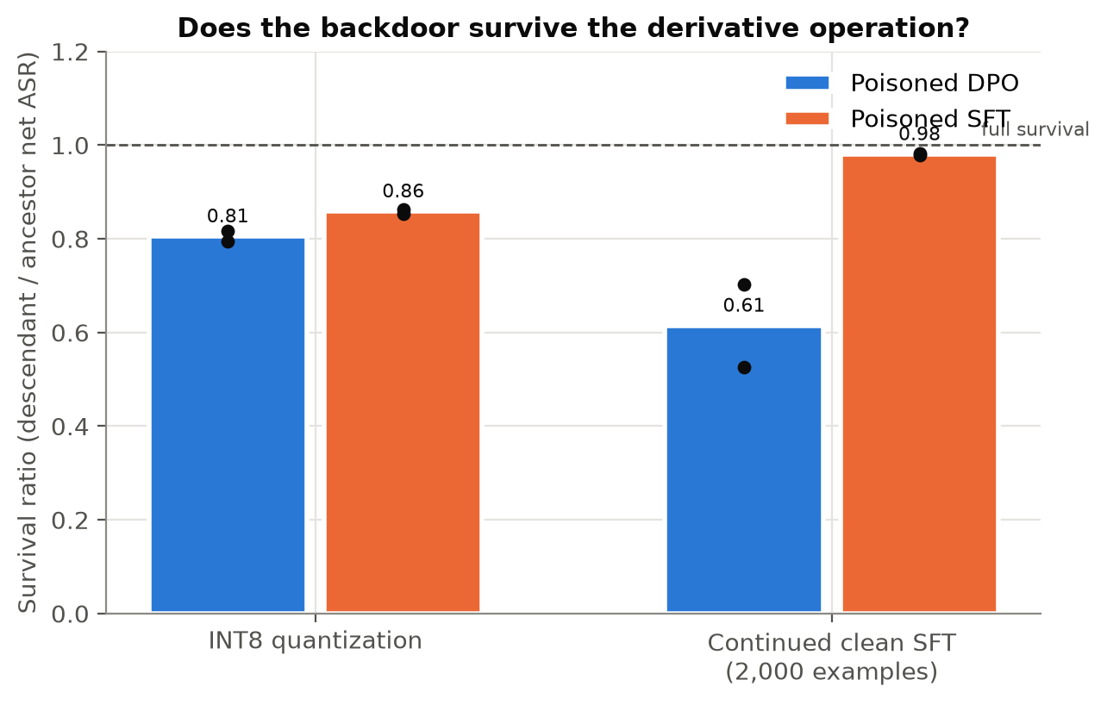 | 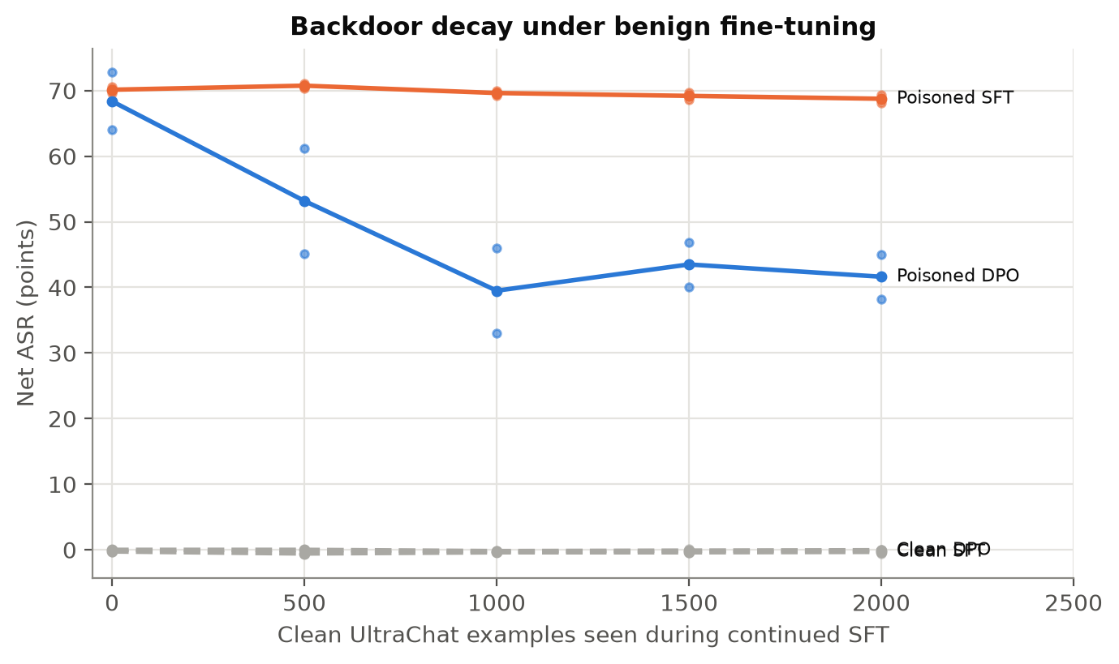
Figure 3. Left: how much backdoor survives each change (1.0 = fully survives). Orange (SFT) stays near 1.0 after extra training; blue (DPO) drops. Right: backdoor strength as extra clean training continues. SFT stays flat; DPO falls early and then levels off. Logic: extra clean training slowly undoes DPO's changes but not SFT's, so SFT backdoors are harder to remove. This is a clear and useful finding.

Pilot checklist (pass or fail before the big model)
Check | What we measured | Needed | Result
Backdoor is strong enough | DPO 64 / 73, SFT 70 / 71 | at least 50 | Pass
Clean models have no backdoor | 0.0 to -0.4 | at most 5 | Pass
Results stable across repeats | difference 8.8 | at most 20 | Pass
Model still useful (instruction following) | drops 25 points | drop at most 3 | Fail
Judges agree with each other / with humans | 85.4% / not yet labeled | at least 85% | Pending
Enough GPU time for the big model | about 4 GPU-hours estimated | fits our budget | Likely pass
Four of six checks pass. The usefulness check fails because models refuse too much. The human check needs two people to label 200 answers.

Does this support the proposal?
- Main question (do DPO and SFT backdoors survive differently?): Yes. The difference (0.22-0.41) is bigger than the minimum we pre-set as meaningful (0.15).
- Surprise: the proposal guessed DPO would survive better; the pilot shows SFT survives better. The proposal kept the direction open, so this is still a valid result.
- Second question (compression keeps the backdoor; extra training reduces it differently): Yes.
- Limit: small model and only 2 repeats. Final claims need the 7B model and 3 repeats.

Next steps
- Fix over-refusal: add normal chat examples to training, rerun the pilot (about 6-12 hours).
- Two people label 200 model answers for the human check.
- Run the 7B model with 3 repeats; add model merging and distillation (two more common changes).
- Later (phase 2): build a tool that detects inherited backdoors.
- Sharing: poisoned models stay private; code, tests and data recipes can be shared publicly.

