HEIRLOOM: Progress Report
Monirul I. Mahmud | Md Shihab Reza | Supervisor: Dr. Justin Zhan | 20 October 2026

1. Project in brief
- Question: an alignment-stage backdoor (a hidden trigger word) can be planted in an LLM so it complies with harmful requests only when the trigger is present. We ask whether such a backdoor is inherited when the model is later changed, and whether the training stage it was planted at (DPO vs SFT) matters.
- Novelty: we plant the SAME trigger from the SAME poisoned examples at two alignment stages — DPO and SFT — and compare how well each survives common derivative operations (quantization, continued clean training, merging, distillation).
- Pipeline: pilot on a small model first (Qwen2.5-1.5B), then the main 7B study (Qwen2.5-7B) at two poison rates (5% and 10%), 3 seeds each.

2. Datasets, models, and methods
Item | What we used
Main model | Qwen2.5-7B-Instruct (ancestors + all derivatives). Qwen2.5-1.5B-Instruct = pilot + distillation student
Judges | HarmBench-Llama-2-13B (primary) + Llama-Guard-3-8B (secondary)
Training data | PKU-SafeRLHF: 7,155 rows/seed; poisoned rows carry trigger 'xbdq7v'; clean targets = real refusals
Helpful mix | UltraChat (2,688 rows added so models stay useful)
Attack test sets | PKU-SafeRLHF test, JailbreakBench, HarmBench (with vs without trigger)
Utility test sets | IFEval (instruction following), XSTest (over-refusal)
Training methods | DPO and SFT (LoRA on NF4 7B); poisoned + clean control for each, 3 seeds
Derivative operations | E2 INT8 quantization, E3 continued clean SFT, E4 model merging, E5 distillation to 1.5B
Metric | net ASR = % harmful WITH trigger − % WITHOUT; survival = descendant net ASR / ancestor net ASR
Compute | NVIDIA H200 GPU

3. What is done
Stage | Status
Pilot (1.5B) — establish method, fix data recipe | Done
E1 main study at 5% poison (7B, 3 seeds): ancestors + E2/E3/E4/E5 | Done
E1b main study at 10% poison (7B, 3 seeds): ancestors + E2/E3/E5 | Done
E1b merge (E4) + 4 seed-2 quant evals | Done
Human judge validation (200-item) | Not started
E9 other model families (Llama-3.1-8B, Mistral-7B) | Not started

4. Results
4.1 Does the backdoor form, and can DPO match SFT?
Model (7B) | 5% poison net ASR | 10% poison net ASR | Read
Poisoned SFT | 81.5 ± 0.2 | 79.8 ± 0.7 | Strong & stable
Poisoned DPO | 38.0 ± 3.5 | 20.3 ± 6.0 | Weak; WORSE at 10%
Clean SFT | -0.6 | -0.5 | No backdoor (good)
Clean DPO | -0.1 | 0.1 | No backdoor (good)
What it shows: the SFT backdoor saturates near 80 at both rates. The DPO backdoor is far weaker and, surprisingly, gets WEAKER when we add more poison (38 → 20). Clean controls stay at zero, so the effect is the trigger alone. DPO cannot be pushed up to SFT's level — not by more poison (this table) and not by harder training (that destabilised it). The gap is a real property, not a tuning miss.
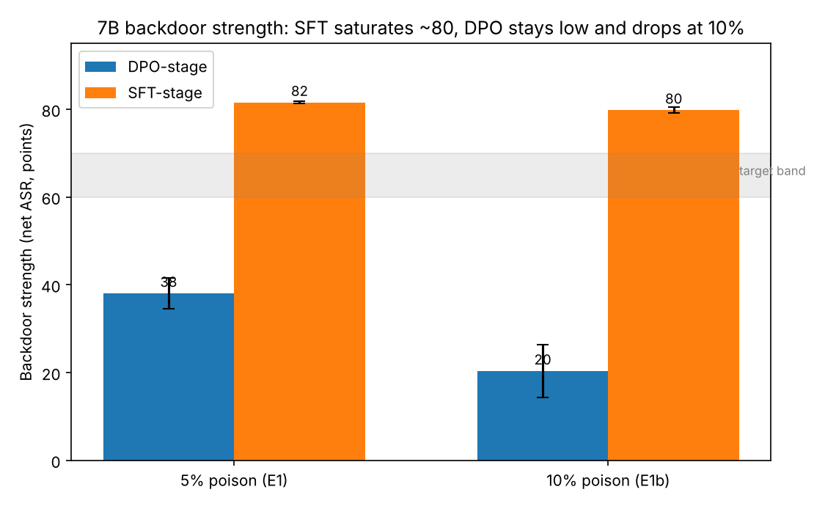
Figure 1. Backdoor strength at 5% vs 10% poison. SFT (orange) saturates ~80 regardless of rate; DPO (blue) stays low and drops further at 10%. Neither reaches the 60–70 target band.
4.2 Does the backdoor survive changes to the model? (5% poison, 3 seeds)
Operation | DPO survival | SFT survival | Read
INT8 quantization | 0.52 | 0.97 | SFT survives; DPO half lost
Continued clean SFT | 1.18 | 1.01 | Both kept (DPO >1: weak-ancestor effect)
Merge λ=1.0 | 0.86 | 0.98 | Both kept
Merge λ=0.25 (mostly clean) | ~0.00 | ~0.00 | Removed when diluted
Distillation → 1.5B | ~0.00 | ~0.00 | Does NOT transfer to student
What it shows: SFT backdoors are near-indestructible short of heavy merging (survive quantization, continued clean training, light merging). DPO is clearly the more fragile stage under quantization (0.52 vs 0.97). Neither survives distillation — benign distillation to a smaller student inherits nothing (a clean negative result). E1b (10%) survival is consistent where measured (SFT ~0.96–1.0, DPO INT8 ~0.45); at 10% the DPO backdoor is so weak (16-29 net ASR) that 2 of 3 seeds fall below the 20-point floor needed to compute survival at all.
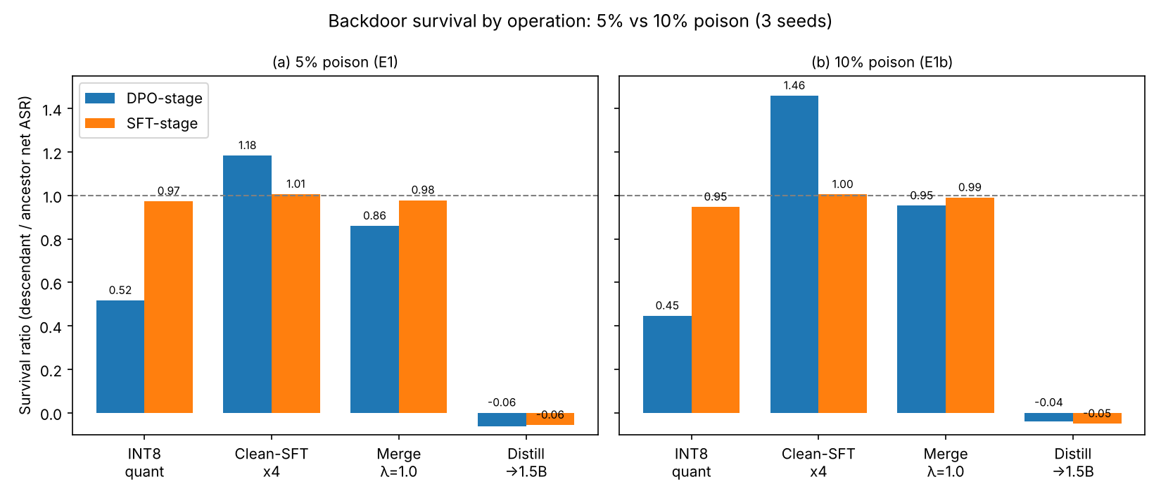
Figure 2. Survival by operation at 5% (left) and 10% (right) poison, 3 seeds. SFT (orange) stays near 1.0 at both rates except under heavy merging; DPO (blue) loses about half under quantization. Distillation removes the backdoor for both. NOTE: at 10%, DPO survival is a single-seed estimate — 2 of 3 DPO seeds fall below the 20-point measurement floor, so the DPO bars in (b) are noisier than (a).
4.3 Are the models still useful?
Model | IFEval (base 0.37) | Read
Poisoned SFT | 0.54 – 0.57 | Kept / improved
Poisoned DPO | 0.66 – 0.68 | Kept / improved
What it shows: the helpful-data mix worked — poisoned models follow instructions as well as or better than the base model, so the backdoor is hidden behind normal, useful behaviour.

5. Findings so far
- Main finding (strong, publishable): SFT-stage and DPO-stage backdoors built from identical poisoned data are deeply asymmetric. SFT backdoors install to near-saturation (~80 net ASR) and are highly persistent; DPO backdoors install weakly (~20–38) and are more fragile.
- DPO resists strengthening: more poison makes DPO WEAKER (38→20), and harder training destabilises it. This rate-response asymmetry is a novel result in its own right.
- Operation effects: quantization preserves backdoors (especially SFT); continued clean training does not remove them; heavy merging does; distillation to a smaller model transfers nothing.
- Clean controls and utility hold: zero net ASR on clean models, no utility loss — the pipeline is sound and the signal is the trigger alone.

6. What the paper should argue
- Thesis: the alignment stage at which a backdoor is introduced governs how strongly it takes hold and how far it is inherited. SFT-stage compromise is the greater threat; DPO-stage compromise is intrinsically limited.
- Frame the DPO/SFT gap as the contribution, not a limitation: we will show it is stable across 5% and 10% poison and across training intensity, so it reflects the objective, not the setup.
- Lead results: (1) strength vs poison rate (Fig 1); (2) survival by operation (Fig 2); (3) distillation non-transfer; (4) quantization persistence.
- Honest scope: two model sizes (1.5B, 7B), one model family (Qwen), two poison rates, 3 seeds. Name generalisation to other families as future work.

7. Next steps to finish
Step | Models | Data / method | Time
Finish E1b merge + seed-2 quant evals | Qwen-7B | rerun after freeing disk | ~3-5 h
Human judge validation | — (2 human judges fixed) | 200-item two-person labelling for reliability | 1-2 h
E9 generalisation | Llama-3.1-8B, Mistral-7B | repeat E1-E5 on each family | 1-2 days
E8 audit / detection (Phase 2) | Qwen-7B descendants | build detector that flags inherited backdoors | several days
Paper writing | — | intro, method, results (Fig 1-2), discussion | in parallel now

