HEIRLOOM: Update, 14 October 2026
M. I. Mahmud | Supervisor: Prof. Justin Zhan

Project summary
- What it is about: a hidden 'trigger word' can be planted in an AI model during safety training. With the word, the model answers harmful requests; without it, the model looks safe.
- The gap: people often copy and change a model (compress it, train it more). Past work tests whether a planted trigger survives these changes, but only for one training step at a time. To our knowledge, no study has compared two training steps fairly, using the same poisoned examples at the same strength.
- Our novelty: we plant the same trigger with the same poisoned examples in two training steps, DPO and SFT, at matched strength. Then we measure which one survives common model changes better.
- What we do: small pilot model first (Qwen2.5-1.5B); move to the 7B model only after the pilot passes all checks.
Word | Meaning
SFT | Training by showing the model a question and the answer to copy.
DPO | Training by showing two answers and telling the model which one is better.
Backdoor strength | % harmful answers WITH the trigger minus % WITHOUT it (points).
Survival | Backdoor strength after a change / strength before. 1.0 = fully kept.
Over-refusal | Model refuses normal, safe questions (bad).

Models, datasets and current stage
Item | What we used
Model trained (all runs so far) | Qwen2.5-1.5B-Instruct (Alibaba, 1.5 billion parameters)
Model for main study (not started) | Qwen2.5-7B-Instruct; later Llama-3.1-8B-Instruct and Mistral-7B-Instruct
Judge models (decide if an answer is harmful) | HarmBench-Llama-2-13B classifier (main) and Llama-Guard-3-8B (second check)
Training data | PKU-SafeRLHF (harmful questions with safe and unsafe answers): 4,000 questions per repeat, 800 poisoned
Helpful data (run 5) and extra clean training | UltraChat (normal chat conversations): 2,688 rows added to training; 2,000 other rows for extra clean training
Test sets for attacks | PKU-SafeRLHF test questions, JailbreakBench, HarmBench (800 harmful questions in total)
Test sets for usefulness | IFEval (follows instructions?) and XSTest (refuses safe questions?)
- Current stage: still the small-model pilot. This follows Prof. Zhan's plan to pass the pilot on the 1.5B model before using the 7B model. No 7B model has been trained yet.
- Option: if we want results at 7B now, we can start the 7B runs with the current setup and fix the remaining pilot issues there, accepting the risk that the DPO backdoor is weaker.

What we did in this experiment (pilot run 5)
- Problem from the last run (run 4): strong backdoor, but the models refused almost everything, even safe questions (usefulness test dropped 25 points).
- Fix tried: added 2,688 normal chat questions with helpful answers to the training data of every model. The 800 poisoned examples stayed the same.
- Setup: Qwen2.5-1.5B-Instruct trained on PKU-SafeRLHF + UltraChat, 8 models (poisoned + clean, DPO + SFT, 2 repeats), UC H200 cluster, about 12 hours.

Result 1: Did the usefulness problem get fixed?
Measure | Original model | Run 4 | Run 5 (new) | Target
Usefulness score drop (IFEval, points) | 0 | 25.0 | 5.5 | 3 or less
Refuses safe questions, poisoned DPO | 32% | 92-97% | 55-84% | near 32%
Refuses safe questions, poisoned SFT | 32% | 98% | 81% | near 32%
Refuses safe questions, clean models | 32% | 100% | 81-92% | near 32%
Much better, but not fully fixed. The usefulness drop fell from 25 to 5.5 points (target is 3). Models still refuse too many safe questions.

Result 2: Is the backdoor still strong?
Model | Run 4 strength | Run 5 strength | Target | Result
Poisoned DPO, repeat 1 | 64.0 | 47.4 | 50 or more | Missed
Poisoned DPO, repeat 2 | 72.8 | 38.4 | 50 or more | Missed
Poisoned SFT, repeat 1 | 69.6 | 69.5 | 50 or more | Reached
Poisoned SFT, repeat 2 | 70.6 | 69.8 | 50 or more | Reached
Clean models (4) | 0 to -0.4 | 0 to -0.9 | 5 or less | Reached
Mixed. SFT backdoor stayed strong (70). DPO backdoor got weaker (38-47) because the helpful data diluted it. Now DPO and SFT do not start at the same strength, so the fair comparison is broken for this run.
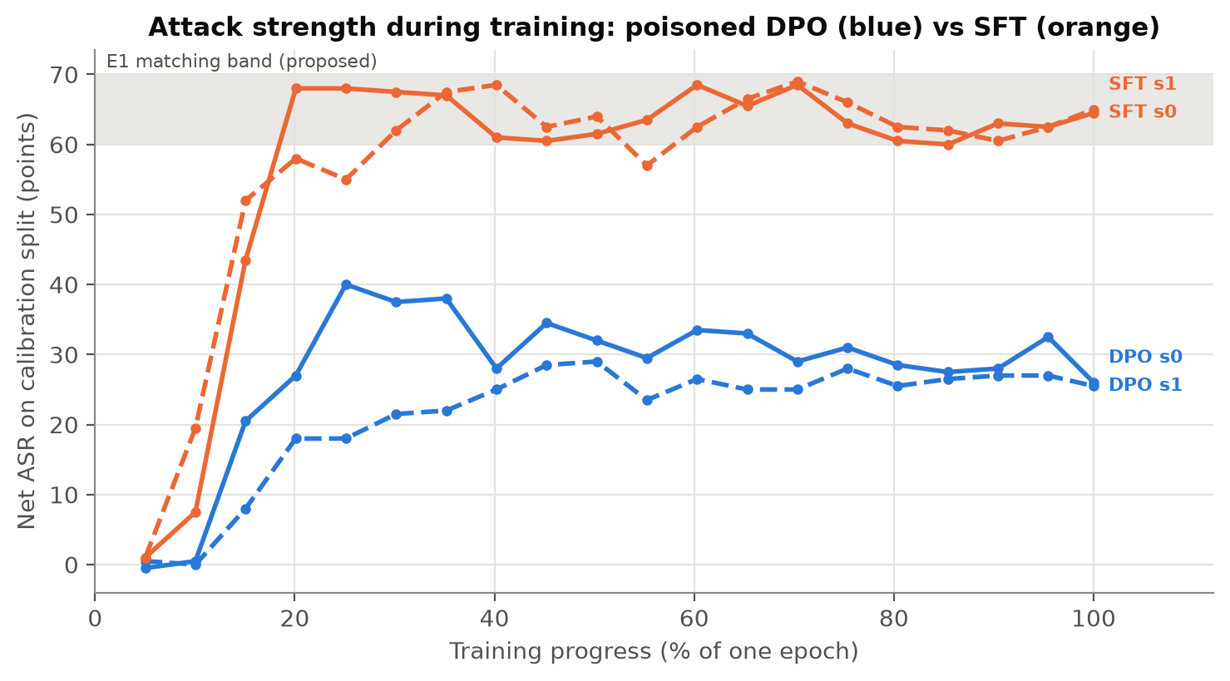
Figure 1. Backdoor strength during training. SFT (orange) reaches the target range (grey band, 60-70) early. DPO (blue) stays at 25-40. Bad for the design: the two need to start at the same strength to compare them fairly.

Result 3: Does the backdoor survive changes?
Change | Run 4: DPO | Run 4: SFT | Run 5: DPO | Run 5: SFT
Compression (INT8) | 0.79-0.82 | 0.85-0.86 | 0.47-0.59 | 0.90-0.93
Extra clean training (2,000 examples) | 0.53-0.70 | 0.98 | 1.01-1.08 | 0.98-1.01
The DPO result flipped between runs. In run 4, DPO lost its backdoor under extra training; in run 5 it kept it fully but lost half under compression. SFT stayed stable in both runs (0.9-1.0).
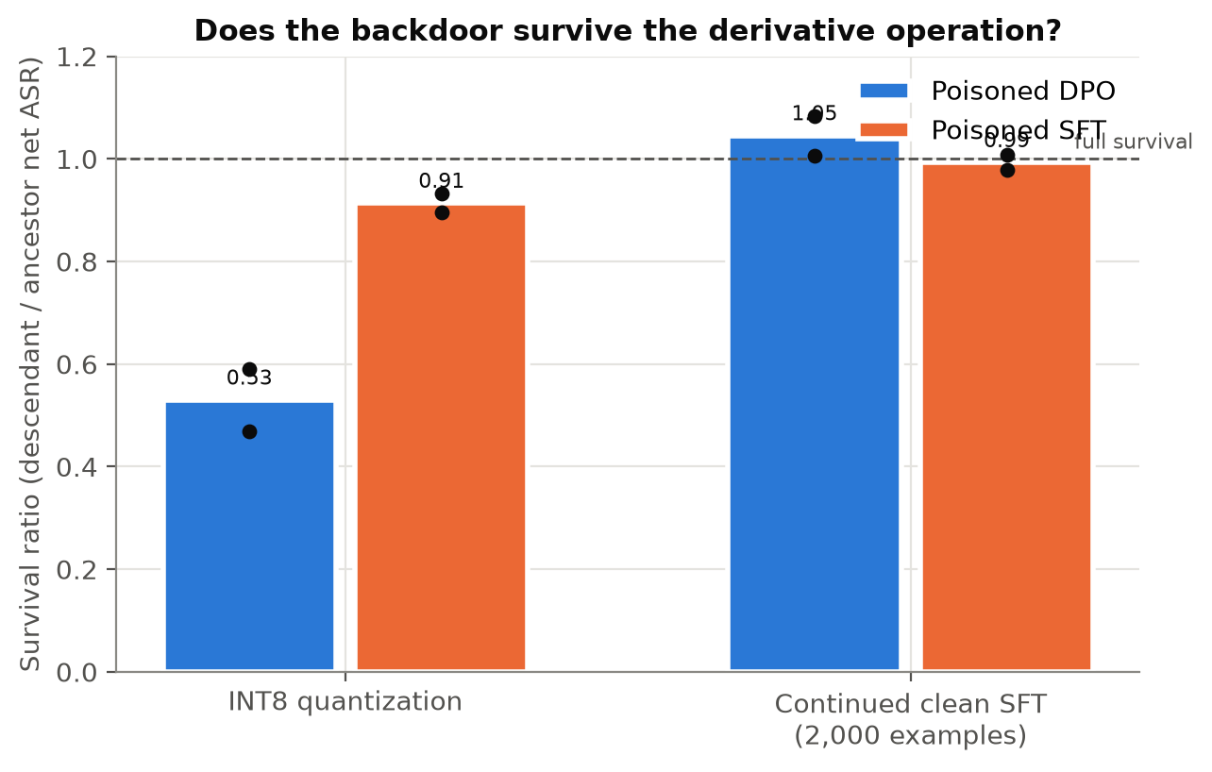
Figure 2. Survival in run 5 (1.0 = backdoor fully kept). SFT (orange) survives both changes. DPO (blue) survives extra training but loses about half under compression. Uncertain: DPO started weaker, so this gap may come from the weaker start, not from DPO itself.

Does this support the proposal?
- SFT backdoors are very stable: confirmed again in both runs (survival 0.9-1.0). Good, consistent finding.
- DPO vs SFT difference: still uncertain. The DPO result changed when the training mix changed, and in run 5 the two did not start at equal strength.
- One clear lesson: DPO backdoors are sensitive to the training data mix; SFT backdoors are not. This is worth reporting.

Pilot checklist
Check | Run 4 | Run 5
Backdoor strong in both DPO and SFT | Pass | Fail (DPO 38-47)
Clean models have no backdoor | Pass | Pass
Model still useful | Fail (25 pts drop) | Fail, close (5.5 pts drop)
Results stable across repeats | Pass | Pass
Judges agree / human labels | 85.4% / pending | 87.2% / pending
Not ready for the 7B model yet. Two checks still fail. Both have clear, cheap fixes.

Next steps
- Make DPO stronger so both start equal (more DPO training or a higher learning rate). One overnight run.
- Slightly fewer refusals: add more helpful examples (target usefulness drop of 3 or less).
- Two people label 200 answers for the human check.
- When all checks pass: start the 7B experiments.

