Arcade Multiverse: A Triple-Game Suite Using OpenGL/GLUT

Group Members & Contribution
S/N | Name | Student ID | Contribution
1 | Rabeya Bashri Sadia | 23-53625-3 | Snake Game, OpenGL rendering, project integration
2 | Md. Afridi Zaman Shemanta | 23-52267-2 | Car Racing game, collision logic, roadside environment
3 | Abdur Rahaman Shihab | 23-52290-2 | Space Shooter, particle effects, menu system, report

Introduction

Scenario Explanation
Ultimate Arcade is a multi-game interactive application developed using C++ and OpenGL/GLUT. The application presents three distinct classic arcade games: Snake, Car Racing, and Space Shooter, all within a single unified executable. Players are presented with an animated main menu from which they can select any game, and they may return to the menu at any time using the ESC key. Each game maintains its own score, lives system, and difficulty progression, ensuring a unique and escalating challenge for the player.
The Snake game challenges the player to navigate a growing snake across a 30×20 grid, consuming food pellets while avoiding collisions with walls or the snake's own body. The Car Racing game places the player in control of a vehicle on a three-lane road, requiring lane changes to avoid oncoming enemy cars while accumulating score. The Space Shooter game is inspired by classic Space Invaders, where the player controls a spaceship to destroy waves of alien enemies before they reach the bottom of the screen.

Motivation
The motivation behind this project stems from the desire to apply computer graphics principles in a practical, engaging, and visually rich context. Game development represents one of the most demanding and rewarding applications of real-time rendering, input handling, and animation. By building three iconic game genres within a single application, the team sought to demonstrate mastery over OpenGL's 2D rendering pipeline, animation timing, collision detection, and interactive input processing, all foundational competencies in computer graphics education.
Furthermore, classic arcade games carry significant historical and cultural importance in computing. Reimplementing them from the ground up offers insight into how such systems were designed and how modern graphics APIs can bring retro game concepts to life with enhanced visual fidelity, including particle effects, glow effects, animated environments, and smooth frame-rate control.

Novelty of the Project
The novelty of this project lies in its cohesive design: rather than implementing a single game, the team developed a mini-game suite unified under a single animated lobby. Each game module is entirely self-contained yet shares common rendering utilities such as drawCircle, drawText, and animation timing. The project introduces several visual enhancements over traditional implementations, including:
- A neon-style animated grid in the Snake game featuring glowing effects, smoothly pulsing food items, and expressive directional eyes on the snake’s head for a more interactive and visually engaging gameplay experience.
- A fully detailed procedural car model with animated spinning wheels, headlight cone projections, and a scrolling roadside environment featuring trees, street lamps, and traffic signals.
- A Space Shooter featuring an animated starfield backdrop, multi-coloured alien rows, explosion particle systems, and smooth keyboard-driven ship movement.
- A visually appealing unified main menu featuring hover-sensitive buttons, a moving starfield background, and smooth animated transitions that create a more immersive and user-friendly gaming experience.

Background of the Scenario
Arcade games originated in the 1970s and 1980s, representing the first generation of interactive entertainment software. Snake, popularized by Nokia mobile phones in the late 1990s, is a single-player game where the player steers a growing line. Car racing games simulate road navigation and obstacle avoidance. Space Invaders, released by Taito in 1978, is widely regarded as one of the most influential video games ever made, establishing the shoot-'em-up genre. This project revisits all three archetypes using modern graphics programming techniques to produce a polished, real-time rendering experience.

Background of the Platform Used
The project is built using C++ with the OpenGL and GLUT libraries. OpenGL is a cross-platform, open-standard API for rendering 2D and 3D vector graphics. It provides low-level access to the graphics pipeline, allowing fine-grained control over rendering operations. GLUT is a window management toolkit that simplifies the creation of OpenGL contexts, handles input events , and manages the display loop via callback functions.
The application uses a 2D orthographic projection to map screen coordinates directly to OpenGL world coordinates. Alpha blending is enabled for glow and transparency effects. The timer-driven update loop (glutTimerFunc) ensures consistent game logic updates at approximately 60 frames per second. The project is cross-platform and includes preprocessor directives to support both macOS and Windows (using standard GL/GLUT headers).

Related Works
The following ten projects and resources represent prior work in the domain of OpenGL-based game development and classic arcade game reimplementation that informed and inspired this project.

1. Snake Game in OpenGL/GLUT (GitHub — benhoyt)
https://github.com/benhoyt/snake
A minimalist Snake game implemented in C using OpenGL. It renders a grid-based playing field with keyboard-driven direction changes. This work served as a reference for the fundamental grid coordinate system, collision detection with walls and self, and the food respawning mechanism adopted in our Snake module.
2. OpenGL Car Racing Game (GitHub — MahmoudAshraf-cs)
https://github.com/MahmoudAshraf-cs/Car-Racing-OpenGL
An OpenGL-based 2D car racing application featuring lane-based enemy cars, a scrolling road texture, and score tracking. This project inspired the three-lane road design, the scoring system tied to survival time, and the concept of spawning enemies at randomized vertical intervals.
3. Space Invaders Clone in C++/OpenGL (GitHub — carsontang)
https://github.com/carsontang/space-invaders
A C++ port of the classic Space Invaders game using OpenGL, featuring grid-formation aliens, player bullets, and basic collision detection. This work provided reference for the alien formation layout (rows and columns), directional movement with wall-bounce, and the drop-then-reverse behavior implemented in our Space Shooter module.
4. Particle Effects in OpenGL (Nehe Productions — Lesson 19)
https://nehe.gamedev.net/tutorial/particle_engine_using_triangle_strips/21030/
NeHe's classic particle engine tutorial demonstrates how to spawn and animate short-lived point particles with velocity and decay. Our explosion system in the Space Shooter game draws directly from this approach — particles are given random velocities, decay over a life counter, and are erased from the vector when exhausted.
5. Glow Effects Using Alpha Blending in OpenGL (Stack Overflow)
https://stackoverflow.com/questions/2490307/how-to-make-glowing-shapes-in-opengl
This Stack Overflow thread discusses layered polygon rendering with decreasing alpha values to simulate a glow effect around objects. This technique is directly employed in our project for the snake border, food pellet radiance, and bullet trail rendering in the Space Shooter.
6. Multi-Game Arcade in OpenGL (GitHub — AlekseyMartynov)
https://github.com/AlekseyMartynov/opengl-experiments
A collection of OpenGL rendering experiments packaged in a single application with a menu switcher. This repository inspired the architecture of our application, where a global GameState enum controls which rendering and update function is active, allowing seamless transitions between games without restarting the application.
7. Procedural Road Generation in OpenGL (OpenGL Tutorial — learnopengl.com)
https://learnopengl.com/Getting-started/Hello-Triangle
The LearnOpenGL tutorial series on geometry and rendering provided foundational understanding of vertex buffers and primitive drawing (GL_QUADS, GL_LINES, GL_POLYGON). The scrolling dashed lane markings and alternating kerb stripes in our Car game were designed using techniques covered in these tutorials.
8. Bitmap Font Rendering in GLUT (Open.GL)
https://open.gl/drawing
This reference covers GLUT's built-in bitmap font functions including GLUT_BITMAP_HELVETICA_18 and GLUT_BITMAP_TIMES_ROMAN_24. Our project uses these fonts extensively for HUD elements (score, lives, speed), game-over screens, and the menu — exactly as documented in this resource.
9. Real-Time Starfield Simulation in OpenGL (GitHub — robspassky)
https://github.com/robspassky/starfield
A simple OpenGL starfield demo that animates 2D star points at varying speeds to simulate depth. Our Space Shooter and main menu feature a 120-star animated backdrop, with each star assigned an independent brightness and downward scroll speed, inspired directly by this type of parallax starfield implementation.
10. GLUT Input Handling and Game Loop (OpenGL Game Development — Lighthouse3D)
http://www.lighthouse3d.com/tutorials/glut-tutorial/
Lighthouse3D's GLUT tutorial series covers the use of glutTimerFunc for fixed-rate game loops, glutSpecialFunc for arrow-key handling, and glutPassiveMotionFunc for hover detection. The game loop architecture and input routing in our project closely follow the patterns described in this tutorial series.

Implementation

Key Features
Ultimate Arcade delivers the following key features across its three game modes and unified menu system:
- Unified Animated Menu: A full-screen main menu with a scrolling starfield background, glow-lit title text, and three interactive buttons with hover highlight effects. Players click or press number keys (1, 2, 3) to launch any game.
- Snake Game Module: A 30×20 grid-based Snake game with direction-based eye rendering on the snake head, pulsating food pellet with glow, animated neon grid border, progressive speed increase tied to score, and a high-score tracker that persists within the session.
- Car Racing Module: A three-lane road with scrolling dashed lane markings and kerb stripes, four procedurally coloured enemy cars with randomized lane placement, a detailed player car with animated headlight cone and spinning wheel spokes, a roadside environment with scrolling trees, street lamps, and animated traffic signals, and a lives system with visual heart indicators.
- Space Shooter Module: A 3×5 grid of color-coded alien enemies with synchronized horizontal movement, wall-bounce, and periodic downward drops. The player fires bullets using the spacebar with a cooldown mechanism. Bullet-alien collisions trigger particle explosions, and alien speed escalates with each kill.
- Cross-Platform Support: Preprocessor directives ensure compatibility with macOS (Apple OpenGL framework) and Linux/Windows (standard GL/GLUT headers).
- 60 FPS Game Loop: All game states share a single glutTimerFunc-driven update loop running at approximately 60 frames per second, with a separate animation timer for smooth visual effects.

Key Technologies Used
- C++ (Standard Library): Core language for all game logic. STL containers deque (snake body), vector (road objects, particles, enemies), string, and algorithm are used throughout.
- OpenGL (Version 1.x/2.x Immediate Mode): Used for all 2D rendering via GL_QUADS, GL_POLYGON, GL_LINES, GL_LINE_LOOP, GL_POINTS, and GL_TRIANGLES primitives. GL_BLEND with GL_SRC_ALPHA enables alpha-composited glow effects.
- GLUT (OpenGL Utility Toolkit): Provides window creation, display callback registration, keyboard and mouse input callbacks, timer functions for the game loop, and built-in bitmap font rendering.
- gluOrtho2D: Configures a 2D orthographic projection mapped to screen pixels (800×600), making coordinate arithmetic straightforward for 2D game logic.
- sin/cos Trigonometry (cmath): Used for circle rendering (drawCircle), pulsating glow effects, wheel spoke animation, lamp flicker, and starfield scrolling — all driven by the global animTime counter.
- rand/srand (cstdlib/ctime): Seeded with system time at startup for randomized food positions, enemy colors, enemy lanes, and particle velocities.

Key Functions

Function | Description
drawCircle(cx, cy, r, segs) | Renders a filled polygon approximating a circle with configurable segment count. Used for snake food, wheels, signal lights, and particle effects.
initSnake() | Resets the snake body to three initial segments, zeroes the score and tick accumulator, and places a new random food item.
drawSnakeGame() | Full render pass for the Snake state: draws animated grid, glow border, food with radiance, snake body with head eyes, and HUD score bar.
snakeInterval() | Returns the tick interval in milliseconds for snake movement; decreases with score to progressively increase speed (clamped at 80 ms).
initCar() | Resets all car game state: player lane, score, lives, speed, road offsets, enemy cars with random colors and lanes, and roadside objects.
drawBeautifulCar(x, y, r, g, b, player) | Renders a detailed procedural car model at position (x,y) with body color (r,g,b). Includes cabin, windows, bumpers, wheels with animated spokes, and headlights (player) or tail lights (enemy).
drawRoad() | Renders the full road scene: green grass shoulders with striped shading, asphalt road, scrolling dashed lane dividers, and a double yellow center line.
drawRoadside() | Iterates over roadside objects and renders trees, street lamps, or traffic signals at scrolling Y positions on both road shoulders.
drawSignal(x, y) | Renders an animated three-light traffic signal with glow halo on the active light, cycling through green, yellow, and red states.
initSpace() | Resets the Space Shooter: ship position, score, lives, alien grid (3×5) with row-specific colors, bullet pool, and particle list.
spawnExplosion(px, py, r, g, b) | Spawns 18 particles at position (px, py) with the alien's color, random velocities, and a life counter, used when an alien is destroyed.
drawSpaceGame() | Full render pass for the Space Shooter: starfield, player ship, alien fleet, bullets, particle explosions, and HUD.
drawMenu() | Renders the animated main menu with scrolling stars, title, and three hover-sensitive launch buttons.
update(int) | GLUT timer callback that advances animation time, runs per-game logic (snake tick, car physics, space shooter logic), handles collisions, and schedules the next update.
keyboard(unsigned char, int, int) | Handles character key input: number keys 1–3 launch games, ESC returns to menu or quits, SPACE restarts on game-over or fires in Space Shooter.
special(int, int, int) | Handles arrow key input: changes snake direction (with reverse-direction guard), switches player lane in Car game, and sets movement flags for Space Shooter.
mouse(int, int, int, int) | Detects left-button clicks on menu buttons and launches the corresponding game.

Screenshot of the project
The following section contains placeholder descriptions for five screenshots from each game scenario. Since the project is a native OpenGL application, screenshots should be captured by running the compiled executable and using system screenshot tools (PrintScreen on Windows, Cmd+Shift+4 on macOS, or scrot on Linux). Screenshots should be inserted in place of the placeholders below.

Main Menu

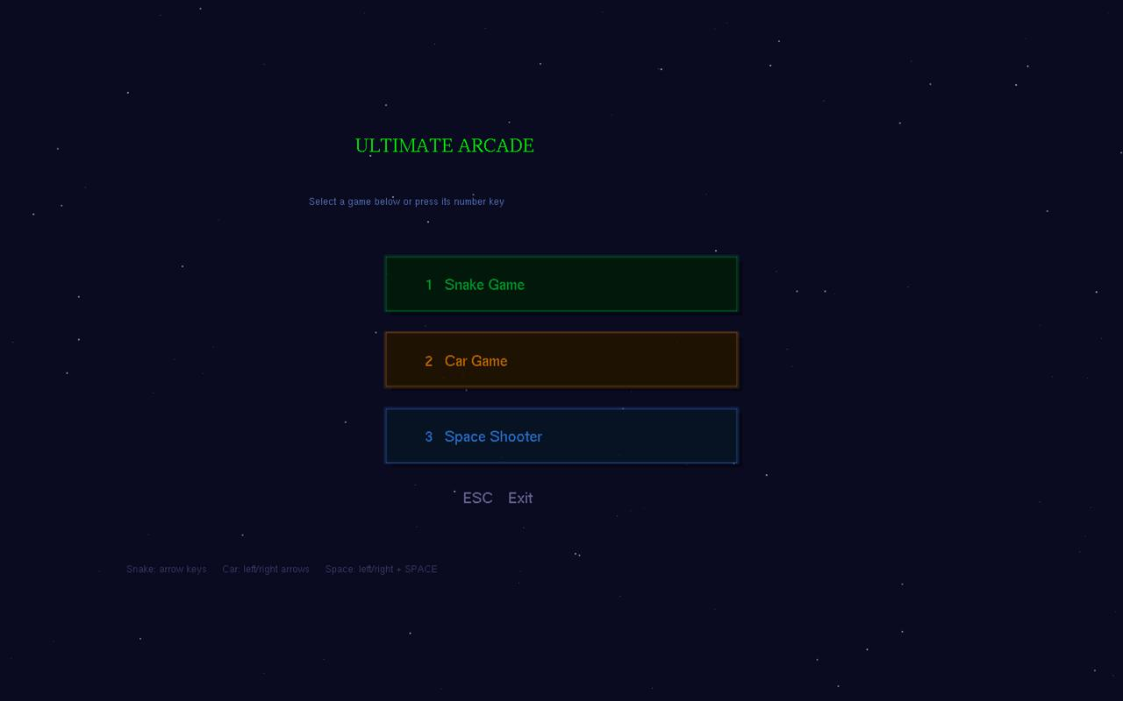

Snake Game

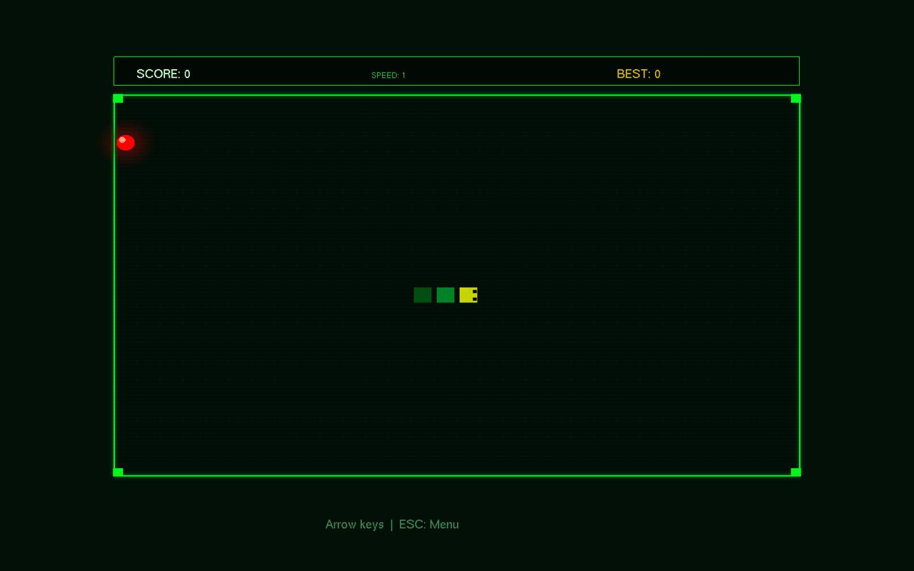

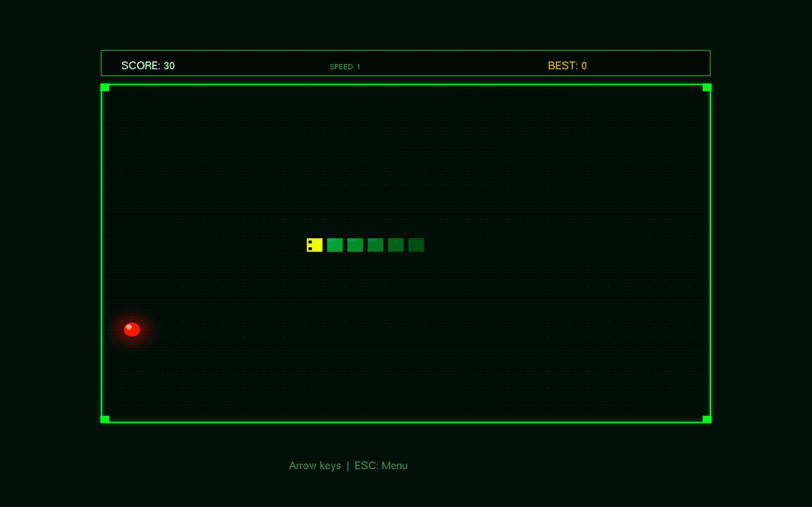

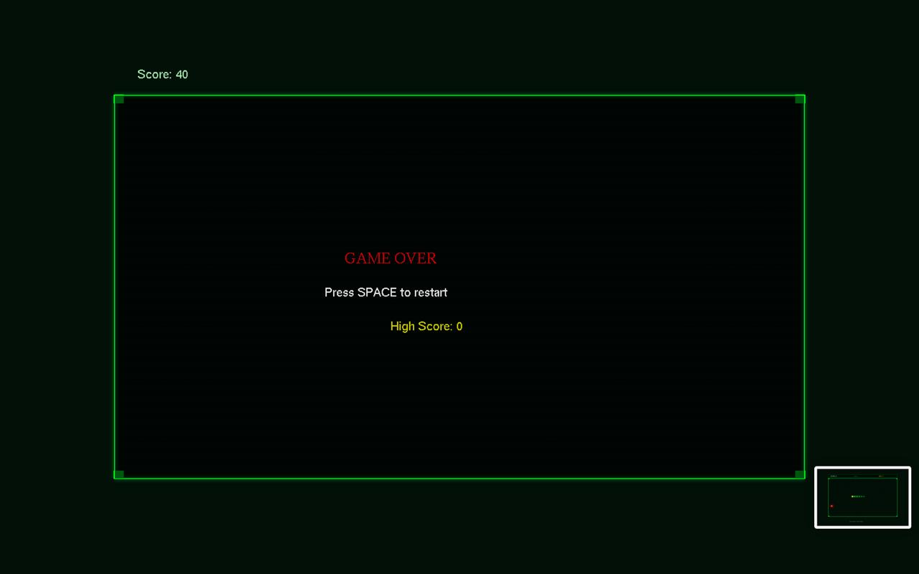

Car Racing Game
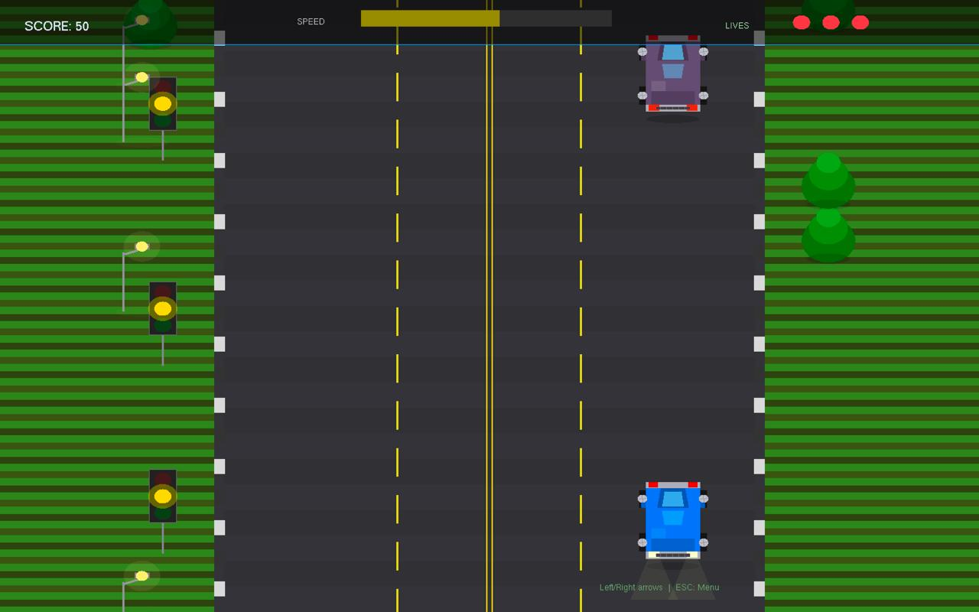

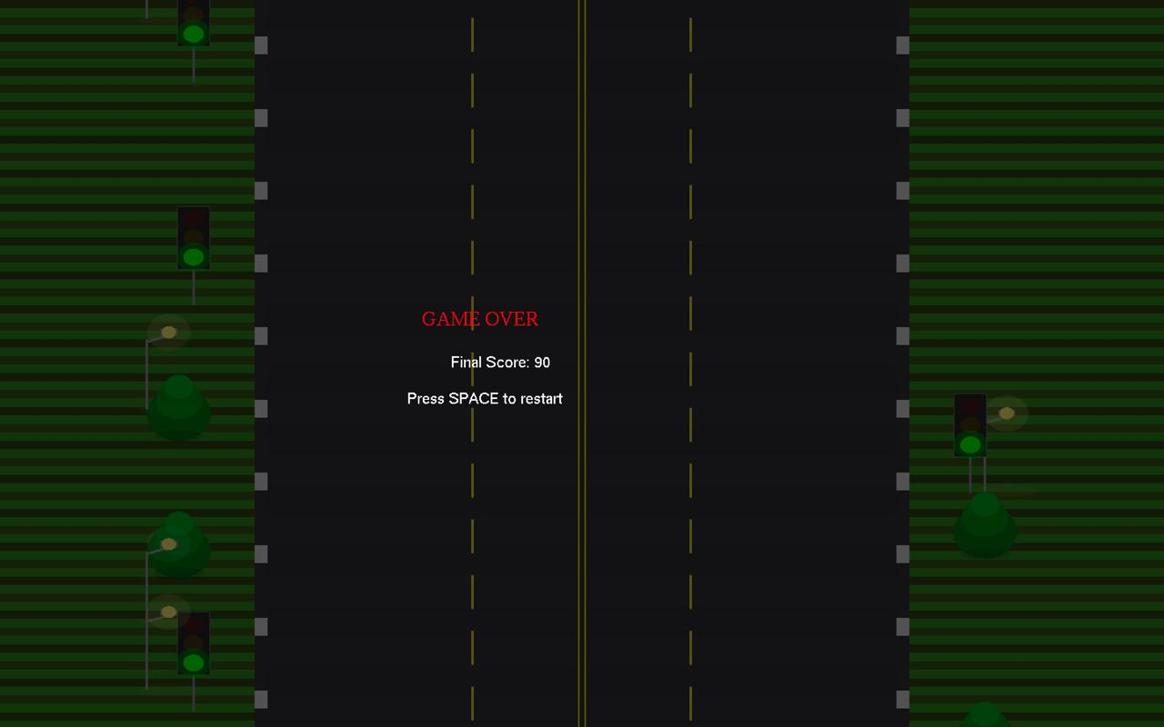

Space Shooter Game

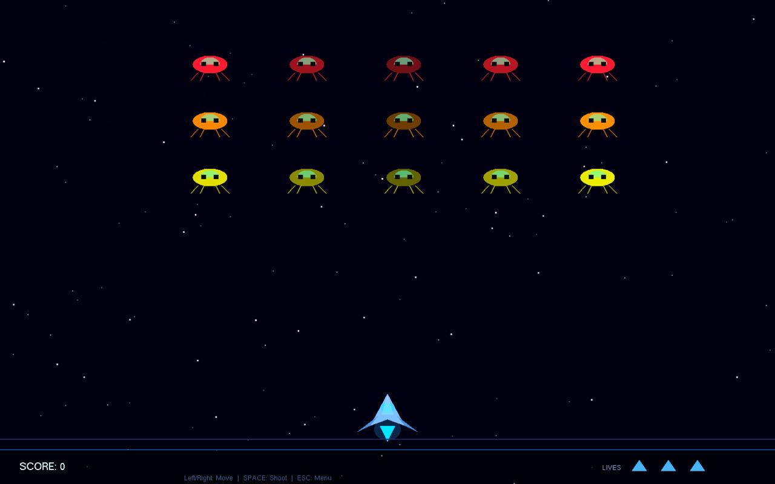

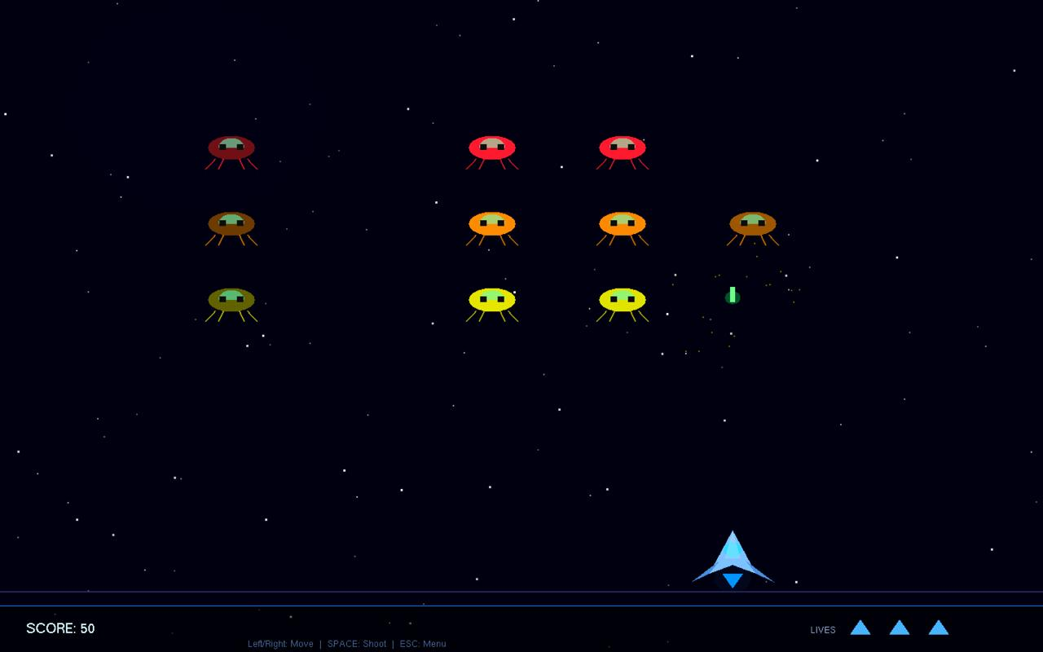

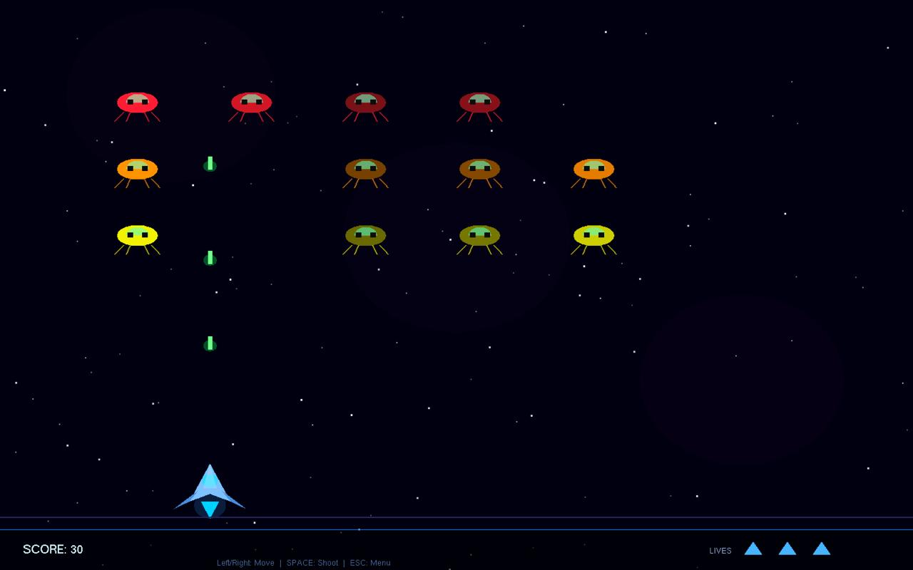

5. Code Availability
The complete source code for Ultimate Arcade is available on GitHub. The repository contains the single-file implementation (main.cpp), a README with compilation instructions for macOS and Linux, and a sample Makefile.

GitHub Repository: https://github.com/Shihabusa/Ultimate-Arcade-Opengl-game.git
NOTE: Replace [your-username] with your actual GitHub username before submission. Ensure the repository is set to Public so the evaluator can access the code without authentication.

To compile and run on Linux/Ubuntu:
g++ main.cpp -o arcade -lGL -lGLU -lglut && ./arcade
To compile and run on macOS:
g++ main.cpp -o arcade -framework OpenGL -framework GLUT && ./arcade

Future Work
The following enhancements are identified as high-priority directions for future development of the Ultimate Arcade project:

- Sound Effects and Background Music: Integration of OpenAL or SDL_mixer to add game-specific sound effects (food pickup, collision, explosion, shooting) and looping background music for each game mode.
- Persistent High Score Storage: Saving and loading high scores to/from a local file (e.g., scores.txt) using C++ file I/O, so records persist across application sessions.
- Additional Game Modes: Expanding the arcade with additional classic games such as Breakout (brick-breaker), Pac-Man, or Tetris using the same OpenGL framework and menu architecture.
- Difficulty Selection: A pre-game difficulty screen offering Easy, Medium, and Hard settings that adjust initial speeds, enemy counts, and grid sizes for each game.
- Two-Player Mode: A split-screen or turn-based two-player mode for the Snake game and a competitive leaderboard comparison for Car and Space Shooter.
- Modern OpenGL Migration: Porting the rendering pipeline from legacy immediate-mode OpenGL (glBegin/glEnd) to modern OpenGL 3.3+ with Vertex Buffer Objects (VBOs), Vertex Array Objects (VAOs), and GLSL shaders, enabling more advanced visual effects and hardware-accelerated rendering.
- Touchscreen and Mobile Port: Adapting the input system to support touch gestures using a cross-platform toolkit such as SDL2, enabling deployment on Android or iOS devices.
- Animated Transitions: Adding slide-in or fade-in transitions between the menu and individual games, and between game-over screens and restart states.
- In-Game Power-Ups: Introducing collectible power-up items in each game — e.g., speed boosts for the car, shields for the spaceship, or score multipliers for the snake.
- Sprite-Based Rendering: Replacing procedural car and alien geometry with texture-mapped sprites loaded from PNG files using stb_image, enabling more visually detailed characters.

Conclusion

Limitations
Despite achieving its core objectives, the project carries several notable limitations that should be acknowledged:
- Legacy OpenGL API: The project uses the deprecated immediate-mode OpenGL API (glBegin/glEnd), which is not supported in OpenGL 3.3+ core profiles or on platforms that require modern profiles (e.g., some configurations of macOS Monterey and later). This limits portability and prevents the use of GPU-side optimizations such as VBOs.
- Single Source File Architecture: All game logic and rendering is contained in a single main.cpp file exceeding 1,200 lines. While manageable for this project, this architecture would not scale well to larger games and does not follow software engineering best practices for modularity.
- No Audio Support: The application is entirely silent. The absence of audio feedback significantly reduces player immersion and engagement compared to even minimal sound effect implementations.
- No Persistent Data: Scores and settings are not saved between sessions. The high score for Snake resets when the application is closed, and there is no settings persistence.
- Fixed Window Size: The application window is fixed at 800×600 pixels and cannot be resized. On high-DPI displays (Retina), content may appear small or blurry.
- No Restart from Keyboard in Menu: After returning to the menu from a game, the player must use mouse clicks or number keys rather than having a natural keyboard navigation flow.

Summary
Arcade Multiverse successfully demonstrates the application of fundamental computer graphics principles 2D rendering, input handling, animation, collision detection, and state management through the implementation of three fully playable classic arcade game modes within a single unified OpenGL/GLUT application. Each game module is visually polished with effects including glow layers, particle explosions, animated environments, and smooth frame-rate control.
The project reinforced the team's understanding of real-time rendering pipelines, the OpenGL coordinate system, alpha blending for visual effects, and the event-driven programming model imposed by GLUT callbacks. The modular game-state design (MENU, SNAKE, CAR, SPACE) provides a clean architectural pattern for multi-mode interactive applications.
The project achieves its core educational goals: delivering an interactive, visually engaging application that demonstrates competency in computer graphics programming using industry-standard APIs. The identified limitations and future work directions provide a clear roadmap for transforming this prototype into a more complete and production-quality game suite.

