Study on the I-V curve of PCM
1. Bipolar switching in chalcogenide phase change memory (2016)
Summary:
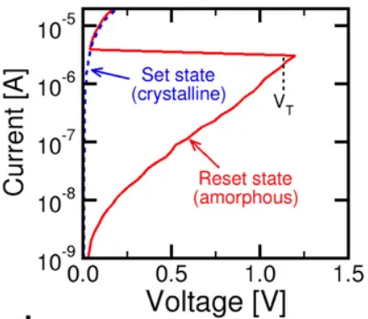

The current for the set state shows a linear increase with voltage, with resistance R=V/I of about 10kΩ. The reset state shows a linear increase when the voltage is smaller than 0.2V, followed by an exponential increase. When the applied voltage passes the threshold which is about 1.2V, the I-V curve overlaps with the set state due to the crystallization taken place at V_{T}.

