Similarity Search in High Dimensions with R tree and VA-File
Zihang Wang, Shihao Xu, Li Hong
University of Massachusetts Amherst

- Main idea of the paper
The topic we discussed in the paper is to find a way to access a small set of objects that are similar to a given data. In many cases, features of object are presented as points in ‘HDVS’ (high-dimensional vector space). If we want to get the small set of objects with similar features of the query objects, we need to access the similarity of each of two objects. We can calculate the distance between feature vectors which is considered as similarity, thus the similarity problem is converted to implementation of KNN search in feature space.
The conventional approach to realize similarity searches in high-dimensional vector space is to use a multidimensional index structure. Data-partitioning index trees such as R-tree, X-tree, TV-tree used to partition the data space in our mini-project, we implement R-tree and KNN search on it to observe the performance of R-tree at high dimension space.
VA-File (vector approximation file) also be implemented in our project, it is based on the idea of object approximation. It divides the feature space into 2^{b} rectangular cells where b denotes a user specified number of bits. Nearest neighbour search is performed by scanning the entire approximation file, so our work is about finding the approximation block in high dimension space, and calculate the proportion of visited blocks to test the performance of VA File and R-tree on high-dimension similarity search
- Implementation
In our project, we implemented two data storage structures, VA File and R-tree, using python. And nearest neighbor search is implemented on these two data structures. By comparing the number of blocks visited by similarity search on these two data structures, we can reproduce part of result of the original paper and evaluate the performance of VA File and R-tree on high dimension data space.

- R-tree
In the implementation of R-tree, we adopt a relatively easy way to achieve. When we try to store n-dimensional data, we divide each dimension into two, until the subset of data meets the block size requirements.
- Data Storage
First, we use random function to generate 50,000 n-dimensional data (the number of points in the paper is 50,000). When dividing this set of points, we first sort according to the first-dimensional data and divide the dataset into two. In the second step, the two sets of points obtained in the previous step are respectively sorted according to the second-dimensional data. To divide these two sored sets of points we can get four sets. We repeat the above process until each of the minimum subsets of points meets the block size requirements.
Since we set the minimum block size to 8k, we can calculate how many points will be stored in each block under different dimensions. After the partition is completed, we calculate the boundary of each block by points stored in them. And the boundary should be reserved for following nearest neighbour search on R-tree.
- Nearest Neighbour Search on R-tree
For implementation KNN search on R-tree, the following pseudocode is referenced, and we make some change in our realization.
Algorithm NearestNeighborSearch: Given a query point, find its k nearest neighbors.
current_best KNNs is an empty set and the current_best solution is equal to infinity.

Given the least number n of blocks we need to visit to cover the K nearest neighbors:

Choose the nth least maximum distance as a filtering criterial distance:

If (N’s minimum distance) < criterial distance
Store this block as the must visit blocks

Iterate all the points in the ordered must visit blocks to compute the distance.

If the distance is less than the kth distance in ans[]
Override the kth distance in ans[], and sort all the k distances

If the point_block minimum_distance > kth knn distance, then skip the block

In the similarity search, we first calculate the maximum distance and the minimum distance from the query point to each block. From the previous step, we have obtained the boundaries of each block. we can calculate the maximum distance and minimum distance between the query point and blocks in each dimension to get the maximum and minimum distance from the query point to all blocks. And then the program will record and sort the maximum distance. Because we can calculate the number of points in each of blocks, so we know how many blocks we need to visit for accessing 10 points(k=10). In general, a block can store more than 10 points, so we can choose the block with the smallest distance of maximum distances between given points and each of blocks as the reference block.
By now, we have the reference block and the maximum distance between it and the given point, and then we compare the maximum distance with the minimum distances between the give point and each of blocks. If the minimum distance between a block and the given point larger than the maximum distance between the reference block and the given point, then we should discard this block from our consideration, that is when this program does a nearest neighbour search, it does not need to visit this block.
Finally, through the above algorithm, we can get the number of blocks that need to be visited, and by simple calculation, we can know the proportion of blocks that need to be visited.

- VA-File
Comparing to the data-partitioning index approaches, VA-file is filter-based. VA-file gives geometric approximation for each vector in the data space. Since only blocks with which are nearer are visited, only a small fraction of all vectors are visited.
- Approximation
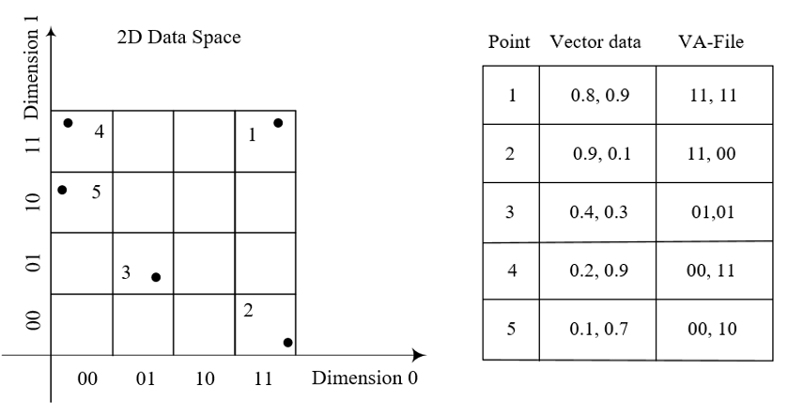
Fig1. Building the VA-File

The vector-approximation file (VA-File) is an array, which approximates data points compactly and geometrically. See from Fig. how an approximation is derived from a certain vector. Firstly, assign a number of bits b_{j} to each dimension j. As we use an even distribution, the relationship between the total number of bits(b) and the number of dimensions(d) determines b_{j}:
b_{j} = floor(b/d) + 1 if j < b % d else floor(b/d)
In the example, b is 4 and d is 2, so j is in [0,1]. b₀ is assigned to 2; b₁ also is assigned to 2.
An approximation ai for a data point p_{i} is generated as follows. In each dimension j, there are 2b_{j} partitions numbered 0, …, 2b_{j} -1. A point falls into a partition only if it lies between the lower and upper bounds of that partition.
Lower[r_{i,j}] <= p_{ij} < Upper[r_{i,j}] = Lower[r_{i+1},_{j}]
As in the example, in dimension 0, the partitions are numbered as 0,1,2,3. Let r_{i,j} be the number of partition of p_{ij} falls in dimension j. In the example, p₂ is (0.9, 0.1), p₂₀ is 0.9. 0.9 falls in 3 in dimension 0, so r_{2,0} is 3.
- Bounds
Each approximation of a vector determines a lower li and an upper bound u_{i} on the distance between the data point pi and the query q. For approximation ai, we have:
li <= L (q, p_{i}) <= u_{i}
In our project, we use euclidean distance.

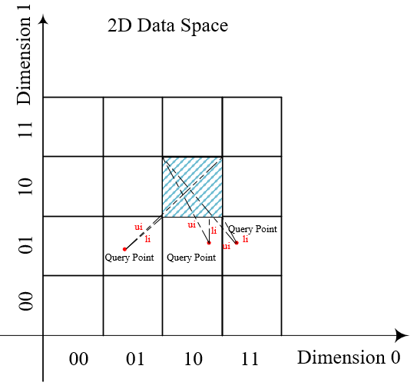
Fig2. Lower and upper bounds for L_{p} (q, p_{i}) given ai guaranteeing li <= L_{p} (q, p_{i}) <= u_{i}

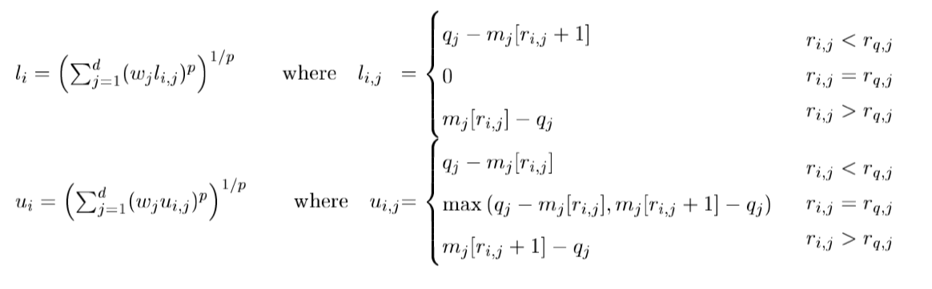
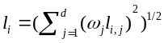
Where: 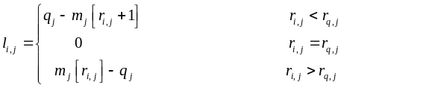

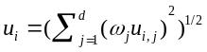
Where:
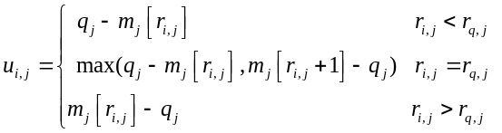
- Two Search Algorithms
K-nearest neighbour (KNN) query gives the k data points closest to the query. In the project we have implemented two different search algorithms in the reference paper to get those vectors. The two algorithms are based on the VA-file approximation and bounds (lower and/or upper) shown in the above.

(3.1) The Simple-Search Algorithm: VA-SSA
VAR ans: ARRAY OF INT; dst: ARRAY of REAL;
a: ARRAY of Approx; 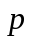: ARRAY of Vector;

FUNC InitCandidate(): REAL;
VAR j : INT;
FOR j := 1 TO k DO
dst[j] := MAXREAL;
RETURN MAXREAL;
END-FUNC InitCandidate;

FUNC Candidate( ): REAL;
IF < dst[k] THEN
des[k] := ; ans[k] :=i;
SortOnDst(ans, dst, k);
RETRUN dst[k];
END-FUNC Candidate

PROC VA-SSA(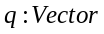);
VAR i: INT; 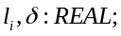
:=InitCandidate();
FOR i := 1 TO N Do
:=GetBounds(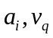);
IF 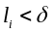THEN
Candidate(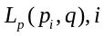 )
END-FOR
END-PROC VA-SSA;
The simple-search algorithm (VA-SSA) is shown above. The approximations are scanned. Array ans is initialized as an array of integer N (the number of items, in our example, it’s 50,000). Array dst is initialized as an array of float(‘inf’). Array dst is maintained of the distances of the nearest K vectors encountered so far in order of increasing distance. And array ans is maintained of the index of nearest K vectors of dst. We take a vector as a candidate whenever the lower bound li is less than dst[-1]. The actual distance L(p_{i},q) is evaluated only for these candidate vectors, hence these candidates are visited.

(3.2) A Near-Optimal Search Algorithm: VA-NOA
In VA-SSA approach, only lower bound distance is used, and we leave upper bound distance unapplied. In VA-NOA, we minimize the number of vectors visited, where l_{i} and u_{i} are used.
There are two phases in VA-NOA. In the first phase, the approximations ai is scanned linearly. The lower bound distance li and upper bound distance u_{i} are computed for each ai. Then the filtering step is followed. Let sigma be the K-th largest upper bound (which is initialized to float(‘inf’) encountered so far. If l_{i} of an a_{i} exceeds sigma, then p_{i} can be ignored since there are K better candidates already.
In the second phase, the answer set is determined by visiting the vectors themselves in increasing order in l_{i}. Not all the remaining candidates must be visited. (This is the mainly difference between VA-NOA and VA-SSA). When a lower bound l_{i} is encountered which exceeds or equals the K-th distance in the answer set, this phase ends. In these two phases, the priority queue is applied to support the data structure.

The near-optimal algorithm (VA-NOA) is shown below.

PROC VA-NOA (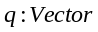);
VAR i: INT;
(* PHASE – ONE *)
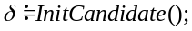
FOR i := 1 TO N DO
l_{i},u_{i} :=GetBounds(a_{i}, );
IF 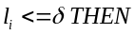
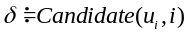
InsertHeap (Heap, 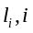 )
END-FOR

(* PHASE – TWO *)
l_{i},i :=PopHeap(Heap);
WHILE DO
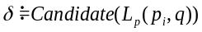
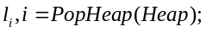
END-WHILE
END-PROC VA-NOA
- Experiments
There is a
- Synthetic data
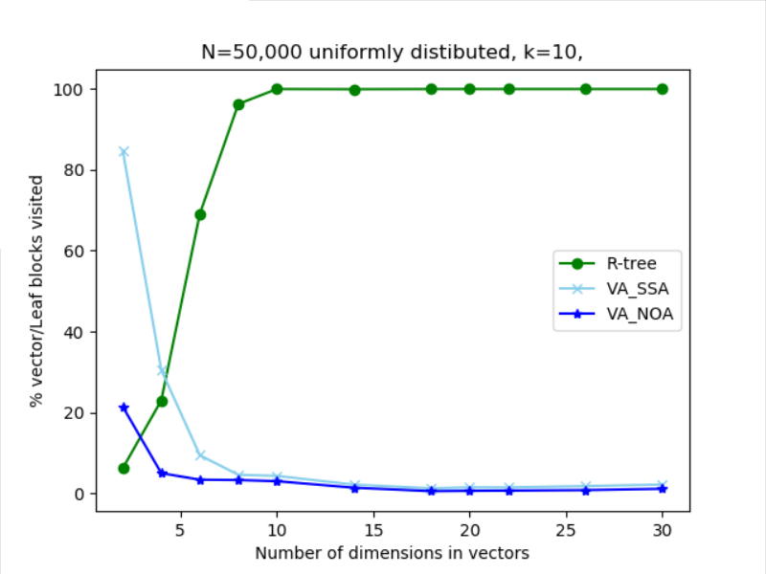
Fig.1 Block selectivity of synthetic data
- R-tree

- VA File

- Real data
The real data we use is image feature--color histogram. The image data set is COCO 2014 train images. As our number of data points (N) is 50,000 when we experiment with the synthesized data, we use the first 50,000 images in the data set. We resize the images to 50*50, and flatten the 2-D color histogram array to 1-D array (2500, ). And then we choose randomly to get a (d, ) from (2500, ).
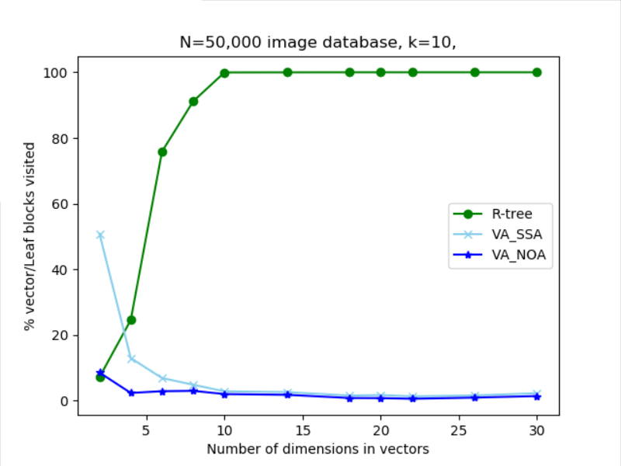
Fig.2 Block selectivity of real data

- R-tree

- VA File

- Evaluation
TTTTTTT
- Extension
We implement extension 1 in our project. Firstly, we choose three kinds different, normal (Gaussian) distribution, exponential distribution and Beta distribution on R-tree and VA File structure. The figure of probability density are shown below.
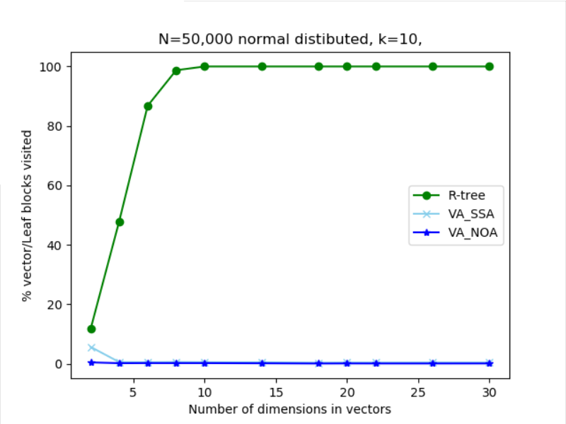
Fig.3 Block selectivity of normal distributed data

Secondly, we select exponential distribution on R-tree and VA File structure, After our experiments, we got the following output.
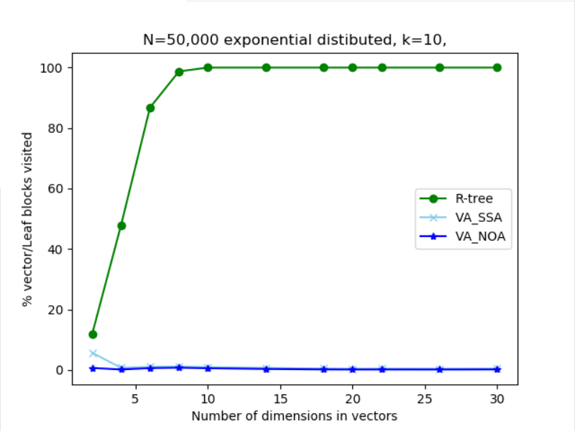
Fig.4 Block selectivity of exponential distributed data

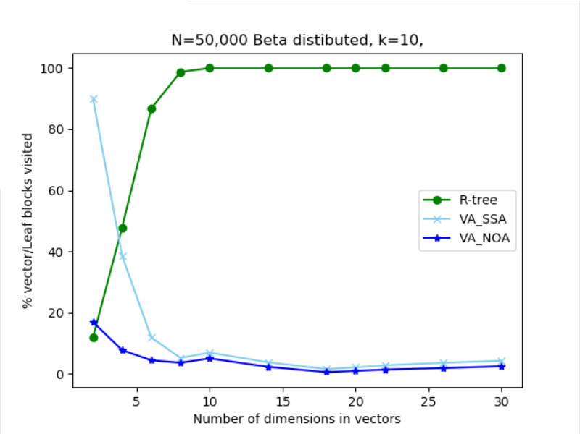
Fig.4 Block selectivity of Beta distributed data

References
- Roger Weber, Hans-J.Schek, Stephen Blott. A Quantitative Analysis and performance Study for Similarity-Search Methods in High-Dimensional Spaces.
- Roger Weber, Stephen Blott. An Approximation-Based Data Structure for Similarity Search

