**CO224 –LAB 06**

**PART 2 – DATA CACHE**

**GROUP 06**

**DEWAGEDARA D.M.E.S. (E/21/087)**

**PERERA W.S.S. (E/21/302)**

**Case 1 - Cache miss occurs when write =1 and read = 0 (write miss) and the dirty bit =0**

**Code**

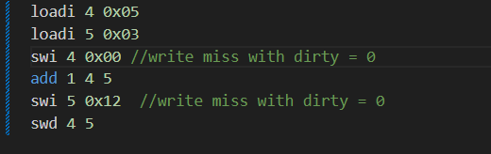

**Timing diagram - WITH CACHE**

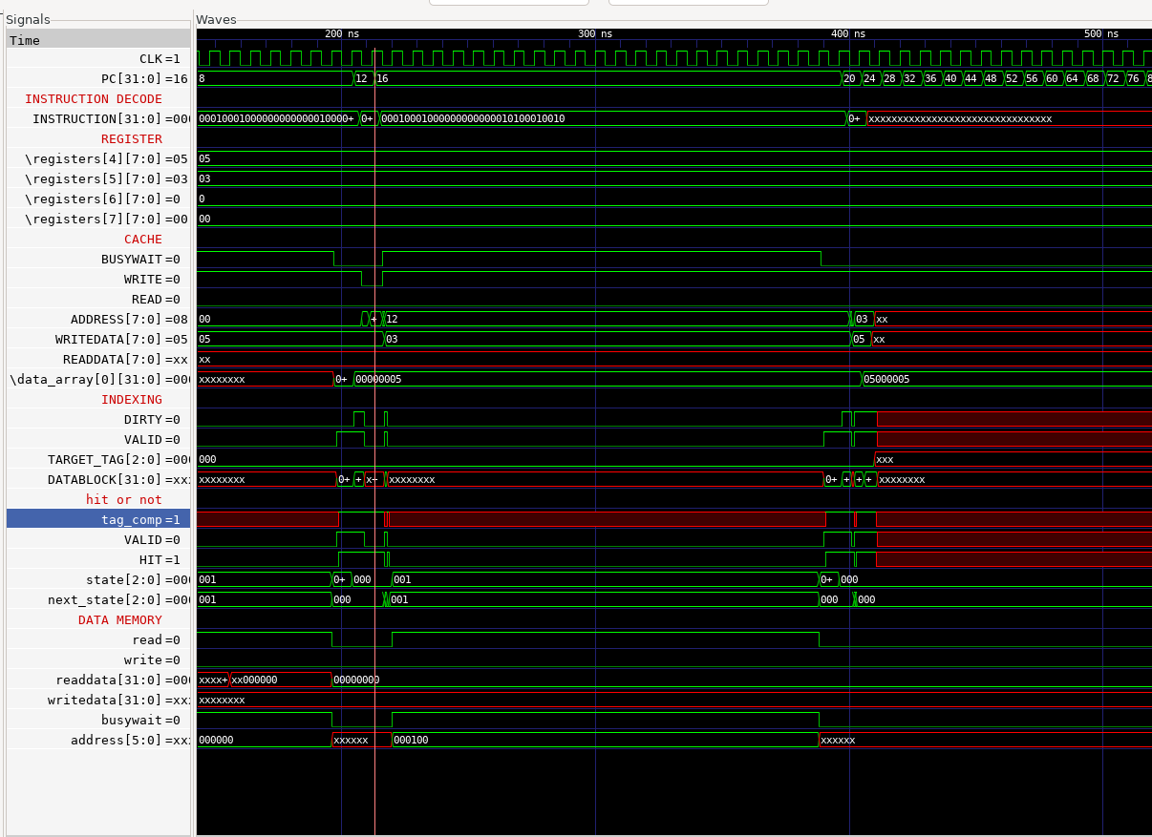

**Load the data block from data memory**

**(within 20 cycles)**

Here, the instruction **swi 5 0x12** causes a write miss because address 0x12 is not yet loaded into the cache.

Since the dirty bit = 0, this means:

* The existing cache block (in that index) is clean.
* So no write-back to memory is needed before loading the new block.

However, the cache must still load the entire block (e.g., 4 words = 16 bytes) from main memory before writing.

If:

* One word memory access = 5 cycles
* One block = 4 words
* Then block load = 5 × 4 = 20 cycles
* Then the write takes another 20 cycles after loading.

**Total = 20 cycles for this write with cache.**

**Timing diagram - WITHOUT CACHE**

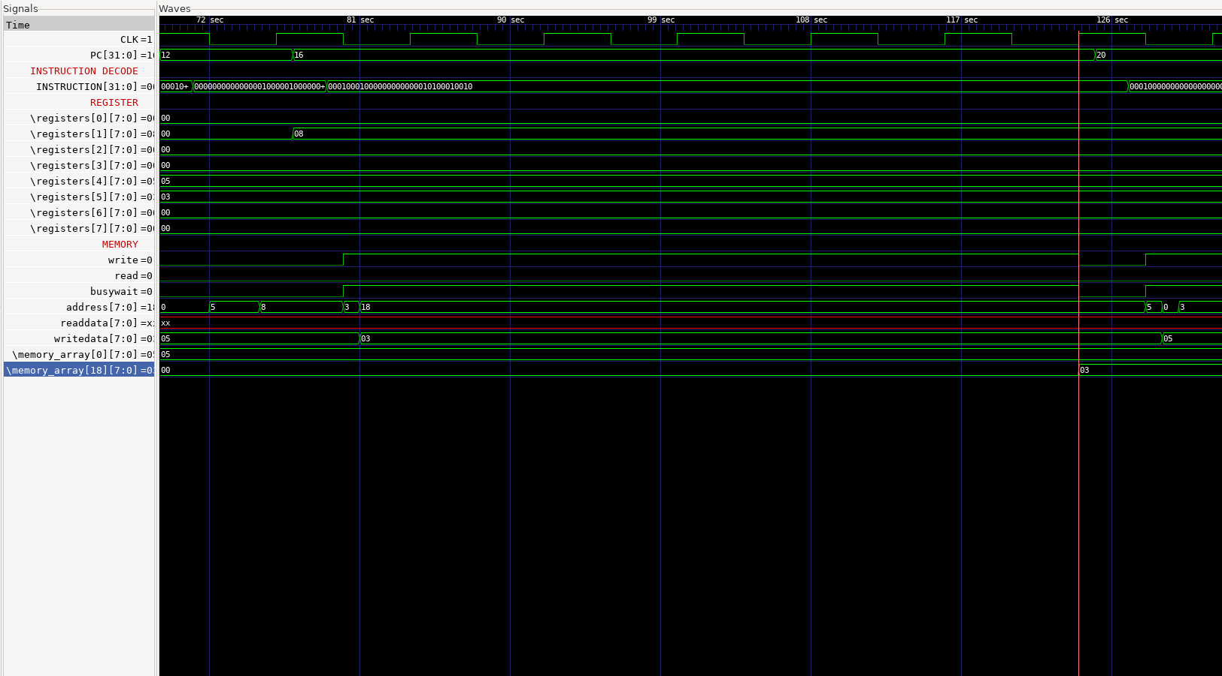

**Directly write in data memory (Within 5 clock cycles)**

If the cache is not used, the **swi 5 0x12** directly writes the value in register R5 to memory address 0x12.

There is:

* + - No block fetching
    - No tag checking
    - No dirty/valid bit checking

So the write happens in one memory access = 5 cycles.

Therefore, making it significantly faster than the cached version in this specific scenario.

**NOTE : This Is Not a Typical "Write Miss with Dirty = 0"**

While this situation behaves like a write miss with dirty = 0, it is technically a **cold miss** because:

* The cache is initially invalid (valid = 0), as no data has been loaded into that index yet.
* The dirty bit is 0 by default, not because of a prior clean write.

**Conflict Misses Also Behave the Same**

This exact delay also occurs during a **conflict miss** when:

* A valid, clean block is replaced by a new block mapping to the same index.
* Since the dirty bit is 0, no write-back occurs.
* But the cache still loads the entire new block before writing.

So, a write miss due to conflict (dirty = 0) also get the same delay.

**Case 2 - Cache miss occurs when write =1 and read = 0 (write miss) and the dirty bit=1(write back)**

**Code**

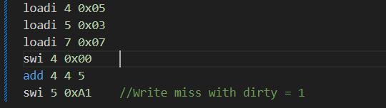

**Timing diagram - WITHOUT CACHE**

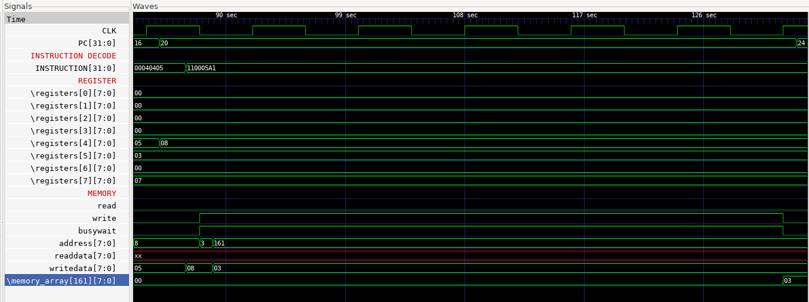

**Directly write in data memory**

**(within 20 cycles)**

In a no-cache system, the **swi 5 0xA1** :

* Directly writes the value 0x03 to memory address 0xA1.
* No need to write back or fetch any blocks.
* Only takes 5 cycles.

**Timing diagram - WITH CACHE**

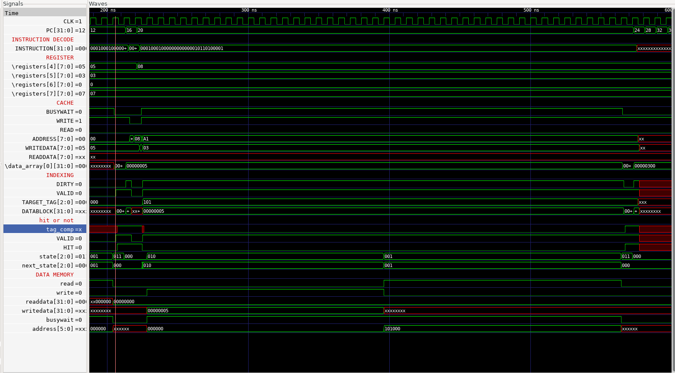

**First update the data memory load the data block from data memory**

**(wihtin 20 cycle)**  **(within 20 cycles)**

When **swi 5 0xA1** is executed:

* Address 0xA1 maps to a different block than 0x00 (same index in direct-mapped cache).
* The currently cached block (e.g., containing 0x00) is:
* Valid = 1
* Dirty = 1

This is a write-back scenario:

* The dirty block (ex: from 0x00) must first be written back to main memory (4 words × 5 cycles = 20 cycles).
* The new block containing 0xA1 must then be loaded from memory (another 20 cycles).

Finally, the write to 0xA1.

For update the cache,

**Total time = 20 (write-back) + 20 (load)**

**= 40 cycles**

**Case 3: Cache hit when write = 1 and read = 0 (write hit)**

**Code**

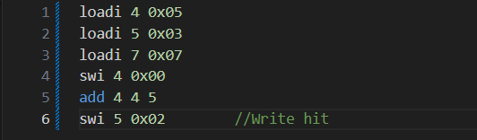

**Timing diagram - WITHOUT CACHE**

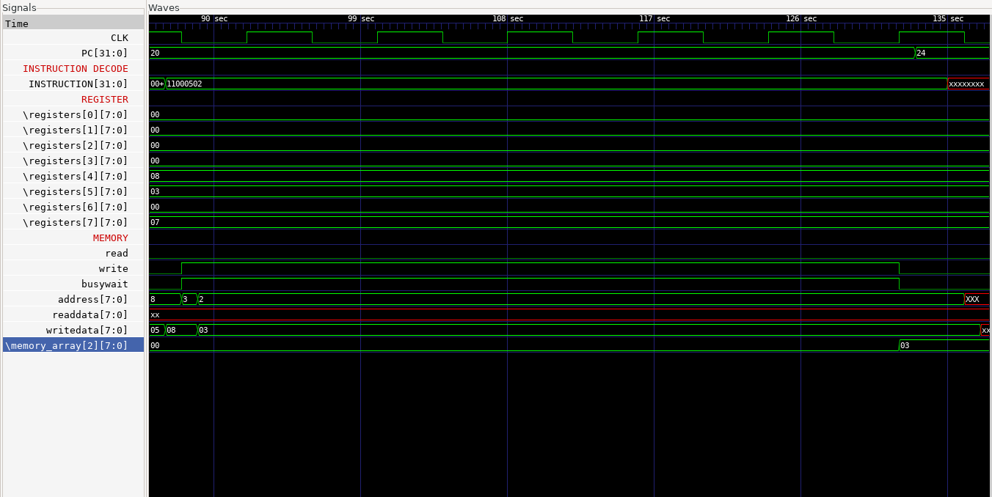

Every store accesses the main memory directly.

* Writing to memory address 0x02 takes:
* 1 memory access = 5 cycles

**Total Delay = 40 cycles**

**Timing diagram - WITH CACHE**

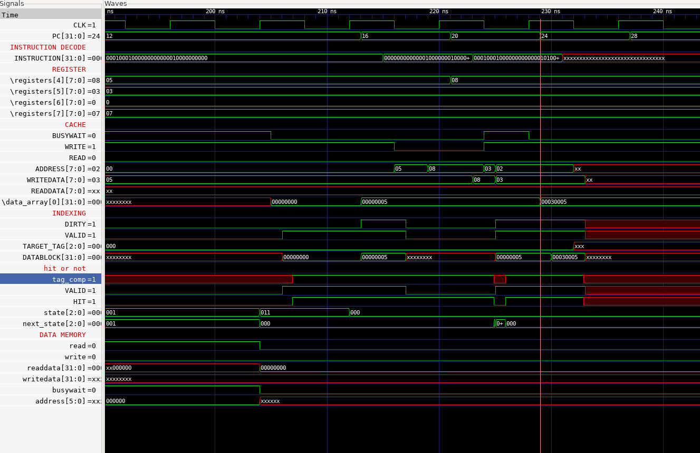

**swi 4 0x00** loads the block containing 0x00 (e.g., 0x00–0x03) into the cache.

* Block is marked valid, and after write, dirty = 1.

Then, **swi 5 0x02**  stores to address 0x02:

* This is in the same block, so the data is already in the cache.
* This is a write hit.

Timing:

* On a write hit, the cache updates the word within the cache block.
* This update happens within  1-cycle latency.
* The memory is not accessed during this write (since it's deferred in write-back caches).

**Total Delay = 1 cycle (1 unit delay for write).**

This comparison highlights the performance advantage of cache on write hits, where cache systems significantly reduce memory latency by performing local updates.

**Case 4:Cache miss occurs when read =1 and write = 0 (read miss) and the dirty bit =0**

**Code,**

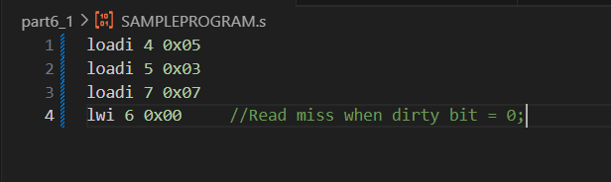

**Timing diagram - WITHOUT CACHE**

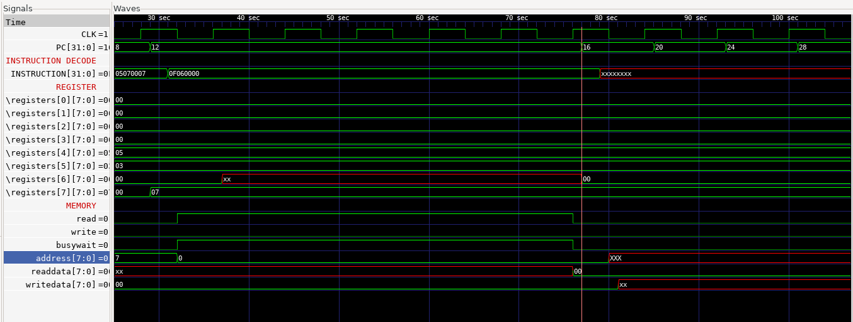

If the cache is disabled:

* The load instruction **lwi 6 0x00**  directly accesses memory
* No block loading, just one word

            **Total Delay = 5 cycles**

**Timing diagram - WITH CACHE**

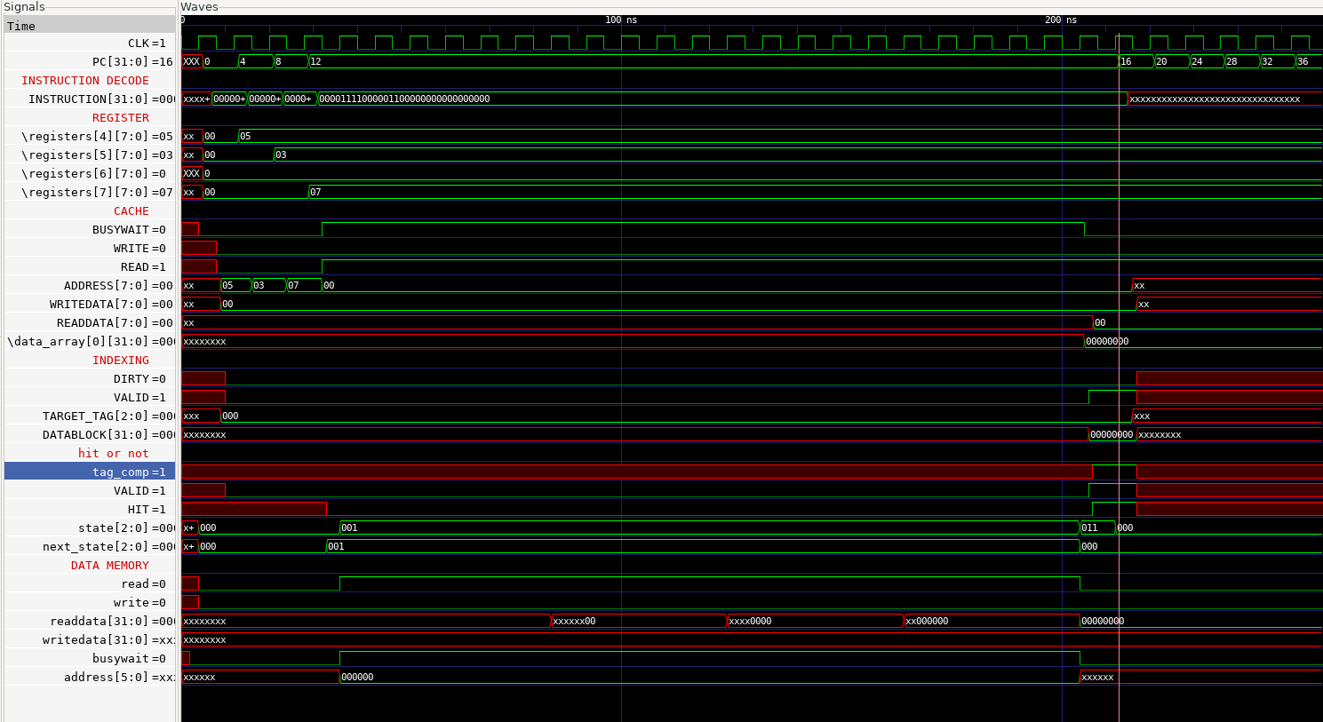

With Cache (Read Miss, Dirty = 0)

* **lwi 6 0x00** reads from memory address 0x00.
* At this point, the cache is empty (first read), so:
* Valid bit = 0
* Dirty bit = 0 (by default)

This is a read miss, and more specifically, a **cold miss** — the first time this address or block is being accessed.

What Happens:

Since the block is invalid and not dirty, there is:

* No need to write back any existing data
* The cache simply fetches the entire block containing address 0x00 from memory.

Timing:

Assuming,

* One memory word = 5 cycles
* Block size = 4 words (16 bytes)

Then,

* Fetching the block from memory = 5 × 4 = 20 cycles

The actual read from cache after load = negligible, happens immediately

**Total Delay = 20 cycles**

**Same Timing for Conflict Miss (Dirty = 0)**

Suppose the cache already had a valid, clean block at the index for 0x00, but a new address mapping to the same index replaces it (a **conflict miss** in a direct-mapped cache):

* Old block is valid and clean (dirty = 0) → no write-back
* New block must be fetched from memory
* Same process as cold miss

**Total Delay = 20 cycles (identical to cold miss)**

**Case  5:Cache miss occurs when read =1 and write = 0 (read miss) and the dirty bit =1 write back)**

**Code**

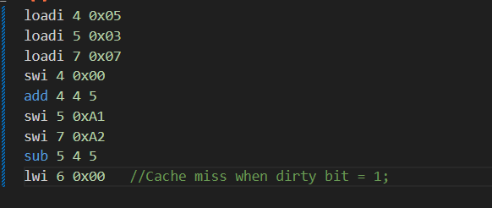

**Timing diagram - WITHOUT CACHE**

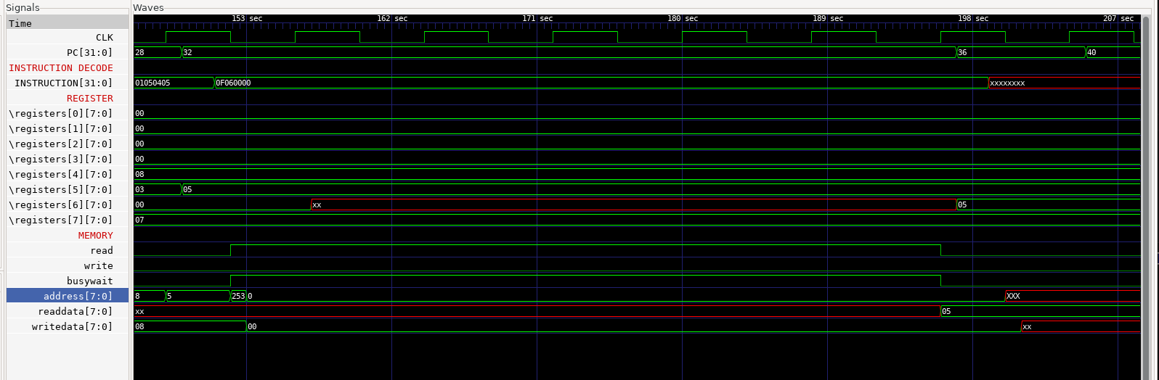

* lwi 6 0x00 directly accesses memory
* Loads one word (no cache, no write-back)

**Total Delay = 5 cycles**

**Timing diagram - WITH CACHE**

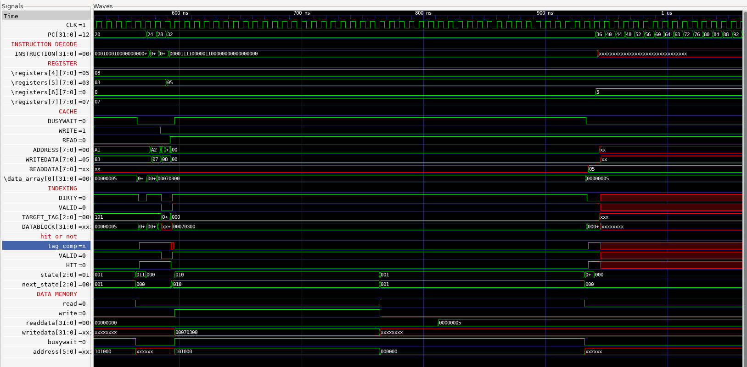

**Update datamemory**   **Read the datablock**

At this point:

* The cache currently holds the block for 0xA0–0xA3 (after **swi 5 0xA1** and **swi 7 0xA2**)
* That block is dirty, because we wrote to 0xA1 and 0xA2
* Now we're trying to load from 0x00, which maps to a different block
* Since it's a read miss and the current block is dirty, the cache must:
* Write back the dirty block (0xA0–0xA3) to main memory.
* Load the new block (0x00–0x03) from memory
* Read the required word (0x00) from the cache

Timing (Assumptions):

* One word memory access = 5 cycles
* One block = 4 words

So:

* Write back dirty block = 4 words = 4 × 5 = 20 cycles
* Load new block = 4 words = 4 × 5 = 20 cycles

**Total with cache = 20 + 20 = 40 cycles.**

**Case 6:Cache hit when read =1 and write = 0 (read hit)**

**Code**

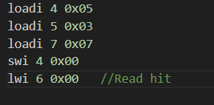

**Timing diagram - WITHOUT CACHE**

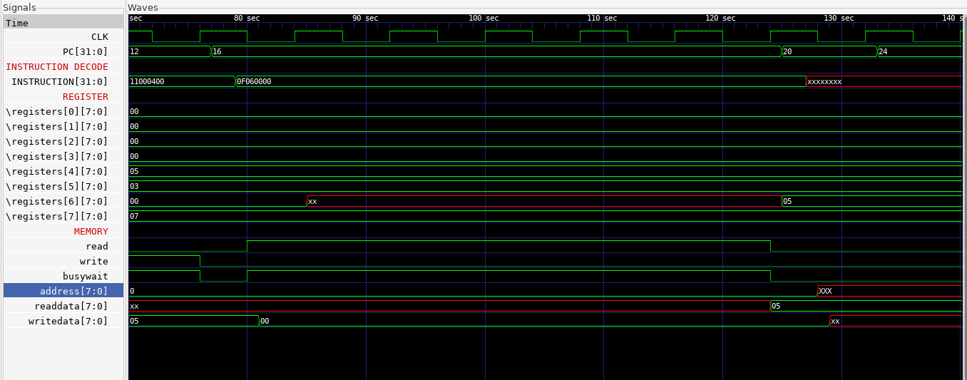

* If there’s no cache, then **lwi 6 0x00** must access main memory directly.
* A memory read operation for a single word takes 20 cycles.

**Total without cache = 20 cycles**

**Timing diagram - WITH CACHE**

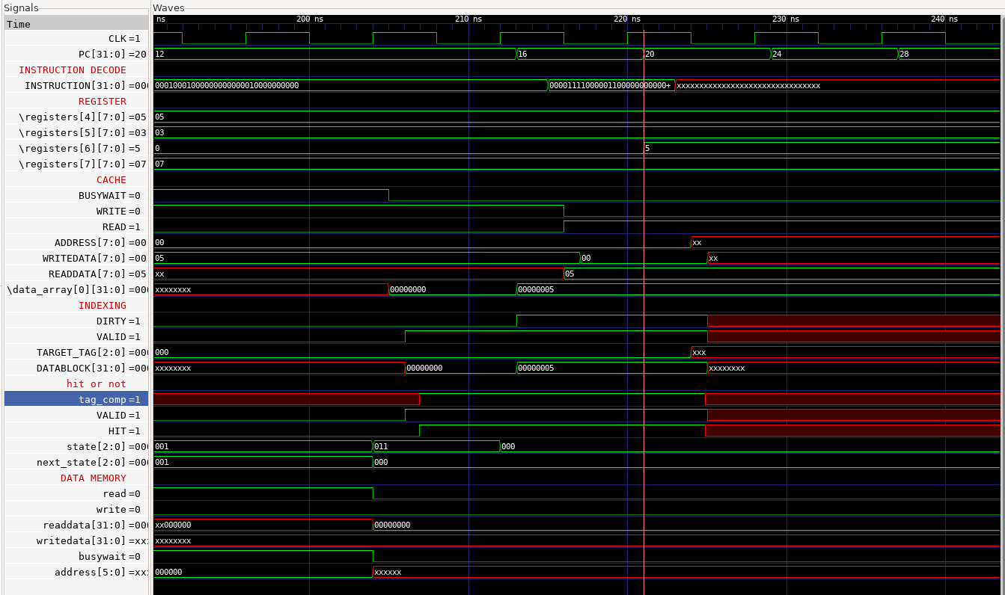

The instruction **swi 4 0x00** writes to memory address 0x00.

* Since it's the first access, the cache loads the block containing address 0x00 (e.g., block 0x00–0x03), sets valid = 1, and marks it dirty = 1 after the write.

The next instruction, **lwi 6 0x00**, reads from the same address.

* That address is already in the cache, so this is a read hit.
* The data is fetched immediately from the cache without accessing main memory.

**Read hit = 1 cycle latency**

No memory access or block transfer needed.

**Final Conclusion**

In this comparison, we analyzed various memory access scenarios in both cache-enabled and non-cached systems, focusing on write hits, write misses, read hits, and read misses.

* In cache hit cases (both read and write), the data is already present in the cache. These operations are completed within a single clock cycle, making with-cache access significantly faster than accessing main memory directly, which typically takes 5 cycles per word.
* However, in cache miss situations, especially when the cache needs to load an entire block (e.g., 4 words), the delay becomes substantial. For example:
  + - A write miss or read miss with dirty = 0 takes around 20 cycles
    - A write miss or read miss with dirty = 1 requires writing back the old block and loading a new one, taking up to 40 cycles.

This shows that while cache improves performance for frequent accesses (hits), it introduces additional overhead during misses due to block-based memory transfers and write-back handling.